RELATÓRIO DO TESTE

Cadastro de Formulário Digital – Cenário 4: Preenchimento dos campos NÃO obrigatórios e salvamento.

Data do teste: 22/09/2025 14:52:21

🔄 Acessando sistema...

✅ Acessando sistema realizada com sucesso.

Screenshot: acessando_sistema

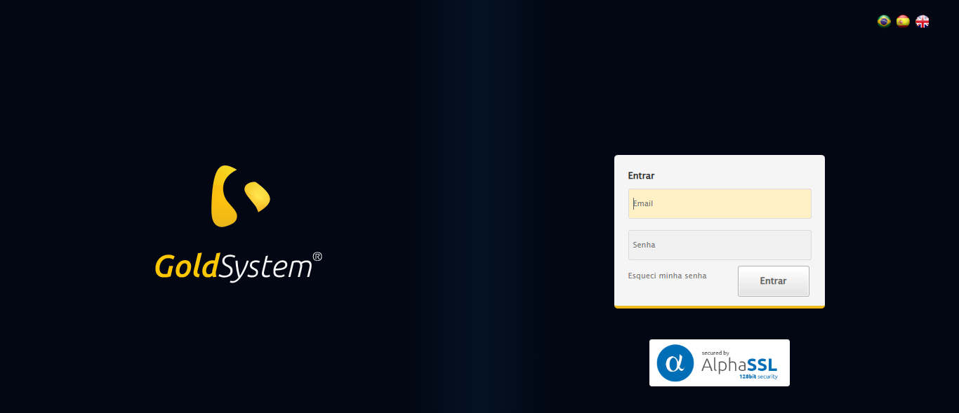

🔄 Realizando login...

✅ Realizando login realizada com sucesso.

Screenshot: realizando_login

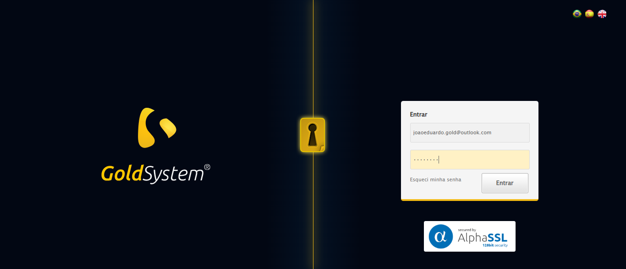

🔄 Esperando sistema carregar e ajustando zoom...

🔍 Zoom ajustado para 90%.

✅ Esperando sistema carregar e ajustando zoom realizada com sucesso.

Screenshot: esperando_sistema_carregar_e_ajustando_zoom

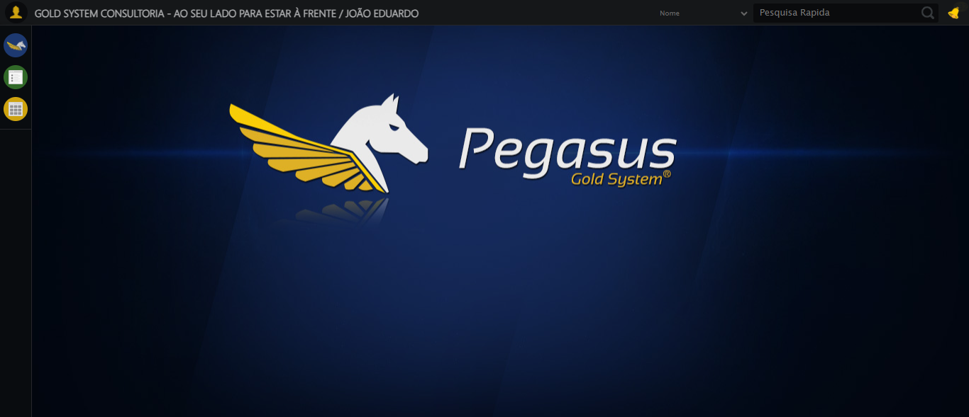

🔄 Abrindo menu Formulário Digital...

✅ Abrindo menu Formulário Digital realizada com sucesso.

Screenshot: abrindo_menu_formulário_digital

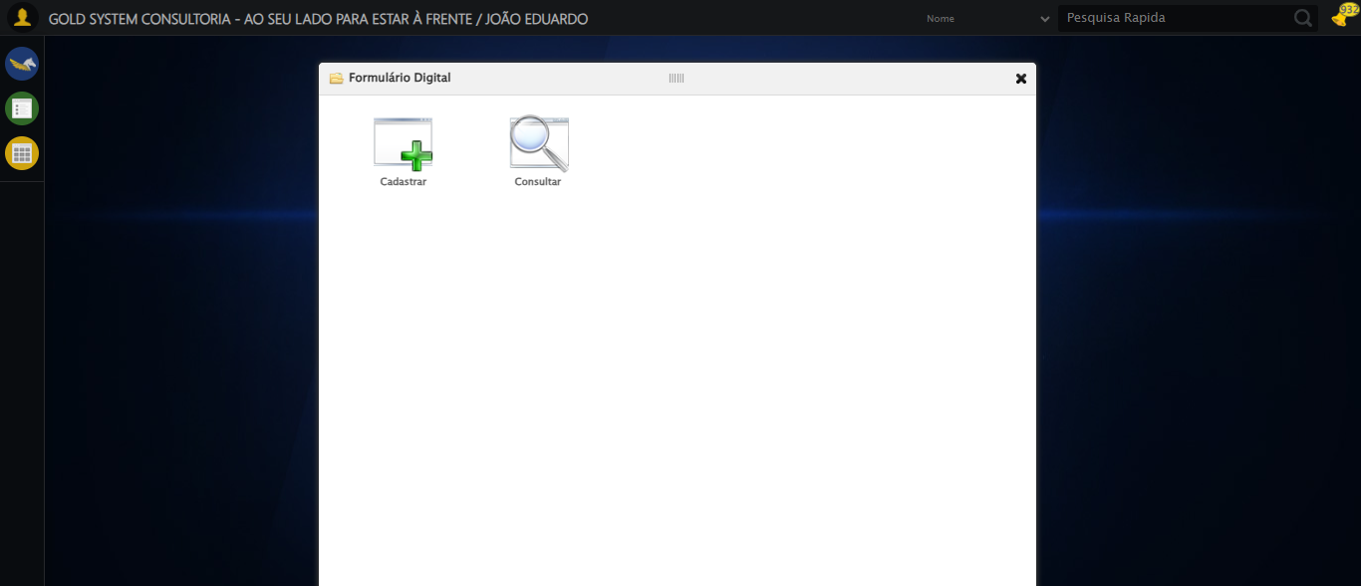

🔄 Clicando em Cadastrar...

✅ Clicando em Cadastrar realizada com sucesso.

Screenshot: clicando_em_cadastrar

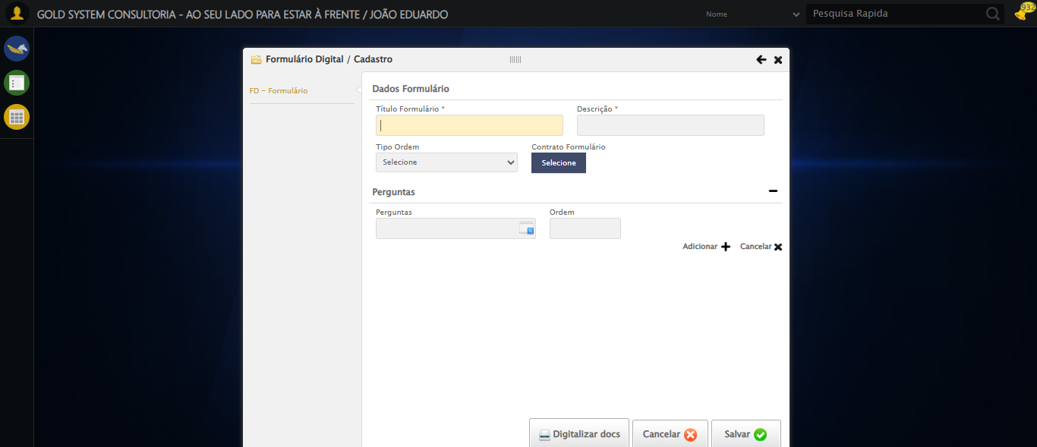

🔄 Selecionando Formato do Formulário...

✅ Selecionando Formato do Formulário realizada com sucesso.

Screenshot: selecionando_formato_do_formulário

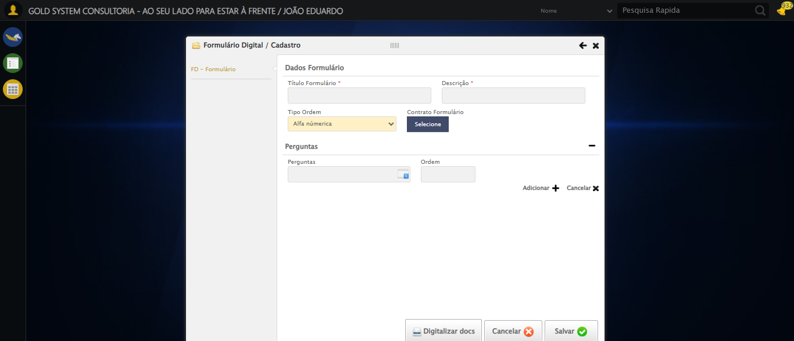

🔄 Criando pergunta 1: POSSUI FILHOS? (TESTE SELENIUM AUTOMATIZADO 917)...

❌ Erro ao criando pergunta 1: possui filhos? (teste selenium automatizado 917): Message: element click intercepted: Element <a class="btAddGroup">...</a> is not clickable at point (931, 324). Other element would receive the click: <div class="btnListHolder">...</div>  
 (Session info: chrome=140.0.7339.129); For documentation on this error, please visit: https://www.selenium.dev/documentation/webdriver/troubleshooting/errors#elementclickinterceptedexception  
Stacktrace:  
 GetHandleVerifier [0x0x470c13+66051]  
 GetHandleVerifier [0x0x470c54+66116]  
 (No symbol) [0x0x24db33]  
 (No symbol) [0x0x29dd90]  
 (No symbol) [0x0x29c0f3]  
 (No symbol) [0x0x299ba7]  
 (No symbol) [0x0x298e2d]  
 (No symbol) [0x0x28d335]  
 (No symbol) [0x0x2b9f8c]  
 (No symbol) [0x0x28cd94]  
 (No symbol) [0x0x2ba144]  
 (No symbol) [0x0x2db7f1]  
 (No symbol) [0x0x2b9d86]  
 (No symbol) [0x0x28b53e]  
 (No symbol) [0x0x28c414]  
 GetHandleVerifier [0x0x6b8a13+2457603]  
 GetHandleVerifier [0x0x6b39d2+2437058]  
 GetHandleVerifier [0x0x4997f2+232930]  
 GetHandleVerifier [0x0x489a18+167944]  
 GetHandleVerifier [0x0x49092d+196381]  
 GetHandleVerifier [0x0x478ee8+99544]  
 GetHandleVerifier [0x0x479082+99954]  
 GetHandleVerifier [0x0x46322a+10266]  
 BaseThreadInitThunk [0x0x7728fcc9+25]  
 RtlGetAppContainerNamedObjectPath [0x0x77e782ae+286]  
 RtlGetAppContainerNamedObjectPath [0x0x77e7827e+238]

Screenshot: erro_criando_pergunta_1:_possui_filhos?_(teste_selenium_automatizado_917)

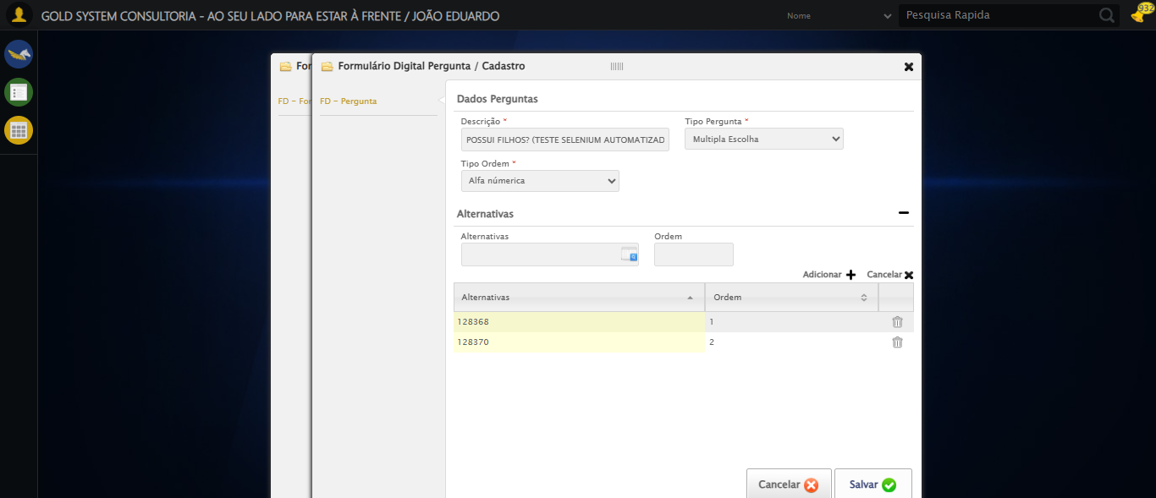

🔄 Criando pergunta 2: CASADO? (TESTE SELENIUM AUTOMATIZADO 917)...

❌ Erro ao criando pergunta 2: casado? (teste selenium automatizado 917): Message: element click intercepted: Element <a class="sprites sp-openLov"></a> is not clickable at point (693, 299). Other element would receive the click: <input type="text" style="width:220px" class="isLovPicker mandatory fc isList" readonly="readonly">  
 (Session info: chrome=140.0.7339.129); For documentation on this error, please visit: https://www.selenium.dev/documentation/webdriver/troubleshooting/errors#elementclickinterceptedexception  
Stacktrace:  
 GetHandleVerifier [0x0x470c13+66051]  
 GetHandleVerifier [0x0x470c54+66116]  
 (No symbol) [0x0x24db33]  
 (No symbol) [0x0x29dd90]  
 (No symbol) [0x0x29c0f3]  
 (No symbol) [0x0x299ba7]  
 (No symbol) [0x0x298e2d]  
 (No symbol) [0x0x28d335]  
 (No symbol) [0x0x2b9f8c]  
 (No symbol) [0x0x28cd94]  
 (No symbol) [0x0x2ba144]  
 (No symbol) [0x0x2db7f1]  
 (No symbol) [0x0x2b9d86]  
 (No symbol) [0x0x28b53e]  
 (No symbol) [0x0x28c414]  
 GetHandleVerifier [0x0x6b8a13+2457603]  
 GetHandleVerifier [0x0x6b39d2+2437058]  
 GetHandleVerifier [0x0x4997f2+232930]  
 GetHandleVerifier [0x0x489a18+167944]  
 GetHandleVerifier [0x0x49092d+196381]  
 GetHandleVerifier [0x0x478ee8+99544]  
 GetHandleVerifier [0x0x479082+99954]  
 GetHandleVerifier [0x0x46322a+10266]  
 BaseThreadInitThunk [0x0x7728fcc9+25]  
 RtlGetAppContainerNamedObjectPath [0x0x77e782ae+286]  
 RtlGetAppContainerNamedObjectPath [0x0x77e7827e+238]

Screenshot: erro_criando_pergunta_2:_casado?_(teste_selenium_automatizado_917)



🔄 Criando pergunta 3: TEM PET? (TESTE SELENIUM AUTOMATIZADO 917)...

❌ Erro ao criando pergunta 3: tem pet? (teste selenium automatizado 917): Message: element click intercepted: Element <a class="sprites sp-openLov"></a> is not clickable at point (693, 299). Other element would receive the click: <input type="text" style="width:220px" class="isLovPicker mandatory fc isList" readonly="readonly">  
 (Session info: chrome=140.0.7339.129); For documentation on this error, please visit: https://www.selenium.dev/documentation/webdriver/troubleshooting/errors#elementclickinterceptedexception  
Stacktrace:  
 GetHandleVerifier [0x0x470c13+66051]  
 GetHandleVerifier [0x0x470c54+66116]  
 (No symbol) [0x0x24db33]  
 (No symbol) [0x0x29dd90]  
 (No symbol) [0x0x29c0f3]  
 (No symbol) [0x0x299ba7]  
 (No symbol) [0x0x298e2d]  
 (No symbol) [0x0x28d335]  
 (No symbol) [0x0x2b9f8c]  
 (No symbol) [0x0x28cd94]  
 (No symbol) [0x0x2ba144]  
 (No symbol) [0x0x2db7f1]  
 (No symbol) [0x0x2b9d86]  
 (No symbol) [0x0x28b53e]  
 (No symbol) [0x0x28c414]  
 GetHandleVerifier [0x0x6b8a13+2457603]  
 GetHandleVerifier [0x0x6b39d2+2437058]  
 GetHandleVerifier [0x0x4997f2+232930]  
 GetHandleVerifier [0x0x489a18+167944]  
 GetHandleVerifier [0x0x49092d+196381]  
 GetHandleVerifier [0x0x478ee8+99544]  
 GetHandleVerifier [0x0x479082+99954]  
 GetHandleVerifier [0x0x46322a+10266]  
 BaseThreadInitThunk [0x0x7728fcc9+25]  
 RtlGetAppContainerNamedObjectPath [0x0x77e782ae+286]  
 RtlGetAppContainerNamedObjectPath [0x0x77e7827e+238]

Screenshot: erro_criando_pergunta_3:_tem_pet?_(teste_selenium_automatizado_917)



🔄 Criando pergunta 4: QUAL É O SEU NOME? (TESTE SELENIUM AUTOMATIZADO 917)...

❌ Erro ao criando pergunta 4: qual é o seu nome? (teste selenium automatizado 917): Message: element click intercepted: Element <a class="sprites sp-openLov"></a> is not clickable at point (693, 299). Other element would receive the click: <input type="text" style="width:220px" class="isLovPicker mandatory fc isList" readonly="readonly">  
 (Session info: chrome=140.0.7339.129); For documentation on this error, please visit: https://www.selenium.dev/documentation/webdriver/troubleshooting/errors#elementclickinterceptedexception  
Stacktrace:  
 GetHandleVerifier [0x0x470c13+66051]  
 GetHandleVerifier [0x0x470c54+66116]  
 (No symbol) [0x0x24db33]  
 (No symbol) [0x0x29dd90]  
 (No symbol) [0x0x29c0f3]  
 (No symbol) [0x0x299ba7]  
 (No symbol) [0x0x298e2d]  
 (No symbol) [0x0x28d335]  
 (No symbol) [0x0x2b9f8c]  
 (No symbol) [0x0x28cd94]  
 (No symbol) [0x0x2ba144]  
 (No symbol) [0x0x2db7f1]  
 (No symbol) [0x0x2b9d86]  
 (No symbol) [0x0x28b53e]  
 (No symbol) [0x0x28c414]  
 GetHandleVerifier [0x0x6b8a13+2457603]  
 GetHandleVerifier [0x0x6b39d2+2437058]  
 GetHandleVerifier [0x0x4997f2+232930]  
 GetHandleVerifier [0x0x489a18+167944]  
 GetHandleVerifier [0x0x49092d+196381]  
 GetHandleVerifier [0x0x478ee8+99544]  
 GetHandleVerifier [0x0x479082+99954]  
 GetHandleVerifier [0x0x46322a+10266]  
 BaseThreadInitThunk [0x0x7728fcc9+25]  
 RtlGetAppContainerNamedObjectPath [0x0x77e782ae+286]  
 RtlGetAppContainerNamedObjectPath [0x0x77e7827e+238]

Screenshot: erro_criando_pergunta_4:_qual_é_o_seu_nome?_(teste_selenium_automatizado_917)



🔄 Salvando formulário digital...

❌ Erro ao salvando formulário digital: Message: element click intercepted: Element <a class="btModel btGray btsave">...</a> is not clickable at point (982, 570). Other element would receive the click: <a class="btModel btGray btcancel">...</a>  
 (Session info: chrome=140.0.7339.129); For documentation on this error, please visit: https://www.selenium.dev/documentation/webdriver/troubleshooting/errors#elementclickinterceptedexception  
Stacktrace:  
 GetHandleVerifier [0x0x470c13+66051]  
 GetHandleVerifier [0x0x470c54+66116]  
 (No symbol) [0x0x24db33]  
 (No symbol) [0x0x29dd90]  
 (No symbol) [0x0x29c0f3]  
 (No symbol) [0x0x299ba7]  
 (No symbol) [0x0x298e2d]  
 (No symbol) [0x0x28d335]  
 (No symbol) [0x0x2b9f8c]  
 (No symbol) [0x0x28cd94]  
 (No symbol) [0x0x2ba144]  
 (No symbol) [0x0x2db7f1]  
 (No symbol) [0x0x2b9d86]  
 (No symbol) [0x0x28b53e]  
 (No symbol) [0x0x28c414]  
 GetHandleVerifier [0x0x6b8a13+2457603]  
 GetHandleVerifier [0x0x6b39d2+2437058]  
 GetHandleVerifier [0x0x4997f2+232930]  
 GetHandleVerifier [0x0x489a18+167944]  
 GetHandleVerifier [0x0x49092d+196381]  
 GetHandleVerifier [0x0x478ee8+99544]  
 GetHandleVerifier [0x0x479082+99954]  
 GetHandleVerifier [0x0x46322a+10266]  
 BaseThreadInitThunk [0x0x7728fcc9+25]  
 RtlGetAppContainerNamedObjectPath [0x0x77e782ae+286]  
 RtlGetAppContainerNamedObjectPath [0x0x77e7827e+238]

Screenshot: erro_salvando_formulário_digital



ℹ️ Nenhuma mensagem de alerta encontrada.

🔄 Fechando modal após salvamento...

❌ Erro ao fechando modal após salvamento: Message: element click intercepted: Element <a class="sprites sp-close">...</a> is not clickable at point (1025, 78). Other element would receive the click: <h2>...</h2>  
 (Session info: chrome=140.0.7339.129); For documentation on this error, please visit: https://www.selenium.dev/documentation/webdriver/troubleshooting/errors#elementclickinterceptedexception  
Stacktrace:  
 GetHandleVerifier [0x0x470c13+66051]  
 GetHandleVerifier [0x0x470c54+66116]  
 (No symbol) [0x0x24db33]  
 (No symbol) [0x0x29dd90]  
 (No symbol) [0x0x29c0f3]  
 (No symbol) [0x0x299ba7]  
 (No symbol) [0x0x298e2d]  
 (No symbol) [0x0x28d335]  
 (No symbol) [0x0x2b9f8c]  
 (No symbol) [0x0x28cd94]  
 (No symbol) [0x0x2ba144]  
 (No symbol) [0x0x2db7f1]  
 (No symbol) [0x0x2b9d86]  
 (No symbol) [0x0x28b53e]  
 (No symbol) [0x0x28c414]  
 GetHandleVerifier [0x0x6b8a13+2457603]  
 GetHandleVerifier [0x0x6b39d2+2437058]  
 GetHandleVerifier [0x0x4997f2+232930]  
 GetHandleVerifier [0x0x489a18+167944]  
 GetHandleVerifier [0x0x49092d+196381]  
 GetHandleVerifier [0x0x478ee8+99544]  
 GetHandleVerifier [0x0x479082+99954]  
 GetHandleVerifier [0x0x46322a+10266]  
 BaseThreadInitThunk [0x0x7728fcc9+25]  
 RtlGetAppContainerNamedObjectPath [0x0x77e782ae+286]  
 RtlGetAppContainerNamedObjectPath [0x0x77e7827e+238]

Screenshot: erro_fechando_modal_após_salvamento



✅ Teste concluído com sucesso.