RELATÓRIO DO TESTE

Geração de Boletos - Gestor Financeiro – Cenário 1: Rotina completa de Geração de Boletos - Tipo de Boleto: Carnê

Data do teste: 21/10/2025 17:19:49

🚀 Iniciando teste de Geração de Títulos

======================================================================

✅ Driver inicializado com sucesso

🔄 Acessando sistema...

✅ Acessando sistema realizada com sucesso.

Screenshot: acessando sistema



🔄 Realizando login...

✅ Realizando login realizada com sucesso.

Screenshot: realizando login

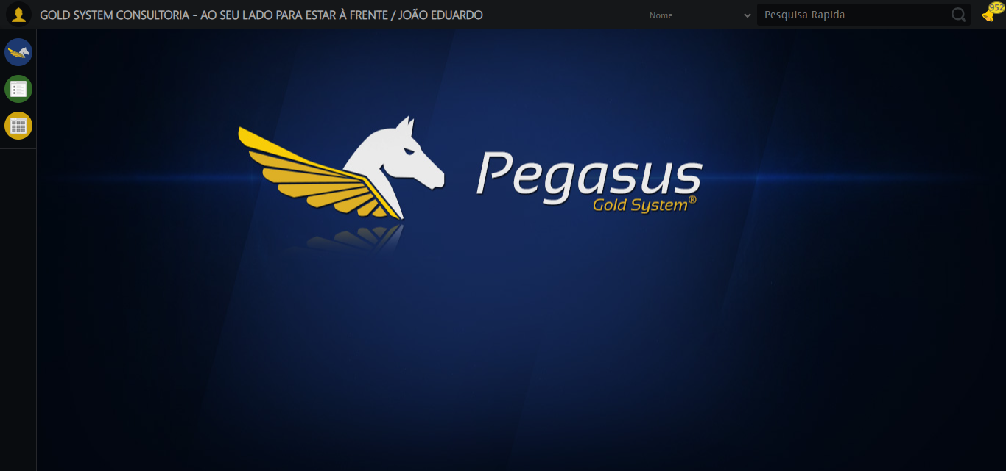

🔄 Abrindo menu (F3)...

✅ Abrindo menu (F3) realizada com sucesso.

Screenshot: abrindo menu (f3)

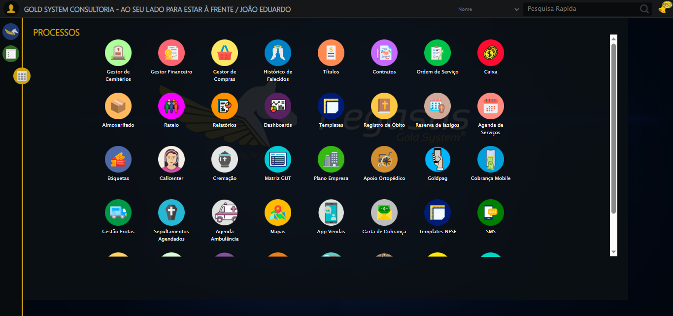

🔄 Acessando Gestor Financeiro...

🎯 Clique forçado em: /html/body/div[15]/ul/li[2]/img

Tentativa 1.1...

✅ Clique bem-sucedido (estratégia 1)

✅ Acessando Gestor Financeiro realizada com sucesso.

Screenshot: acessando gestor financeiro

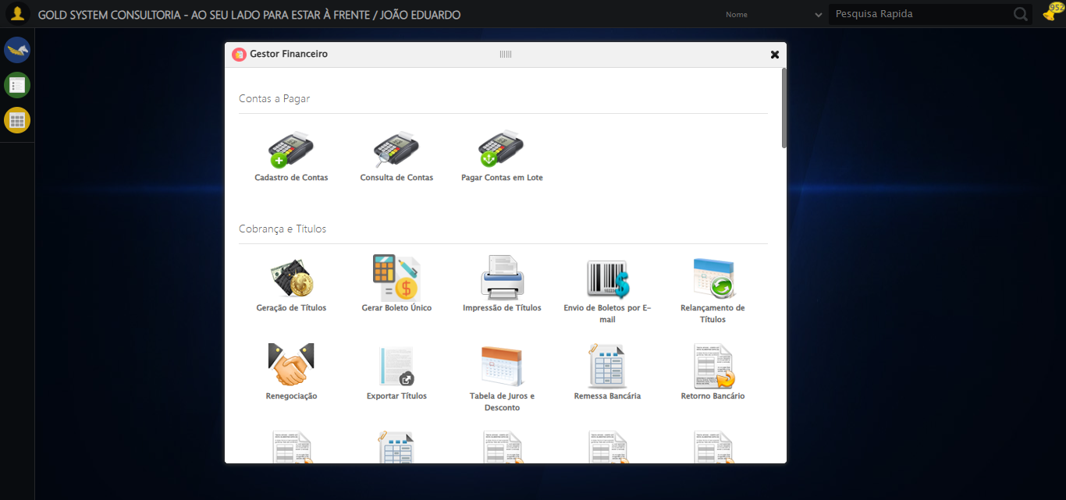

🔄 Clicando em Impressão de Títulos...

🎯 Clique forçado em: #gsFinan > div.wdTelas > div > ul > li:nth-child(8) > a > span

Tentativa 1.1...

✅ Clique bem-sucedido (estratégia 1)

✅ Clicando em Impressão de Títulos realizada com sucesso.

Screenshot: clicando em impressão de títulos

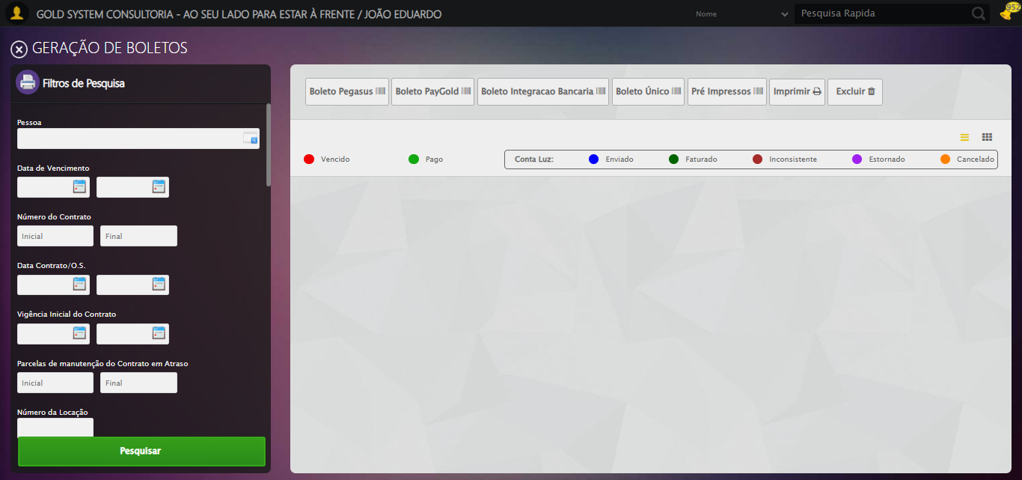

🔄 Selecionando Pessoa...

🔍 Processando LOV: 'JOÃO EDUARDO JUSTINO PASCHOAL' → 'JOÃO EDUARDO JUSTINO PASCHOAL'

Tentativa 1/5

📌 Abrindo LOV...

🎯 Clique forçado em: (//a[@class='sprites sp-openLov'])[1]

Tentativa 1.1...

✅ Clique bem-sucedido (estratégia 1)

✏️ Pesquisando: 'JOÃO EDUARDO JUSTINO PASCHOAL'

✏️ Preenchimento forçado: //input[@id='txtPesquisa'] = 'JOÃO EDUARDO JUSTINO PASCHOAL'

Tentativa 1.1...

✅ Campo preenchido (estratégia 1)

🔎 Executando pesquisa...

🎯 Clique forçado em: //a[contains(@class,'lpFind') and contains(normalize-space(.),'Pesquisar')]

Tentativa 1.1...

✅ Clique bem-sucedido (estratégia 1)

🎯 Selecionando: 'JOÃO EDUARDO JUSTINO PASCHOAL'

🎯 Clique forçado em: //tr[td[contains(normalize-space(.), 'JOÃO EDUARDO JUSTINO PASCHOAL')]]

Tentativa 1.1...

✅ Clique bem-sucedido (estratégia 1)

✅ LOV processado com sucesso!

✅ Selecionando Pessoa realizada com sucesso.

Screenshot: selecionando pessoa

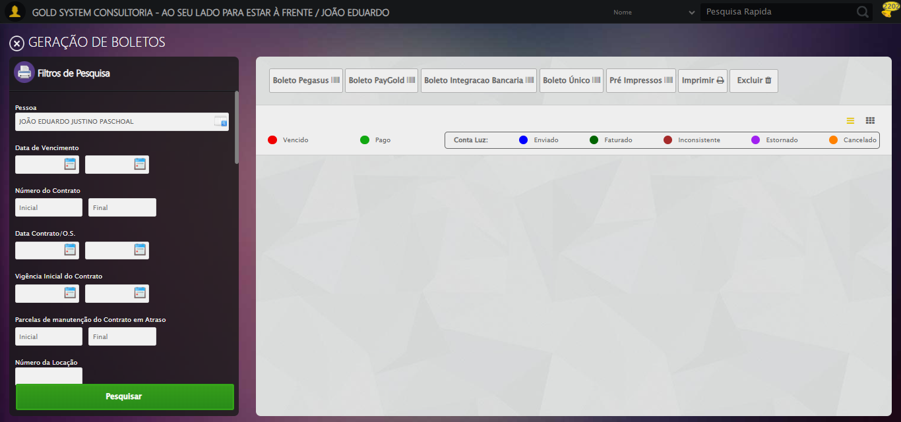

🔄 Selecionando Opção: 'Em aberto'...

✅ Selecionando Opção: 'Em aberto' realizada com sucesso.

Screenshot: selecionando opção_ _em aberto_

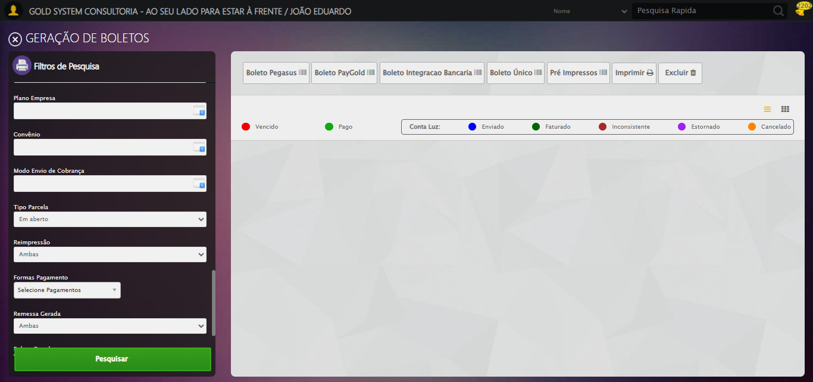

🔄 Clicando em Pesquisar...

🎯 Clique forçado em: //a[@class='btModel btGreen btPesquisar boxsize' and normalize-space()='Pesquisar']

Tentativa 1.1...

✅ Clique bem-sucedido (estratégia 1)

✅ Clicando em Pesquisar realizada com sucesso.

Screenshot: clicando em pesquisar

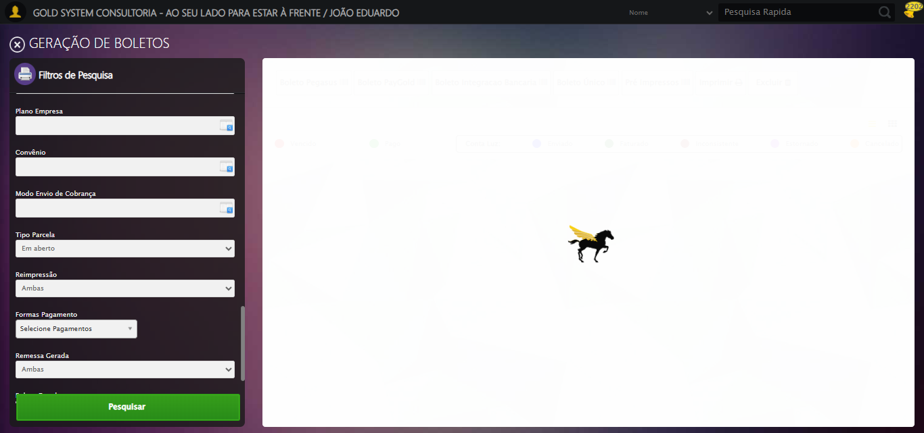

🚀 Iniciando fluxo completo de geração de boletos...

🔍 Validando resultado da pesquisa...

✅ Tabela de Títulos carregada com sucesso, prosseguindo

✅ Prosseguindo com o fluxo — tabela carregada com sucesso.

📄 Total de títulos encontrados: 50

🔍 Abrindo modal de detalhes do primeiro título...

🔄 Visualizando Detalhes...

🎯 Clique forçado em: //i[@class='sprites sp-dadosDinamicos' and @title='Visualizar Detalhes']

Tentativa 1.1...

✅ Clique bem-sucedido (estratégia 1)

✅ Visualizando Detalhes realizada com sucesso.

Screenshot: visualizando detalhes

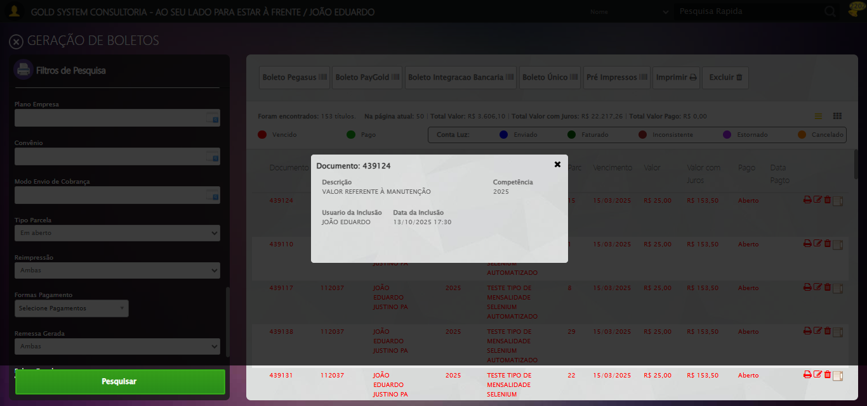

Screenshot: modal_detalhes_aberto



📸 Screenshot capturado com o modal aberto.

🔄 Fechando modal de Detalhes...

🧩 Tentativa 1 de fechar modal...

🎯 Clique forçado em: (//div[contains(@class,'modal') and not(contains(@style,'display: none'))]//a[@class='fa fa-close'])[last()]

Tentativa 1.1...

✅ Clique bem-sucedido (estratégia 1)

🧩 Tentativa 2 de fechar modal...

🎯 Clique forçado em: (//div[contains(@class,'modal') and not(contains(@style,'display: none'))]//a[@class='fa fa-close'])[last()]

Tentativa 1.1...

✅ Clique bem-sucedido (estratégia 1)

✅ Modal fechado com sucesso.

✅ Fechando modal de Detalhes realizada com sucesso.

Screenshot: fechando modal de detalhes

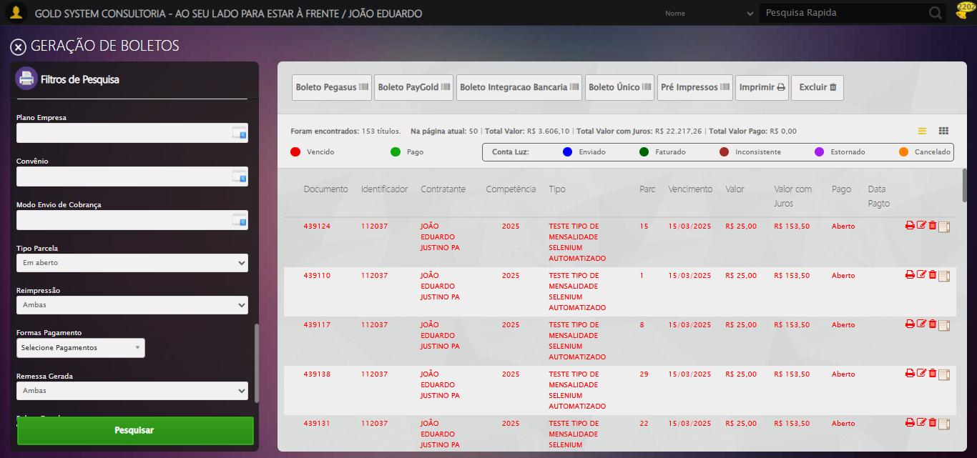

🔄 Clicando em 'Boleto Pegasus'...

🎯 Clique forçado em: //a[@class='btModel btShort btLight boletoPegasus' and normalize-space(text())='Boleto Pegasus']/i[@class='fa fa-barcode']/parent::a

Tentativa 1.1...

✅ Clique bem-sucedido (estratégia 1)

✅ Clicando em 'Boleto Pegasus' realizada com sucesso.

Screenshot: clicando em _boleto pegasus_

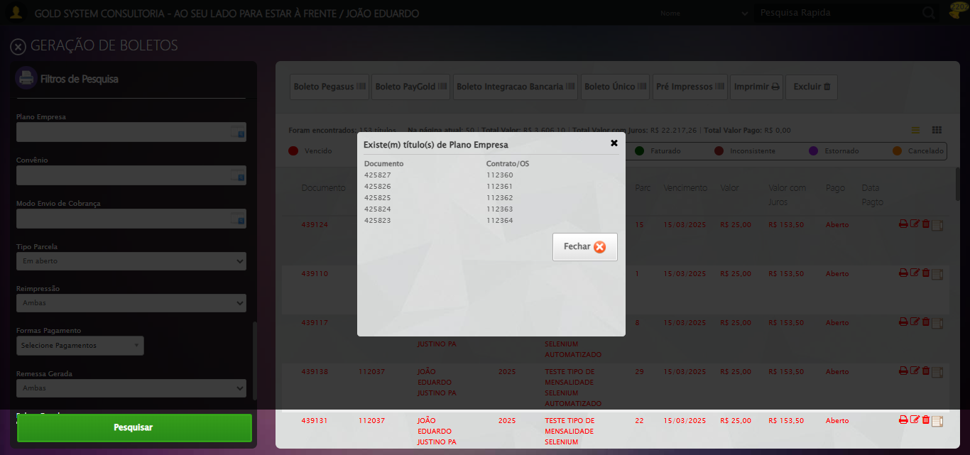

🧾 Detectado modal 'Plano Empresa' após clicar em Boleto Pegasus.

🧩 Procurando botões 'Fechar' dentro do modal Plano Empresa...

🔎 Encontrados 2 botão(ões) 'Fechar' no DOM.

🧩 Fechando 'Plano Empresa' — botão índice 1 de 2

🎯 Clique forçado em: ((//div[contains(@class,'telaModalTitulosPlanoEmpresa')]/ancestor::div[contains(@class,'modal') and contains(@class,'overflow')]//a[contains(@class,'btModel') and contains(@class,'btGray') and normalize-space(.)='Fechar'])|(//div[contains(@class,'telaModalTitulosPlanoEmpresa')]/ancestor::div[contains(@class,'modal') and contains(@class,'overflow')]//a[contains(@class,'fa') and contains(@class,'fa-close')]))[1]

Tentativa 1.1...

✅ Clique bem-sucedido (estratégia 1)

✅ Clique de fechar executado com sucesso.

⚠️ Não foi possível garantir o fechamento do 'Plano Empresa'.

🔚 Encerrando aqui: fluxo de geração NÃO será executado por estar no 'Plano Empresa'.

🔄 Fechando aba de Geração de Boletos...

🎯 Clique forçado em: //a[@class='sprites sp-fecharGrande' and @title='Sair']

Tentativa 1.1...

✅ Clique bem-sucedido (estratégia 1)

✅ Fechando aba de Geração de Boletos realizada com sucesso.

Screenshot: fechando aba de geração de boletos

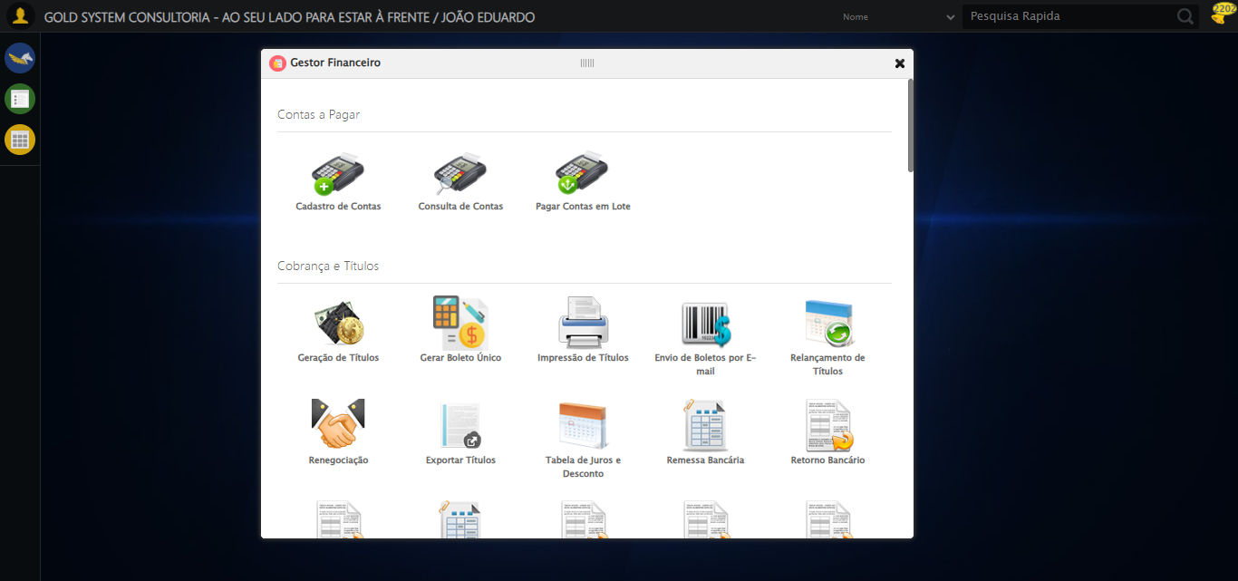

✅ Aba de Geração de Boletos fechada com sucesso.

🔄 Fechando Gestor Financeiro...

🎯 Clique forçado em: #gsFinan > div.wdTop.ui-draggable-handle > div.wdClose > a

Tentativa 1.1...

⚠️ Erro JS: Message: invalid session id: session deleted as the browser has closed the connection  
from disconnected: not connected to DevTools  
 (Session info: ch

Estratégia 1 falhou: Message: invalid session id: session deleted as the browser has closed the conne

Tentativa 1.2...

⚠️ Erro JS: Message: invalid session id; For documentation on this error, please visit: https://www.selenium.dev/documentation/webdriver/troubleshooting/errors#in

Estratégia 2 falhou: Message: invalid session id; For documentation on this error, please visit: http

Tentativa 1.3...

⚠️ Erro JS: Message: invalid session id; For documentation on this error, please visit: https://www.selenium.dev/documentation/webdriver/troubleshooting/errors#in

Estratégia 3 falhou: Message: invalid session id; For documentation on this error, please visit: http

Tentativa 1.4...

⚠️ Erro JS: Message: invalid session id; For documentation on this error, please visit: https://www.selenium.dev/documentation/webdriver/troubleshooting/errors#in

Estratégia 4 falhou: Message: invalid session id; For documentation on this error, please visit: http

Tentativa 1.5...

⚠️ Erro JS: Message: invalid session id; For documentation on this error, please visit: https://www.selenium.dev/documentation/webdriver/troubleshooting/errors#in

Estratégia 5 falhou: Message: invalid session id; For documentation on this error, please visit: http

Tentativa 2.1...

⚠️ Erro JS: Message: invalid session id; For documentation on this error, please visit: https://www.selenium.dev/documentation/webdriver/troubleshooting/errors#in

Estratégia 1 falhou: Message: invalid session id; For documentation on this error, please visit: http

Tentativa 2.2...

⚠️ Erro JS: Message: invalid session id; For documentation on this error, please visit: https://www.selenium.dev/documentation/webdriver/troubleshooting/errors#in

Estratégia 2 falhou: Message: invalid session id; For documentation on this error, please visit: http

Tentativa 2.3...

⚠️ Erro JS: Message: invalid session id; For documentation on this error, please visit: https://www.selenium.dev/documentation/webdriver/troubleshooting/errors#in

Estratégia 3 falhou: Message: invalid session id; For documentation on this error, please visit: http

Tentativa 2.4...

⚠️ Erro JS: Message: invalid session id; For documentation on this error, please visit: https://www.selenium.dev/documentation/webdriver/troubleshooting/errors#in

Estratégia 4 falhou: Message: invalid session id; For documentation on this error, please visit: http

Tentativa 2.5...

⚠️ Erro JS: Message: invalid session id; For documentation on this error, please visit: https://www.selenium.dev/documentation/webdriver/troubleshooting/errors#in

Estratégia 5 falhou: Message: invalid session id; For documentation on this error, please visit: http

Tentativa 3.1...

⚠️ Erro JS: Message: invalid session id; For documentation on this error, please visit: https://www.selenium.dev/documentation/webdriver/troubleshooting/errors#in

Estratégia 1 falhou: Message: invalid session id; For documentation on this error, please visit: http

Tentativa 3.2...

⚠️ Erro JS: Message: invalid session id; For documentation on this error, please visit: https://www.selenium.dev/documentation/webdriver/troubleshooting/errors#in

Estratégia 2 falhou: Message: invalid session id; For documentation on this error, please visit: http

Tentativa 3.3...

⚠️ Erro JS: Message: invalid session id; For documentation on this error, please visit: https://www.selenium.dev/documentation/webdriver/troubleshooting/errors#in

Estratégia 3 falhou: Message: invalid session id; For documentation on this error, please visit: http

Tentativa 3.4...

⚠️ Erro JS: Message: invalid session id; For documentation on this error, please visit: https://www.selenium.dev/documentation/webdriver/troubleshooting/errors#in

Estratégia 4 falhou: Message: invalid session id; For documentation on this error, please visit: http

Tentativa 3.5...

⚠️ Erro JS: Message: invalid session id; For documentation on this error, please visit: https://www.selenium.dev/documentation/webdriver/troubleshooting/errors#in

Estratégia 5 falhou: Message: invalid session id; For documentation on this error, please visit: http

Tentativa 4.1...

⚠️ Erro JS: Message: invalid session id; For documentation on this error, please visit: https://www.selenium.dev/documentation/webdriver/troubleshooting/errors#in

Estratégia 1 falhou: Message: invalid session id; For documentation on this error, please visit: http

Tentativa 4.2...

⚠️ Erro JS: Message: invalid session id; For documentation on this error, please visit: https://www.selenium.dev/documentation/webdriver/troubleshooting/errors#in

Estratégia 2 falhou: Message: invalid session id; For documentation on this error, please visit: http

Tentativa 4.3...

⚠️ Erro JS: Message: invalid session id; For documentation on this error, please visit: https://www.selenium.dev/documentation/webdriver/troubleshooting/errors#in

Estratégia 3 falhou: Message: invalid session id; For documentation on this error, please visit: http

Tentativa 4.4...

⚠️ Erro JS: Message: invalid session id; For documentation on this error, please visit: https://www.selenium.dev/documentation/webdriver/troubleshooting/errors#in

Estratégia 4 falhou: Message: invalid session id; For documentation on this error, please visit: http

Tentativa 4.5...

⚠️ Erro JS: Message: invalid session id; For documentation on this error, please visit: https://www.selenium.dev/documentation/webdriver/troubleshooting/errors#in

Estratégia 5 falhou: Message: invalid session id; For documentation on this error, please visit: http

Tentativa 5.1...

⚠️ Erro JS: Message: invalid session id; For documentation on this error, please visit: https://www.selenium.dev/documentation/webdriver/troubleshooting/errors#in

Estratégia 1 falhou: Message: invalid session id; For documentation on this error, please visit: http

Tentativa 5.2...

⚠️ Erro JS: Message: invalid session id; For documentation on this error, please visit: https://www.selenium.dev/documentation/webdriver/troubleshooting/errors#in

Estratégia 2 falhou: Message: invalid session id; For documentation on this error, please visit: http

Tentativa 5.3...

⚠️ Erro JS: Message: invalid session id; For documentation on this error, please visit: https://www.selenium.dev/documentation/webdriver/troubleshooting/errors#in

Estratégia 3 falhou: Message: invalid session id; For documentation on this error, please visit: http

Tentativa 5.4...

⚠️ Erro JS: Message: invalid session id; For documentation on this error, please visit: https://www.selenium.dev/documentation/webdriver/troubleshooting/errors#in

Estratégia 4 falhou: Message: invalid session id; For documentation on this error, please visit: http

Tentativa 5.5...

⚠️ Erro JS: Message: invalid session id; For documentation on this error, please visit: https://www.selenium.dev/documentation/webdriver/troubleshooting/errors#in

Estratégia 5 falhou: Message: invalid session id; For documentation on this error, please visit: http

⚠️ Tentativa 1 falhou, tentando novamente...

🔄 Fechando Gestor Financeiro... (Tentativa 2)

🎯 Clique forçado em: #gsFinan > div.wdTop.ui-draggable-handle > div.wdClose > a

Tentativa 1.1...

⚠️ Erro JS: Message: invalid session id; For documentation on this error, please visit: https://www.selenium.dev/documentation/webdriver/troubleshooting/errors#in

Estratégia 1 falhou: Message: invalid session id; For documentation on this error, please visit: http

Tentativa 1.2...

⚠️ Erro JS: Message: invalid session id; For documentation on this error, please visit: https://www.selenium.dev/documentation/webdriver/troubleshooting/errors#in

Estratégia 2 falhou: Message: invalid session id; For documentation on this error, please visit: http

Tentativa 1.3...

⚠️ Erro JS: Message: invalid session id; For documentation on this error, please visit: https://www.selenium.dev/documentation/webdriver/troubleshooting/errors#in

Estratégia 3 falhou: Message: invalid session id; For documentation on this error, please visit: http

Tentativa 1.4...

⚠️ Erro JS: Message: invalid session id; For documentation on this error, please visit: https://www.selenium.dev/documentation/webdriver/troubleshooting/errors#in

Estratégia 4 falhou: Message: invalid session id; For documentation on this error, please visit: http

Tentativa 1.5...

⚠️ Erro JS: Message: invalid session id; For documentation on this error, please visit: https://www.selenium.dev/documentation/webdriver/troubleshooting/errors#in

Estratégia 5 falhou: Message: invalid session id; For documentation on this error, please visit: http

Tentativa 2.1...

⚠️ Erro JS: Message: invalid session id; For documentation on this error, please visit: https://www.selenium.dev/documentation/webdriver/troubleshooting/errors#in

Estratégia 1 falhou: Message: invalid session id; For documentation on this error, please visit: http

Tentativa 2.2...

⚠️ Erro JS: Message: invalid session id; For documentation on this error, please visit: https://www.selenium.dev/documentation/webdriver/troubleshooting/errors#in

Estratégia 2 falhou: Message: invalid session id; For documentation on this error, please visit: http

Tentativa 2.3...

⚠️ Erro JS: Message: invalid session id; For documentation on this error, please visit: https://www.selenium.dev/documentation/webdriver/troubleshooting/errors#in

Estratégia 3 falhou: Message: invalid session id; For documentation on this error, please visit: http

Tentativa 2.4...

⚠️ Erro JS: Message: invalid session id; For documentation on this error, please visit: https://www.selenium.dev/documentation/webdriver/troubleshooting/errors#in

Estratégia 4 falhou: Message: invalid session id; For documentation on this error, please visit: http

Tentativa 2.5...

⚠️ Erro JS: Message: invalid session id; For documentation on this error, please visit: https://www.selenium.dev/documentation/webdriver/troubleshooting/errors#in

Estratégia 5 falhou: Message: invalid session id; For documentation on this error, please visit: http

Tentativa 3.1...

⚠️ Erro JS: Message: invalid session id; For documentation on this error, please visit: https://www.selenium.dev/documentation/webdriver/troubleshooting/errors#in

Estratégia 1 falhou: Message: invalid session id; For documentation on this error, please visit: http

Tentativa 3.2...

⚠️ Erro JS: Message: invalid session id; For documentation on this error, please visit: https://www.selenium.dev/documentation/webdriver/troubleshooting/errors#in

Estratégia 2 falhou: Message: invalid session id; For documentation on this error, please visit: http

Tentativa 3.3...

⚠️ Erro JS: Message: invalid session id; For documentation on this error, please visit: https://www.selenium.dev/documentation/webdriver/troubleshooting/errors#in

Estratégia 3 falhou: Message: invalid session id; For documentation on this error, please visit: http

Tentativa 3.4...

⚠️ Erro JS: Message: invalid session id; For documentation on this error, please visit: https://www.selenium.dev/documentation/webdriver/troubleshooting/errors#in

Estratégia 4 falhou: Message: invalid session id; For documentation on this error, please visit: http

Tentativa 3.5...

⚠️ Erro JS: Message: invalid session id; For documentation on this error, please visit: https://www.selenium.dev/documentation/webdriver/troubleshooting/errors#in

Estratégia 5 falhou: Message: invalid session id; For documentation on this error, please visit: http

Tentativa 4.1...

⚠️ Erro JS: Message: invalid session id; For documentation on this error, please visit: https://www.selenium.dev/documentation/webdriver/troubleshooting/errors#in

Estratégia 1 falhou: Message: invalid session id; For documentation on this error, please visit: http

Tentativa 4.2...

⚠️ Erro JS: Message: invalid session id; For documentation on this error, please visit: https://www.selenium.dev/documentation/webdriver/troubleshooting/errors#in

Estratégia 2 falhou: Message: invalid session id; For documentation on this error, please visit: http

Tentativa 4.3...

⚠️ Erro JS: Message: invalid session id; For documentation on this error, please visit: https://www.selenium.dev/documentation/webdriver/troubleshooting/errors#in

Estratégia 3 falhou: Message: invalid session id; For documentation on this error, please visit: http

Tentativa 4.4...

⚠️ Erro JS: Message: invalid session id; For documentation on this error, please visit: https://www.selenium.dev/documentation/webdriver/troubleshooting/errors#in

Estratégia 4 falhou: Message: invalid session id; For documentation on this error, please visit: http

Tentativa 4.5...

⚠️ Erro JS: Message: invalid session id; For documentation on this error, please visit: https://www.selenium.dev/documentation/webdriver/troubleshooting/errors#in

Estratégia 5 falhou: Message: invalid session id; For documentation on this error, please visit: http

Tentativa 5.1...

⚠️ Erro JS: Message: invalid session id; For documentation on this error, please visit: https://www.selenium.dev/documentation/webdriver/troubleshooting/errors#in

Estratégia 1 falhou: Message: invalid session id; For documentation on this error, please visit: http

Tentativa 5.2...

⚠️ Erro JS: Message: invalid session id; For documentation on this error, please visit: https://www.selenium.dev/documentation/webdriver/troubleshooting/errors#in

Estratégia 2 falhou: Message: invalid session id; For documentation on this error, please visit: http

Tentativa 5.3...

⚠️ Erro JS: Message: invalid session id; For documentation on this error, please visit: https://www.selenium.dev/documentation/webdriver/troubleshooting/errors#in

Estratégia 3 falhou: Message: invalid session id; For documentation on this error, please visit: http

Tentativa 5.4...

⚠️ Erro JS: Message: invalid session id; For documentation on this error, please visit: https://www.selenium.dev/documentation/webdriver/troubleshooting/errors#in

Estratégia 4 falhou: Message: invalid session id; For documentation on this error, please visit: http

Tentativa 5.5...

⚠️ Erro JS: Message: invalid session id; For documentation on this error, please visit: https://www.selenium.dev/documentation/webdriver/troubleshooting/errors#in

Estratégia 5 falhou: Message: invalid session id; For documentation on this error, please visit: http

⚠️ Tentativa 2 falhou, tentando novamente...

🔄 Fechando Gestor Financeiro... (Tentativa 3)

🎯 Clique forçado em: #gsFinan > div.wdTop.ui-draggable-handle > div.wdClose > a

Tentativa 1.1...

⚠️ Erro JS: Message: invalid session id; For documentation on this error, please visit: https://www.selenium.dev/documentation/webdriver/troubleshooting/errors#in

Estratégia 1 falhou: Message: invalid session id; For documentation on this error, please visit: http

Tentativa 1.2...

⚠️ Erro JS: Message: invalid session id; For documentation on this error, please visit: https://www.selenium.dev/documentation/webdriver/troubleshooting/errors#in

Estratégia 2 falhou: Message: invalid session id; For documentation on this error, please visit: http

Tentativa 1.3...

⚠️ Erro JS: Message: invalid session id; For documentation on this error, please visit: https://www.selenium.dev/documentation/webdriver/troubleshooting/errors#in

Estratégia 3 falhou: Message: invalid session id; For documentation on this error, please visit: http

Tentativa 1.4...

⚠️ Erro JS: Message: invalid session id; For documentation on this error, please visit: https://www.selenium.dev/documentation/webdriver/troubleshooting/errors#in

Estratégia 4 falhou: Message: invalid session id; For documentation on this error, please visit: http

Tentativa 1.5...

⚠️ Erro JS: Message: invalid session id; For documentation on this error, please visit: https://www.selenium.dev/documentation/webdriver/troubleshooting/errors#in

Estratégia 5 falhou: Message: invalid session id; For documentation on this error, please visit: http

Tentativa 2.1...

⚠️ Erro JS: Message: invalid session id; For documentation on this error, please visit: https://www.selenium.dev/documentation/webdriver/troubleshooting/errors#in

Estratégia 1 falhou: Message: invalid session id; For documentation on this error, please visit: http

Tentativa 2.2...

⚠️ Erro JS: Message: invalid session id; For documentation on this error, please visit: https://www.selenium.dev/documentation/webdriver/troubleshooting/errors#in

Estratégia 2 falhou: Message: invalid session id; For documentation on this error, please visit: http

Tentativa 2.3...

⚠️ Erro JS: Message: invalid session id; For documentation on this error, please visit: https://www.selenium.dev/documentation/webdriver/troubleshooting/errors#in

Estratégia 3 falhou: Message: invalid session id; For documentation on this error, please visit: http

Tentativa 2.4...

⚠️ Erro JS: Message: invalid session id; For documentation on this error, please visit: https://www.selenium.dev/documentation/webdriver/troubleshooting/errors#in

Estratégia 4 falhou: Message: invalid session id; For documentation on this error, please visit: http

Tentativa 2.5...

⚠️ Erro JS: Message: invalid session id; For documentation on this error, please visit: https://www.selenium.dev/documentation/webdriver/troubleshooting/errors#in

Estratégia 5 falhou: Message: invalid session id; For documentation on this error, please visit: http

Tentativa 3.1...

⚠️ Erro JS: Message: invalid session id; For documentation on this error, please visit: https://www.selenium.dev/documentation/webdriver/troubleshooting/errors#in

Estratégia 1 falhou: Message: invalid session id; For documentation on this error, please visit: http

Tentativa 3.2...

⚠️ Erro JS: Message: invalid session id; For documentation on this error, please visit: https://www.selenium.dev/documentation/webdriver/troubleshooting/errors#in

Estratégia 2 falhou: Message: invalid session id; For documentation on this error, please visit: http

Tentativa 3.3...

⚠️ Erro JS: Message: invalid session id; For documentation on this error, please visit: https://www.selenium.dev/documentation/webdriver/troubleshooting/errors#in

Estratégia 3 falhou: Message: invalid session id; For documentation on this error, please visit: http

Tentativa 3.4...

⚠️ Erro JS: Message: invalid session id; For documentation on this error, please visit: https://www.selenium.dev/documentation/webdriver/troubleshooting/errors#in

Estratégia 4 falhou: Message: invalid session id; For documentation on this error, please visit: http

Tentativa 3.5...

⚠️ Erro JS: Message: invalid session id; For documentation on this error, please visit: https://www.selenium.dev/documentation/webdriver/troubleshooting/errors#in

Estratégia 5 falhou: Message: invalid session id; For documentation on this error, please visit: http

Tentativa 4.1...

⚠️ Erro JS: Message: invalid session id; For documentation on this error, please visit: https://www.selenium.dev/documentation/webdriver/troubleshooting/errors#in

Estratégia 1 falhou: Message: invalid session id; For documentation on this error, please visit: http

Tentativa 4.2...

⚠️ Erro JS: Message: invalid session id; For documentation on this error, please visit: https://www.selenium.dev/documentation/webdriver/troubleshooting/errors#in

Estratégia 2 falhou: Message: invalid session id; For documentation on this error, please visit: http

Tentativa 4.3...

⚠️ Erro JS: Message: invalid session id; For documentation on this error, please visit: https://www.selenium.dev/documentation/webdriver/troubleshooting/errors#in

Estratégia 3 falhou: Message: invalid session id; For documentation on this error, please visit: http

Tentativa 4.4...

⚠️ Erro JS: Message: invalid session id; For documentation on this error, please visit: https://www.selenium.dev/documentation/webdriver/troubleshooting/errors#in

Estratégia 4 falhou: Message: invalid session id; For documentation on this error, please visit: http

Tentativa 4.5...

⚠️ Erro JS: Message: invalid session id; For documentation on this error, please visit: https://www.selenium.dev/documentation/webdriver/troubleshooting/errors#in

Estratégia 5 falhou: Message: invalid session id; For documentation on this error, please visit: http

Tentativa 5.1...

⚠️ Erro JS: Message: invalid session id; For documentation on this error, please visit: https://www.selenium.dev/documentation/webdriver/troubleshooting/errors#in

Estratégia 1 falhou: Message: invalid session id; For documentation on this error, please visit: http

Tentativa 5.2...

⚠️ Erro JS: Message: invalid session id; For documentation on this error, please visit: https://www.selenium.dev/documentation/webdriver/troubleshooting/errors#in

Estratégia 2 falhou: Message: invalid session id; For documentation on this error, please visit: http

Tentativa 5.3...

⚠️ Erro JS: Message: invalid session id; For documentation on this error, please visit: https://www.selenium.dev/documentation/webdriver/troubleshooting/errors#in

Estratégia 3 falhou: Message: invalid session id; For documentation on this error, please visit: http

Tentativa 5.4...

⚠️ Erro JS: Message: invalid session id; For documentation on this error, please visit: https://www.selenium.dev/documentation/webdriver/troubleshooting/errors#in

Estratégia 4 falhou: Message: invalid session id; For documentation on this error, please visit: http

Tentativa 5.5...

⚠️ Erro JS: Message: invalid session id; For documentation on this error, please visit: https://www.selenium.dev/documentation/webdriver/troubleshooting/errors#in

Estratégia 5 falhou: Message: invalid session id; For documentation on this error, please visit: http

❌ Erro após 3 tentativas: Falha ao clicar após 5 tentativas: #gsFinan > div.wdTop.ui-draggable-handle > div.wdClose > a

⚠️ Erro ao tirar screenshot erro_fechando gestor financeiro: Message: invalid session id; For documentation on this error, please visit: https://www.selenium.dev/documentation/webdriver/troubleshooting/errors#invalidsessionidexception  
Stacktrace:  
 GetHandleVerifier [0x0xacfe43+66515]  
 GetHandleVerifier [0x0xacfe84+66580]  
 (No symbol) [0x0x8bda6b]  
 (No symbol) [0x0x8fb5ab]  
 (No symbol) [0x0x92b086]  
 (No symbol) [0x0x92667c]  
 (No symbol) [0x0x925bf3]  
 (No symbol) [0x0x88e72d]  
 (No symbol) [0x0x88ecae]  
 (No symbol) [0x0x88f14d]  
 GetHandleVerifier [0x0xd27353+2521315]  
 GetHandleVerifier [0x0xd222d3+2500707]  
 GetHandleVerifier [0x0xaf7c94+229924]  
 GetHandleVerifier [0x0xae81f8+165768]  
 GetHandleVerifier [0x0xaeecad+193085]  
 (No symbol) [0x0x88e3e3]  
 (No symbol) [0x0x88db60]  
 GetHandleVerifier [0x0xe6c20f+3852191]  
 BaseThreadInitThunk [0x0x76adfcc9+25]  
 RtlGetAppContainerNamedObjectPath [0x0x77e982ae+286]  
 RtlGetAppContainerNamedObjectPath [0x0x77e9827e+238]

✅ Gestor Financeiro fechado com sucesso.

✅ Todas as abas foram fechadas com sucesso.

🎉 Teste concluído com sucesso!

======================================================================

✅ TESTE EXECUTADO COM SUCESSO!