RELATÓRIO DO TESTE

Geração de Boletos - Gestor Financeiro – Cenário 1: Rotina completa de Geração de Boletos

Data do teste: 15/10/2025 17:44:31

🚀 Iniciando teste de Geração de Títulos

======================================================================

✅ Driver inicializado com sucesso

🔄 Acessando sistema...

✅ Acessando sistema realizada com sucesso.

Screenshot: acessando sistema



🔄 Realizando login...

✅ Realizando login realizada com sucesso.

Screenshot: realizando login

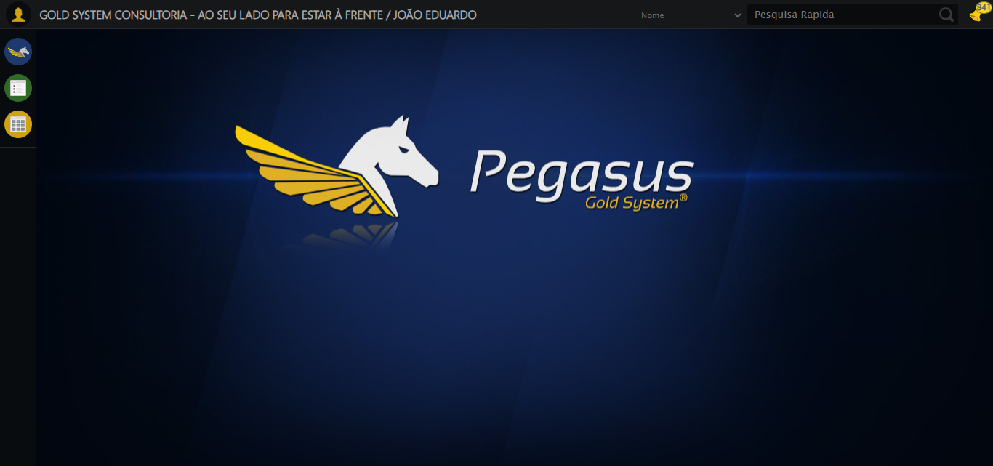

🔄 Abrindo menu (F3)...

✅ Abrindo menu (F3) realizada com sucesso.

Screenshot: abrindo menu (f3)

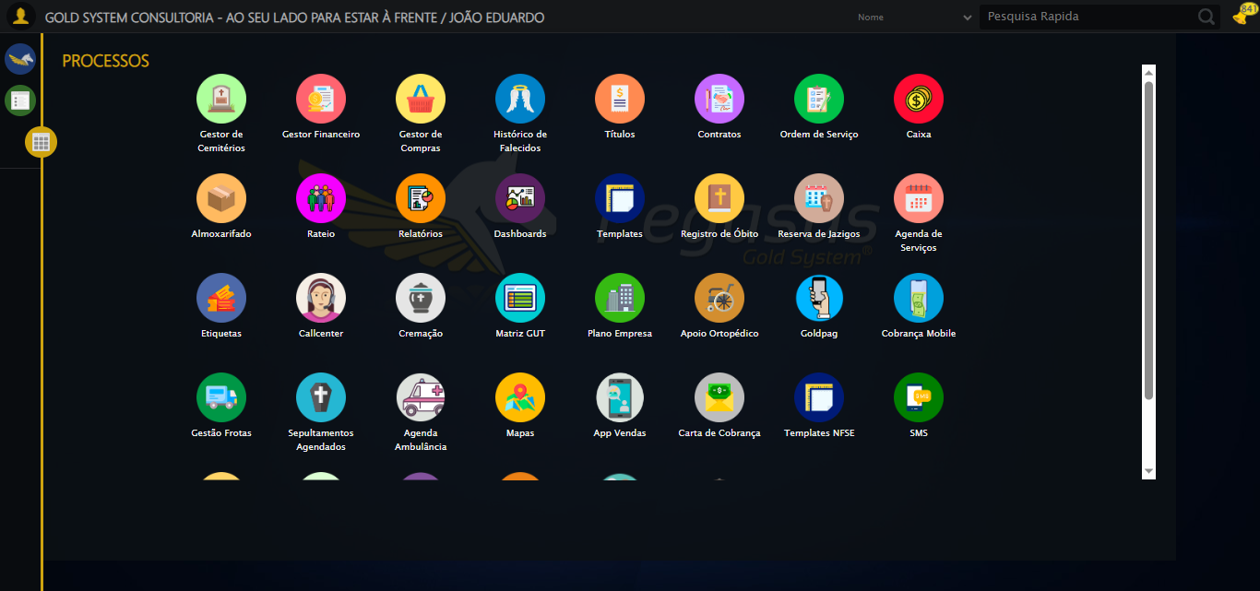

🔄 Acessando Gestor Financeiro...

🎯 Clique forçado em: /html/body/div[15]/ul/li[2]/img

Tentativa 1.1...

✅ Clique bem-sucedido (estratégia 1)

✅ Acessando Gestor Financeiro realizada com sucesso.

Screenshot: acessando gestor financeiro

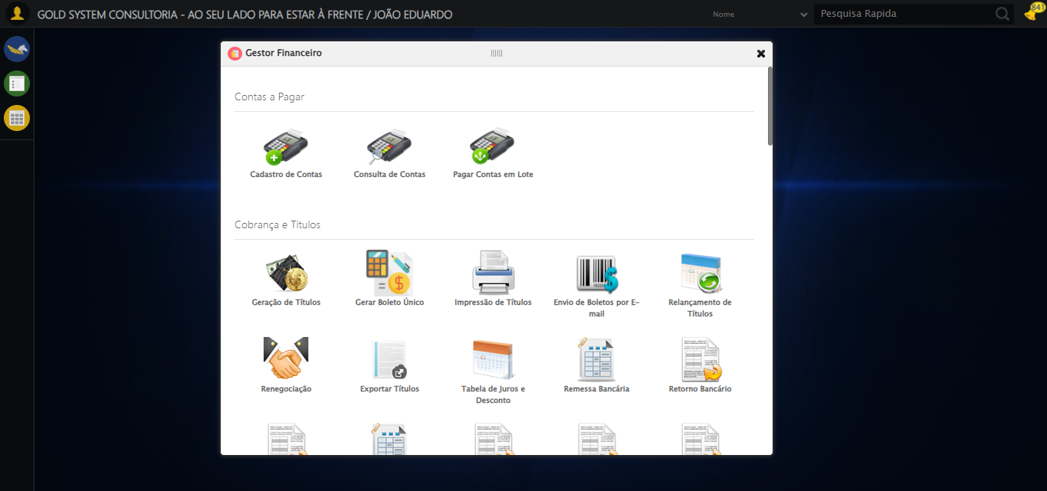

🔄 Clicando em Impressão de Títulos...

🎯 Clique forçado em: #gsFinan > div.wdTelas > div > ul > li:nth-child(8) > a > span

Tentativa 1.1...

✅ Clique bem-sucedido (estratégia 1)

✅ Clicando em Impressão de Títulos realizada com sucesso.

Screenshot: clicando em impressão de títulos

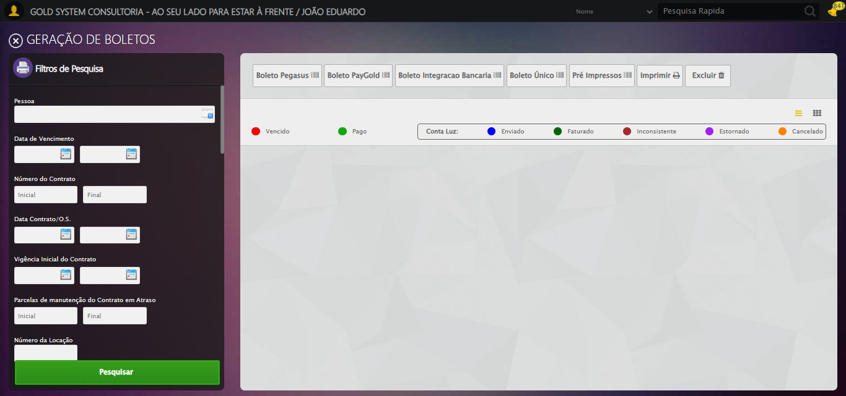

🔄 Selecionando Pessoa...

🔍 Processando LOV: 'JOÃO EDUARDO JUSTINO PASCHOAL' → 'JOÃO EDUARDO JUSTINO PASCHOAL'

Tentativa 1/5

📌 Abrindo LOV...

🎯 Clique forçado em: (//a[@class='sprites sp-openLov'])[1]

Tentativa 1.1...

✅ Clique bem-sucedido (estratégia 1)

✏️ Pesquisando: 'JOÃO EDUARDO JUSTINO PASCHOAL'

✏️ Preenchimento forçado: //input[@id='txtPesquisa'] = 'JOÃO EDUARDO JUSTINO PASCHOAL'

Tentativa 1.1...

✅ Campo preenchido (estratégia 1)

🔎 Executando pesquisa...

🎯 Clique forçado em: //a[contains(@class,'lpFind') and contains(normalize-space(.),'Pesquisar')]

Tentativa 1.1...

✅ Clique bem-sucedido (estratégia 1)

🎯 Selecionando: 'JOÃO EDUARDO JUSTINO PASCHOAL'

🎯 Clique forçado em: //tr[td[contains(normalize-space(.), 'JOÃO EDUARDO JUSTINO PASCHOAL')]]

Tentativa 1.1...

✅ Clique bem-sucedido (estratégia 1)

✅ LOV processado com sucesso!

✅ Selecionando Pessoa realizada com sucesso.

Screenshot: selecionando pessoa

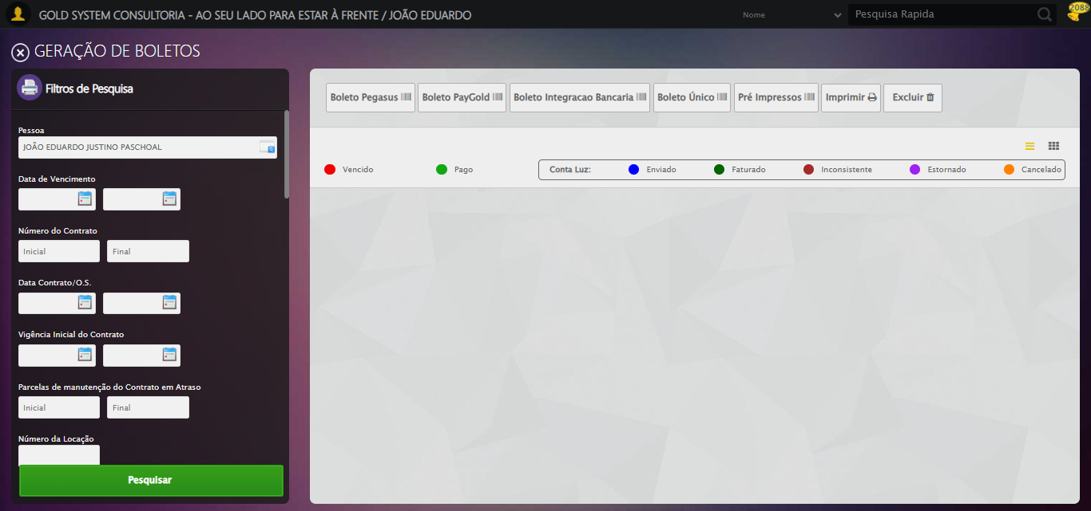

🔄 Selecionando Opção: 'Em aberto'...

✅ Selecionando Opção: 'Em aberto' realizada com sucesso.

Screenshot: selecionando opção_ _em aberto_

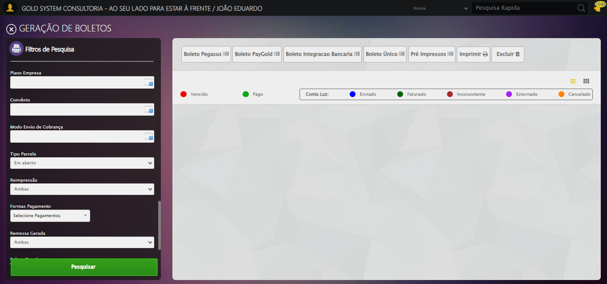

🔄 Clicando em Pesquisar...

🎯 Clique forçado em: //a[@class='btModel btGreen btPesquisar boxsize' and normalize-space()='Pesquisar']

Tentativa 1.1...

✅ Clique bem-sucedido (estratégia 1)

✅ Clicando em Pesquisar realizada com sucesso.

Screenshot: clicando em pesquisar

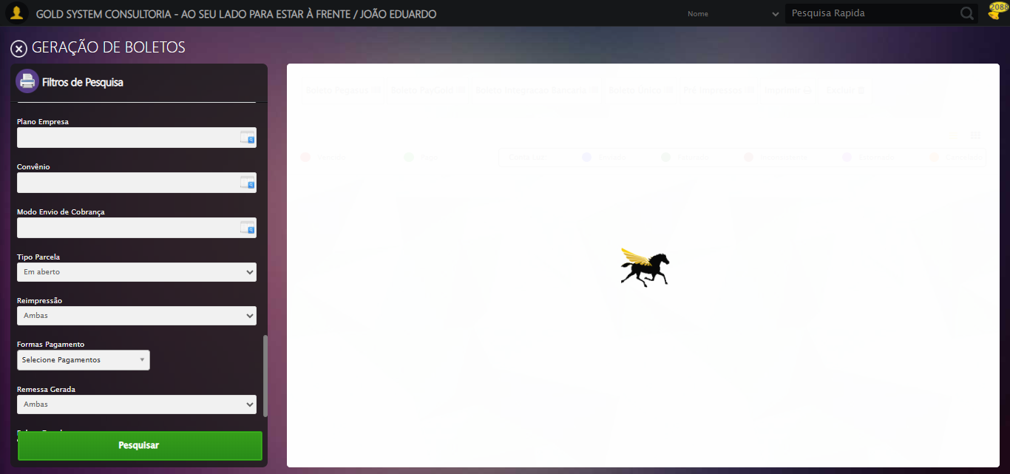

🔍 Validando resultado da pesquisa...

✅ Tabela de Títulos carregada com sucesso, prosseguindo

✅ Prosseguindo com o fluxo — tabela carregada com sucesso.

🔄 Visualizando Detalhes...

🎯 Clique forçado em: //i[@class='sprites sp-dadosDinamicos' and @title='Visualizar Detalhes']

Tentativa 1.1...

✅ Clique bem-sucedido (estratégia 1)

Screenshot: modal_detalhes_aberto

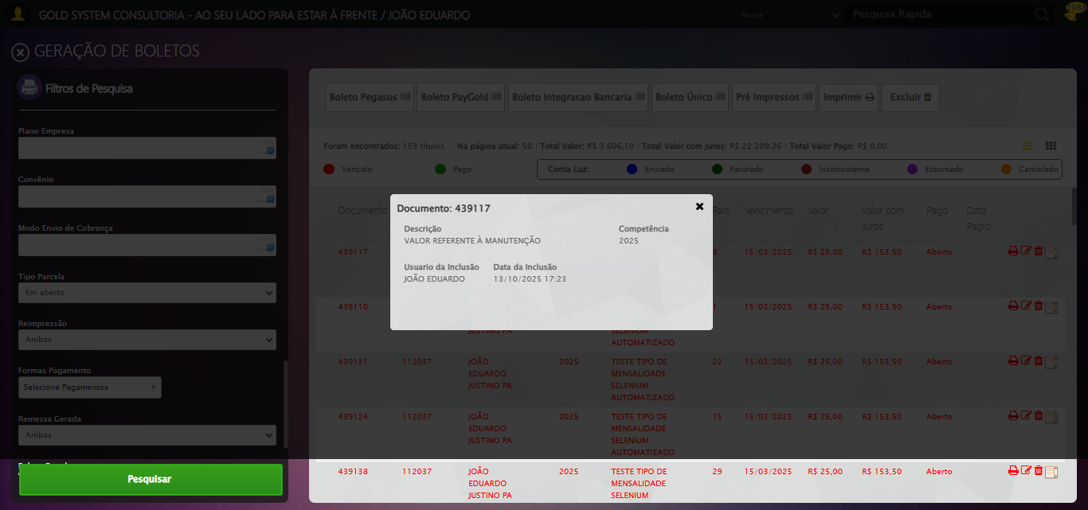

✅ Visualizando Detalhes realizada com sucesso.

Screenshot: visualizando detalhes



🔄 Fechando aba de Detalhes...

🧩 Tentativa 1 de fechar modal...

🎯 Clique forçado em: (//div[contains(@class,'modal') and not(contains(@style,'display: none'))]//a[@class='fa fa-close'])[last()]

Tentativa 1.1...

✅ Clique bem-sucedido (estratégia 1)

🧩 Tentativa 2 de fechar modal...

🎯 Clique forçado em: (//div[contains(@class,'modal') and not(contains(@style,'display: none'))]//a[@class='fa fa-close'])[last()]

Tentativa 1.1...

✅ Clique bem-sucedido (estratégia 1)

✅ Modal fechado com sucesso.

✅ Fechando aba de Detalhes realizada com sucesso.

Screenshot: fechando aba de detalhes

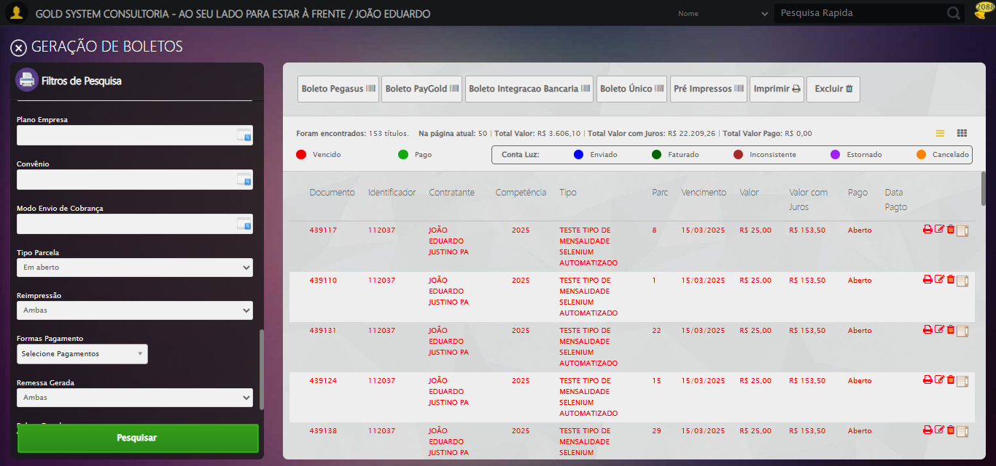

🔄 Selecionando Opção: 'Pagas'...

✅ Selecionando Opção: 'Pagas' realizada com sucesso.

Screenshot: selecionando opção_ _pagas_

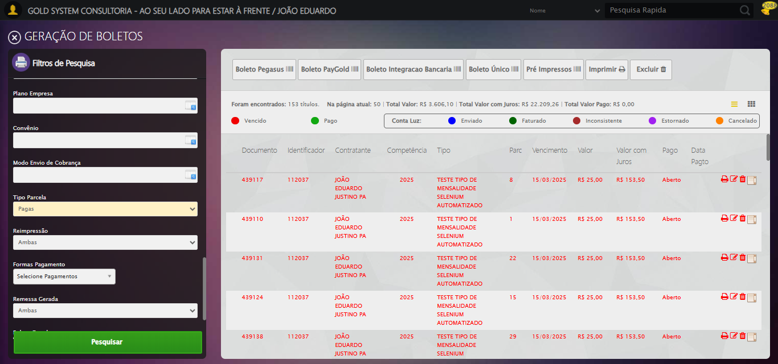

🔄 Selecionando para permitir reimpressão...

✅ Selecionando para permitir reimpressão realizada com sucesso.

Screenshot: selecionando para permitir reimpressão

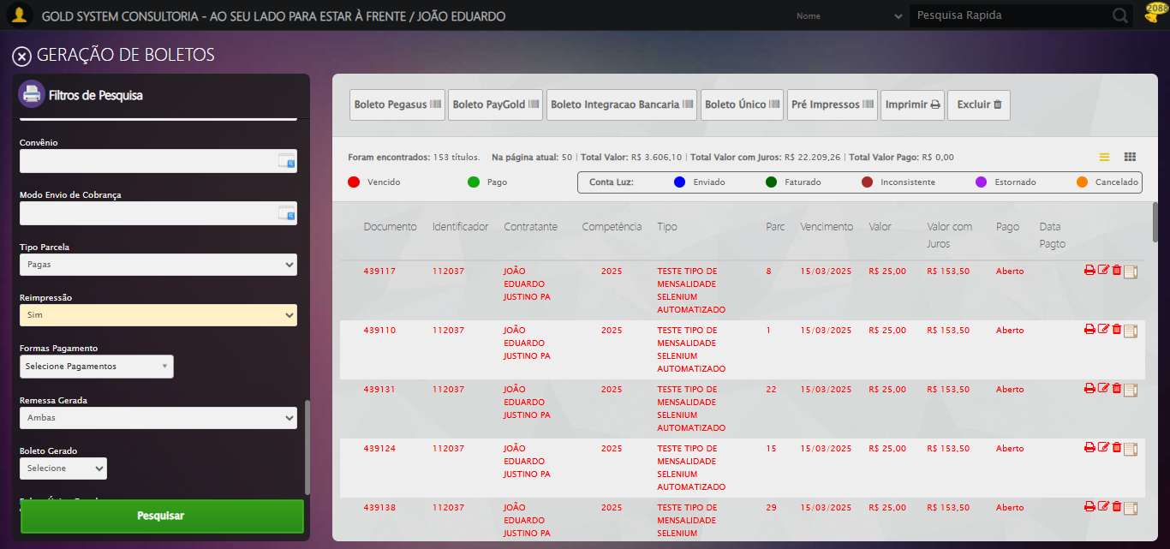

🔄 Clicando em Pesquisar...

🎯 Clique forçado em: //a[@class='btModel btGreen btPesquisar boxsize' and normalize-space()='Pesquisar']

Tentativa 1.1...

✅ Clique bem-sucedido (estratégia 1)

✅ Clicando em Pesquisar realizada com sucesso.

🔍 Validando resultado da pesquisa...

✅ Tabela de Títulos carregada com sucesso, prosseguindo

✅ Prosseguindo com o fluxo — tabela carregada com sucesso.

🔄 Visualizando Detalhes...

🎯 Clique forçado em: //i[@class='sprites sp-dadosDinamicos' and @title='Visualizar Detalhes']

Tentativa 1.1...

✅ Clique bem-sucedido (estratégia 1)

✅ Visualizando Detalhes realizada com sucesso.

🔄 Fechando aba de Detalhes...

🧩 Tentativa 1 de fechar modal...

🎯 Clique forçado em: (//div[contains(@class,'modal') and not(contains(@style,'display: none'))]//a[@class='fa fa-close'])[last()]

Tentativa 1.1...

✅ Clique bem-sucedido (estratégia 1)

🧩 Tentativa 2 de fechar modal...

🎯 Clique forçado em: (//div[contains(@class,'modal') and not(contains(@style,'display: none'))]//a[@class='fa fa-close'])[last()]

Tentativa 1.1...

✅ Clique bem-sucedido (estratégia 1)

✅ Modal fechado com sucesso.

✅ Fechando aba de Detalhes realizada com sucesso.

🔄 Selecionando Opção: 'Ambas'...

✅ Selecionando Opção: 'Ambas' realizada com sucesso.

Screenshot: selecionando opção_ _ambas_

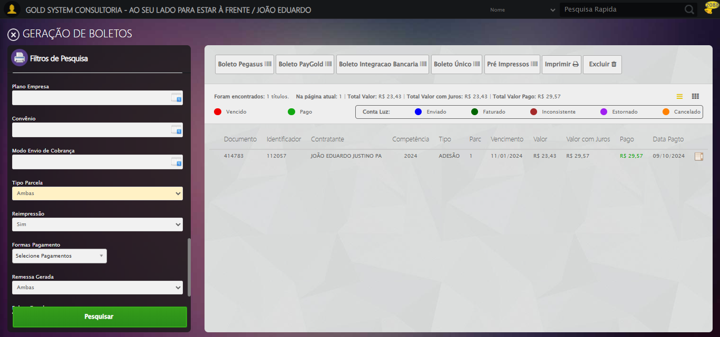

🔄 Selecionando para permitir reimpressão...

✅ Selecionando para permitir reimpressão realizada com sucesso.

🔄 Clicando em Pesquisar...

🎯 Clique forçado em: //a[@class='btModel btGreen btPesquisar boxsize' and normalize-space()='Pesquisar']

Tentativa 1.1...

✅ Clique bem-sucedido (estratégia 1)

✅ Clicando em Pesquisar realizada com sucesso.

🔍 Validando resultado da pesquisa...

✅ Tabela de Títulos carregada com sucesso, prosseguindo

✅ Prosseguindo com o fluxo — tabela carregada com sucesso.

🔄 Visualizando Detalhes...

🎯 Clique forçado em: //i[@class='sprites sp-dadosDinamicos' and @title='Visualizar Detalhes']

Tentativa 1.1...

✅ Clique bem-sucedido (estratégia 1)

✅ Visualizando Detalhes realizada com sucesso.

🔄 Fechando aba de Detalhes...

🧩 Tentativa 1 de fechar modal...

🎯 Clique forçado em: (//div[contains(@class,'modal') and not(contains(@style,'display: none'))]//a[@class='fa fa-close'])[last()]

Tentativa 1.1...

✅ Clique bem-sucedido (estratégia 1)

🧩 Tentativa 2 de fechar modal...

🎯 Clique forçado em: (//div[contains(@class,'modal') and not(contains(@style,'display: none'))]//a[@class='fa fa-close'])[last()]

Tentativa 1.1...

✅ Clique bem-sucedido (estratégia 1)

✅ Modal fechado com sucesso.

✅ Fechando aba de Detalhes realizada com sucesso.

🔄 Clicando em 'Boleto Pegasus'...

🎯 Clique forçado em: //a[@class='btModel btShort btLight boletoPegasus' and normalize-space(text())='Boleto Pegasus']/i[@class='fa fa-barcode']/parent::a

Tentativa 1.1...

✅ Clique bem-sucedido (estratégia 1)

✅ Clicando em 'Boleto Pegasus' realizada com sucesso.

Screenshot: clicando em _boleto pegasus_

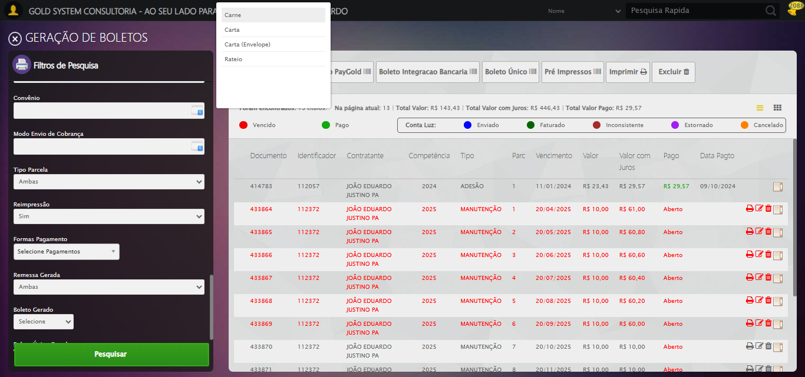

🔄 Selecionando a opção 'Carnê'...

🎯 Clique forçado em: //li[@tabindex='1' and @ref='carne' and @rel='undefined' and normalize-space(text())='Carne']

Tentativa 1.1...

✅ Clique bem-sucedido (estratégia 1)

✅ Selecionando a opção 'Carnê' realizada com sucesso.

Screenshot: selecionando a opção _carnê_

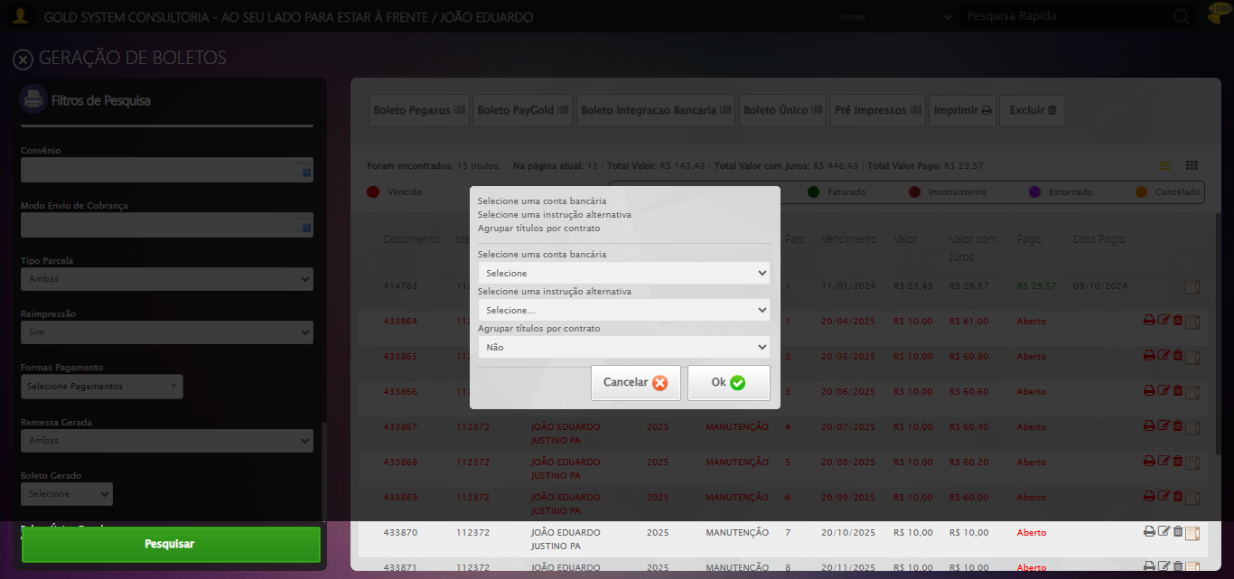

🔄 Selecionando Conta Bancária...

✅ Selecionando Conta Bancária realizada com sucesso.

Screenshot: selecionando conta bancária



🔄 Selecionando Instrução Alternativa...

⚠️ Tentativa 1 falhou, tentando novamente...

🔄 Selecionando Instrução Alternativa... (Tentativa 2)

⚠️ Tentativa 2 falhou, tentando novamente...

🔄 Selecionando Instrução Alternativa... (Tentativa 3)

❌ Erro após 3 tentativas: Message: Could not locate element with visible text: TESTE NOME SELENIUM AUTOMATIZADO; For documentation on this error, please visit: https://www.selenium.dev/documentation/webdriver/troubleshooting/errors#nosuchelementexception

Screenshot: erro_selecionando instrução alternativa



🔄 Confirmando salvamento... (Tentativa 1)

🎯 Iniciando confirmação de modal e retorno ao sistema...

ℹ️ Botão '#BtYes' não encontrado, pulando clique...

🧹 Removendo overlays e modais...

✅ Overlays/modais removidos

🎯 Clique forçado em: #gsFinan > div.wdTop.ui-draggable-handle > div.wdClose > a

Tentativa 1.1...

✅ Clique bem-sucedido (estratégia 1)

✅ Botão de fechar do módulo clicado

✅ ESC enviado como fallback

🔍 Validando presença da tela principal (#gsFinan)...

⏳ Aguardando tela principal aparecer (máx 12s)...

🔄 Último recurso: refresh + limpeza final...

❌ Não foi possível confirmar retorno à tela do sistema

⚠️ Tentativa 1 falhou: Função retornou False... Tentando novamente...

🔄 Confirmando salvamento... (Tentativa 2)

🎯 Iniciando confirmação de modal e retorno ao sistema...

ℹ️ Botão '#BtYes' não encontrado, pulando clique...

🧹 Removendo overlays e modais...

✅ Overlays/modais removidos

🎯 Clique forçado em: #gsFinan > div.wdTop.ui-draggable-handle > div.wdClose > a

Tentativa 1.1...

⚠️ Erro JS: Message: javascript error: Elemento não encontrado  
 (Session info: chrome=140.0.7339.208)  
Stacktrace:  
 GetHandleVerifier [0x0x105c333+65459]  
 GetHand

Estratégia 1 falhou: Message: javascript error: Elemento não encontrado  
 (Session info: chrome=140.0

Tentativa 1.2...

⚠️ Erro JS: Message: javascript error: Elemento não encontrado  
 (Session info: chrome=140.0.7339.208)  
Stacktrace:  
 GetHandleVerifier [0x0x105c333+65459]  
 GetHand

Estratégia 2 falhou: Message: javascript error: Elemento não encontrado  
 (Session info: chrome=140.0

Tentativa 1.3...

⚠️ Erro JS: Message: javascript error: Elemento não encontrado  
 (Session info: chrome=140.0.7339.208)  
Stacktrace:  
 GetHandleVerifier [0x0x105c333+65459]  
 GetHand

Estratégia 3 falhou: Message: javascript error: Elemento não encontrado  
 (Session info: chrome=140.0

Tentativa 1.4...

⚠️ Erro JS: Message: javascript error: Elemento não encontrado  
 (Session info: chrome=140.0.7339.208)  
Stacktrace:  
 GetHandleVerifier [0x0x105c333+65459]  
 GetHand

Estratégia 4 falhou: Message: javascript error: Elemento não encontrado  
 (Session info: chrome=140.0

Tentativa 1.5...

⚠️ Erro JS: Message: javascript error: Elemento não encontrado  
 (Session info: chrome=140.0.7339.208)  
Stacktrace:  
 GetHandleVerifier [0x0x105c333+65459]  
 GetHand

Estratégia 5 falhou: Message: javascript error: Elemento não encontrado  
 (Session info: chrome=140.0

Tentativa 2.1...

⚠️ Erro JS: Message: javascript error: Elemento não encontrado  
 (Session info: chrome=140.0.7339.208)  
Stacktrace:  
 GetHandleVerifier [0x0x105c333+65459]  
 GetHand

Estratégia 1 falhou: Message: javascript error: Elemento não encontrado  
 (Session info: chrome=140.0

Tentativa 2.2...

⚠️ Erro JS: Message: javascript error: Elemento não encontrado  
 (Session info: chrome=140.0.7339.208)  
Stacktrace:  
 GetHandleVerifier [0x0x105c333+65459]  
 GetHand

Estratégia 2 falhou: Message: javascript error: Elemento não encontrado  
 (Session info: chrome=140.0

Tentativa 2.3...

⚠️ Erro JS: Message: javascript error: Elemento não encontrado  
 (Session info: chrome=140.0.7339.208)  
Stacktrace:  
 GetHandleVerifier [0x0x105c333+65459]  
 GetHand

Estratégia 3 falhou: Message: javascript error: Elemento não encontrado  
 (Session info: chrome=140.0

Tentativa 2.4...

⚠️ Erro JS: Message: javascript error: Elemento não encontrado  
 (Session info: chrome=140.0.7339.208)  
Stacktrace:  
 GetHandleVerifier [0x0x105c333+65459]  
 GetHand

Estratégia 4 falhou: Message: javascript error: Elemento não encontrado  
 (Session info: chrome=140.0

Tentativa 2.5...

⚠️ Erro JS: Message: javascript error: Elemento não encontrado  
 (Session info: chrome=140.0.7339.208)  
Stacktrace:  
 GetHandleVerifier [0x0x105c333+65459]  
 GetHand

Estratégia 5 falhou: Message: javascript error: Elemento não encontrado  
 (Session info: chrome=140.0

Tentativa 3.1...

⚠️ Erro JS: Message: javascript error: Elemento não encontrado  
 (Session info: chrome=140.0.7339.208)  
Stacktrace:  
 GetHandleVerifier [0x0x105c333+65459]  
 GetHand

Estratégia 1 falhou: Message: javascript error: Elemento não encontrado  
 (Session info: chrome=140.0

Tentativa 3.2...

⚠️ Erro JS: Message: javascript error: Elemento não encontrado  
 (Session info: chrome=140.0.7339.208)  
Stacktrace:  
 GetHandleVerifier [0x0x105c333+65459]  
 GetHand

Estratégia 2 falhou: Message: javascript error: Elemento não encontrado  
 (Session info: chrome=140.0

Tentativa 3.3...

⚠️ Erro JS: Message: javascript error: Elemento não encontrado  
 (Session info: chrome=140.0.7339.208)  
Stacktrace:  
 GetHandleVerifier [0x0x105c333+65459]  
 GetHand

Estratégia 3 falhou: Message: javascript error: Elemento não encontrado  
 (Session info: chrome=140.0

Tentativa 3.4...

⚠️ Erro JS: Message: javascript error: Elemento não encontrado  
 (Session info: chrome=140.0.7339.208)  
Stacktrace:  
 GetHandleVerifier [0x0x105c333+65459]  
 GetHand

Estratégia 4 falhou: Message: javascript error: Elemento não encontrado  
 (Session info: chrome=140.0

Tentativa 3.5...

⚠️ Erro JS: Message: javascript error: Elemento não encontrado  
 (Session info: chrome=140.0.7339.208)  
Stacktrace:  
 GetHandleVerifier [0x0x105c333+65459]  
 GetHand

Estratégia 5 falhou: Message: javascript error: Elemento não encontrado  
 (Session info: chrome=140.0

ℹ️ Botão de fechar não disponível: Falha ao clicar após 3 tentativas: #gsFinan > div.wdTop.ui-draggable-handle > div.wdClose > a

✅ ESC enviado como fallback

🔍 Validando presença da tela principal (#gsFinan)...

⏳ Aguardando tela principal aparecer (máx 12s)...

🔄 Último recurso: refresh + limpeza final...

⚠️ Erro JS: Message: script timeout  
 (Session info: chrome=140.0.7339.208)  
Stacktrace:  
 GetHandleVerifier [0x0x105c333+65459]  
 GetHandleVerifier [0x0x105c374+655

⚠️ Falha ao recarregar página: Message: script timeout  
 (Session info: chrome=140.0.7339.208)  
Stacktrace:  
 GetHandleVerifier [0x0x105c333+65459]  
 GetHandleVerifier [0x0x105c374+65524]  
 (No symbol) [0x0xe7d7c0]  
 (No symbol) [0x0xf0c687]  
 (No symbol) [0x0xee9dfc]  
 (No symbol) [0x0xf0b606]  
 (No symbol) [0x0xee9bf6]  
 (No symbol) [0x0xebb38e]  
 (No symbol) [0x0xebc274]  
 GetHandleVerifier [0x0x12deda3+2697763]  
 GetHandleVerifier [0x0x12d9ec7+2677575]  
 GetHandleVerifier [0x0x1084194+228884]  
 GetHandleVerifier [0x0x10749f8+165496]  
 GetHandleVerifier [0x0x107b18d+192013]  
 GetHandleVerifier [0x0x10647d8+99416]  
 GetHandleVerifier [0x0x1064972+99826]  
 GetHandleVerifier [0x0x104ebea+10346]  
 BaseThreadInitThunk [0x0x7567fcc9+25]  
 RtlGetAppContainerNamedObjectPath [0x0x775f82ae+286]  
 RtlGetAppContainerNamedObjectPath [0x0x775f827e+238]

❌ Não foi possível confirmar retorno à tela do sistema

⚠️ Tentativa 2 falhou: Função retornou False... Tentando novamente...

🔄 Confirmando salvamento... (Tentativa 3)

🎯 Iniciando confirmação de modal e retorno ao sistema...

ℹ️ Botão '#BtYes' não encontrado, pulando clique...

🧹 Removendo overlays e modais...

✅ Overlays/modais removidos

🎯 Clique forçado em: #gsFinan > div.wdTop.ui-draggable-handle > div.wdClose > a

Tentativa 1.1...

⚠️ Erro JS: Message: javascript error: Elemento não encontrado  
 (Session info: chrome=140.0.7339.208)  
Stacktrace:  
 GetHandleVerifier [0x0x105c333+65459]  
 GetHand

Estratégia 1 falhou: Message: javascript error: Elemento não encontrado  
 (Session info: chrome=140.0

Tentativa 1.2...

⚠️ Erro JS: Message: target frame detached  
 (failed to check if window was closed: disconnected: Unable to receive message from renderer)  
 (Session info: chrome

Estratégia 2 falhou: Message: target frame detached  
 (failed to check if window was closed: disconne

Tentativa 1.3...

⚠️ Erro JS: Message: invalid session id: session deleted as the browser has closed the connection  
from disconnected: not connected to DevTools  
 (Session info: ch

Estratégia 3 falhou: Message: invalid session id: session deleted as the browser has closed the conne

Tentativa 1.4...

⚠️ Erro JS: Message: invalid session id; For documentation on this error, please visit: https://www.selenium.dev/documentation/webdriver/troubleshooting/errors#in

Estratégia 4 falhou: Message: invalid session id; For documentation on this error, please visit: http

Tentativa 1.5...

⚠️ Erro JS: Message: invalid session id; For documentation on this error, please visit: https://www.selenium.dev/documentation/webdriver/troubleshooting/errors#in

Estratégia 5 falhou: Message: invalid session id; For documentation on this error, please visit: http

Tentativa 2.1...

⚠️ Erro JS: Message: invalid session id; For documentation on this error, please visit: https://www.selenium.dev/documentation/webdriver/troubleshooting/errors#in

Estratégia 1 falhou: Message: invalid session id; For documentation on this error, please visit: http

Tentativa 2.2...

⚠️ Erro JS: Message: invalid session id; For documentation on this error, please visit: https://www.selenium.dev/documentation/webdriver/troubleshooting/errors#in

Estratégia 2 falhou: Message: invalid session id; For documentation on this error, please visit: http

Tentativa 2.3...

⚠️ Erro JS: Message: invalid session id; For documentation on this error, please visit: https://www.selenium.dev/documentation/webdriver/troubleshooting/errors#in

Estratégia 3 falhou: Message: invalid session id; For documentation on this error, please visit: http

Tentativa 2.4...

⚠️ Erro JS: Message: invalid session id; For documentation on this error, please visit: https://www.selenium.dev/documentation/webdriver/troubleshooting/errors#in

Estratégia 4 falhou: Message: invalid session id; For documentation on this error, please visit: http

Tentativa 2.5...

⚠️ Erro JS: Message: invalid session id; For documentation on this error, please visit: https://www.selenium.dev/documentation/webdriver/troubleshooting/errors#in

Estratégia 5 falhou: Message: invalid session id; For documentation on this error, please visit: http

Tentativa 3.1...

⚠️ Erro JS: Message: invalid session id; For documentation on this error, please visit: https://www.selenium.dev/documentation/webdriver/troubleshooting/errors#in

Estratégia 1 falhou: Message: invalid session id; For documentation on this error, please visit: http

Tentativa 3.2...

⚠️ Erro JS: Message: invalid session id; For documentation on this error, please visit: https://www.selenium.dev/documentation/webdriver/troubleshooting/errors#in

Estratégia 2 falhou: Message: invalid session id; For documentation on this error, please visit: http

Tentativa 3.3...

⚠️ Erro JS: Message: invalid session id; For documentation on this error, please visit: https://www.selenium.dev/documentation/webdriver/troubleshooting/errors#in

Estratégia 3 falhou: Message: invalid session id; For documentation on this error, please visit: http

Tentativa 3.4...

⚠️ Erro JS: Message: invalid session id; For documentation on this error, please visit: https://www.selenium.dev/documentation/webdriver/troubleshooting/errors#in

Estratégia 4 falhou: Message: invalid session id; For documentation on this error, please visit: http

Tentativa 3.5...

⚠️ Erro JS: Message: invalid session id; For documentation on this error, please visit: https://www.selenium.dev/documentation/webdriver/troubleshooting/errors#in

Estratégia 5 falhou: Message: invalid session id; For documentation on this error, please visit: http

ℹ️ Botão de fechar não disponível: Falha ao clicar após 3 tentativas: #gsFinan > div.wdTop.ui-draggable-handle > div.wdClose > a

⚠️ Não foi possível enviar ESC: Message: invalid session id; For documentation on this error, please visit: https://www.selenium.dev/documentation/webdriver/troubleshooting/errors#invalidsessionidexception  
Stacktrace:  
 GetHandleVerifier [0x0x105c333+65459]  
 GetHandleVerifier [0x0x105c374+65524]  
 (No symbol) [0x0xe7d7c0]  
 (No symbol) [0x0xeba663]  
 (No symbol) [0x0xee9cb6]  
 (No symbol) [0x0xee555e]  
 (No symbol) [0x0xee4ad3]  
 (No symbol) [0x0xe4e73d]  
 (No symbol) [0x0xe4ecbe]  
 (No symbol) [0x0xe4f15d]  
 GetHandleVerifier [0x0x12deda3+2697763]  
 GetHandleVerifier [0x0x12d9ec7+2677575]  
 GetHandleVerifier [0x0x1084194+228884]  
 GetHandleVerifier [0x0x10749f8+165496]  
 GetHandleVerifier [0x0x107b18d+192013]  
 (No symbol) [0x0xe4e3f2]  
 (No symbol) [0x0xe4db72]  
 GetHandleVerifier [0x0x143340c+4092044]  
 BaseThreadInitThunk [0x0x7567fcc9+25]  
 RtlGetAppContainerNamedObjectPath [0x0x775f82ae+286]  
 RtlGetAppContainerNamedObjectPath [0x0x775f827e+238]

🔍 Validando presença da tela principal (#gsFinan)...

⚠️ Erro JS: Message: invalid session id; For documentation on this error, please visit: https://www.selenium.dev/documentation/webdriver/troubleshooting/errors#in

❌ Erro em confirmar_modal_e_retornar_sistema: Message: invalid session id; For documentation on this error, please visit: https://www.selenium.dev/documentation/webdriver/troubleshooting/errors#invalidsessionidexception  
Stacktrace:  
 GetHandleVerifier [0x0x105c333+65459]  
 GetHandleVerifier [0x0x105c374+65524]  
 (No symbol) [0x0xe7d7c0]  
 (No symbol) [0x0xeba663]  
 (No symbol) [0x0xee9cb6]  
 (No symbol) [0x0xee555e]  
 (No symbol) [0x0xee4ad3]  
 (No symbol) [0x0xe4e73d]  
 (No symbol) [0x0xe4ecbe]  
 (No symbol) [0x0xe4f15d]  
 GetHandleVerifier [0x0x12deda3+2697763]  
 GetHandleVerifier [0x0x12d9ec7+2677575]  
 GetHandleVerifier [0x0x1084194+228884]  
 GetHandleVerifier [0x0x10749f8+165496]  
 GetHandleVerifier [0x0x107b18d+192013]  
 (No symbol) [0x0xe4e3f2]  
 (No symbol) [0x0xe4db72]  
 GetHandleVerifier [0x0x143340c+4092044]  
 BaseThreadInitThunk [0x0x7567fcc9+25]  
 RtlGetAppContainerNamedObjectPath [0x0x775f82ae+286]  
 RtlGetAppContainerNamedObjectPath [0x0x775f827e+238]

Traceback: Traceback (most recent call last):  
 File "C:\RPASelenium\RPAsPegasusSelenium\cenariostestespegasus\Processos\CadastrosCenáriosGestorFinanceiro\CadastrosCenáriosGeraçãoDeBoletos\consultadegeraçaodeboletos1ºcenario.py", line 2270, in confirmar_modal_e_retornar_sistema  
 na_tela = js_engine.execute_js(f"""  
 var elemento = document.querySelector('{esperado_selector}');  
 ...<8 lines>...  
 );  
 """)  
 File "C:\RPASelenium\RPAsPegasusSelenium\cenariostestespegasus\Processos\CadastrosCenáriosGestorFinanceiro\CadastrosCenáriosGeraçãoDeBoletos\consultadegeraçaodeboletos1ºcenario.py", line 495, in execute_js  
 return self.driver.execute_script(script, *args)  
 ~~~~~~~~~~~~~~~~~~~~~~~~~~^^^^^^^^^^^^^^^  
 File "C:\RPASelenium\RPAsPegasusSelenium\venv\Lib\site-packages\selenium\webdriver\remote\webdriver.py", line 555, in execute_script  
 return self.execute(command, {"script": script, "args": converted_args})["value"]  
 ~~~~~~~~~~~~^^^^^^^^^^^^^^^^^^^^^^^^^^^^^^^^^^^^^^^^^^^^^^^^^^^^^  
 File "C:\RPASelenium\RPAsPegasusSelenium\venv\Lib\site-packages\selenium\webdriver\remote\webdriver.py", line 458, in execute  
 self.error_handler.check_response(response)  
 ~~~~~~~~~~~~~~~~~~~~~~~~~~~~~~~~~^^^^^^^^^^  
 File "C:\RPASelenium\RPAsPegasusSelenium\venv\Lib\site-packages\selenium\webdriver\remote\errorhandler.py", line 232, in check_response  
 raise exception_class(message, screen, stacktrace)  
selenium.common.exceptions.InvalidSessionIdException: Message: invalid session id; For documentation on this error, please visit: https://www.selenium.dev/documentation/webdriver/troubleshooting/errors#invalidsessionidexception  
Stacktrace:  
 GetHandleVerifier [0x0x105c333+65459]  
 GetHandleVerifier [0x0x105c374+65524]  
 (No symbol) [0x0xe7d7c0]  
 (No symbol) [0x0xeba663]  
 (No symbol) [0x0xee9cb6]  
 (No symbol) [0x0xee555e]  
 (No symbol) [0x0xee4ad3]  
 (No symbol) [0x0xe4e73d]  
 (No symbol) [0x0xe4ecbe]  
 (No symbol) [0x0xe4f15d]  
 GetHandleVerifier [0x0x12deda3+2697763]  
 GetHandleVerifier [0x0x12d9ec7+2677575]  
 GetHandleVerifier [0x0x1084194+228884]  
 GetHandleVerifier [0x0x10749f8+165496]  
 GetHandleVerifier [0x0x107b18d+192013]  
 (No symbol) [0x0xe4e3f2]  
 (No symbol) [0x0xe4db72]  
 GetHandleVerifier [0x0x143340c+4092044]  
 BaseThreadInitThunk [0x0x7567fcc9+25]  
 RtlGetAppContainerNamedObjectPath [0x0x775f82ae+286]  
 RtlGetAppContainerNamedObjectPath [0x0x775f827e+238]

❌ Erro ao confirmando salvamento: Função retornou False...

⚠️ Erro ao tirar screenshot erro_confirmando_salvamento: Message: invalid session id; For documentation on this error, please visit: https://www.selenium.dev/documentation/webdriver/troubleshooting/errors#invalidsessionidexception  
Stacktrace:  
 GetHandleVerifier [0x0x105c333+65459]  
 GetHandleVerifier [0x0x105c374+65524]  
 (No symbol) [0x0xe7d7c0]  
 (No symbol) [0x0xeba663]  
 (No symbol) [0x0xee9cb6]  
 (No symbol) [0x0xee555e]  
 (No symbol) [0x0xee4ad3]  
 (No symbol) [0x0xe4e73d]  
 (No symbol) [0x0xe4ecbe]  
 (No symbol) [0x0xe4f15d]  
 GetHandleVerifier [0x0x12deda3+2697763]  
 GetHandleVerifier [0x0x12d9ec7+2677575]  
 GetHandleVerifier [0x0x1084194+228884]  
 GetHandleVerifier [0x0x10749f8+165496]  
 GetHandleVerifier [0x0x107b18d+192013]  
 (No symbol) [0x0xe4e3f2]  
 (No symbol) [0x0xe4db72]  
 GetHandleVerifier [0x0x143340c+4092044]  
 BaseThreadInitThunk [0x0x7567fcc9+25]  
 RtlGetAppContainerNamedObjectPath [0x0x775f82ae+286]  
 RtlGetAppContainerNamedObjectPath [0x0x775f827e+238]

ℹ️ Nenhuma mensagem de alerta encontrada.

🔄 Fechando aba de Geração de Boletos...

🎯 Clique forçado em: //a[@class='sprites sp-fecharGrande' and @title='Sair']

Tentativa 1.1...

⚠️ Erro JS: Message: invalid session id; For documentation on this error, please visit: https://www.selenium.dev/documentation/webdriver/troubleshooting/errors#in

Estratégia 1 falhou: Message: invalid session id; For documentation on this error, please visit: http

Tentativa 1.2...

⚠️ Erro JS: Message: invalid session id; For documentation on this error, please visit: https://www.selenium.dev/documentation/webdriver/troubleshooting/errors#in

Estratégia 2 falhou: Message: invalid session id; For documentation on this error, please visit: http

Tentativa 1.3...

⚠️ Erro JS: Message: invalid session id; For documentation on this error, please visit: https://www.selenium.dev/documentation/webdriver/troubleshooting/errors#in

Estratégia 3 falhou: Message: invalid session id; For documentation on this error, please visit: http

Tentativa 1.4...

⚠️ Erro JS: Message: invalid session id; For documentation on this error, please visit: https://www.selenium.dev/documentation/webdriver/troubleshooting/errors#in

Estratégia 4 falhou: Message: invalid session id; For documentation on this error, please visit: http

Tentativa 1.5...

⚠️ Erro JS: Message: invalid session id; For documentation on this error, please visit: https://www.selenium.dev/documentation/webdriver/troubleshooting/errors#in

Estratégia 5 falhou: Message: invalid session id; For documentation on this error, please visit: http

Tentativa 2.1...

⚠️ Erro JS: Message: invalid session id; For documentation on this error, please visit: https://www.selenium.dev/documentation/webdriver/troubleshooting/errors#in

Estratégia 1 falhou: Message: invalid session id; For documentation on this error, please visit: http

Tentativa 2.2...

⚠️ Erro JS: Message: invalid session id; For documentation on this error, please visit: https://www.selenium.dev/documentation/webdriver/troubleshooting/errors#in

Estratégia 2 falhou: Message: invalid session id; For documentation on this error, please visit: http

Tentativa 2.3...

⚠️ Erro JS: Message: invalid session id; For documentation on this error, please visit: https://www.selenium.dev/documentation/webdriver/troubleshooting/errors#in

Estratégia 3 falhou: Message: invalid session id; For documentation on this error, please visit: http

Tentativa 2.4...

⚠️ Erro JS: Message: invalid session id; For documentation on this error, please visit: https://www.selenium.dev/documentation/webdriver/troubleshooting/errors#in

Estratégia 4 falhou: Message: invalid session id; For documentation on this error, please visit: http

Tentativa 2.5...

⚠️ Erro JS: Message: invalid session id; For documentation on this error, please visit: https://www.selenium.dev/documentation/webdriver/troubleshooting/errors#in

Estratégia 5 falhou: Message: invalid session id; For documentation on this error, please visit: http

Tentativa 3.1...

⚠️ Erro JS: Message: invalid session id; For documentation on this error, please visit: https://www.selenium.dev/documentation/webdriver/troubleshooting/errors#in

Estratégia 1 falhou: Message: invalid session id; For documentation on this error, please visit: http

Tentativa 3.2...

⚠️ Erro JS: Message: invalid session id; For documentation on this error, please visit: https://www.selenium.dev/documentation/webdriver/troubleshooting/errors#in

Estratégia 2 falhou: Message: invalid session id; For documentation on this error, please visit: http

Tentativa 3.3...

⚠️ Erro JS: Message: invalid session id; For documentation on this error, please visit: https://www.selenium.dev/documentation/webdriver/troubleshooting/errors#in

Estratégia 3 falhou: Message: invalid session id; For documentation on this error, please visit: http

Tentativa 3.4...

⚠️ Erro JS: Message: invalid session id; For documentation on this error, please visit: https://www.selenium.dev/documentation/webdriver/troubleshooting/errors#in

Estratégia 4 falhou: Message: invalid session id; For documentation on this error, please visit: http

Tentativa 3.5...

⚠️ Erro JS: Message: invalid session id; For documentation on this error, please visit: https://www.selenium.dev/documentation/webdriver/troubleshooting/errors#in

Estratégia 5 falhou: Message: invalid session id; For documentation on this error, please visit: http

Tentativa 4.1...

⚠️ Erro JS: Message: invalid session id; For documentation on this error, please visit: https://www.selenium.dev/documentation/webdriver/troubleshooting/errors#in

Estratégia 1 falhou: Message: invalid session id; For documentation on this error, please visit: http

Tentativa 4.2...

⚠️ Erro JS: Message: invalid session id; For documentation on this error, please visit: https://www.selenium.dev/documentation/webdriver/troubleshooting/errors#in

Estratégia 2 falhou: Message: invalid session id; For documentation on this error, please visit: http

Tentativa 4.3...

⚠️ Erro JS: Message: invalid session id; For documentation on this error, please visit: https://www.selenium.dev/documentation/webdriver/troubleshooting/errors#in

Estratégia 3 falhou: Message: invalid session id; For documentation on this error, please visit: http

Tentativa 4.4...

⚠️ Erro JS: Message: invalid session id; For documentation on this error, please visit: https://www.selenium.dev/documentation/webdriver/troubleshooting/errors#in

Estratégia 4 falhou: Message: invalid session id; For documentation on this error, please visit: http

Tentativa 4.5...

⚠️ Erro JS: Message: invalid session id; For documentation on this error, please visit: https://www.selenium.dev/documentation/webdriver/troubleshooting/errors#in

Estratégia 5 falhou: Message: invalid session id; For documentation on this error, please visit: http

Tentativa 5.1...

⚠️ Erro JS: Message: invalid session id; For documentation on this error, please visit: https://www.selenium.dev/documentation/webdriver/troubleshooting/errors#in

Estratégia 1 falhou: Message: invalid session id; For documentation on this error, please visit: http

Tentativa 5.2...

⚠️ Erro JS: Message: invalid session id; For documentation on this error, please visit: https://www.selenium.dev/documentation/webdriver/troubleshooting/errors#in

Estratégia 2 falhou: Message: invalid session id; For documentation on this error, please visit: http

Tentativa 5.3...

⚠️ Erro JS: Message: invalid session id; For documentation on this error, please visit: https://www.selenium.dev/documentation/webdriver/troubleshooting/errors#in

Estratégia 3 falhou: Message: invalid session id; For documentation on this error, please visit: http

Tentativa 5.4...

⚠️ Erro JS: Message: invalid session id; For documentation on this error, please visit: https://www.selenium.dev/documentation/webdriver/troubleshooting/errors#in

Estratégia 4 falhou: Message: invalid session id; For documentation on this error, please visit: http

Tentativa 5.5...

⚠️ Erro JS: Message: invalid session id; For documentation on this error, please visit: https://www.selenium.dev/documentation/webdriver/troubleshooting/errors#in

Estratégia 5 falhou: Message: invalid session id; For documentation on this error, please visit: http

⚠️ Tentativa 1 falhou, tentando novamente...

🔄 Fechando aba de Geração de Boletos... (Tentativa 2)

🎯 Clique forçado em: //a[@class='sprites sp-fecharGrande' and @title='Sair']

Tentativa 1.1...

⚠️ Erro JS: Message: invalid session id; For documentation on this error, please visit: https://www.selenium.dev/documentation/webdriver/troubleshooting/errors#in

Estratégia 1 falhou: Message: invalid session id; For documentation on this error, please visit: http

Tentativa 1.2...

⚠️ Erro JS: Message: invalid session id; For documentation on this error, please visit: https://www.selenium.dev/documentation/webdriver/troubleshooting/errors#in

Estratégia 2 falhou: Message: invalid session id; For documentation on this error, please visit: http

Tentativa 1.3...

⚠️ Erro JS: Message: invalid session id; For documentation on this error, please visit: https://www.selenium.dev/documentation/webdriver/troubleshooting/errors#in

Estratégia 3 falhou: Message: invalid session id; For documentation on this error, please visit: http

Tentativa 1.4...

⚠️ Erro JS: Message: invalid session id; For documentation on this error, please visit: https://www.selenium.dev/documentation/webdriver/troubleshooting/errors#in

Estratégia 4 falhou: Message: invalid session id; For documentation on this error, please visit: http

Tentativa 1.5...

⚠️ Erro JS: Message: invalid session id; For documentation on this error, please visit: https://www.selenium.dev/documentation/webdriver/troubleshooting/errors#in

Estratégia 5 falhou: Message: invalid session id; For documentation on this error, please visit: http

Tentativa 2.1...

⚠️ Erro JS: Message: invalid session id; For documentation on this error, please visit: https://www.selenium.dev/documentation/webdriver/troubleshooting/errors#in

Estratégia 1 falhou: Message: invalid session id; For documentation on this error, please visit: http

Tentativa 2.2...

⚠️ Erro JS: Message: invalid session id; For documentation on this error, please visit: https://www.selenium.dev/documentation/webdriver/troubleshooting/errors#in

Estratégia 2 falhou: Message: invalid session id; For documentation on this error, please visit: http

Tentativa 2.3...

⚠️ Erro JS: Message: invalid session id; For documentation on this error, please visit: https://www.selenium.dev/documentation/webdriver/troubleshooting/errors#in

Estratégia 3 falhou: Message: invalid session id; For documentation on this error, please visit: http

Tentativa 2.4...

⚠️ Erro JS: Message: invalid session id; For documentation on this error, please visit: https://www.selenium.dev/documentation/webdriver/troubleshooting/errors#in

Estratégia 4 falhou: Message: invalid session id; For documentation on this error, please visit: http

Tentativa 2.5...

⚠️ Erro JS: Message: invalid session id; For documentation on this error, please visit: https://www.selenium.dev/documentation/webdriver/troubleshooting/errors#in

Estratégia 5 falhou: Message: invalid session id; For documentation on this error, please visit: http

Tentativa 3.1...

⚠️ Erro JS: Message: invalid session id; For documentation on this error, please visit: https://www.selenium.dev/documentation/webdriver/troubleshooting/errors#in

Estratégia 1 falhou: Message: invalid session id; For documentation on this error, please visit: http

Tentativa 3.2...

⚠️ Erro JS: Message: invalid session id; For documentation on this error, please visit: https://www.selenium.dev/documentation/webdriver/troubleshooting/errors#in

Estratégia 2 falhou: Message: invalid session id; For documentation on this error, please visit: http

Tentativa 3.3...

⚠️ Erro JS: Message: invalid session id; For documentation on this error, please visit: https://www.selenium.dev/documentation/webdriver/troubleshooting/errors#in

Estratégia 3 falhou: Message: invalid session id; For documentation on this error, please visit: http

Tentativa 3.4...

⚠️ Erro JS: Message: invalid session id; For documentation on this error, please visit: https://www.selenium.dev/documentation/webdriver/troubleshooting/errors#in

Estratégia 4 falhou: Message: invalid session id; For documentation on this error, please visit: http

Tentativa 3.5...

⚠️ Erro JS: Message: invalid session id; For documentation on this error, please visit: https://www.selenium.dev/documentation/webdriver/troubleshooting/errors#in

Estratégia 5 falhou: Message: invalid session id; For documentation on this error, please visit: http

Tentativa 4.1...

⚠️ Erro JS: Message: invalid session id; For documentation on this error, please visit: https://www.selenium.dev/documentation/webdriver/troubleshooting/errors#in

Estratégia 1 falhou: Message: invalid session id; For documentation on this error, please visit: http

Tentativa 4.2...

⚠️ Erro JS: Message: invalid session id; For documentation on this error, please visit: https://www.selenium.dev/documentation/webdriver/troubleshooting/errors#in

Estratégia 2 falhou: Message: invalid session id; For documentation on this error, please visit: http

Tentativa 4.3...

⚠️ Erro JS: Message: invalid session id; For documentation on this error, please visit: https://www.selenium.dev/documentation/webdriver/troubleshooting/errors#in

Estratégia 3 falhou: Message: invalid session id; For documentation on this error, please visit: http

Tentativa 4.4...

⚠️ Erro JS: Message: invalid session id; For documentation on this error, please visit: https://www.selenium.dev/documentation/webdriver/troubleshooting/errors#in

Estratégia 4 falhou: Message: invalid session id; For documentation on this error, please visit: http

Tentativa 4.5...

⚠️ Erro JS: Message: invalid session id; For documentation on this error, please visit: https://www.selenium.dev/documentation/webdriver/troubleshooting/errors#in

Estratégia 5 falhou: Message: invalid session id; For documentation on this error, please visit: http

Tentativa 5.1...

⚠️ Erro JS: Message: invalid session id; For documentation on this error, please visit: https://www.selenium.dev/documentation/webdriver/troubleshooting/errors#in

Estratégia 1 falhou: Message: invalid session id; For documentation on this error, please visit: http

Tentativa 5.2...

⚠️ Erro JS: Message: invalid session id; For documentation on this error, please visit: https://www.selenium.dev/documentation/webdriver/troubleshooting/errors#in

Estratégia 2 falhou: Message: invalid session id; For documentation on this error, please visit: http

Tentativa 5.3...

⚠️ Erro JS: Message: invalid session id; For documentation on this error, please visit: https://www.selenium.dev/documentation/webdriver/troubleshooting/errors#in

Estratégia 3 falhou: Message: invalid session id; For documentation on this error, please visit: http

Tentativa 5.4...

⚠️ Erro JS: Message: invalid session id; For documentation on this error, please visit: https://www.selenium.dev/documentation/webdriver/troubleshooting/errors#in

Estratégia 4 falhou: Message: invalid session id; For documentation on this error, please visit: http

Tentativa 5.5...

⚠️ Erro JS: Message: invalid session id; For documentation on this error, please visit: https://www.selenium.dev/documentation/webdriver/troubleshooting/errors#in

Estratégia 5 falhou: Message: invalid session id; For documentation on this error, please visit: http

⚠️ Tentativa 2 falhou, tentando novamente...

🔄 Fechando aba de Geração de Boletos... (Tentativa 3)

🎯 Clique forçado em: //a[@class='sprites sp-fecharGrande' and @title='Sair']

Tentativa 1.1...

⚠️ Erro JS: Message: invalid session id; For documentation on this error, please visit: https://www.selenium.dev/documentation/webdriver/troubleshooting/errors#in

Estratégia 1 falhou: Message: invalid session id; For documentation on this error, please visit: http

Tentativa 1.2...

⚠️ Erro JS: Message: invalid session id; For documentation on this error, please visit: https://www.selenium.dev/documentation/webdriver/troubleshooting/errors#in

Estratégia 2 falhou: Message: invalid session id; For documentation on this error, please visit: http

Tentativa 1.3...

⚠️ Erro JS: Message: invalid session id; For documentation on this error, please visit: https://www.selenium.dev/documentation/webdriver/troubleshooting/errors#in

Estratégia 3 falhou: Message: invalid session id; For documentation on this error, please visit: http

Tentativa 1.4...

⚠️ Erro JS: Message: invalid session id; For documentation on this error, please visit: https://www.selenium.dev/documentation/webdriver/troubleshooting/errors#in

Estratégia 4 falhou: Message: invalid session id; For documentation on this error, please visit: http

Tentativa 1.5...

⚠️ Erro JS: Message: invalid session id; For documentation on this error, please visit: https://www.selenium.dev/documentation/webdriver/troubleshooting/errors#in

Estratégia 5 falhou: Message: invalid session id; For documentation on this error, please visit: http

Tentativa 2.1...

⚠️ Erro JS: Message: invalid session id; For documentation on this error, please visit: https://www.selenium.dev/documentation/webdriver/troubleshooting/errors#in

Estratégia 1 falhou: Message: invalid session id; For documentation on this error, please visit: http

Tentativa 2.2...

⚠️ Erro JS: Message: invalid session id; For documentation on this error, please visit: https://www.selenium.dev/documentation/webdriver/troubleshooting/errors#in

Estratégia 2 falhou: Message: invalid session id; For documentation on this error, please visit: http

Tentativa 2.3...

⚠️ Erro JS: Message: invalid session id; For documentation on this error, please visit: https://www.selenium.dev/documentation/webdriver/troubleshooting/errors#in

Estratégia 3 falhou: Message: invalid session id; For documentation on this error, please visit: http

Tentativa 2.4...

⚠️ Erro JS: Message: invalid session id; For documentation on this error, please visit: https://www.selenium.dev/documentation/webdriver/troubleshooting/errors#in

Estratégia 4 falhou: Message: invalid session id; For documentation on this error, please visit: http

Tentativa 2.5...

⚠️ Erro JS: Message: invalid session id; For documentation on this error, please visit: https://www.selenium.dev/documentation/webdriver/troubleshooting/errors#in

Estratégia 5 falhou: Message: invalid session id; For documentation on this error, please visit: http

Tentativa 3.1...

⚠️ Erro JS: Message: invalid session id; For documentation on this error, please visit: https://www.selenium.dev/documentation/webdriver/troubleshooting/errors#in

Estratégia 1 falhou: Message: invalid session id; For documentation on this error, please visit: http

Tentativa 3.2...

⚠️ Erro JS: Message: invalid session id; For documentation on this error, please visit: https://www.selenium.dev/documentation/webdriver/troubleshooting/errors#in

Estratégia 2 falhou: Message: invalid session id; For documentation on this error, please visit: http

Tentativa 3.3...

⚠️ Erro JS: Message: invalid session id; For documentation on this error, please visit: https://www.selenium.dev/documentation/webdriver/troubleshooting/errors#in

Estratégia 3 falhou: Message: invalid session id; For documentation on this error, please visit: http

Tentativa 3.4...

⚠️ Erro JS: Message: invalid session id; For documentation on this error, please visit: https://www.selenium.dev/documentation/webdriver/troubleshooting/errors#in

Estratégia 4 falhou: Message: invalid session id; For documentation on this error, please visit: http

Tentativa 3.5...

⚠️ Erro JS: Message: invalid session id; For documentation on this error, please visit: https://www.selenium.dev/documentation/webdriver/troubleshooting/errors#in

Estratégia 5 falhou: Message: invalid session id; For documentation on this error, please visit: http

Tentativa 4.1...

⚠️ Erro JS: Message: invalid session id; For documentation on this error, please visit: https://www.selenium.dev/documentation/webdriver/troubleshooting/errors#in

Estratégia 1 falhou: Message: invalid session id; For documentation on this error, please visit: http

Tentativa 4.2...

⚠️ Erro JS: Message: invalid session id; For documentation on this error, please visit: https://www.selenium.dev/documentation/webdriver/troubleshooting/errors#in

Estratégia 2 falhou: Message: invalid session id; For documentation on this error, please visit: http

Tentativa 4.3...

⚠️ Erro JS: Message: invalid session id; For documentation on this error, please visit: https://www.selenium.dev/documentation/webdriver/troubleshooting/errors#in

Estratégia 3 falhou: Message: invalid session id; For documentation on this error, please visit: http

Tentativa 4.4...

⚠️ Erro JS: Message: invalid session id; For documentation on this error, please visit: https://www.selenium.dev/documentation/webdriver/troubleshooting/errors#in

Estratégia 4 falhou: Message: invalid session id; For documentation on this error, please visit: http

Tentativa 4.5...

⚠️ Erro JS: Message: invalid session id; For documentation on this error, please visit: https://www.selenium.dev/documentation/webdriver/troubleshooting/errors#in

Estratégia 5 falhou: Message: invalid session id; For documentation on this error, please visit: http

Tentativa 5.1...

⚠️ Erro JS: Message: invalid session id; For documentation on this error, please visit: https://www.selenium.dev/documentation/webdriver/troubleshooting/errors#in

Estratégia 1 falhou: Message: invalid session id; For documentation on this error, please visit: http

Tentativa 5.2...

⚠️ Erro JS: Message: invalid session id; For documentation on this error, please visit: https://www.selenium.dev/documentation/webdriver/troubleshooting/errors#in

Estratégia 2 falhou: Message: invalid session id; For documentation on this error, please visit: http

Tentativa 5.3...

⚠️ Erro JS: Message: invalid session id; For documentation on this error, please visit: https://www.selenium.dev/documentation/webdriver/troubleshooting/errors#in

Estratégia 3 falhou: Message: invalid session id; For documentation on this error, please visit: http

Tentativa 5.4...

⚠️ Erro JS: Message: invalid session id; For documentation on this error, please visit: https://www.selenium.dev/documentation/webdriver/troubleshooting/errors#in

Estratégia 4 falhou: Message: invalid session id; For documentation on this error, please visit: http

Tentativa 5.5...

⚠️ Erro JS: Message: invalid session id; For documentation on this error, please visit: https://www.selenium.dev/documentation/webdriver/troubleshooting/errors#in

Estratégia 5 falhou: Message: invalid session id; For documentation on this error, please visit: http

❌ Erro após 3 tentativas: Falha ao clicar após 5 tentativas: //a[@class='sprites sp-fecharGrande' and @title='Sair']

⚠️ Erro ao tirar screenshot erro_fechando aba de geração de boletos: Message: invalid session id; For documentation on this error, please visit: https://www.selenium.dev/documentation/webdriver/troubleshooting/errors#invalidsessionidexception  
Stacktrace:  
 GetHandleVerifier [0x0x105c333+65459]  
 GetHandleVerifier [0x0x105c374+65524]  
 (No symbol) [0x0xe7d7c0]  
 (No symbol) [0x0xeba663]  
 (No symbol) [0x0xee9cb6]  
 (No symbol) [0x0xee555e]  
 (No symbol) [0x0xee4ad3]  
 (No symbol) [0x0xe4e73d]  
 (No symbol) [0x0xe4ecbe]  
 (No symbol) [0x0xe4f15d]  
 GetHandleVerifier [0x0x12deda3+2697763]  
 GetHandleVerifier [0x0x12d9ec7+2677575]  
 GetHandleVerifier [0x0x1084194+228884]  
 GetHandleVerifier [0x0x10749f8+165496]  
 GetHandleVerifier [0x0x107b18d+192013]  
 (No symbol) [0x0xe4e3f2]  
 (No symbol) [0x0xe4db72]  
 GetHandleVerifier [0x0x143340c+4092044]  
 BaseThreadInitThunk [0x0x7567fcc9+25]  
 RtlGetAppContainerNamedObjectPath [0x0x775f82ae+286]  
 RtlGetAppContainerNamedObjectPath [0x0x775f827e+238]

🔄 Fechando Gestor Financeiro...

🎯 Clique forçado em: #gsFinan > div.wdTop.ui-draggable-handle > div.wdClose > a

Tentativa 1.1...

⚠️ Erro JS: Message: invalid session id; For documentation on this error, please visit: https://www.selenium.dev/documentation/webdriver/troubleshooting/errors#in

Estratégia 1 falhou: Message: invalid session id; For documentation on this error, please visit: http

Tentativa 1.2...

⚠️ Erro JS: Message: invalid session id; For documentation on this error, please visit: https://www.selenium.dev/documentation/webdriver/troubleshooting/errors#in

Estratégia 2 falhou: Message: invalid session id; For documentation on this error, please visit: http

Tentativa 1.3...

⚠️ Erro JS: Message: invalid session id; For documentation on this error, please visit: https://www.selenium.dev/documentation/webdriver/troubleshooting/errors#in

Estratégia 3 falhou: Message: invalid session id; For documentation on this error, please visit: http

Tentativa 1.4...

⚠️ Erro JS: Message: invalid session id; For documentation on this error, please visit: https://www.selenium.dev/documentation/webdriver/troubleshooting/errors#in

Estratégia 4 falhou: Message: invalid session id; For documentation on this error, please visit: http

Tentativa 1.5...

⚠️ Erro JS: Message: invalid session id; For documentation on this error, please visit: https://www.selenium.dev/documentation/webdriver/troubleshooting/errors#in

Estratégia 5 falhou: Message: invalid session id; For documentation on this error, please visit: http

Tentativa 2.1...

⚠️ Erro JS: Message: invalid session id; For documentation on this error, please visit: https://www.selenium.dev/documentation/webdriver/troubleshooting/errors#in

Estratégia 1 falhou: Message: invalid session id; For documentation on this error, please visit: http

Tentativa 2.2...

⚠️ Erro JS: Message: invalid session id; For documentation on this error, please visit: https://www.selenium.dev/documentation/webdriver/troubleshooting/errors#in

Estratégia 2 falhou: Message: invalid session id; For documentation on this error, please visit: http

Tentativa 2.3...

⚠️ Erro JS: Message: invalid session id; For documentation on this error, please visit: https://www.selenium.dev/documentation/webdriver/troubleshooting/errors#in

Estratégia 3 falhou: Message: invalid session id; For documentation on this error, please visit: http

Tentativa 2.4...

⚠️ Erro JS: Message: invalid session id; For documentation on this error, please visit: https://www.selenium.dev/documentation/webdriver/troubleshooting/errors#in

Estratégia 4 falhou: Message: invalid session id; For documentation on this error, please visit: http

Tentativa 2.5...

⚠️ Erro JS: Message: invalid session id; For documentation on this error, please visit: https://www.selenium.dev/documentation/webdriver/troubleshooting/errors#in

Estratégia 5 falhou: Message: invalid session id; For documentation on this error, please visit: http

Tentativa 3.1...

⚠️ Erro JS: Message: invalid session id; For documentation on this error, please visit: https://www.selenium.dev/documentation/webdriver/troubleshooting/errors#in

Estratégia 1 falhou: Message: invalid session id; For documentation on this error, please visit: http

Tentativa 3.2...

⚠️ Erro JS: Message: invalid session id; For documentation on this error, please visit: https://www.selenium.dev/documentation/webdriver/troubleshooting/errors#in

Estratégia 2 falhou: Message: invalid session id; For documentation on this error, please visit: http

Tentativa 3.3...

⚠️ Erro JS: Message: invalid session id; For documentation on this error, please visit: https://www.selenium.dev/documentation/webdriver/troubleshooting/errors#in

Estratégia 3 falhou: Message: invalid session id; For documentation on this error, please visit: http

Tentativa 3.4...

⚠️ Erro JS: Message: invalid session id; For documentation on this error, please visit: https://www.selenium.dev/documentation/webdriver/troubleshooting/errors#in

Estratégia 4 falhou: Message: invalid session id; For documentation on this error, please visit: http

Tentativa 3.5...

⚠️ Erro JS: Message: invalid session id; For documentation on this error, please visit: https://www.selenium.dev/documentation/webdriver/troubleshooting/errors#in

Estratégia 5 falhou: Message: invalid session id; For documentation on this error, please visit: http

Tentativa 4.1...

⚠️ Erro JS: Message: invalid session id; For documentation on this error, please visit: https://www.selenium.dev/documentation/webdriver/troubleshooting/errors#in

Estratégia 1 falhou: Message: invalid session id; For documentation on this error, please visit: http

Tentativa 4.2...

⚠️ Erro JS: Message: invalid session id; For documentation on this error, please visit: https://www.selenium.dev/documentation/webdriver/troubleshooting/errors#in

Estratégia 2 falhou: Message: invalid session id; For documentation on this error, please visit: http

Tentativa 4.3...

⚠️ Erro JS: Message: invalid session id; For documentation on this error, please visit: https://www.selenium.dev/documentation/webdriver/troubleshooting/errors#in

Estratégia 3 falhou: Message: invalid session id; For documentation on this error, please visit: http

Tentativa 4.4...

⚠️ Erro JS: Message: invalid session id; For documentation on this error, please visit: https://www.selenium.dev/documentation/webdriver/troubleshooting/errors#in

Estratégia 4 falhou: Message: invalid session id; For documentation on this error, please visit: http

Tentativa 4.5...

⚠️ Erro JS: Message: invalid session id; For documentation on this error, please visit: https://www.selenium.dev/documentation/webdriver/troubleshooting/errors#in

Estratégia 5 falhou: Message: invalid session id; For documentation on this error, please visit: http

Tentativa 5.1...

⚠️ Erro JS: Message: invalid session id; For documentation on this error, please visit: https://www.selenium.dev/documentation/webdriver/troubleshooting/errors#in

Estratégia 1 falhou: Message: invalid session id; For documentation on this error, please visit: http

Tentativa 5.2...

⚠️ Erro JS: Message: invalid session id; For documentation on this error, please visit: https://www.selenium.dev/documentation/webdriver/troubleshooting/errors#in

Estratégia 2 falhou: Message: invalid session id; For documentation on this error, please visit: http

Tentativa 5.3...

⚠️ Erro JS: Message: invalid session id; For documentation on this error, please visit: https://www.selenium.dev/documentation/webdriver/troubleshooting/errors#in

Estratégia 3 falhou: Message: invalid session id; For documentation on this error, please visit: http

Tentativa 5.4...

⚠️ Erro JS: Message: invalid session id; For documentation on this error, please visit: https://www.selenium.dev/documentation/webdriver/troubleshooting/errors#in

Estratégia 4 falhou: Message: invalid session id; For documentation on this error, please visit: http

Tentativa 5.5...

⚠️ Erro JS: Message: invalid session id; For documentation on this error, please visit: https://www.selenium.dev/documentation/webdriver/troubleshooting/errors#in

Estratégia 5 falhou: Message: invalid session id; For documentation on this error, please visit: http

⚠️ Tentativa 1 falhou, tentando novamente...

🔄 Fechando Gestor Financeiro... (Tentativa 2)

🎯 Clique forçado em: #gsFinan > div.wdTop.ui-draggable-handle > div.wdClose > a

Tentativa 1.1...

⚠️ Erro JS: Message: invalid session id; For documentation on this error, please visit: https://www.selenium.dev/documentation/webdriver/troubleshooting/errors#in

Estratégia 1 falhou: Message: invalid session id; For documentation on this error, please visit: http

Tentativa 1.2...

⚠️ Erro JS: Message: invalid session id; For documentation on this error, please visit: https://www.selenium.dev/documentation/webdriver/troubleshooting/errors#in

Estratégia 2 falhou: Message: invalid session id; For documentation on this error, please visit: http

Tentativa 1.3...

⚠️ Erro JS: Message: invalid session id; For documentation on this error, please visit: https://www.selenium.dev/documentation/webdriver/troubleshooting/errors#in

Estratégia 3 falhou: Message: invalid session id; For documentation on this error, please visit: http

Tentativa 1.4...

⚠️ Erro JS: Message: invalid session id; For documentation on this error, please visit: https://www.selenium.dev/documentation/webdriver/troubleshooting/errors#in

Estratégia 4 falhou: Message: invalid session id; For documentation on this error, please visit: http

Tentativa 1.5...

⚠️ Erro JS: Message: invalid session id; For documentation on this error, please visit: https://www.selenium.dev/documentation/webdriver/troubleshooting/errors#in

Estratégia 5 falhou: Message: invalid session id; For documentation on this error, please visit: http

Tentativa 2.1...

⚠️ Erro JS: Message: invalid session id; For documentation on this error, please visit: https://www.selenium.dev/documentation/webdriver/troubleshooting/errors#in

Estratégia 1 falhou: Message: invalid session id; For documentation on this error, please visit: http

Tentativa 2.2...

⚠️ Erro JS: Message: invalid session id; For documentation on this error, please visit: https://www.selenium.dev/documentation/webdriver/troubleshooting/errors#in

Estratégia 2 falhou: Message: invalid session id; For documentation on this error, please visit: http

Tentativa 2.3...

⚠️ Erro JS: Message: invalid session id; For documentation on this error, please visit: https://www.selenium.dev/documentation/webdriver/troubleshooting/errors#in

Estratégia 3 falhou: Message: invalid session id; For documentation on this error, please visit: http

Tentativa 2.4...

⚠️ Erro JS: Message: invalid session id; For documentation on this error, please visit: https://www.selenium.dev/documentation/webdriver/troubleshooting/errors#in

Estratégia 4 falhou: Message: invalid session id; For documentation on this error, please visit: http

Tentativa 2.5...

⚠️ Erro JS: Message: invalid session id; For documentation on this error, please visit: https://www.selenium.dev/documentation/webdriver/troubleshooting/errors#in

Estratégia 5 falhou: Message: invalid session id; For documentation on this error, please visit: http

Tentativa 3.1...

⚠️ Erro JS: Message: invalid session id; For documentation on this error, please visit: https://www.selenium.dev/documentation/webdriver/troubleshooting/errors#in

Estratégia 1 falhou: Message: invalid session id; For documentation on this error, please visit: http

Tentativa 3.2...

⚠️ Erro JS: Message: invalid session id; For documentation on this error, please visit: https://www.selenium.dev/documentation/webdriver/troubleshooting/errors#in

Estratégia 2 falhou: Message: invalid session id; For documentation on this error, please visit: http

Tentativa 3.3...

⚠️ Erro JS: Message: invalid session id; For documentation on this error, please visit: https://www.selenium.dev/documentation/webdriver/troubleshooting/errors#in

Estratégia 3 falhou: Message: invalid session id; For documentation on this error, please visit: http

Tentativa 3.4...

⚠️ Erro JS: Message: invalid session id; For documentation on this error, please visit: https://www.selenium.dev/documentation/webdriver/troubleshooting/errors#in

Estratégia 4 falhou: Message: invalid session id; For documentation on this error, please visit: http

Tentativa 3.5...

⚠️ Erro JS: Message: invalid session id; For documentation on this error, please visit: https://www.selenium.dev/documentation/webdriver/troubleshooting/errors#in

Estratégia 5 falhou: Message: invalid session id; For documentation on this error, please visit: http

Tentativa 4.1...

⚠️ Erro JS: Message: invalid session id; For documentation on this error, please visit: https://www.selenium.dev/documentation/webdriver/troubleshooting/errors#in

Estratégia 1 falhou: Message: invalid session id; For documentation on this error, please visit: http

Tentativa 4.2...

⚠️ Erro JS: Message: invalid session id; For documentation on this error, please visit: https://www.selenium.dev/documentation/webdriver/troubleshooting/errors#in

Estratégia 2 falhou: Message: invalid session id; For documentation on this error, please visit: http

Tentativa 4.3...

⚠️ Erro JS: Message: invalid session id; For documentation on this error, please visit: https://www.selenium.dev/documentation/webdriver/troubleshooting/errors#in

Estratégia 3 falhou: Message: invalid session id; For documentation on this error, please visit: http

Tentativa 4.4...

⚠️ Erro JS: Message: invalid session id; For documentation on this error, please visit: https://www.selenium.dev/documentation/webdriver/troubleshooting/errors#in

Estratégia 4 falhou: Message: invalid session id; For documentation on this error, please visit: http

Tentativa 4.5...

⚠️ Erro JS: Message: invalid session id; For documentation on this error, please visit: https://www.selenium.dev/documentation/webdriver/troubleshooting/errors#in

Estratégia 5 falhou: Message: invalid session id; For documentation on this error, please visit: http

Tentativa 5.1...

⚠️ Erro JS: Message: invalid session id; For documentation on this error, please visit: https://www.selenium.dev/documentation/webdriver/troubleshooting/errors#in

Estratégia 1 falhou: Message: invalid session id; For documentation on this error, please visit: http

Tentativa 5.2...

⚠️ Erro JS: Message: invalid session id; For documentation on this error, please visit: https://www.selenium.dev/documentation/webdriver/troubleshooting/errors#in

Estratégia 2 falhou: Message: invalid session id; For documentation on this error, please visit: http

Tentativa 5.3...

⚠️ Erro JS: Message: invalid session id; For documentation on this error, please visit: https://www.selenium.dev/documentation/webdriver/troubleshooting/errors#in

Estratégia 3 falhou: Message: invalid session id; For documentation on this error, please visit: http

Tentativa 5.4...

⚠️ Erro JS: Message: invalid session id; For documentation on this error, please visit: https://www.selenium.dev/documentation/webdriver/troubleshooting/errors#in

Estratégia 4 falhou: Message: invalid session id; For documentation on this error, please visit: http

Tentativa 5.5...

⚠️ Erro JS: Message: invalid session id; For documentation on this error, please visit: https://www.selenium.dev/documentation/webdriver/troubleshooting/errors#in

Estratégia 5 falhou: Message: invalid session id; For documentation on this error, please visit: http

⚠️ Tentativa 2 falhou, tentando novamente...

🔄 Fechando Gestor Financeiro... (Tentativa 3)

🎯 Clique forçado em: #gsFinan > div.wdTop.ui-draggable-handle > div.wdClose > a

Tentativa 1.1...

⚠️ Erro JS: Message: invalid session id; For documentation on this error, please visit: https://www.selenium.dev/documentation/webdriver/troubleshooting/errors#in

Estratégia 1 falhou: Message: invalid session id; For documentation on this error, please visit: http

Tentativa 1.2...

⚠️ Erro JS: Message: invalid session id; For documentation on this error, please visit: https://www.selenium.dev/documentation/webdriver/troubleshooting/errors#in

Estratégia 2 falhou: Message: invalid session id; For documentation on this error, please visit: http

Tentativa 1.3...

⚠️ Erro JS: Message: invalid session id; For documentation on this error, please visit: https://www.selenium.dev/documentation/webdriver/troubleshooting/errors#in

Estratégia 3 falhou: Message: invalid session id; For documentation on this error, please visit: http

Tentativa 1.4...

⚠️ Erro JS: Message: invalid session id; For documentation on this error, please visit: https://www.selenium.dev/documentation/webdriver/troubleshooting/errors#in

Estratégia 4 falhou: Message: invalid session id; For documentation on this error, please visit: http

Tentativa 1.5...

⚠️ Erro JS: Message: invalid session id; For documentation on this error, please visit: https://www.selenium.dev/documentation/webdriver/troubleshooting/errors#in

Estratégia 5 falhou: Message: invalid session id; For documentation on this error, please visit: http

Tentativa 2.1...

⚠️ Erro JS: Message: invalid session id; For documentation on this error, please visit: https://www.selenium.dev/documentation/webdriver/troubleshooting/errors#in

Estratégia 1 falhou: Message: invalid session id; For documentation on this error, please visit: http

Tentativa 2.2...

⚠️ Erro JS: Message: invalid session id; For documentation on this error, please visit: https://www.selenium.dev/documentation/webdriver/troubleshooting/errors#in

Estratégia 2 falhou: Message: invalid session id; For documentation on this error, please visit: http

Tentativa 2.3...

⚠️ Erro JS: Message: invalid session id; For documentation on this error, please visit: https://www.selenium.dev/documentation/webdriver/troubleshooting/errors#in

Estratégia 3 falhou: Message: invalid session id; For documentation on this error, please visit: http

Tentativa 2.4...

⚠️ Erro JS: Message: invalid session id; For documentation on this error, please visit: https://www.selenium.dev/documentation/webdriver/troubleshooting/errors#in

Estratégia 4 falhou: Message: invalid session id; For documentation on this error, please visit: http

Tentativa 2.5...

⚠️ Erro JS: Message: invalid session id; For documentation on this error, please visit: https://www.selenium.dev/documentation/webdriver/troubleshooting/errors#in

Estratégia 5 falhou: Message: invalid session id; For documentation on this error, please visit: http

Tentativa 3.1...

⚠️ Erro JS: Message: invalid session id; For documentation on this error, please visit: https://www.selenium.dev/documentation/webdriver/troubleshooting/errors#in

Estratégia 1 falhou: Message: invalid session id; For documentation on this error, please visit: http

Tentativa 3.2...

⚠️ Erro JS: Message: invalid session id; For documentation on this error, please visit: https://www.selenium.dev/documentation/webdriver/troubleshooting/errors#in

Estratégia 2 falhou: Message: invalid session id; For documentation on this error, please visit: http

Tentativa 3.3...

⚠️ Erro JS: Message: invalid session id; For documentation on this error, please visit: https://www.selenium.dev/documentation/webdriver/troubleshooting/errors#in

Estratégia 3 falhou: Message: invalid session id; For documentation on this error, please visit: http

Tentativa 3.4...

⚠️ Erro JS: Message: invalid session id; For documentation on this error, please visit: https://www.selenium.dev/documentation/webdriver/troubleshooting/errors#in

Estratégia 4 falhou: Message: invalid session id; For documentation on this error, please visit: http

Tentativa 3.5...

⚠️ Erro JS: Message: invalid session id; For documentation on this error, please visit: https://www.selenium.dev/documentation/webdriver/troubleshooting/errors#in

Estratégia 5 falhou: Message: invalid session id; For documentation on this error, please visit: http

Tentativa 4.1...

⚠️ Erro JS: Message: invalid session id; For documentation on this error, please visit: https://www.selenium.dev/documentation/webdriver/troubleshooting/errors#in

Estratégia 1 falhou: Message: invalid session id; For documentation on this error, please visit: http

Tentativa 4.2...

⚠️ Erro JS: Message: invalid session id; For documentation on this error, please visit: https://www.selenium.dev/documentation/webdriver/troubleshooting/errors#in

Estratégia 2 falhou: Message: invalid session id; For documentation on this error, please visit: http

Tentativa 4.3...

⚠️ Erro JS: Message: invalid session id; For documentation on this error, please visit: https://www.selenium.dev/documentation/webdriver/troubleshooting/errors#in

Estratégia 3 falhou: Message: invalid session id; For documentation on this error, please visit: http

Tentativa 4.4...

⚠️ Erro JS: Message: invalid session id; For documentation on this error, please visit: https://www.selenium.dev/documentation/webdriver/troubleshooting/errors#in

Estratégia 4 falhou: Message: invalid session id; For documentation on this error, please visit: http

Tentativa 4.5...

⚠️ Erro JS: Message: invalid session id; For documentation on this error, please visit: https://www.selenium.dev/documentation/webdriver/troubleshooting/errors#in

Estratégia 5 falhou: Message: invalid session id; For documentation on this error, please visit: http

Tentativa 5.1...

⚠️ Erro JS: Message: invalid session id; For documentation on this error, please visit: https://www.selenium.dev/documentation/webdriver/troubleshooting/errors#in

Estratégia 1 falhou: Message: invalid session id; For documentation on this error, please visit: http

Tentativa 5.2...

⚠️ Erro JS: Message: invalid session id; For documentation on this error, please visit: https://www.selenium.dev/documentation/webdriver/troubleshooting/errors#in

Estratégia 2 falhou: Message: invalid session id; For documentation on this error, please visit: http

Tentativa 5.3...

⚠️ Erro JS: Message: invalid session id; For documentation on this error, please visit: https://www.selenium.dev/documentation/webdriver/troubleshooting/errors#in

Estratégia 3 falhou: Message: invalid session id; For documentation on this error, please visit: http

Tentativa 5.4...

⚠️ Erro JS: Message: invalid session id; For documentation on this error, please visit: https://www.selenium.dev/documentation/webdriver/troubleshooting/errors#in

Estratégia 4 falhou: Message: invalid session id; For documentation on this error, please visit: http

Tentativa 5.5...

⚠️ Erro JS: Message: invalid session id; For documentation on this error, please visit: https://www.selenium.dev/documentation/webdriver/troubleshooting/errors#in

Estratégia 5 falhou: Message: invalid session id; For documentation on this error, please visit: http

❌ Erro após 3 tentativas: Falha ao clicar após 5 tentativas: #gsFinan > div.wdTop.ui-draggable-handle > div.wdClose > a

⚠️ Erro ao tirar screenshot erro_fechando gestor financeiro: Message: invalid session id; For documentation on this error, please visit: https://www.selenium.dev/documentation/webdriver/troubleshooting/errors#invalidsessionidexception  
Stacktrace:  
 GetHandleVerifier [0x0x105c333+65459]  
 GetHandleVerifier [0x0x105c374+65524]  
 (No symbol) [0x0xe7d7c0]  
 (No symbol) [0x0xeba663]  
 (No symbol) [0x0xee9cb6]  
 (No symbol) [0x0xee555e]  
 (No symbol) [0x0xee4ad3]  
 (No symbol) [0x0xe4e73d]  
 (No symbol) [0x0xe4ecbe]  
 (No symbol) [0x0xe4f15d]  
 GetHandleVerifier [0x0x12deda3+2697763]  
 GetHandleVerifier [0x0x12d9ec7+2677575]  
 GetHandleVerifier [0x0x1084194+228884]  
 GetHandleVerifier [0x0x10749f8+165496]  
 GetHandleVerifier [0x0x107b18d+192013]  
 (No symbol) [0x0xe4e3f2]  
 (No symbol) [0x0xe4db72]  
 GetHandleVerifier [0x0x143340c+4092044]  
 BaseThreadInitThunk [0x0x7567fcc9+25]  
 RtlGetAppContainerNamedObjectPath [0x0x775f82ae+286]  
 RtlGetAppContainerNamedObjectPath [0x0x775f827e+238]

🎉 Teste concluído com sucesso!

======================================================================

✅ TESTE EXECUTADO COM SUCESSO!