RELATÓRIO DO TESTE

Geração de Boletos - Gestor Financeiro – Cenário 1: Rotina completa de Geração de Boletos

Data do teste: 17/10/2025 17:58:49

🚀 Iniciando teste de Geração de Títulos

======================================================================

✅ Driver inicializado com sucesso

🔄 Acessando sistema...

✅ Acessando sistema realizada com sucesso.

Screenshot: acessando sistema



🔄 Realizando login...

✅ Realizando login realizada com sucesso.

Screenshot: realizando login

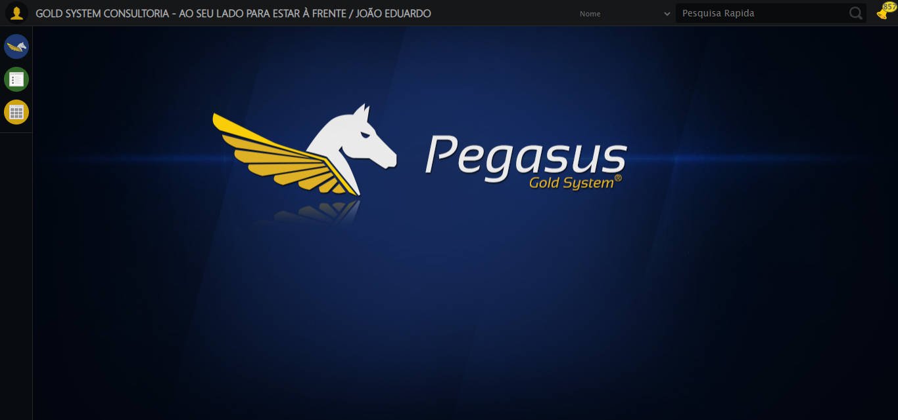

🔄 Abrindo menu (F3)...

✅ Abrindo menu (F3) realizada com sucesso.

Screenshot: abrindo menu (f3)

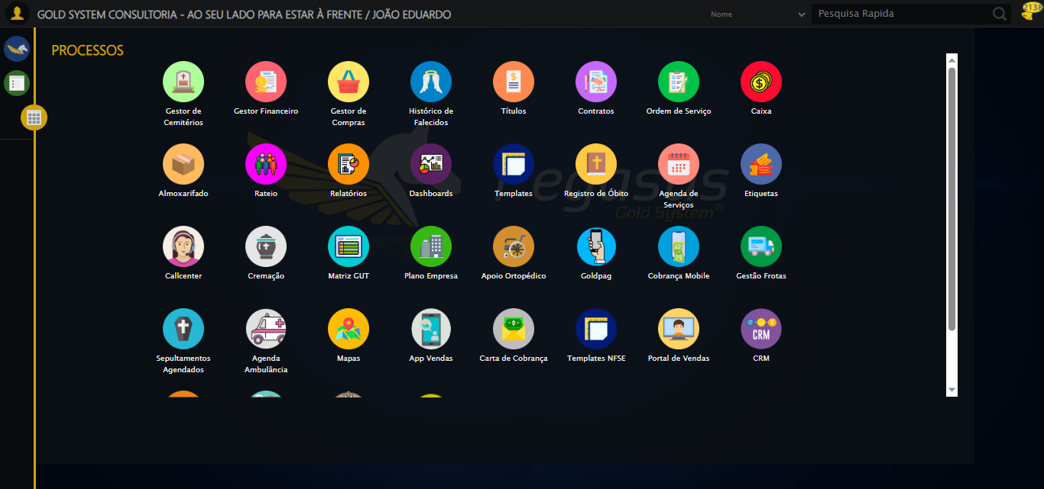

🔄 Acessando Gestor Financeiro...

🎯 Clique forçado em: /html/body/div[15]/ul/li[2]/img

Tentativa 1.1...

✅ Clique bem-sucedido (estratégia 1)

✅ Acessando Gestor Financeiro realizada com sucesso.

Screenshot: acessando gestor financeiro

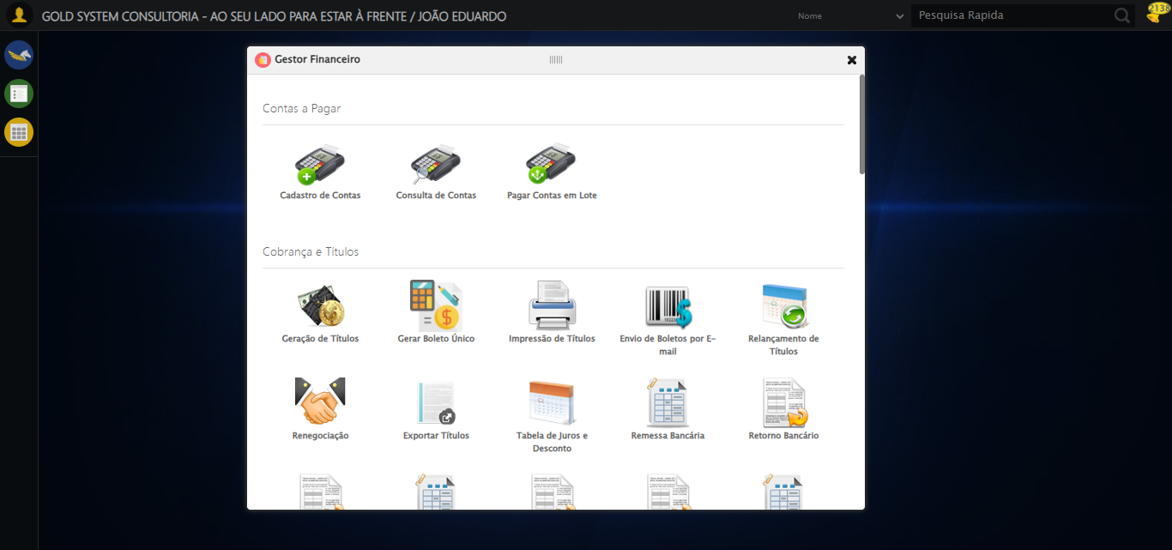

🔄 Clicando em Impressão de Títulos...

🎯 Clique forçado em: #gsFinan > div.wdTelas > div > ul > li:nth-child(8) > a > span

Tentativa 1.1...

✅ Clique bem-sucedido (estratégia 1)

✅ Clicando em Impressão de Títulos realizada com sucesso.

Screenshot: clicando em impressão de títulos

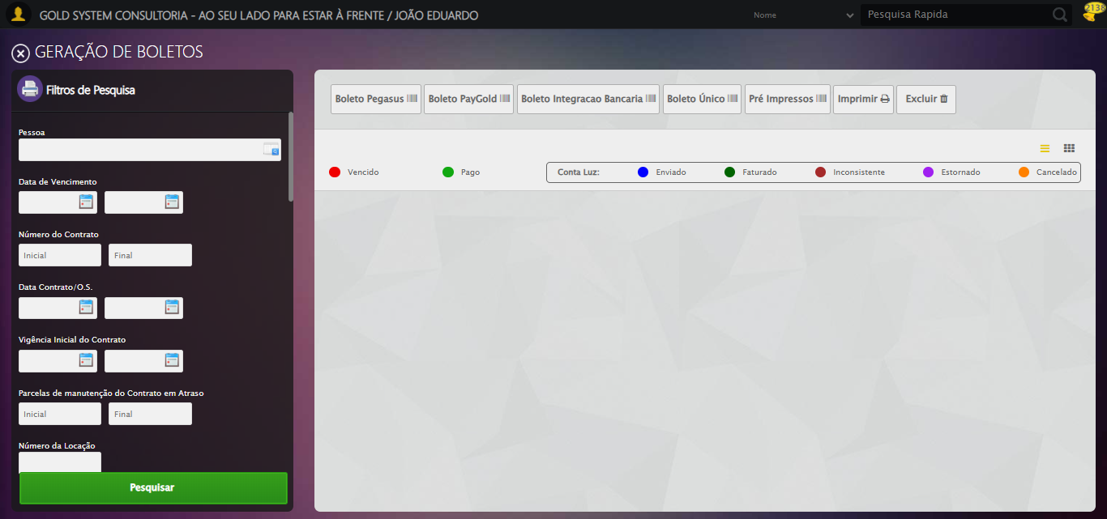

🔄 Selecionando Pessoa...

🔍 Processando LOV: 'ESTER SARAH BRUNA GONÇALVES' → 'ESTER SARAH BRUNA GONÇALVES'

Tentativa 1/5

📌 Abrindo LOV...

🎯 Clique forçado em: (//a[@class='sprites sp-openLov'])[1]

Tentativa 1.1...

✅ Clique bem-sucedido (estratégia 1)

✏️ Pesquisando: 'ESTER SARAH BRUNA GONÇALVES'

✏️ Preenchimento forçado: //input[@id='txtPesquisa'] = 'ESTER SARAH BRUNA GONÇALVES'

Tentativa 1.1...

✅ Campo preenchido (estratégia 1)

🔎 Executando pesquisa...

🎯 Clique forçado em: //a[contains(@class,'lpFind') and contains(normalize-space(.),'Pesquisar')]

Tentativa 1.1...

✅ Clique bem-sucedido (estratégia 1)

🎯 Selecionando: 'ESTER SARAH BRUNA GONÇALVES'

🎯 Clique forçado em: //tr[td[contains(normalize-space(.), 'ESTER SARAH BRUNA GONÇALVES')]]

Tentativa 1.1...

✅ Clique bem-sucedido (estratégia 1)

✅ LOV processado com sucesso!

✅ Selecionando Pessoa realizada com sucesso.

Screenshot: selecionando pessoa

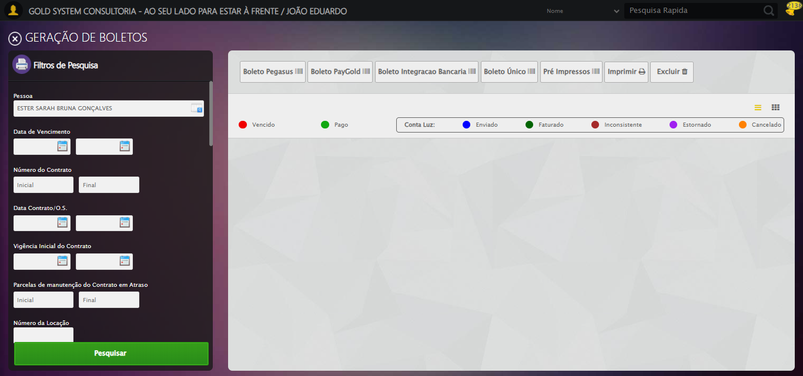

🔄 Selecionando Opção: 'Em aberto'...

✅ Selecionando Opção: 'Em aberto' realizada com sucesso.

Screenshot: selecionando opção_ _em aberto_

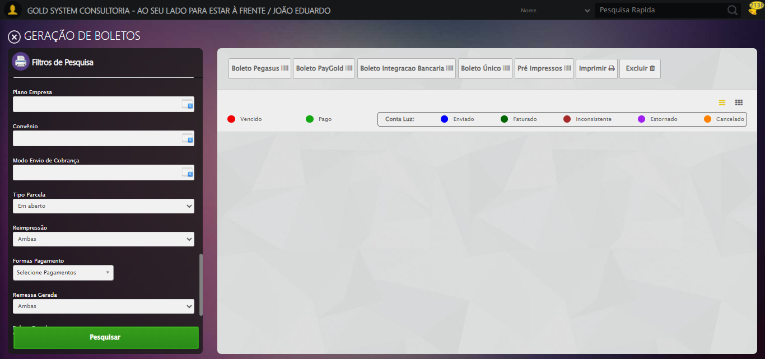

🔄 Clicando em Pesquisar...

🎯 Clique forçado em: //a[@class='btModel btGreen btPesquisar boxsize' and normalize-space()='Pesquisar']

Tentativa 1.1...

✅ Clique bem-sucedido (estratégia 1)

✅ Clicando em Pesquisar realizada com sucesso.

Screenshot: clicando em pesquisar

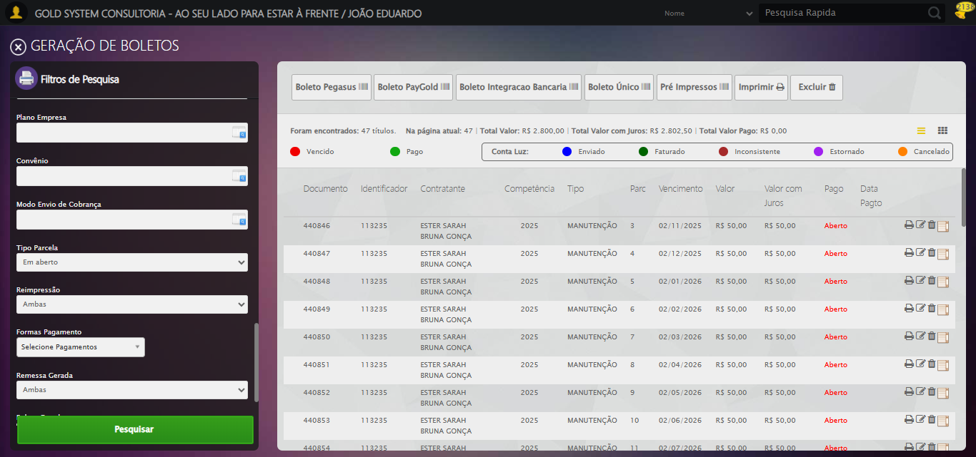

🚀 Iniciando fluxo completo de geração de boletos...

🔍 Validando resultado da pesquisa...

✅ Tabela de Títulos carregada com sucesso, prosseguindo

✅ Prosseguindo com o fluxo — tabela carregada com sucesso.

📄 Total de títulos encontrados: 47

🔍 Abrindo modal de detalhes do primeiro título...

🔄 Visualizando Detalhes...

🎯 Clique forçado em: //i[@class='sprites sp-dadosDinamicos' and @title='Visualizar Detalhes']

Tentativa 1.1...

✅ Clique bem-sucedido (estratégia 1)

✅ Visualizando Detalhes realizada com sucesso.

Screenshot: visualizando detalhes

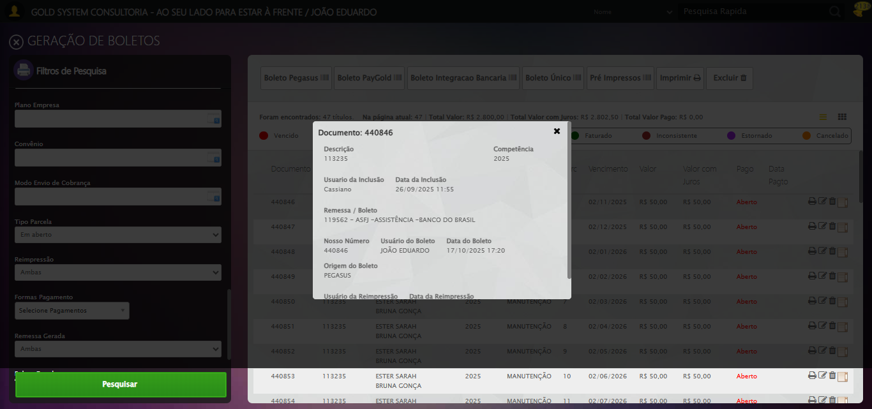

Screenshot: modal_detalhes_aberto



📸 Screenshot capturado com o modal aberto.

🔄 Fechando modal de Detalhes...

🧩 Tentativa 1 de fechar modal...

🎯 Clique forçado em: (//div[contains(@class,'modal') and not(contains(@style,'display: none'))]//a[@class='fa fa-close'])[last()]

Tentativa 1.1...

✅ Clique bem-sucedido (estratégia 1)

🧩 Tentativa 2 de fechar modal...

🎯 Clique forçado em: (//div[contains(@class,'modal') and not(contains(@style,'display: none'))]//a[@class='fa fa-close'])[last()]

Tentativa 1.1...

✅ Clique bem-sucedido (estratégia 1)

✅ Modal fechado com sucesso.

✅ Fechando modal de Detalhes realizada com sucesso.

Screenshot: fechando modal de detalhes



🔄 Clicando em 'Boleto Pegasus'...

🎯 Clique forçado em: //a[@class='btModel btShort btLight boletoPegasus' and normalize-space(text())='Boleto Pegasus']/i[@class='fa fa-barcode']/parent::a

Tentativa 1.1...

✅ Clique bem-sucedido (estratégia 1)

✅ Clicando em 'Boleto Pegasus' realizada com sucesso.

Screenshot: clicando em _boleto pegasus_

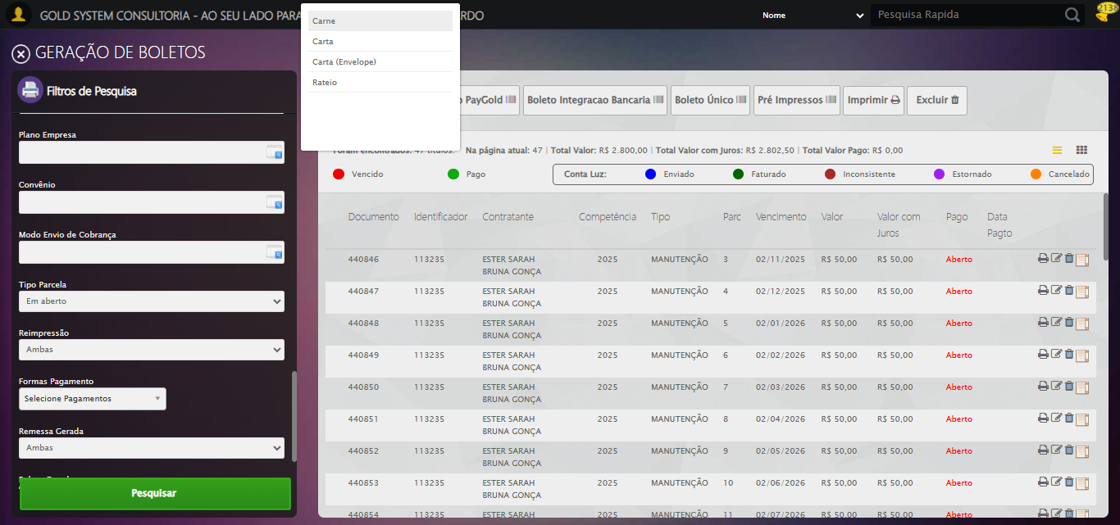

🔄 Selecionando a opção 'Carnê'...

🎯 Clique forçado em: //li[@tabindex='1' and @ref='carne' and @rel='undefined' and normalize-space(text())='Carne']

Tentativa 1.1...

✅ Clique bem-sucedido (estratégia 1)

✅ Selecionando a opção 'Carnê' realizada com sucesso.

Screenshot: selecionando a opção _carnê_

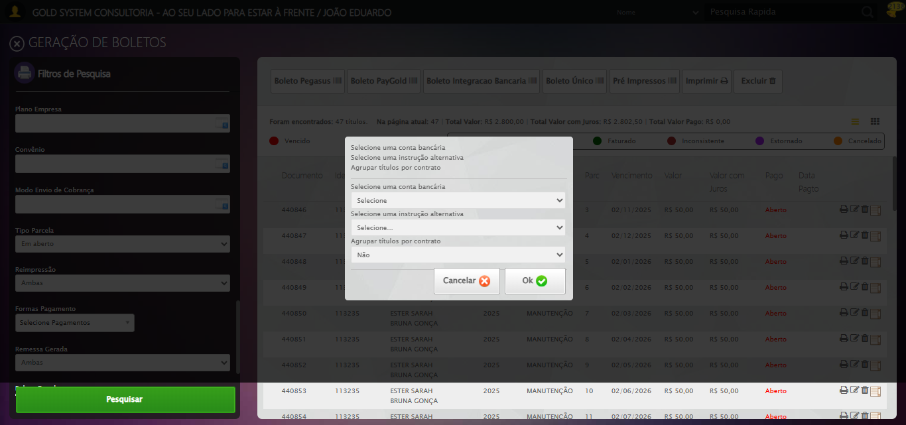

🔄 Selecionando Conta Bancária...

🔎 Tentativa 1: Localizando selects (XPath: '//select[@class='contaBancaria' and @style='width: 360px;' and @rev='10']')...

🎯 Select #1 localizado (total: 2).

📋 Select tem 270 opções

🎯 Selecionando opção #1: '119562 - ASFJ -ASSISTÊNCIA -BANCO DO BRASIL'

▶️ Estratégia 1 de seleção...

✅ Opção selecionada com sucesso (estratégia 1): '119562 - ASFJ -ASSISTÊNCIA -BANCO DO BRASIL'

✅ Selecionando Conta Bancária realizada com sucesso.

Screenshot: selecionando conta bancária

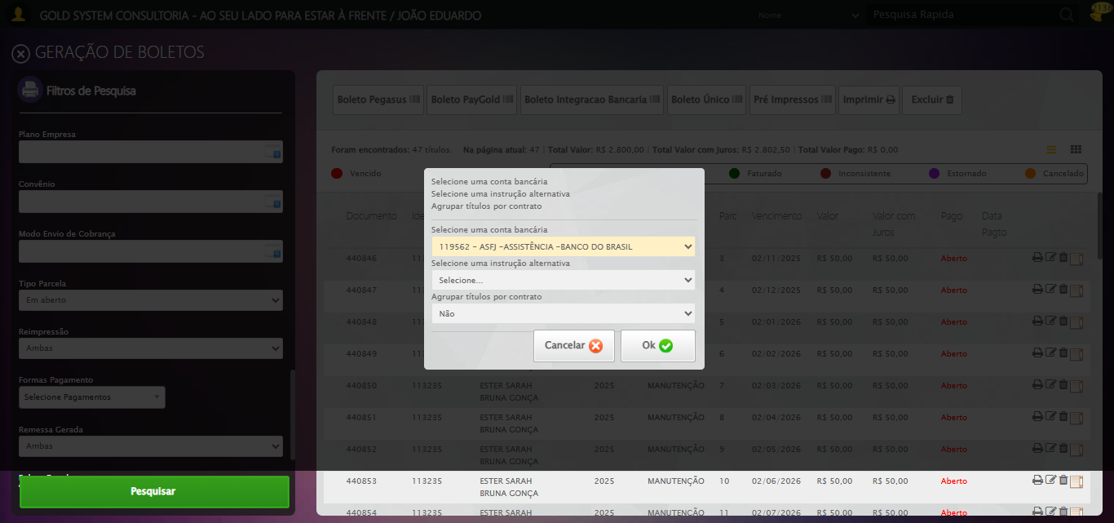

🔄 Selecionando Instrução Alternativa...

🔎 Tentativa 1: Localizando selects (XPath: '//select[@class='instrucaoBoleto' and @style='width: 360px; padding-top: 10px;']')...

🎯 Select #1 localizado (total: 2).

📋 Select tem 14 opções

🎯 Selecionando opção #1: 'TESTE CASSIANO'

▶️ Estratégia 1 de seleção...

✅ Opção selecionada com sucesso (estratégia 1): 'TESTE CASSIANO'

✅ Selecionando Instrução Alternativa realizada com sucesso.

Screenshot: selecionando instrução alternativa

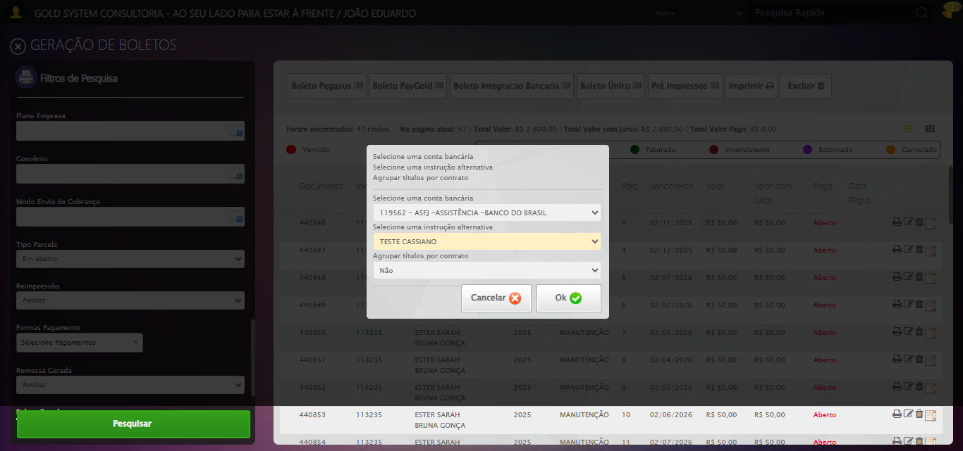

🔄 Clicando em 'Ok'...

🎯 Tentando botão Ok #5 de 5...

▶️ Estratégia 1/4 de clique...

✅ Clique executado (estratégia 1).

ℹ️ Modal de confirmação não detectado.

✅ Clicando em 'Ok' realizada com sucesso.

Screenshot: clicando em _ok_

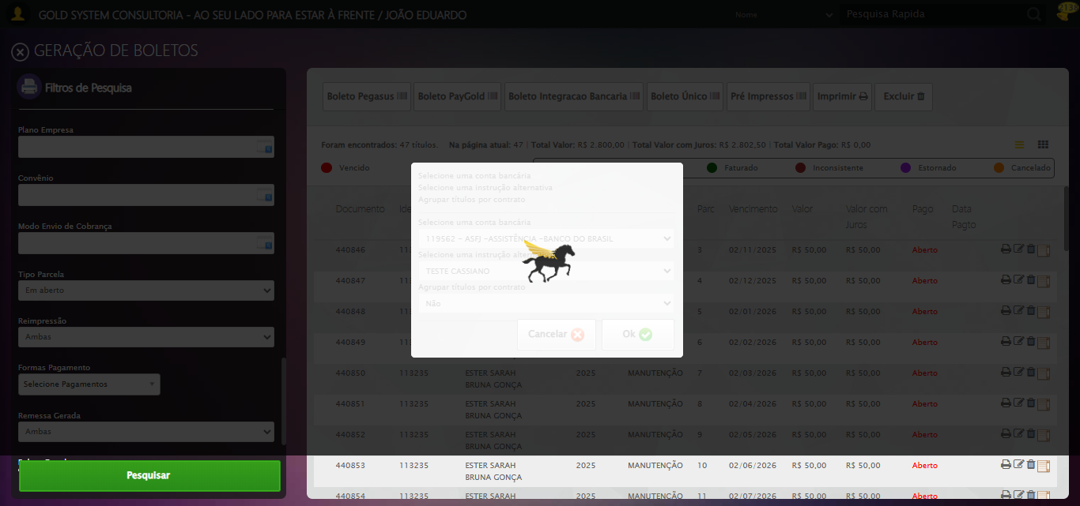

🔄 Confirmar ou detectar relatório...

✅ Confirmar ou detectar relatório realizada com sucesso.

Screenshot: confirmar ou detectar relatório

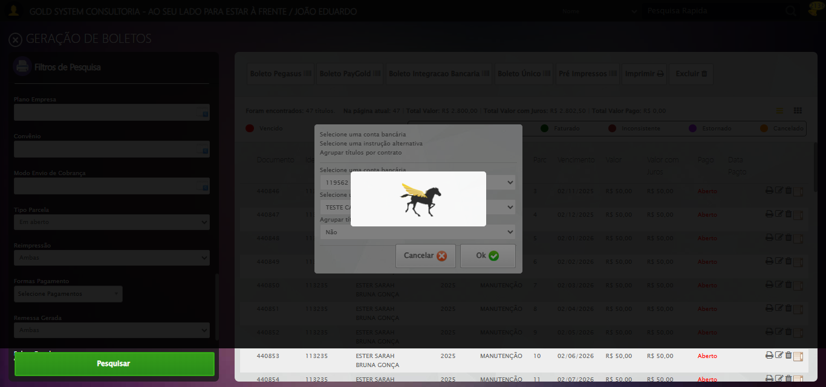

🔄 Confirmando o envio de boletos por E-mail...

🎯 Clique forçado em: (//a[@class='btModel btGray btok' and normalize-space()='Ok'])[1]

Tentativa 1.1...

✅ Clique bem-sucedido (estratégia 1)

✅ Confirmando o envio de boletos por E-mail realizada com sucesso.

Screenshot: confirmando o envio de boletos por e-mail

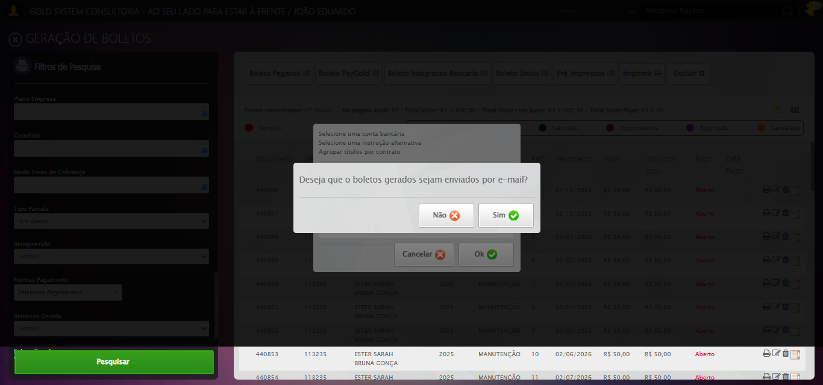

ℹ️ Nenhuma mensagem de alerta encontrada.

Screenshot: retorno_tela_sistema



✅ Fluxo concluído com sucesso.

🔄 Selecionando Opção: 'Pagas'...

✅ Selecionando Opção: 'Pagas' realizada com sucesso.

Screenshot: selecionando opção_ _pagas_

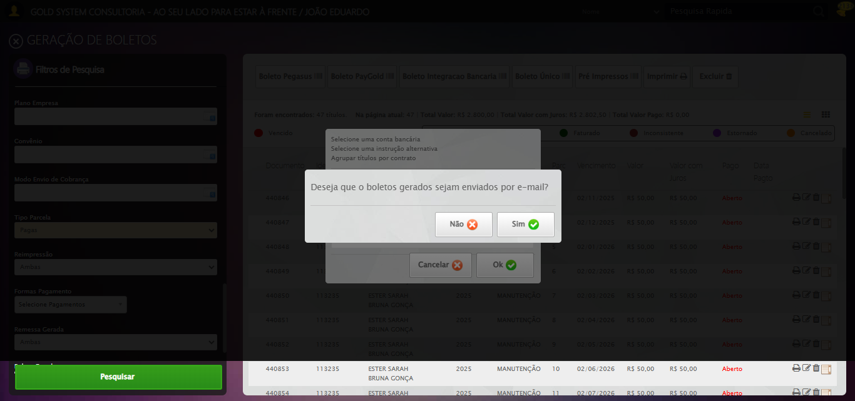

🔄 Selecionando para permitir reimpressão...

✅ Selecionando para permitir reimpressão realizada com sucesso.

Screenshot: selecionando para permitir reimpressão

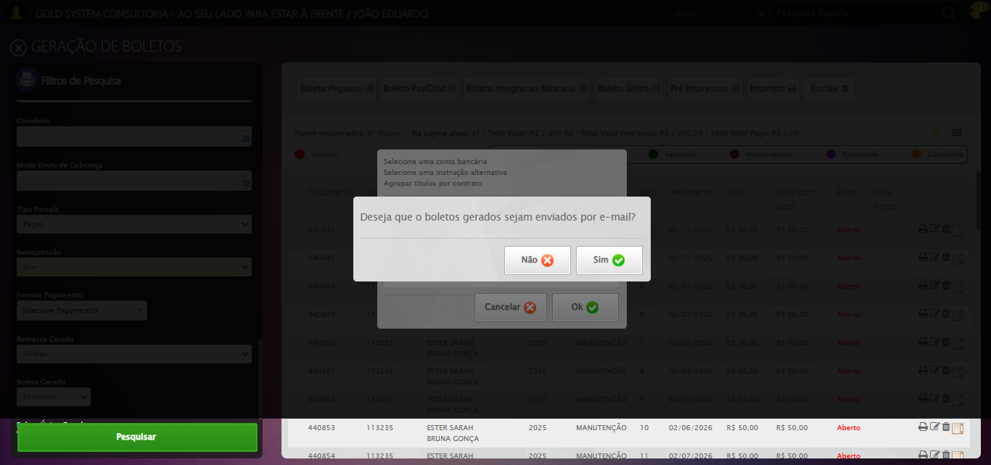

🔄 Clicando em Pesquisar...

🎯 Clique forçado em: //a[@class='btModel btGreen btPesquisar boxsize' and normalize-space()='Pesquisar']

Tentativa 1.1...

✅ Clique bem-sucedido (estratégia 1)

✅ Clicando em Pesquisar realizada com sucesso.

🚀 Iniciando fluxo completo de geração de boletos...

🔍 Validando resultado da pesquisa...

⚠️ Erro JS: Message: invalid session id: session deleted as the browser has closed the connection  
from disconnected: not connected to DevTools  
 (Session info: ch

❌ Erro ao validar resultado: Message: invalid session id: session deleted as the browser has closed the connection  
from disconnected: not connected to DevTools  
 (Session info: chrome=141.0.7390.108); For documentation on this error, please visit: https://www.selenium.dev/documentation/webdriver/troubleshooting/errors#invalidsessionidexception  
Stacktrace:  
 GetHandleVerifier [0x0x105fe83+66515]  
 GetHandleVerifier [0x0x105fec4+66580]  
 (No symbol) [0x0xe4dc48]  
 (No symbol) [0x0xe3ce80]  
 (No symbol) [0x0xe5b81b]  
 (No symbol) [0x0xec1c25]  
 (No symbol) [0x0xedc4d9]  
 (No symbol) [0x0xebafc6]  
 (No symbol) [0x0xe8c2ca]  
 (No symbol) [0x0xe8d154]  
 GetHandleVerifier [0x0x12b73b3+2521347]  
 GetHandleVerifier [0x0x12b2333+2500739]  
 GetHandleVerifier [0x0x1087cd4+229924]  
 GetHandleVerifier [0x0x1078238+165768]  
 GetHandleVerifier [0x0x107eced+193085]  
 GetHandleVerifier [0x0x1068198+100072]  
 GetHandleVerifier [0x0x1068330+100480]  
 GetHandleVerifier [0x0x10525ea+11066]  
 BaseThreadInitThunk [0x0x76adfcc9+25]  
 RtlGetAppContainerNamedObjectPath [0x0x77e982ae+286]  
 RtlGetAppContainerNamedObjectPath [0x0x77e9827e+238]

⚠️ Nenhum resultado encontrado — encerrando o processo.

🔄 Selecionando Opção: 'Ambas'...

⚠️ Tentativa 1 falhou, tentando novamente...

🔄 Selecionando Opção: 'Ambas'... (Tentativa 2)

⚠️ Tentativa 2 falhou, tentando novamente...

🔄 Selecionando Opção: 'Ambas'... (Tentativa 3)

❌ Erro após 3 tentativas: Message: invalid session id; For documentation on this error, please visit: https://www.selenium.dev/documentation/webdriver/troubleshooting/errors#invalidsessionidexception  
Stacktrace:  
 GetHandleVerifier [0x0x105fe83+66515]  
 GetHandleVerifier [0x0x105fec4+66580]  
 (No symbol) [0x0xe4da6b]  
 (No symbol) [0x0xe8b5ab]  
 (No symbol) [0x0xebb086]  
 (No symbol) [0x0xeb667c]  
 (No symbol) [0x0xeb5bf3]  
 (No symbol) [0x0xe1e72d]  
 (No symbol) [0x0xe1ecae]  
 (No symbol) [0x0xe1f14d]  
 GetHandleVerifier [0x0x12b73b3+2521347]  
 GetHandleVerifier [0x0x12b2333+2500739]  
 GetHandleVerifier [0x0x1087cd4+229924]  
 GetHandleVerifier [0x0x1078238+165768]  
 GetHandleVerifier [0x0x107eced+193085]  
 (No symbol) [0x0xe1e3e3]  
 (No symbol) [0x0xe1db60]  
 GetHandleVerifier [0x0x13fc26f+3852223]  
 BaseThreadInitThunk [0x0x76adfcc9+25]  
 RtlGetAppContainerNamedObjectPath [0x0x77e982ae+286]  
 RtlGetAppContainerNamedObjectPath [0x0x77e9827e+238]

⚠️ Erro ao tirar screenshot erro_selecionando opção_ _ambas_: Message: invalid session id; For documentation on this error, please visit: https://www.selenium.dev/documentation/webdriver/troubleshooting/errors#invalidsessionidexception  
Stacktrace:  
 GetHandleVerifier [0x0x105fe83+66515]  
 GetHandleVerifier [0x0x105fec4+66580]  
 (No symbol) [0x0xe4da6b]  
 (No symbol) [0x0xe8b5ab]  
 (No symbol) [0x0xebb086]  
 (No symbol) [0x0xeb667c]  
 (No symbol) [0x0xeb5bf3]  
 (No symbol) [0x0xe1e72d]  
 (No symbol) [0x0xe1ecae]  
 (No symbol) [0x0xe1f14d]  
 GetHandleVerifier [0x0x12b73b3+2521347]  
 GetHandleVerifier [0x0x12b2333+2500739]  
 GetHandleVerifier [0x0x1087cd4+229924]  
 GetHandleVerifier [0x0x1078238+165768]  
 GetHandleVerifier [0x0x107eced+193085]  
 (No symbol) [0x0xe1e3e3]  
 (No symbol) [0x0xe1db60]  
 GetHandleVerifier [0x0x13fc26f+3852223]  
 BaseThreadInitThunk [0x0x76adfcc9+25]  
 RtlGetAppContainerNamedObjectPath [0x0x77e982ae+286]  
 RtlGetAppContainerNamedObjectPath [0x0x77e9827e+238]

🔄 Selecionando para permitir reimpressão...

⚠️ Tentativa 1 falhou, tentando novamente...

🔄 Selecionando para permitir reimpressão... (Tentativa 2)

⚠️ Tentativa 2 falhou, tentando novamente...

🔄 Selecionando para permitir reimpressão... (Tentativa 3)

❌ Erro após 3 tentativas: Message: invalid session id; For documentation on this error, please visit: https://www.selenium.dev/documentation/webdriver/troubleshooting/errors#invalidsessionidexception  
Stacktrace:  
 GetHandleVerifier [0x0x105fe83+66515]  
 GetHandleVerifier [0x0x105fec4+66580]  
 (No symbol) [0x0xe4da6b]  
 (No symbol) [0x0xe8b5ab]  
 (No symbol) [0x0xebb086]  
 (No symbol) [0x0xeb667c]  
 (No symbol) [0x0xeb5bf3]  
 (No symbol) [0x0xe1e72d]  
 (No symbol) [0x0xe1ecae]  
 (No symbol) [0x0xe1f14d]  
 GetHandleVerifier [0x0x12b73b3+2521347]  
 GetHandleVerifier [0x0x12b2333+2500739]  
 GetHandleVerifier [0x0x1087cd4+229924]  
 GetHandleVerifier [0x0x1078238+165768]  
 GetHandleVerifier [0x0x107eced+193085]  
 (No symbol) [0x0xe1e3e3]  
 (No symbol) [0x0xe1db60]  
 GetHandleVerifier [0x0x13fc26f+3852223]  
 BaseThreadInitThunk [0x0x76adfcc9+25]  
 RtlGetAppContainerNamedObjectPath [0x0x77e982ae+286]  
 RtlGetAppContainerNamedObjectPath [0x0x77e9827e+238]

⚠️ Erro ao tirar screenshot erro_selecionando para permitir reimpressão: Message: invalid session id; For documentation on this error, please visit: https://www.selenium.dev/documentation/webdriver/troubleshooting/errors#invalidsessionidexception  
Stacktrace:  
 GetHandleVerifier [0x0x105fe83+66515]  
 GetHandleVerifier [0x0x105fec4+66580]  
 (No symbol) [0x0xe4da6b]  
 (No symbol) [0x0xe8b5ab]  
 (No symbol) [0x0xebb086]  
 (No symbol) [0x0xeb667c]  
 (No symbol) [0x0xeb5bf3]  
 (No symbol) [0x0xe1e72d]  
 (No symbol) [0x0xe1ecae]  
 (No symbol) [0x0xe1f14d]  
 GetHandleVerifier [0x0x12b73b3+2521347]  
 GetHandleVerifier [0x0x12b2333+2500739]  
 GetHandleVerifier [0x0x1087cd4+229924]  
 GetHandleVerifier [0x0x1078238+165768]  
 GetHandleVerifier [0x0x107eced+193085]  
 (No symbol) [0x0xe1e3e3]  
 (No symbol) [0x0xe1db60]  
 GetHandleVerifier [0x0x13fc26f+3852223]  
 BaseThreadInitThunk [0x0x76adfcc9+25]  
 RtlGetAppContainerNamedObjectPath [0x0x77e982ae+286]  
 RtlGetAppContainerNamedObjectPath [0x0x77e9827e+238]

🔄 Clicando em Pesquisar...

🎯 Clique forçado em: //a[@class='btModel btGreen btPesquisar boxsize' and normalize-space()='Pesquisar']

Tentativa 1.1...

⚠️ Erro JS: Message: invalid session id; For documentation on this error, please visit: https://www.selenium.dev/documentation/webdriver/troubleshooting/errors#in

Estratégia 1 falhou: Message: invalid session id; For documentation on this error, please visit: http

Tentativa 1.2...

⚠️ Erro JS: Message: invalid session id; For documentation on this error, please visit: https://www.selenium.dev/documentation/webdriver/troubleshooting/errors#in

Estratégia 2 falhou: Message: invalid session id; For documentation on this error, please visit: http

Tentativa 1.3...

⚠️ Erro JS: Message: invalid session id; For documentation on this error, please visit: https://www.selenium.dev/documentation/webdriver/troubleshooting/errors#in

Estratégia 3 falhou: Message: invalid session id; For documentation on this error, please visit: http

Tentativa 1.4...

⚠️ Erro JS: Message: invalid session id; For documentation on this error, please visit: https://www.selenium.dev/documentation/webdriver/troubleshooting/errors#in

Estratégia 4 falhou: Message: invalid session id; For documentation on this error, please visit: http

Tentativa 1.5...

⚠️ Erro JS: Message: invalid session id; For documentation on this error, please visit: https://www.selenium.dev/documentation/webdriver/troubleshooting/errors#in

Estratégia 5 falhou: Message: invalid session id; For documentation on this error, please visit: http

Tentativa 2.1...

⚠️ Erro JS: Message: invalid session id; For documentation on this error, please visit: https://www.selenium.dev/documentation/webdriver/troubleshooting/errors#in

Estratégia 1 falhou: Message: invalid session id; For documentation on this error, please visit: http

Tentativa 2.2...

⚠️ Erro JS: Message: invalid session id; For documentation on this error, please visit: https://www.selenium.dev/documentation/webdriver/troubleshooting/errors#in

Estratégia 2 falhou: Message: invalid session id; For documentation on this error, please visit: http

Tentativa 2.3...

⚠️ Erro JS: Message: invalid session id; For documentation on this error, please visit: https://www.selenium.dev/documentation/webdriver/troubleshooting/errors#in

Estratégia 3 falhou: Message: invalid session id; For documentation on this error, please visit: http

Tentativa 2.4...

⚠️ Erro JS: Message: invalid session id; For documentation on this error, please visit: https://www.selenium.dev/documentation/webdriver/troubleshooting/errors#in

Estratégia 4 falhou: Message: invalid session id; For documentation on this error, please visit: http

Tentativa 2.5...

⚠️ Erro JS: Message: invalid session id; For documentation on this error, please visit: https://www.selenium.dev/documentation/webdriver/troubleshooting/errors#in

Estratégia 5 falhou: Message: invalid session id; For documentation on this error, please visit: http

Tentativa 3.1...

⚠️ Erro JS: Message: invalid session id; For documentation on this error, please visit: https://www.selenium.dev/documentation/webdriver/troubleshooting/errors#in

Estratégia 1 falhou: Message: invalid session id; For documentation on this error, please visit: http

Tentativa 3.2...

⚠️ Erro JS: Message: invalid session id; For documentation on this error, please visit: https://www.selenium.dev/documentation/webdriver/troubleshooting/errors#in

Estratégia 2 falhou: Message: invalid session id; For documentation on this error, please visit: http

Tentativa 3.3...

⚠️ Erro JS: Message: invalid session id; For documentation on this error, please visit: https://www.selenium.dev/documentation/webdriver/troubleshooting/errors#in

Estratégia 3 falhou: Message: invalid session id; For documentation on this error, please visit: http

Tentativa 3.4...

⚠️ Erro JS: Message: invalid session id; For documentation on this error, please visit: https://www.selenium.dev/documentation/webdriver/troubleshooting/errors#in

Estratégia 4 falhou: Message: invalid session id; For documentation on this error, please visit: http

Tentativa 3.5...

⚠️ Erro JS: Message: invalid session id; For documentation on this error, please visit: https://www.selenium.dev/documentation/webdriver/troubleshooting/errors#in

Estratégia 5 falhou: Message: invalid session id; For documentation on this error, please visit: http

Tentativa 4.1...

⚠️ Erro JS: Message: invalid session id; For documentation on this error, please visit: https://www.selenium.dev/documentation/webdriver/troubleshooting/errors#in

Estratégia 1 falhou: Message: invalid session id; For documentation on this error, please visit: http

Tentativa 4.2...

⚠️ Erro JS: Message: invalid session id; For documentation on this error, please visit: https://www.selenium.dev/documentation/webdriver/troubleshooting/errors#in

Estratégia 2 falhou: Message: invalid session id; For documentation on this error, please visit: http

Tentativa 4.3...

⚠️ Erro JS: Message: invalid session id; For documentation on this error, please visit: https://www.selenium.dev/documentation/webdriver/troubleshooting/errors#in

Estratégia 3 falhou: Message: invalid session id; For documentation on this error, please visit: http

Tentativa 4.4...

⚠️ Erro JS: Message: invalid session id; For documentation on this error, please visit: https://www.selenium.dev/documentation/webdriver/troubleshooting/errors#in

Estratégia 4 falhou: Message: invalid session id; For documentation on this error, please visit: http

Tentativa 4.5...

⚠️ Erro JS: Message: invalid session id; For documentation on this error, please visit: https://www.selenium.dev/documentation/webdriver/troubleshooting/errors#in

Estratégia 5 falhou: Message: invalid session id; For documentation on this error, please visit: http

Tentativa 5.1...

⚠️ Erro JS: Message: invalid session id; For documentation on this error, please visit: https://www.selenium.dev/documentation/webdriver/troubleshooting/errors#in

Estratégia 1 falhou: Message: invalid session id; For documentation on this error, please visit: http

Tentativa 5.2...

⚠️ Erro JS: Message: invalid session id; For documentation on this error, please visit: https://www.selenium.dev/documentation/webdriver/troubleshooting/errors#in

Estratégia 2 falhou: Message: invalid session id; For documentation on this error, please visit: http

Tentativa 5.3...

⚠️ Erro JS: Message: invalid session id; For documentation on this error, please visit: https://www.selenium.dev/documentation/webdriver/troubleshooting/errors#in

Estratégia 3 falhou: Message: invalid session id; For documentation on this error, please visit: http

Tentativa 5.4...

⚠️ Erro JS: Message: invalid session id; For documentation on this error, please visit: https://www.selenium.dev/documentation/webdriver/troubleshooting/errors#in

Estratégia 4 falhou: Message: invalid session id; For documentation on this error, please visit: http

Tentativa 5.5...

⚠️ Erro JS: Message: invalid session id; For documentation on this error, please visit: https://www.selenium.dev/documentation/webdriver/troubleshooting/errors#in

Estratégia 5 falhou: Message: invalid session id; For documentation on this error, please visit: http

⚠️ Tentativa 1 falhou, tentando novamente...

🔄 Clicando em Pesquisar... (Tentativa 2)

🎯 Clique forçado em: //a[@class='btModel btGreen btPesquisar boxsize' and normalize-space()='Pesquisar']

Tentativa 1.1...

⚠️ Erro JS: Message: invalid session id; For documentation on this error, please visit: https://www.selenium.dev/documentation/webdriver/troubleshooting/errors#in

Estratégia 1 falhou: Message: invalid session id; For documentation on this error, please visit: http

Tentativa 1.2...

⚠️ Erro JS: Message: invalid session id; For documentation on this error, please visit: https://www.selenium.dev/documentation/webdriver/troubleshooting/errors#in

Estratégia 2 falhou: Message: invalid session id; For documentation on this error, please visit: http

Tentativa 1.3...

⚠️ Erro JS: Message: invalid session id; For documentation on this error, please visit: https://www.selenium.dev/documentation/webdriver/troubleshooting/errors#in

Estratégia 3 falhou: Message: invalid session id; For documentation on this error, please visit: http

Tentativa 1.4...

⚠️ Erro JS: Message: invalid session id; For documentation on this error, please visit: https://www.selenium.dev/documentation/webdriver/troubleshooting/errors#in

Estratégia 4 falhou: Message: invalid session id; For documentation on this error, please visit: http

Tentativa 1.5...

⚠️ Erro JS: Message: invalid session id; For documentation on this error, please visit: https://www.selenium.dev/documentation/webdriver/troubleshooting/errors#in

Estratégia 5 falhou: Message: invalid session id; For documentation on this error, please visit: http

Tentativa 2.1...

⚠️ Erro JS: Message: invalid session id; For documentation on this error, please visit: https://www.selenium.dev/documentation/webdriver/troubleshooting/errors#in

Estratégia 1 falhou: Message: invalid session id; For documentation on this error, please visit: http

Tentativa 2.2...

⚠️ Erro JS: Message: invalid session id; For documentation on this error, please visit: https://www.selenium.dev/documentation/webdriver/troubleshooting/errors#in

Estratégia 2 falhou: Message: invalid session id; For documentation on this error, please visit: http

Tentativa 2.3...

⚠️ Erro JS: Message: invalid session id; For documentation on this error, please visit: https://www.selenium.dev/documentation/webdriver/troubleshooting/errors#in

Estratégia 3 falhou: Message: invalid session id; For documentation on this error, please visit: http

Tentativa 2.4...

⚠️ Erro JS: Message: invalid session id; For documentation on this error, please visit: https://www.selenium.dev/documentation/webdriver/troubleshooting/errors#in

Estratégia 4 falhou: Message: invalid session id; For documentation on this error, please visit: http

Tentativa 2.5...

⚠️ Erro JS: Message: invalid session id; For documentation on this error, please visit: https://www.selenium.dev/documentation/webdriver/troubleshooting/errors#in

Estratégia 5 falhou: Message: invalid session id; For documentation on this error, please visit: http

Tentativa 3.1...

⚠️ Erro JS: Message: invalid session id; For documentation on this error, please visit: https://www.selenium.dev/documentation/webdriver/troubleshooting/errors#in

Estratégia 1 falhou: Message: invalid session id; For documentation on this error, please visit: http

Tentativa 3.2...

⚠️ Erro JS: Message: invalid session id; For documentation on this error, please visit: https://www.selenium.dev/documentation/webdriver/troubleshooting/errors#in

Estratégia 2 falhou: Message: invalid session id; For documentation on this error, please visit: http

Tentativa 3.3...

⚠️ Erro JS: Message: invalid session id; For documentation on this error, please visit: https://www.selenium.dev/documentation/webdriver/troubleshooting/errors#in

Estratégia 3 falhou: Message: invalid session id; For documentation on this error, please visit: http

Tentativa 3.4...

⚠️ Erro JS: Message: invalid session id; For documentation on this error, please visit: https://www.selenium.dev/documentation/webdriver/troubleshooting/errors#in

Estratégia 4 falhou: Message: invalid session id; For documentation on this error, please visit: http

Tentativa 3.5...

⚠️ Erro JS: Message: invalid session id; For documentation on this error, please visit: https://www.selenium.dev/documentation/webdriver/troubleshooting/errors#in

Estratégia 5 falhou: Message: invalid session id; For documentation on this error, please visit: http

Tentativa 4.1...

⚠️ Erro JS: Message: invalid session id; For documentation on this error, please visit: https://www.selenium.dev/documentation/webdriver/troubleshooting/errors#in

Estratégia 1 falhou: Message: invalid session id; For documentation on this error, please visit: http

Tentativa 4.2...

⚠️ Erro JS: Message: invalid session id; For documentation on this error, please visit: https://www.selenium.dev/documentation/webdriver/troubleshooting/errors#in

Estratégia 2 falhou: Message: invalid session id; For documentation on this error, please visit: http

Tentativa 4.3...

⚠️ Erro JS: Message: invalid session id; For documentation on this error, please visit: https://www.selenium.dev/documentation/webdriver/troubleshooting/errors#in

Estratégia 3 falhou: Message: invalid session id; For documentation on this error, please visit: http

Tentativa 4.4...

⚠️ Erro JS: Message: invalid session id; For documentation on this error, please visit: https://www.selenium.dev/documentation/webdriver/troubleshooting/errors#in

Estratégia 4 falhou: Message: invalid session id; For documentation on this error, please visit: http

Tentativa 4.5...

⚠️ Erro JS: Message: invalid session id; For documentation on this error, please visit: https://www.selenium.dev/documentation/webdriver/troubleshooting/errors#in

Estratégia 5 falhou: Message: invalid session id; For documentation on this error, please visit: http

Tentativa 5.1...

⚠️ Erro JS: Message: invalid session id; For documentation on this error, please visit: https://www.selenium.dev/documentation/webdriver/troubleshooting/errors#in

Estratégia 1 falhou: Message: invalid session id; For documentation on this error, please visit: http

Tentativa 5.2...

⚠️ Erro JS: Message: invalid session id; For documentation on this error, please visit: https://www.selenium.dev/documentation/webdriver/troubleshooting/errors#in

Estratégia 2 falhou: Message: invalid session id; For documentation on this error, please visit: http

Tentativa 5.3...

⚠️ Erro JS: Message: invalid session id; For documentation on this error, please visit: https://www.selenium.dev/documentation/webdriver/troubleshooting/errors#in

Estratégia 3 falhou: Message: invalid session id; For documentation on this error, please visit: http

Tentativa 5.4...

⚠️ Erro JS: Message: invalid session id; For documentation on this error, please visit: https://www.selenium.dev/documentation/webdriver/troubleshooting/errors#in

Estratégia 4 falhou: Message: invalid session id; For documentation on this error, please visit: http

Tentativa 5.5...

⚠️ Erro JS: Message: invalid session id; For documentation on this error, please visit: https://www.selenium.dev/documentation/webdriver/troubleshooting/errors#in

Estratégia 5 falhou: Message: invalid session id; For documentation on this error, please visit: http

⚠️ Tentativa 2 falhou, tentando novamente...

🔄 Clicando em Pesquisar... (Tentativa 3)

🎯 Clique forçado em: //a[@class='btModel btGreen btPesquisar boxsize' and normalize-space()='Pesquisar']

Tentativa 1.1...

⚠️ Erro JS: Message: invalid session id; For documentation on this error, please visit: https://www.selenium.dev/documentation/webdriver/troubleshooting/errors#in

Estratégia 1 falhou: Message: invalid session id; For documentation on this error, please visit: http

Tentativa 1.2...

⚠️ Erro JS: Message: invalid session id; For documentation on this error, please visit: https://www.selenium.dev/documentation/webdriver/troubleshooting/errors#in

Estratégia 2 falhou: Message: invalid session id; For documentation on this error, please visit: http

Tentativa 1.3...

⚠️ Erro JS: Message: invalid session id; For documentation on this error, please visit: https://www.selenium.dev/documentation/webdriver/troubleshooting/errors#in

Estratégia 3 falhou: Message: invalid session id; For documentation on this error, please visit: http

Tentativa 1.4...

⚠️ Erro JS: Message: invalid session id; For documentation on this error, please visit: https://www.selenium.dev/documentation/webdriver/troubleshooting/errors#in

Estratégia 4 falhou: Message: invalid session id; For documentation on this error, please visit: http

Tentativa 1.5...

⚠️ Erro JS: Message: invalid session id; For documentation on this error, please visit: https://www.selenium.dev/documentation/webdriver/troubleshooting/errors#in

Estratégia 5 falhou: Message: invalid session id; For documentation on this error, please visit: http

Tentativa 2.1...

⚠️ Erro JS: Message: invalid session id; For documentation on this error, please visit: https://www.selenium.dev/documentation/webdriver/troubleshooting/errors#in

Estratégia 1 falhou: Message: invalid session id; For documentation on this error, please visit: http

Tentativa 2.2...

⚠️ Erro JS: Message: invalid session id; For documentation on this error, please visit: https://www.selenium.dev/documentation/webdriver/troubleshooting/errors#in

Estratégia 2 falhou: Message: invalid session id; For documentation on this error, please visit: http

Tentativa 2.3...

⚠️ Erro JS: Message: invalid session id; For documentation on this error, please visit: https://www.selenium.dev/documentation/webdriver/troubleshooting/errors#in

Estratégia 3 falhou: Message: invalid session id; For documentation on this error, please visit: http

Tentativa 2.4...

⚠️ Erro JS: Message: invalid session id; For documentation on this error, please visit: https://www.selenium.dev/documentation/webdriver/troubleshooting/errors#in

Estratégia 4 falhou: Message: invalid session id; For documentation on this error, please visit: http

Tentativa 2.5...

⚠️ Erro JS: Message: invalid session id; For documentation on this error, please visit: https://www.selenium.dev/documentation/webdriver/troubleshooting/errors#in

Estratégia 5 falhou: Message: invalid session id; For documentation on this error, please visit: http

Tentativa 3.1...

⚠️ Erro JS: Message: invalid session id; For documentation on this error, please visit: https://www.selenium.dev/documentation/webdriver/troubleshooting/errors#in

Estratégia 1 falhou: Message: invalid session id; For documentation on this error, please visit: http

Tentativa 3.2...

⚠️ Erro JS: Message: invalid session id; For documentation on this error, please visit: https://www.selenium.dev/documentation/webdriver/troubleshooting/errors#in

Estratégia 2 falhou: Message: invalid session id; For documentation on this error, please visit: http

Tentativa 3.3...

⚠️ Erro JS: Message: invalid session id; For documentation on this error, please visit: https://www.selenium.dev/documentation/webdriver/troubleshooting/errors#in

Estratégia 3 falhou: Message: invalid session id; For documentation on this error, please visit: http

Tentativa 3.4...

⚠️ Erro JS: Message: invalid session id; For documentation on this error, please visit: https://www.selenium.dev/documentation/webdriver/troubleshooting/errors#in

Estratégia 4 falhou: Message: invalid session id; For documentation on this error, please visit: http

Tentativa 3.5...

⚠️ Erro JS: Message: invalid session id; For documentation on this error, please visit: https://www.selenium.dev/documentation/webdriver/troubleshooting/errors#in

Estratégia 5 falhou: Message: invalid session id; For documentation on this error, please visit: http

Tentativa 4.1...

⚠️ Erro JS: Message: invalid session id; For documentation on this error, please visit: https://www.selenium.dev/documentation/webdriver/troubleshooting/errors#in

Estratégia 1 falhou: Message: invalid session id; For documentation on this error, please visit: http

Tentativa 4.2...

⚠️ Erro JS: Message: invalid session id; For documentation on this error, please visit: https://www.selenium.dev/documentation/webdriver/troubleshooting/errors#in

Estratégia 2 falhou: Message: invalid session id; For documentation on this error, please visit: http

Tentativa 4.3...

⚠️ Erro JS: Message: invalid session id; For documentation on this error, please visit: https://www.selenium.dev/documentation/webdriver/troubleshooting/errors#in

Estratégia 3 falhou: Message: invalid session id; For documentation on this error, please visit: http

Tentativa 4.4...

⚠️ Erro JS: Message: invalid session id; For documentation on this error, please visit: https://www.selenium.dev/documentation/webdriver/troubleshooting/errors#in

Estratégia 4 falhou: Message: invalid session id; For documentation on this error, please visit: http

Tentativa 4.5...

⚠️ Erro JS: Message: invalid session id; For documentation on this error, please visit: https://www.selenium.dev/documentation/webdriver/troubleshooting/errors#in

Estratégia 5 falhou: Message: invalid session id; For documentation on this error, please visit: http

Tentativa 5.1...

⚠️ Erro JS: Message: invalid session id; For documentation on this error, please visit: https://www.selenium.dev/documentation/webdriver/troubleshooting/errors#in

Estratégia 1 falhou: Message: invalid session id; For documentation on this error, please visit: http

Tentativa 5.2...

⚠️ Erro JS: Message: invalid session id; For documentation on this error, please visit: https://www.selenium.dev/documentation/webdriver/troubleshooting/errors#in

Estratégia 2 falhou: Message: invalid session id; For documentation on this error, please visit: http

Tentativa 5.3...

⚠️ Erro JS: Message: invalid session id; For documentation on this error, please visit: https://www.selenium.dev/documentation/webdriver/troubleshooting/errors#in

Estratégia 3 falhou: Message: invalid session id; For documentation on this error, please visit: http

Tentativa 5.4...

⚠️ Erro JS: Message: invalid session id; For documentation on this error, please visit: https://www.selenium.dev/documentation/webdriver/troubleshooting/errors#in

Estratégia 4 falhou: Message: invalid session id; For documentation on this error, please visit: http

Tentativa 5.5...

⚠️ Erro JS: Message: invalid session id; For documentation on this error, please visit: https://www.selenium.dev/documentation/webdriver/troubleshooting/errors#in

Estratégia 5 falhou: Message: invalid session id; For documentation on this error, please visit: http

❌ Erro após 3 tentativas: Falha ao clicar após 5 tentativas: //a[@class='btModel btGreen btPesquisar boxsize' and normalize-space()='Pesquisar']

⚠️ Erro ao tirar screenshot erro_clicando em pesquisar: Message: invalid session id; For documentation on this error, please visit: https://www.selenium.dev/documentation/webdriver/troubleshooting/errors#invalidsessionidexception  
Stacktrace:  
 GetHandleVerifier [0x0x105fe83+66515]  
 GetHandleVerifier [0x0x105fec4+66580]  
 (No symbol) [0x0xe4da6b]  
 (No symbol) [0x0xe8b5ab]  
 (No symbol) [0x0xebb086]  
 (No symbol) [0x0xeb667c]  
 (No symbol) [0x0xeb5bf3]  
 (No symbol) [0x0xe1e72d]  
 (No symbol) [0x0xe1ecae]  
 (No symbol) [0x0xe1f14d]  
 GetHandleVerifier [0x0x12b73b3+2521347]  
 GetHandleVerifier [0x0x12b2333+2500739]  
 GetHandleVerifier [0x0x1087cd4+229924]  
 GetHandleVerifier [0x0x1078238+165768]  
 GetHandleVerifier [0x0x107eced+193085]  
 (No symbol) [0x0xe1e3e3]  
 (No symbol) [0x0xe1db60]  
 GetHandleVerifier [0x0x13fc26f+3852223]  
 BaseThreadInitThunk [0x0x76adfcc9+25]  
 RtlGetAppContainerNamedObjectPath [0x0x77e982ae+286]  
 RtlGetAppContainerNamedObjectPath [0x0x77e9827e+238]

🚀 Iniciando fluxo completo de geração de boletos...

🔍 Validando resultado da pesquisa...

⚠️ Erro JS: Message: invalid session id; For documentation on this error, please visit: https://www.selenium.dev/documentation/webdriver/troubleshooting/errors#in

❌ Erro ao validar resultado: Message: invalid session id; For documentation on this error, please visit: https://www.selenium.dev/documentation/webdriver/troubleshooting/errors#invalidsessionidexception  
Stacktrace:  
 GetHandleVerifier [0x0x105fe83+66515]  
 GetHandleVerifier [0x0x105fec4+66580]  
 (No symbol) [0x0xe4da6b]  
 (No symbol) [0x0xe8b5ab]  
 (No symbol) [0x0xebb086]  
 (No symbol) [0x0xeb667c]  
 (No symbol) [0x0xeb5bf3]  
 (No symbol) [0x0xe1e72d]  
 (No symbol) [0x0xe1ecae]  
 (No symbol) [0x0xe1f14d]  
 GetHandleVerifier [0x0x12b73b3+2521347]  
 GetHandleVerifier [0x0x12b2333+2500739]  
 GetHandleVerifier [0x0x1087cd4+229924]  
 GetHandleVerifier [0x0x1078238+165768]  
 GetHandleVerifier [0x0x107eced+193085]  
 (No symbol) [0x0xe1e3e3]  
 (No symbol) [0x0xe1db60]  
 GetHandleVerifier [0x0x13fc26f+3852223]  
 BaseThreadInitThunk [0x0x76adfcc9+25]  
 RtlGetAppContainerNamedObjectPath [0x0x77e982ae+286]  
 RtlGetAppContainerNamedObjectPath [0x0x77e9827e+238]

⚠️ Nenhum resultado encontrado — encerrando o processo.

⚠️ Erro ao verificar/fechar abas de boletos: Message: invalid session id; For documentation on this error, please visit: https://www.selenium.dev/documentation/webdriver/troubleshooting/errors#invalidsessionidexception  
Stacktrace:  
 GetHandleVerifier [0x0x105fe83+66515]  
 GetHandleVerifier [0x0x105fec4+66580]  
 (No symbol) [0x0xe4da6b]  
 (No symbol) [0x0xe8b5ab]  
 (No symbol) [0x0xebb086]  
 (No symbol) [0x0xeb667c]  
 (No symbol) [0x0xeb5bf3]  
 (No symbol) [0x0xe1e72d]  
 (No symbol) [0x0xe1ecae]  
 (No symbol) [0x0xe1f14d]  
 GetHandleVerifier [0x0x12b73b3+2521347]  
 GetHandleVerifier [0x0x12b2333+2500739]  
 GetHandleVerifier [0x0x1087cd4+229924]  
 GetHandleVerifier [0x0x1078238+165768]  
 GetHandleVerifier [0x0x107eced+193085]  
 (No symbol) [0x0xe1e3e3]  
 (No symbol) [0x0xe1db60]  
 GetHandleVerifier [0x0x13fc26f+3852223]  
 BaseThreadInitThunk [0x0x76adfcc9+25]  
 RtlGetAppContainerNamedObjectPath [0x0x77e982ae+286]  
 RtlGetAppContainerNamedObjectPath [0x0x77e9827e+238]

🔄 Fechando Gestor Financeiro...

🎯 Clique forçado em: #gsFinan > div.wdTop.ui-draggable-handle > div.wdClose > a

Tentativa 1.1...

⚠️ Erro JS: Message: invalid session id; For documentation on this error, please visit: https://www.selenium.dev/documentation/webdriver/troubleshooting/errors#in

Estratégia 1 falhou: Message: invalid session id; For documentation on this error, please visit: http

Tentativa 1.2...

⚠️ Erro JS: Message: invalid session id; For documentation on this error, please visit: https://www.selenium.dev/documentation/webdriver/troubleshooting/errors#in

Estratégia 2 falhou: Message: invalid session id; For documentation on this error, please visit: http

Tentativa 1.3...

⚠️ Erro JS: Message: invalid session id; For documentation on this error, please visit: https://www.selenium.dev/documentation/webdriver/troubleshooting/errors#in

Estratégia 3 falhou: Message: invalid session id; For documentation on this error, please visit: http

Tentativa 1.4...

⚠️ Erro JS: Message: invalid session id; For documentation on this error, please visit: https://www.selenium.dev/documentation/webdriver/troubleshooting/errors#in

Estratégia 4 falhou: Message: invalid session id; For documentation on this error, please visit: http

Tentativa 1.5...

⚠️ Erro JS: Message: invalid session id; For documentation on this error, please visit: https://www.selenium.dev/documentation/webdriver/troubleshooting/errors#in

Estratégia 5 falhou: Message: invalid session id; For documentation on this error, please visit: http

Tentativa 2.1...

⚠️ Erro JS: Message: invalid session id; For documentation on this error, please visit: https://www.selenium.dev/documentation/webdriver/troubleshooting/errors#in

Estratégia 1 falhou: Message: invalid session id; For documentation on this error, please visit: http

Tentativa 2.2...

⚠️ Erro JS: Message: invalid session id; For documentation on this error, please visit: https://www.selenium.dev/documentation/webdriver/troubleshooting/errors#in

Estratégia 2 falhou: Message: invalid session id; For documentation on this error, please visit: http

Tentativa 2.3...

⚠️ Erro JS: Message: invalid session id; For documentation on this error, please visit: https://www.selenium.dev/documentation/webdriver/troubleshooting/errors#in

Estratégia 3 falhou: Message: invalid session id; For documentation on this error, please visit: http

Tentativa 2.4...

⚠️ Erro JS: Message: invalid session id; For documentation on this error, please visit: https://www.selenium.dev/documentation/webdriver/troubleshooting/errors#in

Estratégia 4 falhou: Message: invalid session id; For documentation on this error, please visit: http

Tentativa 2.5...

⚠️ Erro JS: Message: invalid session id; For documentation on this error, please visit: https://www.selenium.dev/documentation/webdriver/troubleshooting/errors#in

Estratégia 5 falhou: Message: invalid session id; For documentation on this error, please visit: http

Tentativa 3.1...

⚠️ Erro JS: Message: invalid session id; For documentation on this error, please visit: https://www.selenium.dev/documentation/webdriver/troubleshooting/errors#in

Estratégia 1 falhou: Message: invalid session id; For documentation on this error, please visit: http

Tentativa 3.2...

⚠️ Erro JS: Message: invalid session id; For documentation on this error, please visit: https://www.selenium.dev/documentation/webdriver/troubleshooting/errors#in

Estratégia 2 falhou: Message: invalid session id; For documentation on this error, please visit: http

Tentativa 3.3...

⚠️ Erro JS: Message: invalid session id; For documentation on this error, please visit: https://www.selenium.dev/documentation/webdriver/troubleshooting/errors#in

Estratégia 3 falhou: Message: invalid session id; For documentation on this error, please visit: http

Tentativa 3.4...

⚠️ Erro JS: Message: invalid session id; For documentation on this error, please visit: https://www.selenium.dev/documentation/webdriver/troubleshooting/errors#in

Estratégia 4 falhou: Message: invalid session id; For documentation on this error, please visit: http

Tentativa 3.5...

⚠️ Erro JS: Message: invalid session id; For documentation on this error, please visit: https://www.selenium.dev/documentation/webdriver/troubleshooting/errors#in

Estratégia 5 falhou: Message: invalid session id; For documentation on this error, please visit: http

Tentativa 4.1...

⚠️ Erro JS: Message: invalid session id; For documentation on this error, please visit: https://www.selenium.dev/documentation/webdriver/troubleshooting/errors#in

Estratégia 1 falhou: Message: invalid session id; For documentation on this error, please visit: http

Tentativa 4.2...

⚠️ Erro JS: Message: invalid session id; For documentation on this error, please visit: https://www.selenium.dev/documentation/webdriver/troubleshooting/errors#in

Estratégia 2 falhou: Message: invalid session id; For documentation on this error, please visit: http

Tentativa 4.3...

⚠️ Erro JS: Message: invalid session id; For documentation on this error, please visit: https://www.selenium.dev/documentation/webdriver/troubleshooting/errors#in

Estratégia 3 falhou: Message: invalid session id; For documentation on this error, please visit: http

Tentativa 4.4...

⚠️ Erro JS: Message: invalid session id; For documentation on this error, please visit: https://www.selenium.dev/documentation/webdriver/troubleshooting/errors#in

Estratégia 4 falhou: Message: invalid session id; For documentation on this error, please visit: http

Tentativa 4.5...

⚠️ Erro JS: Message: invalid session id; For documentation on this error, please visit: https://www.selenium.dev/documentation/webdriver/troubleshooting/errors#in

Estratégia 5 falhou: Message: invalid session id; For documentation on this error, please visit: http

Tentativa 5.1...

⚠️ Erro JS: Message: invalid session id; For documentation on this error, please visit: https://www.selenium.dev/documentation/webdriver/troubleshooting/errors#in

Estratégia 1 falhou: Message: invalid session id; For documentation on this error, please visit: http

Tentativa 5.2...

⚠️ Erro JS: Message: invalid session id; For documentation on this error, please visit: https://www.selenium.dev/documentation/webdriver/troubleshooting/errors#in

Estratégia 2 falhou: Message: invalid session id; For documentation on this error, please visit: http

Tentativa 5.3...

⚠️ Erro JS: Message: invalid session id; For documentation on this error, please visit: https://www.selenium.dev/documentation/webdriver/troubleshooting/errors#in

Estratégia 3 falhou: Message: invalid session id; For documentation on this error, please visit: http

Tentativa 5.4...

⚠️ Erro JS: Message: invalid session id; For documentation on this error, please visit: https://www.selenium.dev/documentation/webdriver/troubleshooting/errors#in

Estratégia 4 falhou: Message: invalid session id; For documentation on this error, please visit: http

Tentativa 5.5...

⚠️ Erro JS: Message: invalid session id; For documentation on this error, please visit: https://www.selenium.dev/documentation/webdriver/troubleshooting/errors#in

Estratégia 5 falhou: Message: invalid session id; For documentation on this error, please visit: http

⚠️ Tentativa 1 falhou, tentando novamente...

🔄 Fechando Gestor Financeiro... (Tentativa 2)

🎯 Clique forçado em: #gsFinan > div.wdTop.ui-draggable-handle > div.wdClose > a

Tentativa 1.1...

⚠️ Erro JS: Message: invalid session id; For documentation on this error, please visit: https://www.selenium.dev/documentation/webdriver/troubleshooting/errors#in

Estratégia 1 falhou: Message: invalid session id; For documentation on this error, please visit: http

Tentativa 1.2...

⚠️ Erro JS: Message: invalid session id; For documentation on this error, please visit: https://www.selenium.dev/documentation/webdriver/troubleshooting/errors#in

Estratégia 2 falhou: Message: invalid session id; For documentation on this error, please visit: http

Tentativa 1.3...

⚠️ Erro JS: Message: invalid session id; For documentation on this error, please visit: https://www.selenium.dev/documentation/webdriver/troubleshooting/errors#in

Estratégia 3 falhou: Message: invalid session id; For documentation on this error, please visit: http

Tentativa 1.4...

⚠️ Erro JS: Message: invalid session id; For documentation on this error, please visit: https://www.selenium.dev/documentation/webdriver/troubleshooting/errors#in

Estratégia 4 falhou: Message: invalid session id; For documentation on this error, please visit: http

Tentativa 1.5...

⚠️ Erro JS: Message: invalid session id; For documentation on this error, please visit: https://www.selenium.dev/documentation/webdriver/troubleshooting/errors#in

Estratégia 5 falhou: Message: invalid session id; For documentation on this error, please visit: http

Tentativa 2.1...

⚠️ Erro JS: Message: invalid session id; For documentation on this error, please visit: https://www.selenium.dev/documentation/webdriver/troubleshooting/errors#in

Estratégia 1 falhou: Message: invalid session id; For documentation on this error, please visit: http

Tentativa 2.2...

⚠️ Erro JS: Message: invalid session id; For documentation on this error, please visit: https://www.selenium.dev/documentation/webdriver/troubleshooting/errors#in

Estratégia 2 falhou: Message: invalid session id; For documentation on this error, please visit: http

Tentativa 2.3...

⚠️ Erro JS: Message: invalid session id; For documentation on this error, please visit: https://www.selenium.dev/documentation/webdriver/troubleshooting/errors#in

Estratégia 3 falhou: Message: invalid session id; For documentation on this error, please visit: http

Tentativa 2.4...

⚠️ Erro JS: Message: invalid session id; For documentation on this error, please visit: https://www.selenium.dev/documentation/webdriver/troubleshooting/errors#in

Estratégia 4 falhou: Message: invalid session id; For documentation on this error, please visit: http

Tentativa 2.5...

⚠️ Erro JS: Message: invalid session id; For documentation on this error, please visit: https://www.selenium.dev/documentation/webdriver/troubleshooting/errors#in

Estratégia 5 falhou: Message: invalid session id; For documentation on this error, please visit: http

Tentativa 3.1...

⚠️ Erro JS: Message: invalid session id; For documentation on this error, please visit: https://www.selenium.dev/documentation/webdriver/troubleshooting/errors#in

Estratégia 1 falhou: Message: invalid session id; For documentation on this error, please visit: http

Tentativa 3.2...

⚠️ Erro JS: Message: invalid session id; For documentation on this error, please visit: https://www.selenium.dev/documentation/webdriver/troubleshooting/errors#in

Estratégia 2 falhou: Message: invalid session id; For documentation on this error, please visit: http

Tentativa 3.3...

⚠️ Erro JS: Message: invalid session id; For documentation on this error, please visit: https://www.selenium.dev/documentation/webdriver/troubleshooting/errors#in

Estratégia 3 falhou: Message: invalid session id; For documentation on this error, please visit: http

Tentativa 3.4...

⚠️ Erro JS: Message: invalid session id; For documentation on this error, please visit: https://www.selenium.dev/documentation/webdriver/troubleshooting/errors#in

Estratégia 4 falhou: Message: invalid session id; For documentation on this error, please visit: http

Tentativa 3.5...

⚠️ Erro JS: Message: invalid session id; For documentation on this error, please visit: https://www.selenium.dev/documentation/webdriver/troubleshooting/errors#in

Estratégia 5 falhou: Message: invalid session id; For documentation on this error, please visit: http

Tentativa 4.1...

⚠️ Erro JS: Message: invalid session id; For documentation on this error, please visit: https://www.selenium.dev/documentation/webdriver/troubleshooting/errors#in

Estratégia 1 falhou: Message: invalid session id; For documentation on this error, please visit: http

Tentativa 4.2...

⚠️ Erro JS: Message: invalid session id; For documentation on this error, please visit: https://www.selenium.dev/documentation/webdriver/troubleshooting/errors#in

Estratégia 2 falhou: Message: invalid session id; For documentation on this error, please visit: http

Tentativa 4.3...

⚠️ Erro JS: Message: invalid session id; For documentation on this error, please visit: https://www.selenium.dev/documentation/webdriver/troubleshooting/errors#in

Estratégia 3 falhou: Message: invalid session id; For documentation on this error, please visit: http

Tentativa 4.4...

⚠️ Erro JS: Message: invalid session id; For documentation on this error, please visit: https://www.selenium.dev/documentation/webdriver/troubleshooting/errors#in

Estratégia 4 falhou: Message: invalid session id; For documentation on this error, please visit: http

Tentativa 4.5...

⚠️ Erro JS: Message: invalid session id; For documentation on this error, please visit: https://www.selenium.dev/documentation/webdriver/troubleshooting/errors#in

Estratégia 5 falhou: Message: invalid session id; For documentation on this error, please visit: http

Tentativa 5.1...

⚠️ Erro JS: Message: invalid session id; For documentation on this error, please visit: https://www.selenium.dev/documentation/webdriver/troubleshooting/errors#in

Estratégia 1 falhou: Message: invalid session id; For documentation on this error, please visit: http

Tentativa 5.2...

⚠️ Erro JS: Message: invalid session id; For documentation on this error, please visit: https://www.selenium.dev/documentation/webdriver/troubleshooting/errors#in

Estratégia 2 falhou: Message: invalid session id; For documentation on this error, please visit: http

Tentativa 5.3...

⚠️ Erro JS: Message: invalid session id; For documentation on this error, please visit: https://www.selenium.dev/documentation/webdriver/troubleshooting/errors#in

Estratégia 3 falhou: Message: invalid session id; For documentation on this error, please visit: http

Tentativa 5.4...

⚠️ Erro JS: Message: invalid session id; For documentation on this error, please visit: https://www.selenium.dev/documentation/webdriver/troubleshooting/errors#in

Estratégia 4 falhou: Message: invalid session id; For documentation on this error, please visit: http

Tentativa 5.5...

⚠️ Erro JS: Message: invalid session id; For documentation on this error, please visit: https://www.selenium.dev/documentation/webdriver/troubleshooting/errors#in

Estratégia 5 falhou: Message: invalid session id; For documentation on this error, please visit: http

⚠️ Tentativa 2 falhou, tentando novamente...

🔄 Fechando Gestor Financeiro... (Tentativa 3)

🎯 Clique forçado em: #gsFinan > div.wdTop.ui-draggable-handle > div.wdClose > a

Tentativa 1.1...

⚠️ Erro JS: Message: invalid session id; For documentation on this error, please visit: https://www.selenium.dev/documentation/webdriver/troubleshooting/errors#in

Estratégia 1 falhou: Message: invalid session id; For documentation on this error, please visit: http

Tentativa 1.2...

⚠️ Erro JS: Message: invalid session id; For documentation on this error, please visit: https://www.selenium.dev/documentation/webdriver/troubleshooting/errors#in

Estratégia 2 falhou: Message: invalid session id; For documentation on this error, please visit: http

Tentativa 1.3...

⚠️ Erro JS: Message: invalid session id; For documentation on this error, please visit: https://www.selenium.dev/documentation/webdriver/troubleshooting/errors#in

Estratégia 3 falhou: Message: invalid session id; For documentation on this error, please visit: http

Tentativa 1.4...

⚠️ Erro JS: Message: invalid session id; For documentation on this error, please visit: https://www.selenium.dev/documentation/webdriver/troubleshooting/errors#in

Estratégia 4 falhou: Message: invalid session id; For documentation on this error, please visit: http

Tentativa 1.5...

⚠️ Erro JS: Message: invalid session id; For documentation on this error, please visit: https://www.selenium.dev/documentation/webdriver/troubleshooting/errors#in

Estratégia 5 falhou: Message: invalid session id; For documentation on this error, please visit: http

Tentativa 2.1...

⚠️ Erro JS: Message: invalid session id; For documentation on this error, please visit: https://www.selenium.dev/documentation/webdriver/troubleshooting/errors#in

Estratégia 1 falhou: Message: invalid session id; For documentation on this error, please visit: http

Tentativa 2.2...

⚠️ Erro JS: Message: invalid session id; For documentation on this error, please visit: https://www.selenium.dev/documentation/webdriver/troubleshooting/errors#in

Estratégia 2 falhou: Message: invalid session id; For documentation on this error, please visit: http

Tentativa 2.3...

⚠️ Erro JS: Message: invalid session id; For documentation on this error, please visit: https://www.selenium.dev/documentation/webdriver/troubleshooting/errors#in

Estratégia 3 falhou: Message: invalid session id; For documentation on this error, please visit: http

Tentativa 2.4...

⚠️ Erro JS: Message: invalid session id; For documentation on this error, please visit: https://www.selenium.dev/documentation/webdriver/troubleshooting/errors#in

Estratégia 4 falhou: Message: invalid session id; For documentation on this error, please visit: http

Tentativa 2.5...

⚠️ Erro JS: Message: invalid session id; For documentation on this error, please visit: https://www.selenium.dev/documentation/webdriver/troubleshooting/errors#in

Estratégia 5 falhou: Message: invalid session id; For documentation on this error, please visit: http

Tentativa 3.1...

⚠️ Erro JS: Message: invalid session id; For documentation on this error, please visit: https://www.selenium.dev/documentation/webdriver/troubleshooting/errors#in

Estratégia 1 falhou: Message: invalid session id; For documentation on this error, please visit: http

Tentativa 3.2...

⚠️ Erro JS: Message: invalid session id; For documentation on this error, please visit: https://www.selenium.dev/documentation/webdriver/troubleshooting/errors#in

Estratégia 2 falhou: Message: invalid session id; For documentation on this error, please visit: http

Tentativa 3.3...

⚠️ Erro JS: Message: invalid session id; For documentation on this error, please visit: https://www.selenium.dev/documentation/webdriver/troubleshooting/errors#in

Estratégia 3 falhou: Message: invalid session id; For documentation on this error, please visit: http

Tentativa 3.4...

⚠️ Erro JS: Message: invalid session id; For documentation on this error, please visit: https://www.selenium.dev/documentation/webdriver/troubleshooting/errors#in

Estratégia 4 falhou: Message: invalid session id; For documentation on this error, please visit: http

Tentativa 3.5...

⚠️ Erro JS: Message: invalid session id; For documentation on this error, please visit: https://www.selenium.dev/documentation/webdriver/troubleshooting/errors#in

Estratégia 5 falhou: Message: invalid session id; For documentation on this error, please visit: http

Tentativa 4.1...

⚠️ Erro JS: Message: invalid session id; For documentation on this error, please visit: https://www.selenium.dev/documentation/webdriver/troubleshooting/errors#in

Estratégia 1 falhou: Message: invalid session id; For documentation on this error, please visit: http

Tentativa 4.2...

⚠️ Erro JS: Message: invalid session id; For documentation on this error, please visit: https://www.selenium.dev/documentation/webdriver/troubleshooting/errors#in

Estratégia 2 falhou: Message: invalid session id; For documentation on this error, please visit: http

Tentativa 4.3...

⚠️ Erro JS: Message: invalid session id; For documentation on this error, please visit: https://www.selenium.dev/documentation/webdriver/troubleshooting/errors#in

Estratégia 3 falhou: Message: invalid session id; For documentation on this error, please visit: http

Tentativa 4.4...

⚠️ Erro JS: Message: invalid session id; For documentation on this error, please visit: https://www.selenium.dev/documentation/webdriver/troubleshooting/errors#in

Estratégia 4 falhou: Message: invalid session id; For documentation on this error, please visit: http

Tentativa 4.5...

⚠️ Erro JS: Message: invalid session id; For documentation on this error, please visit: https://www.selenium.dev/documentation/webdriver/troubleshooting/errors#in

Estratégia 5 falhou: Message: invalid session id; For documentation on this error, please visit: http

Tentativa 5.1...

⚠️ Erro JS: Message: invalid session id; For documentation on this error, please visit: https://www.selenium.dev/documentation/webdriver/troubleshooting/errors#in

Estratégia 1 falhou: Message: invalid session id; For documentation on this error, please visit: http

Tentativa 5.2...

⚠️ Erro JS: Message: invalid session id; For documentation on this error, please visit: https://www.selenium.dev/documentation/webdriver/troubleshooting/errors#in

Estratégia 2 falhou: Message: invalid session id; For documentation on this error, please visit: http

Tentativa 5.3...

⚠️ Erro JS: Message: invalid session id; For documentation on this error, please visit: https://www.selenium.dev/documentation/webdriver/troubleshooting/errors#in

Estratégia 3 falhou: Message: invalid session id; For documentation on this error, please visit: http

Tentativa 5.4...

⚠️ Erro JS: Message: invalid session id; For documentation on this error, please visit: https://www.selenium.dev/documentation/webdriver/troubleshooting/errors#in

Estratégia 4 falhou: Message: invalid session id; For documentation on this error, please visit: http

Tentativa 5.5...

⚠️ Erro JS: Message: invalid session id; For documentation on this error, please visit: https://www.selenium.dev/documentation/webdriver/troubleshooting/errors#in

Estratégia 5 falhou: Message: invalid session id; For documentation on this error, please visit: http

❌ Erro após 3 tentativas: Falha ao clicar após 5 tentativas: #gsFinan > div.wdTop.ui-draggable-handle > div.wdClose > a

⚠️ Erro ao tirar screenshot erro_fechando gestor financeiro: Message: invalid session id; For documentation on this error, please visit: https://www.selenium.dev/documentation/webdriver/troubleshooting/errors#invalidsessionidexception  
Stacktrace:  
 GetHandleVerifier [0x0x105fe83+66515]  
 GetHandleVerifier [0x0x105fec4+66580]  
 (No symbol) [0x0xe4da6b]  
 (No symbol) [0x0xe8b5ab]  
 (No symbol) [0x0xebb086]  
 (No symbol) [0x0xeb667c]  
 (No symbol) [0x0xeb5bf3]  
 (No symbol) [0x0xe1e72d]  
 (No symbol) [0x0xe1ecae]  
 (No symbol) [0x0xe1f14d]  
 GetHandleVerifier [0x0x12b73b3+2521347]  
 GetHandleVerifier [0x0x12b2333+2500739]  
 GetHandleVerifier [0x0x1087cd4+229924]  
 GetHandleVerifier [0x0x1078238+165768]  
 GetHandleVerifier [0x0x107eced+193085]  
 (No symbol) [0x0xe1e3e3]  
 (No symbol) [0x0xe1db60]  
 GetHandleVerifier [0x0x13fc26f+3852223]  
 BaseThreadInitThunk [0x0x76adfcc9+25]  
 RtlGetAppContainerNamedObjectPath [0x0x77e982ae+286]  
 RtlGetAppContainerNamedObjectPath [0x0x77e9827e+238]

🎉 Teste concluído com sucesso!

======================================================================

✅ TESTE EXECUTADO COM SUCESSO!