RELATÓRIO DO TESTE

Geração de Títulos - Gestor Financeiro – Cenário 1: Rotina completa de Geração de Títulos

Data do teste: 10/10/2025 16:16:16

🚀 Iniciando teste de Geração de Títulos

🔄 Acessando sistema...

✅ Acessando sistema realizada com sucesso.

Screenshot: acessando sistema

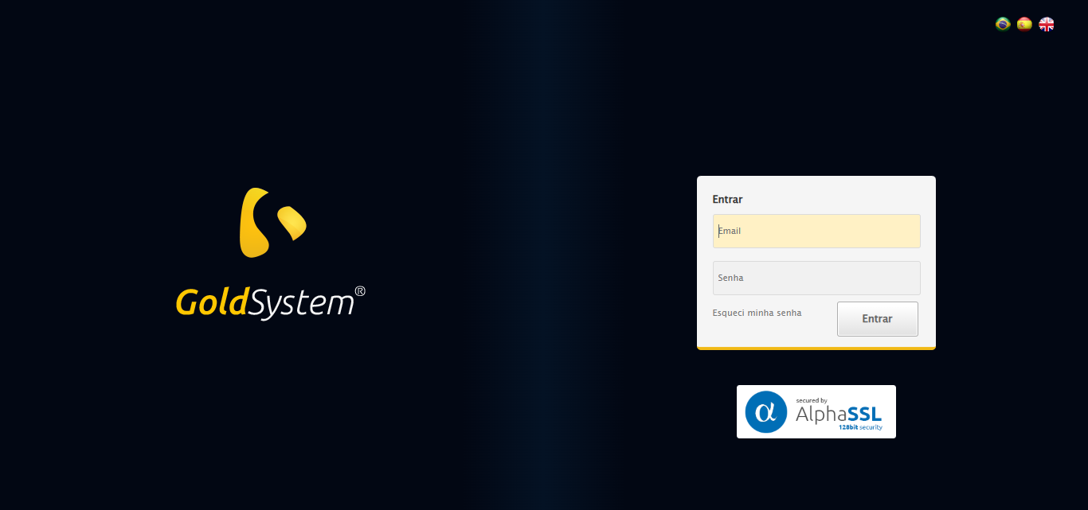

🔄 Realizando login...

✅ Realizando login realizada com sucesso.

Screenshot: realizando login

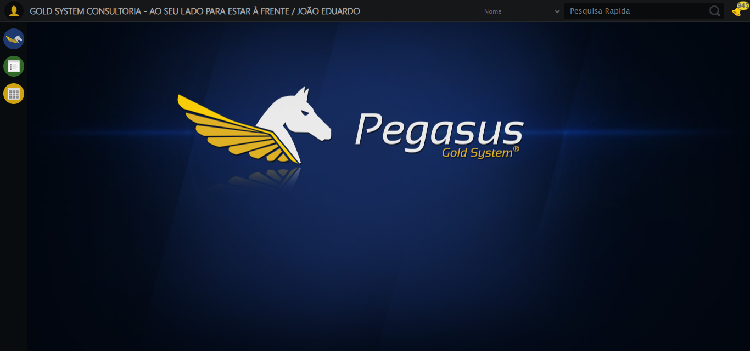

🔄 Ajustando zoom e abrindo menu...

🔍 Zoom ajustado para 90%.

✅ Ajustando zoom e abrindo menu realizada com sucesso.

Screenshot: ajustando zoom e abrindo menu

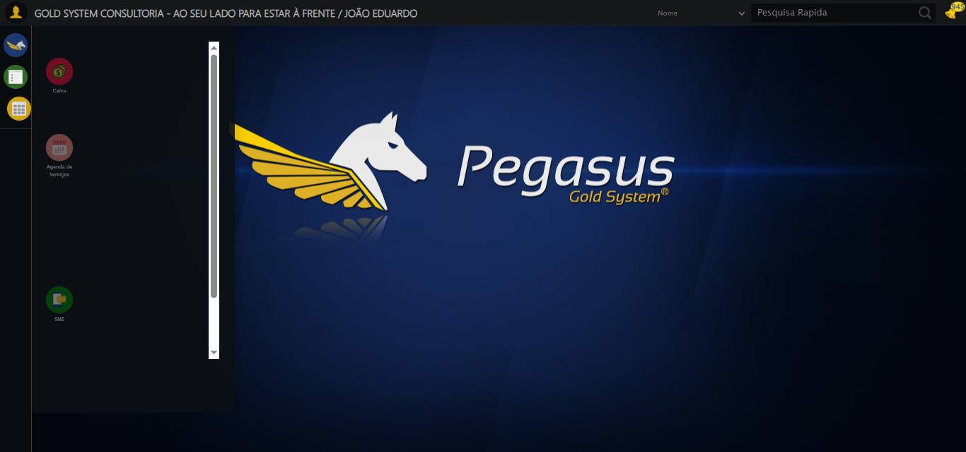

🔄 Acessando Gestor Financeiro...

✅ Acessando Gestor Financeiro realizada com sucesso.

Screenshot: acessando gestor financeiro

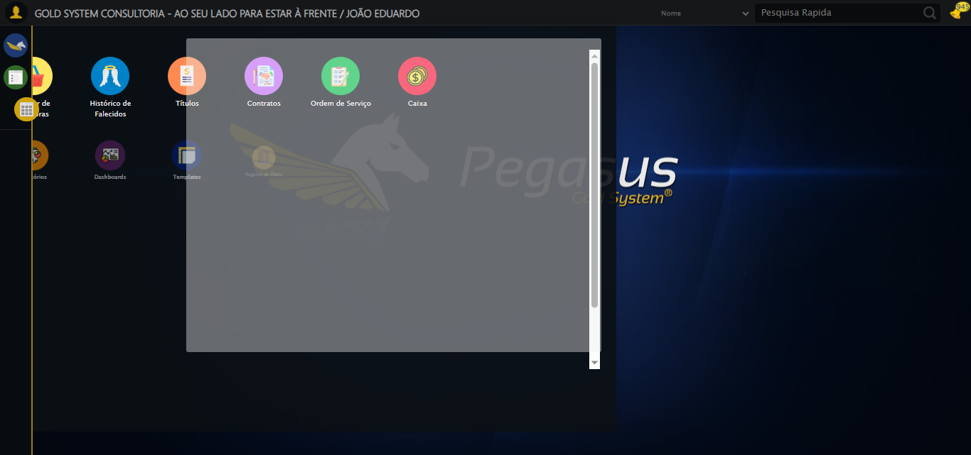

🔄 Clicando em Geração de Títulos...

✅ Clicando em Geração de Títulos realizada com sucesso.

Screenshot: clicando em geração de títulos

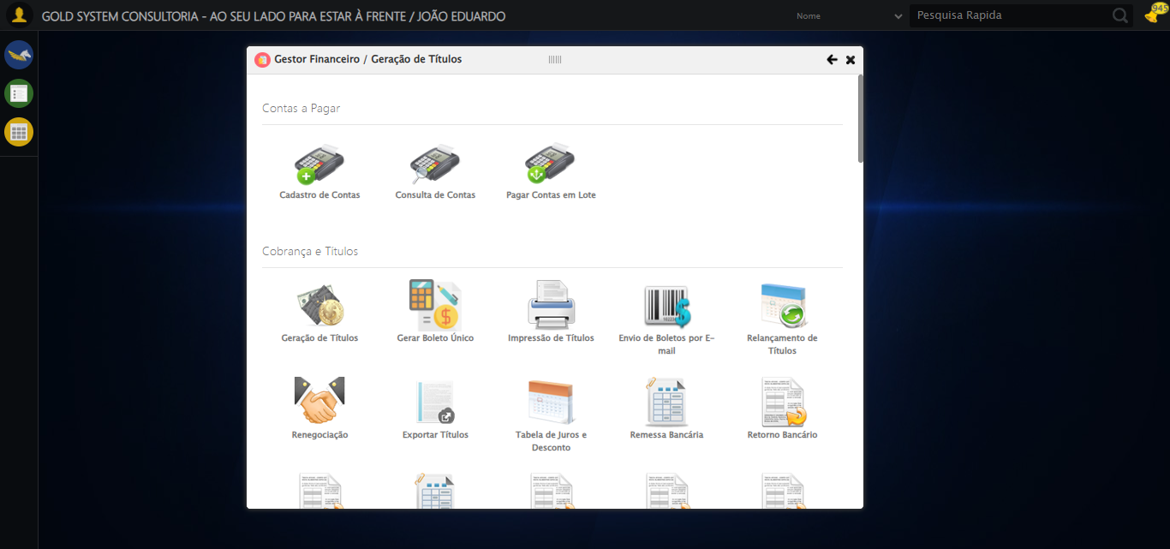

🔄 Selecionando Contratante/Titular...

⚠️ Tentativa 1/3 falhou: Índice LOV 0 inválido. Encontrados 0 botões LOV. Retentando…

⚠️ Tentativa 2/3 falhou: Índice LOV 0 inválido. Encontrados 0 botões LOV. Retentando…

❌ Erro inesperado ao selecionando contratante/titular: Índice LOV 0 inválido. Encontrados 0 botões LOV

Screenshot: erro_selecionando contratante_titular

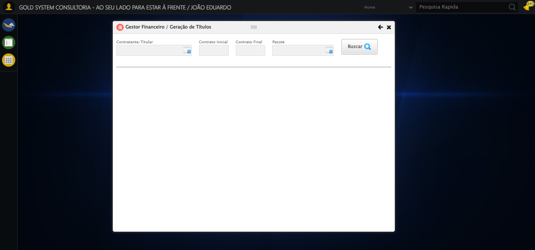

🔄 Selecionando Pacote...

⚠️ Tentativa 1/3 falhou: Índice LOV 1 inválido. Encontrados 0 botões LOV. Retentando…

⚠️ Tentativa 2/3 falhou: Índice LOV 1 inválido. Encontrados 0 botões LOV. Retentando…

❌ Erro inesperado ao selecionando pacote: Índice LOV 1 inválido. Encontrados 0 botões LOV

Screenshot: erro_selecionando pacote



🔄 Pesquisando...

✅ Pesquisando realizada com sucesso.

Screenshot: pesquisando

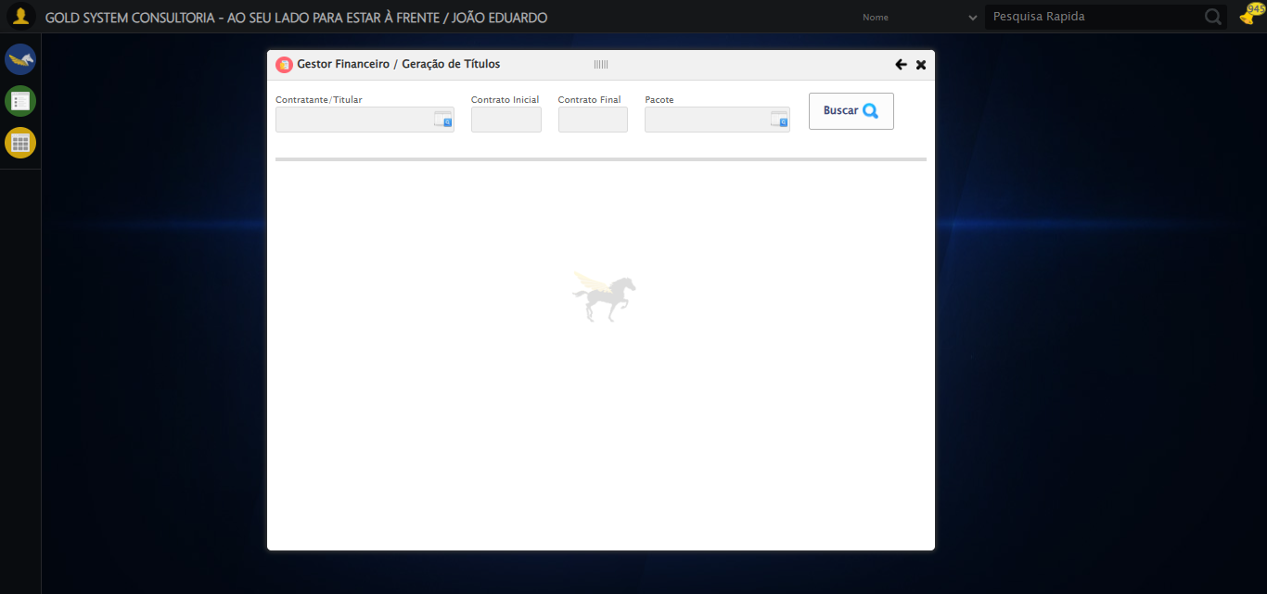

🔄 Verificando resultado da busca de Títulos...

❌ Nenhuma Título encontrada

✅ Gestor Financeiro fechado.

✅ Verificando resultado da busca de Títulos realizada com sucesso.

Screenshot: verificando resultado da busca de títulos

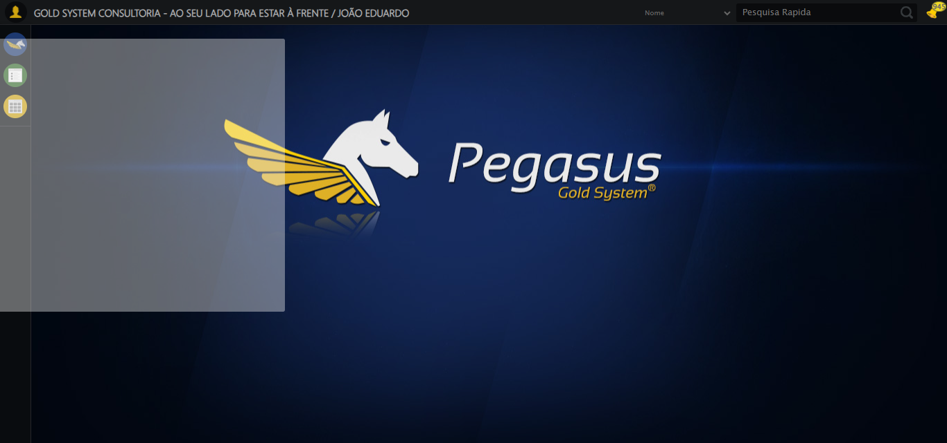

➡️ Título encontrado. Prosseguindo com as próximas ações...

🔄 Preenchendo Data Inicial...

📊 Encontrados 0 campos datepicker

❌ Erro inesperado ao preenchendo data inicial: log() takes 2 positional arguments but 3 were given

Screenshot: erro_preenchendo data inicial

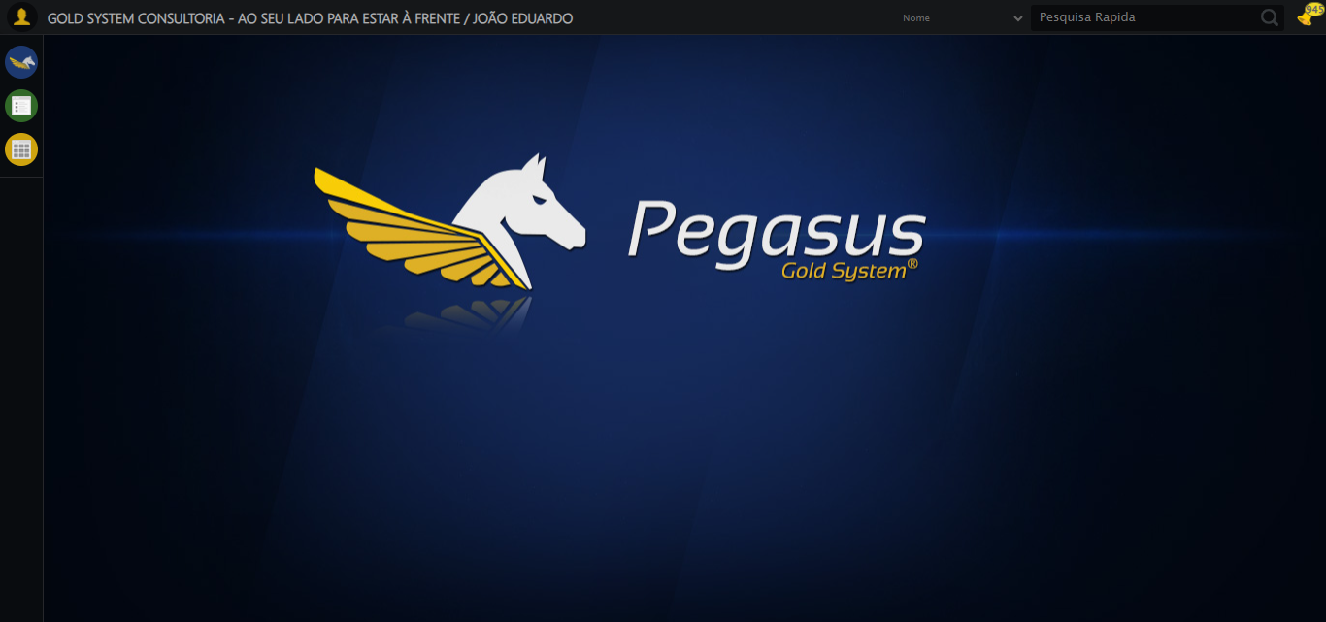

🔄 Preenchendo Data Final...

📊 Encontrados 0 campos datepicker

❌ Erro inesperado ao preenchendo data final: log() takes 2 positional arguments but 3 were given

Screenshot: erro_preenchendo data final



🔄 Preenchendo Dia de Vencimento...

⚠️ Tentativa 1 falhou: Message:

⚠️ Tentativa 2 falhou: Message: target frame detached  
 (failed to check if window was closed: disconnected: Unable to receive message from renderer)  
 (Session info: chrome=140.0.7339.208)  
Stacktrace:  
 GetHandleVerifier [0x0x52c333+65459]  
 GetHandleVerifier [0x0x52c374+65524]  
 (No symbol) [0x0x34d7c0]  
 (No symbol) [0x0x33de79]  
 (No symbol) [0x0x33cfaa]  
 (No symbol) [0x0x35b4af]  
 (No symbol) [0x0x3c0775]  
 (No symbol) [0x0x3daef9]  
 (No symbol) [0x0x3b9bf6]  
 (No symbol) [0x0x38b38e]  
 (No symbol) [0x0x38c274]  
 GetHandleVerifier [0x0x7aeda3+2697763]  
 GetHandleVerifier [0x0x7a9ec7+2677575]  
 GetHandleVerifier [0x0x554194+228884]  
 GetHandleVerifier [0x0x5449f8+165496]  
 GetHandleVerifier [0x0x54b18d+192013]  
 GetHandleVerifier [0x0x5347d8+99416]  
 GetHandleVerifier [0x0x534972+99826]  
 GetHandleVerifier [0x0x51ebea+10346]  
 BaseThreadInitThunk [0x0x755bfcc9+25]  
 RtlGetAppContainerNamedObjectPath [0x0x773a82ae+286]  
 RtlGetAppContainerNamedObjectPath [0x0x773a827e+238]

⚠️ Tentativa 3 falhou: Message: invalid session id: session deleted as the browser has closed the connection  
from disconnected: not connected to DevTools  
 (Session info: chrome=140.0.7339.208); For documentation on this error, please visit: https://www.selenium.dev/documentation/webdriver/troubleshooting/errors#invalidsessionidexception  
Stacktrace:  
 GetHandleVerifier [0x0x52c333+65459]  
 GetHandleVerifier [0x0x52c374+65524]  
 (No symbol) [0x0x34d973]  
 (No symbol) [0x0x33cdf0]  
 (No symbol) [0x0x35b4af]  
 (No symbol) [0x0x3c0775]  
 (No symbol) [0x0x3daef9]  
 (No symbol) [0x0x3b9bf6]  
 (No symbol) [0x0x38b38e]  
 (No symbol) [0x0x38c274]  
 GetHandleVerifier [0x0x7aeda3+2697763]  
 GetHandleVerifier [0x0x7a9ec7+2677575]  
 GetHandleVerifier [0x0x554194+228884]  
 GetHandleVerifier [0x0x5449f8+165496]  
 GetHandleVerifier [0x0x54b18d+192013]  
 GetHandleVerifier [0x0x5347d8+99416]  
 GetHandleVerifier [0x0x534972+99826]  
 GetHandleVerifier [0x0x51ebea+10346]  
 BaseThreadInitThunk [0x0x755bfcc9+25]  
 RtlGetAppContainerNamedObjectPath [0x0x773a82ae+286]  
 RtlGetAppContainerNamedObjectPath [0x0x773a827e+238]

✅ Preenchendo Dia de Vencimento realizada com sucesso.

⚠️ Erro ao tirar screenshot preenchendo dia de vencimento: Message: invalid session id; For documentation on this error, please visit: https://www.selenium.dev/documentation/webdriver/troubleshooting/errors#invalidsessionidexception  
Stacktrace:  
 GetHandleVerifier [0x0x52c333+65459]  
 GetHandleVerifier [0x0x52c374+65524]  
 (No symbol) [0x0x34d7c0]  
 (No symbol) [0x0x38a663]  
 (No symbol) [0x0x3b9cb6]  
 (No symbol) [0x0x3b555e]  
 (No symbol) [0x0x3b4ad3]  
 (No symbol) [0x0x31e73d]  
 (No symbol) [0x0x31ecbe]  
 (No symbol) [0x0x31f15d]  
 GetHandleVerifier [0x0x7aeda3+2697763]  
 GetHandleVerifier [0x0x7a9ec7+2677575]  
 GetHandleVerifier [0x0x554194+228884]  
 GetHandleVerifier [0x0x5449f8+165496]  
 GetHandleVerifier [0x0x54b18d+192013]  
 (No symbol) [0x0x31e3f2]  
 (No symbol) [0x0x31db72]  
 GetHandleVerifier [0x0x90340c+4092044]  
 BaseThreadInitThunk [0x0x755bfcc9+25]  
 RtlGetAppContainerNamedObjectPath [0x0x773a82ae+286]  
 RtlGetAppContainerNamedObjectPath [0x0x773a827e+238]

🔄 Preenchendo Quantidade de Parcelas...

⚠️ Tentativa 1 falhou: Message: invalid session id; For documentation on this error, please visit: https://www.selenium.dev/documentation/webdriver/troubleshooting/errors#invalidsessionidexception  
Stacktrace:  
 GetHandleVerifier [0x0x52c333+65459]  
 GetHandleVerifier [0x0x52c374+65524]  
 (No symbol) [0x0x34d7c0]  
 (No symbol) [0x0x38a663]  
 (No symbol) [0x0x3b9cb6]  
 (No symbol) [0x0x3b555e]  
 (No symbol) [0x0x3b4ad3]  
 (No symbol) [0x0x31e73d]  
 (No symbol) [0x0x31ecbe]  
 (No symbol) [0x0x31f15d]  
 GetHandleVerifier [0x0x7aeda3+2697763]  
 GetHandleVerifier [0x0x7a9ec7+2677575]  
 GetHandleVerifier [0x0x554194+228884]  
 GetHandleVerifier [0x0x5449f8+165496]  
 GetHandleVerifier [0x0x54b18d+192013]  
 (No symbol) [0x0x31e3f2]  
 (No symbol) [0x0x31db72]  
 GetHandleVerifier [0x0x90340c+4092044]  
 BaseThreadInitThunk [0x0x755bfcc9+25]  
 RtlGetAppContainerNamedObjectPath [0x0x773a82ae+286]  
 RtlGetAppContainerNamedObjectPath [0x0x773a827e+238]

⚠️ Tentativa 2 falhou: Message: invalid session id; For documentation on this error, please visit: https://www.selenium.dev/documentation/webdriver/troubleshooting/errors#invalidsessionidexception  
Stacktrace:  
 GetHandleVerifier [0x0x52c333+65459]  
 GetHandleVerifier [0x0x52c374+65524]  
 (No symbol) [0x0x34d7c0]  
 (No symbol) [0x0x38a663]  
 (No symbol) [0x0x3b9cb6]  
 (No symbol) [0x0x3b555e]  
 (No symbol) [0x0x3b4ad3]  
 (No symbol) [0x0x31e73d]  
 (No symbol) [0x0x31ecbe]  
 (No symbol) [0x0x31f15d]  
 GetHandleVerifier [0x0x7aeda3+2697763]  
 GetHandleVerifier [0x0x7a9ec7+2677575]  
 GetHandleVerifier [0x0x554194+228884]  
 GetHandleVerifier [0x0x5449f8+165496]  
 GetHandleVerifier [0x0x54b18d+192013]  
 (No symbol) [0x0x31e3f2]  
 (No symbol) [0x0x31db72]  
 GetHandleVerifier [0x0x90340c+4092044]  
 BaseThreadInitThunk [0x0x755bfcc9+25]  
 RtlGetAppContainerNamedObjectPath [0x0x773a82ae+286]  
 RtlGetAppContainerNamedObjectPath [0x0x773a827e+238]

⚠️ Tentativa 3 falhou: Message: invalid session id; For documentation on this error, please visit: https://www.selenium.dev/documentation/webdriver/troubleshooting/errors#invalidsessionidexception  
Stacktrace:  
 GetHandleVerifier [0x0x52c333+65459]  
 GetHandleVerifier [0x0x52c374+65524]  
 (No symbol) [0x0x34d7c0]  
 (No symbol) [0x0x38a663]  
 (No symbol) [0x0x3b9cb6]  
 (No symbol) [0x0x3b555e]  
 (No symbol) [0x0x3b4ad3]  
 (No symbol) [0x0x31e73d]  
 (No symbol) [0x0x31ecbe]  
 (No symbol) [0x0x31f15d]  
 GetHandleVerifier [0x0x7aeda3+2697763]  
 GetHandleVerifier [0x0x7a9ec7+2677575]  
 GetHandleVerifier [0x0x554194+228884]  
 GetHandleVerifier [0x0x5449f8+165496]  
 GetHandleVerifier [0x0x54b18d+192013]  
 (No symbol) [0x0x31e3f2]  
 (No symbol) [0x0x31db72]  
 GetHandleVerifier [0x0x90340c+4092044]  
 BaseThreadInitThunk [0x0x755bfcc9+25]  
 RtlGetAppContainerNamedObjectPath [0x0x773a82ae+286]  
 RtlGetAppContainerNamedObjectPath [0x0x773a827e+238]

✅ Preenchendo Quantidade de Parcelas realizada com sucesso.

⚠️ Erro ao tirar screenshot preenchendo quantidade de parcelas: Message: invalid session id; For documentation on this error, please visit: https://www.selenium.dev/documentation/webdriver/troubleshooting/errors#invalidsessionidexception  
Stacktrace:  
 GetHandleVerifier [0x0x52c333+65459]  
 GetHandleVerifier [0x0x52c374+65524]  
 (No symbol) [0x0x34d7c0]  
 (No symbol) [0x0x38a663]  
 (No symbol) [0x0x3b9cb6]  
 (No symbol) [0x0x3b555e]  
 (No symbol) [0x0x3b4ad3]  
 (No symbol) [0x0x31e73d]  
 (No symbol) [0x0x31ecbe]  
 (No symbol) [0x0x31f15d]  
 GetHandleVerifier [0x0x7aeda3+2697763]  
 GetHandleVerifier [0x0x7a9ec7+2677575]  
 GetHandleVerifier [0x0x554194+228884]  
 GetHandleVerifier [0x0x5449f8+165496]  
 GetHandleVerifier [0x0x54b18d+192013]  
 (No symbol) [0x0x31e3f2]  
 (No symbol) [0x0x31db72]  
 GetHandleVerifier [0x0x90340c+4092044]  
 BaseThreadInitThunk [0x0x755bfcc9+25]  
 RtlGetAppContainerNamedObjectPath [0x0x773a82ae+286]  
 RtlGetAppContainerNamedObjectPath [0x0x773a827e+238]

🔄 Preenchendo Valor das Parcelas...

⚠️ Tentativa 1 falhou: Message: invalid session id; For documentation on this error, please visit: https://www.selenium.dev/documentation/webdriver/troubleshooting/errors#invalidsessionidexception  
Stacktrace:  
 GetHandleVerifier [0x0x52c333+65459]  
 GetHandleVerifier [0x0x52c374+65524]  
 (No symbol) [0x0x34d7c0]  
 (No symbol) [0x0x38a663]  
 (No symbol) [0x0x3b9cb6]  
 (No symbol) [0x0x3b555e]  
 (No symbol) [0x0x3b4ad3]  
 (No symbol) [0x0x31e73d]  
 (No symbol) [0x0x31ecbe]  
 (No symbol) [0x0x31f15d]  
 GetHandleVerifier [0x0x7aeda3+2697763]  
 GetHandleVerifier [0x0x7a9ec7+2677575]  
 GetHandleVerifier [0x0x554194+228884]  
 GetHandleVerifier [0x0x5449f8+165496]  
 GetHandleVerifier [0x0x54b18d+192013]  
 (No symbol) [0x0x31e3f2]  
 (No symbol) [0x0x31db72]  
 GetHandleVerifier [0x0x90340c+4092044]  
 BaseThreadInitThunk [0x0x755bfcc9+25]  
 RtlGetAppContainerNamedObjectPath [0x0x773a82ae+286]  
 RtlGetAppContainerNamedObjectPath [0x0x773a827e+238]

⚠️ Tentativa 2 falhou: Message: invalid session id; For documentation on this error, please visit: https://www.selenium.dev/documentation/webdriver/troubleshooting/errors#invalidsessionidexception  
Stacktrace:  
 GetHandleVerifier [0x0x52c333+65459]  
 GetHandleVerifier [0x0x52c374+65524]  
 (No symbol) [0x0x34d7c0]  
 (No symbol) [0x0x38a663]  
 (No symbol) [0x0x3b9cb6]  
 (No symbol) [0x0x3b555e]  
 (No symbol) [0x0x3b4ad3]  
 (No symbol) [0x0x31e73d]  
 (No symbol) [0x0x31ecbe]  
 (No symbol) [0x0x31f15d]  
 GetHandleVerifier [0x0x7aeda3+2697763]  
 GetHandleVerifier [0x0x7a9ec7+2677575]  
 GetHandleVerifier [0x0x554194+228884]  
 GetHandleVerifier [0x0x5449f8+165496]  
 GetHandleVerifier [0x0x54b18d+192013]  
 (No symbol) [0x0x31e3f2]  
 (No symbol) [0x0x31db72]  
 GetHandleVerifier [0x0x90340c+4092044]  
 BaseThreadInitThunk [0x0x755bfcc9+25]  
 RtlGetAppContainerNamedObjectPath [0x0x773a82ae+286]  
 RtlGetAppContainerNamedObjectPath [0x0x773a827e+238]

⚠️ Tentativa 3 falhou: Message: invalid session id; For documentation on this error, please visit: https://www.selenium.dev/documentation/webdriver/troubleshooting/errors#invalidsessionidexception  
Stacktrace:  
 GetHandleVerifier [0x0x52c333+65459]  
 GetHandleVerifier [0x0x52c374+65524]  
 (No symbol) [0x0x34d7c0]  
 (No symbol) [0x0x38a663]  
 (No symbol) [0x0x3b9cb6]  
 (No symbol) [0x0x3b555e]  
 (No symbol) [0x0x3b4ad3]  
 (No symbol) [0x0x31e73d]  
 (No symbol) [0x0x31ecbe]  
 (No symbol) [0x0x31f15d]  
 GetHandleVerifier [0x0x7aeda3+2697763]  
 GetHandleVerifier [0x0x7a9ec7+2677575]  
 GetHandleVerifier [0x0x554194+228884]  
 GetHandleVerifier [0x0x5449f8+165496]  
 GetHandleVerifier [0x0x54b18d+192013]  
 (No symbol) [0x0x31e3f2]  
 (No symbol) [0x0x31db72]  
 GetHandleVerifier [0x0x90340c+4092044]  
 BaseThreadInitThunk [0x0x755bfcc9+25]  
 RtlGetAppContainerNamedObjectPath [0x0x773a82ae+286]  
 RtlGetAppContainerNamedObjectPath [0x0x773a827e+238]

✅ Preenchendo Valor das Parcelas realizada com sucesso.

⚠️ Erro ao tirar screenshot preenchendo valor das parcelas: Message: invalid session id; For documentation on this error, please visit: https://www.selenium.dev/documentation/webdriver/troubleshooting/errors#invalidsessionidexception  
Stacktrace:  
 GetHandleVerifier [0x0x52c333+65459]  
 GetHandleVerifier [0x0x52c374+65524]  
 (No symbol) [0x0x34d7c0]  
 (No symbol) [0x0x38a663]  
 (No symbol) [0x0x3b9cb6]  
 (No symbol) [0x0x3b555e]  
 (No symbol) [0x0x3b4ad3]  
 (No symbol) [0x0x31e73d]  
 (No symbol) [0x0x31ecbe]  
 (No symbol) [0x0x31f15d]  
 GetHandleVerifier [0x0x7aeda3+2697763]  
 GetHandleVerifier [0x0x7a9ec7+2677575]  
 GetHandleVerifier [0x0x554194+228884]  
 GetHandleVerifier [0x0x5449f8+165496]  
 GetHandleVerifier [0x0x54b18d+192013]  
 (No symbol) [0x0x31e3f2]  
 (No symbol) [0x0x31db72]  
 GetHandleVerifier [0x0x90340c+4092044]  
 BaseThreadInitThunk [0x0x755bfcc9+25]  
 RtlGetAppContainerNamedObjectPath [0x0x773a82ae+286]  
 RtlGetAppContainerNamedObjectPath [0x0x773a827e+238]

🔄 Selecionando Tipo de Mensalidade...

⚠️ Tentativa 1/3 falhou: Message: invalid session id; For documentation on this error, please visit: https://www.selenium.dev/documentation/webdriver/troubleshooting/errors#invalidsessionidexception  
Stacktrace:  
 GetHandleVerifier [0x0x52c333+65459]  
 GetHandleVerifier [0x0x52c374+65524]  
 (No symbol) [0x0x34d7c0]  
 (No symbol) [0x0x38a663]  
 (No symbol) [0x0x3b9cb6]  
 (No symbol) [0x0x3b555e]  
 (No symbol) [0x0x3b4ad3]  
 (No symbol) [0x0x31e73d]  
 (No symbol) [0x0x31ecbe]  
 (No symbol) [0x0x31f15d]  
 GetHandleVerifier [0x0x7aeda3+2697763]  
 GetHandleVerifier [0x0x7a9ec7+2677575]  
 GetHandleVerifier [0x0x554194+228884]  
 GetHandleVerifier [0x0x5449f8+165496]  
 GetHandleVerifier [0x0x54b18d+192013]  
 (No symbol) [0x0x31e3f2]  
 (No symbol) [0x0x31db72]  
 GetHandleVerifier [0x0x90340c+4092044]  
 BaseThreadInitThunk [0x0x755bfcc9+25]  
 RtlGetAppContainerNamedObjectPath [0x0x773a82ae+286]  
 RtlGetAppContainerNamedObjectPath [0x0x773a827e+238]  
. Retentando…

⚠️ Tentativa 2/3 falhou: Message: invalid session id; For documentation on this error, please visit: https://www.selenium.dev/documentation/webdriver/troubleshooting/errors#invalidsessionidexception  
Stacktrace:  
 GetHandleVerifier [0x0x52c333+65459]  
 GetHandleVerifier [0x0x52c374+65524]  
 (No symbol) [0x0x34d7c0]  
 (No symbol) [0x0x38a663]  
 (No symbol) [0x0x3b9cb6]  
 (No symbol) [0x0x3b555e]  
 (No symbol) [0x0x3b4ad3]  
 (No symbol) [0x0x31e73d]  
 (No symbol) [0x0x31ecbe]  
 (No symbol) [0x0x31f15d]  
 GetHandleVerifier [0x0x7aeda3+2697763]  
 GetHandleVerifier [0x0x7a9ec7+2677575]  
 GetHandleVerifier [0x0x554194+228884]  
 GetHandleVerifier [0x0x5449f8+165496]  
 GetHandleVerifier [0x0x54b18d+192013]  
 (No symbol) [0x0x31e3f2]  
 (No symbol) [0x0x31db72]  
 GetHandleVerifier [0x0x90340c+4092044]  
 BaseThreadInitThunk [0x0x755bfcc9+25]  
 RtlGetAppContainerNamedObjectPath [0x0x773a82ae+286]  
 RtlGetAppContainerNamedObjectPath [0x0x773a827e+238]  
. Retentando…

❌ Erro inesperado ao selecionando tipo de mensalidade: Message: invalid session id; For documentation on this error, please visit: https://www.selenium.dev/documentation/webdriver/troubleshooting/errors#invalidsessionidexception  
Stacktrace:  
 GetHandleVerifier [0x0x52c333+65459]  
 GetHandleVerifier [0x0x52c374+65524]  
 (No symbol) [0x0x34d7c0]  
 (No symbol) [0x0x38a663]  
 (No symbol) [0x0x3b9cb6]  
 (No symbol) [0x0x3b555e]  
 (No symbol) [0x0x3b4ad3]  
 (No symbol) [0x0x31e73d]  
 (No symbol) [0x0x31ecbe]  
 (No symbol) [0x0x31f15d]  
 GetHandleVerifier [0x0x7aeda3+2697763]  
 GetHandleVerifier [0x0x7a9ec7+2677575]  
 GetHandleVerifier [0x0x554194+228884]  
 GetHandleVerifier [0x0x5449f8+165496]  
 GetHandleVerifier [0x0x54b18d+192013]  
 (No symbol) [0x0x31e3f2]  
 (No symbol) [0x0x31db72]  
 GetHandleVerifier [0x0x90340c+4092044]  
 BaseThreadInitThunk [0x0x755bfcc9+25]  
 RtlGetAppContainerNamedObjectPath [0x0x773a82ae+286]  
 RtlGetAppContainerNamedObjectPath [0x0x773a827e+238]

⚠️ Erro ao tirar screenshot erro_selecionando tipo de mensalidade: Message: invalid session id; For documentation on this error, please visit: https://www.selenium.dev/documentation/webdriver/troubleshooting/errors#invalidsessionidexception  
Stacktrace:  
 GetHandleVerifier [0x0x52c333+65459]  
 GetHandleVerifier [0x0x52c374+65524]  
 (No symbol) [0x0x34d7c0]  
 (No symbol) [0x0x38a663]  
 (No symbol) [0x0x3b9cb6]  
 (No symbol) [0x0x3b555e]  
 (No symbol) [0x0x3b4ad3]  
 (No symbol) [0x0x31e73d]  
 (No symbol) [0x0x31ecbe]  
 (No symbol) [0x0x31f15d]  
 GetHandleVerifier [0x0x7aeda3+2697763]  
 GetHandleVerifier [0x0x7a9ec7+2677575]  
 GetHandleVerifier [0x0x554194+228884]  
 GetHandleVerifier [0x0x5449f8+165496]  
 GetHandleVerifier [0x0x54b18d+192013]  
 (No symbol) [0x0x31e3f2]  
 (No symbol) [0x0x31db72]  
 GetHandleVerifier [0x0x90340c+4092044]  
 BaseThreadInitThunk [0x0x755bfcc9+25]  
 RtlGetAppContainerNamedObjectPath [0x0x773a82ae+286]  
 RtlGetAppContainerNamedObjectPath [0x0x773a827e+238]

🔄 Marcando checkbox: Ano de vencimento/competência do título...

❌ Erro inesperado ao marcando checkbox: ano de vencimento/competência do título: Message: invalid session id; For documentation on this error, please visit: https://www.selenium.dev/documentation/webdriver/troubleshooting/errors#invalidsessionidexception  
Stacktrace:  
 GetHandleVerifier [0x0x52c333+65459]  
 GetHandleVerifier [0x0x52c374+65524]  
 (No symbol) [0x0x34d7c0]  
 (No symbol) [0x0x38a663]  
 (No symbol) [0x0x3b9cb6]  
 (No symbol) [0x0x3b555e]  
 (No symbol) [0x0x3b4ad3]  
 (No symbol) [0x0x31e73d]  
 (No symbol) [0x0x31ecbe]  
 (No symbol) [0x0x31f15d]  
 GetHandleVerifier [0x0x7aeda3+2697763]  
 GetHandleVerifier [0x0x7a9ec7+2677575]  
 GetHandleVerifier [0x0x554194+228884]  
 GetHandleVerifier [0x0x5449f8+165496]  
 GetHandleVerifier [0x0x54b18d+192013]  
 (No symbol) [0x0x31e3f2]  
 (No symbol) [0x0x31db72]  
 GetHandleVerifier [0x0x90340c+4092044]  
 BaseThreadInitThunk [0x0x755bfcc9+25]  
 RtlGetAppContainerNamedObjectPath [0x0x773a82ae+286]  
 RtlGetAppContainerNamedObjectPath [0x0x773a827e+238]

⚠️ Erro ao tirar screenshot erro_marcando checkbox_ ano de vencimento_competência do título: Message: invalid session id; For documentation on this error, please visit: https://www.selenium.dev/documentation/webdriver/troubleshooting/errors#invalidsessionidexception  
Stacktrace:  
 GetHandleVerifier [0x0x52c333+65459]  
 GetHandleVerifier [0x0x52c374+65524]  
 (No symbol) [0x0x34d7c0]  
 (No symbol) [0x0x38a663]  
 (No symbol) [0x0x3b9cb6]  
 (No symbol) [0x0x3b555e]  
 (No symbol) [0x0x3b4ad3]  
 (No symbol) [0x0x31e73d]  
 (No symbol) [0x0x31ecbe]  
 (No symbol) [0x0x31f15d]  
 GetHandleVerifier [0x0x7aeda3+2697763]  
 GetHandleVerifier [0x0x7a9ec7+2677575]  
 GetHandleVerifier [0x0x554194+228884]  
 GetHandleVerifier [0x0x5449f8+165496]  
 GetHandleVerifier [0x0x54b18d+192013]  
 (No symbol) [0x0x31e3f2]  
 (No symbol) [0x0x31db72]  
 GetHandleVerifier [0x0x90340c+4092044]  
 BaseThreadInitThunk [0x0x755bfcc9+25]  
 RtlGetAppContainerNamedObjectPath [0x0x773a82ae+286]  
 RtlGetAppContainerNamedObjectPath [0x0x773a827e+238]

🔄 Preenchendo Ano Competência...

⚠️ Tentativa 1 falhou: Message: invalid session id; For documentation on this error, please visit: https://www.selenium.dev/documentation/webdriver/troubleshooting/errors#invalidsessionidexception  
Stacktrace:  
 GetHandleVerifier [0x0x52c333+65459]  
 GetHandleVerifier [0x0x52c374+65524]  
 (No symbol) [0x0x34d7c0]  
 (No symbol) [0x0x38a663]  
 (No symbol) [0x0x3b9cb6]  
 (No symbol) [0x0x3b555e]  
 (No symbol) [0x0x3b4ad3]  
 (No symbol) [0x0x31e73d]  
 (No symbol) [0x0x31ecbe]  
 (No symbol) [0x0x31f15d]  
 GetHandleVerifier [0x0x7aeda3+2697763]  
 GetHandleVerifier [0x0x7a9ec7+2677575]  
 GetHandleVerifier [0x0x554194+228884]  
 GetHandleVerifier [0x0x5449f8+165496]  
 GetHandleVerifier [0x0x54b18d+192013]  
 (No symbol) [0x0x31e3f2]  
 (No symbol) [0x0x31db72]  
 GetHandleVerifier [0x0x90340c+4092044]  
 BaseThreadInitThunk [0x0x755bfcc9+25]  
 RtlGetAppContainerNamedObjectPath [0x0x773a82ae+286]  
 RtlGetAppContainerNamedObjectPath [0x0x773a827e+238]

⚠️ Tentativa 2 falhou: Message: invalid session id; For documentation on this error, please visit: https://www.selenium.dev/documentation/webdriver/troubleshooting/errors#invalidsessionidexception  
Stacktrace:  
 GetHandleVerifier [0x0x52c333+65459]  
 GetHandleVerifier [0x0x52c374+65524]  
 (No symbol) [0x0x34d7c0]  
 (No symbol) [0x0x38a663]  
 (No symbol) [0x0x3b9cb6]  
 (No symbol) [0x0x3b555e]  
 (No symbol) [0x0x3b4ad3]  
 (No symbol) [0x0x31e73d]  
 (No symbol) [0x0x31ecbe]  
 (No symbol) [0x0x31f15d]  
 GetHandleVerifier [0x0x7aeda3+2697763]  
 GetHandleVerifier [0x0x7a9ec7+2677575]  
 GetHandleVerifier [0x0x554194+228884]  
 GetHandleVerifier [0x0x5449f8+165496]  
 GetHandleVerifier [0x0x54b18d+192013]  
 (No symbol) [0x0x31e3f2]  
 (No symbol) [0x0x31db72]  
 GetHandleVerifier [0x0x90340c+4092044]  
 BaseThreadInitThunk [0x0x755bfcc9+25]  
 RtlGetAppContainerNamedObjectPath [0x0x773a82ae+286]  
 RtlGetAppContainerNamedObjectPath [0x0x773a827e+238]

⚠️ Tentativa 3 falhou: Message: invalid session id; For documentation on this error, please visit: https://www.selenium.dev/documentation/webdriver/troubleshooting/errors#invalidsessionidexception  
Stacktrace:  
 GetHandleVerifier [0x0x52c333+65459]  
 GetHandleVerifier [0x0x52c374+65524]  
 (No symbol) [0x0x34d7c0]  
 (No symbol) [0x0x38a663]  
 (No symbol) [0x0x3b9cb6]  
 (No symbol) [0x0x3b555e]  
 (No symbol) [0x0x3b4ad3]  
 (No symbol) [0x0x31e73d]  
 (No symbol) [0x0x31ecbe]  
 (No symbol) [0x0x31f15d]  
 GetHandleVerifier [0x0x7aeda3+2697763]  
 GetHandleVerifier [0x0x7a9ec7+2677575]  
 GetHandleVerifier [0x0x554194+228884]  
 GetHandleVerifier [0x0x5449f8+165496]  
 GetHandleVerifier [0x0x54b18d+192013]  
 (No symbol) [0x0x31e3f2]  
 (No symbol) [0x0x31db72]  
 GetHandleVerifier [0x0x90340c+4092044]  
 BaseThreadInitThunk [0x0x755bfcc9+25]  
 RtlGetAppContainerNamedObjectPath [0x0x773a82ae+286]  
 RtlGetAppContainerNamedObjectPath [0x0x773a827e+238]

✅ Preenchendo Ano Competência realizada com sucesso.

⚠️ Erro ao tirar screenshot preenchendo ano competência: Message: invalid session id; For documentation on this error, please visit: https://www.selenium.dev/documentation/webdriver/troubleshooting/errors#invalidsessionidexception  
Stacktrace:  
 GetHandleVerifier [0x0x52c333+65459]  
 GetHandleVerifier [0x0x52c374+65524]  
 (No symbol) [0x0x34d7c0]  
 (No symbol) [0x0x38a663]  
 (No symbol) [0x0x3b9cb6]  
 (No symbol) [0x0x3b555e]  
 (No symbol) [0x0x3b4ad3]  
 (No symbol) [0x0x31e73d]  
 (No symbol) [0x0x31ecbe]  
 (No symbol) [0x0x31f15d]  
 GetHandleVerifier [0x0x7aeda3+2697763]  
 GetHandleVerifier [0x0x7a9ec7+2677575]  
 GetHandleVerifier [0x0x554194+228884]  
 GetHandleVerifier [0x0x5449f8+165496]  
 GetHandleVerifier [0x0x54b18d+192013]  
 (No symbol) [0x0x31e3f2]  
 (No symbol) [0x0x31db72]  
 GetHandleVerifier [0x0x90340c+4092044]  
 BaseThreadInitThunk [0x0x755bfcc9+25]  
 RtlGetAppContainerNamedObjectPath [0x0x773a82ae+286]  
 RtlGetAppContainerNamedObjectPath [0x0x773a827e+238]

🔄 Clicando em 'Gerar'...

❌ Erro inesperado ao clicando em 'gerar': Message: invalid session id; For documentation on this error, please visit: https://www.selenium.dev/documentation/webdriver/troubleshooting/errors#invalidsessionidexception  
Stacktrace:  
 GetHandleVerifier [0x0x52c333+65459]  
 GetHandleVerifier [0x0x52c374+65524]  
 (No symbol) [0x0x34d7c0]  
 (No symbol) [0x0x38a663]  
 (No symbol) [0x0x3b9cb6]  
 (No symbol) [0x0x3b555e]  
 (No symbol) [0x0x3b4ad3]  
 (No symbol) [0x0x31e73d]  
 (No symbol) [0x0x31ecbe]  
 (No symbol) [0x0x31f15d]  
 GetHandleVerifier [0x0x7aeda3+2697763]  
 GetHandleVerifier [0x0x7a9ec7+2677575]  
 GetHandleVerifier [0x0x554194+228884]  
 GetHandleVerifier [0x0x5449f8+165496]  
 GetHandleVerifier [0x0x54b18d+192013]  
 (No symbol) [0x0x31e3f2]  
 (No symbol) [0x0x31db72]  
 GetHandleVerifier [0x0x90340c+4092044]  
 BaseThreadInitThunk [0x0x755bfcc9+25]  
 RtlGetAppContainerNamedObjectPath [0x0x773a82ae+286]  
 RtlGetAppContainerNamedObjectPath [0x0x773a827e+238]

⚠️ Erro ao tirar screenshot erro_clicando em _gerar_: Message: invalid session id; For documentation on this error, please visit: https://www.selenium.dev/documentation/webdriver/troubleshooting/errors#invalidsessionidexception  
Stacktrace:  
 GetHandleVerifier [0x0x52c333+65459]  
 GetHandleVerifier [0x0x52c374+65524]  
 (No symbol) [0x0x34d7c0]  
 (No symbol) [0x0x38a663]  
 (No symbol) [0x0x3b9cb6]  
 (No symbol) [0x0x3b555e]  
 (No symbol) [0x0x3b4ad3]  
 (No symbol) [0x0x31e73d]  
 (No symbol) [0x0x31ecbe]  
 (No symbol) [0x0x31f15d]  
 GetHandleVerifier [0x0x7aeda3+2697763]  
 GetHandleVerifier [0x0x7a9ec7+2677575]  
 GetHandleVerifier [0x0x554194+228884]  
 GetHandleVerifier [0x0x5449f8+165496]  
 GetHandleVerifier [0x0x54b18d+192013]  
 (No symbol) [0x0x31e3f2]  
 (No symbol) [0x0x31db72]  
 GetHandleVerifier [0x0x90340c+4092044]  
 BaseThreadInitThunk [0x0x755bfcc9+25]  
 RtlGetAppContainerNamedObjectPath [0x0x773a82ae+286]  
 RtlGetAppContainerNamedObjectPath [0x0x773a827e+238]

🔄 Clicando em 'Gerar'...

❌ Erro inesperado ao clicando em 'gerar': Message: invalid session id; For documentation on this error, please visit: https://www.selenium.dev/documentation/webdriver/troubleshooting/errors#invalidsessionidexception  
Stacktrace:  
 GetHandleVerifier [0x0x52c333+65459]  
 GetHandleVerifier [0x0x52c374+65524]  
 (No symbol) [0x0x34d7c0]  
 (No symbol) [0x0x38a663]  
 (No symbol) [0x0x3b9cb6]  
 (No symbol) [0x0x3b555e]  
 (No symbol) [0x0x3b4ad3]  
 (No symbol) [0x0x31e73d]  
 (No symbol) [0x0x31ecbe]  
 (No symbol) [0x0x31f15d]  
 GetHandleVerifier [0x0x7aeda3+2697763]  
 GetHandleVerifier [0x0x7a9ec7+2677575]  
 GetHandleVerifier [0x0x554194+228884]  
 GetHandleVerifier [0x0x5449f8+165496]  
 GetHandleVerifier [0x0x54b18d+192013]  
 (No symbol) [0x0x31e3f2]  
 (No symbol) [0x0x31db72]  
 GetHandleVerifier [0x0x90340c+4092044]  
 BaseThreadInitThunk [0x0x755bfcc9+25]  
 RtlGetAppContainerNamedObjectPath [0x0x773a82ae+286]  
 RtlGetAppContainerNamedObjectPath [0x0x773a827e+238]

⚠️ Erro ao tirar screenshot erro_clicando em _gerar_: Message: invalid session id; For documentation on this error, please visit: https://www.selenium.dev/documentation/webdriver/troubleshooting/errors#invalidsessionidexception  
Stacktrace:  
 GetHandleVerifier [0x0x52c333+65459]  
 GetHandleVerifier [0x0x52c374+65524]  
 (No symbol) [0x0x34d7c0]  
 (No symbol) [0x0x38a663]  
 (No symbol) [0x0x3b9cb6]  
 (No symbol) [0x0x3b555e]  
 (No symbol) [0x0x3b4ad3]  
 (No symbol) [0x0x31e73d]  
 (No symbol) [0x0x31ecbe]  
 (No symbol) [0x0x31f15d]  
 GetHandleVerifier [0x0x7aeda3+2697763]  
 GetHandleVerifier [0x0x7a9ec7+2677575]  
 GetHandleVerifier [0x0x554194+228884]  
 GetHandleVerifier [0x0x5449f8+165496]  
 GetHandleVerifier [0x0x54b18d+192013]  
 (No symbol) [0x0x31e3f2]  
 (No symbol) [0x0x31db72]  
 GetHandleVerifier [0x0x90340c+4092044]  
 BaseThreadInitThunk [0x0x755bfcc9+25]  
 RtlGetAppContainerNamedObjectPath [0x0x773a82ae+286]  
 RtlGetAppContainerNamedObjectPath [0x0x773a827e+238]

🔄 Confirmando...

❌ Erro inesperado ao confirmando: Message: invalid session id; For documentation on this error, please visit: https://www.selenium.dev/documentation/webdriver/troubleshooting/errors#invalidsessionidexception  
Stacktrace:  
 GetHandleVerifier [0x0x52c333+65459]  
 GetHandleVerifier [0x0x52c374+65524]  
 (No symbol) [0x0x34d7c0]  
 (No symbol) [0x0x38a663]  
 (No symbol) [0x0x3b9cb6]  
 (No symbol) [0x0x3b555e]  
 (No symbol) [0x0x3b4ad3]  
 (No symbol) [0x0x31e73d]  
 (No symbol) [0x0x31ecbe]  
 (No symbol) [0x0x31f15d]  
 GetHandleVerifier [0x0x7aeda3+2697763]  
 GetHandleVerifier [0x0x7a9ec7+2677575]  
 GetHandleVerifier [0x0x554194+228884]  
 GetHandleVerifier [0x0x5449f8+165496]  
 GetHandleVerifier [0x0x54b18d+192013]  
 (No symbol) [0x0x31e3f2]  
 (No symbol) [0x0x31db72]  
 GetHandleVerifier [0x0x90340c+4092044]  
 BaseThreadInitThunk [0x0x755bfcc9+25]  
 RtlGetAppContainerNamedObjectPath [0x0x773a82ae+286]  
 RtlGetAppContainerNamedObjectPath [0x0x773a827e+238]

⚠️ Erro ao tirar screenshot erro_confirmando: Message: invalid session id; For documentation on this error, please visit: https://www.selenium.dev/documentation/webdriver/troubleshooting/errors#invalidsessionidexception  
Stacktrace:  
 GetHandleVerifier [0x0x52c333+65459]  
 GetHandleVerifier [0x0x52c374+65524]  
 (No symbol) [0x0x34d7c0]  
 (No symbol) [0x0x38a663]  
 (No symbol) [0x0x3b9cb6]  
 (No symbol) [0x0x3b555e]  
 (No symbol) [0x0x3b4ad3]  
 (No symbol) [0x0x31e73d]  
 (No symbol) [0x0x31ecbe]  
 (No symbol) [0x0x31f15d]  
 GetHandleVerifier [0x0x7aeda3+2697763]  
 GetHandleVerifier [0x0x7a9ec7+2677575]  
 GetHandleVerifier [0x0x554194+228884]  
 GetHandleVerifier [0x0x5449f8+165496]  
 GetHandleVerifier [0x0x54b18d+192013]  
 (No symbol) [0x0x31e3f2]  
 (No symbol) [0x0x31db72]  
 GetHandleVerifier [0x0x90340c+4092044]  
 BaseThreadInitThunk [0x0x755bfcc9+25]  
 RtlGetAppContainerNamedObjectPath [0x0x773a82ae+286]  
 RtlGetAppContainerNamedObjectPath [0x0x773a827e+238]

🔍 Verificando mensagens de alerta

ℹ️ Nenhuma mensagem de alerta encontrada.

🔄 Fechando modal Gestor Financeiro...

❌ Erro inesperado ao fechando modal gestor financeiro: Message: invalid session id; For documentation on this error, please visit: https://www.selenium.dev/documentation/webdriver/troubleshooting/errors#invalidsessionidexception  
Stacktrace:  
 GetHandleVerifier [0x0x52c333+65459]  
 GetHandleVerifier [0x0x52c374+65524]  
 (No symbol) [0x0x34d7c0]  
 (No symbol) [0x0x38a663]  
 (No symbol) [0x0x3b9cb6]  
 (No symbol) [0x0x3b555e]  
 (No symbol) [0x0x3b4ad3]  
 (No symbol) [0x0x31e73d]  
 (No symbol) [0x0x31ecbe]  
 (No symbol) [0x0x31f15d]  
 GetHandleVerifier [0x0x7aeda3+2697763]  
 GetHandleVerifier [0x0x7a9ec7+2677575]  
 GetHandleVerifier [0x0x554194+228884]  
 GetHandleVerifier [0x0x5449f8+165496]  
 GetHandleVerifier [0x0x54b18d+192013]  
 (No symbol) [0x0x31e3f2]  
 (No symbol) [0x0x31db72]  
 GetHandleVerifier [0x0x90340c+4092044]  
 BaseThreadInitThunk [0x0x755bfcc9+25]  
 RtlGetAppContainerNamedObjectPath [0x0x773a82ae+286]  
 RtlGetAppContainerNamedObjectPath [0x0x773a827e+238]

⚠️ Erro ao tirar screenshot erro_fechando modal gestor financeiro: Message: invalid session id; For documentation on this error, please visit: https://www.selenium.dev/documentation/webdriver/troubleshooting/errors#invalidsessionidexception  
Stacktrace:  
 GetHandleVerifier [0x0x52c333+65459]  
 GetHandleVerifier [0x0x52c374+65524]  
 (No symbol) [0x0x34d7c0]  
 (No symbol) [0x0x38a663]  
 (No symbol) [0x0x3b9cb6]  
 (No symbol) [0x0x3b555e]  
 (No symbol) [0x0x3b4ad3]  
 (No symbol) [0x0x31e73d]  
 (No symbol) [0x0x31ecbe]  
 (No symbol) [0x0x31f15d]  
 GetHandleVerifier [0x0x7aeda3+2697763]  
 GetHandleVerifier [0x0x7a9ec7+2677575]  
 GetHandleVerifier [0x0x554194+228884]  
 GetHandleVerifier [0x0x5449f8+165496]  
 GetHandleVerifier [0x0x54b18d+192013]  
 (No symbol) [0x0x31e3f2]  
 (No symbol) [0x0x31db72]  
 GetHandleVerifier [0x0x90340c+4092044]  
 BaseThreadInitThunk [0x0x755bfcc9+25]  
 RtlGetAppContainerNamedObjectPath [0x0x773a82ae+286]  
 RtlGetAppContainerNamedObjectPath [0x0x773a827e+238]

✅ Teste concluído.

✅ Teste executado com sucesso!