RELATÓRIO DO TESTE

Geração de Títulos - Gestor Financeiro – Cenário 1: Rotina completa de Geração de Títulos

Data do teste: 10/10/2025 17:10:01

🚀 Iniciando teste de Geração de Títulos

🔄 Acessando sistema...

✅ Acessando sistema realizada com sucesso.

Screenshot: acessando sistema

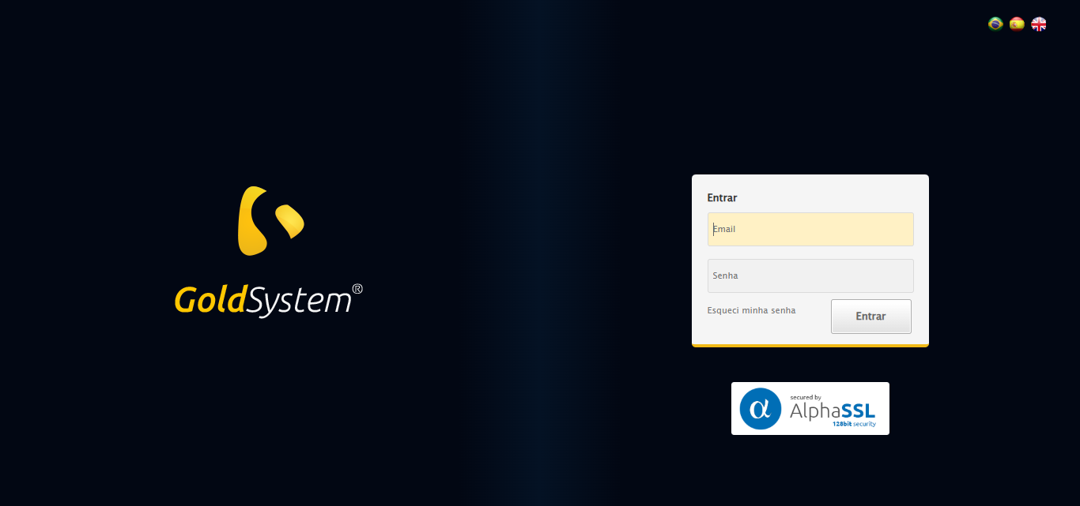

🔄 Realizando login...

✅ Realizando login realizada com sucesso.

Screenshot: realizando login

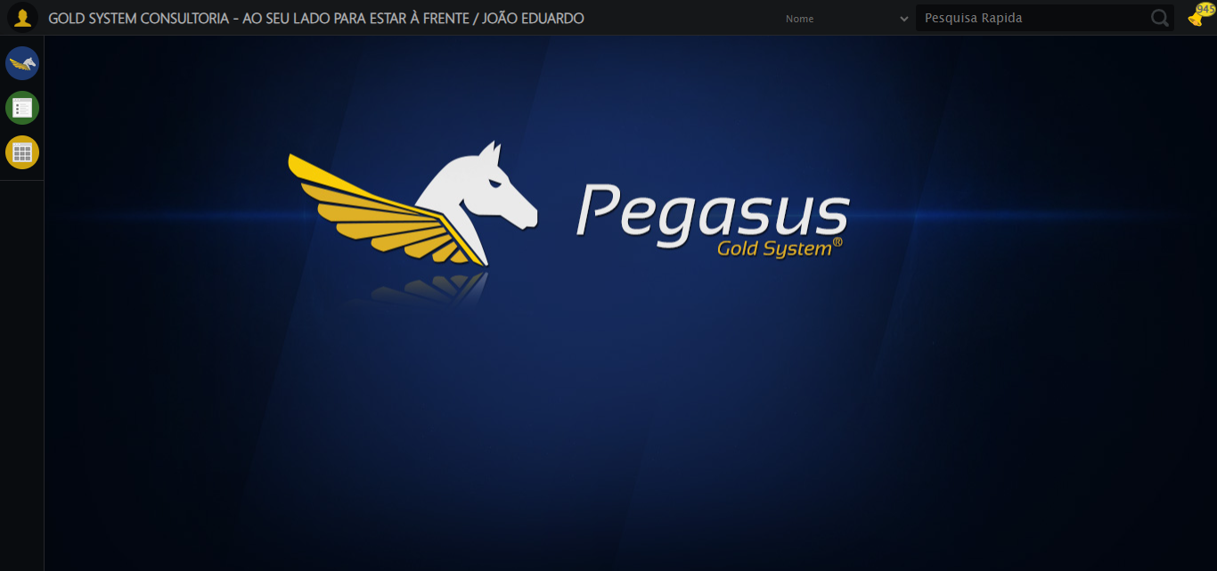

🔄 Ajustando zoom e abrindo menu...

🔍 Zoom ajustado para 90%.

✅ Ajustando zoom e abrindo menu realizada com sucesso.

Screenshot: ajustando zoom e abrindo menu

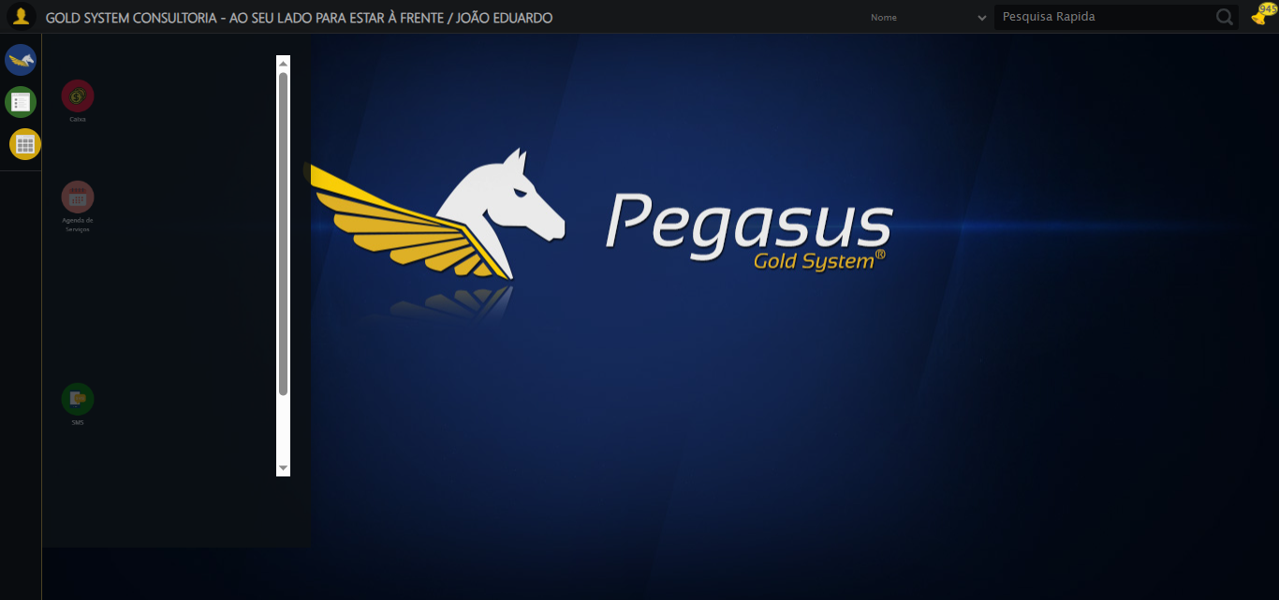

🔄 Acessando Gestor Financeiro...

✅ Acessando Gestor Financeiro realizada com sucesso.

Screenshot: acessando gestor financeiro

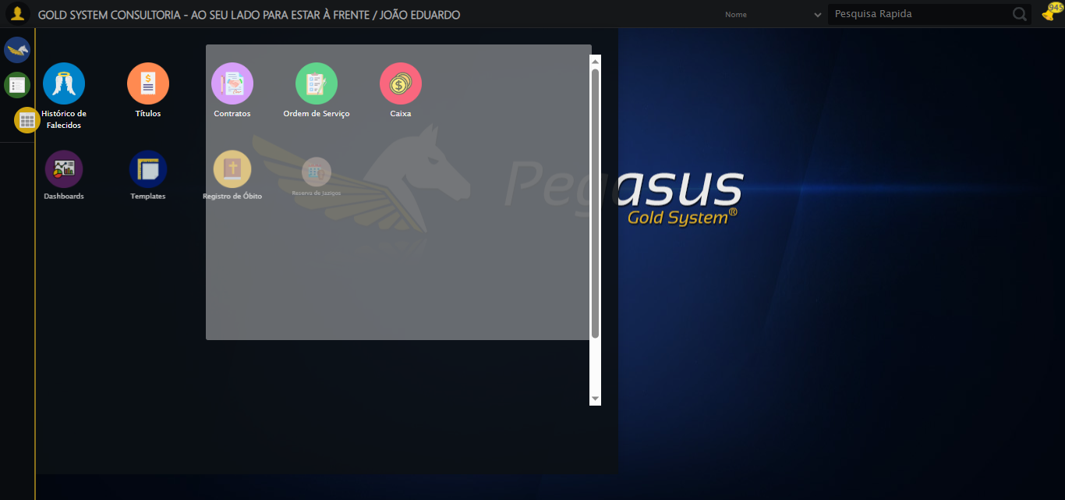

🔄 Clicando em Geração de Títulos...

✅ Clicando em Geração de Títulos realizada com sucesso.

Screenshot: clicando em geração de títulos

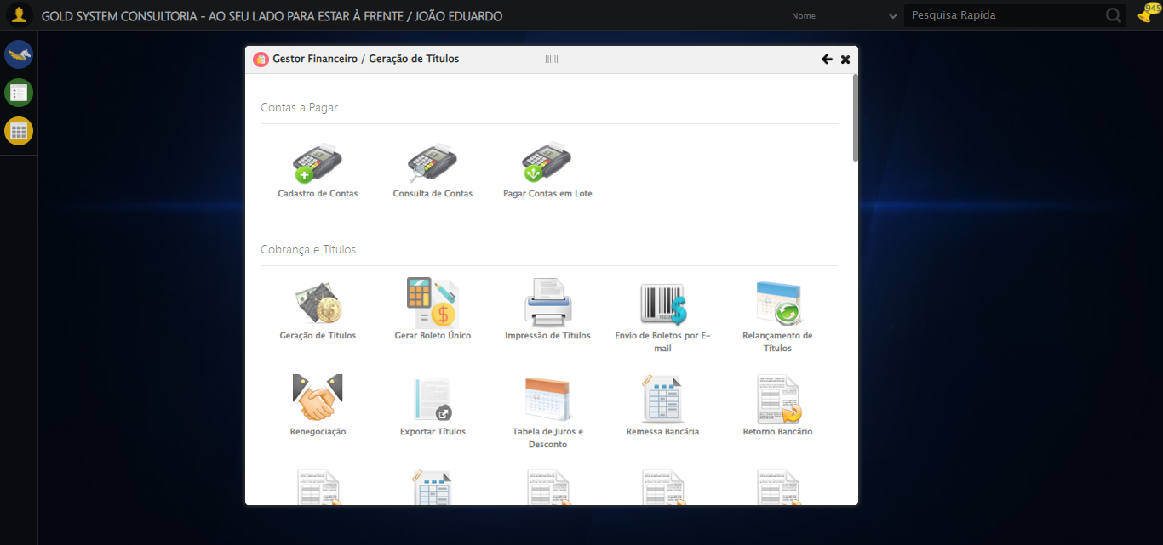

🔄 Selecionando Contratante/Titular...

🔄 Tentativa 1/3 de abrir modal LOV

🔍 Localizando botão LOV por índice: 1

✅ Botão LOV #1 localizado

✅ Clique em botão LOV com estratégia 1

⏳ Aguardando modal carregar...

🔍 Localizando campo de pesquisa

⚠️ Tentativa 1/3 falhou: Message:   
Stacktrace:  
 GetHandleVerifier [0x0xe9c333+65459]  
 GetHandleVerifier [0x0xe9c374+65524]  
 (No symbol) [0x0xcbd973]  
 (No symbol) [0x0xd076e7]  
 (No symbol) [0x0xd07a8b]  
 (No symbol) [0x0xd4dea2

⏳ Aguardando 2.5s antes de retentar...

🔄 Tentativa 2/3 de abrir modal LOV

🔍 Localizando botão LOV por índice: 1

✅ Botão LOV #1 localizado

✅ Clique em botão LOV com estratégia 2

⏳ Aguardando modal carregar...

🔍 Localizando campo de pesquisa

✏️ Preenchendo campo com: 'JOÃO EDUARDO JUSTINO PASCHOAL'

✅ Campo preenchido: 'JOÃO EDUARDO JUSTINO PASCHOAL'

🔍 Clicando em Pesquisar

✅ Clique em botão Pesquisar com estratégia 2

⏳ Aguardando resultados da pesquisa...

🎯 Localizando resultado da pesquisa

✅ Clique em resultado da pesquisa com estratégia 2

✅ Modal LOV processado com sucesso (tentativa 2)

✅ Selecionando Contratante/Titular realizada com sucesso.

⚠️ Erro ao tirar screenshot selecionando contratante_titular: Message: no such window: target window already closed  
from unknown error: web view not found  
 (Session info: chrome=140.0.7339.208)  
Stacktrace:  
 GetHandleVerifier [0x0xe9c333+65459]  
 GetHandleVerifier [0x0xe9c374+65524]  
 (No symbol) [0x0xcbd973]  
 (No symbol) [0x0xc9c19d]  
 (No symbol) [0x0xd3059e]  
 (No symbol) [0x0xd4aef9]  
 (No symbol) [0x0xd29bf6]  
 (No symbol) [0x0xcfb38e]  
 (No symbol) [0x0xcfc274]  
 GetHandleVerifier [0x0x111eda3+2697763]  
 GetHandleVerifier [0x0x1119ec7+2677575]  
 GetHandleVerifier [0x0xec4194+228884]  
 GetHandleVerifier [0x0xeb49f8+165496]  
 GetHandleVerifier [0x0xebb18d+192013]  
 GetHandleVerifier [0x0xea47d8+99416]  
 GetHandleVerifier [0x0xea4972+99826]  
 GetHandleVerifier [0x0xe8ebea+10346]  
 BaseThreadInitThunk [0x0x755bfcc9+25]  
 RtlGetAppContainerNamedObjectPath [0x0x773a82ae+286]  
 RtlGetAppContainerNamedObjectPath [0x0x773a827e+238]

🔄 Selecionando Pacote...

🔄 Tentativa 1/3 de abrir modal LOV

🔍 Localizando botão LOV por índice: 2

⚠️ Tentativa 1/3 falhou: Message: no such window: target window already closed  
from unknown error: web view not found  
 (Session info: chrome=140.0.7339.208)  
Stacktrace:  
 GetHandleVerifier [0x0xe9c333+65459]  
 GetHandleVerifie

⏳ Aguardando 2.5s antes de retentar...

🔄 Tentativa 2/3 de abrir modal LOV

🔍 Localizando botão LOV por índice: 2

⚠️ Tentativa 2/3 falhou: Message: no such window: target window already closed  
from unknown error: web view not found  
 (Session info: chrome=140.0.7339.208)  
Stacktrace:  
 GetHandleVerifier [0x0xe9c333+65459]  
 GetHandleVerifie

⏳ Aguardando 3.0s antes de retentar...

🔄 Tentativa 3/3 de abrir modal LOV

🔍 Localizando botão LOV por índice: 2

⚠️ Tentativa 3/3 falhou: Message: no such window: target window already closed  
from unknown error: web view not found  
 (Session info: chrome=140.0.7339.208)  
Stacktrace:  
 GetHandleVerifier [0x0xe9c333+65459]  
 GetHandleVerifie

❌ Erro inesperado ao selecionando pacote: Falha ao processar modal LOV após 3 tentativas. Último erro: Message: no such window: target window already closed  
from unknown error: web view not found  
 (Session info: chrome=140.0.7339.208)  
Stacktrace:  
 GetHandleVerifier [0x0xe9c333+65459]  
 GetHandleVerifier [0x0xe9c374+65524]  
 (No symbol) [0x0xcbd973]  
 (No symbol) [0x0xc9c19d]  
 (No symbol) [0x0xd3059e]  
 (No symbol) [0x0xd4aef9]  
 (No symbol) [0x0xd29bf6]  
 (No symbol) [0x0xcfb38e]  
 (No symbol) [0x0xcfc274]  
 GetHandleVerifier [0x0x111eda3+2697763]  
 GetHandleVerifier [0x0x1119ec7+2677575]  
 GetHandleVerifier [0x0xec4194+228884]  
 GetHandleVerifier [0x0xeb49f8+165496]  
 GetHandleVerifier [0x0xebb18d+192013]  
 GetHandleVerifier [0x0xea47d8+99416]  
 GetHandleVerifier [0x0xea4972+99826]  
 GetHandleVerifier [0x0xe8ebea+10346]  
 BaseThreadInitThunk [0x0x755bfcc9+25]  
 RtlGetAppContainerNamedObjectPath [0x0x773a82ae+286]  
 RtlGetAppContainerNamedObjectPath [0x0x773a827e+238]

⚠️ Erro ao tirar screenshot erro_selecionando pacote: Message: no such window: target window already closed  
from unknown error: web view not found  
 (Session info: chrome=140.0.7339.208)  
Stacktrace:  
 GetHandleVerifier [0x0xe9c333+65459]  
 GetHandleVerifier [0x0xe9c374+65524]  
 (No symbol) [0x0xcbd973]  
 (No symbol) [0x0xc9c19d]  
 (No symbol) [0x0xd3059e]  
 (No symbol) [0x0xd4aef9]  
 (No symbol) [0x0xd29bf6]  
 (No symbol) [0x0xcfb38e]  
 (No symbol) [0x0xcfc274]  
 GetHandleVerifier [0x0x111eda3+2697763]  
 GetHandleVerifier [0x0x1119ec7+2677575]  
 GetHandleVerifier [0x0xec4194+228884]  
 GetHandleVerifier [0x0xeb49f8+165496]  
 GetHandleVerifier [0x0xebb18d+192013]  
 GetHandleVerifier [0x0xea47d8+99416]  
 GetHandleVerifier [0x0xea4972+99826]  
 GetHandleVerifier [0x0xe8ebea+10346]  
 BaseThreadInitThunk [0x0x755bfcc9+25]  
 RtlGetAppContainerNamedObjectPath [0x0x773a82ae+286]  
 RtlGetAppContainerNamedObjectPath [0x0x773a827e+238]

🔄 Pesquisando...

❌ Erro inesperado ao pesquisando: Message: no such window: target window already closed  
from unknown error: web view not found  
 (Session info: chrome=140.0.7339.208)  
Stacktrace:  
 GetHandleVerifier [0x0xe9c333+65459]  
 GetHandleVerifier [0x0xe9c374+65524]  
 (No symbol) [0x0xcbd973]  
 (No symbol) [0x0xc9c19d]  
 (No symbol) [0x0xd3059e]  
 (No symbol) [0x0xd4aef9]  
 (No symbol) [0x0xd29bf6]  
 (No symbol) [0x0xcfb38e]  
 (No symbol) [0x0xcfc274]  
 GetHandleVerifier [0x0x111eda3+2697763]  
 GetHandleVerifier [0x0x1119ec7+2677575]  
 GetHandleVerifier [0x0xec4194+228884]  
 GetHandleVerifier [0x0xeb49f8+165496]  
 GetHandleVerifier [0x0xebb18d+192013]  
 GetHandleVerifier [0x0xea47d8+99416]  
 GetHandleVerifier [0x0xea4972+99826]  
 GetHandleVerifier [0x0xe8ebea+10346]  
 BaseThreadInitThunk [0x0x755bfcc9+25]  
 RtlGetAppContainerNamedObjectPath [0x0x773a82ae+286]  
 RtlGetAppContainerNamedObjectPath [0x0x773a827e+238]

⚠️ Erro ao tirar screenshot erro_pesquisando: Message: no such window: target window already closed  
from unknown error: web view not found  
 (Session info: chrome=140.0.7339.208)  
Stacktrace:  
 GetHandleVerifier [0x0xe9c333+65459]  
 GetHandleVerifier [0x0xe9c374+65524]  
 (No symbol) [0x0xcbd973]  
 (No symbol) [0x0xc9c19d]  
 (No symbol) [0x0xd3059e]  
 (No symbol) [0x0xd4aef9]  
 (No symbol) [0x0xd29bf6]  
 (No symbol) [0x0xcfb38e]  
 (No symbol) [0x0xcfc274]  
 GetHandleVerifier [0x0x111eda3+2697763]  
 GetHandleVerifier [0x0x1119ec7+2677575]  
 GetHandleVerifier [0x0xec4194+228884]  
 GetHandleVerifier [0x0xeb49f8+165496]  
 GetHandleVerifier [0x0xebb18d+192013]  
 GetHandleVerifier [0x0xea47d8+99416]  
 GetHandleVerifier [0x0xea4972+99826]  
 GetHandleVerifier [0x0xe8ebea+10346]  
 BaseThreadInitThunk [0x0x755bfcc9+25]  
 RtlGetAppContainerNamedObjectPath [0x0x773a82ae+286]  
 RtlGetAppContainerNamedObjectPath [0x0x773a827e+238]

🔄 Verificando resultado da busca de Títulos...

❌ Erro ao tratar resultado pesquisa: Message: no such window: target window already closed  
from unknown error: web view not found  
 (Session info: chrome=140.0.7339.208)  
Stacktrace:  
 GetHandleVerifier [0x0xe9c333+65459]  
 GetHandleVerifier [0x0xe9c374+65524]  
 (No symbol) [0x0xcbd973]  
 (No symbol) [0x0xc9c19d]  
 (No symbol) [0x0xd3059e]  
 (No symbol) [0x0xd4aef9]  
 (No symbol) [0x0xd29bf6]  
 (No symbol) [0x0xcfb38e]  
 (No symbol) [0x0xcfc274]  
 GetHandleVerifier [0x0x111eda3+2697763]  
 GetHandleVerifier [0x0x1119ec7+2677575]  
 GetHandleVerifier [0x0xec4194+228884]  
 GetHandleVerifier [0x0xeb49f8+165496]  
 GetHandleVerifier [0x0xebb18d+192013]  
 GetHandleVerifier [0x0xea47d8+99416]  
 GetHandleVerifier [0x0xea4972+99826]  
 GetHandleVerifier [0x0xe8ebea+10346]  
 BaseThreadInitThunk [0x0x755bfcc9+25]  
 RtlGetAppContainerNamedObjectPath [0x0x773a82ae+286]  
 RtlGetAppContainerNamedObjectPath [0x0x773a827e+238]

✅ Verificando resultado da busca de Títulos realizada com sucesso.

⚠️ Erro ao tirar screenshot verificando resultado da busca de títulos: Message: no such window: target window already closed  
from unknown error: web view not found  
 (Session info: chrome=140.0.7339.208)  
Stacktrace:  
 GetHandleVerifier [0x0xe9c333+65459]  
 GetHandleVerifier [0x0xe9c374+65524]  
 (No symbol) [0x0xcbd973]  
 (No symbol) [0x0xc9c19d]  
 (No symbol) [0x0xd3059e]  
 (No symbol) [0x0xd4aef9]  
 (No symbol) [0x0xd29bf6]  
 (No symbol) [0x0xcfb38e]  
 (No symbol) [0x0xcfc274]  
 GetHandleVerifier [0x0x111eda3+2697763]  
 GetHandleVerifier [0x0x1119ec7+2677575]  
 GetHandleVerifier [0x0xec4194+228884]  
 GetHandleVerifier [0x0xeb49f8+165496]  
 GetHandleVerifier [0x0xebb18d+192013]  
 GetHandleVerifier [0x0xea47d8+99416]  
 GetHandleVerifier [0x0xea4972+99826]  
 GetHandleVerifier [0x0xe8ebea+10346]  
 BaseThreadInitThunk [0x0x755bfcc9+25]  
 RtlGetAppContainerNamedObjectPath [0x0x773a82ae+286]  
 RtlGetAppContainerNamedObjectPath [0x0x773a827e+238]

➡️ Título encontrado. Prosseguindo com as próximas ações...

🔄 Preenchendo Data Inicial...

📊 Encontrados 0 campos datepicker

Nenhum campo datepicker encontrado, tentativa 1/5

📊 Encontrados 0 campos datepicker

Nenhum campo datepicker encontrado, tentativa 2/5

📊 Encontrados 0 campos datepicker

Nenhum campo datepicker encontrado, tentativa 3/5

📊 Encontrados 0 campos datepicker

Nenhum campo datepicker encontrado, tentativa 4/5

📊 Encontrados 0 campos datepicker

❌ Erro inesperado ao preenchendo data inicial: Nenhum campo datepicker encontrado na página

⚠️ Erro ao tirar screenshot erro_preenchendo data inicial: Message: no such window: target window already closed  
from unknown error: web view not found  
 (Session info: chrome=140.0.7339.208)  
Stacktrace:  
 GetHandleVerifier [0x0xe9c333+65459]  
 GetHandleVerifier [0x0xe9c374+65524]  
 (No symbol) [0x0xcbd973]  
 (No symbol) [0x0xc9c19d]  
 (No symbol) [0x0xd3059e]  
 (No symbol) [0x0xd4aef9]  
 (No symbol) [0x0xd29bf6]  
 (No symbol) [0x0xcfb38e]  
 (No symbol) [0x0xcfc274]  
 GetHandleVerifier [0x0x111eda3+2697763]  
 GetHandleVerifier [0x0x1119ec7+2677575]  
 GetHandleVerifier [0x0xec4194+228884]  
 GetHandleVerifier [0x0xeb49f8+165496]  
 GetHandleVerifier [0x0xebb18d+192013]  
 GetHandleVerifier [0x0xea47d8+99416]  
 GetHandleVerifier [0x0xea4972+99826]  
 GetHandleVerifier [0x0xe8ebea+10346]  
 BaseThreadInitThunk [0x0x755bfcc9+25]  
 RtlGetAppContainerNamedObjectPath [0x0x773a82ae+286]  
 RtlGetAppContainerNamedObjectPath [0x0x773a827e+238]

🔄 Preenchendo Data Final...

📊 Encontrados 0 campos datepicker

Nenhum campo datepicker encontrado, tentativa 1/5

📊 Encontrados 0 campos datepicker

Nenhum campo datepicker encontrado, tentativa 2/5

📊 Encontrados 0 campos datepicker

Nenhum campo datepicker encontrado, tentativa 3/5

📊 Encontrados 0 campos datepicker

Nenhum campo datepicker encontrado, tentativa 4/5

📊 Encontrados 0 campos datepicker

❌ Erro inesperado ao preenchendo data final: Nenhum campo datepicker encontrado na página

⚠️ Erro ao tirar screenshot erro_preenchendo data final: Message: no such window: target window already closed  
from unknown error: web view not found  
 (Session info: chrome=140.0.7339.208)  
Stacktrace:  
 GetHandleVerifier [0x0xe9c333+65459]  
 GetHandleVerifier [0x0xe9c374+65524]  
 (No symbol) [0x0xcbd973]  
 (No symbol) [0x0xc9c19d]  
 (No symbol) [0x0xd3059e]  
 (No symbol) [0x0xd4aef9]  
 (No symbol) [0x0xd29bf6]  
 (No symbol) [0x0xcfb38e]  
 (No symbol) [0x0xcfc274]  
 GetHandleVerifier [0x0x111eda3+2697763]  
 GetHandleVerifier [0x0x1119ec7+2677575]  
 GetHandleVerifier [0x0xec4194+228884]  
 GetHandleVerifier [0x0xeb49f8+165496]  
 GetHandleVerifier [0x0xebb18d+192013]  
 GetHandleVerifier [0x0xea47d8+99416]  
 GetHandleVerifier [0x0xea4972+99826]  
 GetHandleVerifier [0x0xe8ebea+10346]  
 BaseThreadInitThunk [0x0x755bfcc9+25]  
 RtlGetAppContainerNamedObjectPath [0x0x773a82ae+286]  
 RtlGetAppContainerNamedObjectPath [0x0x773a827e+238]

🔄 Preenchendo Dia de Vencimento...

⚠️ Tentativa 1 falhou: Message: no such window: target window already closed  
from unknown error: web view not found  
 (Session info: chrome=140.0.7339.208)  
Stacktrace:  
 GetHandleVerifier [0x0xe9c333+65459]  
 GetHandleVerifier [0x0xe9c374+65524]  
 (No symbol) [0x0xcbd973]  
 (No symbol) [0x0xc9c19d]  
 (No symbol) [0x0xd3059e]  
 (No symbol) [0x0xd4aef9]  
 (No symbol) [0x0xd29bf6]  
 (No symbol) [0x0xcfb38e]  
 (No symbol) [0x0xcfc274]  
 GetHandleVerifier [0x0x111eda3+2697763]  
 GetHandleVerifier [0x0x1119ec7+2677575]  
 GetHandleVerifier [0x0xec4194+228884]  
 GetHandleVerifier [0x0xeb49f8+165496]  
 GetHandleVerifier [0x0xebb18d+192013]  
 GetHandleVerifier [0x0xea47d8+99416]  
 GetHandleVerifier [0x0xea4972+99826]  
 GetHandleVerifier [0x0xe8ebea+10346]  
 BaseThreadInitThunk [0x0x755bfcc9+25]  
 RtlGetAppContainerNamedObjectPath [0x0x773a82ae+286]  
 RtlGetAppContainerNamedObjectPath [0x0x773a827e+238]

⚠️ Tentativa 2 falhou: Message: no such window: target window already closed  
from unknown error: web view not found  
 (Session info: chrome=140.0.7339.208)  
Stacktrace:  
 GetHandleVerifier [0x0xe9c333+65459]  
 GetHandleVerifier [0x0xe9c374+65524]  
 (No symbol) [0x0xcbd973]  
 (No symbol) [0x0xc9c19d]  
 (No symbol) [0x0xd3059e]  
 (No symbol) [0x0xd4aef9]  
 (No symbol) [0x0xd29bf6]  
 (No symbol) [0x0xcfb38e]  
 (No symbol) [0x0xcfc274]  
 GetHandleVerifier [0x0x111eda3+2697763]  
 GetHandleVerifier [0x0x1119ec7+2677575]  
 GetHandleVerifier [0x0xec4194+228884]  
 GetHandleVerifier [0x0xeb49f8+165496]  
 GetHandleVerifier [0x0xebb18d+192013]  
 GetHandleVerifier [0x0xea47d8+99416]  
 GetHandleVerifier [0x0xea4972+99826]  
 GetHandleVerifier [0x0xe8ebea+10346]  
 BaseThreadInitThunk [0x0x755bfcc9+25]  
 RtlGetAppContainerNamedObjectPath [0x0x773a82ae+286]  
 RtlGetAppContainerNamedObjectPath [0x0x773a827e+238]

⚠️ Tentativa 3 falhou: Message: no such window: target window already closed  
from unknown error: web view not found  
 (Session info: chrome=140.0.7339.208)  
Stacktrace:  
 GetHandleVerifier [0x0xe9c333+65459]  
 GetHandleVerifier [0x0xe9c374+65524]  
 (No symbol) [0x0xcbd973]  
 (No symbol) [0x0xc9c19d]  
 (No symbol) [0x0xd3059e]  
 (No symbol) [0x0xd4aef9]  
 (No symbol) [0x0xd29bf6]  
 (No symbol) [0x0xcfb38e]  
 (No symbol) [0x0xcfc274]  
 GetHandleVerifier [0x0x111eda3+2697763]  
 GetHandleVerifier [0x0x1119ec7+2677575]  
 GetHandleVerifier [0x0xec4194+228884]  
 GetHandleVerifier [0x0xeb49f8+165496]  
 GetHandleVerifier [0x0xebb18d+192013]  
 GetHandleVerifier [0x0xea47d8+99416]  
 GetHandleVerifier [0x0xea4972+99826]  
 GetHandleVerifier [0x0xe8ebea+10346]  
 BaseThreadInitThunk [0x0x755bfcc9+25]  
 RtlGetAppContainerNamedObjectPath [0x0x773a82ae+286]  
 RtlGetAppContainerNamedObjectPath [0x0x773a827e+238]

✅ Preenchendo Dia de Vencimento realizada com sucesso.

⚠️ Erro ao tirar screenshot preenchendo dia de vencimento: Message: no such window: target window already closed  
from unknown error: web view not found  
 (Session info: chrome=140.0.7339.208)  
Stacktrace:  
 GetHandleVerifier [0x0xe9c333+65459]  
 GetHandleVerifier [0x0xe9c374+65524]  
 (No symbol) [0x0xcbd973]  
 (No symbol) [0x0xc9c19d]  
 (No symbol) [0x0xd3059e]  
 (No symbol) [0x0xd4aef9]  
 (No symbol) [0x0xd29bf6]  
 (No symbol) [0x0xcfb38e]  
 (No symbol) [0x0xcfc274]  
 GetHandleVerifier [0x0x111eda3+2697763]  
 GetHandleVerifier [0x0x1119ec7+2677575]  
 GetHandleVerifier [0x0xec4194+228884]  
 GetHandleVerifier [0x0xeb49f8+165496]  
 GetHandleVerifier [0x0xebb18d+192013]  
 GetHandleVerifier [0x0xea47d8+99416]  
 GetHandleVerifier [0x0xea4972+99826]  
 GetHandleVerifier [0x0xe8ebea+10346]  
 BaseThreadInitThunk [0x0x755bfcc9+25]  
 RtlGetAppContainerNamedObjectPath [0x0x773a82ae+286]  
 RtlGetAppContainerNamedObjectPath [0x0x773a827e+238]

🔄 Preenchendo Quantidade de Parcelas...

⚠️ Tentativa 1 falhou: Message: no such window: target window already closed  
from unknown error: web view not found  
 (Session info: chrome=140.0.7339.208)  
Stacktrace:  
 GetHandleVerifier [0x0xe9c333+65459]  
 GetHandleVerifier [0x0xe9c374+65524]  
 (No symbol) [0x0xcbd973]  
 (No symbol) [0x0xc9c19d]  
 (No symbol) [0x0xd3059e]  
 (No symbol) [0x0xd4aef9]  
 (No symbol) [0x0xd29bf6]  
 (No symbol) [0x0xcfb38e]  
 (No symbol) [0x0xcfc274]  
 GetHandleVerifier [0x0x111eda3+2697763]  
 GetHandleVerifier [0x0x1119ec7+2677575]  
 GetHandleVerifier [0x0xec4194+228884]  
 GetHandleVerifier [0x0xeb49f8+165496]  
 GetHandleVerifier [0x0xebb18d+192013]  
 GetHandleVerifier [0x0xea47d8+99416]  
 GetHandleVerifier [0x0xea4972+99826]  
 GetHandleVerifier [0x0xe8ebea+10346]  
 BaseThreadInitThunk [0x0x755bfcc9+25]  
 RtlGetAppContainerNamedObjectPath [0x0x773a82ae+286]  
 RtlGetAppContainerNamedObjectPath [0x0x773a827e+238]

⚠️ Tentativa 2 falhou: Message: no such window: target window already closed  
from unknown error: web view not found  
 (Session info: chrome=140.0.7339.208)  
Stacktrace:  
 GetHandleVerifier [0x0xe9c333+65459]  
 GetHandleVerifier [0x0xe9c374+65524]  
 (No symbol) [0x0xcbd973]  
 (No symbol) [0x0xc9c19d]  
 (No symbol) [0x0xd3059e]  
 (No symbol) [0x0xd4aef9]  
 (No symbol) [0x0xd29bf6]  
 (No symbol) [0x0xcfb38e]  
 (No symbol) [0x0xcfc274]  
 GetHandleVerifier [0x0x111eda3+2697763]  
 GetHandleVerifier [0x0x1119ec7+2677575]  
 GetHandleVerifier [0x0xec4194+228884]  
 GetHandleVerifier [0x0xeb49f8+165496]  
 GetHandleVerifier [0x0xebb18d+192013]  
 GetHandleVerifier [0x0xea47d8+99416]  
 GetHandleVerifier [0x0xea4972+99826]  
 GetHandleVerifier [0x0xe8ebea+10346]  
 BaseThreadInitThunk [0x0x755bfcc9+25]  
 RtlGetAppContainerNamedObjectPath [0x0x773a82ae+286]  
 RtlGetAppContainerNamedObjectPath [0x0x773a827e+238]

⚠️ Tentativa 3 falhou: Message: no such window: target window already closed  
from unknown error: web view not found  
 (Session info: chrome=140.0.7339.208)  
Stacktrace:  
 GetHandleVerifier [0x0xe9c333+65459]  
 GetHandleVerifier [0x0xe9c374+65524]  
 (No symbol) [0x0xcbd973]  
 (No symbol) [0x0xc9c19d]  
 (No symbol) [0x0xd3059e]  
 (No symbol) [0x0xd4aef9]  
 (No symbol) [0x0xd29bf6]  
 (No symbol) [0x0xcfb38e]  
 (No symbol) [0x0xcfc274]  
 GetHandleVerifier [0x0x111eda3+2697763]  
 GetHandleVerifier [0x0x1119ec7+2677575]  
 GetHandleVerifier [0x0xec4194+228884]  
 GetHandleVerifier [0x0xeb49f8+165496]  
 GetHandleVerifier [0x0xebb18d+192013]  
 GetHandleVerifier [0x0xea47d8+99416]  
 GetHandleVerifier [0x0xea4972+99826]  
 GetHandleVerifier [0x0xe8ebea+10346]  
 BaseThreadInitThunk [0x0x755bfcc9+25]  
 RtlGetAppContainerNamedObjectPath [0x0x773a82ae+286]  
 RtlGetAppContainerNamedObjectPath [0x0x773a827e+238]

✅ Preenchendo Quantidade de Parcelas realizada com sucesso.

⚠️ Erro ao tirar screenshot preenchendo quantidade de parcelas: Message: no such window: target window already closed  
from unknown error: web view not found  
 (Session info: chrome=140.0.7339.208)  
Stacktrace:  
 GetHandleVerifier [0x0xe9c333+65459]  
 GetHandleVerifier [0x0xe9c374+65524]  
 (No symbol) [0x0xcbd973]  
 (No symbol) [0x0xc9c19d]  
 (No symbol) [0x0xd3059e]  
 (No symbol) [0x0xd4aef9]  
 (No symbol) [0x0xd29bf6]  
 (No symbol) [0x0xcfb38e]  
 (No symbol) [0x0xcfc274]  
 GetHandleVerifier [0x0x111eda3+2697763]  
 GetHandleVerifier [0x0x1119ec7+2677575]  
 GetHandleVerifier [0x0xec4194+228884]  
 GetHandleVerifier [0x0xeb49f8+165496]  
 GetHandleVerifier [0x0xebb18d+192013]  
 GetHandleVerifier [0x0xea47d8+99416]  
 GetHandleVerifier [0x0xea4972+99826]  
 GetHandleVerifier [0x0xe8ebea+10346]  
 BaseThreadInitThunk [0x0x755bfcc9+25]  
 RtlGetAppContainerNamedObjectPath [0x0x773a82ae+286]  
 RtlGetAppContainerNamedObjectPath [0x0x773a827e+238]

🔄 Preenchendo Valor das Parcelas...

⚠️ Tentativa 1 falhou: Message: no such window: target window already closed  
from unknown error: web view not found  
 (Session info: chrome=140.0.7339.208)  
Stacktrace:  
 GetHandleVerifier [0x0xe9c333+65459]  
 GetHandleVerifier [0x0xe9c374+65524]  
 (No symbol) [0x0xcbd973]  
 (No symbol) [0x0xc9c19d]  
 (No symbol) [0x0xd3059e]  
 (No symbol) [0x0xd4aef9]  
 (No symbol) [0x0xd29bf6]  
 (No symbol) [0x0xcfb38e]  
 (No symbol) [0x0xcfc274]  
 GetHandleVerifier [0x0x111eda3+2697763]  
 GetHandleVerifier [0x0x1119ec7+2677575]  
 GetHandleVerifier [0x0xec4194+228884]  
 GetHandleVerifier [0x0xeb49f8+165496]  
 GetHandleVerifier [0x0xebb18d+192013]  
 GetHandleVerifier [0x0xea47d8+99416]  
 GetHandleVerifier [0x0xea4972+99826]  
 GetHandleVerifier [0x0xe8ebea+10346]  
 BaseThreadInitThunk [0x0x755bfcc9+25]  
 RtlGetAppContainerNamedObjectPath [0x0x773a82ae+286]  
 RtlGetAppContainerNamedObjectPath [0x0x773a827e+238]

⚠️ Tentativa 2 falhou: Message: no such window: target window already closed  
from unknown error: web view not found  
 (Session info: chrome=140.0.7339.208)  
Stacktrace:  
 GetHandleVerifier [0x0xe9c333+65459]  
 GetHandleVerifier [0x0xe9c374+65524]  
 (No symbol) [0x0xcbd973]  
 (No symbol) [0x0xc9c19d]  
 (No symbol) [0x0xd3059e]  
 (No symbol) [0x0xd4aef9]  
 (No symbol) [0x0xd29bf6]  
 (No symbol) [0x0xcfb38e]  
 (No symbol) [0x0xcfc274]  
 GetHandleVerifier [0x0x111eda3+2697763]  
 GetHandleVerifier [0x0x1119ec7+2677575]  
 GetHandleVerifier [0x0xec4194+228884]  
 GetHandleVerifier [0x0xeb49f8+165496]  
 GetHandleVerifier [0x0xebb18d+192013]  
 GetHandleVerifier [0x0xea47d8+99416]  
 GetHandleVerifier [0x0xea4972+99826]  
 GetHandleVerifier [0x0xe8ebea+10346]  
 BaseThreadInitThunk [0x0x755bfcc9+25]  
 RtlGetAppContainerNamedObjectPath [0x0x773a82ae+286]  
 RtlGetAppContainerNamedObjectPath [0x0x773a827e+238]

⚠️ Tentativa 3 falhou: Message: no such window: target window already closed  
from unknown error: web view not found  
 (Session info: chrome=140.0.7339.208)  
Stacktrace:  
 GetHandleVerifier [0x0xe9c333+65459]  
 GetHandleVerifier [0x0xe9c374+65524]  
 (No symbol) [0x0xcbd973]  
 (No symbol) [0x0xc9c19d]  
 (No symbol) [0x0xd3059e]  
 (No symbol) [0x0xd4aef9]  
 (No symbol) [0x0xd29bf6]  
 (No symbol) [0x0xcfb38e]  
 (No symbol) [0x0xcfc274]  
 GetHandleVerifier [0x0x111eda3+2697763]  
 GetHandleVerifier [0x0x1119ec7+2677575]  
 GetHandleVerifier [0x0xec4194+228884]  
 GetHandleVerifier [0x0xeb49f8+165496]  
 GetHandleVerifier [0x0xebb18d+192013]  
 GetHandleVerifier [0x0xea47d8+99416]  
 GetHandleVerifier [0x0xea4972+99826]  
 GetHandleVerifier [0x0xe8ebea+10346]  
 BaseThreadInitThunk [0x0x755bfcc9+25]  
 RtlGetAppContainerNamedObjectPath [0x0x773a82ae+286]  
 RtlGetAppContainerNamedObjectPath [0x0x773a827e+238]

✅ Preenchendo Valor das Parcelas realizada com sucesso.

⚠️ Erro ao tirar screenshot preenchendo valor das parcelas: Message: no such window: target window already closed  
from unknown error: web view not found  
 (Session info: chrome=140.0.7339.208)  
Stacktrace:  
 GetHandleVerifier [0x0xe9c333+65459]  
 GetHandleVerifier [0x0xe9c374+65524]  
 (No symbol) [0x0xcbd973]  
 (No symbol) [0x0xc9c19d]  
 (No symbol) [0x0xd3059e]  
 (No symbol) [0x0xd4aef9]  
 (No symbol) [0x0xd29bf6]  
 (No symbol) [0x0xcfb38e]  
 (No symbol) [0x0xcfc274]  
 GetHandleVerifier [0x0x111eda3+2697763]  
 GetHandleVerifier [0x0x1119ec7+2677575]  
 GetHandleVerifier [0x0xec4194+228884]  
 GetHandleVerifier [0x0xeb49f8+165496]  
 GetHandleVerifier [0x0xebb18d+192013]  
 GetHandleVerifier [0x0xea47d8+99416]  
 GetHandleVerifier [0x0xea4972+99826]  
 GetHandleVerifier [0x0xe8ebea+10346]  
 BaseThreadInitThunk [0x0x755bfcc9+25]  
 RtlGetAppContainerNamedObjectPath [0x0x773a82ae+286]  
 RtlGetAppContainerNamedObjectPath [0x0x773a827e+238]

🔄 Selecionando Tipo de Mensalidade...

🔄 Tentativa 1/3 de abrir modal LOV

🔍 Localizando botão LOV por índice: 3

⚠️ Tentativa 1/3 falhou: Message: no such window: target window already closed  
from unknown error: web view not found  
 (Session info: chrome=140.0.7339.208)  
Stacktrace:  
 GetHandleVerifier [0x0xe9c333+65459]  
 GetHandleVerifie

⏳ Aguardando 2.5s antes de retentar...

🔄 Tentativa 2/3 de abrir modal LOV

🔍 Localizando botão LOV por índice: 3

⚠️ Tentativa 2/3 falhou: Message: no such window: target window already closed  
from unknown error: web view not found  
 (Session info: chrome=140.0.7339.208)  
Stacktrace:  
 GetHandleVerifier [0x0xe9c333+65459]  
 GetHandleVerifie

⏳ Aguardando 3.0s antes de retentar...

🔄 Tentativa 3/3 de abrir modal LOV

🔍 Localizando botão LOV por índice: 3

⚠️ Tentativa 3/3 falhou: Message: no such window: target window already closed  
from unknown error: web view not found  
 (Session info: chrome=140.0.7339.208)  
Stacktrace:  
 GetHandleVerifier [0x0xe9c333+65459]  
 GetHandleVerifie

❌ Erro inesperado ao selecionando tipo de mensalidade: Falha ao processar modal LOV após 3 tentativas. Último erro: Message: no such window: target window already closed  
from unknown error: web view not found  
 (Session info: chrome=140.0.7339.208)  
Stacktrace:  
 GetHandleVerifier [0x0xe9c333+65459]  
 GetHandleVerifier [0x0xe9c374+65524]  
 (No symbol) [0x0xcbd973]  
 (No symbol) [0x0xc9c19d]  
 (No symbol) [0x0xd3059e]  
 (No symbol) [0x0xd4aef9]  
 (No symbol) [0x0xd29bf6]  
 (No symbol) [0x0xcfb38e]  
 (No symbol) [0x0xcfc274]  
 GetHandleVerifier [0x0x111eda3+2697763]  
 GetHandleVerifier [0x0x1119ec7+2677575]  
 GetHandleVerifier [0x0xec4194+228884]  
 GetHandleVerifier [0x0xeb49f8+165496]  
 GetHandleVerifier [0x0xebb18d+192013]  
 GetHandleVerifier [0x0xea47d8+99416]  
 GetHandleVerifier [0x0xea4972+99826]  
 GetHandleVerifier [0x0xe8ebea+10346]  
 BaseThreadInitThunk [0x0x755bfcc9+25]  
 RtlGetAppContainerNamedObjectPath [0x0x773a82ae+286]  
 RtlGetAppContainerNamedObjectPath [0x0x773a827e+238]

⚠️ Erro ao tirar screenshot erro_selecionando tipo de mensalidade: Message: no such window: target window already closed  
from unknown error: web view not found  
 (Session info: chrome=140.0.7339.208)  
Stacktrace:  
 GetHandleVerifier [0x0xe9c333+65459]  
 GetHandleVerifier [0x0xe9c374+65524]  
 (No symbol) [0x0xcbd973]  
 (No symbol) [0x0xc9c19d]  
 (No symbol) [0x0xd3059e]  
 (No symbol) [0x0xd4aef9]  
 (No symbol) [0x0xd29bf6]  
 (No symbol) [0x0xcfb38e]  
 (No symbol) [0x0xcfc274]  
 GetHandleVerifier [0x0x111eda3+2697763]  
 GetHandleVerifier [0x0x1119ec7+2677575]  
 GetHandleVerifier [0x0xec4194+228884]  
 GetHandleVerifier [0x0xeb49f8+165496]  
 GetHandleVerifier [0x0xebb18d+192013]  
 GetHandleVerifier [0x0xea47d8+99416]  
 GetHandleVerifier [0x0xea4972+99826]  
 GetHandleVerifier [0x0xe8ebea+10346]  
 BaseThreadInitThunk [0x0x755bfcc9+25]  
 RtlGetAppContainerNamedObjectPath [0x0x773a82ae+286]  
 RtlGetAppContainerNamedObjectPath [0x0x773a827e+238]

🔄 Marcando checkbox: Ano de vencimento/competência do título...

❌ Erro inesperado ao marcando checkbox: ano de vencimento/competência do título: Message: no such window: target window already closed  
from unknown error: web view not found  
 (Session info: chrome=140.0.7339.208)  
Stacktrace:  
 GetHandleVerifier [0x0xe9c333+65459]  
 GetHandleVerifier [0x0xe9c374+65524]  
 (No symbol) [0x0xcbd973]  
 (No symbol) [0x0xc9c19d]  
 (No symbol) [0x0xd3059e]  
 (No symbol) [0x0xd4aef9]  
 (No symbol) [0x0xd29bf6]  
 (No symbol) [0x0xcfb38e]  
 (No symbol) [0x0xcfc274]  
 GetHandleVerifier [0x0x111eda3+2697763]  
 GetHandleVerifier [0x0x1119ec7+2677575]  
 GetHandleVerifier [0x0xec4194+228884]  
 GetHandleVerifier [0x0xeb49f8+165496]  
 GetHandleVerifier [0x0xebb18d+192013]  
 GetHandleVerifier [0x0xea47d8+99416]  
 GetHandleVerifier [0x0xea4972+99826]  
 GetHandleVerifier [0x0xe8ebea+10346]  
 BaseThreadInitThunk [0x0x755bfcc9+25]  
 RtlGetAppContainerNamedObjectPath [0x0x773a82ae+286]  
 RtlGetAppContainerNamedObjectPath [0x0x773a827e+238]

⚠️ Erro ao tirar screenshot erro_marcando checkbox_ ano de vencimento_competência do título: Message: no such window: target window already closed  
from unknown error: web view not found  
 (Session info: chrome=140.0.7339.208)  
Stacktrace:  
 GetHandleVerifier [0x0xe9c333+65459]  
 GetHandleVerifier [0x0xe9c374+65524]  
 (No symbol) [0x0xcbd973]  
 (No symbol) [0x0xc9c19d]  
 (No symbol) [0x0xd3059e]  
 (No symbol) [0x0xd4aef9]  
 (No symbol) [0x0xd29bf6]  
 (No symbol) [0x0xcfb38e]  
 (No symbol) [0x0xcfc274]  
 GetHandleVerifier [0x0x111eda3+2697763]  
 GetHandleVerifier [0x0x1119ec7+2677575]  
 GetHandleVerifier [0x0xec4194+228884]  
 GetHandleVerifier [0x0xeb49f8+165496]  
 GetHandleVerifier [0x0xebb18d+192013]  
 GetHandleVerifier [0x0xea47d8+99416]  
 GetHandleVerifier [0x0xea4972+99826]  
 GetHandleVerifier [0x0xe8ebea+10346]  
 BaseThreadInitThunk [0x0x755bfcc9+25]  
 RtlGetAppContainerNamedObjectPath [0x0x773a82ae+286]  
 RtlGetAppContainerNamedObjectPath [0x0x773a827e+238]

🔄 Preenchendo Ano Competência...

⚠️ Tentativa 1 falhou: Message: no such window: target window already closed  
from unknown error: web view not found  
 (Session info: chrome=140.0.7339.208)  
Stacktrace:  
 GetHandleVerifier [0x0xe9c333+65459]  
 GetHandleVerifier [0x0xe9c374+65524]  
 (No symbol) [0x0xcbd973]  
 (No symbol) [0x0xc9c19d]  
 (No symbol) [0x0xd3059e]  
 (No symbol) [0x0xd4aef9]  
 (No symbol) [0x0xd29bf6]  
 (No symbol) [0x0xcfb38e]  
 (No symbol) [0x0xcfc274]  
 GetHandleVerifier [0x0x111eda3+2697763]  
 GetHandleVerifier [0x0x1119ec7+2677575]  
 GetHandleVerifier [0x0xec4194+228884]  
 GetHandleVerifier [0x0xeb49f8+165496]  
 GetHandleVerifier [0x0xebb18d+192013]  
 GetHandleVerifier [0x0xea47d8+99416]  
 GetHandleVerifier [0x0xea4972+99826]  
 GetHandleVerifier [0x0xe8ebea+10346]  
 BaseThreadInitThunk [0x0x755bfcc9+25]  
 RtlGetAppContainerNamedObjectPath [0x0x773a82ae+286]  
 RtlGetAppContainerNamedObjectPath [0x0x773a827e+238]

⚠️ Tentativa 2 falhou: Message: no such window: target window already closed  
from unknown error: web view not found  
 (Session info: chrome=140.0.7339.208)  
Stacktrace:  
 GetHandleVerifier [0x0xe9c333+65459]  
 GetHandleVerifier [0x0xe9c374+65524]  
 (No symbol) [0x0xcbd973]  
 (No symbol) [0x0xc9c19d]  
 (No symbol) [0x0xd3059e]  
 (No symbol) [0x0xd4aef9]  
 (No symbol) [0x0xd29bf6]  
 (No symbol) [0x0xcfb38e]  
 (No symbol) [0x0xcfc274]  
 GetHandleVerifier [0x0x111eda3+2697763]  
 GetHandleVerifier [0x0x1119ec7+2677575]  
 GetHandleVerifier [0x0xec4194+228884]  
 GetHandleVerifier [0x0xeb49f8+165496]  
 GetHandleVerifier [0x0xebb18d+192013]  
 GetHandleVerifier [0x0xea47d8+99416]  
 GetHandleVerifier [0x0xea4972+99826]  
 GetHandleVerifier [0x0xe8ebea+10346]  
 BaseThreadInitThunk [0x0x755bfcc9+25]  
 RtlGetAppContainerNamedObjectPath [0x0x773a82ae+286]  
 RtlGetAppContainerNamedObjectPath [0x0x773a827e+238]

⚠️ Tentativa 3 falhou: Message: no such window: target window already closed  
from unknown error: web view not found  
 (Session info: chrome=140.0.7339.208)  
Stacktrace:  
 GetHandleVerifier [0x0xe9c333+65459]  
 GetHandleVerifier [0x0xe9c374+65524]  
 (No symbol) [0x0xcbd973]  
 (No symbol) [0x0xc9c19d]  
 (No symbol) [0x0xd3059e]  
 (No symbol) [0x0xd4aef9]  
 (No symbol) [0x0xd29bf6]  
 (No symbol) [0x0xcfb38e]  
 (No symbol) [0x0xcfc274]  
 GetHandleVerifier [0x0x111eda3+2697763]  
 GetHandleVerifier [0x0x1119ec7+2677575]  
 GetHandleVerifier [0x0xec4194+228884]  
 GetHandleVerifier [0x0xeb49f8+165496]  
 GetHandleVerifier [0x0xebb18d+192013]  
 GetHandleVerifier [0x0xea47d8+99416]  
 GetHandleVerifier [0x0xea4972+99826]  
 GetHandleVerifier [0x0xe8ebea+10346]  
 BaseThreadInitThunk [0x0x755bfcc9+25]  
 RtlGetAppContainerNamedObjectPath [0x0x773a82ae+286]  
 RtlGetAppContainerNamedObjectPath [0x0x773a827e+238]

✅ Preenchendo Ano Competência realizada com sucesso.

⚠️ Erro ao tirar screenshot preenchendo ano competência: Message: no such window: target window already closed  
from unknown error: web view not found  
 (Session info: chrome=140.0.7339.208)  
Stacktrace:  
 GetHandleVerifier [0x0xe9c333+65459]  
 GetHandleVerifier [0x0xe9c374+65524]  
 (No symbol) [0x0xcbd973]  
 (No symbol) [0x0xc9c19d]  
 (No symbol) [0x0xd3059e]  
 (No symbol) [0x0xd4aef9]  
 (No symbol) [0x0xd29bf6]  
 (No symbol) [0x0xcfb38e]  
 (No symbol) [0x0xcfc274]  
 GetHandleVerifier [0x0x111eda3+2697763]  
 GetHandleVerifier [0x0x1119ec7+2677575]  
 GetHandleVerifier [0x0xec4194+228884]  
 GetHandleVerifier [0x0xeb49f8+165496]  
 GetHandleVerifier [0x0xebb18d+192013]  
 GetHandleVerifier [0x0xea47d8+99416]  
 GetHandleVerifier [0x0xea4972+99826]  
 GetHandleVerifier [0x0xe8ebea+10346]  
 BaseThreadInitThunk [0x0x755bfcc9+25]  
 RtlGetAppContainerNamedObjectPath [0x0x773a82ae+286]  
 RtlGetAppContainerNamedObjectPath [0x0x773a827e+238]

🔄 Clicando em 'Gerar'...

❌ Erro inesperado ao clicando em 'gerar': Message: no such window: target window already closed  
from unknown error: web view not found  
 (Session info: chrome=140.0.7339.208)  
Stacktrace:  
 GetHandleVerifier [0x0xe9c333+65459]  
 GetHandleVerifier [0x0xe9c374+65524]  
 (No symbol) [0x0xcbd973]  
 (No symbol) [0x0xc9c19d]  
 (No symbol) [0x0xd3059e]  
 (No symbol) [0x0xd4aef9]  
 (No symbol) [0x0xd29bf6]  
 (No symbol) [0x0xcfb38e]  
 (No symbol) [0x0xcfc274]  
 GetHandleVerifier [0x0x111eda3+2697763]  
 GetHandleVerifier [0x0x1119ec7+2677575]  
 GetHandleVerifier [0x0xec4194+228884]  
 GetHandleVerifier [0x0xeb49f8+165496]  
 GetHandleVerifier [0x0xebb18d+192013]  
 GetHandleVerifier [0x0xea47d8+99416]  
 GetHandleVerifier [0x0xea4972+99826]  
 GetHandleVerifier [0x0xe8ebea+10346]  
 BaseThreadInitThunk [0x0x755bfcc9+25]  
 RtlGetAppContainerNamedObjectPath [0x0x773a82ae+286]  
 RtlGetAppContainerNamedObjectPath [0x0x773a827e+238]

⚠️ Erro ao tirar screenshot erro_clicando em _gerar_: Message: no such window: target window already closed  
from unknown error: web view not found  
 (Session info: chrome=140.0.7339.208)  
Stacktrace:  
 GetHandleVerifier [0x0xe9c333+65459]  
 GetHandleVerifier [0x0xe9c374+65524]  
 (No symbol) [0x0xcbd973]  
 (No symbol) [0x0xc9c19d]  
 (No symbol) [0x0xd3059e]  
 (No symbol) [0x0xd4aef9]  
 (No symbol) [0x0xd29bf6]  
 (No symbol) [0x0xcfb38e]  
 (No symbol) [0x0xcfc274]  
 GetHandleVerifier [0x0x111eda3+2697763]  
 GetHandleVerifier [0x0x1119ec7+2677575]  
 GetHandleVerifier [0x0xec4194+228884]  
 GetHandleVerifier [0x0xeb49f8+165496]  
 GetHandleVerifier [0x0xebb18d+192013]  
 GetHandleVerifier [0x0xea47d8+99416]  
 GetHandleVerifier [0x0xea4972+99826]  
 GetHandleVerifier [0x0xe8ebea+10346]  
 BaseThreadInitThunk [0x0x755bfcc9+25]  
 RtlGetAppContainerNamedObjectPath [0x0x773a82ae+286]  
 RtlGetAppContainerNamedObjectPath [0x0x773a827e+238]

🔄 Confirmando...

❌ Erro inesperado ao confirmando: Message: no such window: target window already closed  
from unknown error: web view not found  
 (Session info: chrome=140.0.7339.208)  
Stacktrace:  
 GetHandleVerifier [0x0xe9c333+65459]  
 GetHandleVerifier [0x0xe9c374+65524]  
 (No symbol) [0x0xcbd973]  
 (No symbol) [0x0xc9c19d]  
 (No symbol) [0x0xd3059e]  
 (No symbol) [0x0xd4aef9]  
 (No symbol) [0x0xd29bf6]  
 (No symbol) [0x0xcfb38e]  
 (No symbol) [0x0xcfc274]  
 GetHandleVerifier [0x0x111eda3+2697763]  
 GetHandleVerifier [0x0x1119ec7+2677575]  
 GetHandleVerifier [0x0xec4194+228884]  
 GetHandleVerifier [0x0xeb49f8+165496]  
 GetHandleVerifier [0x0xebb18d+192013]  
 GetHandleVerifier [0x0xea47d8+99416]  
 GetHandleVerifier [0x0xea4972+99826]  
 GetHandleVerifier [0x0xe8ebea+10346]  
 BaseThreadInitThunk [0x0x755bfcc9+25]  
 RtlGetAppContainerNamedObjectPath [0x0x773a82ae+286]  
 RtlGetAppContainerNamedObjectPath [0x0x773a827e+238]

⚠️ Erro ao tirar screenshot erro_confirmando: Message: no such window: target window already closed  
from unknown error: web view not found  
 (Session info: chrome=140.0.7339.208)  
Stacktrace:  
 GetHandleVerifier [0x0xe9c333+65459]  
 GetHandleVerifier [0x0xe9c374+65524]  
 (No symbol) [0x0xcbd973]  
 (No symbol) [0x0xc9c19d]  
 (No symbol) [0x0xd3059e]  
 (No symbol) [0x0xd4aef9]  
 (No symbol) [0x0xd29bf6]  
 (No symbol) [0x0xcfb38e]  
 (No symbol) [0x0xcfc274]  
 GetHandleVerifier [0x0x111eda3+2697763]  
 GetHandleVerifier [0x0x1119ec7+2677575]  
 GetHandleVerifier [0x0xec4194+228884]  
 GetHandleVerifier [0x0xeb49f8+165496]  
 GetHandleVerifier [0x0xebb18d+192013]  
 GetHandleVerifier [0x0xea47d8+99416]  
 GetHandleVerifier [0x0xea4972+99826]  
 GetHandleVerifier [0x0xe8ebea+10346]  
 BaseThreadInitThunk [0x0x755bfcc9+25]  
 RtlGetAppContainerNamedObjectPath [0x0x773a82ae+286]  
 RtlGetAppContainerNamedObjectPath [0x0x773a827e+238]

🔍 Verificando mensagens de alerta

ℹ️ Nenhuma mensagem de alerta encontrada.

🔄 Fechando modal Gestor Financeiro...

❌ Erro inesperado ao fechando modal gestor financeiro: Message: no such window: target window already closed  
from unknown error: web view not found  
 (Session info: chrome=140.0.7339.208)  
Stacktrace:  
 GetHandleVerifier [0x0xe9c333+65459]  
 GetHandleVerifier [0x0xe9c374+65524]  
 (No symbol) [0x0xcbd973]  
 (No symbol) [0x0xc9c19d]  
 (No symbol) [0x0xd3059e]  
 (No symbol) [0x0xd4aef9]  
 (No symbol) [0x0xd29bf6]  
 (No symbol) [0x0xcfb38e]  
 (No symbol) [0x0xcfc274]  
 GetHandleVerifier [0x0x111eda3+2697763]  
 GetHandleVerifier [0x0x1119ec7+2677575]  
 GetHandleVerifier [0x0xec4194+228884]  
 GetHandleVerifier [0x0xeb49f8+165496]  
 GetHandleVerifier [0x0xebb18d+192013]  
 GetHandleVerifier [0x0xea47d8+99416]  
 GetHandleVerifier [0x0xea4972+99826]  
 GetHandleVerifier [0x0xe8ebea+10346]  
 BaseThreadInitThunk [0x0x755bfcc9+25]  
 RtlGetAppContainerNamedObjectPath [0x0x773a82ae+286]  
 RtlGetAppContainerNamedObjectPath [0x0x773a827e+238]

⚠️ Erro ao tirar screenshot erro_fechando modal gestor financeiro: Message: no such window: target window already closed  
from unknown error: web view not found  
 (Session info: chrome=140.0.7339.208)  
Stacktrace:  
 GetHandleVerifier [0x0xe9c333+65459]  
 GetHandleVerifier [0x0xe9c374+65524]  
 (No symbol) [0x0xcbd973]  
 (No symbol) [0x0xc9c19d]  
 (No symbol) [0x0xd3059e]  
 (No symbol) [0x0xd4aef9]  
 (No symbol) [0x0xd29bf6]  
 (No symbol) [0x0xcfb38e]  
 (No symbol) [0x0xcfc274]  
 GetHandleVerifier [0x0x111eda3+2697763]  
 GetHandleVerifier [0x0x1119ec7+2677575]  
 GetHandleVerifier [0x0xec4194+228884]  
 GetHandleVerifier [0x0xeb49f8+165496]  
 GetHandleVerifier [0x0xebb18d+192013]  
 GetHandleVerifier [0x0xea47d8+99416]  
 GetHandleVerifier [0x0xea4972+99826]  
 GetHandleVerifier [0x0xe8ebea+10346]  
 BaseThreadInitThunk [0x0x755bfcc9+25]  
 RtlGetAppContainerNamedObjectPath [0x0x773a82ae+286]  
 RtlGetAppContainerNamedObjectPath [0x0x773a827e+238]

✅ Teste concluído.

✅ Teste executado com sucesso!