RELATÓRIO DO TESTE

Geração de Títulos - Gestor Financeiro – Cenário 1: Rotina completa de Geração de Títulos

Data do teste: 10/10/2025 17:39:23

🚀 Iniciando teste de Geração de Títulos

🔄 Acessando sistema...

✅ Acessando sistema realizada com sucesso.

Screenshot: acessando sistema

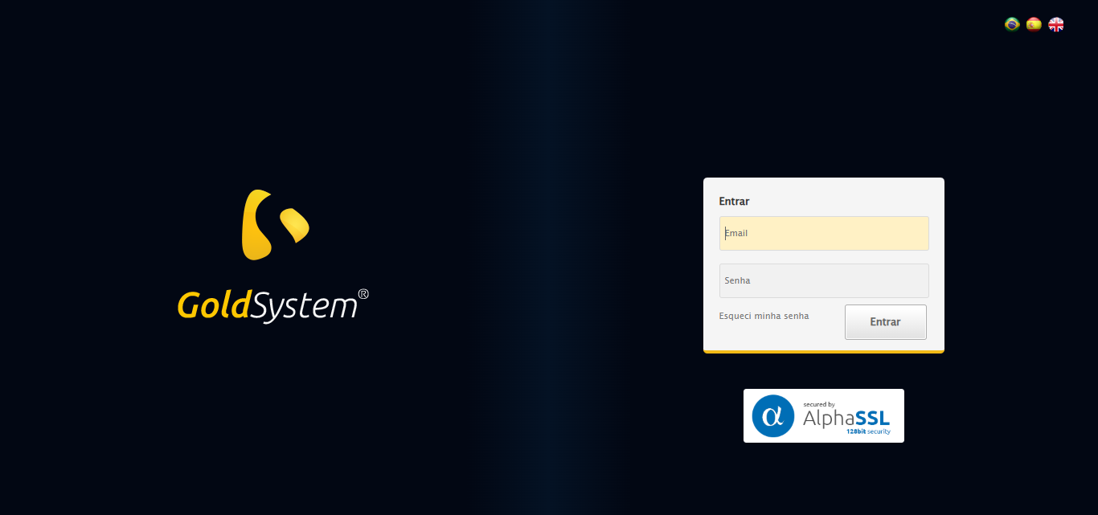

🔄 Realizando login...

✅ Realizando login realizada com sucesso.

Screenshot: realizando login

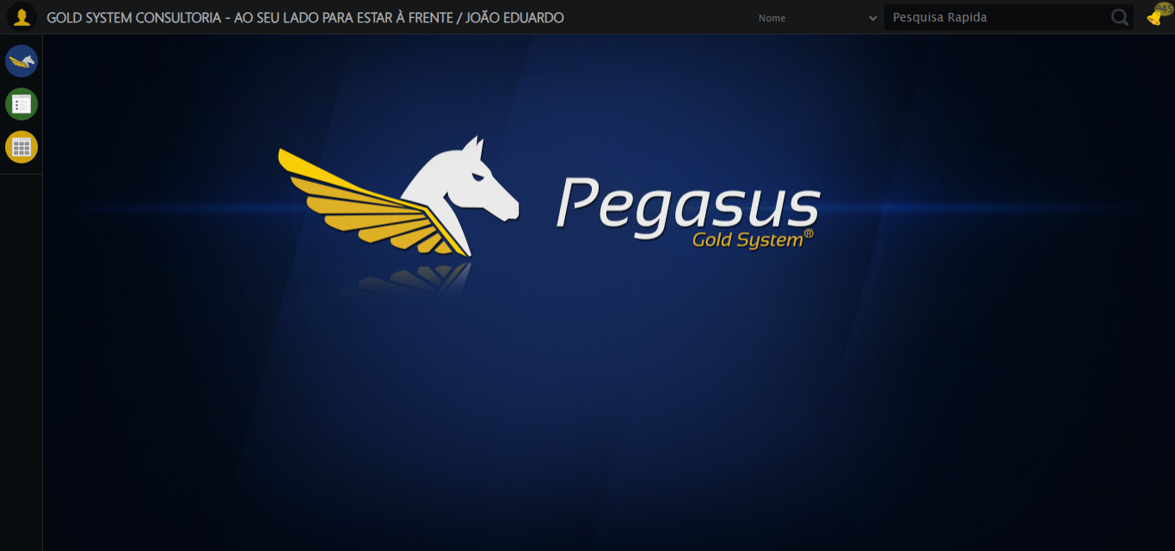

🔄 Ajustando zoom e abrindo menu...

🔍 Zoom ajustado para 90%.

✅ Ajustando zoom e abrindo menu realizada com sucesso.

Screenshot: ajustando zoom e abrindo menu

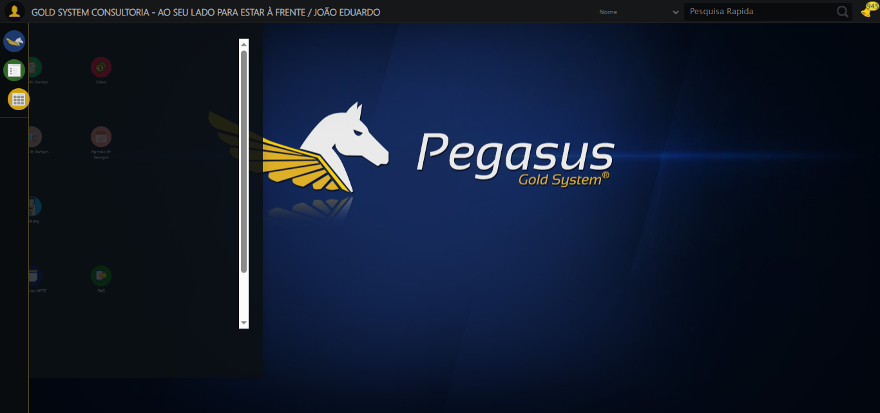

🔄 Acessando Gestor Financeiro...

✅ Acessando Gestor Financeiro realizada com sucesso.

Screenshot: acessando gestor financeiro

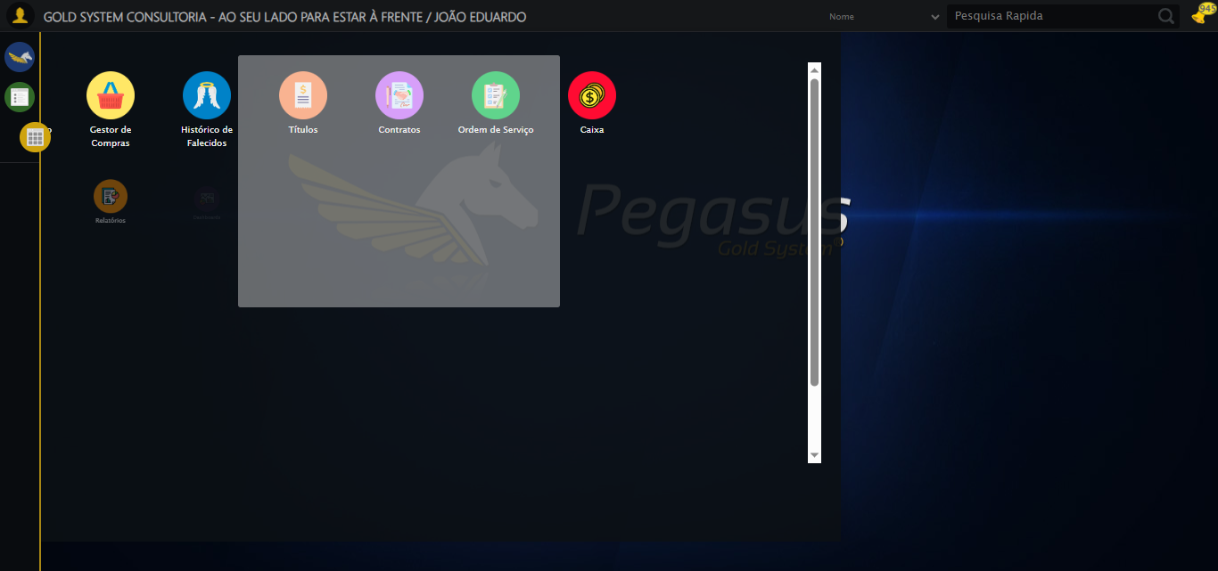

🔄 Clicando em Geração de Títulos...

✅ Clicando em Geração de Títulos realizada com sucesso.

Screenshot: clicando em geração de títulos

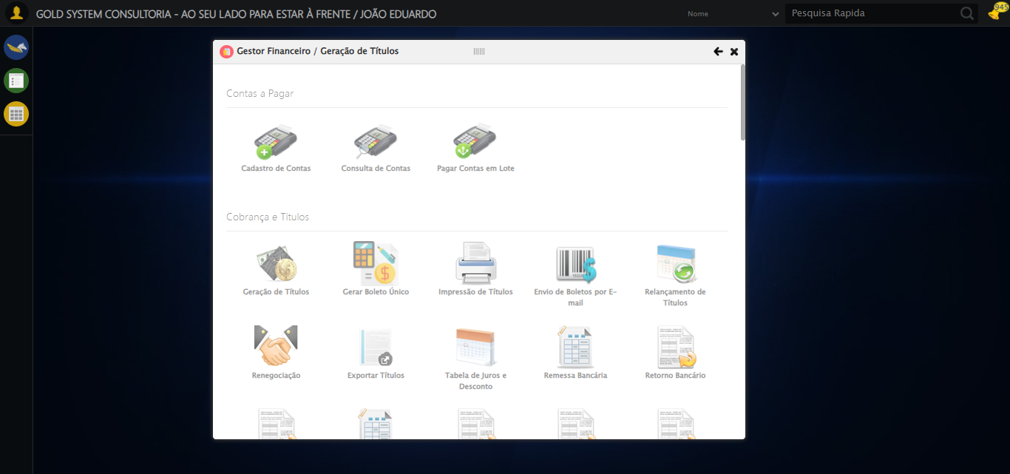

🔄 Selecionando Contratante/Titular...

🔄 Tentativa 1/2 - Modal LOV (JS Puro)

🔍 Localizando botão LOV por índice: 1

✅ Botão LOV #1 localizado

✅ Clique JS em botão LOV

⏳ Aguardando modal carregar...

🔍 Aguardando campo de pesquisa

⚠️ Tentativa 1 falhou: Elemento não encontrado após 15s: //input[@type='text' and @id='txtPesquisa' and @class='campoPesquisa' and @maxlength='30' and @style='width:200px;']

⏳ Aguardando 2.5s antes de retentar...

🔄 Tentativa 2/2 - Modal LOV (JS Puro)

🔍 Localizando botão LOV por índice: 1

✅ Botão LOV #1 localizado

⚠️ Tentativa 2 falhou: Elemento não encontrado após 15s: (//a[@class='sprites sp-openLov'])[2]

❌ Erro inesperado ao selecionando contratante/titular: Falha após 2 tentativas (JS Puro). Último erro: Elemento não encontrado após 15s: (//a[@class='sprites sp-openLov'])[2]

Screenshot: erro_selecionando contratante_titular

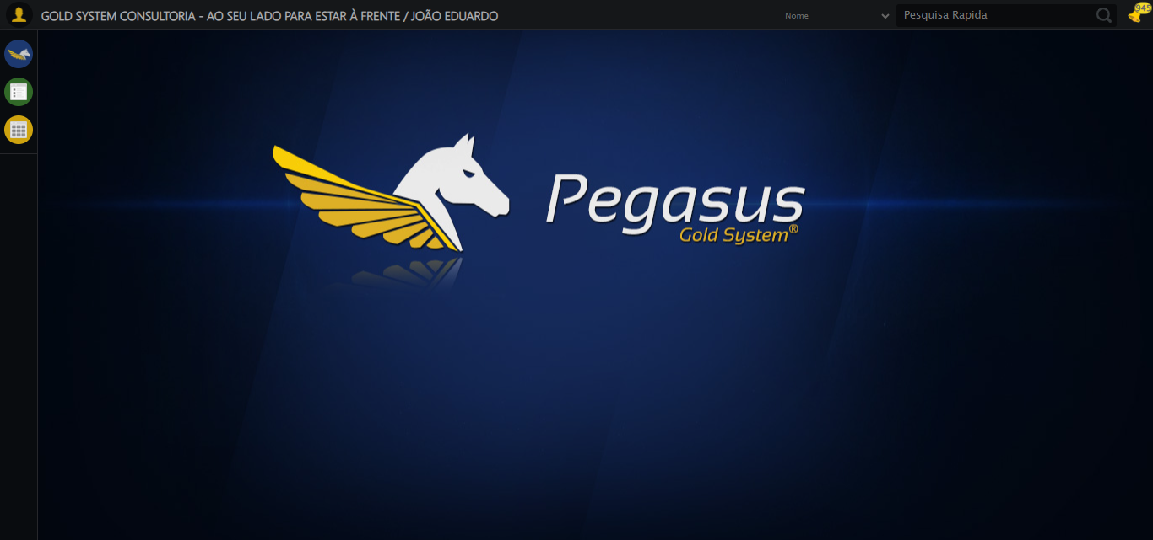

🔄 Pesquisando...

⚠️ Tentativa 1 falhou para Pesquisando, tentando novamente...

🔄 Pesquisando... (Tentativa 2)

✅ Pesquisando realizada com sucesso.

Screenshot: pesquisando

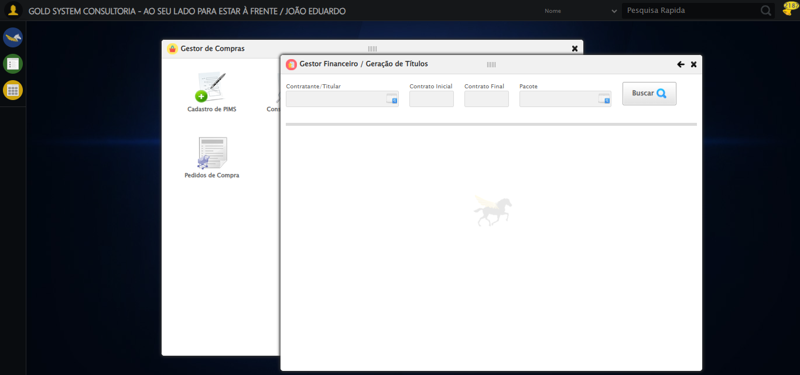

🔄 Verificando resultado da busca de Títulos...

❌ Nenhum Título encontrado

✅ Gestor Financeiro fechado.

✅ Verificando resultado da busca de Títulos realizada com sucesso.

Screenshot: verificando resultado da busca de títulos

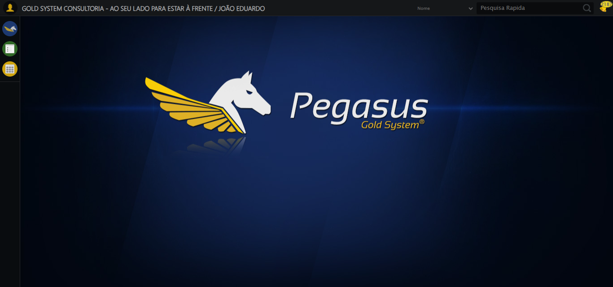

➡️ Título encontrado. Prosseguindo com as próximas ações...

🔄 Preenchendo Data Inicial...

📊 Encontrados 0 campos datepicker

Nenhum campo datepicker encontrado, tentativa 1/5

📊 Encontrados 0 campos datepicker

Nenhum campo datepicker encontrado, tentativa 2/5

📊 Encontrados 0 campos datepicker

Nenhum campo datepicker encontrado, tentativa 3/5

📊 Encontrados 0 campos datepicker

Nenhum campo datepicker encontrado, tentativa 4/5

📊 Encontrados 0 campos datepicker

❌ Erro inesperado ao preenchendo data inicial: Nenhum campo datepicker encontrado na página

Screenshot: erro_preenchendo data inicial



🔄 Preenchendo Data Final...

📊 Encontrados 0 campos datepicker

Nenhum campo datepicker encontrado, tentativa 1/5

📊 Encontrados 0 campos datepicker

Nenhum campo datepicker encontrado, tentativa 2/5

📊 Encontrados 0 campos datepicker

Nenhum campo datepicker encontrado, tentativa 3/5

📊 Encontrados 0 campos datepicker

Nenhum campo datepicker encontrado, tentativa 4/5

📊 Encontrados 0 campos datepicker

❌ Erro inesperado ao preenchendo data final: Nenhum campo datepicker encontrado na página

Screenshot: erro_preenchendo data final



🔄 Preenchendo Dia de Vencimento...

⚠️ Tentativa 1 falhou: Message:

⚠️ Tentativa 2 falhou: Message:

⚠️ Tentativa 3 falhou: Message:

✅ Preenchendo Dia de Vencimento realizada com sucesso.

Screenshot: preenchendo dia de vencimento

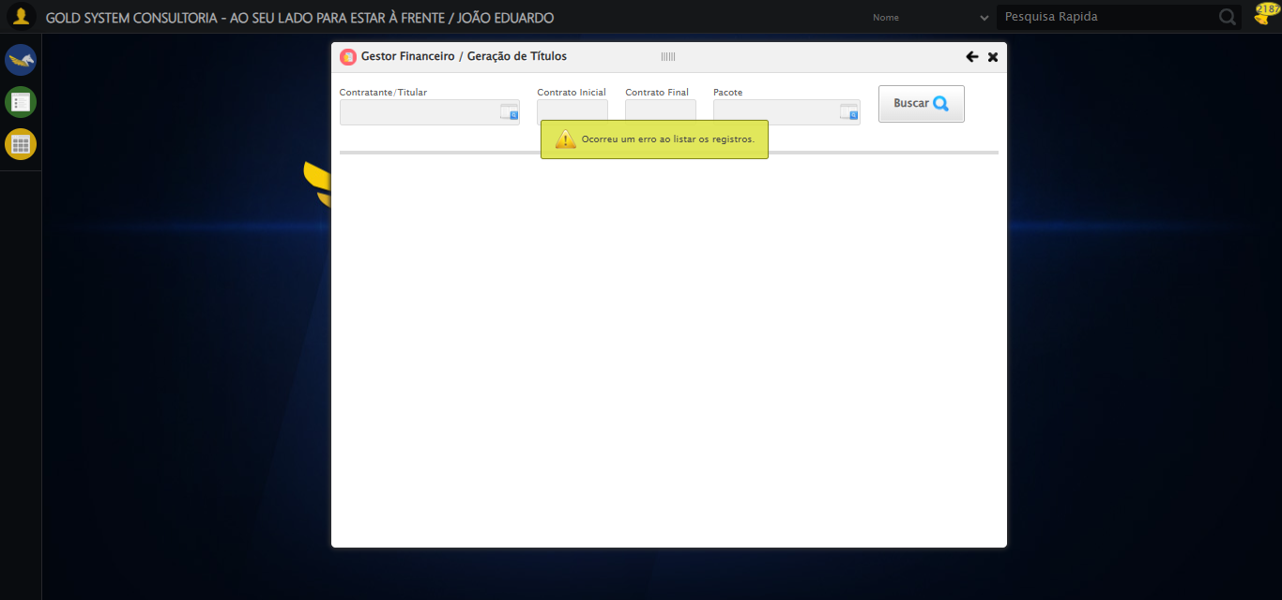

🔄 Preenchendo Quantidade de Parcelas...

⚠️ Tentativa 1 falhou: Message:

⚠️ Tentativa 2 falhou: Message:

⚠️ Tentativa 3 falhou: Message: invalid session id: session deleted as the browser has closed the connection  
from disconnected: not connected to DevTools  
 (Session info: chrome=140.0.7339.208); For documentation on this error, please visit: https://www.selenium.dev/documentation/webdriver/troubleshooting/errors#invalidsessionidexception  
Stacktrace:  
 GetHandleVerifier [0x0xe9c333+65459]  
 GetHandleVerifier [0x0xe9c374+65524]  
 (No symbol) [0x0xcbd973]  
 (No symbol) [0x0xcacdf0]  
 (No symbol) [0x0xccb4af]  
 (No symbol) [0x0xd30775]  
 (No symbol) [0x0xd4aef9]  
 (No symbol) [0x0xd29bf6]  
 (No symbol) [0x0xcfb38e]  
 (No symbol) [0x0xcfc274]  
 GetHandleVerifier [0x0x111eda3+2697763]  
 GetHandleVerifier [0x0x1119ec7+2677575]  
 GetHandleVerifier [0x0xec4194+228884]  
 GetHandleVerifier [0x0xeb49f8+165496]  
 GetHandleVerifier [0x0xebb18d+192013]  
 GetHandleVerifier [0x0xea47d8+99416]  
 GetHandleVerifier [0x0xea4972+99826]  
 GetHandleVerifier [0x0xe8ebea+10346]  
 BaseThreadInitThunk [0x0x755bfcc9+25]  
 RtlGetAppContainerNamedObjectPath [0x0x773a82ae+286]  
 RtlGetAppContainerNamedObjectPath [0x0x773a827e+238]

✅ Preenchendo Quantidade de Parcelas realizada com sucesso.

⚠️ Erro ao tirar screenshot preenchendo quantidade de parcelas: Message: invalid session id; For documentation on this error, please visit: https://www.selenium.dev/documentation/webdriver/troubleshooting/errors#invalidsessionidexception  
Stacktrace:  
 GetHandleVerifier [0x0xe9c333+65459]  
 GetHandleVerifier [0x0xe9c374+65524]  
 (No symbol) [0x0xcbd7c0]  
 (No symbol) [0x0xcfa663]  
 (No symbol) [0x0xd29cb6]  
 (No symbol) [0x0xd2555e]  
 (No symbol) [0x0xd24ad3]  
 (No symbol) [0x0xc8e73d]  
 (No symbol) [0x0xc8ecbe]  
 (No symbol) [0x0xc8f15d]  
 GetHandleVerifier [0x0x111eda3+2697763]  
 GetHandleVerifier [0x0x1119ec7+2677575]  
 GetHandleVerifier [0x0xec4194+228884]  
 GetHandleVerifier [0x0xeb49f8+165496]  
 GetHandleVerifier [0x0xebb18d+192013]  
 (No symbol) [0x0xc8e3f2]  
 (No symbol) [0x0xc8db72]  
 GetHandleVerifier [0x0x127340c+4092044]  
 BaseThreadInitThunk [0x0x755bfcc9+25]  
 RtlGetAppContainerNamedObjectPath [0x0x773a82ae+286]  
 RtlGetAppContainerNamedObjectPath [0x0x773a827e+238]

🔄 Preenchendo Valor das Parcelas...

⚠️ Tentativa 1 falhou: Message: invalid session id; For documentation on this error, please visit: https://www.selenium.dev/documentation/webdriver/troubleshooting/errors#invalidsessionidexception  
Stacktrace:  
 GetHandleVerifier [0x0xe9c333+65459]  
 GetHandleVerifier [0x0xe9c374+65524]  
 (No symbol) [0x0xcbd7c0]  
 (No symbol) [0x0xcfa663]  
 (No symbol) [0x0xd29cb6]  
 (No symbol) [0x0xd2555e]  
 (No symbol) [0x0xd24ad3]  
 (No symbol) [0x0xc8e73d]  
 (No symbol) [0x0xc8ecbe]  
 (No symbol) [0x0xc8f15d]  
 GetHandleVerifier [0x0x111eda3+2697763]  
 GetHandleVerifier [0x0x1119ec7+2677575]  
 GetHandleVerifier [0x0xec4194+228884]  
 GetHandleVerifier [0x0xeb49f8+165496]  
 GetHandleVerifier [0x0xebb18d+192013]  
 (No symbol) [0x0xc8e3f2]  
 (No symbol) [0x0xc8db72]  
 GetHandleVerifier [0x0x127340c+4092044]  
 BaseThreadInitThunk [0x0x755bfcc9+25]  
 RtlGetAppContainerNamedObjectPath [0x0x773a82ae+286]  
 RtlGetAppContainerNamedObjectPath [0x0x773a827e+238]

⚠️ Tentativa 2 falhou: Message: invalid session id; For documentation on this error, please visit: https://www.selenium.dev/documentation/webdriver/troubleshooting/errors#invalidsessionidexception  
Stacktrace:  
 GetHandleVerifier [0x0xe9c333+65459]  
 GetHandleVerifier [0x0xe9c374+65524]  
 (No symbol) [0x0xcbd7c0]  
 (No symbol) [0x0xcfa663]  
 (No symbol) [0x0xd29cb6]  
 (No symbol) [0x0xd2555e]  
 (No symbol) [0x0xd24ad3]  
 (No symbol) [0x0xc8e73d]  
 (No symbol) [0x0xc8ecbe]  
 (No symbol) [0x0xc8f15d]  
 GetHandleVerifier [0x0x111eda3+2697763]  
 GetHandleVerifier [0x0x1119ec7+2677575]  
 GetHandleVerifier [0x0xec4194+228884]  
 GetHandleVerifier [0x0xeb49f8+165496]  
 GetHandleVerifier [0x0xebb18d+192013]  
 (No symbol) [0x0xc8e3f2]  
 (No symbol) [0x0xc8db72]  
 GetHandleVerifier [0x0x127340c+4092044]  
 BaseThreadInitThunk [0x0x755bfcc9+25]  
 RtlGetAppContainerNamedObjectPath [0x0x773a82ae+286]  
 RtlGetAppContainerNamedObjectPath [0x0x773a827e+238]

⚠️ Tentativa 3 falhou: Message: invalid session id; For documentation on this error, please visit: https://www.selenium.dev/documentation/webdriver/troubleshooting/errors#invalidsessionidexception  
Stacktrace:  
 GetHandleVerifier [0x0xe9c333+65459]  
 GetHandleVerifier [0x0xe9c374+65524]  
 (No symbol) [0x0xcbd7c0]  
 (No symbol) [0x0xcfa663]  
 (No symbol) [0x0xd29cb6]  
 (No symbol) [0x0xd2555e]  
 (No symbol) [0x0xd24ad3]  
 (No symbol) [0x0xc8e73d]  
 (No symbol) [0x0xc8ecbe]  
 (No symbol) [0x0xc8f15d]  
 GetHandleVerifier [0x0x111eda3+2697763]  
 GetHandleVerifier [0x0x1119ec7+2677575]  
 GetHandleVerifier [0x0xec4194+228884]  
 GetHandleVerifier [0x0xeb49f8+165496]  
 GetHandleVerifier [0x0xebb18d+192013]  
 (No symbol) [0x0xc8e3f2]  
 (No symbol) [0x0xc8db72]  
 GetHandleVerifier [0x0x127340c+4092044]  
 BaseThreadInitThunk [0x0x755bfcc9+25]  
 RtlGetAppContainerNamedObjectPath [0x0x773a82ae+286]  
 RtlGetAppContainerNamedObjectPath [0x0x773a827e+238]

✅ Preenchendo Valor das Parcelas realizada com sucesso.

⚠️ Erro ao tirar screenshot preenchendo valor das parcelas: Message: invalid session id; For documentation on this error, please visit: https://www.selenium.dev/documentation/webdriver/troubleshooting/errors#invalidsessionidexception  
Stacktrace:  
 GetHandleVerifier [0x0xe9c333+65459]  
 GetHandleVerifier [0x0xe9c374+65524]  
 (No symbol) [0x0xcbd7c0]  
 (No symbol) [0x0xcfa663]  
 (No symbol) [0x0xd29cb6]  
 (No symbol) [0x0xd2555e]  
 (No symbol) [0x0xd24ad3]  
 (No symbol) [0x0xc8e73d]  
 (No symbol) [0x0xc8ecbe]  
 (No symbol) [0x0xc8f15d]  
 GetHandleVerifier [0x0x111eda3+2697763]  
 GetHandleVerifier [0x0x1119ec7+2677575]  
 GetHandleVerifier [0x0xec4194+228884]  
 GetHandleVerifier [0x0xeb49f8+165496]  
 GetHandleVerifier [0x0xebb18d+192013]  
 (No symbol) [0x0xc8e3f2]  
 (No symbol) [0x0xc8db72]  
 GetHandleVerifier [0x0x127340c+4092044]  
 BaseThreadInitThunk [0x0x755bfcc9+25]  
 RtlGetAppContainerNamedObjectPath [0x0x773a82ae+286]  
 RtlGetAppContainerNamedObjectPath [0x0x773a827e+238]

🔄 Selecionando Tipo de Mensalidade...

🔄 Tentativa 1/2 - Modal LOV (JS Puro)

🔍 Localizando botão LOV por índice: 3

⚠️ Erro JS: Message: invalid session id; For documentation on this error, please visit: https://www.selenium.dev

⚠️ Tentativa 1 falhou: Message: invalid session id; For documentation on this error, please visit: https://www.selenium.dev/documentation/webdriver/troubleshooting/errors#invalidsessionidexception  
Stacktrace:  
 GetHandleVeri

⚠️ Erro JS: Message: invalid session id; For documentation on this error, please visit: https://www.selenium.dev

⏳ Aguardando 2.5s antes de retentar...

🔄 Tentativa 2/2 - Modal LOV (JS Puro)

🔍 Localizando botão LOV por índice: 3

⚠️ Erro JS: Message: invalid session id; For documentation on this error, please visit: https://www.selenium.dev

⚠️ Tentativa 2 falhou: Message: invalid session id; For documentation on this error, please visit: https://www.selenium.dev/documentation/webdriver/troubleshooting/errors#invalidsessionidexception  
Stacktrace:  
 GetHandleVeri

⚠️ Erro JS: Message: invalid session id; For documentation on this error, please visit: https://www.selenium.dev

❌ Erro inesperado ao selecionando tipo de mensalidade: Falha após 2 tentativas (JS Puro). Último erro: Message: invalid session id; For documentation on this error, please visit: https://www.selenium.dev/documentation/webdriver/troubleshooting/errors#invalidsessionidexception  
Stacktrace:  
 GetHandleVerifier [0x0xe9c333+65459]  
 GetHandleVerifier [0x0xe9c374+65524]  
 (No symbol) [0x0xcbd7c0]  
 (No symbol) [0x0xcfa663]  
 (No symbol) [0x0xd29cb6]  
 (No symbol) [0x0xd2555e]  
 (No symbol) [0x0xd24ad3]  
 (No symbol) [0x0xc8e73d]  
 (No symbol) [0x0xc8ecbe]  
 (No symbol) [0x0xc8f15d]  
 GetHandleVerifier [0x0x111eda3+2697763]  
 GetHandleVerifier [0x0x1119ec7+2677575]  
 GetHandleVerifier [0x0xec4194+228884]  
 GetHandleVerifier [0x0xeb49f8+165496]  
 GetHandleVerifier [0x0xebb18d+192013]  
 (No symbol) [0x0xc8e3f2]  
 (No symbol) [0x0xc8db72]  
 GetHandleVerifier [0x0x127340c+4092044]  
 BaseThreadInitThunk [0x0x755bfcc9+25]  
 RtlGetAppContainerNamedObjectPath [0x0x773a82ae+286]  
 RtlGetAppContainerNamedObjectPath [0x0x773a827e+238]

⚠️ Erro ao tirar screenshot erro_selecionando tipo de mensalidade: Message: invalid session id; For documentation on this error, please visit: https://www.selenium.dev/documentation/webdriver/troubleshooting/errors#invalidsessionidexception  
Stacktrace:  
 GetHandleVerifier [0x0xe9c333+65459]  
 GetHandleVerifier [0x0xe9c374+65524]  
 (No symbol) [0x0xcbd7c0]  
 (No symbol) [0x0xcfa663]  
 (No symbol) [0x0xd29cb6]  
 (No symbol) [0x0xd2555e]  
 (No symbol) [0x0xd24ad3]  
 (No symbol) [0x0xc8e73d]  
 (No symbol) [0x0xc8ecbe]  
 (No symbol) [0x0xc8f15d]  
 GetHandleVerifier [0x0x111eda3+2697763]  
 GetHandleVerifier [0x0x1119ec7+2677575]  
 GetHandleVerifier [0x0xec4194+228884]  
 GetHandleVerifier [0x0xeb49f8+165496]  
 GetHandleVerifier [0x0xebb18d+192013]  
 (No symbol) [0x0xc8e3f2]  
 (No symbol) [0x0xc8db72]  
 GetHandleVerifier [0x0x127340c+4092044]  
 BaseThreadInitThunk [0x0x755bfcc9+25]  
 RtlGetAppContainerNamedObjectPath [0x0x773a82ae+286]  
 RtlGetAppContainerNamedObjectPath [0x0x773a827e+238]

🔄 Marcando checkbox: Ano de vencimento/competência do título...

❌ Erro inesperado ao marcando checkbox: ano de vencimento/competência do título: Message: invalid session id; For documentation on this error, please visit: https://www.selenium.dev/documentation/webdriver/troubleshooting/errors#invalidsessionidexception  
Stacktrace:  
 GetHandleVerifier [0x0xe9c333+65459]  
 GetHandleVerifier [0x0xe9c374+65524]  
 (No symbol) [0x0xcbd7c0]  
 (No symbol) [0x0xcfa663]  
 (No symbol) [0x0xd29cb6]  
 (No symbol) [0x0xd2555e]  
 (No symbol) [0x0xd24ad3]  
 (No symbol) [0x0xc8e73d]  
 (No symbol) [0x0xc8ecbe]  
 (No symbol) [0x0xc8f15d]  
 GetHandleVerifier [0x0x111eda3+2697763]  
 GetHandleVerifier [0x0x1119ec7+2677575]  
 GetHandleVerifier [0x0xec4194+228884]  
 GetHandleVerifier [0x0xeb49f8+165496]  
 GetHandleVerifier [0x0xebb18d+192013]  
 (No symbol) [0x0xc8e3f2]  
 (No symbol) [0x0xc8db72]  
 GetHandleVerifier [0x0x127340c+4092044]  
 BaseThreadInitThunk [0x0x755bfcc9+25]  
 RtlGetAppContainerNamedObjectPath [0x0x773a82ae+286]  
 RtlGetAppContainerNamedObjectPath [0x0x773a827e+238]

⚠️ Erro ao tirar screenshot erro_marcando checkbox_ ano de vencimento_competência do título: Message: invalid session id; For documentation on this error, please visit: https://www.selenium.dev/documentation/webdriver/troubleshooting/errors#invalidsessionidexception  
Stacktrace:  
 GetHandleVerifier [0x0xe9c333+65459]  
 GetHandleVerifier [0x0xe9c374+65524]  
 (No symbol) [0x0xcbd7c0]  
 (No symbol) [0x0xcfa663]  
 (No symbol) [0x0xd29cb6]  
 (No symbol) [0x0xd2555e]  
 (No symbol) [0x0xd24ad3]  
 (No symbol) [0x0xc8e73d]  
 (No symbol) [0x0xc8ecbe]  
 (No symbol) [0x0xc8f15d]  
 GetHandleVerifier [0x0x111eda3+2697763]  
 GetHandleVerifier [0x0x1119ec7+2677575]  
 GetHandleVerifier [0x0xec4194+228884]  
 GetHandleVerifier [0x0xeb49f8+165496]  
 GetHandleVerifier [0x0xebb18d+192013]  
 (No symbol) [0x0xc8e3f2]  
 (No symbol) [0x0xc8db72]  
 GetHandleVerifier [0x0x127340c+4092044]  
 BaseThreadInitThunk [0x0x755bfcc9+25]  
 RtlGetAppContainerNamedObjectPath [0x0x773a82ae+286]  
 RtlGetAppContainerNamedObjectPath [0x0x773a827e+238]

🔄 Preenchendo Ano Competência...

⚠️ Tentativa 1 falhou: Message: invalid session id; For documentation on this error, please visit: https://www.selenium.dev/documentation/webdriver/troubleshooting/errors#invalidsessionidexception  
Stacktrace:  
 GetHandleVerifier [0x0xe9c333+65459]  
 GetHandleVerifier [0x0xe9c374+65524]  
 (No symbol) [0x0xcbd7c0]  
 (No symbol) [0x0xcfa663]  
 (No symbol) [0x0xd29cb6]  
 (No symbol) [0x0xd2555e]  
 (No symbol) [0x0xd24ad3]  
 (No symbol) [0x0xc8e73d]  
 (No symbol) [0x0xc8ecbe]  
 (No symbol) [0x0xc8f15d]  
 GetHandleVerifier [0x0x111eda3+2697763]  
 GetHandleVerifier [0x0x1119ec7+2677575]  
 GetHandleVerifier [0x0xec4194+228884]  
 GetHandleVerifier [0x0xeb49f8+165496]  
 GetHandleVerifier [0x0xebb18d+192013]  
 (No symbol) [0x0xc8e3f2]  
 (No symbol) [0x0xc8db72]  
 GetHandleVerifier [0x0x127340c+4092044]  
 BaseThreadInitThunk [0x0x755bfcc9+25]  
 RtlGetAppContainerNamedObjectPath [0x0x773a82ae+286]  
 RtlGetAppContainerNamedObjectPath [0x0x773a827e+238]

⚠️ Tentativa 2 falhou: Message: invalid session id; For documentation on this error, please visit: https://www.selenium.dev/documentation/webdriver/troubleshooting/errors#invalidsessionidexception  
Stacktrace:  
 GetHandleVerifier [0x0xe9c333+65459]  
 GetHandleVerifier [0x0xe9c374+65524]  
 (No symbol) [0x0xcbd7c0]  
 (No symbol) [0x0xcfa663]  
 (No symbol) [0x0xd29cb6]  
 (No symbol) [0x0xd2555e]  
 (No symbol) [0x0xd24ad3]  
 (No symbol) [0x0xc8e73d]  
 (No symbol) [0x0xc8ecbe]  
 (No symbol) [0x0xc8f15d]  
 GetHandleVerifier [0x0x111eda3+2697763]  
 GetHandleVerifier [0x0x1119ec7+2677575]  
 GetHandleVerifier [0x0xec4194+228884]  
 GetHandleVerifier [0x0xeb49f8+165496]  
 GetHandleVerifier [0x0xebb18d+192013]  
 (No symbol) [0x0xc8e3f2]  
 (No symbol) [0x0xc8db72]  
 GetHandleVerifier [0x0x127340c+4092044]  
 BaseThreadInitThunk [0x0x755bfcc9+25]  
 RtlGetAppContainerNamedObjectPath [0x0x773a82ae+286]  
 RtlGetAppContainerNamedObjectPath [0x0x773a827e+238]

⚠️ Tentativa 3 falhou: Message: invalid session id; For documentation on this error, please visit: https://www.selenium.dev/documentation/webdriver/troubleshooting/errors#invalidsessionidexception  
Stacktrace:  
 GetHandleVerifier [0x0xe9c333+65459]  
 GetHandleVerifier [0x0xe9c374+65524]  
 (No symbol) [0x0xcbd7c0]  
 (No symbol) [0x0xcfa663]  
 (No symbol) [0x0xd29cb6]  
 (No symbol) [0x0xd2555e]  
 (No symbol) [0x0xd24ad3]  
 (No symbol) [0x0xc8e73d]  
 (No symbol) [0x0xc8ecbe]  
 (No symbol) [0x0xc8f15d]  
 GetHandleVerifier [0x0x111eda3+2697763]  
 GetHandleVerifier [0x0x1119ec7+2677575]  
 GetHandleVerifier [0x0xec4194+228884]  
 GetHandleVerifier [0x0xeb49f8+165496]  
 GetHandleVerifier [0x0xebb18d+192013]  
 (No symbol) [0x0xc8e3f2]  
 (No symbol) [0x0xc8db72]  
 GetHandleVerifier [0x0x127340c+4092044]  
 BaseThreadInitThunk [0x0x755bfcc9+25]  
 RtlGetAppContainerNamedObjectPath [0x0x773a82ae+286]  
 RtlGetAppContainerNamedObjectPath [0x0x773a827e+238]

✅ Preenchendo Ano Competência realizada com sucesso.

⚠️ Erro ao tirar screenshot preenchendo ano competência: Message: invalid session id; For documentation on this error, please visit: https://www.selenium.dev/documentation/webdriver/troubleshooting/errors#invalidsessionidexception  
Stacktrace:  
 GetHandleVerifier [0x0xe9c333+65459]  
 GetHandleVerifier [0x0xe9c374+65524]  
 (No symbol) [0x0xcbd7c0]  
 (No symbol) [0x0xcfa663]  
 (No symbol) [0x0xd29cb6]  
 (No symbol) [0x0xd2555e]  
 (No symbol) [0x0xd24ad3]  
 (No symbol) [0x0xc8e73d]  
 (No symbol) [0x0xc8ecbe]  
 (No symbol) [0x0xc8f15d]  
 GetHandleVerifier [0x0x111eda3+2697763]  
 GetHandleVerifier [0x0x1119ec7+2677575]  
 GetHandleVerifier [0x0xec4194+228884]  
 GetHandleVerifier [0x0xeb49f8+165496]  
 GetHandleVerifier [0x0xebb18d+192013]  
 (No symbol) [0x0xc8e3f2]  
 (No symbol) [0x0xc8db72]  
 GetHandleVerifier [0x0x127340c+4092044]  
 BaseThreadInitThunk [0x0x755bfcc9+25]  
 RtlGetAppContainerNamedObjectPath [0x0x773a82ae+286]  
 RtlGetAppContainerNamedObjectPath [0x0x773a827e+238]

🔄 Clicando em 'Gerar'...

❌ Erro inesperado ao clicando em 'gerar': Message: invalid session id; For documentation on this error, please visit: https://www.selenium.dev/documentation/webdriver/troubleshooting/errors#invalidsessionidexception  
Stacktrace:  
 GetHandleVerifier [0x0xe9c333+65459]  
 GetHandleVerifier [0x0xe9c374+65524]  
 (No symbol) [0x0xcbd7c0]  
 (No symbol) [0x0xcfa663]  
 (No symbol) [0x0xd29cb6]  
 (No symbol) [0x0xd2555e]  
 (No symbol) [0x0xd24ad3]  
 (No symbol) [0x0xc8e73d]  
 (No symbol) [0x0xc8ecbe]  
 (No symbol) [0x0xc8f15d]  
 GetHandleVerifier [0x0x111eda3+2697763]  
 GetHandleVerifier [0x0x1119ec7+2677575]  
 GetHandleVerifier [0x0xec4194+228884]  
 GetHandleVerifier [0x0xeb49f8+165496]  
 GetHandleVerifier [0x0xebb18d+192013]  
 (No symbol) [0x0xc8e3f2]  
 (No symbol) [0x0xc8db72]  
 GetHandleVerifier [0x0x127340c+4092044]  
 BaseThreadInitThunk [0x0x755bfcc9+25]  
 RtlGetAppContainerNamedObjectPath [0x0x773a82ae+286]  
 RtlGetAppContainerNamedObjectPath [0x0x773a827e+238]

⚠️ Erro ao tirar screenshot erro_clicando em _gerar_: Message: invalid session id; For documentation on this error, please visit: https://www.selenium.dev/documentation/webdriver/troubleshooting/errors#invalidsessionidexception  
Stacktrace:  
 GetHandleVerifier [0x0xe9c333+65459]  
 GetHandleVerifier [0x0xe9c374+65524]  
 (No symbol) [0x0xcbd7c0]  
 (No symbol) [0x0xcfa663]  
 (No symbol) [0x0xd29cb6]  
 (No symbol) [0x0xd2555e]  
 (No symbol) [0x0xd24ad3]  
 (No symbol) [0x0xc8e73d]  
 (No symbol) [0x0xc8ecbe]  
 (No symbol) [0x0xc8f15d]  
 GetHandleVerifier [0x0x111eda3+2697763]  
 GetHandleVerifier [0x0x1119ec7+2677575]  
 GetHandleVerifier [0x0xec4194+228884]  
 GetHandleVerifier [0x0xeb49f8+165496]  
 GetHandleVerifier [0x0xebb18d+192013]  
 (No symbol) [0x0xc8e3f2]  
 (No symbol) [0x0xc8db72]  
 GetHandleVerifier [0x0x127340c+4092044]  
 BaseThreadInitThunk [0x0x755bfcc9+25]  
 RtlGetAppContainerNamedObjectPath [0x0x773a82ae+286]  
 RtlGetAppContainerNamedObjectPath [0x0x773a827e+238]

🔄 Confirmando...

❌ Erro inesperado ao confirmando: Message: invalid session id; For documentation on this error, please visit: https://www.selenium.dev/documentation/webdriver/troubleshooting/errors#invalidsessionidexception  
Stacktrace:  
 GetHandleVerifier [0x0xe9c333+65459]  
 GetHandleVerifier [0x0xe9c374+65524]  
 (No symbol) [0x0xcbd7c0]  
 (No symbol) [0x0xcfa663]  
 (No symbol) [0x0xd29cb6]  
 (No symbol) [0x0xd2555e]  
 (No symbol) [0x0xd24ad3]  
 (No symbol) [0x0xc8e73d]  
 (No symbol) [0x0xc8ecbe]  
 (No symbol) [0x0xc8f15d]  
 GetHandleVerifier [0x0x111eda3+2697763]  
 GetHandleVerifier [0x0x1119ec7+2677575]  
 GetHandleVerifier [0x0xec4194+228884]  
 GetHandleVerifier [0x0xeb49f8+165496]  
 GetHandleVerifier [0x0xebb18d+192013]  
 (No symbol) [0x0xc8e3f2]  
 (No symbol) [0x0xc8db72]  
 GetHandleVerifier [0x0x127340c+4092044]  
 BaseThreadInitThunk [0x0x755bfcc9+25]  
 RtlGetAppContainerNamedObjectPath [0x0x773a82ae+286]  
 RtlGetAppContainerNamedObjectPath [0x0x773a827e+238]

⚠️ Erro ao tirar screenshot erro_confirmando: Message: invalid session id; For documentation on this error, please visit: https://www.selenium.dev/documentation/webdriver/troubleshooting/errors#invalidsessionidexception  
Stacktrace:  
 GetHandleVerifier [0x0xe9c333+65459]  
 GetHandleVerifier [0x0xe9c374+65524]  
 (No symbol) [0x0xcbd7c0]  
 (No symbol) [0x0xcfa663]  
 (No symbol) [0x0xd29cb6]  
 (No symbol) [0x0xd2555e]  
 (No symbol) [0x0xd24ad3]  
 (No symbol) [0x0xc8e73d]  
 (No symbol) [0x0xc8ecbe]  
 (No symbol) [0x0xc8f15d]  
 GetHandleVerifier [0x0x111eda3+2697763]  
 GetHandleVerifier [0x0x1119ec7+2677575]  
 GetHandleVerifier [0x0xec4194+228884]  
 GetHandleVerifier [0x0xeb49f8+165496]  
 GetHandleVerifier [0x0xebb18d+192013]  
 (No symbol) [0x0xc8e3f2]  
 (No symbol) [0x0xc8db72]  
 GetHandleVerifier [0x0x127340c+4092044]  
 BaseThreadInitThunk [0x0x755bfcc9+25]  
 RtlGetAppContainerNamedObjectPath [0x0x773a82ae+286]  
 RtlGetAppContainerNamedObjectPath [0x0x773a827e+238]

🔍 Verificando mensagens de alerta

ℹ️ Nenhuma mensagem de alerta encontrada.

🔄 Fechando modal Gestor Financeiro...

❌ Erro inesperado ao fechando modal gestor financeiro: Message: invalid session id; For documentation on this error, please visit: https://www.selenium.dev/documentation/webdriver/troubleshooting/errors#invalidsessionidexception  
Stacktrace:  
 GetHandleVerifier [0x0xe9c333+65459]  
 GetHandleVerifier [0x0xe9c374+65524]  
 (No symbol) [0x0xcbd7c0]  
 (No symbol) [0x0xcfa663]  
 (No symbol) [0x0xd29cb6]  
 (No symbol) [0x0xd2555e]  
 (No symbol) [0x0xd24ad3]  
 (No symbol) [0x0xc8e73d]  
 (No symbol) [0x0xc8ecbe]  
 (No symbol) [0x0xc8f15d]  
 GetHandleVerifier [0x0x111eda3+2697763]  
 GetHandleVerifier [0x0x1119ec7+2677575]  
 GetHandleVerifier [0x0xec4194+228884]  
 GetHandleVerifier [0x0xeb49f8+165496]  
 GetHandleVerifier [0x0xebb18d+192013]  
 (No symbol) [0x0xc8e3f2]  
 (No symbol) [0x0xc8db72]  
 GetHandleVerifier [0x0x127340c+4092044]  
 BaseThreadInitThunk [0x0x755bfcc9+25]  
 RtlGetAppContainerNamedObjectPath [0x0x773a82ae+286]  
 RtlGetAppContainerNamedObjectPath [0x0x773a827e+238]

⚠️ Erro ao tirar screenshot erro_fechando modal gestor financeiro: Message: invalid session id; For documentation on this error, please visit: https://www.selenium.dev/documentation/webdriver/troubleshooting/errors#invalidsessionidexception  
Stacktrace:  
 GetHandleVerifier [0x0xe9c333+65459]  
 GetHandleVerifier [0x0xe9c374+65524]  
 (No symbol) [0x0xcbd7c0]  
 (No symbol) [0x0xcfa663]  
 (No symbol) [0x0xd29cb6]  
 (No symbol) [0x0xd2555e]  
 (No symbol) [0x0xd24ad3]  
 (No symbol) [0x0xc8e73d]  
 (No symbol) [0x0xc8ecbe]  
 (No symbol) [0x0xc8f15d]  
 GetHandleVerifier [0x0x111eda3+2697763]  
 GetHandleVerifier [0x0x1119ec7+2677575]  
 GetHandleVerifier [0x0xec4194+228884]  
 GetHandleVerifier [0x0xeb49f8+165496]  
 GetHandleVerifier [0x0xebb18d+192013]  
 (No symbol) [0x0xc8e3f2]  
 (No symbol) [0x0xc8db72]  
 GetHandleVerifier [0x0x127340c+4092044]  
 BaseThreadInitThunk [0x0x755bfcc9+25]  
 RtlGetAppContainerNamedObjectPath [0x0x773a82ae+286]  
 RtlGetAppContainerNamedObjectPath [0x0x773a827e+238]

✅ Teste concluído.

✅ Teste executado com sucesso!