RELATÓRIO DO TESTE AUTOMATIZADO

Consulta de Locação de Equipamentos - Apoio Ortopédico – Cenário 1

Data do teste: 27/08/2025 16:43:27

[16:43:27] [INFO] Iniciando teste de Consulta de Locação de Equipamentos

[16:43:30] [INFO] ✅ Driver Chrome inicializado com sucesso

[16:43:30] [INFO] 🚀 Iniciando teste de Consulta de Locação de Equipamentos

[16:43:30] [INFO] 🔄 Acessando sistema...

[16:43:31] [INFO] ✅ Acessando sistema realizada com sucesso.

[16:43:32] [INFO] Screenshot capturada: acessando_sistema

Screenshot: acessando_sistema

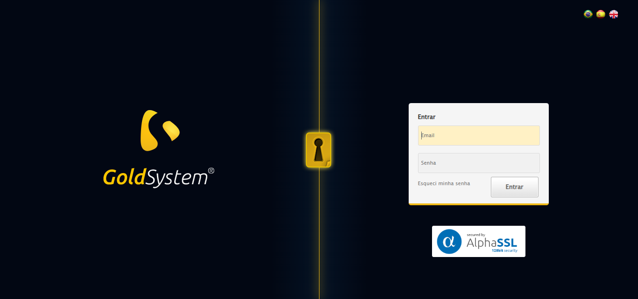

[16:43:32] [INFO] 🔄 Realizando login...

[16:43:37] [INFO] ✅ Realizando login realizada com sucesso.

[16:43:40] [INFO] Screenshot capturada: realizando_login

Screenshot: realizando_login

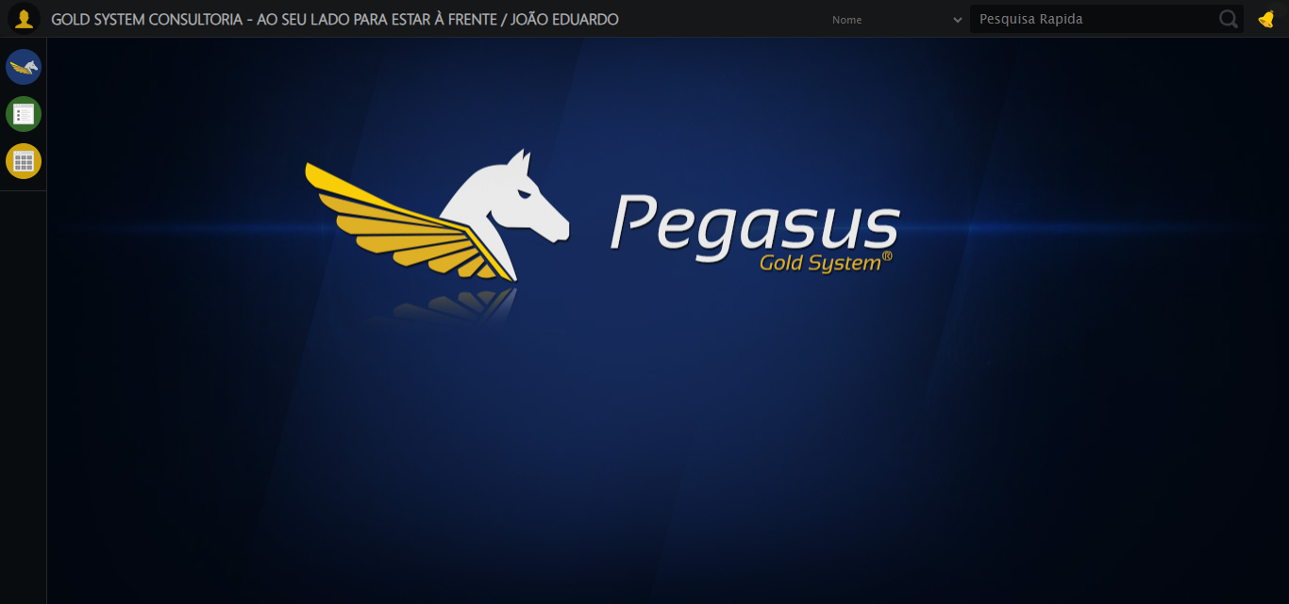

[16:43:40] [INFO] 🔄 Configurando interface...

[16:43:40] [INFO] 🔍 Zoom ajustado para 90%.

[16:43:42] [INFO] ✅ Configurando interface realizada com sucesso.

[16:43:44] [INFO] Screenshot capturada: configurando_interface

Screenshot: configurando_interface

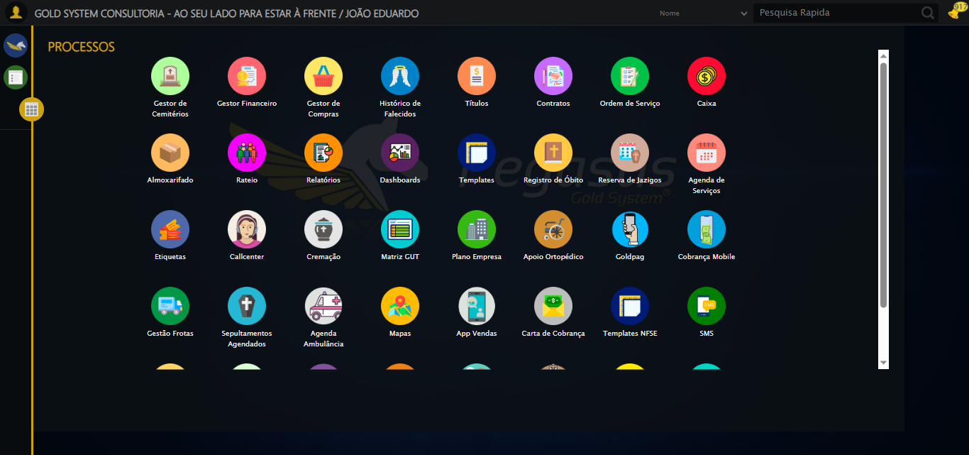

[16:43:44] [INFO] 🔄 Acessando Apoio Ortopédico...

[16:43:45] [INFO] ✅ Clique realizado com estratégia 1

[16:43:45] [INFO] ✅ Acessando Apoio Ortopédico realizada com sucesso.

[16:43:46] [INFO] Screenshot capturada: acessando_apoio_ortopédico

Screenshot: acessando_apoio_ortopédico

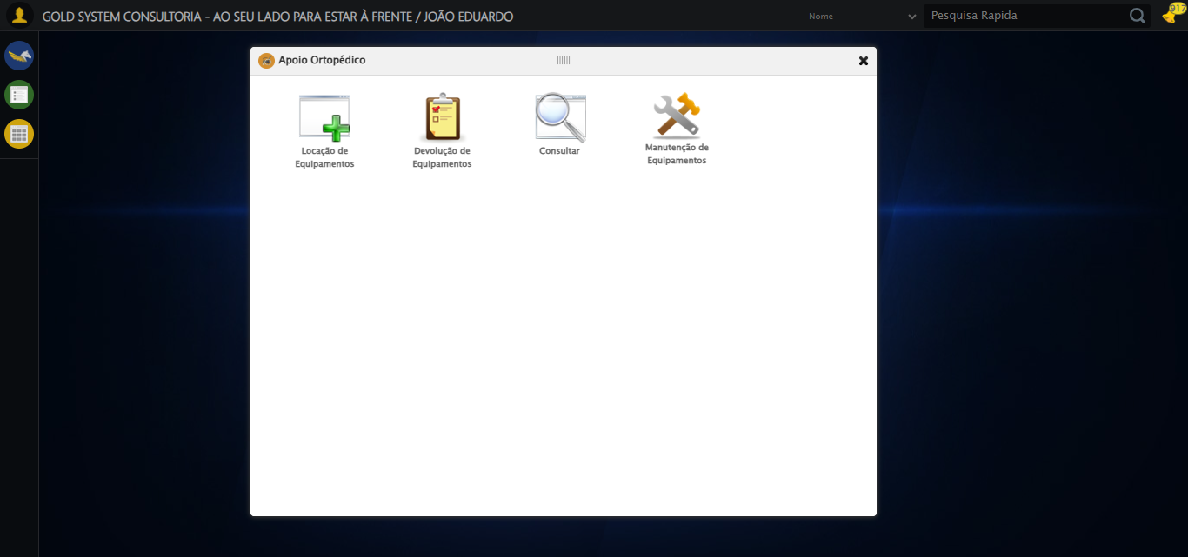

[16:43:46] [INFO] 🔄 Acessando Consulta Locação de Equipamentos...

[16:43:47] [INFO] ✅ Clique realizado com estratégia 1

[16:43:47] [INFO] ✅ Acessando Consulta Locação de Equipamentos realizada com sucesso.

[16:43:48] [INFO] Screenshot capturada: acessando_consulta_locação_de_equipamentos

Screenshot: acessando_consulta_locação_de_equipamentos

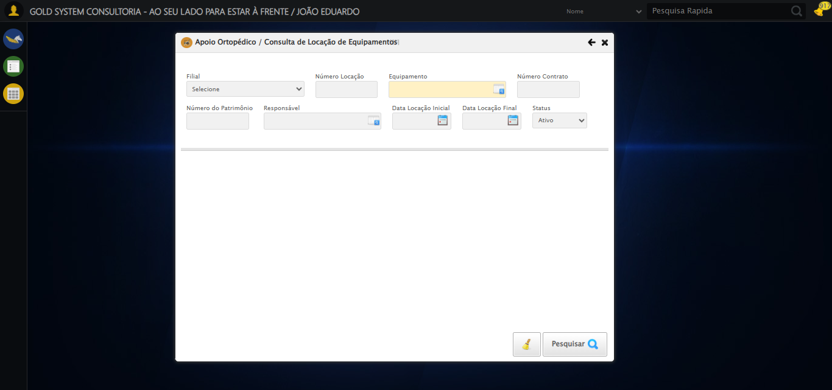

[16:43:51] [INFO] 🔄 Preenchendo Número da Locação...

[16:43:53] [INFO] ✅ Campo preenchido com estratégia 1: '306'

[16:43:53] [INFO] ✅ Preenchendo Número da Locação realizada com sucesso.

[16:43:54] [INFO] Screenshot capturada: preenchendo_número_da_locação

Screenshot: preenchendo_número_da_locação

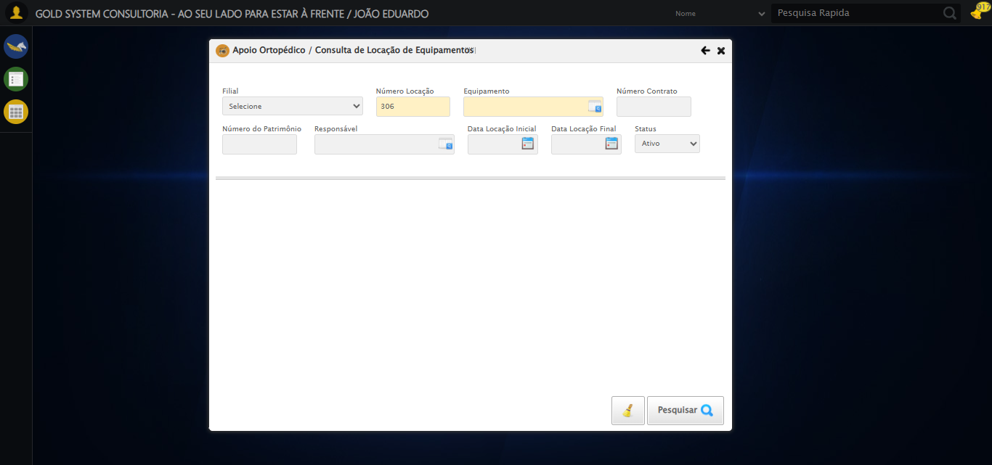

[16:43:54] [INFO] 🔄 Abrindo LOV de Equipamentos...

[16:43:55] [INFO] ✅ Clique realizado com estratégia 1

[16:43:55] [INFO] ✅ Abrindo LOV de Equipamentos realizada com sucesso.

[16:43:56] [INFO] Screenshot capturada: abrindo_lov_de_equipamentos

Screenshot: abrindo_lov_de_equipamentos

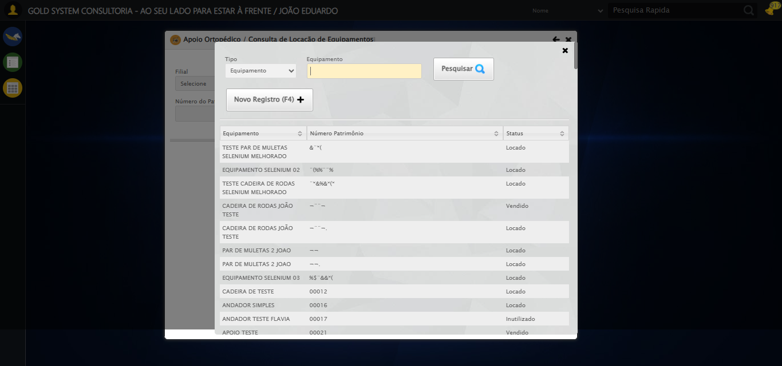

[16:43:56] [INFO] 🔄 Pesquisando equipamento...

[16:43:57] [INFO] ✅ Campo preenchido com estratégia 1: 'EQUIPAMENTO SELENIUM 01'

[16:44:03] [ERROR] ❌ Timeout aguardando elemento: /html/body/div[19]/div[2]/div[1]/div[1]/div[3]/a (timeout: 5s)

[16:44:03] [WARN] ⚠️ Estratégia 1 falhou: Message:

[16:44:03] [WARN] ⚠️ Estratégia 2 falhou: Message: element not interactable: has no size and location  
 (Session info: chrome=139.0.7258.128); For documentation on this error, please visit: https://www.selenium.dev/documentation/webdriver/troubleshooting/errors#elementnotinteractableexception  
Stacktrace:  
 GetHandleVerifier [0x0x7da8a3+63283]  
 GetHandleVerifier [0x0x7da8e4+63348]  
 (No symbol) [0x0x613e43]  
 (No symbol) [0x0x61a609]  
 (No symbol) [0x0x61c97a]  
 (No symbol) [0x0x61c9f7]  
 (No symbol) [0x0x662334]  
 (No symbol) [0x0x6618a7]  
 (No symbol) [0x0x6ab0b8]  
 (No symbol) [0x0x68141c]  
 (No symbol) [0x0x6a271a]  
 (No symbol) [0x0x681216]  
 (No symbol) [0x0x650855]  
 (No symbol) [0x0x6516f4]  
 GetHandleVerifier [0x0xa4bb43+2623955]  
 GetHandleVerifier [0x0xa46daa+2604090]  
 GetHandleVerifier [0x0x80069a+218410]  
 GetHandleVerifier [0x0x7f0ed8+154984]  
 GetHandleVerifier [0x0x7f742d+180925]  
 GetHandleVerifier [0x0x7e22b8+94536]  
 GetHandleVerifier [0x0x7e2442+94930]  
 GetHandleVerifier [0x0x7cd5ea+9338]  
 BaseThreadInitThunk [0x0x76b1fcc9+25]  
 RtlGetAppContainerNamedObjectPath [0x0x776a82ae+286]  
 RtlGetAppContainerNamedObjectPath [0x0x776a827e+238]

[16:44:03] [INFO] ✅ Clique realizado com estratégia 3

[16:44:35] [ERROR] ❌ Timeout aguardando elemento: //tr[td[2][contains(normalize-space(.),'EQUIPAMENTO SELENIUM 01')]] (timeout: 30s)

[16:44:35] [ERROR] ❌ Erro no clique robusto: Message:   
Stacktrace:  
 GetHandleVerifier [0x0x7da8a3+63283]  
 GetHandleVerifier [0x0x7da8e4+63348]  
 (No symbol) [0x0x613e43]  
 (No symbol) [0x0x65c8de]  
 (No symbol) [0x0x65cc7b]  
 (No symbol) [0x0x6a4ef2]  
 (No symbol) [0x0x681464]  
 (No symbol) [0x0x6a271a]  
 (No symbol) [0x0x681216]  
 (No symbol) [0x0x650855]  
 (No symbol) [0x0x6516f4]  
 GetHandleVerifier [0x0xa4bb43+2623955]  
 GetHandleVerifier [0x0xa46daa+2604090]  
 GetHandleVerifier [0x0x80069a+218410]  
 GetHandleVerifier [0x0x7f0ed8+154984]  
 GetHandleVerifier [0x0x7f742d+180925]  
 GetHandleVerifier [0x0x7e22b8+94536]  
 GetHandleVerifier [0x0x7e2442+94930]  
 GetHandleVerifier [0x0x7cd5ea+9338]  
 BaseThreadInitThunk [0x0x76b1fcc9+25]  
 RtlGetAppContainerNamedObjectPath [0x0x776a82ae+286]  
 RtlGetAppContainerNamedObjectPath [0x0x776a827e+238]

[16:44:35] [INFO] ✅ Pesquisando equipamento realizada com sucesso.

[16:44:36] [INFO] Screenshot capturada: pesquisando_equipamento

Screenshot: pesquisando_equipamento

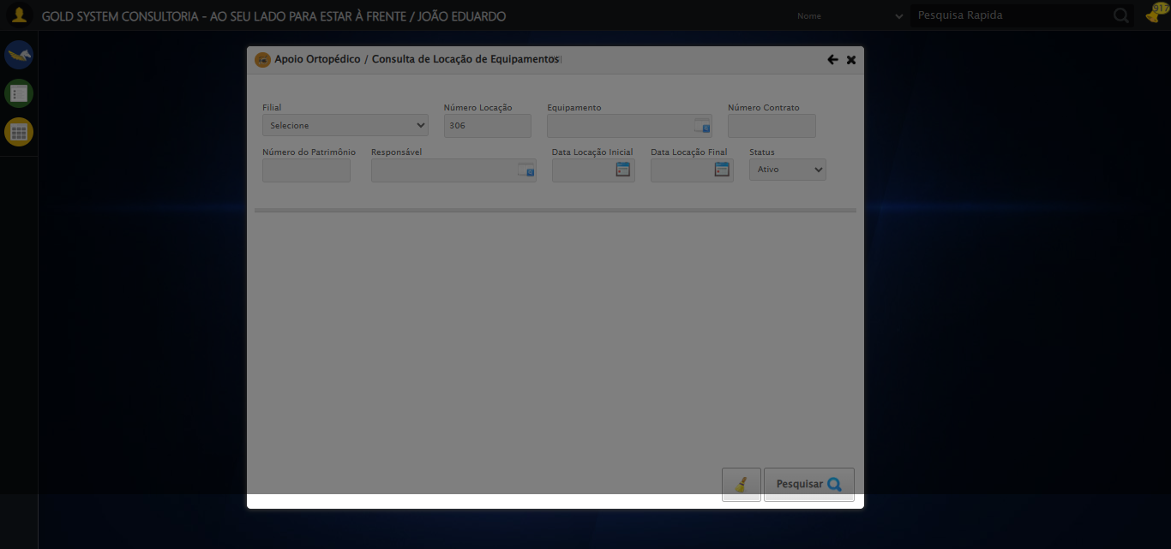

[16:44:36] [INFO] 🔄 Preenchendo Número do Contrato...

[16:44:38] [WARN] ⚠️ Estratégia 1 falhou: Message: element click intercepted: Element <input type="text" maxlength="" class="numeroContrato" style="width: 100px;"> is not clickable at point (900, 146). Other element would receive the click: <div class="blockScreen" style="height: 641px; z-index: 10001; opacity: 0.5;"></div>  
 (Session info: chrome=139.0.7258.128); For documentation on this error, please visit: https://www.selenium.dev/documentation/webdriver/troubleshooting/errors#elementclickinterceptedexception  
Stacktrace:  
 GetHandleVerifier [0x0x7da8a3+63283]  
 GetHandleVerifier [0x0x7da8e4+63348]  
 (No symbol) [0x0x613e43]  
 (No symbol) [0x0x662c20]  
 (No symbol) [0x0x660fda]  
 (No symbol) [0x0x65eb37]  
 (No symbol) [0x0x65ddf4]  
 (No symbol) [0x0x6525b5]  
 (No symbol) [0x0x68141c]  
 (No symbol) [0x0x652044]  
 (No symbol) [0x0x681694]  
 (No symbol) [0x0x6a271a]  
 (No symbol) [0x0x681216]  
 (No symbol) [0x0x650855]  
 (No symbol) [0x0x6516f4]  
 GetHandleVerifier [0x0xa4bb43+2623955]  
 GetHandleVerifier [0x0xa46daa+2604090]  
 GetHandleVerifier [0x0x80069a+218410]  
 GetHandleVerifier [0x0x7f0ed8+154984]  
 GetHandleVerifier [0x0x7f742d+180925]  
 GetHandleVerifier [0x0x7e22b8+94536]  
 GetHandleVerifier [0x0x7e2442+94930]  
 GetHandleVerifier [0x0x7cd5ea+9338]  
 BaseThreadInitThunk [0x0x76b1fcc9+25]  
 RtlGetAppContainerNamedObjectPath [0x0x776a82ae+286]  
 RtlGetAppContainerNamedObjectPath [0x0x776a827e+238]

[16:44:40] [INFO] ✅ Campo preenchido com estratégia 3: '113060'

[16:44:40] [INFO] ✅ Preenchendo Número do Contrato realizada com sucesso.

[16:44:41] [INFO] Screenshot capturada: preenchendo_número_do_contrato

Screenshot: preenchendo_número_do_contrato

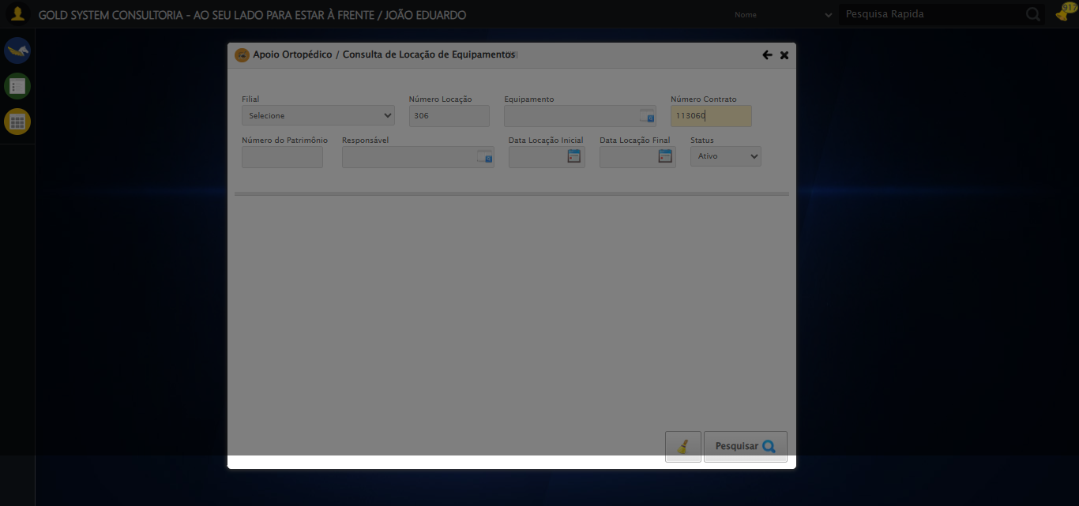

[16:44:41] [INFO] 🔄 Preenchendo Número do Patrimônio...

[16:44:43] [WARN] ⚠️ Estratégia 1 falhou: Message: element click intercepted: Element <input type="text" class="fc numeroPatrimonio" name="numeroPatrimonio" maxlength="20" style="width: 100px; text-align: left;"> is not clickable at point (357, 198). Other element would receive the click: <div class="blockScreen" style="height: 641px; z-index: 10001; opacity: 0.5;"></div>  
 (Session info: chrome=139.0.7258.128); For documentation on this error, please visit: https://www.selenium.dev/documentation/webdriver/troubleshooting/errors#elementclickinterceptedexception  
Stacktrace:  
 GetHandleVerifier [0x0x7da8a3+63283]  
 GetHandleVerifier [0x0x7da8e4+63348]  
 (No symbol) [0x0x613e43]  
 (No symbol) [0x0x662c20]  
 (No symbol) [0x0x660fda]  
 (No symbol) [0x0x65eb37]  
 (No symbol) [0x0x65ddf4]  
 (No symbol) [0x0x6525b5]  
 (No symbol) [0x0x68141c]  
 (No symbol) [0x0x652044]  
 (No symbol) [0x0x681694]  
 (No symbol) [0x0x6a271a]  
 (No symbol) [0x0x681216]  
 (No symbol) [0x0x650855]  
 (No symbol) [0x0x6516f4]  
 GetHandleVerifier [0x0xa4bb43+2623955]  
 GetHandleVerifier [0x0xa46daa+2604090]  
 GetHandleVerifier [0x0x80069a+218410]  
 GetHandleVerifier [0x0x7f0ed8+154984]  
 GetHandleVerifier [0x0x7f742d+180925]  
 GetHandleVerifier [0x0x7e22b8+94536]  
 GetHandleVerifier [0x0x7e2442+94930]  
 GetHandleVerifier [0x0x7cd5ea+9338]  
 BaseThreadInitThunk [0x0x76b1fcc9+25]  
 RtlGetAppContainerNamedObjectPath [0x0x776a82ae+286]  
 RtlGetAppContainerNamedObjectPath [0x0x776a827e+238]

[16:44:44] [INFO] ✅ Campo preenchido com estratégia 3: '876*&'

[16:44:44] [INFO] ✅ Preenchendo Número do Patrimônio realizada com sucesso.

[16:44:46] [INFO] Screenshot capturada: preenchendo_número_do_patrimônio

Screenshot: preenchendo_número_do_patrimônio

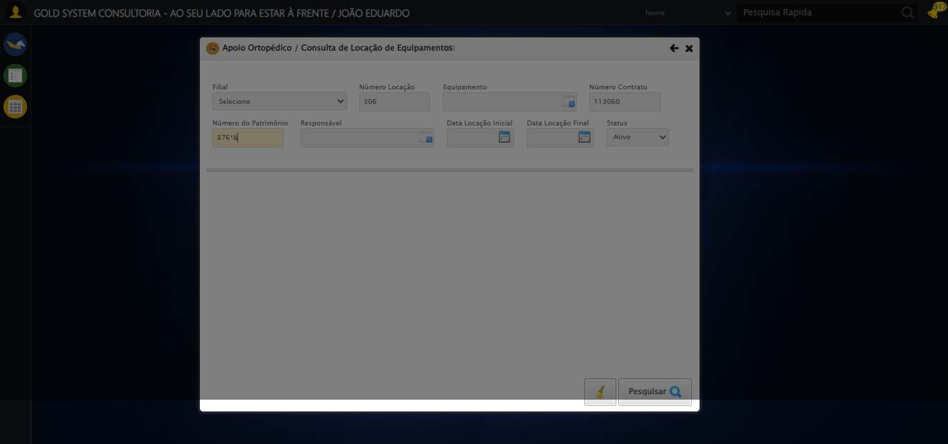

[16:44:46] [INFO] 🔄 Abrindo LOV do Responsável...

[16:44:47] [WARN] ⚠️ Estratégia 1 falhou: Message: element click intercepted: Element <a class="sprites sp-openLov"></a> is not clickable at point (612, 197). Other element would receive the click: <div class="blockScreen" style="height: 641px; z-index: 10001; opacity: 0.5;"></div>  
 (Session info: chrome=139.0.7258.128); For documentation on this error, please visit: https://www.selenium.dev/documentation/webdriver/troubleshooting/errors#elementclickinterceptedexception  
Stacktrace:  
 GetHandleVerifier [0x0x7da8a3+63283]  
 GetHandleVerifier [0x0x7da8e4+63348]  
 (No symbol) [0x0x613e43]  
 (No symbol) [0x0x662c20]  
 (No symbol) [0x0x660fda]  
 (No symbol) [0x0x65eb37]  
 (No symbol) [0x0x65ddf4]  
 (No symbol) [0x0x6525b5]  
 (No symbol) [0x0x68141c]  
 (No symbol) [0x0x652044]  
 (No symbol) [0x0x681694]  
 (No symbol) [0x0x6a271a]  
 (No symbol) [0x0x681216]  
 (No symbol) [0x0x650855]  
 (No symbol) [0x0x6516f4]  
 GetHandleVerifier [0x0xa4bb43+2623955]  
 GetHandleVerifier [0x0xa46daa+2604090]  
 GetHandleVerifier [0x0x80069a+218410]  
 GetHandleVerifier [0x0x7f0ed8+154984]  
 GetHandleVerifier [0x0x7f742d+180925]  
 GetHandleVerifier [0x0x7e22b8+94536]  
 GetHandleVerifier [0x0x7e2442+94930]  
 GetHandleVerifier [0x0x7cd5ea+9338]  
 BaseThreadInitThunk [0x0x76b1fcc9+25]  
 RtlGetAppContainerNamedObjectPath [0x0x776a82ae+286]  
 RtlGetAppContainerNamedObjectPath [0x0x776a827e+238]

[16:44:48] [INFO] ✅ Clique realizado com estratégia 2

[16:44:48] [INFO] ✅ Abrindo LOV do Responsável realizada com sucesso.

[16:44:49] [INFO] Screenshot capturada: abrindo_lov_do_responsável

Screenshot: abrindo_lov_do_responsável

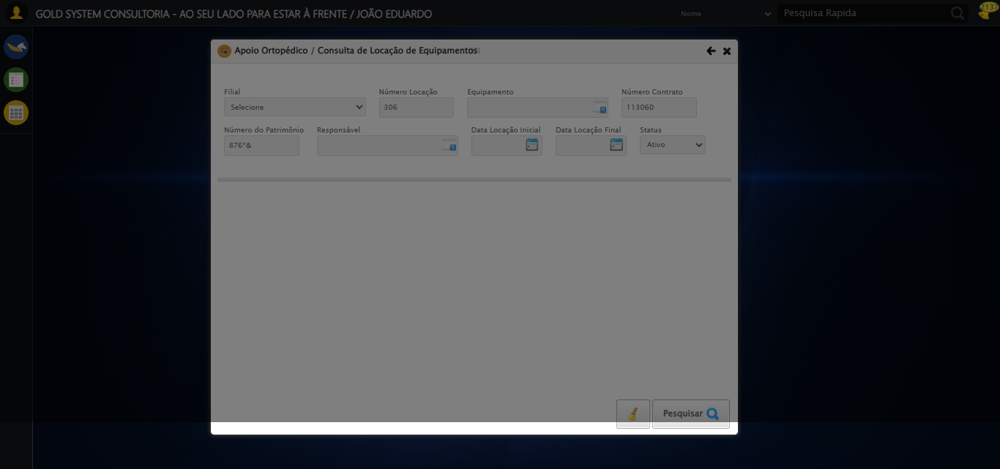

[16:44:49] [INFO] 🔄 Pesquisando responsável...

[16:45:19] [ERROR] ❌ Timeout aguardando elemento: //*[@id='txtPesquisa'] (timeout: 30s)

[16:45:19] [ERROR] ❌ Erro no preenchimento: Message:   
Stacktrace:  
 GetHandleVerifier [0x0x7da8a3+63283]  
 GetHandleVerifier [0x0x7da8e4+63348]  
 (No symbol) [0x0x613e43]  
 (No symbol) [0x0x65c8de]  
 (No symbol) [0x0x65cc7b]  
 (No symbol) [0x0x6a4ef2]  
 (No symbol) [0x0x681464]  
 (No symbol) [0x0x6a271a]  
 (No symbol) [0x0x681216]  
 (No symbol) [0x0x650855]  
 (No symbol) [0x0x6516f4]  
 GetHandleVerifier [0x0xa4bb43+2623955]  
 GetHandleVerifier [0x0xa46daa+2604090]  
 GetHandleVerifier [0x0x80069a+218410]  
 GetHandleVerifier [0x0x7f0ed8+154984]  
 GetHandleVerifier [0x0x7f742d+180925]  
 GetHandleVerifier [0x0x7e22b8+94536]  
 GetHandleVerifier [0x0x7e2442+94930]  
 GetHandleVerifier [0x0x7cd5ea+9338]  
 BaseThreadInitThunk [0x0x76b1fcc9+25]  
 RtlGetAppContainerNamedObjectPath [0x0x776a82ae+286]  
 RtlGetAppContainerNamedObjectPath [0x0x776a827e+238]

[16:45:49] [ERROR] ❌ Timeout aguardando elemento: /html/body/div[20]/div[2]/div[1]/div[1]/div[2]/a (timeout: 30s)

[16:45:49] [ERROR] ❌ Erro no clique robusto: Message:   
Stacktrace:  
 GetHandleVerifier [0x0x7da8a3+63283]  
 GetHandleVerifier [0x0x7da8e4+63348]  
 (No symbol) [0x0x613e43]  
 (No symbol) [0x0x65c8de]  
 (No symbol) [0x0x65cc7b]  
 (No symbol) [0x0x6a4ef2]  
 (No symbol) [0x0x681464]  
 (No symbol) [0x0x6a271a]  
 (No symbol) [0x0x681216]  
 (No symbol) [0x0x650855]  
 (No symbol) [0x0x6516f4]  
 GetHandleVerifier [0x0xa4bb43+2623955]  
 GetHandleVerifier [0x0xa46daa+2604090]  
 GetHandleVerifier [0x0x80069a+218410]  
 GetHandleVerifier [0x0x7f0ed8+154984]  
 GetHandleVerifier [0x0x7f742d+180925]  
 GetHandleVerifier [0x0x7e22b8+94536]  
 GetHandleVerifier [0x0x7e2442+94930]  
 GetHandleVerifier [0x0x7cd5ea+9338]  
 BaseThreadInitThunk [0x0x76b1fcc9+25]  
 RtlGetAppContainerNamedObjectPath [0x0x776a82ae+286]  
 RtlGetAppContainerNamedObjectPath [0x0x776a827e+238]

[16:46:22] [ERROR] ❌ Timeout aguardando elemento: //tr[td[2][contains(normalize-space(.),'TESTE TITULAR 233')]] (timeout: 30s)

[16:46:22] [ERROR] ❌ Erro no clique robusto: Message:   
Stacktrace:  
 GetHandleVerifier [0x0x7da8a3+63283]  
 GetHandleVerifier [0x0x7da8e4+63348]  
 (No symbol) [0x0x613e43]  
 (No symbol) [0x0x65c8de]  
 (No symbol) [0x0x65cc7b]  
 (No symbol) [0x0x6a4ef2]  
 (No symbol) [0x0x681464]  
 (No symbol) [0x0x6a271a]  
 (No symbol) [0x0x681216]  
 (No symbol) [0x0x650855]  
 (No symbol) [0x0x6516f4]  
 GetHandleVerifier [0x0xa4bb43+2623955]  
 GetHandleVerifier [0x0xa46daa+2604090]  
 GetHandleVerifier [0x0x80069a+218410]  
 GetHandleVerifier [0x0x7f0ed8+154984]  
 GetHandleVerifier [0x0x7f742d+180925]  
 GetHandleVerifier [0x0x7e22b8+94536]  
 GetHandleVerifier [0x0x7e2442+94930]  
 GetHandleVerifier [0x0x7cd5ea+9338]  
 BaseThreadInitThunk [0x0x76b1fcc9+25]  
 RtlGetAppContainerNamedObjectPath [0x0x776a82ae+286]  
 RtlGetAppContainerNamedObjectPath [0x0x776a827e+238]

[16:46:22] [INFO] ✅ Pesquisando responsável realizada com sucesso.

[16:46:23] [INFO] Screenshot capturada: pesquisando_responsável

Screenshot: pesquisando_responsável

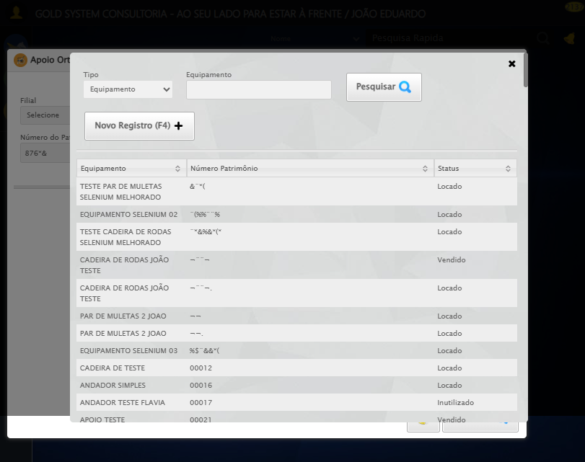

[16:46:23] [INFO] 🔄 Preenchendo Data Locação Inicial...

[16:46:23] [INFO] 🎯 Tentativa 1: Preenchendo datepicker 0 com '21/08/2025'

[16:46:25] [INFO] 📊 Encontrados 2 campos datepicker

[16:46:25] [INFO] Aplicando estratégia 1 para datepicker...

[16:46:26] [INFO] ✅ Datepicker preenchido com estratégia 1: '21/08/2025'

[16:46:26] [INFO] ✅ Preenchendo Data Locação Inicial realizada com sucesso.

[16:46:27] [INFO] Screenshot capturada: preenchendo_data_locação_inicial

Screenshot: preenchendo_data_locação_inicial



[16:46:27] [INFO] 🔄 Preenchendo Data Locação Final...

[16:46:27] [INFO] 🎯 Tentativa 1: Preenchendo datepicker 1 com '21/08/2025'

[16:46:28] [INFO] 📊 Encontrados 2 campos datepicker

[16:46:28] [INFO] Aplicando estratégia 1 para datepicker...

[16:46:29] [INFO] ✅ Datepicker preenchido com estratégia 1: '21/08/2025'

[16:46:29] [INFO] ✅ Preenchendo Data Locação Final realizada com sucesso.

[16:46:30] [INFO] Screenshot capturada: preenchendo_data_locação_final

Screenshot: preenchendo_data_locação_final



[16:46:30] [INFO] 🔄 Realizando consulta...

[16:46:32] [WARN] ⚠️ Estratégia 1 falhou: Message: element click intercepted: Element <a class="btModel btGray btfind">...</a> is not clickable at point (666, 534). Other element would receive the click: <div class="blockScreen" style="height: 641px; z-index: 10007; opacity: 0.5;"></div>  
 (Session info: chrome=139.0.7258.128); For documentation on this error, please visit: https://www.selenium.dev/documentation/webdriver/troubleshooting/errors#elementclickinterceptedexception  
Stacktrace:  
 GetHandleVerifier [0x0x7da8a3+63283]  
 GetHandleVerifier [0x0x7da8e4+63348]  
 (No symbol) [0x0x613e43]  
 (No symbol) [0x0x662c20]  
 (No symbol) [0x0x660fda]  
 (No symbol) [0x0x65eb37]  
 (No symbol) [0x0x65ddf4]  
 (No symbol) [0x0x6525b5]  
 (No symbol) [0x0x68141c]  
 (No symbol) [0x0x652044]  
 (No symbol) [0x0x681694]  
 (No symbol) [0x0x6a271a]  
 (No symbol) [0x0x681216]  
 (No symbol) [0x0x650855]  
 (No symbol) [0x0x6516f4]  
 GetHandleVerifier [0x0xa4bb43+2623955]  
 GetHandleVerifier [0x0xa46daa+2604090]  
 GetHandleVerifier [0x0x80069a+218410]  
 GetHandleVerifier [0x0x7f0ed8+154984]  
 GetHandleVerifier [0x0x7f742d+180925]  
 GetHandleVerifier [0x0x7e22b8+94536]  
 GetHandleVerifier [0x0x7e2442+94930]  
 GetHandleVerifier [0x0x7cd5ea+9338]  
 BaseThreadInitThunk [0x0x76b1fcc9+25]  
 RtlGetAppContainerNamedObjectPath [0x0x776a82ae+286]  
 RtlGetAppContainerNamedObjectPath [0x0x776a827e+238]

[16:46:32] [INFO] ✅ Clique realizado com estratégia 2

[16:46:42] [INFO] ✅ Realizando consulta realizada com sucesso.

[16:46:43] [INFO] Screenshot capturada: realizando_consulta

Screenshot: realizando_consulta

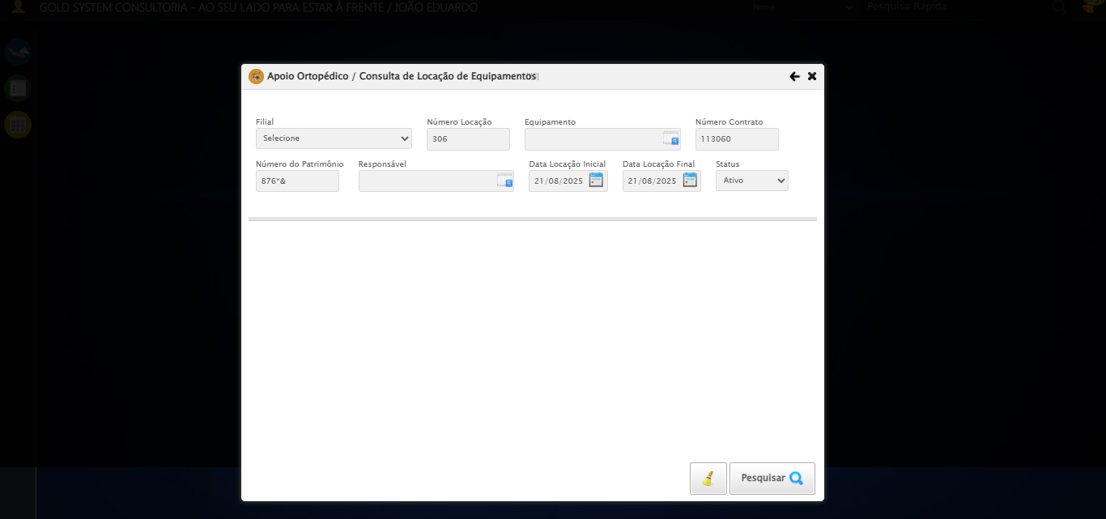

[16:46:43] [INFO] 🔄 Validando resultados da consulta...

[16:46:43] [INFO] 🔍 Validando registros encontrados...

[16:47:02] [WARN] ⚠️ Não foi possível determinar se há registros

[16:47:02] [INFO] ✅ Validando resultados da consulta realizada com sucesso.

[16:47:03] [INFO] Screenshot capturada: validando_resultados_da_consulta

Screenshot: validando_resultados_da_consulta

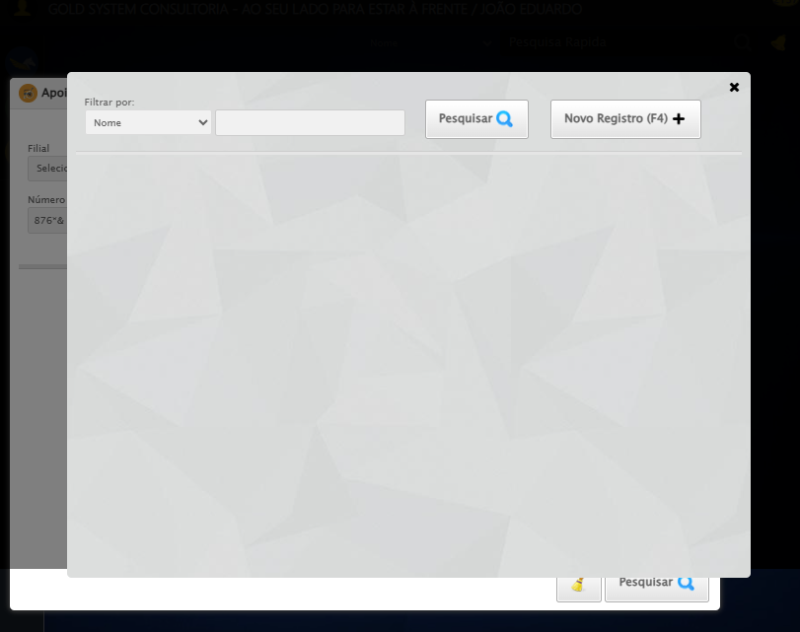

[16:47:03] [INFO] Processando 1 registro(s) encontrado(s)

[16:47:03] [INFO] 🔄 Visualizando Detalhes da Locação...

[16:47:34] [ERROR] ❌ Timeout aguardando elemento: //span[@title='Detalhes da Locação'] (timeout: 30s)

[16:47:34] [ERROR] ❌ Erro no clique robusto: Message:   
Stacktrace:  
 GetHandleVerifier [0x0x7da8a3+63283]  
 GetHandleVerifier [0x0x7da8e4+63348]  
 (No symbol) [0x0x613e43]  
 (No symbol) [0x0x65c8de]  
 (No symbol) [0x0x65cc7b]  
 (No symbol) [0x0x6a4ef2]  
 (No symbol) [0x0x681464]  
 (No symbol) [0x0x6a271a]  
 (No symbol) [0x0x681216]  
 (No symbol) [0x0x650855]  
 (No symbol) [0x0x6516f4]  
 GetHandleVerifier [0x0xa4bb43+2623955]  
 GetHandleVerifier [0x0xa46daa+2604090]  
 GetHandleVerifier [0x0x80069a+218410]  
 GetHandleVerifier [0x0x7f0ed8+154984]  
 GetHandleVerifier [0x0x7f742d+180925]  
 GetHandleVerifier [0x0x7e22b8+94536]  
 GetHandleVerifier [0x0x7e2442+94930]  
 GetHandleVerifier [0x0x7cd5ea+9338]  
 BaseThreadInitThunk [0x0x76b1fcc9+25]  
 RtlGetAppContainerNamedObjectPath [0x0x776a82ae+286]  
 RtlGetAppContainerNamedObjectPath [0x0x776a827e+238]

[16:47:34] [INFO] ✅ Visualizando Detalhes da Locação realizada com sucesso.

[16:47:35] [INFO] Screenshot capturada: visualizando_detalhes_da_locação

Screenshot: visualizando_detalhes_da_locação

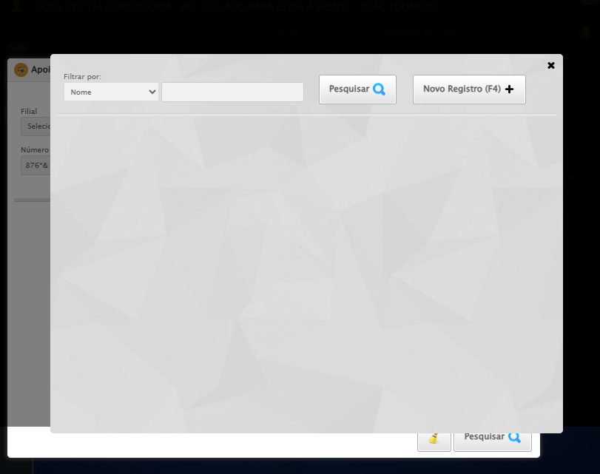

[16:47:35] [INFO] 🔄 Visualizando Títulos...

[16:47:44] [ERROR] ❌ Erro no clique robusto: Message: no such window: target window already closed  
from unknown error: web view not found  
 (Session info: chrome=139.0.7258.128)  
Stacktrace:  
 GetHandleVerifier [0x0x7da8a3+63283]  
 GetHandleVerifier [0x0x7da8e4+63348]  
 (No symbol) [0x0x613e43]  
 (No symbol) [0x0x5f2c49]  
 (No symbol) [0x0x687b0e]  
 (No symbol) [0x0x6a1ff9]  
 (No symbol) [0x0x681216]  
 (No symbol) [0x0x650855]  
 (No symbol) [0x0x6516f4]  
 GetHandleVerifier [0x0xa4bb43+2623955]  
 GetHandleVerifier [0x0xa46daa+2604090]  
 GetHandleVerifier [0x0x80069a+218410]  
 GetHandleVerifier [0x0x7f0ed8+154984]  
 GetHandleVerifier [0x0x7f742d+180925]  
 GetHandleVerifier [0x0x7e22b8+94536]  
 GetHandleVerifier [0x0x7e2442+94930]  
 GetHandleVerifier [0x0x7cd5ea+9338]  
 BaseThreadInitThunk [0x0x76b1fcc9+25]  
 RtlGetAppContainerNamedObjectPath [0x0x776a82ae+286]  
 RtlGetAppContainerNamedObjectPath [0x0x776a827e+238]

[16:48:04] [INFO] ✅ Visualizando Títulos realizada com sucesso.

[16:48:05] [WARN] Erro ao capturar screenshot visualizando_títulos: Message: no such window: target window already closed  
from unknown error: web view not found  
 (Session info: chrome=139.0.7258.128)  
Stacktrace:  
 GetHandleVerifier [0x0x7da8a3+63283]  
 GetHandleVerifier [0x0x7da8e4+63348]  
 (No symbol) [0x0x613e43]  
 (No symbol) [0x0x5f2c49]  
 (No symbol) [0x0x687b0e]  
 (No symbol) [0x0x6a1ff9]  
 (No symbol) [0x0x681216]  
 (No symbol) [0x0x650855]  
 (No symbol) [0x0x6516f4]  
 GetHandleVerifier [0x0xa4bb43+2623955]  
 GetHandleVerifier [0x0xa46daa+2604090]  
 GetHandleVerifier [0x0x80069a+218410]  
 GetHandleVerifier [0x0x7f0ed8+154984]  
 GetHandleVerifier [0x0x7f742d+180925]  
 GetHandleVerifier [0x0x7e22b8+94536]  
 GetHandleVerifier [0x0x7e2442+94930]  
 GetHandleVerifier [0x0x7cd5ea+9338]  
 BaseThreadInitThunk [0x0x76b1fcc9+25]  
 RtlGetAppContainerNamedObjectPath [0x0x776a82ae+286]  
 RtlGetAppContainerNamedObjectPath [0x0x776a827e+238]

[16:48:05] [INFO] 🔄 Capturando screenshot dos títulos...

[16:48:05] [WARN] Erro ao capturar screenshot tela_titulos: Message: no such window: target window already closed  
from unknown error: web view not found  
 (Session info: chrome=139.0.7258.128)  
Stacktrace:  
 GetHandleVerifier [0x0x7da8a3+63283]  
 GetHandleVerifier [0x0x7da8e4+63348]  
 (No symbol) [0x0x613e43]  
 (No symbol) [0x0x5f2c49]  
 (No symbol) [0x0x687b0e]  
 (No symbol) [0x0x6a1ff9]  
 (No symbol) [0x0x681216]  
 (No symbol) [0x0x650855]  
 (No symbol) [0x0x6516f4]  
 GetHandleVerifier [0x0xa4bb43+2623955]  
 GetHandleVerifier [0x0xa46daa+2604090]  
 GetHandleVerifier [0x0x80069a+218410]  
 GetHandleVerifier [0x0x7f0ed8+154984]  
 GetHandleVerifier [0x0x7f742d+180925]  
 GetHandleVerifier [0x0x7e22b8+94536]  
 GetHandleVerifier [0x0x7e2442+94930]  
 GetHandleVerifier [0x0x7cd5ea+9338]  
 BaseThreadInitThunk [0x0x76b1fcc9+25]  
 RtlGetAppContainerNamedObjectPath [0x0x776a82ae+286]  
 RtlGetAppContainerNamedObjectPath [0x0x776a827e+238]

[16:48:05] [INFO] ✅ Capturando screenshot dos títulos realizada com sucesso.

[16:48:06] [WARN] Erro ao capturar screenshot capturando_screenshot_dos_títulos: Message: no such window: target window already closed  
from unknown error: web view not found  
 (Session info: chrome=139.0.7258.128)  
Stacktrace:  
 GetHandleVerifier [0x0x7da8a3+63283]  
 GetHandleVerifier [0x0x7da8e4+63348]  
 (No symbol) [0x0x613e43]  
 (No symbol) [0x0x5f2c49]  
 (No symbol) [0x0x687b0e]  
 (No symbol) [0x0x6a1ff9]  
 (No symbol) [0x0x681216]  
 (No symbol) [0x0x650855]  
 (No symbol) [0x0x6516f4]  
 GetHandleVerifier [0x0xa4bb43+2623955]  
 GetHandleVerifier [0x0xa46daa+2604090]  
 GetHandleVerifier [0x0x80069a+218410]  
 GetHandleVerifier [0x0x7f0ed8+154984]  
 GetHandleVerifier [0x0x7f742d+180925]  
 GetHandleVerifier [0x0x7e22b8+94536]  
 GetHandleVerifier [0x0x7e2442+94930]  
 GetHandleVerifier [0x0x7cd5ea+9338]  
 BaseThreadInitThunk [0x0x76b1fcc9+25]  
 RtlGetAppContainerNamedObjectPath [0x0x776a82ae+286]  
 RtlGetAppContainerNamedObjectPath [0x0x776a827e+238]

[16:48:06] [INFO] 🔄 Fechando aba de títulos...

[16:48:06] [ERROR] ❌ Erro no clique robusto: Message: no such window: target window already closed  
from unknown error: web view not found  
 (Session info: chrome=139.0.7258.128)  
Stacktrace:  
 GetHandleVerifier [0x0x7da8a3+63283]  
 GetHandleVerifier [0x0x7da8e4+63348]  
 (No symbol) [0x0x613e43]  
 (No symbol) [0x0x5f2c49]  
 (No symbol) [0x0x687b0e]  
 (No symbol) [0x0x6a1ff9]  
 (No symbol) [0x0x681216]  
 (No symbol) [0x0x650855]  
 (No symbol) [0x0x6516f4]  
 GetHandleVerifier [0x0xa4bb43+2623955]  
 GetHandleVerifier [0x0xa46daa+2604090]  
 GetHandleVerifier [0x0x80069a+218410]  
 GetHandleVerifier [0x0x7f0ed8+154984]  
 GetHandleVerifier [0x0x7f742d+180925]  
 GetHandleVerifier [0x0x7e22b8+94536]  
 GetHandleVerifier [0x0x7e2442+94930]  
 GetHandleVerifier [0x0x7cd5ea+9338]  
 BaseThreadInitThunk [0x0x76b1fcc9+25]  
 RtlGetAppContainerNamedObjectPath [0x0x776a82ae+286]  
 RtlGetAppContainerNamedObjectPath [0x0x776a827e+238]

[16:48:06] [INFO] ✅ Fechando aba de títulos realizada com sucesso.

[16:48:07] [WARN] Erro ao capturar screenshot fechando_aba_de_títulos: Message: no such window: target window already closed  
from unknown error: web view not found  
 (Session info: chrome=139.0.7258.128)  
Stacktrace:  
 GetHandleVerifier [0x0x7da8a3+63283]  
 GetHandleVerifier [0x0x7da8e4+63348]  
 (No symbol) [0x0x613e43]  
 (No symbol) [0x0x5f2c49]  
 (No symbol) [0x0x687b0e]  
 (No symbol) [0x0x6a1ff9]  
 (No symbol) [0x0x681216]  
 (No symbol) [0x0x650855]  
 (No symbol) [0x0x6516f4]  
 GetHandleVerifier [0x0xa4bb43+2623955]  
 GetHandleVerifier [0x0xa46daa+2604090]  
 GetHandleVerifier [0x0x80069a+218410]  
 GetHandleVerifier [0x0x7f0ed8+154984]  
 GetHandleVerifier [0x0x7f742d+180925]  
 GetHandleVerifier [0x0x7e22b8+94536]  
 GetHandleVerifier [0x0x7e2442+94930]  
 GetHandleVerifier [0x0x7cd5ea+9338]  
 BaseThreadInitThunk [0x0x76b1fcc9+25]  
 RtlGetAppContainerNamedObjectPath [0x0x776a82ae+286]  
 RtlGetAppContainerNamedObjectPath [0x0x776a827e+238]

[16:48:07] [INFO] 🔄 Reabrindo detalhes da locação...

[16:48:07] [ERROR] ❌ Erro no clique robusto: Message: no such window: target window already closed  
from unknown error: web view not found  
 (Session info: chrome=139.0.7258.128)  
Stacktrace:  
 GetHandleVerifier [0x0x7da8a3+63283]  
 GetHandleVerifier [0x0x7da8e4+63348]  
 (No symbol) [0x0x613e43]  
 (No symbol) [0x0x5f2c49]  
 (No symbol) [0x0x687b0e]  
 (No symbol) [0x0x6a1ff9]  
 (No symbol) [0x0x681216]  
 (No symbol) [0x0x650855]  
 (No symbol) [0x0x6516f4]  
 GetHandleVerifier [0x0xa4bb43+2623955]  
 GetHandleVerifier [0x0xa46daa+2604090]  
 GetHandleVerifier [0x0x80069a+218410]  
 GetHandleVerifier [0x0x7f0ed8+154984]  
 GetHandleVerifier [0x0x7f742d+180925]  
 GetHandleVerifier [0x0x7e22b8+94536]  
 GetHandleVerifier [0x0x7e2442+94930]  
 GetHandleVerifier [0x0x7cd5ea+9338]  
 BaseThreadInitThunk [0x0x76b1fcc9+25]  
 RtlGetAppContainerNamedObjectPath [0x0x776a82ae+286]  
 RtlGetAppContainerNamedObjectPath [0x0x776a827e+238]

[16:48:10] [INFO] ✅ Reabrindo detalhes da locação realizada com sucesso.

[16:48:11] [WARN] Erro ao capturar screenshot reabrindo_detalhes_da_locação: Message: no such window: target window already closed  
from unknown error: web view not found  
 (Session info: chrome=139.0.7258.128)  
Stacktrace:  
 GetHandleVerifier [0x0x7da8a3+63283]  
 GetHandleVerifier [0x0x7da8e4+63348]  
 (No symbol) [0x0x613e43]  
 (No symbol) [0x0x5f2c49]  
 (No symbol) [0x0x687b0e]  
 (No symbol) [0x0x6a1ff9]  
 (No symbol) [0x0x681216]  
 (No symbol) [0x0x650855]  
 (No symbol) [0x0x6516f4]  
 GetHandleVerifier [0x0xa4bb43+2623955]  
 GetHandleVerifier [0x0xa46daa+2604090]  
 GetHandleVerifier [0x0x80069a+218410]  
 GetHandleVerifier [0x0x7f0ed8+154984]  
 GetHandleVerifier [0x0x7f742d+180925]  
 GetHandleVerifier [0x0x7e22b8+94536]  
 GetHandleVerifier [0x0x7e2442+94930]  
 GetHandleVerifier [0x0x7cd5ea+9338]  
 BaseThreadInitThunk [0x0x76b1fcc9+25]  
 RtlGetAppContainerNamedObjectPath [0x0x776a82ae+286]  
 RtlGetAppContainerNamedObjectPath [0x0x776a827e+238]

[16:48:11] [INFO] Verificando mensagens de alerta...

[16:48:11] [INFO] ℹ️ Nenhuma mensagem de alerta encontrada.

[16:48:11] [INFO] 🔄 Abrindo digitalização de documentos...

[16:48:11] [ERROR] ❌ Erro no clique robusto: Message: no such window: target window already closed  
from unknown error: web view not found  
 (Session info: chrome=139.0.7258.128)  
Stacktrace:  
 GetHandleVerifier [0x0x7da8a3+63283]  
 GetHandleVerifier [0x0x7da8e4+63348]  
 (No symbol) [0x0x613e43]  
 (No symbol) [0x0x5f2c49]  
 (No symbol) [0x0x687b0e]  
 (No symbol) [0x0x6a1ff9]  
 (No symbol) [0x0x681216]  
 (No symbol) [0x0x650855]  
 (No symbol) [0x0x6516f4]  
 GetHandleVerifier [0x0xa4bb43+2623955]  
 GetHandleVerifier [0x0xa46daa+2604090]  
 GetHandleVerifier [0x0x80069a+218410]  
 GetHandleVerifier [0x0x7f0ed8+154984]  
 GetHandleVerifier [0x0x7f742d+180925]  
 GetHandleVerifier [0x0x7e22b8+94536]  
 GetHandleVerifier [0x0x7e2442+94930]  
 GetHandleVerifier [0x0x7cd5ea+9338]  
 BaseThreadInitThunk [0x0x76b1fcc9+25]  
 RtlGetAppContainerNamedObjectPath [0x0x776a82ae+286]  
 RtlGetAppContainerNamedObjectPath [0x0x776a827e+238]

[16:48:11] [INFO] ✅ Abrindo digitalização de documentos realizada com sucesso.

[16:48:12] [WARN] Erro ao capturar screenshot abrindo_digitalização_de_documentos: Message: no such window: target window already closed  
from unknown error: web view not found  
 (Session info: chrome=139.0.7258.128)  
Stacktrace:  
 GetHandleVerifier [0x0x7da8a3+63283]  
 GetHandleVerifier [0x0x7da8e4+63348]  
 (No symbol) [0x0x613e43]  
 (No symbol) [0x0x5f2c49]  
 (No symbol) [0x0x687b0e]  
 (No symbol) [0x0x6a1ff9]  
 (No symbol) [0x0x681216]  
 (No symbol) [0x0x650855]  
 (No symbol) [0x0x6516f4]  
 GetHandleVerifier [0x0xa4bb43+2623955]  
 GetHandleVerifier [0x0xa46daa+2604090]  
 GetHandleVerifier [0x0x80069a+218410]  
 GetHandleVerifier [0x0x7f0ed8+154984]  
 GetHandleVerifier [0x0x7f742d+180925]  
 GetHandleVerifier [0x0x7e22b8+94536]  
 GetHandleVerifier [0x0x7e2442+94930]  
 GetHandleVerifier [0x0x7cd5ea+9338]  
 BaseThreadInitThunk [0x0x76b1fcc9+25]  
 RtlGetAppContainerNamedObjectPath [0x0x776a82ae+286]  
 RtlGetAppContainerNamedObjectPath [0x0x776a827e+238]

[16:48:12] [INFO] 🔄 Adicionando novo documento...

[16:48:12] [ERROR] ❌ Erro no clique robusto: Message: no such window: target window already closed  
from unknown error: web view not found  
 (Session info: chrome=139.0.7258.128)  
Stacktrace:  
 GetHandleVerifier [0x0x7da8a3+63283]  
 GetHandleVerifier [0x0x7da8e4+63348]  
 (No symbol) [0x0x613e43]  
 (No symbol) [0x0x5f2c49]  
 (No symbol) [0x0x687b0e]  
 (No symbol) [0x0x6a1ff9]  
 (No symbol) [0x0x681216]  
 (No symbol) [0x0x650855]  
 (No symbol) [0x0x6516f4]  
 GetHandleVerifier [0x0xa4bb43+2623955]  
 GetHandleVerifier [0x0xa46daa+2604090]  
 GetHandleVerifier [0x0x80069a+218410]  
 GetHandleVerifier [0x0x7f0ed8+154984]  
 GetHandleVerifier [0x0x7f742d+180925]  
 GetHandleVerifier [0x0x7e22b8+94536]  
 GetHandleVerifier [0x0x7e2442+94930]  
 GetHandleVerifier [0x0x7cd5ea+9338]  
 BaseThreadInitThunk [0x0x76b1fcc9+25]  
 RtlGetAppContainerNamedObjectPath [0x0x776a82ae+286]  
 RtlGetAppContainerNamedObjectPath [0x0x776a827e+238]

[16:48:12] [INFO] ✅ Adicionando novo documento realizada com sucesso.

[16:48:13] [WARN] Erro ao capturar screenshot adicionando_novo_documento: Message: no such window: target window already closed  
from unknown error: web view not found  
 (Session info: chrome=139.0.7258.128)  
Stacktrace:  
 GetHandleVerifier [0x0x7da8a3+63283]  
 GetHandleVerifier [0x0x7da8e4+63348]  
 (No symbol) [0x0x613e43]  
 (No symbol) [0x0x5f2c49]  
 (No symbol) [0x0x687b0e]  
 (No symbol) [0x0x6a1ff9]  
 (No symbol) [0x0x681216]  
 (No symbol) [0x0x650855]  
 (No symbol) [0x0x6516f4]  
 GetHandleVerifier [0x0xa4bb43+2623955]  
 GetHandleVerifier [0x0xa46daa+2604090]  
 GetHandleVerifier [0x0x80069a+218410]  
 GetHandleVerifier [0x0x7f0ed8+154984]  
 GetHandleVerifier [0x0x7f742d+180925]  
 GetHandleVerifier [0x0x7e22b8+94536]  
 GetHandleVerifier [0x0x7e2442+94930]  
 GetHandleVerifier [0x0x7cd5ea+9338]  
 BaseThreadInitThunk [0x0x76b1fcc9+25]  
 RtlGetAppContainerNamedObjectPath [0x0x776a82ae+286]  
 RtlGetAppContainerNamedObjectPath [0x0x776a827e+238]

[16:48:13] [INFO] 🔄 Fazendo upload do arquivo...

[16:48:13] [INFO] 📄 Realizando upload do arquivo.

[16:48:13] [ERROR] ❌ Erro no upload: Message: no such window: target window already closed  
from unknown error: web view not found  
 (Session info: chrome=139.0.7258.128)  
Stacktrace:  
 GetHandleVerifier [0x0x7da8a3+63283]  
 GetHandleVerifier [0x0x7da8e4+63348]  
 (No symbol) [0x0x613e43]  
 (No symbol) [0x0x5f2c49]  
 (No symbol) [0x0x687b0e]  
 (No symbol) [0x0x6a1ff9]  
 (No symbol) [0x0x681216]  
 (No symbol) [0x0x650855]  
 (No symbol) [0x0x6516f4]  
 GetHandleVerifier [0x0xa4bb43+2623955]  
 GetHandleVerifier [0x0xa46daa+2604090]  
 GetHandleVerifier [0x0x80069a+218410]  
 GetHandleVerifier [0x0x7f0ed8+154984]  
 GetHandleVerifier [0x0x7f742d+180925]  
 GetHandleVerifier [0x0x7e22b8+94536]  
 GetHandleVerifier [0x0x7e2442+94930]  
 GetHandleVerifier [0x0x7cd5ea+9338]  
 BaseThreadInitThunk [0x0x76b1fcc9+25]  
 RtlGetAppContainerNamedObjectPath [0x0x776a82ae+286]  
 RtlGetAppContainerNamedObjectPath [0x0x776a827e+238]

[16:48:13] [INFO] ✅ Fazendo upload do arquivo realizada com sucesso.

[16:48:14] [WARN] Erro ao capturar screenshot fazendo_upload_do_arquivo: Message: no such window: target window already closed  
from unknown error: web view not found  
 (Session info: chrome=139.0.7258.128)  
Stacktrace:  
 GetHandleVerifier [0x0x7da8a3+63283]  
 GetHandleVerifier [0x0x7da8e4+63348]  
 (No symbol) [0x0x613e43]  
 (No symbol) [0x0x5f2c49]  
 (No symbol) [0x0x687b0e]  
 (No symbol) [0x0x6a1ff9]  
 (No symbol) [0x0x681216]  
 (No symbol) [0x0x650855]  
 (No symbol) [0x0x6516f4]  
 GetHandleVerifier [0x0xa4bb43+2623955]  
 GetHandleVerifier [0x0xa46daa+2604090]  
 GetHandleVerifier [0x0x80069a+218410]  
 GetHandleVerifier [0x0x7f0ed8+154984]  
 GetHandleVerifier [0x0x7f742d+180925]  
 GetHandleVerifier [0x0x7e22b8+94536]  
 GetHandleVerifier [0x0x7e2442+94930]  
 GetHandleVerifier [0x0x7cd5ea+9338]  
 BaseThreadInitThunk [0x0x76b1fcc9+25]  
 RtlGetAppContainerNamedObjectPath [0x0x776a82ae+286]  
 RtlGetAppContainerNamedObjectPath [0x0x776a827e+238]

[16:48:14] [INFO] 🔄 Salvando arquivo digitalizado...

[16:48:14] [ERROR] ❌ Erro no clique robusto: Message: no such window: target window already closed  
from unknown error: web view not found  
 (Session info: chrome=139.0.7258.128)  
Stacktrace:  
 GetHandleVerifier [0x0x7da8a3+63283]  
 GetHandleVerifier [0x0x7da8e4+63348]  
 (No symbol) [0x0x613e43]  
 (No symbol) [0x0x5f2c49]  
 (No symbol) [0x0x687b0e]  
 (No symbol) [0x0x6a1ff9]  
 (No symbol) [0x0x681216]  
 (No symbol) [0x0x650855]  
 (No symbol) [0x0x6516f4]  
 GetHandleVerifier [0x0xa4bb43+2623955]  
 GetHandleVerifier [0x0xa46daa+2604090]  
 GetHandleVerifier [0x0x80069a+218410]  
 GetHandleVerifier [0x0x7f0ed8+154984]  
 GetHandleVerifier [0x0x7f742d+180925]  
 GetHandleVerifier [0x0x7e22b8+94536]  
 GetHandleVerifier [0x0x7e2442+94930]  
 GetHandleVerifier [0x0x7cd5ea+9338]  
 BaseThreadInitThunk [0x0x76b1fcc9+25]  
 RtlGetAppContainerNamedObjectPath [0x0x776a82ae+286]  
 RtlGetAppContainerNamedObjectPath [0x0x776a827e+238]

[16:48:14] [INFO] ✅ Salvando arquivo digitalizado realizada com sucesso.

[16:48:15] [WARN] Erro ao capturar screenshot salvando_arquivo_digitalizado: Message: no such window: target window already closed  
from unknown error: web view not found  
 (Session info: chrome=139.0.7258.128)  
Stacktrace:  
 GetHandleVerifier [0x0x7da8a3+63283]  
 GetHandleVerifier [0x0x7da8e4+63348]  
 (No symbol) [0x0x613e43]  
 (No symbol) [0x0x5f2c49]  
 (No symbol) [0x0x687b0e]  
 (No symbol) [0x0x6a1ff9]  
 (No symbol) [0x0x681216]  
 (No symbol) [0x0x650855]  
 (No symbol) [0x0x6516f4]  
 GetHandleVerifier [0x0xa4bb43+2623955]  
 GetHandleVerifier [0x0xa46daa+2604090]  
 GetHandleVerifier [0x0x80069a+218410]  
 GetHandleVerifier [0x0x7f0ed8+154984]  
 GetHandleVerifier [0x0x7f742d+180925]  
 GetHandleVerifier [0x0x7e22b8+94536]  
 GetHandleVerifier [0x0x7e2442+94930]  
 GetHandleVerifier [0x0x7cd5ea+9338]  
 BaseThreadInitThunk [0x0x76b1fcc9+25]  
 RtlGetAppContainerNamedObjectPath [0x0x776a82ae+286]  
 RtlGetAppContainerNamedObjectPath [0x0x776a827e+238]

[16:48:15] [INFO] Verificando mensagens de alerta após digitalização...

[16:48:15] [INFO] ℹ️ Nenhuma mensagem de alerta encontrada.

[16:48:15] [INFO] 🔄 Fechando modal de digitalização...

[16:48:15] [ERROR] ❌ Erro no clique robusto: Message: no such window: target window already closed  
from unknown error: web view not found  
 (Session info: chrome=139.0.7258.128)  
Stacktrace:  
 GetHandleVerifier [0x0x7da8a3+63283]  
 GetHandleVerifier [0x0x7da8e4+63348]  
 (No symbol) [0x0x613e43]  
 (No symbol) [0x0x5f2c49]  
 (No symbol) [0x0x687b0e]  
 (No symbol) [0x0x6a1ff9]  
 (No symbol) [0x0x681216]  
 (No symbol) [0x0x650855]  
 (No symbol) [0x0x6516f4]  
 GetHandleVerifier [0x0xa4bb43+2623955]  
 GetHandleVerifier [0x0xa46daa+2604090]  
 GetHandleVerifier [0x0x80069a+218410]  
 GetHandleVerifier [0x0x7f0ed8+154984]  
 GetHandleVerifier [0x0x7f742d+180925]  
 GetHandleVerifier [0x0x7e22b8+94536]  
 GetHandleVerifier [0x0x7e2442+94930]  
 GetHandleVerifier [0x0x7cd5ea+9338]  
 BaseThreadInitThunk [0x0x76b1fcc9+25]  
 RtlGetAppContainerNamedObjectPath [0x0x776a82ae+286]  
 RtlGetAppContainerNamedObjectPath [0x0x776a827e+238]

[16:48:15] [INFO] ✅ Fechando modal de digitalização realizada com sucesso.

[16:48:16] [WARN] Erro ao capturar screenshot fechando_modal_de_digitalização: Message: no such window: target window already closed  
from unknown error: web view not found  
 (Session info: chrome=139.0.7258.128)  
Stacktrace:  
 GetHandleVerifier [0x0x7da8a3+63283]  
 GetHandleVerifier [0x0x7da8e4+63348]  
 (No symbol) [0x0x613e43]  
 (No symbol) [0x0x5f2c49]  
 (No symbol) [0x0x687b0e]  
 (No symbol) [0x0x6a1ff9]  
 (No symbol) [0x0x681216]  
 (No symbol) [0x0x650855]  
 (No symbol) [0x0x6516f4]  
 GetHandleVerifier [0x0xa4bb43+2623955]  
 GetHandleVerifier [0x0xa46daa+2604090]  
 GetHandleVerifier [0x0x80069a+218410]  
 GetHandleVerifier [0x0x7f0ed8+154984]  
 GetHandleVerifier [0x0x7f742d+180925]  
 GetHandleVerifier [0x0x7e22b8+94536]  
 GetHandleVerifier [0x0x7e2442+94930]  
 GetHandleVerifier [0x0x7cd5ea+9338]  
 BaseThreadInitThunk [0x0x76b1fcc9+25]  
 RtlGetAppContainerNamedObjectPath [0x0x776a82ae+286]  
 RtlGetAppContainerNamedObjectPath [0x0x776a827e+238]

[16:48:16] [INFO] 🔄 Fechando tela de consulta...

[16:48:16] [ERROR] ❌ Erro no clique robusto: Message: no such window: target window already closed  
from unknown error: web view not found  
 (Session info: chrome=139.0.7258.128)  
Stacktrace:  
 GetHandleVerifier [0x0x7da8a3+63283]  
 GetHandleVerifier [0x0x7da8e4+63348]  
 (No symbol) [0x0x613e43]  
 (No symbol) [0x0x5f2c49]  
 (No symbol) [0x0x687b0e]  
 (No symbol) [0x0x6a1ff9]  
 (No symbol) [0x0x681216]  
 (No symbol) [0x0x650855]  
 (No symbol) [0x0x6516f4]  
 GetHandleVerifier [0x0xa4bb43+2623955]  
 GetHandleVerifier [0x0xa46daa+2604090]  
 GetHandleVerifier [0x0x80069a+218410]  
 GetHandleVerifier [0x0x7f0ed8+154984]  
 GetHandleVerifier [0x0x7f742d+180925]  
 GetHandleVerifier [0x0x7e22b8+94536]  
 GetHandleVerifier [0x0x7e2442+94930]  
 GetHandleVerifier [0x0x7cd5ea+9338]  
 BaseThreadInitThunk [0x0x76b1fcc9+25]  
 RtlGetAppContainerNamedObjectPath [0x0x776a82ae+286]  
 RtlGetAppContainerNamedObjectPath [0x0x776a827e+238]

[16:48:16] [INFO] ✅ Fechando tela de consulta realizada com sucesso.

[16:48:17] [WARN] Erro ao capturar screenshot fechando_tela_de_consulta: Message: no such window: target window already closed  
from unknown error: web view not found  
 (Session info: chrome=139.0.7258.128)  
Stacktrace:  
 GetHandleVerifier [0x0x7da8a3+63283]  
 GetHandleVerifier [0x0x7da8e4+63348]  
 (No symbol) [0x0x613e43]  
 (No symbol) [0x0x5f2c49]  
 (No symbol) [0x0x687b0e]  
 (No symbol) [0x0x6a1ff9]  
 (No symbol) [0x0x681216]  
 (No symbol) [0x0x650855]  
 (No symbol) [0x0x6516f4]  
 GetHandleVerifier [0x0xa4bb43+2623955]  
 GetHandleVerifier [0x0xa46daa+2604090]  
 GetHandleVerifier [0x0x80069a+218410]  
 GetHandleVerifier [0x0x7f0ed8+154984]  
 GetHandleVerifier [0x0x7f742d+180925]  
 GetHandleVerifier [0x0x7e22b8+94536]  
 GetHandleVerifier [0x0x7e2442+94930]  
 GetHandleVerifier [0x0x7cd5ea+9338]  
 BaseThreadInitThunk [0x0x76b1fcc9+25]  
 RtlGetAppContainerNamedObjectPath [0x0x776a82ae+286]  
 RtlGetAppContainerNamedObjectPath [0x0x776a827e+238]

[16:48:18] [INFO] Teste concluído com sucesso!

[16:48:18] [INFO] Teste executado com sucesso!