RELATÓRIO DO TESTE AUTOMATIZADO

Consulta de Locação de Equipamentos - Apoio Ortopédico – Cenário 1

Data do teste: 27/08/2025 16:56:53

[16:56:53] [INFO] Iniciando teste de Consulta de Locação de Equipamentos

[16:56:59] [INFO] ✅ Driver Chrome inicializado com sucesso

[16:56:59] [INFO] 🚀 Iniciando teste de Consulta de Locação de Equipamentos

[16:56:59] [INFO] 🔄 Acessando sistema...

[16:56:59] [INFO] ✅ Acessando sistema realizada com sucesso.

[16:57:00] [INFO] Screenshot capturada: acessando_sistema

Screenshot: acessando_sistema

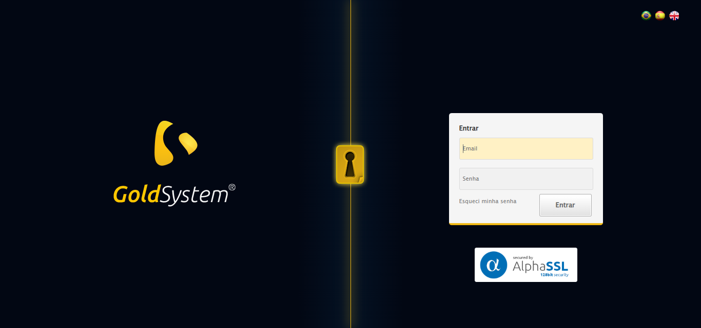

[16:57:00] [INFO] 🔄 Realizando login...

[16:57:06] [INFO] ✅ Realizando login realizada com sucesso.

[16:57:07] [INFO] Screenshot capturada: realizando_login

Screenshot: realizando_login

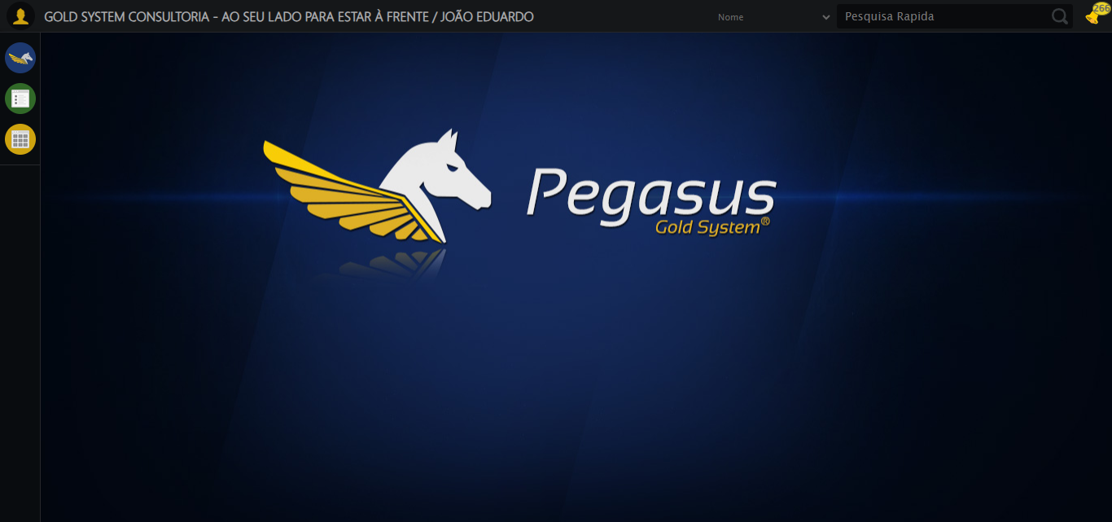

[16:57:07] [INFO] 🔄 Configurando interface...

[16:57:08] [INFO] 🔍 Zoom ajustado para 90%.

[16:57:10] [INFO] ✅ Configurando interface realizada com sucesso.

[16:57:11] [INFO] Screenshot capturada: configurando_interface

Screenshot: configurando_interface

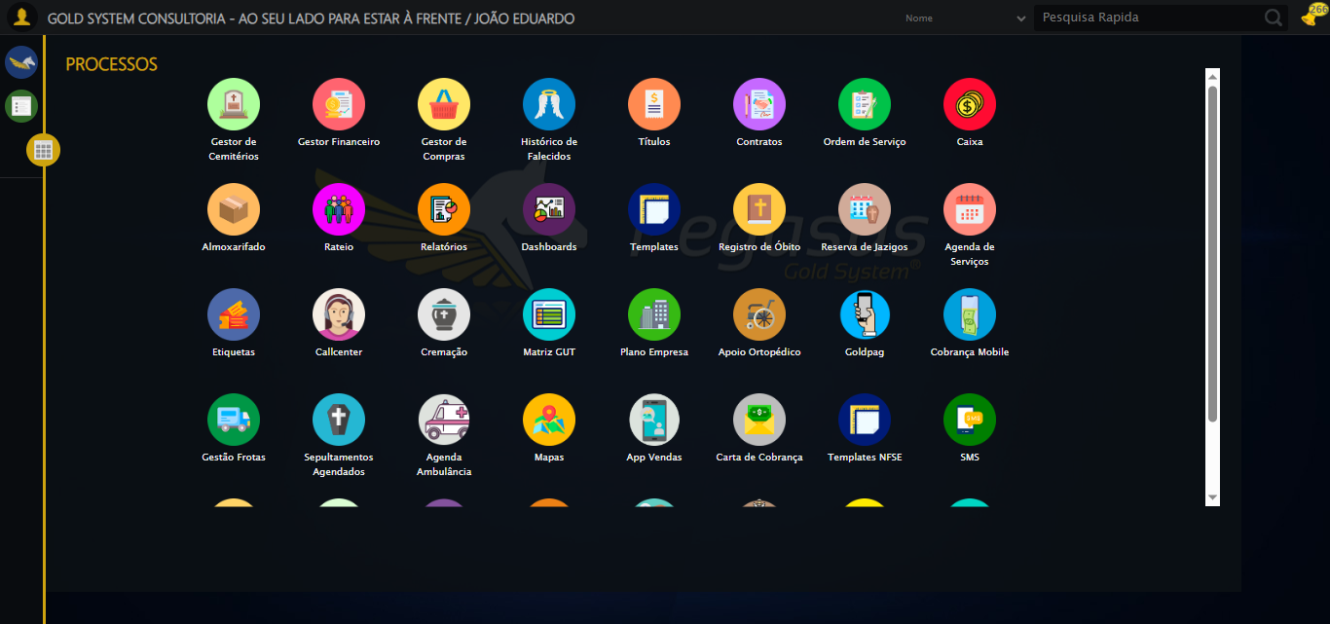

[16:57:11] [INFO] 🔄 Acessando Apoio Ortopédico...

[16:57:12] [INFO] ✅ Clique realizado com estratégia 1

[16:57:12] [INFO] ✅ Acessando Apoio Ortopédico realizada com sucesso.

[16:57:13] [INFO] Screenshot capturada: acessando_apoio_ortopédico

Screenshot: acessando_apoio_ortopédico

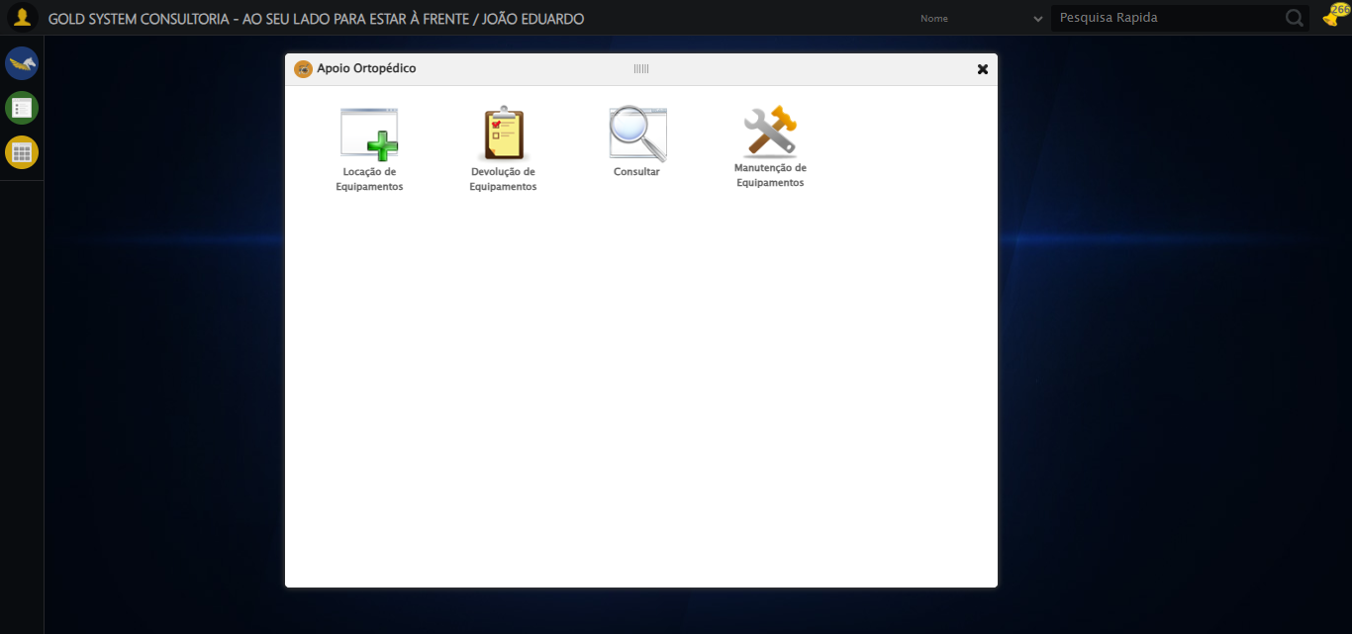

[16:57:13] [INFO] 🔄 Acessando Consulta Locação de Equipamentos...

[16:57:14] [INFO] ✅ Clique realizado com estratégia 1

[16:57:14] [INFO] ✅ Acessando Consulta Locação de Equipamentos realizada com sucesso.

[16:57:15] [INFO] Screenshot capturada: acessando_consulta_locação_de_equipamentos

Screenshot: acessando_consulta_locação_de_equipamentos

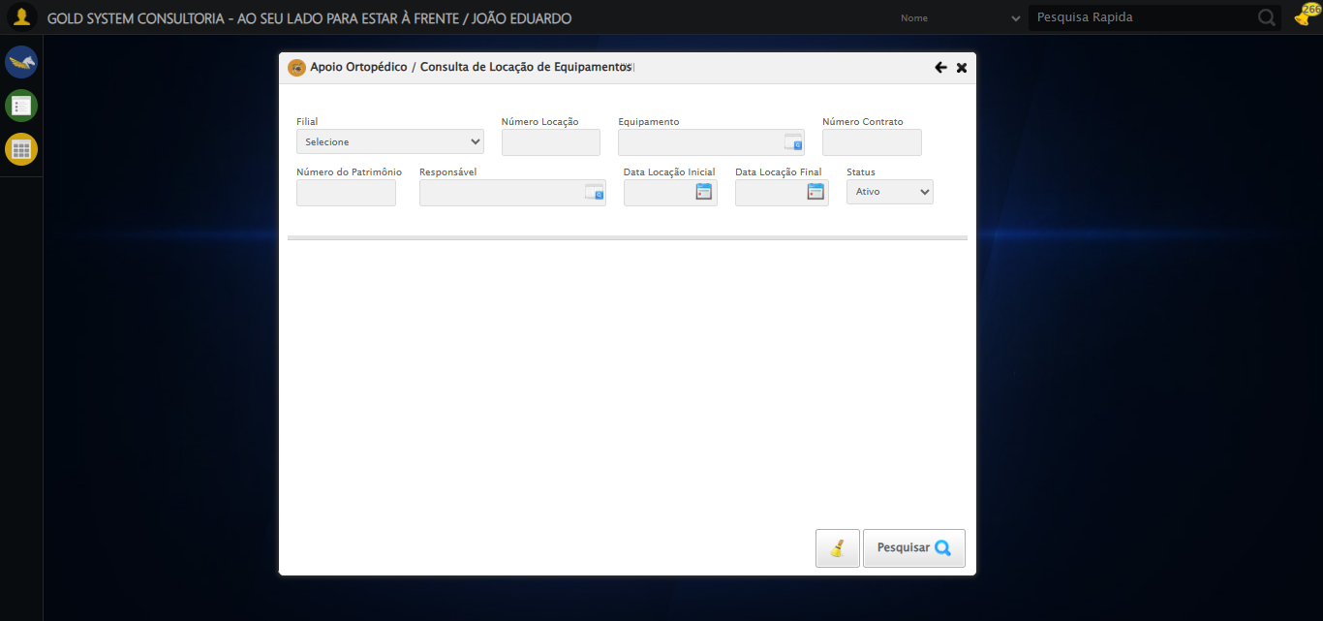

[16:57:18] [INFO] 🔄 Preenchendo Número da Locação...

[16:57:20] [INFO] ✅ Campo preenchido com estratégia 1: '306'

[16:57:20] [INFO] ✅ Preenchendo Número da Locação realizada com sucesso.

[16:57:21] [INFO] Screenshot capturada: preenchendo_número_da_locação

Screenshot: preenchendo_número_da_locação

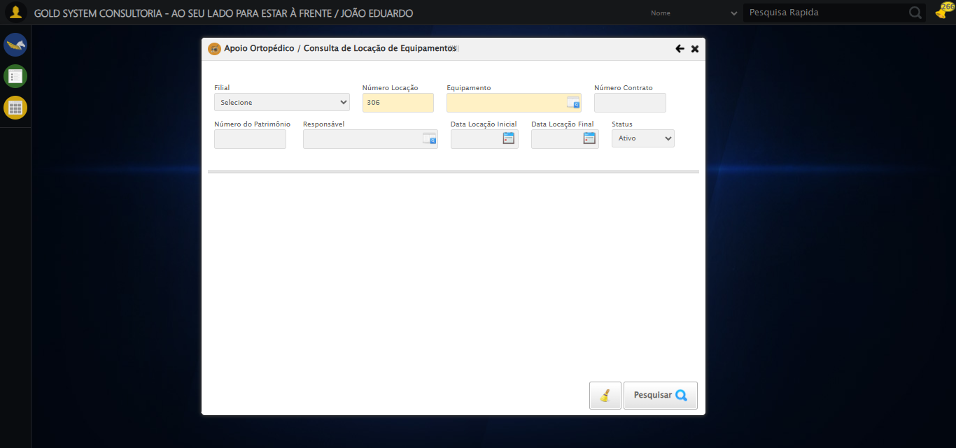

[16:57:21] [INFO] 🔄 Abrindo LOV de Equipamentos...

[16:57:51] [ERROR] ❌ Timeout aguardando elemento: //*[@id='gsApoioOrtopedico']/div[2]/div[3]/div/div[1]/div/div[3]/div/a (timeout: 30s)

[16:57:51] [ERROR] ❌ Erro no clique robusto: Message:   
Stacktrace:  
 GetHandleVerifier [0x0x7da8a3+63283]  
 GetHandleVerifier [0x0x7da8e4+63348]  
 (No symbol) [0x0x613e43]  
 (No symbol) [0x0x65c8de]  
 (No symbol) [0x0x65cc7b]  
 (No symbol) [0x0x6a4ef2]  
 (No symbol) [0x0x681464]  
 (No symbol) [0x0x6a271a]  
 (No symbol) [0x0x681216]  
 (No symbol) [0x0x650855]  
 (No symbol) [0x0x6516f4]  
 GetHandleVerifier [0x0xa4bb43+2623955]  
 GetHandleVerifier [0x0xa46daa+2604090]  
 GetHandleVerifier [0x0x80069a+218410]  
 GetHandleVerifier [0x0x7f0ed8+154984]  
 GetHandleVerifier [0x0x7f742d+180925]  
 GetHandleVerifier [0x0x7e22b8+94536]  
 GetHandleVerifier [0x0x7e2442+94930]  
 GetHandleVerifier [0x0x7cd5ea+9338]  
 BaseThreadInitThunk [0x0x76b1fcc9+25]  
 RtlGetAppContainerNamedObjectPath [0x0x776a82ae+286]  
 RtlGetAppContainerNamedObjectPath [0x0x776a827e+238]

[16:57:51] [INFO] ✅ Abrindo LOV de Equipamentos realizada com sucesso.

[16:57:52] [INFO] Screenshot capturada: abrindo_lov_de_equipamentos

Screenshot: abrindo_lov_de_equipamentos

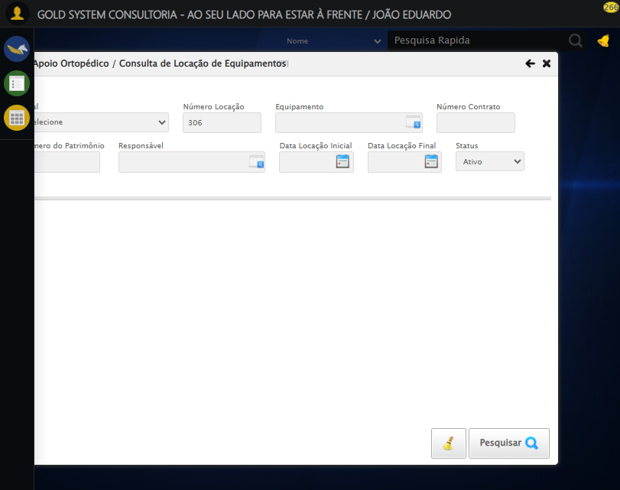

[16:57:52] [INFO] 🔄 Pesquisando equipamento...

[16:58:23] [ERROR] ❌ Timeout aguardando elemento: /html/body/div[20]/div[2]/div[1]/div[1]/div[3]/a (timeout: 30s)

[16:58:23] [ERROR] ❌ Erro no clique robusto: Message:   
Stacktrace:  
 GetHandleVerifier [0x0x7da8a3+63283]  
 GetHandleVerifier [0x0x7da8e4+63348]  
 (No symbol) [0x0x613e43]  
 (No symbol) [0x0x65c8de]  
 (No symbol) [0x0x65cc7b]  
 (No symbol) [0x0x6a4ef2]  
 (No symbol) [0x0x681464]  
 (No symbol) [0x0x6a271a]  
 (No symbol) [0x0x681216]  
 (No symbol) [0x0x650855]  
 (No symbol) [0x0x6516f4]  
 GetHandleVerifier [0x0xa4bb43+2623955]  
 GetHandleVerifier [0x0xa46daa+2604090]  
 GetHandleVerifier [0x0x80069a+218410]  
 GetHandleVerifier [0x0x7f0ed8+154984]  
 GetHandleVerifier [0x0x7f742d+180925]  
 GetHandleVerifier [0x0x7e22b8+94536]  
 GetHandleVerifier [0x0x7e2442+94930]  
 GetHandleVerifier [0x0x7cd5ea+9338]  
 BaseThreadInitThunk [0x0x76b1fcc9+25]  
 RtlGetAppContainerNamedObjectPath [0x0x776a82ae+286]  
 RtlGetAppContainerNamedObjectPath [0x0x776a827e+238]

[16:58:55] [ERROR] ❌ Timeout aguardando elemento: //tr[td[2][contains(normalize-space(.),'EQUIPAMENTO SELENIUM 01')]] (timeout: 30s)

[16:58:55] [ERROR] ❌ Erro no clique robusto: Message:   
Stacktrace:  
 GetHandleVerifier [0x0x7da8a3+63283]  
 GetHandleVerifier [0x0x7da8e4+63348]  
 (No symbol) [0x0x613e43]  
 (No symbol) [0x0x65c8de]  
 (No symbol) [0x0x65cc7b]  
 (No symbol) [0x0x6a4ef2]  
 (No symbol) [0x0x681464]  
 (No symbol) [0x0x6a271a]  
 (No symbol) [0x0x681216]  
 (No symbol) [0x0x650855]  
 (No symbol) [0x0x6516f4]  
 GetHandleVerifier [0x0xa4bb43+2623955]  
 GetHandleVerifier [0x0xa46daa+2604090]  
 GetHandleVerifier [0x0x80069a+218410]  
 GetHandleVerifier [0x0x7f0ed8+154984]  
 GetHandleVerifier [0x0x7f742d+180925]  
 GetHandleVerifier [0x0x7e22b8+94536]  
 GetHandleVerifier [0x0x7e2442+94930]  
 GetHandleVerifier [0x0x7cd5ea+9338]  
 BaseThreadInitThunk [0x0x76b1fcc9+25]  
 RtlGetAppContainerNamedObjectPath [0x0x776a82ae+286]  
 RtlGetAppContainerNamedObjectPath [0x0x776a827e+238]

[16:58:55] [INFO] ✅ Pesquisando equipamento realizada com sucesso.

[16:58:56] [INFO] Screenshot capturada: pesquisando_equipamento

Screenshot: pesquisando_equipamento

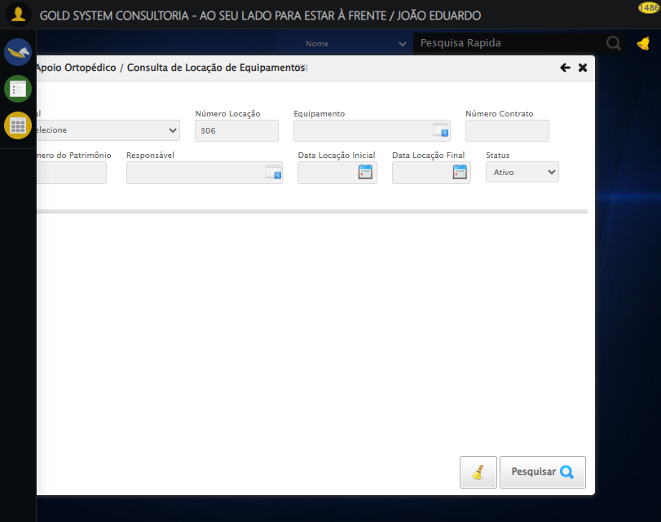

[16:58:56] [INFO] 🔄 Preenchendo Número do Contrato...

[16:59:01] [INFO] ✅ Campo preenchido com estratégia 1: '113060'

[16:59:01] [INFO] ✅ Preenchendo Número do Contrato realizada com sucesso.

[16:59:02] [INFO] Screenshot capturada: preenchendo_número_do_contrato

Screenshot: preenchendo_número_do_contrato

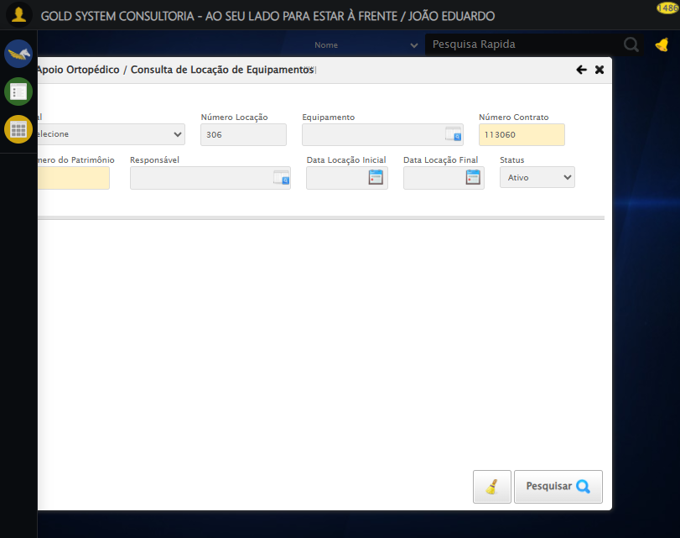

[16:59:02] [INFO] 🔄 Preenchendo Número do Patrimônio...

[16:59:06] [INFO] ✅ Campo preenchido com estratégia 1: '876*&'

[16:59:06] [INFO] ✅ Preenchendo Número do Patrimônio realizada com sucesso.

[16:59:07] [INFO] Screenshot capturada: preenchendo_número_do_patrimônio

Screenshot: preenchendo_número_do_patrimônio

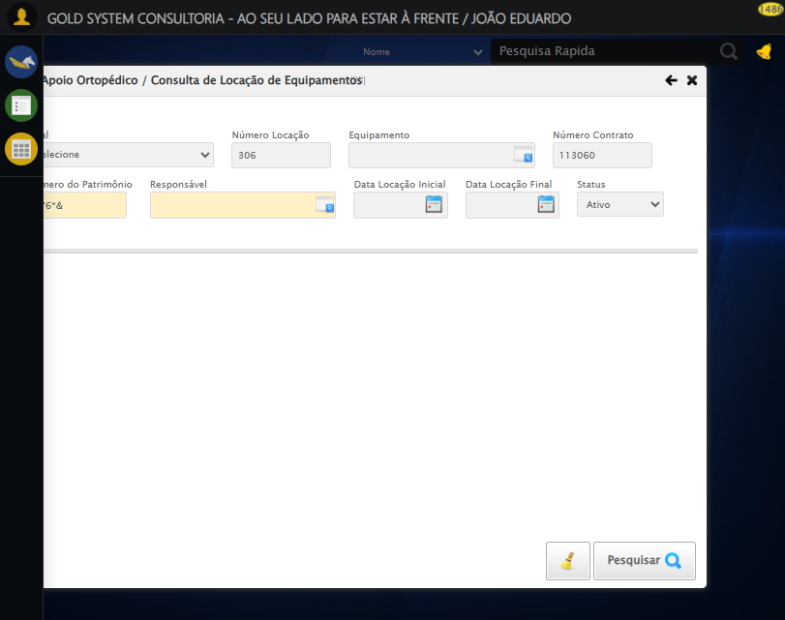

[16:59:07] [INFO] 🔄 Abrindo LOV do Responsável...

[16:59:24] [ERROR] ❌ Erro no clique robusto: Message: invalid session id: session deleted as the browser has closed the connection  
from disconnected: not connected to DevTools  
 (Session info: chrome=139.0.7258.128); For documentation on this error, please visit: https://www.selenium.dev/documentation/webdriver/troubleshooting/errors#invalidsessionidexception  
Stacktrace:  
 GetHandleVerifier [0x0x7da8a3+63283]  
 GetHandleVerifier [0x0x7da8e4+63348]  
 (No symbol) [0x0x613e43]  
 (No symbol) [0x0x603790]  
 (No symbol) [0x0x621602]  
 (No symbol) [0x0x687cdc]  
 (No symbol) [0x0x6a1ff9]  
 (No symbol) [0x0x681216]  
 (No symbol) [0x0x650855]  
 (No symbol) [0x0x6516f4]  
 GetHandleVerifier [0x0xa4bb43+2623955]  
 GetHandleVerifier [0x0xa46daa+2604090]  
 GetHandleVerifier [0x0x80069a+218410]  
 GetHandleVerifier [0x0x7f0ed8+154984]  
 GetHandleVerifier [0x0x7f742d+180925]  
 GetHandleVerifier [0x0x7e22b8+94536]  
 GetHandleVerifier [0x0x7e2442+94930]  
 GetHandleVerifier [0x0x7cd5ea+9338]  
 BaseThreadInitThunk [0x0x76b1fcc9+25]  
 RtlGetAppContainerNamedObjectPath [0x0x776a82ae+286]  
 RtlGetAppContainerNamedObjectPath [0x0x776a827e+238]

[16:59:24] [INFO] ✅ Abrindo LOV do Responsável realizada com sucesso.

[16:59:25] [WARN] Erro ao capturar screenshot abrindo_lov_do_responsável: Message: invalid session id; For documentation on this error, please visit: https://www.selenium.dev/documentation/webdriver/troubleshooting/errors#invalidsessionidexception  
Stacktrace:  
 GetHandleVerifier [0x0x7da8a3+63283]  
 GetHandleVerifier [0x0x7da8e4+63348]  
 (No symbol) [0x0x613ca0]  
 (No symbol) [0x0x64fb48]  
 (No symbol) [0x0x6812d6]  
 (No symbol) [0x0x67ceb5]  
 (No symbol) [0x0x67c436]  
 (No symbol) [0x0x5e5755]  
 (No symbol) [0x0x5e5cae]  
 (No symbol) [0x0x5e613d]  
 GetHandleVerifier [0x0xa4bb43+2623955]  
 GetHandleVerifier [0x0xa46daa+2604090]  
 GetHandleVerifier [0x0x80069a+218410]  
 GetHandleVerifier [0x0x7f0ed8+154984]  
 GetHandleVerifier [0x0x7f742d+180925]  
 (No symbol) [0x0x5e5420]  
 (No symbol) [0x0x5e4c36]  
 GetHandleVerifier [0x0xb868fc+3913612]  
 BaseThreadInitThunk [0x0x76b1fcc9+25]  
 RtlGetAppContainerNamedObjectPath [0x0x776a82ae+286]  
 RtlGetAppContainerNamedObjectPath [0x0x776a827e+238]

[16:59:25] [INFO] 🔄 Pesquisando responsável...

[16:59:25] [ERROR] ❌ Erro no preenchimento: Message: invalid session id; For documentation on this error, please visit: https://www.selenium.dev/documentation/webdriver/troubleshooting/errors#invalidsessionidexception  
Stacktrace:  
 GetHandleVerifier [0x0x7da8a3+63283]  
 GetHandleVerifier [0x0x7da8e4+63348]  
 (No symbol) [0x0x613ca0]  
 (No symbol) [0x0x64fb48]  
 (No symbol) [0x0x6812d6]  
 (No symbol) [0x0x67ceb5]  
 (No symbol) [0x0x67c436]  
 (No symbol) [0x0x5e5755]  
 (No symbol) [0x0x5e5cae]  
 (No symbol) [0x0x5e613d]  
 GetHandleVerifier [0x0xa4bb43+2623955]  
 GetHandleVerifier [0x0xa46daa+2604090]  
 GetHandleVerifier [0x0x80069a+218410]  
 GetHandleVerifier [0x0x7f0ed8+154984]  
 GetHandleVerifier [0x0x7f742d+180925]  
 (No symbol) [0x0x5e5420]  
 (No symbol) [0x0x5e4c36]  
 GetHandleVerifier [0x0xb868fc+3913612]  
 BaseThreadInitThunk [0x0x76b1fcc9+25]  
 RtlGetAppContainerNamedObjectPath [0x0x776a82ae+286]  
 RtlGetAppContainerNamedObjectPath [0x0x776a827e+238]

[16:59:25] [ERROR] ❌ Erro no clique robusto: Message: invalid session id; For documentation on this error, please visit: https://www.selenium.dev/documentation/webdriver/troubleshooting/errors#invalidsessionidexception  
Stacktrace:  
 GetHandleVerifier [0x0x7da8a3+63283]  
 GetHandleVerifier [0x0x7da8e4+63348]  
 (No symbol) [0x0x613ca0]  
 (No symbol) [0x0x64fb48]  
 (No symbol) [0x0x6812d6]  
 (No symbol) [0x0x67ceb5]  
 (No symbol) [0x0x67c436]  
 (No symbol) [0x0x5e5755]  
 (No symbol) [0x0x5e5cae]  
 (No symbol) [0x0x5e613d]  
 GetHandleVerifier [0x0xa4bb43+2623955]  
 GetHandleVerifier [0x0xa46daa+2604090]  
 GetHandleVerifier [0x0x80069a+218410]  
 GetHandleVerifier [0x0x7f0ed8+154984]  
 GetHandleVerifier [0x0x7f742d+180925]  
 (No symbol) [0x0x5e5420]  
 (No symbol) [0x0x5e4c36]  
 GetHandleVerifier [0x0xb868fc+3913612]  
 BaseThreadInitThunk [0x0x76b1fcc9+25]  
 RtlGetAppContainerNamedObjectPath [0x0x776a82ae+286]  
 RtlGetAppContainerNamedObjectPath [0x0x776a827e+238]

[16:59:27] [ERROR] ❌ Erro no clique robusto: Message: invalid session id; For documentation on this error, please visit: https://www.selenium.dev/documentation/webdriver/troubleshooting/errors#invalidsessionidexception  
Stacktrace:  
 GetHandleVerifier [0x0x7da8a3+63283]  
 GetHandleVerifier [0x0x7da8e4+63348]  
 (No symbol) [0x0x613ca0]  
 (No symbol) [0x0x64fb48]  
 (No symbol) [0x0x6812d6]  
 (No symbol) [0x0x67ceb5]  
 (No symbol) [0x0x67c436]  
 (No symbol) [0x0x5e5755]  
 (No symbol) [0x0x5e5cae]  
 (No symbol) [0x0x5e613d]  
 GetHandleVerifier [0x0xa4bb43+2623955]  
 GetHandleVerifier [0x0xa46daa+2604090]  
 GetHandleVerifier [0x0x80069a+218410]  
 GetHandleVerifier [0x0x7f0ed8+154984]  
 GetHandleVerifier [0x0x7f742d+180925]  
 (No symbol) [0x0x5e5420]  
 (No symbol) [0x0x5e4c36]  
 GetHandleVerifier [0x0xb868fc+3913612]  
 BaseThreadInitThunk [0x0x76b1fcc9+25]  
 RtlGetAppContainerNamedObjectPath [0x0x776a82ae+286]  
 RtlGetAppContainerNamedObjectPath [0x0x776a827e+238]

[16:59:27] [INFO] ✅ Pesquisando responsável realizada com sucesso.

[16:59:28] [WARN] Erro ao capturar screenshot pesquisando_responsável: Message: invalid session id; For documentation on this error, please visit: https://www.selenium.dev/documentation/webdriver/troubleshooting/errors#invalidsessionidexception  
Stacktrace:  
 GetHandleVerifier [0x0x7da8a3+63283]  
 GetHandleVerifier [0x0x7da8e4+63348]  
 (No symbol) [0x0x613ca0]  
 (No symbol) [0x0x64fb48]  
 (No symbol) [0x0x6812d6]  
 (No symbol) [0x0x67ceb5]  
 (No symbol) [0x0x67c436]  
 (No symbol) [0x0x5e5755]  
 (No symbol) [0x0x5e5cae]  
 (No symbol) [0x0x5e613d]  
 GetHandleVerifier [0x0xa4bb43+2623955]  
 GetHandleVerifier [0x0xa46daa+2604090]  
 GetHandleVerifier [0x0x80069a+218410]  
 GetHandleVerifier [0x0x7f0ed8+154984]  
 GetHandleVerifier [0x0x7f742d+180925]  
 (No symbol) [0x0x5e5420]  
 (No symbol) [0x0x5e4c36]  
 GetHandleVerifier [0x0xb868fc+3913612]  
 BaseThreadInitThunk [0x0x76b1fcc9+25]  
 RtlGetAppContainerNamedObjectPath [0x0x776a82ae+286]  
 RtlGetAppContainerNamedObjectPath [0x0x776a827e+238]

[16:59:28] [INFO] 🔄 Preenchendo Data Locação Inicial...

[16:59:28] [INFO] 🎯 Tentativa 1: Preenchendo datepicker 0 com '21/08/2025'

[16:59:28] [INFO] 📊 Encontrados 0 campos datepicker

[16:59:30] [INFO] 🎯 Tentativa 2: Preenchendo datepicker 0 com '21/08/2025'

[16:59:30] [INFO] 📊 Encontrados 0 campos datepicker

[16:59:32] [INFO] 🎯 Tentativa 3: Preenchendo datepicker 0 com '21/08/2025'

[16:59:32] [INFO] 📊 Encontrados 0 campos datepicker

[16:59:34] [INFO] 🎯 Tentativa 4: Preenchendo datepicker 0 com '21/08/2025'

[16:59:34] [INFO] 📊 Encontrados 0 campos datepicker

[16:59:36] [INFO] 🎯 Tentativa 5: Preenchendo datepicker 0 com '21/08/2025'

[16:59:36] [INFO] 📊 Encontrados 0 campos datepicker

[16:59:36] [WARN] ⚠️ Tentativa 1 falhou: Falha ao preencher datepicker 0 após 5 tentativas: Nenhum campo datepicker encontrado. Tentando novamente...

[16:59:38] [INFO] 🔄 Preenchendo Data Locação Inicial... (Tentativa 2)

[16:59:38] [INFO] 🎯 Tentativa 1: Preenchendo datepicker 0 com '21/08/2025'

[16:59:38] [INFO] 📊 Encontrados 0 campos datepicker

[16:59:40] [INFO] 🎯 Tentativa 2: Preenchendo datepicker 0 com '21/08/2025'

[16:59:40] [INFO] 📊 Encontrados 0 campos datepicker

[16:59:42] [INFO] 🎯 Tentativa 3: Preenchendo datepicker 0 com '21/08/2025'

[16:59:42] [INFO] 📊 Encontrados 0 campos datepicker

[16:59:44] [INFO] 🎯 Tentativa 4: Preenchendo datepicker 0 com '21/08/2025'

[16:59:44] [INFO] 📊 Encontrados 0 campos datepicker

[16:59:46] [INFO] 🎯 Tentativa 5: Preenchendo datepicker 0 com '21/08/2025'

[16:59:46] [INFO] 📊 Encontrados 0 campos datepicker

[16:59:46] [WARN] ⚠️ Tentativa 2 falhou: Falha ao preencher datepicker 0 após 5 tentativas: Nenhum campo datepicker encontrado. Tentando novamente...

[16:59:48] [INFO] 🔄 Preenchendo Data Locação Inicial... (Tentativa 3)

[16:59:48] [INFO] 🎯 Tentativa 1: Preenchendo datepicker 0 com '21/08/2025'

[16:59:48] [INFO] 📊 Encontrados 0 campos datepicker

[16:59:50] [INFO] 🎯 Tentativa 2: Preenchendo datepicker 0 com '21/08/2025'

[16:59:50] [INFO] 📊 Encontrados 0 campos datepicker

[16:59:52] [INFO] 🎯 Tentativa 3: Preenchendo datepicker 0 com '21/08/2025'

[16:59:52] [INFO] 📊 Encontrados 0 campos datepicker

[16:59:54] [INFO] 🎯 Tentativa 4: Preenchendo datepicker 0 com '21/08/2025'

[16:59:54] [INFO] 📊 Encontrados 0 campos datepicker

[16:59:56] [INFO] 🎯 Tentativa 5: Preenchendo datepicker 0 com '21/08/2025'

[16:59:56] [INFO] 📊 Encontrados 0 campos datepicker

[16:59:56] [WARN] Erro ao capturar screenshot erro_preenchendo_data_locação_inicial: Message: invalid session id; For documentation on this error, please visit: https://www.selenium.dev/documentation/webdriver/troubleshooting/errors#invalidsessionidexception  
Stacktrace:  
 GetHandleVerifier [0x0x7da8a3+63283]  
 GetHandleVerifier [0x0x7da8e4+63348]  
 (No symbol) [0x0x613ca0]  
 (No symbol) [0x0x64fb48]  
 (No symbol) [0x0x6812d6]  
 (No symbol) [0x0x67ceb5]  
 (No symbol) [0x0x67c436]  
 (No symbol) [0x0x5e5755]  
 (No symbol) [0x0x5e5cae]  
 (No symbol) [0x0x5e613d]  
 GetHandleVerifier [0x0xa4bb43+2623955]  
 GetHandleVerifier [0x0xa46daa+2604090]  
 GetHandleVerifier [0x0x80069a+218410]  
 GetHandleVerifier [0x0x7f0ed8+154984]  
 GetHandleVerifier [0x0x7f742d+180925]  
 (No symbol) [0x0x5e5420]  
 (No symbol) [0x0x5e4c36]  
 GetHandleVerifier [0x0xb868fc+3913612]  
 BaseThreadInitThunk [0x0x76b1fcc9+25]  
 RtlGetAppContainerNamedObjectPath [0x0x776a82ae+286]  
 RtlGetAppContainerNamedObjectPath [0x0x776a827e+238]

[16:59:56] [ERROR] ❌ Preenchendo Data Locação Inicial falhou após 3 tentativas: Falha ao preencher datepicker 0 após 5 tentativas: Nenhum campo datepicker encontrado

[16:59:56] [WARN] ⚠️ Continuando execução apesar do erro em: Preenchendo Data Locação Inicial

[16:59:56] [INFO] 🔄 Preenchendo Data Locação Final...

[16:59:56] [INFO] 🎯 Tentativa 1: Preenchendo datepicker 1 com '21/08/2025'

[16:59:56] [INFO] 📊 Encontrados 0 campos datepicker

[16:59:58] [INFO] 🎯 Tentativa 2: Preenchendo datepicker 1 com '21/08/2025'

[16:59:58] [INFO] 📊 Encontrados 0 campos datepicker

[17:00:00] [INFO] 🎯 Tentativa 3: Preenchendo datepicker 1 com '21/08/2025'

[17:00:00] [INFO] 📊 Encontrados 0 campos datepicker

[17:00:02] [INFO] 🎯 Tentativa 4: Preenchendo datepicker 1 com '21/08/2025'

[17:00:02] [INFO] 📊 Encontrados 0 campos datepicker

[17:00:04] [INFO] 🎯 Tentativa 5: Preenchendo datepicker 1 com '21/08/2025'

[17:00:04] [INFO] 📊 Encontrados 0 campos datepicker

[17:00:04] [WARN] ⚠️ Tentativa 1 falhou: Falha ao preencher datepicker 1 após 5 tentativas: Nenhum campo datepicker encontrado. Tentando novamente...

[17:00:06] [INFO] 🔄 Preenchendo Data Locação Final... (Tentativa 2)

[17:00:06] [INFO] 🎯 Tentativa 1: Preenchendo datepicker 1 com '21/08/2025'

[17:00:06] [INFO] 📊 Encontrados 0 campos datepicker

[17:00:08] [INFO] 🎯 Tentativa 2: Preenchendo datepicker 1 com '21/08/2025'

[17:00:08] [INFO] 📊 Encontrados 0 campos datepicker

[17:00:10] [INFO] 🎯 Tentativa 3: Preenchendo datepicker 1 com '21/08/2025'

[17:00:10] [INFO] 📊 Encontrados 0 campos datepicker

[17:00:12] [INFO] 🎯 Tentativa 4: Preenchendo datepicker 1 com '21/08/2025'

[17:00:12] [INFO] 📊 Encontrados 0 campos datepicker

[17:00:14] [INFO] 🎯 Tentativa 5: Preenchendo datepicker 1 com '21/08/2025'

[17:00:14] [INFO] 📊 Encontrados 0 campos datepicker

[17:00:14] [WARN] ⚠️ Tentativa 2 falhou: Falha ao preencher datepicker 1 após 5 tentativas: Nenhum campo datepicker encontrado. Tentando novamente...

[17:00:16] [INFO] 🔄 Preenchendo Data Locação Final... (Tentativa 3)

[17:00:16] [INFO] 🎯 Tentativa 1: Preenchendo datepicker 1 com '21/08/2025'

[17:00:16] [INFO] 📊 Encontrados 0 campos datepicker

[17:00:18] [INFO] 🎯 Tentativa 2: Preenchendo datepicker 1 com '21/08/2025'

[17:00:19] [INFO] 📊 Encontrados 0 campos datepicker

[17:00:21] [INFO] 🎯 Tentativa 3: Preenchendo datepicker 1 com '21/08/2025'

[17:00:21] [INFO] 📊 Encontrados 0 campos datepicker

[17:00:23] [INFO] 🎯 Tentativa 4: Preenchendo datepicker 1 com '21/08/2025'

[17:00:23] [INFO] 📊 Encontrados 0 campos datepicker

[17:00:25] [INFO] 🎯 Tentativa 5: Preenchendo datepicker 1 com '21/08/2025'

[17:00:25] [INFO] 📊 Encontrados 0 campos datepicker

[17:00:25] [WARN] Erro ao capturar screenshot erro_preenchendo_data_locação_final: Message: invalid session id; For documentation on this error, please visit: https://www.selenium.dev/documentation/webdriver/troubleshooting/errors#invalidsessionidexception  
Stacktrace:  
 GetHandleVerifier [0x0x7da8a3+63283]  
 GetHandleVerifier [0x0x7da8e4+63348]  
 (No symbol) [0x0x613ca0]  
 (No symbol) [0x0x64fb48]  
 (No symbol) [0x0x6812d6]  
 (No symbol) [0x0x67ceb5]  
 (No symbol) [0x0x67c436]  
 (No symbol) [0x0x5e5755]  
 (No symbol) [0x0x5e5cae]  
 (No symbol) [0x0x5e613d]  
 GetHandleVerifier [0x0xa4bb43+2623955]  
 GetHandleVerifier [0x0xa46daa+2604090]  
 GetHandleVerifier [0x0x80069a+218410]  
 GetHandleVerifier [0x0x7f0ed8+154984]  
 GetHandleVerifier [0x0x7f742d+180925]  
 (No symbol) [0x0x5e5420]  
 (No symbol) [0x0x5e4c36]  
 GetHandleVerifier [0x0xb868fc+3913612]  
 BaseThreadInitThunk [0x0x76b1fcc9+25]  
 RtlGetAppContainerNamedObjectPath [0x0x776a82ae+286]  
 RtlGetAppContainerNamedObjectPath [0x0x776a827e+238]

[17:00:25] [ERROR] ❌ Preenchendo Data Locação Final falhou após 3 tentativas: Falha ao preencher datepicker 1 após 5 tentativas: Nenhum campo datepicker encontrado

[17:00:25] [WARN] ⚠️ Continuando execução apesar do erro em: Preenchendo Data Locação Final

[17:00:25] [INFO] 🔄 Realizando consulta...

[17:00:25] [ERROR] ❌ Erro no clique robusto: Message: invalid session id; For documentation on this error, please visit: https://www.selenium.dev/documentation/webdriver/troubleshooting/errors#invalidsessionidexception  
Stacktrace:  
 GetHandleVerifier [0x0x7da8a3+63283]  
 GetHandleVerifier [0x0x7da8e4+63348]  
 (No symbol) [0x0x613ca0]  
 (No symbol) [0x0x64fb48]  
 (No symbol) [0x0x6812d6]  
 (No symbol) [0x0x67ceb5]  
 (No symbol) [0x0x67c436]  
 (No symbol) [0x0x5e5755]  
 (No symbol) [0x0x5e5cae]  
 (No symbol) [0x0x5e613d]  
 GetHandleVerifier [0x0xa4bb43+2623955]  
 GetHandleVerifier [0x0xa46daa+2604090]  
 GetHandleVerifier [0x0x80069a+218410]  
 GetHandleVerifier [0x0x7f0ed8+154984]  
 GetHandleVerifier [0x0x7f742d+180925]  
 (No symbol) [0x0x5e5420]  
 (No symbol) [0x0x5e4c36]  
 GetHandleVerifier [0x0xb868fc+3913612]  
 BaseThreadInitThunk [0x0x76b1fcc9+25]  
 RtlGetAppContainerNamedObjectPath [0x0x776a82ae+286]  
 RtlGetAppContainerNamedObjectPath [0x0x776a827e+238]

[17:00:35] [INFO] ✅ Realizando consulta realizada com sucesso.

[17:00:36] [WARN] Erro ao capturar screenshot realizando_consulta: Message: invalid session id; For documentation on this error, please visit: https://www.selenium.dev/documentation/webdriver/troubleshooting/errors#invalidsessionidexception  
Stacktrace:  
 GetHandleVerifier [0x0x7da8a3+63283]  
 GetHandleVerifier [0x0x7da8e4+63348]  
 (No symbol) [0x0x613ca0]  
 (No symbol) [0x0x64fb48]  
 (No symbol) [0x0x6812d6]  
 (No symbol) [0x0x67ceb5]  
 (No symbol) [0x0x67c436]  
 (No symbol) [0x0x5e5755]  
 (No symbol) [0x0x5e5cae]  
 (No symbol) [0x0x5e613d]  
 GetHandleVerifier [0x0xa4bb43+2623955]  
 GetHandleVerifier [0x0xa46daa+2604090]  
 GetHandleVerifier [0x0x80069a+218410]  
 GetHandleVerifier [0x0x7f0ed8+154984]  
 GetHandleVerifier [0x0x7f742d+180925]  
 (No symbol) [0x0x5e5420]  
 (No symbol) [0x0x5e4c36]  
 GetHandleVerifier [0x0xb868fc+3913612]  
 BaseThreadInitThunk [0x0x76b1fcc9+25]  
 RtlGetAppContainerNamedObjectPath [0x0x776a82ae+286]  
 RtlGetAppContainerNamedObjectPath [0x0x776a827e+238]

[17:00:36] [INFO] 🔄 Validando resultados da consulta...

[17:00:36] [INFO] 🔍 Validando registros encontrados...

[17:00:41] [WARN] ⚠️ Erro ao verificar tabela com #DataTables_Table_0 tbody tr: Message: invalid session id; For documentation on this error, please visit: https://www.selenium.dev/documentation/webdriver/troubleshooting/errors#invalidsessionidexception  
Stacktrace:  
 GetHandleVerifier [0x0x7da8a3+63283]  
 GetHandleVerifier [0x0x7da8e4+63348]  
 (No symbol) [0x0x613ca0]  
 (No symbol) [0x0x64fb48]  
 (No symbol) [0x0x6812d6]  
 (No symbol) [0x0x67ceb5]  
 (No symbol) [0x0x67c436]  
 (No symbol) [0x0x5e5755]  
 (No symbol) [0x0x5e5cae]  
 (No symbol) [0x0x5e613d]  
 GetHandleVerifier [0x0xa4bb43+2623955]  
 GetHandleVerifier [0x0xa46daa+2604090]  
 GetHandleVerifier [0x0x80069a+218410]  
 GetHandleVerifier [0x0x7f0ed8+154984]  
 GetHandleVerifier [0x0x7f742d+180925]  
 (No symbol) [0x0x5e5420]  
 (No symbol) [0x0x5e4c36]  
 GetHandleVerifier [0x0xb868fc+3913612]  
 BaseThreadInitThunk [0x0x76b1fcc9+25]  
 RtlGetAppContainerNamedObjectPath [0x0x776a82ae+286]  
 RtlGetAppContainerNamedObjectPath [0x0x776a827e+238]

[17:00:41] [WARN] ⚠️ Erro ao verificar tabela com #DataTables_Table_1 tbody tr: Message: invalid session id; For documentation on this error, please visit: https://www.selenium.dev/documentation/webdriver/troubleshooting/errors#invalidsessionidexception  
Stacktrace:  
 GetHandleVerifier [0x0x7da8a3+63283]  
 GetHandleVerifier [0x0x7da8e4+63348]  
 (No symbol) [0x0x613ca0]  
 (No symbol) [0x0x64fb48]  
 (No symbol) [0x0x6812d6]  
 (No symbol) [0x0x67ceb5]  
 (No symbol) [0x0x67c436]  
 (No symbol) [0x0x5e5755]  
 (No symbol) [0x0x5e5cae]  
 (No symbol) [0x0x5e613d]  
 GetHandleVerifier [0x0xa4bb43+2623955]  
 GetHandleVerifier [0x0xa46daa+2604090]  
 GetHandleVerifier [0x0x80069a+218410]  
 GetHandleVerifier [0x0x7f0ed8+154984]  
 GetHandleVerifier [0x0x7f742d+180925]  
 (No symbol) [0x0x5e5420]  
 (No symbol) [0x0x5e4c36]  
 GetHandleVerifier [0x0xb868fc+3913612]  
 BaseThreadInitThunk [0x0x76b1fcc9+25]  
 RtlGetAppContainerNamedObjectPath [0x0x776a82ae+286]  
 RtlGetAppContainerNamedObjectPath [0x0x776a827e+238]

[17:00:41] [WARN] ⚠️ Erro ao verificar tabela com table[id*="DataTables"] tbody tr: Message: invalid session id; For documentation on this error, please visit: https://www.selenium.dev/documentation/webdriver/troubleshooting/errors#invalidsessionidexception  
Stacktrace:  
 GetHandleVerifier [0x0x7da8a3+63283]  
 GetHandleVerifier [0x0x7da8e4+63348]  
 (No symbol) [0x0x613ca0]  
 (No symbol) [0x0x64fb48]  
 (No symbol) [0x0x6812d6]  
 (No symbol) [0x0x67ceb5]  
 (No symbol) [0x0x67c436]  
 (No symbol) [0x0x5e5755]  
 (No symbol) [0x0x5e5cae]  
 (No symbol) [0x0x5e613d]  
 GetHandleVerifier [0x0xa4bb43+2623955]  
 GetHandleVerifier [0x0xa46daa+2604090]  
 GetHandleVerifier [0x0x80069a+218410]  
 GetHandleVerifier [0x0x7f0ed8+154984]  
 GetHandleVerifier [0x0x7f742d+180925]  
 (No symbol) [0x0x5e5420]  
 (No symbol) [0x0x5e4c36]  
 GetHandleVerifier [0x0xb868fc+3913612]  
 BaseThreadInitThunk [0x0x76b1fcc9+25]  
 RtlGetAppContainerNamedObjectPath [0x0x776a82ae+286]  
 RtlGetAppContainerNamedObjectPath [0x0x776a827e+238]

[17:00:41] [WARN] ⚠️ Erro ao verificar tabela com .wdGrid table tbody tr: Message: invalid session id; For documentation on this error, please visit: https://www.selenium.dev/documentation/webdriver/troubleshooting/errors#invalidsessionidexception  
Stacktrace:  
 GetHandleVerifier [0x0x7da8a3+63283]  
 GetHandleVerifier [0x0x7da8e4+63348]  
 (No symbol) [0x0x613ca0]  
 (No symbol) [0x0x64fb48]  
 (No symbol) [0x0x6812d6]  
 (No symbol) [0x0x67ceb5]  
 (No symbol) [0x0x67c436]  
 (No symbol) [0x0x5e5755]  
 (No symbol) [0x0x5e5cae]  
 (No symbol) [0x0x5e613d]  
 GetHandleVerifier [0x0xa4bb43+2623955]  
 GetHandleVerifier [0x0xa46daa+2604090]  
 GetHandleVerifier [0x0x80069a+218410]  
 GetHandleVerifier [0x0x7f0ed8+154984]  
 GetHandleVerifier [0x0x7f742d+180925]  
 (No symbol) [0x0x5e5420]  
 (No symbol) [0x0x5e4c36]  
 GetHandleVerifier [0x0xb868fc+3913612]  
 BaseThreadInitThunk [0x0x76b1fcc9+25]  
 RtlGetAppContainerNamedObjectPath [0x0x776a82ae+286]  
 RtlGetAppContainerNamedObjectPath [0x0x776a827e+238]

[17:00:41] [WARN] ⚠️ Erro ao verificar tabela com table tbody tr: Message: invalid session id; For documentation on this error, please visit: https://www.selenium.dev/documentation/webdriver/troubleshooting/errors#invalidsessionidexception  
Stacktrace:  
 GetHandleVerifier [0x0x7da8a3+63283]  
 GetHandleVerifier [0x0x7da8e4+63348]  
 (No symbol) [0x0x613ca0]  
 (No symbol) [0x0x64fb48]  
 (No symbol) [0x0x6812d6]  
 (No symbol) [0x0x67ceb5]  
 (No symbol) [0x0x67c436]  
 (No symbol) [0x0x5e5755]  
 (No symbol) [0x0x5e5cae]  
 (No symbol) [0x0x5e613d]  
 GetHandleVerifier [0x0xa4bb43+2623955]  
 GetHandleVerifier [0x0xa46daa+2604090]  
 GetHandleVerifier [0x0x80069a+218410]  
 GetHandleVerifier [0x0x7f0ed8+154984]  
 GetHandleVerifier [0x0x7f742d+180925]  
 (No symbol) [0x0x5e5420]  
 (No symbol) [0x0x5e4c36]  
 GetHandleVerifier [0x0xb868fc+3913612]  
 BaseThreadInitThunk [0x0x76b1fcc9+25]  
 RtlGetAppContainerNamedObjectPath [0x0x776a82ae+286]  
 RtlGetAppContainerNamedObjectPath [0x0x776a827e+238]

[17:00:41] [WARN] ⚠️ Não foi possível determinar se há registros

[17:00:41] [INFO] ✅ Validando resultados da consulta realizada com sucesso.

[17:00:42] [WARN] Erro ao capturar screenshot validando_resultados_da_consulta: Message: invalid session id; For documentation on this error, please visit: https://www.selenium.dev/documentation/webdriver/troubleshooting/errors#invalidsessionidexception  
Stacktrace:  
 GetHandleVerifier [0x0x7da8a3+63283]  
 GetHandleVerifier [0x0x7da8e4+63348]  
 (No symbol) [0x0x613ca0]  
 (No symbol) [0x0x64fb48]  
 (No symbol) [0x0x6812d6]  
 (No symbol) [0x0x67ceb5]  
 (No symbol) [0x0x67c436]  
 (No symbol) [0x0x5e5755]  
 (No symbol) [0x0x5e5cae]  
 (No symbol) [0x0x5e613d]  
 GetHandleVerifier [0x0xa4bb43+2623955]  
 GetHandleVerifier [0x0xa46daa+2604090]  
 GetHandleVerifier [0x0x80069a+218410]  
 GetHandleVerifier [0x0x7f0ed8+154984]  
 GetHandleVerifier [0x0x7f742d+180925]  
 (No symbol) [0x0x5e5420]  
 (No symbol) [0x0x5e4c36]  
 GetHandleVerifier [0x0xb868fc+3913612]  
 BaseThreadInitThunk [0x0x76b1fcc9+25]  
 RtlGetAppContainerNamedObjectPath [0x0x776a82ae+286]  
 RtlGetAppContainerNamedObjectPath [0x0x776a827e+238]

[17:00:42] [INFO] Processando 1 registro(s) encontrado(s)

[17:00:42] [INFO] 🔄 Visualizando Detalhes da Locação...

[17:00:42] [ERROR] ❌ Erro no clique robusto: Message: invalid session id; For documentation on this error, please visit: https://www.selenium.dev/documentation/webdriver/troubleshooting/errors#invalidsessionidexception  
Stacktrace:  
 GetHandleVerifier [0x0x7da8a3+63283]  
 GetHandleVerifier [0x0x7da8e4+63348]  
 (No symbol) [0x0x613ca0]  
 (No symbol) [0x0x64fb48]  
 (No symbol) [0x0x6812d6]  
 (No symbol) [0x0x67ceb5]  
 (No symbol) [0x0x67c436]  
 (No symbol) [0x0x5e5755]  
 (No symbol) [0x0x5e5cae]  
 (No symbol) [0x0x5e613d]  
 GetHandleVerifier [0x0xa4bb43+2623955]  
 GetHandleVerifier [0x0xa46daa+2604090]  
 GetHandleVerifier [0x0x80069a+218410]  
 GetHandleVerifier [0x0x7f0ed8+154984]  
 GetHandleVerifier [0x0x7f742d+180925]  
 (No symbol) [0x0x5e5420]  
 (No symbol) [0x0x5e4c36]  
 GetHandleVerifier [0x0xb868fc+3913612]  
 BaseThreadInitThunk [0x0x76b1fcc9+25]  
 RtlGetAppContainerNamedObjectPath [0x0x776a82ae+286]  
 RtlGetAppContainerNamedObjectPath [0x0x776a827e+238]

[17:00:42] [INFO] ✅ Visualizando Detalhes da Locação realizada com sucesso.

[17:00:43] [WARN] Erro ao capturar screenshot visualizando_detalhes_da_locação: Message: invalid session id; For documentation on this error, please visit: https://www.selenium.dev/documentation/webdriver/troubleshooting/errors#invalidsessionidexception  
Stacktrace:  
 GetHandleVerifier [0x0x7da8a3+63283]  
 GetHandleVerifier [0x0x7da8e4+63348]  
 (No symbol) [0x0x613ca0]  
 (No symbol) [0x0x64fb48]  
 (No symbol) [0x0x6812d6]  
 (No symbol) [0x0x67ceb5]  
 (No symbol) [0x0x67c436]  
 (No symbol) [0x0x5e5755]  
 (No symbol) [0x0x5e5cae]  
 (No symbol) [0x0x5e613d]  
 GetHandleVerifier [0x0xa4bb43+2623955]  
 GetHandleVerifier [0x0xa46daa+2604090]  
 GetHandleVerifier [0x0x80069a+218410]  
 GetHandleVerifier [0x0x7f0ed8+154984]  
 GetHandleVerifier [0x0x7f742d+180925]  
 (No symbol) [0x0x5e5420]  
 (No symbol) [0x0x5e4c36]  
 GetHandleVerifier [0x0xb868fc+3913612]  
 BaseThreadInitThunk [0x0x76b1fcc9+25]  
 RtlGetAppContainerNamedObjectPath [0x0x776a82ae+286]  
 RtlGetAppContainerNamedObjectPath [0x0x776a827e+238]

[17:00:43] [INFO] 🔄 Visualizando Títulos...

[17:00:43] [ERROR] ❌ Erro no clique robusto: Message: invalid session id; For documentation on this error, please visit: https://www.selenium.dev/documentation/webdriver/troubleshooting/errors#invalidsessionidexception  
Stacktrace:  
 GetHandleVerifier [0x0x7da8a3+63283]  
 GetHandleVerifier [0x0x7da8e4+63348]  
 (No symbol) [0x0x613ca0]  
 (No symbol) [0x0x64fb48]  
 (No symbol) [0x0x6812d6]  
 (No symbol) [0x0x67ceb5]  
 (No symbol) [0x0x67c436]  
 (No symbol) [0x0x5e5755]  
 (No symbol) [0x0x5e5cae]  
 (No symbol) [0x0x5e613d]  
 GetHandleVerifier [0x0xa4bb43+2623955]  
 GetHandleVerifier [0x0xa46daa+2604090]  
 GetHandleVerifier [0x0x80069a+218410]  
 GetHandleVerifier [0x0x7f0ed8+154984]  
 GetHandleVerifier [0x0x7f742d+180925]  
 (No symbol) [0x0x5e5420]  
 (No symbol) [0x0x5e4c36]  
 GetHandleVerifier [0x0xb868fc+3913612]  
 BaseThreadInitThunk [0x0x76b1fcc9+25]  
 RtlGetAppContainerNamedObjectPath [0x0x776a82ae+286]  
 RtlGetAppContainerNamedObjectPath [0x0x776a827e+238]

[17:01:03] [INFO] ✅ Visualizando Títulos realizada com sucesso.

[17:01:04] [WARN] Erro ao capturar screenshot visualizando_títulos: Message: invalid session id; For documentation on this error, please visit: https://www.selenium.dev/documentation/webdriver/troubleshooting/errors#invalidsessionidexception  
Stacktrace:  
 GetHandleVerifier [0x0x7da8a3+63283]  
 GetHandleVerifier [0x0x7da8e4+63348]  
 (No symbol) [0x0x613ca0]  
 (No symbol) [0x0x64fb48]  
 (No symbol) [0x0x6812d6]  
 (No symbol) [0x0x67ceb5]  
 (No symbol) [0x0x67c436]  
 (No symbol) [0x0x5e5755]  
 (No symbol) [0x0x5e5cae]  
 (No symbol) [0x0x5e613d]  
 GetHandleVerifier [0x0xa4bb43+2623955]  
 GetHandleVerifier [0x0xa46daa+2604090]  
 GetHandleVerifier [0x0x80069a+218410]  
 GetHandleVerifier [0x0x7f0ed8+154984]  
 GetHandleVerifier [0x0x7f742d+180925]  
 (No symbol) [0x0x5e5420]  
 (No symbol) [0x0x5e4c36]  
 GetHandleVerifier [0x0xb868fc+3913612]  
 BaseThreadInitThunk [0x0x76b1fcc9+25]  
 RtlGetAppContainerNamedObjectPath [0x0x776a82ae+286]  
 RtlGetAppContainerNamedObjectPath [0x0x776a827e+238]

[17:01:04] [INFO] 🔄 Capturando screenshot dos títulos...

[17:01:04] [WARN] Erro ao capturar screenshot tela_titulos: Message: invalid session id; For documentation on this error, please visit: https://www.selenium.dev/documentation/webdriver/troubleshooting/errors#invalidsessionidexception  
Stacktrace:  
 GetHandleVerifier [0x0x7da8a3+63283]  
 GetHandleVerifier [0x0x7da8e4+63348]  
 (No symbol) [0x0x613ca0]  
 (No symbol) [0x0x64fb48]  
 (No symbol) [0x0x6812d6]  
 (No symbol) [0x0x67ceb5]  
 (No symbol) [0x0x67c436]  
 (No symbol) [0x0x5e5755]  
 (No symbol) [0x0x5e5cae]  
 (No symbol) [0x0x5e613d]  
 GetHandleVerifier [0x0xa4bb43+2623955]  
 GetHandleVerifier [0x0xa46daa+2604090]  
 GetHandleVerifier [0x0x80069a+218410]  
 GetHandleVerifier [0x0x7f0ed8+154984]  
 GetHandleVerifier [0x0x7f742d+180925]  
 (No symbol) [0x0x5e5420]  
 (No symbol) [0x0x5e4c36]  
 GetHandleVerifier [0x0xb868fc+3913612]  
 BaseThreadInitThunk [0x0x76b1fcc9+25]  
 RtlGetAppContainerNamedObjectPath [0x0x776a82ae+286]  
 RtlGetAppContainerNamedObjectPath [0x0x776a827e+238]

[17:01:04] [INFO] ✅ Capturando screenshot dos títulos realizada com sucesso.

[17:01:05] [WARN] Erro ao capturar screenshot capturando_screenshot_dos_títulos: Message: invalid session id; For documentation on this error, please visit: https://www.selenium.dev/documentation/webdriver/troubleshooting/errors#invalidsessionidexception  
Stacktrace:  
 GetHandleVerifier [0x0x7da8a3+63283]  
 GetHandleVerifier [0x0x7da8e4+63348]  
 (No symbol) [0x0x613ca0]  
 (No symbol) [0x0x64fb48]  
 (No symbol) [0x0x6812d6]  
 (No symbol) [0x0x67ceb5]  
 (No symbol) [0x0x67c436]  
 (No symbol) [0x0x5e5755]  
 (No symbol) [0x0x5e5cae]  
 (No symbol) [0x0x5e613d]  
 GetHandleVerifier [0x0xa4bb43+2623955]  
 GetHandleVerifier [0x0xa46daa+2604090]  
 GetHandleVerifier [0x0x80069a+218410]  
 GetHandleVerifier [0x0x7f0ed8+154984]  
 GetHandleVerifier [0x0x7f742d+180925]  
 (No symbol) [0x0x5e5420]  
 (No symbol) [0x0x5e4c36]  
 GetHandleVerifier [0x0xb868fc+3913612]  
 BaseThreadInitThunk [0x0x76b1fcc9+25]  
 RtlGetAppContainerNamedObjectPath [0x0x776a82ae+286]  
 RtlGetAppContainerNamedObjectPath [0x0x776a827e+238]

[17:01:05] [INFO] 🔄 Fechando aba de títulos...

[17:01:05] [ERROR] ❌ Erro no clique robusto: Message: invalid session id; For documentation on this error, please visit: https://www.selenium.dev/documentation/webdriver/troubleshooting/errors#invalidsessionidexception  
Stacktrace:  
 GetHandleVerifier [0x0x7da8a3+63283]  
 GetHandleVerifier [0x0x7da8e4+63348]  
 (No symbol) [0x0x613ca0]  
 (No symbol) [0x0x64fb48]  
 (No symbol) [0x0x6812d6]  
 (No symbol) [0x0x67ceb5]  
 (No symbol) [0x0x67c436]  
 (No symbol) [0x0x5e5755]  
 (No symbol) [0x0x5e5cae]  
 (No symbol) [0x0x5e613d]  
 GetHandleVerifier [0x0xa4bb43+2623955]  
 GetHandleVerifier [0x0xa46daa+2604090]  
 GetHandleVerifier [0x0x80069a+218410]  
 GetHandleVerifier [0x0x7f0ed8+154984]  
 GetHandleVerifier [0x0x7f742d+180925]  
 (No symbol) [0x0x5e5420]  
 (No symbol) [0x0x5e4c36]  
 GetHandleVerifier [0x0xb868fc+3913612]  
 BaseThreadInitThunk [0x0x76b1fcc9+25]  
 RtlGetAppContainerNamedObjectPath [0x0x776a82ae+286]  
 RtlGetAppContainerNamedObjectPath [0x0x776a827e+238]

[17:01:05] [INFO] ✅ Fechando aba de títulos realizada com sucesso.

[17:01:06] [WARN] Erro ao capturar screenshot fechando_aba_de_títulos: Message: invalid session id; For documentation on this error, please visit: https://www.selenium.dev/documentation/webdriver/troubleshooting/errors#invalidsessionidexception  
Stacktrace:  
 GetHandleVerifier [0x0x7da8a3+63283]  
 GetHandleVerifier [0x0x7da8e4+63348]  
 (No symbol) [0x0x613ca0]  
 (No symbol) [0x0x64fb48]  
 (No symbol) [0x0x6812d6]  
 (No symbol) [0x0x67ceb5]  
 (No symbol) [0x0x67c436]  
 (No symbol) [0x0x5e5755]  
 (No symbol) [0x0x5e5cae]  
 (No symbol) [0x0x5e613d]  
 GetHandleVerifier [0x0xa4bb43+2623955]  
 GetHandleVerifier [0x0xa46daa+2604090]  
 GetHandleVerifier [0x0x80069a+218410]  
 GetHandleVerifier [0x0x7f0ed8+154984]  
 GetHandleVerifier [0x0x7f742d+180925]  
 (No symbol) [0x0x5e5420]  
 (No symbol) [0x0x5e4c36]  
 GetHandleVerifier [0x0xb868fc+3913612]  
 BaseThreadInitThunk [0x0x76b1fcc9+25]  
 RtlGetAppContainerNamedObjectPath [0x0x776a82ae+286]  
 RtlGetAppContainerNamedObjectPath [0x0x776a827e+238]

[17:01:06] [INFO] 🔄 Reabrindo detalhes da locação...

[17:01:06] [ERROR] ❌ Erro no clique robusto: Message: invalid session id; For documentation on this error, please visit: https://www.selenium.dev/documentation/webdriver/troubleshooting/errors#invalidsessionidexception  
Stacktrace:  
 GetHandleVerifier [0x0x7da8a3+63283]  
 GetHandleVerifier [0x0x7da8e4+63348]  
 (No symbol) [0x0x613ca0]  
 (No symbol) [0x0x64fb48]  
 (No symbol) [0x0x6812d6]  
 (No symbol) [0x0x67ceb5]  
 (No symbol) [0x0x67c436]  
 (No symbol) [0x0x5e5755]  
 (No symbol) [0x0x5e5cae]  
 (No symbol) [0x0x5e613d]  
 GetHandleVerifier [0x0xa4bb43+2623955]  
 GetHandleVerifier [0x0xa46daa+2604090]  
 GetHandleVerifier [0x0x80069a+218410]  
 GetHandleVerifier [0x0x7f0ed8+154984]  
 GetHandleVerifier [0x0x7f742d+180925]  
 (No symbol) [0x0x5e5420]  
 (No symbol) [0x0x5e4c36]  
 GetHandleVerifier [0x0xb868fc+3913612]  
 BaseThreadInitThunk [0x0x76b1fcc9+25]  
 RtlGetAppContainerNamedObjectPath [0x0x776a82ae+286]  
 RtlGetAppContainerNamedObjectPath [0x0x776a827e+238]

[17:01:09] [INFO] ✅ Reabrindo detalhes da locação realizada com sucesso.

[17:01:10] [WARN] Erro ao capturar screenshot reabrindo_detalhes_da_locação: Message: invalid session id; For documentation on this error, please visit: https://www.selenium.dev/documentation/webdriver/troubleshooting/errors#invalidsessionidexception  
Stacktrace:  
 GetHandleVerifier [0x0x7da8a3+63283]  
 GetHandleVerifier [0x0x7da8e4+63348]  
 (No symbol) [0x0x613ca0]  
 (No symbol) [0x0x64fb48]  
 (No symbol) [0x0x6812d6]  
 (No symbol) [0x0x67ceb5]  
 (No symbol) [0x0x67c436]  
 (No symbol) [0x0x5e5755]  
 (No symbol) [0x0x5e5cae]  
 (No symbol) [0x0x5e613d]  
 GetHandleVerifier [0x0xa4bb43+2623955]  
 GetHandleVerifier [0x0xa46daa+2604090]  
 GetHandleVerifier [0x0x80069a+218410]  
 GetHandleVerifier [0x0x7f0ed8+154984]  
 GetHandleVerifier [0x0x7f742d+180925]  
 (No symbol) [0x0x5e5420]  
 (No symbol) [0x0x5e4c36]  
 GetHandleVerifier [0x0xb868fc+3913612]  
 BaseThreadInitThunk [0x0x76b1fcc9+25]  
 RtlGetAppContainerNamedObjectPath [0x0x776a82ae+286]  
 RtlGetAppContainerNamedObjectPath [0x0x776a827e+238]

[17:01:10] [INFO] Verificando mensagens de alerta...

[17:01:10] [INFO] ℹ️ Nenhuma mensagem de alerta encontrada.

[17:01:10] [INFO] 🔄 Abrindo digitalização de documentos...

[17:01:10] [ERROR] ❌ Erro no clique robusto: Message: invalid session id; For documentation on this error, please visit: https://www.selenium.dev/documentation/webdriver/troubleshooting/errors#invalidsessionidexception  
Stacktrace:  
 GetHandleVerifier [0x0x7da8a3+63283]  
 GetHandleVerifier [0x0x7da8e4+63348]  
 (No symbol) [0x0x613ca0]  
 (No symbol) [0x0x64fb48]  
 (No symbol) [0x0x6812d6]  
 (No symbol) [0x0x67ceb5]  
 (No symbol) [0x0x67c436]  
 (No symbol) [0x0x5e5755]  
 (No symbol) [0x0x5e5cae]  
 (No symbol) [0x0x5e613d]  
 GetHandleVerifier [0x0xa4bb43+2623955]  
 GetHandleVerifier [0x0xa46daa+2604090]  
 GetHandleVerifier [0x0x80069a+218410]  
 GetHandleVerifier [0x0x7f0ed8+154984]  
 GetHandleVerifier [0x0x7f742d+180925]  
 (No symbol) [0x0x5e5420]  
 (No symbol) [0x0x5e4c36]  
 GetHandleVerifier [0x0xb868fc+3913612]  
 BaseThreadInitThunk [0x0x76b1fcc9+25]  
 RtlGetAppContainerNamedObjectPath [0x0x776a82ae+286]  
 RtlGetAppContainerNamedObjectPath [0x0x776a827e+238]

[17:01:10] [INFO] ✅ Abrindo digitalização de documentos realizada com sucesso.

[17:01:11] [WARN] Erro ao capturar screenshot abrindo_digitalização_de_documentos: Message: invalid session id; For documentation on this error, please visit: https://www.selenium.dev/documentation/webdriver/troubleshooting/errors#invalidsessionidexception  
Stacktrace:  
 GetHandleVerifier [0x0x7da8a3+63283]  
 GetHandleVerifier [0x0x7da8e4+63348]  
 (No symbol) [0x0x613ca0]  
 (No symbol) [0x0x64fb48]  
 (No symbol) [0x0x6812d6]  
 (No symbol) [0x0x67ceb5]  
 (No symbol) [0x0x67c436]  
 (No symbol) [0x0x5e5755]  
 (No symbol) [0x0x5e5cae]  
 (No symbol) [0x0x5e613d]  
 GetHandleVerifier [0x0xa4bb43+2623955]  
 GetHandleVerifier [0x0xa46daa+2604090]  
 GetHandleVerifier [0x0x80069a+218410]  
 GetHandleVerifier [0x0x7f0ed8+154984]  
 GetHandleVerifier [0x0x7f742d+180925]  
 (No symbol) [0x0x5e5420]  
 (No symbol) [0x0x5e4c36]  
 GetHandleVerifier [0x0xb868fc+3913612]  
 BaseThreadInitThunk [0x0x76b1fcc9+25]  
 RtlGetAppContainerNamedObjectPath [0x0x776a82ae+286]  
 RtlGetAppContainerNamedObjectPath [0x0x776a827e+238]

[17:01:11] [INFO] 🔄 Adicionando novo documento...

[17:01:11] [ERROR] ❌ Erro no clique robusto: Message: invalid session id; For documentation on this error, please visit: https://www.selenium.dev/documentation/webdriver/troubleshooting/errors#invalidsessionidexception  
Stacktrace:  
 GetHandleVerifier [0x0x7da8a3+63283]  
 GetHandleVerifier [0x0x7da8e4+63348]  
 (No symbol) [0x0x613ca0]  
 (No symbol) [0x0x64fb48]  
 (No symbol) [0x0x6812d6]  
 (No symbol) [0x0x67ceb5]  
 (No symbol) [0x0x67c436]  
 (No symbol) [0x0x5e5755]  
 (No symbol) [0x0x5e5cae]  
 (No symbol) [0x0x5e613d]  
 GetHandleVerifier [0x0xa4bb43+2623955]  
 GetHandleVerifier [0x0xa46daa+2604090]  
 GetHandleVerifier [0x0x80069a+218410]  
 GetHandleVerifier [0x0x7f0ed8+154984]  
 GetHandleVerifier [0x0x7f742d+180925]  
 (No symbol) [0x0x5e5420]  
 (No symbol) [0x0x5e4c36]  
 GetHandleVerifier [0x0xb868fc+3913612]  
 BaseThreadInitThunk [0x0x76b1fcc9+25]  
 RtlGetAppContainerNamedObjectPath [0x0x776a82ae+286]  
 RtlGetAppContainerNamedObjectPath [0x0x776a827e+238]

[17:01:11] [INFO] ✅ Adicionando novo documento realizada com sucesso.

[17:01:12] [WARN] Erro ao capturar screenshot adicionando_novo_documento: Message: invalid session id; For documentation on this error, please visit: https://www.selenium.dev/documentation/webdriver/troubleshooting/errors#invalidsessionidexception  
Stacktrace:  
 GetHandleVerifier [0x0x7da8a3+63283]  
 GetHandleVerifier [0x0x7da8e4+63348]  
 (No symbol) [0x0x613ca0]  
 (No symbol) [0x0x64fb48]  
 (No symbol) [0x0x6812d6]  
 (No symbol) [0x0x67ceb5]  
 (No symbol) [0x0x67c436]  
 (No symbol) [0x0x5e5755]  
 (No symbol) [0x0x5e5cae]  
 (No symbol) [0x0x5e613d]  
 GetHandleVerifier [0x0xa4bb43+2623955]  
 GetHandleVerifier [0x0xa46daa+2604090]  
 GetHandleVerifier [0x0x80069a+218410]  
 GetHandleVerifier [0x0x7f0ed8+154984]  
 GetHandleVerifier [0x0x7f742d+180925]  
 (No symbol) [0x0x5e5420]  
 (No symbol) [0x0x5e4c36]  
 GetHandleVerifier [0x0xb868fc+3913612]  
 BaseThreadInitThunk [0x0x76b1fcc9+25]  
 RtlGetAppContainerNamedObjectPath [0x0x776a82ae+286]  
 RtlGetAppContainerNamedObjectPath [0x0x776a827e+238]

[17:01:12] [INFO] 🔄 Fazendo upload do arquivo...

[17:01:12] [INFO] 📄 Realizando upload do arquivo.

[17:01:12] [ERROR] ❌ Erro no upload: Message: invalid session id; For documentation on this error, please visit: https://www.selenium.dev/documentation/webdriver/troubleshooting/errors#invalidsessionidexception  
Stacktrace:  
 GetHandleVerifier [0x0x7da8a3+63283]  
 GetHandleVerifier [0x0x7da8e4+63348]  
 (No symbol) [0x0x613ca0]  
 (No symbol) [0x0x64fb48]  
 (No symbol) [0x0x6812d6]  
 (No symbol) [0x0x67ceb5]  
 (No symbol) [0x0x67c436]  
 (No symbol) [0x0x5e5755]  
 (No symbol) [0x0x5e5cae]  
 (No symbol) [0x0x5e613d]  
 GetHandleVerifier [0x0xa4bb43+2623955]  
 GetHandleVerifier [0x0xa46daa+2604090]  
 GetHandleVerifier [0x0x80069a+218410]  
 GetHandleVerifier [0x0x7f0ed8+154984]  
 GetHandleVerifier [0x0x7f742d+180925]  
 (No symbol) [0x0x5e5420]  
 (No symbol) [0x0x5e4c36]  
 GetHandleVerifier [0x0xb868fc+3913612]  
 BaseThreadInitThunk [0x0x76b1fcc9+25]  
 RtlGetAppContainerNamedObjectPath [0x0x776a82ae+286]  
 RtlGetAppContainerNamedObjectPath [0x0x776a827e+238]

[17:01:12] [INFO] ✅ Fazendo upload do arquivo realizada com sucesso.

[17:01:13] [WARN] Erro ao capturar screenshot fazendo_upload_do_arquivo: Message: invalid session id; For documentation on this error, please visit: https://www.selenium.dev/documentation/webdriver/troubleshooting/errors#invalidsessionidexception  
Stacktrace:  
 GetHandleVerifier [0x0x7da8a3+63283]  
 GetHandleVerifier [0x0x7da8e4+63348]  
 (No symbol) [0x0x613ca0]  
 (No symbol) [0x0x64fb48]  
 (No symbol) [0x0x6812d6]  
 (No symbol) [0x0x67ceb5]  
 (No symbol) [0x0x67c436]  
 (No symbol) [0x0x5e5755]  
 (No symbol) [0x0x5e5cae]  
 (No symbol) [0x0x5e613d]  
 GetHandleVerifier [0x0xa4bb43+2623955]  
 GetHandleVerifier [0x0xa46daa+2604090]  
 GetHandleVerifier [0x0x80069a+218410]  
 GetHandleVerifier [0x0x7f0ed8+154984]  
 GetHandleVerifier [0x0x7f742d+180925]  
 (No symbol) [0x0x5e5420]  
 (No symbol) [0x0x5e4c36]  
 GetHandleVerifier [0x0xb868fc+3913612]  
 BaseThreadInitThunk [0x0x76b1fcc9+25]  
 RtlGetAppContainerNamedObjectPath [0x0x776a82ae+286]  
 RtlGetAppContainerNamedObjectPath [0x0x776a827e+238]

[17:01:13] [INFO] 🔄 Salvando arquivo digitalizado...

[17:01:13] [ERROR] ❌ Erro no clique robusto: Message: invalid session id; For documentation on this error, please visit: https://www.selenium.dev/documentation/webdriver/troubleshooting/errors#invalidsessionidexception  
Stacktrace:  
 GetHandleVerifier [0x0x7da8a3+63283]  
 GetHandleVerifier [0x0x7da8e4+63348]  
 (No symbol) [0x0x613ca0]  
 (No symbol) [0x0x64fb48]  
 (No symbol) [0x0x6812d6]  
 (No symbol) [0x0x67ceb5]  
 (No symbol) [0x0x67c436]  
 (No symbol) [0x0x5e5755]  
 (No symbol) [0x0x5e5cae]  
 (No symbol) [0x0x5e613d]  
 GetHandleVerifier [0x0xa4bb43+2623955]  
 GetHandleVerifier [0x0xa46daa+2604090]  
 GetHandleVerifier [0x0x80069a+218410]  
 GetHandleVerifier [0x0x7f0ed8+154984]  
 GetHandleVerifier [0x0x7f742d+180925]  
 (No symbol) [0x0x5e5420]  
 (No symbol) [0x0x5e4c36]  
 GetHandleVerifier [0x0xb868fc+3913612]  
 BaseThreadInitThunk [0x0x76b1fcc9+25]  
 RtlGetAppContainerNamedObjectPath [0x0x776a82ae+286]  
 RtlGetAppContainerNamedObjectPath [0x0x776a827e+238]

[17:01:13] [INFO] ✅ Salvando arquivo digitalizado realizada com sucesso.

[17:01:14] [WARN] Erro ao capturar screenshot salvando_arquivo_digitalizado: Message: invalid session id; For documentation on this error, please visit: https://www.selenium.dev/documentation/webdriver/troubleshooting/errors#invalidsessionidexception  
Stacktrace:  
 GetHandleVerifier [0x0x7da8a3+63283]  
 GetHandleVerifier [0x0x7da8e4+63348]  
 (No symbol) [0x0x613ca0]  
 (No symbol) [0x0x64fb48]  
 (No symbol) [0x0x6812d6]  
 (No symbol) [0x0x67ceb5]  
 (No symbol) [0x0x67c436]  
 (No symbol) [0x0x5e5755]  
 (No symbol) [0x0x5e5cae]  
 (No symbol) [0x0x5e613d]  
 GetHandleVerifier [0x0xa4bb43+2623955]  
 GetHandleVerifier [0x0xa46daa+2604090]  
 GetHandleVerifier [0x0x80069a+218410]  
 GetHandleVerifier [0x0x7f0ed8+154984]  
 GetHandleVerifier [0x0x7f742d+180925]  
 (No symbol) [0x0x5e5420]  
 (No symbol) [0x0x5e4c36]  
 GetHandleVerifier [0x0xb868fc+3913612]  
 BaseThreadInitThunk [0x0x76b1fcc9+25]  
 RtlGetAppContainerNamedObjectPath [0x0x776a82ae+286]  
 RtlGetAppContainerNamedObjectPath [0x0x776a827e+238]

[17:01:14] [INFO] Verificando mensagens de alerta após digitalização...

[17:01:14] [INFO] ℹ️ Nenhuma mensagem de alerta encontrada.

[17:01:14] [INFO] 🔄 Fechando modal de digitalização...

[17:01:14] [ERROR] ❌ Erro no clique robusto: Message: invalid session id; For documentation on this error, please visit: https://www.selenium.dev/documentation/webdriver/troubleshooting/errors#invalidsessionidexception  
Stacktrace:  
 GetHandleVerifier [0x0x7da8a3+63283]  
 GetHandleVerifier [0x0x7da8e4+63348]  
 (No symbol) [0x0x613ca0]  
 (No symbol) [0x0x64fb48]  
 (No symbol) [0x0x6812d6]  
 (No symbol) [0x0x67ceb5]  
 (No symbol) [0x0x67c436]  
 (No symbol) [0x0x5e5755]  
 (No symbol) [0x0x5e5cae]  
 (No symbol) [0x0x5e613d]  
 GetHandleVerifier [0x0xa4bb43+2623955]  
 GetHandleVerifier [0x0xa46daa+2604090]  
 GetHandleVerifier [0x0x80069a+218410]  
 GetHandleVerifier [0x0x7f0ed8+154984]  
 GetHandleVerifier [0x0x7f742d+180925]  
 (No symbol) [0x0x5e5420]  
 (No symbol) [0x0x5e4c36]  
 GetHandleVerifier [0x0xb868fc+3913612]  
 BaseThreadInitThunk [0x0x76b1fcc9+25]  
 RtlGetAppContainerNamedObjectPath [0x0x776a82ae+286]  
 RtlGetAppContainerNamedObjectPath [0x0x776a827e+238]

[17:01:14] [INFO] ✅ Fechando modal de digitalização realizada com sucesso.

[17:01:15] [WARN] Erro ao capturar screenshot fechando_modal_de_digitalização: Message: invalid session id; For documentation on this error, please visit: https://www.selenium.dev/documentation/webdriver/troubleshooting/errors#invalidsessionidexception  
Stacktrace:  
 GetHandleVerifier [0x0x7da8a3+63283]  
 GetHandleVerifier [0x0x7da8e4+63348]  
 (No symbol) [0x0x613ca0]  
 (No symbol) [0x0x64fb48]  
 (No symbol) [0x0x6812d6]  
 (No symbol) [0x0x67ceb5]  
 (No symbol) [0x0x67c436]  
 (No symbol) [0x0x5e5755]  
 (No symbol) [0x0x5e5cae]  
 (No symbol) [0x0x5e613d]  
 GetHandleVerifier [0x0xa4bb43+2623955]  
 GetHandleVerifier [0x0xa46daa+2604090]  
 GetHandleVerifier [0x0x80069a+218410]  
 GetHandleVerifier [0x0x7f0ed8+154984]  
 GetHandleVerifier [0x0x7f742d+180925]  
 (No symbol) [0x0x5e5420]  
 (No symbol) [0x0x5e4c36]  
 GetHandleVerifier [0x0xb868fc+3913612]  
 BaseThreadInitThunk [0x0x76b1fcc9+25]  
 RtlGetAppContainerNamedObjectPath [0x0x776a82ae+286]  
 RtlGetAppContainerNamedObjectPath [0x0x776a827e+238]

[17:01:15] [INFO] 🔄 Fechando tela de consulta...

[17:01:15] [ERROR] ❌ Erro no clique robusto: Message: invalid session id; For documentation on this error, please visit: https://www.selenium.dev/documentation/webdriver/troubleshooting/errors#invalidsessionidexception  
Stacktrace:  
 GetHandleVerifier [0x0x7da8a3+63283]  
 GetHandleVerifier [0x0x7da8e4+63348]  
 (No symbol) [0x0x613ca0]  
 (No symbol) [0x0x64fb48]  
 (No symbol) [0x0x6812d6]  
 (No symbol) [0x0x67ceb5]  
 (No symbol) [0x0x67c436]  
 (No symbol) [0x0x5e5755]  
 (No symbol) [0x0x5e5cae]  
 (No symbol) [0x0x5e613d]  
 GetHandleVerifier [0x0xa4bb43+2623955]  
 GetHandleVerifier [0x0xa46daa+2604090]  
 GetHandleVerifier [0x0x80069a+218410]  
 GetHandleVerifier [0x0x7f0ed8+154984]  
 GetHandleVerifier [0x0x7f742d+180925]  
 (No symbol) [0x0x5e5420]  
 (No symbol) [0x0x5e4c36]  
 GetHandleVerifier [0x0xb868fc+3913612]  
 BaseThreadInitThunk [0x0x76b1fcc9+25]  
 RtlGetAppContainerNamedObjectPath [0x0x776a82ae+286]  
 RtlGetAppContainerNamedObjectPath [0x0x776a827e+238]

[17:01:15] [INFO] ✅ Fechando tela de consulta realizada com sucesso.

[17:01:16] [WARN] Erro ao capturar screenshot fechando_tela_de_consulta: Message: invalid session id; For documentation on this error, please visit: https://www.selenium.dev/documentation/webdriver/troubleshooting/errors#invalidsessionidexception  
Stacktrace:  
 GetHandleVerifier [0x0x7da8a3+63283]  
 GetHandleVerifier [0x0x7da8e4+63348]  
 (No symbol) [0x0x613ca0]  
 (No symbol) [0x0x64fb48]  
 (No symbol) [0x0x6812d6]  
 (No symbol) [0x0x67ceb5]  
 (No symbol) [0x0x67c436]  
 (No symbol) [0x0x5e5755]  
 (No symbol) [0x0x5e5cae]  
 (No symbol) [0x0x5e613d]  
 GetHandleVerifier [0x0xa4bb43+2623955]  
 GetHandleVerifier [0x0xa46daa+2604090]  
 GetHandleVerifier [0x0x80069a+218410]  
 GetHandleVerifier [0x0x7f0ed8+154984]  
 GetHandleVerifier [0x0x7f742d+180925]  
 (No symbol) [0x0x5e5420]  
 (No symbol) [0x0x5e4c36]  
 GetHandleVerifier [0x0xb868fc+3913612]  
 BaseThreadInitThunk [0x0x76b1fcc9+25]  
 RtlGetAppContainerNamedObjectPath [0x0x776a82ae+286]  
 RtlGetAppContainerNamedObjectPath [0x0x776a827e+238]

[17:01:16] [INFO] Teste concluído com sucesso!

[17:01:16] [INFO] Teste executado com sucesso!