RELATÓRIO DO TESTE AUTOMATIZADO

Consulta de Locação de Equipamentos - Apoio Ortopédico – Cenário 1

Data do teste: 27/08/2025 17:10:03

[17:10:03] [INFO] Iniciando teste de Consulta de Locação de Equipamentos

[17:10:06] [INFO] ✅ Driver Chrome inicializado com sucesso

[17:10:06] [INFO] 🚀 Iniciando teste de Consulta de Locação de Equipamentos

[17:10:06] [INFO] 🔄 Acessando sistema...

[17:10:07] [INFO] ✅ Acessando sistema realizada com sucesso.

[17:10:08] [INFO] Screenshot capturada: acessando_sistema

Screenshot: acessando_sistema

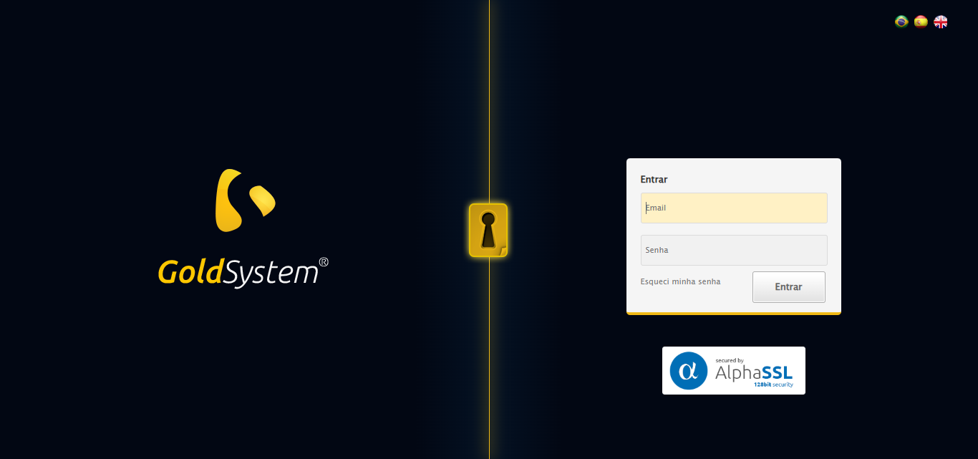

[17:10:08] [INFO] 🔄 Realizando login...

[17:10:13] [INFO] ✅ Realizando login realizada com sucesso.

[17:10:15] [INFO] Screenshot capturada: realizando_login

Screenshot: realizando_login

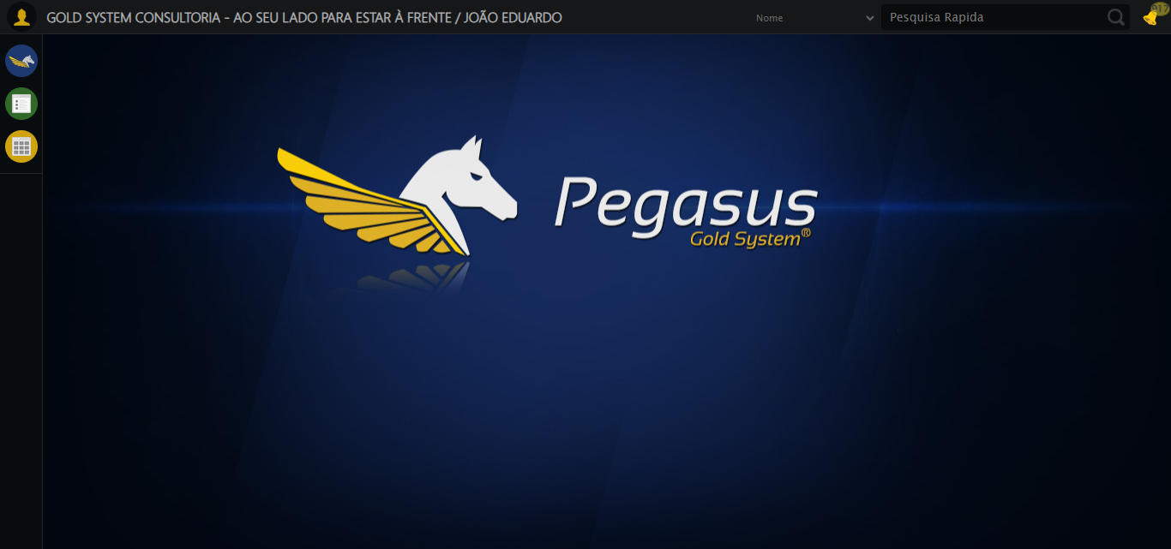

[17:10:15] [INFO] 🔄 Configurando interface...

[17:10:15] [INFO] 🔍 Zoom ajustado para 90%.

[17:10:18] [INFO] ✅ Configurando interface realizada com sucesso.

[17:10:19] [INFO] Screenshot capturada: configurando_interface

Screenshot: configurando_interface

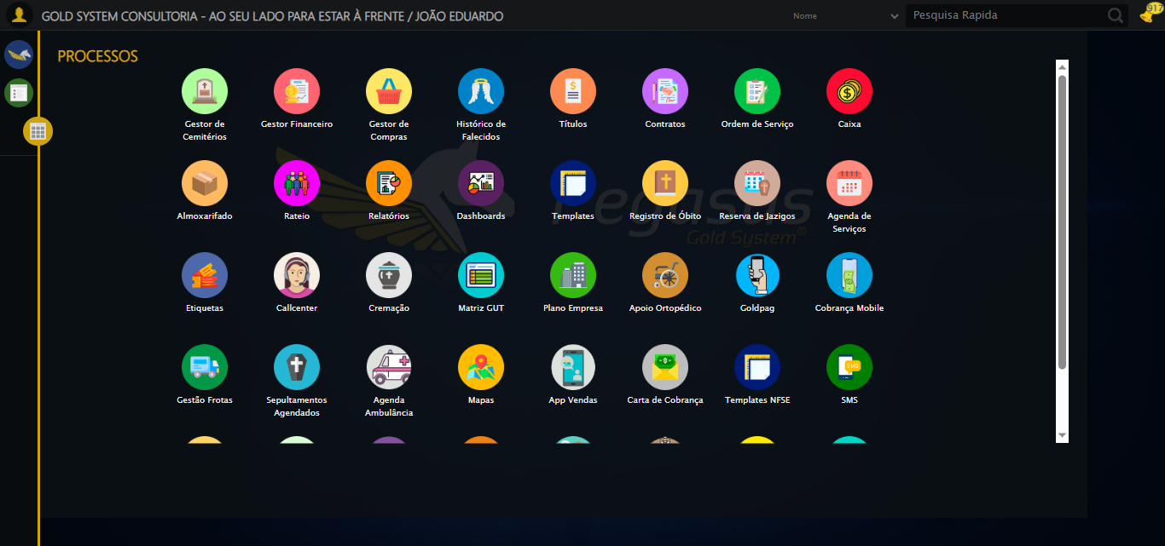

[17:10:19] [INFO] 🔄 Acessando Apoio Ortopédico...

[17:10:20] [INFO] ✅ Clique realizado com estratégia 1

[17:10:20] [INFO] ✅ Acessando Apoio Ortopédico realizada com sucesso.

[17:10:21] [INFO] Screenshot capturada: acessando_apoio_ortopédico

Screenshot: acessando_apoio_ortopédico

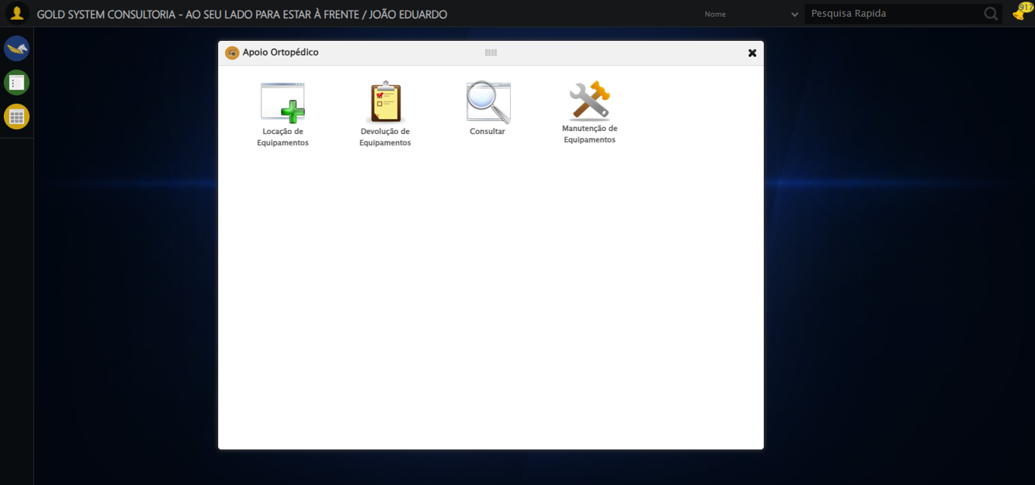

[17:10:21] [INFO] 🔄 Acessando Consulta Locação de Equipamentos...

[17:10:22] [INFO] ✅ Clique realizado com estratégia 1

[17:10:22] [INFO] ✅ Acessando Consulta Locação de Equipamentos realizada com sucesso.

[17:10:23] [INFO] Screenshot capturada: acessando_consulta_locação_de_equipamentos

Screenshot: acessando_consulta_locação_de_equipamentos

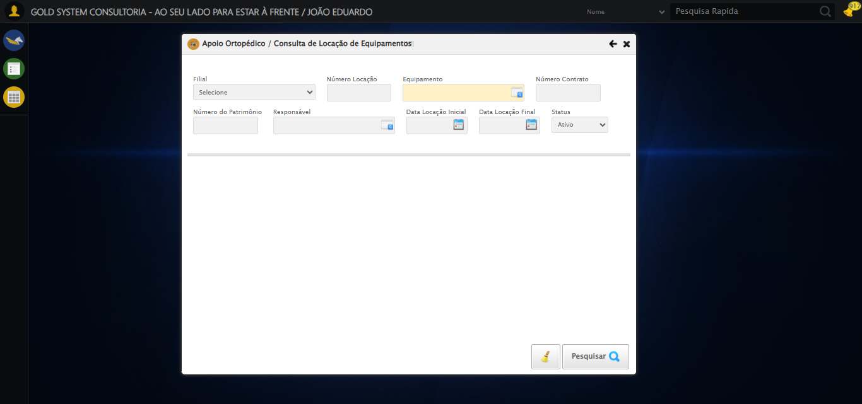

[17:10:26] [INFO] 🔄 Preenchendo Número da Locação...

[17:10:27] [INFO] ✅ Campo preenchido com estratégia 1: '306'

[17:10:27] [INFO] ✅ Preenchendo Número da Locação realizada com sucesso.

[17:10:29] [INFO] Screenshot capturada: preenchendo_número_da_locação

Screenshot: preenchendo_número_da_locação

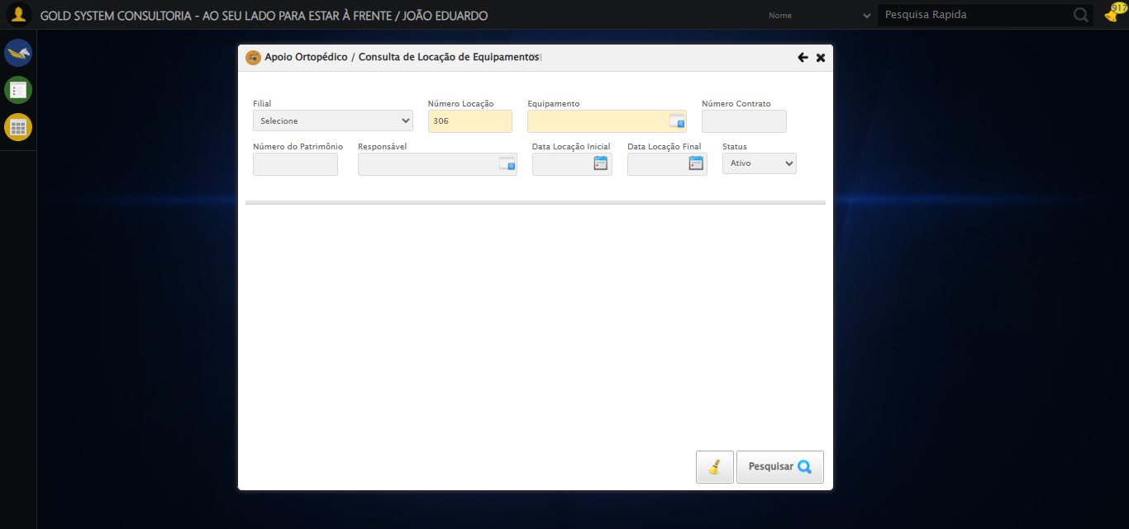

[17:10:29] [INFO] 🔄 Abrindo LOV de Equipamentos...

[17:10:29] [INFO] ✅ Clique realizado com estratégia 1

[17:10:29] [INFO] ✅ Abrindo LOV de Equipamentos realizada com sucesso.

[17:10:30] [INFO] Screenshot capturada: abrindo_lov_de_equipamentos

Screenshot: abrindo_lov_de_equipamentos

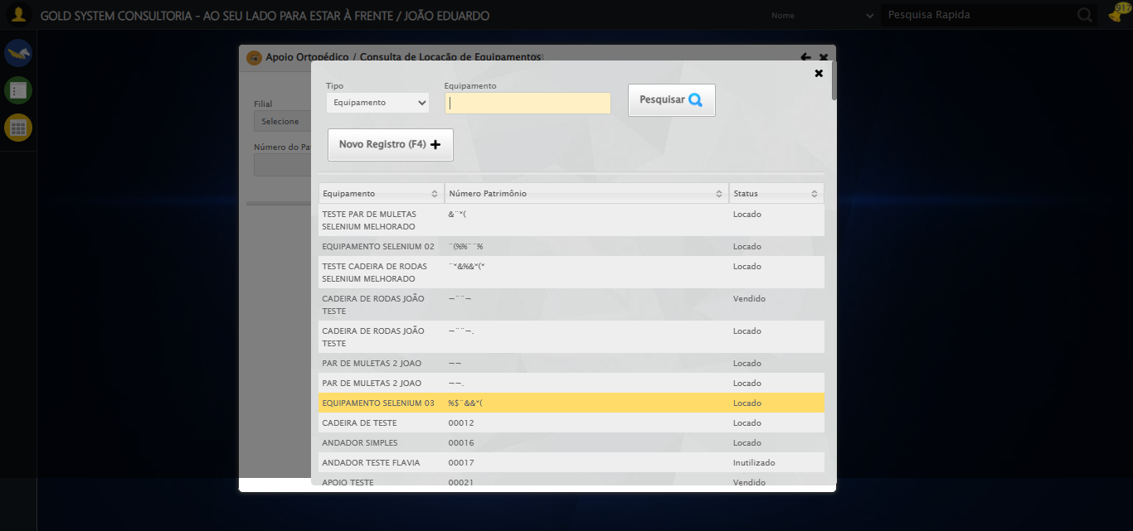

[17:10:30] [INFO] 🔄 Pesquisando equipamento...

[17:10:36] [ERROR] ❌ Timeout aguardando elemento: //input[@type='text' and contains(@class, 'nomePesquisa')] (timeout: 5s)

[17:10:36] [WARN] ⚠️ Estratégia 1 falhou: Message:

[17:10:36] [WARN] ⚠️ Estratégia 2 falhou: Message: element not interactable: [object HTMLInputElement] has no size and location  
 (Session info: chrome=139.0.7258.128); For documentation on this error, please visit: https://www.selenium.dev/documentation/webdriver/troubleshooting/errors#elementnotinteractableexception  
Stacktrace:  
 GetHandleVerifier [0x0x7da8a3+63283]  
 GetHandleVerifier [0x0x7da8e4+63348]  
 (No symbol) [0x0x613e43]  
 (No symbol) [0x0x61a609]  
 (No symbol) [0x0x61c97a]  
 (No symbol) [0x0x61c9f7]  
 (No symbol) [0x0x662334]  
 (No symbol) [0x0x6618a7]  
 (No symbol) [0x0x6ab0b8]  
 (No symbol) [0x0x68141c]  
 (No symbol) [0x0x6a271a]  
 (No symbol) [0x0x681216]  
 (No symbol) [0x0x650855]  
 (No symbol) [0x0x6516f4]  
 GetHandleVerifier [0x0xa4bb43+2623955]  
 GetHandleVerifier [0x0xa46daa+2604090]  
 GetHandleVerifier [0x0x80069a+218410]  
 GetHandleVerifier [0x0x7f0ed8+154984]  
 GetHandleVerifier [0x0x7f742d+180925]  
 GetHandleVerifier [0x0x7e22b8+94536]  
 GetHandleVerifier [0x0x7e2442+94930]  
 GetHandleVerifier [0x0x7cd5ea+9338]  
 BaseThreadInitThunk [0x0x76b1fcc9+25]  
 RtlGetAppContainerNamedObjectPath [0x0x776a82ae+286]  
 RtlGetAppContainerNamedObjectPath [0x0x776a827e+238]

[17:10:36] [INFO] ✅ Clique realizado com estratégia 3

[17:11:08] [ERROR] ❌ Timeout aguardando elemento: //tr[td[2][contains(normalize-space(.),'EQUIPAMENTO SELENIUM 01')]] (timeout: 30s)

[17:11:08] [ERROR] ❌ Erro no clique robusto: Message:   
Stacktrace:  
 GetHandleVerifier [0x0x7da8a3+63283]  
 GetHandleVerifier [0x0x7da8e4+63348]  
 (No symbol) [0x0x613e43]  
 (No symbol) [0x0x65c8de]  
 (No symbol) [0x0x65cc7b]  
 (No symbol) [0x0x6a4ef2]  
 (No symbol) [0x0x681464]  
 (No symbol) [0x0x6a271a]  
 (No symbol) [0x0x681216]  
 (No symbol) [0x0x650855]  
 (No symbol) [0x0x6516f4]  
 GetHandleVerifier [0x0xa4bb43+2623955]  
 GetHandleVerifier [0x0xa46daa+2604090]  
 GetHandleVerifier [0x0x80069a+218410]  
 GetHandleVerifier [0x0x7f0ed8+154984]  
 GetHandleVerifier [0x0x7f742d+180925]  
 GetHandleVerifier [0x0x7e22b8+94536]  
 GetHandleVerifier [0x0x7e2442+94930]  
 GetHandleVerifier [0x0x7cd5ea+9338]  
 BaseThreadInitThunk [0x0x76b1fcc9+25]  
 RtlGetAppContainerNamedObjectPath [0x0x776a82ae+286]  
 RtlGetAppContainerNamedObjectPath [0x0x776a827e+238]

[17:11:08] [INFO] ✅ Pesquisando equipamento realizada com sucesso.

[17:11:09] [INFO] Screenshot capturada: pesquisando_equipamento

Screenshot: pesquisando_equipamento

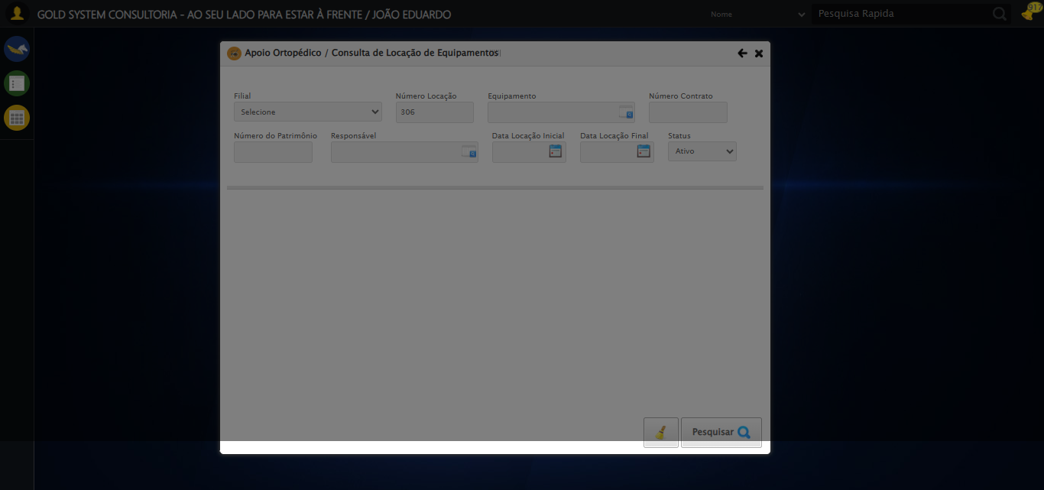

[17:11:09] [INFO] 🔄 Preenchendo Número do Contrato...

[17:11:11] [WARN] ⚠️ Estratégia 1 falhou: Message: element click intercepted: Element <input type="text" maxlength="" class="numeroContrato" style="width: 100px;"> is not clickable at point (900, 146). Other element would receive the click: <div class="blockScreen" style="height: 641px; z-index: 10001; opacity: 0.5;"></div>  
 (Session info: chrome=139.0.7258.128); For documentation on this error, please visit: https://www.selenium.dev/documentation/webdriver/troubleshooting/errors#elementclickinterceptedexception  
Stacktrace:  
 GetHandleVerifier [0x0x7da8a3+63283]  
 GetHandleVerifier [0x0x7da8e4+63348]  
 (No symbol) [0x0x613e43]  
 (No symbol) [0x0x662c20]  
 (No symbol) [0x0x660fda]  
 (No symbol) [0x0x65eb37]  
 (No symbol) [0x0x65ddf4]  
 (No symbol) [0x0x6525b5]  
 (No symbol) [0x0x68141c]  
 (No symbol) [0x0x652044]  
 (No symbol) [0x0x681694]  
 (No symbol) [0x0x6a271a]  
 (No symbol) [0x0x681216]  
 (No symbol) [0x0x650855]  
 (No symbol) [0x0x6516f4]  
 GetHandleVerifier [0x0xa4bb43+2623955]  
 GetHandleVerifier [0x0xa46daa+2604090]  
 GetHandleVerifier [0x0x80069a+218410]  
 GetHandleVerifier [0x0x7f0ed8+154984]  
 GetHandleVerifier [0x0x7f742d+180925]  
 GetHandleVerifier [0x0x7e22b8+94536]  
 GetHandleVerifier [0x0x7e2442+94930]  
 GetHandleVerifier [0x0x7cd5ea+9338]  
 BaseThreadInitThunk [0x0x76b1fcc9+25]  
 RtlGetAppContainerNamedObjectPath [0x0x776a82ae+286]  
 RtlGetAppContainerNamedObjectPath [0x0x776a827e+238]

[17:11:13] [INFO] ✅ Campo preenchido com estratégia 3: '113060'

[17:11:13] [INFO] ✅ Preenchendo Número do Contrato realizada com sucesso.

[17:11:14] [INFO] Screenshot capturada: preenchendo_número_do_contrato

Screenshot: preenchendo_número_do_contrato

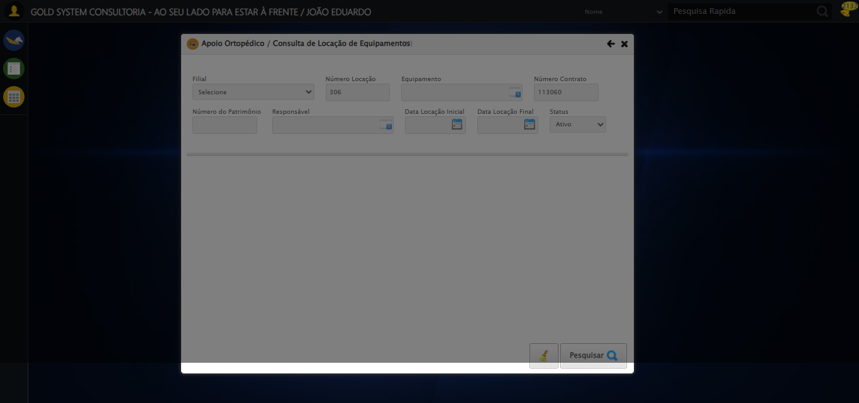

[17:11:14] [INFO] 🔄 Preenchendo Número do Patrimônio...

[17:11:15] [WARN] ⚠️ Estratégia 1 falhou: Message: element click intercepted: Element <input type="text" class="fc numeroPatrimonio" name="numeroPatrimonio" maxlength="20" style="width: 100px; text-align: left;"> is not clickable at point (357, 198). Other element would receive the click: <div class="blockScreen" style="height: 641px; z-index: 10001; opacity: 0.5;"></div>  
 (Session info: chrome=139.0.7258.128); For documentation on this error, please visit: https://www.selenium.dev/documentation/webdriver/troubleshooting/errors#elementclickinterceptedexception  
Stacktrace:  
 GetHandleVerifier [0x0x7da8a3+63283]  
 GetHandleVerifier [0x0x7da8e4+63348]  
 (No symbol) [0x0x613e43]  
 (No symbol) [0x0x662c20]  
 (No symbol) [0x0x660fda]  
 (No symbol) [0x0x65eb37]  
 (No symbol) [0x0x65ddf4]  
 (No symbol) [0x0x6525b5]  
 (No symbol) [0x0x68141c]  
 (No symbol) [0x0x652044]  
 (No symbol) [0x0x681694]  
 (No symbol) [0x0x6a271a]  
 (No symbol) [0x0x681216]  
 (No symbol) [0x0x650855]  
 (No symbol) [0x0x6516f4]  
 GetHandleVerifier [0x0xa4bb43+2623955]  
 GetHandleVerifier [0x0xa46daa+2604090]  
 GetHandleVerifier [0x0x80069a+218410]  
 GetHandleVerifier [0x0x7f0ed8+154984]  
 GetHandleVerifier [0x0x7f742d+180925]  
 GetHandleVerifier [0x0x7e22b8+94536]  
 GetHandleVerifier [0x0x7e2442+94930]  
 GetHandleVerifier [0x0x7cd5ea+9338]  
 BaseThreadInitThunk [0x0x76b1fcc9+25]  
 RtlGetAppContainerNamedObjectPath [0x0x776a82ae+286]  
 RtlGetAppContainerNamedObjectPath [0x0x776a827e+238]

[17:11:17] [INFO] ✅ Campo preenchido com estratégia 3: '876*&'

[17:11:17] [INFO] ✅ Preenchendo Número do Patrimônio realizada com sucesso.

[17:11:18] [INFO] Screenshot capturada: preenchendo_número_do_patrimônio

Screenshot: preenchendo_número_do_patrimônio

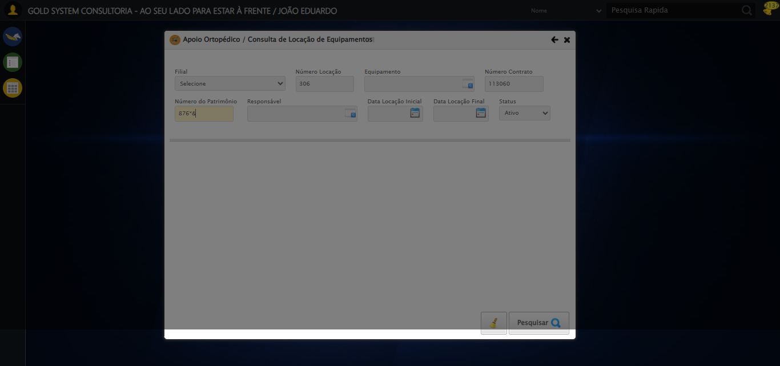

[17:11:18] [INFO] 🔄 Abrindo LOV do Responsável...

[17:11:20] [WARN] ⚠️ Estratégia 1 falhou: Message: element click intercepted: Element <a class="sprites sp-openLov"></a> is not clickable at point (818, 145). Other element would receive the click: <div class="blockScreen" style="height: 641px; z-index: 10001; opacity: 0.5;"></div>  
 (Session info: chrome=139.0.7258.128); For documentation on this error, please visit: https://www.selenium.dev/documentation/webdriver/troubleshooting/errors#elementclickinterceptedexception  
Stacktrace:  
 GetHandleVerifier [0x0x7da8a3+63283]  
 GetHandleVerifier [0x0x7da8e4+63348]  
 (No symbol) [0x0x613e43]  
 (No symbol) [0x0x662c20]  
 (No symbol) [0x0x660fda]  
 (No symbol) [0x0x65eb37]  
 (No symbol) [0x0x65ddf4]  
 (No symbol) [0x0x6525b5]  
 (No symbol) [0x0x68141c]  
 (No symbol) [0x0x652044]  
 (No symbol) [0x0x681694]  
 (No symbol) [0x0x6a271a]  
 (No symbol) [0x0x681216]  
 (No symbol) [0x0x650855]  
 (No symbol) [0x0x6516f4]  
 GetHandleVerifier [0x0xa4bb43+2623955]  
 GetHandleVerifier [0x0xa46daa+2604090]  
 GetHandleVerifier [0x0x80069a+218410]  
 GetHandleVerifier [0x0x7f0ed8+154984]  
 GetHandleVerifier [0x0x7f742d+180925]  
 GetHandleVerifier [0x0x7e22b8+94536]  
 GetHandleVerifier [0x0x7e2442+94930]  
 GetHandleVerifier [0x0x7cd5ea+9338]  
 BaseThreadInitThunk [0x0x76b1fcc9+25]  
 RtlGetAppContainerNamedObjectPath [0x0x776a82ae+286]  
 RtlGetAppContainerNamedObjectPath [0x0x776a827e+238]

[17:11:20] [INFO] ✅ Clique realizado com estratégia 2

[17:11:20] [INFO] ✅ Abrindo LOV do Responsável realizada com sucesso.

[17:11:21] [INFO] Screenshot capturada: abrindo_lov_do_responsável

Screenshot: abrindo_lov_do_responsável

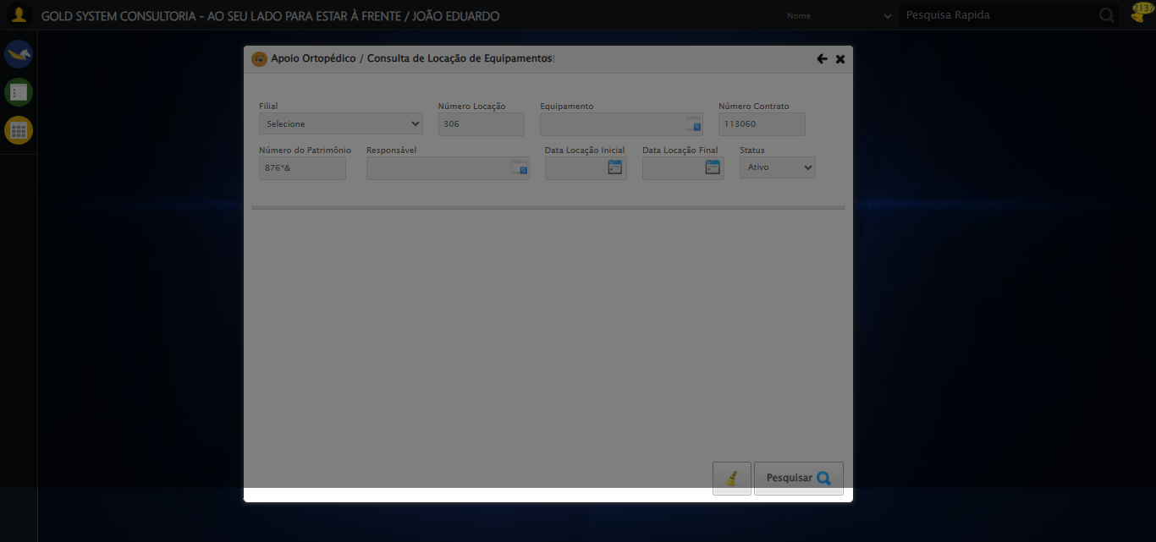

[17:11:21] [INFO] 🔄 Pesquisando responsável...

[17:11:52] [ERROR] ❌ Timeout aguardando elemento: //input[@id='txtPesquisa'] (timeout: 30s)

[17:11:52] [ERROR] ❌ Erro no preenchimento: Message:   
Stacktrace:  
 GetHandleVerifier [0x0x7da8a3+63283]  
 GetHandleVerifier [0x0x7da8e4+63348]  
 (No symbol) [0x0x613e43]  
 (No symbol) [0x0x65c8de]  
 (No symbol) [0x0x65cc7b]  
 (No symbol) [0x0x6a4ef2]  
 (No symbol) [0x0x681464]  
 (No symbol) [0x0x6a271a]  
 (No symbol) [0x0x681216]  
 (No symbol) [0x0x650855]  
 (No symbol) [0x0x6516f4]  
 GetHandleVerifier [0x0xa4bb43+2623955]  
 GetHandleVerifier [0x0xa46daa+2604090]  
 GetHandleVerifier [0x0x80069a+218410]  
 GetHandleVerifier [0x0x7f0ed8+154984]  
 GetHandleVerifier [0x0x7f742d+180925]  
 GetHandleVerifier [0x0x7e22b8+94536]  
 GetHandleVerifier [0x0x7e2442+94930]  
 GetHandleVerifier [0x0x7cd5ea+9338]  
 BaseThreadInitThunk [0x0x76b1fcc9+25]  
 RtlGetAppContainerNamedObjectPath [0x0x776a82ae+286]  
 RtlGetAppContainerNamedObjectPath [0x0x776a827e+238]

[17:11:57] [ERROR] ❌ Timeout aguardando elemento: //a[contains(concat(' ', normalize-space(@class), ' '), ' lpFind ') and contains(normalize-space(.), 'Pesquisar')] (timeout: 5s)

[17:11:57] [WARN] ⚠️ Estratégia 1 falhou: Message:

[17:11:57] [WARN] ⚠️ Estratégia 2 falhou: Message: element not interactable: has no size and location  
 (Session info: chrome=139.0.7258.128); For documentation on this error, please visit: https://www.selenium.dev/documentation/webdriver/troubleshooting/errors#elementnotinteractableexception  
Stacktrace:  
 GetHandleVerifier [0x0x7da8a3+63283]  
 GetHandleVerifier [0x0x7da8e4+63348]  
 (No symbol) [0x0x613e43]  
 (No symbol) [0x0x61a609]  
 (No symbol) [0x0x61c97a]  
 (No symbol) [0x0x61c9f7]  
 (No symbol) [0x0x662334]  
 (No symbol) [0x0x6618a7]  
 (No symbol) [0x0x6ab0b8]  
 (No symbol) [0x0x68141c]  
 (No symbol) [0x0x6a271a]  
 (No symbol) [0x0x681216]  
 (No symbol) [0x0x650855]  
 (No symbol) [0x0x6516f4]  
 GetHandleVerifier [0x0xa4bb43+2623955]  
 GetHandleVerifier [0x0xa46daa+2604090]  
 GetHandleVerifier [0x0x80069a+218410]  
 GetHandleVerifier [0x0x7f0ed8+154984]  
 GetHandleVerifier [0x0x7f742d+180925]  
 GetHandleVerifier [0x0x7e22b8+94536]  
 GetHandleVerifier [0x0x7e2442+94930]  
 GetHandleVerifier [0x0x7cd5ea+9338]  
 BaseThreadInitThunk [0x0x76b1fcc9+25]  
 RtlGetAppContainerNamedObjectPath [0x0x776a82ae+286]  
 RtlGetAppContainerNamedObjectPath [0x0x776a827e+238]

[17:11:57] [INFO] ✅ Clique realizado com estratégia 3

[17:12:29] [ERROR] ❌ Timeout aguardando elemento: //tr[td[2][contains(normalize-space(.),'TESTE TITULAR 233')]] (timeout: 30s)

[17:12:29] [ERROR] ❌ Erro no clique robusto: Message:   
Stacktrace:  
 GetHandleVerifier [0x0x7da8a3+63283]  
 GetHandleVerifier [0x0x7da8e4+63348]  
 (No symbol) [0x0x613e43]  
 (No symbol) [0x0x65c8de]  
 (No symbol) [0x0x65cc7b]  
 (No symbol) [0x0x6a4ef2]  
 (No symbol) [0x0x681464]  
 (No symbol) [0x0x6a271a]  
 (No symbol) [0x0x681216]  
 (No symbol) [0x0x650855]  
 (No symbol) [0x0x6516f4]  
 GetHandleVerifier [0x0xa4bb43+2623955]  
 GetHandleVerifier [0x0xa46daa+2604090]  
 GetHandleVerifier [0x0x80069a+218410]  
 GetHandleVerifier [0x0x7f0ed8+154984]  
 GetHandleVerifier [0x0x7f742d+180925]  
 GetHandleVerifier [0x0x7e22b8+94536]  
 GetHandleVerifier [0x0x7e2442+94930]  
 GetHandleVerifier [0x0x7cd5ea+9338]  
 BaseThreadInitThunk [0x0x76b1fcc9+25]  
 RtlGetAppContainerNamedObjectPath [0x0x776a82ae+286]  
 RtlGetAppContainerNamedObjectPath [0x0x776a827e+238]

[17:12:29] [INFO] ✅ Pesquisando responsável realizada com sucesso.

[17:12:30] [INFO] Screenshot capturada: pesquisando_responsável

Screenshot: pesquisando_responsável



[17:12:30] [INFO] 🔄 Preenchendo Data Locação Inicial...

[17:12:30] [INFO] 🎯 Tentativa 1: Preenchendo datepicker 0 com '21/08/2025'

[17:12:31] [INFO] 📊 Encontrados 2 campos datepicker

[17:12:31] [INFO] Aplicando estratégia 1 para datepicker...

[17:12:32] [INFO] ✅ Datepicker preenchido com estratégia 1: '21/08/2025'

[17:12:32] [INFO] ✅ Preenchendo Data Locação Inicial realizada com sucesso.

[17:12:33] [INFO] Screenshot capturada: preenchendo_data_locação_inicial

Screenshot: preenchendo_data_locação_inicial

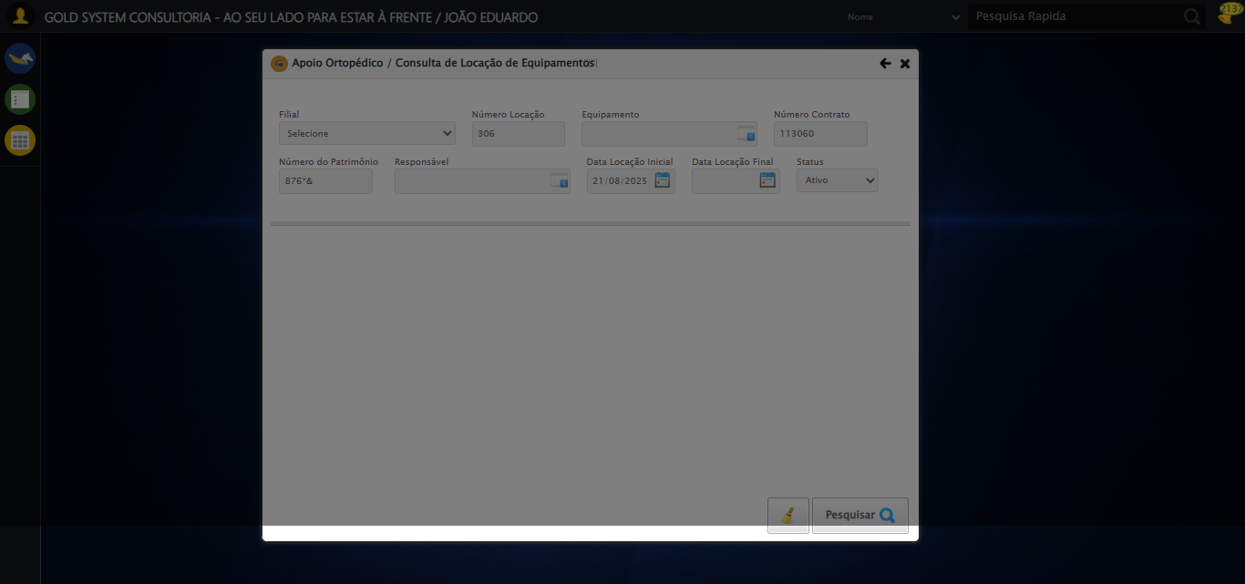

[17:12:33] [INFO] 🔄 Preenchendo Data Locação Final...

[17:12:33] [INFO] 🎯 Tentativa 1: Preenchendo datepicker 1 com '21/08/2025'

[17:12:33] [INFO] 📊 Encontrados 2 campos datepicker

[17:12:33] [INFO] Aplicando estratégia 1 para datepicker...

[17:12:34] [INFO] ✅ Datepicker preenchido com estratégia 1: '21/08/2025'

[17:12:34] [INFO] ✅ Preenchendo Data Locação Final realizada com sucesso.

[17:12:36] [INFO] Screenshot capturada: preenchendo_data_locação_final

Screenshot: preenchendo_data_locação_final

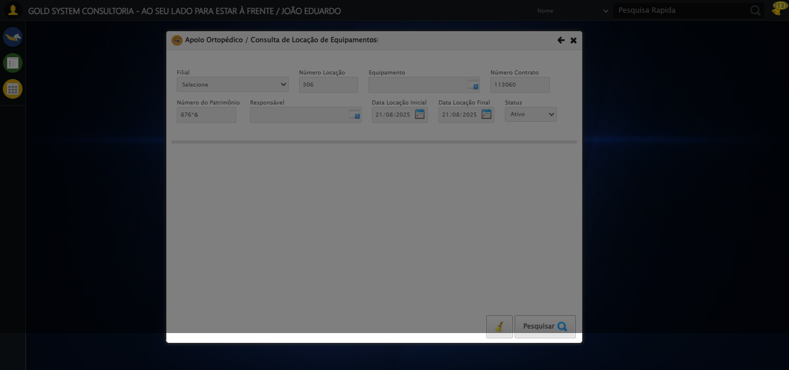

[17:12:36] [INFO] 🔄 Realizando consulta...

[17:12:37] [WARN] ⚠️ Estratégia 1 falhou: Message: element click intercepted: Element <a class="btModel btGray btfind">...</a> is not clickable at point (944, 530). Other element would receive the click: <div class="blockScreen" style="height: 641px; z-index: 10001; opacity: 0.5;"></div>  
 (Session info: chrome=139.0.7258.128); For documentation on this error, please visit: https://www.selenium.dev/documentation/webdriver/troubleshooting/errors#elementclickinterceptedexception  
Stacktrace:  
 GetHandleVerifier [0x0x7da8a3+63283]  
 GetHandleVerifier [0x0x7da8e4+63348]  
 (No symbol) [0x0x613e43]  
 (No symbol) [0x0x662c20]  
 (No symbol) [0x0x660fda]  
 (No symbol) [0x0x65eb37]  
 (No symbol) [0x0x65ddf4]  
 (No symbol) [0x0x6525b5]  
 (No symbol) [0x0x68141c]  
 (No symbol) [0x0x652044]  
 (No symbol) [0x0x681694]  
 (No symbol) [0x0x6a271a]  
 (No symbol) [0x0x681216]  
 (No symbol) [0x0x650855]  
 (No symbol) [0x0x6516f4]  
 GetHandleVerifier [0x0xa4bb43+2623955]  
 GetHandleVerifier [0x0xa46daa+2604090]  
 GetHandleVerifier [0x0x80069a+218410]  
 GetHandleVerifier [0x0x7f0ed8+154984]  
 GetHandleVerifier [0x0x7f742d+180925]  
 GetHandleVerifier [0x0x7e22b8+94536]  
 GetHandleVerifier [0x0x7e2442+94930]  
 GetHandleVerifier [0x0x7cd5ea+9338]  
 BaseThreadInitThunk [0x0x76b1fcc9+25]  
 RtlGetAppContainerNamedObjectPath [0x0x776a82ae+286]  
 RtlGetAppContainerNamedObjectPath [0x0x776a827e+238]

[17:12:38] [INFO] ✅ Clique realizado com estratégia 2

[17:12:48] [INFO] ✅ Realizando consulta realizada com sucesso.

[17:12:49] [INFO] Screenshot capturada: realizando_consulta

Screenshot: realizando_consulta

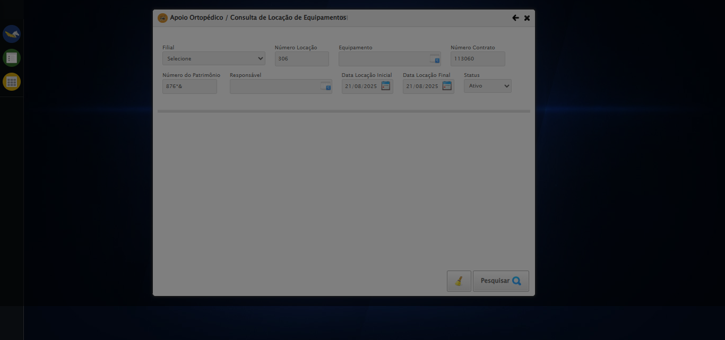

[17:12:49] [INFO] 🔄 Validando resultados da consulta...

[17:12:49] [INFO] 🔍 Validando registros encontrados...

[17:12:59] [WARN] ⚠️ Não foi possível determinar se há registros

[17:12:59] [INFO] ✅ Validando resultados da consulta realizada com sucesso.

[17:13:00] [INFO] Screenshot capturada: validando_resultados_da_consulta

Screenshot: validando_resultados_da_consulta



[17:13:00] [INFO] Processando 1 registro(s) encontrado(s)

[17:13:00] [INFO] 🔄 Visualizando Detalhes da Locação...

[17:13:30] [ERROR] ❌ Timeout aguardando elemento: //span[@title='Detalhes da Locação'] (timeout: 30s)

[17:13:30] [ERROR] ❌ Erro no clique robusto: Message:   
Stacktrace:  
 GetHandleVerifier [0x0x7da8a3+63283]  
 GetHandleVerifier [0x0x7da8e4+63348]  
 (No symbol) [0x0x613e43]  
 (No symbol) [0x0x65c8de]  
 (No symbol) [0x0x65cc7b]  
 (No symbol) [0x0x6a4ef2]  
 (No symbol) [0x0x681464]  
 (No symbol) [0x0x6a271a]  
 (No symbol) [0x0x681216]  
 (No symbol) [0x0x650855]  
 (No symbol) [0x0x6516f4]  
 GetHandleVerifier [0x0xa4bb43+2623955]  
 GetHandleVerifier [0x0xa46daa+2604090]  
 GetHandleVerifier [0x0x80069a+218410]  
 GetHandleVerifier [0x0x7f0ed8+154984]  
 GetHandleVerifier [0x0x7f742d+180925]  
 GetHandleVerifier [0x0x7e22b8+94536]  
 GetHandleVerifier [0x0x7e2442+94930]  
 GetHandleVerifier [0x0x7cd5ea+9338]  
 BaseThreadInitThunk [0x0x76b1fcc9+25]  
 RtlGetAppContainerNamedObjectPath [0x0x776a82ae+286]  
 RtlGetAppContainerNamedObjectPath [0x0x776a827e+238]

[17:13:30] [INFO] ✅ Visualizando Detalhes da Locação realizada com sucesso.

[17:13:31] [INFO] Screenshot capturada: visualizando_detalhes_da_locação

Screenshot: visualizando_detalhes_da_locação



[17:13:31] [INFO] 🔄 Visualizando Títulos...

[17:14:02] [ERROR] ❌ Timeout aguardando elemento: //button[contains(normalize-space(.),'Ver Títulos')] (timeout: 30s)

[17:14:02] [ERROR] ❌ Erro no clique robusto: Message:   
Stacktrace:  
 GetHandleVerifier [0x0x7da8a3+63283]  
 GetHandleVerifier [0x0x7da8e4+63348]  
 (No symbol) [0x0x613e43]  
 (No symbol) [0x0x65c8de]  
 (No symbol) [0x0x65cc7b]  
 (No symbol) [0x0x6a4ef2]  
 (No symbol) [0x0x681464]  
 (No symbol) [0x0x6a271a]  
 (No symbol) [0x0x681216]  
 (No symbol) [0x0x650855]  
 (No symbol) [0x0x6516f4]  
 GetHandleVerifier [0x0xa4bb43+2623955]  
 GetHandleVerifier [0x0xa46daa+2604090]  
 GetHandleVerifier [0x0x80069a+218410]  
 GetHandleVerifier [0x0x7f0ed8+154984]  
 GetHandleVerifier [0x0x7f742d+180925]  
 GetHandleVerifier [0x0x7e22b8+94536]  
 GetHandleVerifier [0x0x7e2442+94930]  
 GetHandleVerifier [0x0x7cd5ea+9338]  
 BaseThreadInitThunk [0x0x76b1fcc9+25]  
 RtlGetAppContainerNamedObjectPath [0x0x776a82ae+286]  
 RtlGetAppContainerNamedObjectPath [0x0x776a827e+238]

[17:14:22] [INFO] ✅ Visualizando Títulos realizada com sucesso.

[17:14:23] [INFO] Screenshot capturada: visualizando_títulos

Screenshot: visualizando_títulos

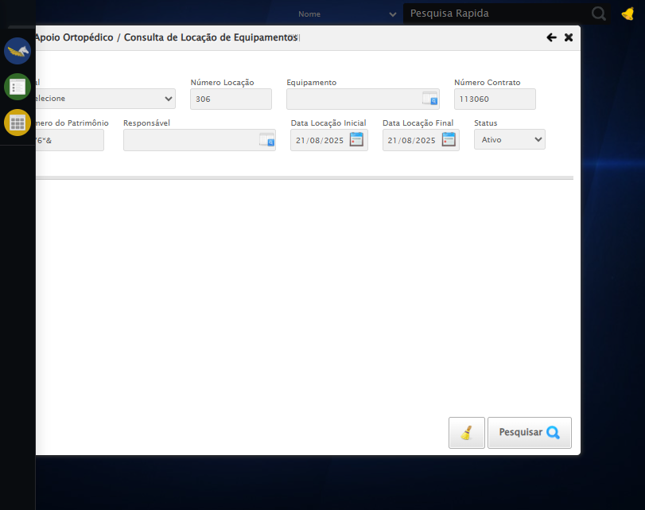

[17:14:23] [INFO] 🔄 Capturando screenshot dos títulos...

[17:14:23] [INFO] Screenshot capturada: tela_titulos

Screenshot: tela_titulos



[17:14:23] [INFO] ✅ Capturando screenshot dos títulos realizada com sucesso.

[17:14:24] [INFO] Screenshot capturada: capturando_screenshot_dos_títulos

Screenshot: capturando_screenshot_dos_títulos



[17:14:24] [INFO] 🔄 Fechando aba de títulos...

[17:14:42] [INFO] ✅ Clique realizado com estratégia 1

[17:14:42] [INFO] ✅ Fechando aba de títulos realizada com sucesso.

[17:14:43] [INFO] Screenshot capturada: fechando_aba_de_títulos

Screenshot: fechando_aba_de_títulos

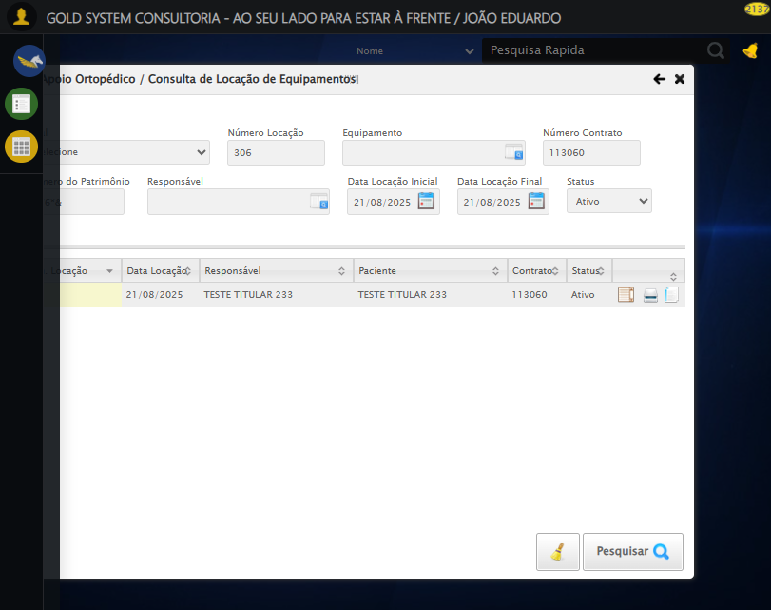

[17:14:43] [INFO] 🔄 Reabrindo detalhes da locação...

[17:14:44] [INFO] ✅ Clique realizado com estratégia 1

[17:14:47] [INFO] ✅ Reabrindo detalhes da locação realizada com sucesso.

[17:14:48] [INFO] Screenshot capturada: reabrindo_detalhes_da_locação

Screenshot: reabrindo_detalhes_da_locação

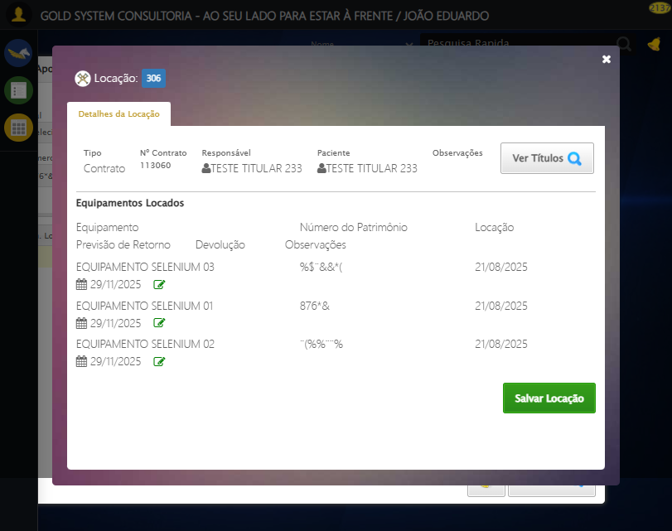

[17:14:48] [INFO] Verificando mensagens de alerta...

[17:14:48] [INFO] ℹ️ Nenhuma mensagem de alerta encontrada.

[17:14:48] [INFO] 🔄 Abrindo digitalização de documentos...

[17:14:50] [WARN] ⚠️ Estratégia 1 falhou: Message: element click intercepted: Element <span class="sprites sp-scanner" title="Digitalizar documentos"></span> is not clickable at point (684, 310). Other element would receive the click: <div class="blockScreen" style="height: 641px; z-index: 10001; opacity: 0.5;"></div>  
 (Session info: chrome=139.0.7258.128); For documentation on this error, please visit: https://www.selenium.dev/documentation/webdriver/troubleshooting/errors#elementclickinterceptedexception  
Stacktrace:  
 GetHandleVerifier [0x0x7da8a3+63283]  
 GetHandleVerifier [0x0x7da8e4+63348]  
 (No symbol) [0x0x613e43]  
 (No symbol) [0x0x662c20]  
 (No symbol) [0x0x660fda]  
 (No symbol) [0x0x65eb37]  
 (No symbol) [0x0x65ddf4]  
 (No symbol) [0x0x6525b5]  
 (No symbol) [0x0x68141c]  
 (No symbol) [0x0x652044]  
 (No symbol) [0x0x681694]  
 (No symbol) [0x0x6a271a]  
 (No symbol) [0x0x681216]  
 (No symbol) [0x0x650855]  
 (No symbol) [0x0x6516f4]  
 GetHandleVerifier [0x0xa4bb43+2623955]  
 GetHandleVerifier [0x0xa46daa+2604090]  
 GetHandleVerifier [0x0x80069a+218410]  
 GetHandleVerifier [0x0x7f0ed8+154984]  
 GetHandleVerifier [0x0x7f742d+180925]  
 GetHandleVerifier [0x0x7e22b8+94536]  
 GetHandleVerifier [0x0x7e2442+94930]  
 GetHandleVerifier [0x0x7cd5ea+9338]  
 BaseThreadInitThunk [0x0x76b1fcc9+25]  
 RtlGetAppContainerNamedObjectPath [0x0x776a82ae+286]  
 RtlGetAppContainerNamedObjectPath [0x0x776a827e+238]

[17:14:50] [INFO] ✅ Clique realizado com estratégia 2

[17:14:50] [INFO] ✅ Abrindo digitalização de documentos realizada com sucesso.

[17:14:51] [INFO] Screenshot capturada: abrindo_digitalização_de_documentos

Screenshot: abrindo_digitalização_de_documentos

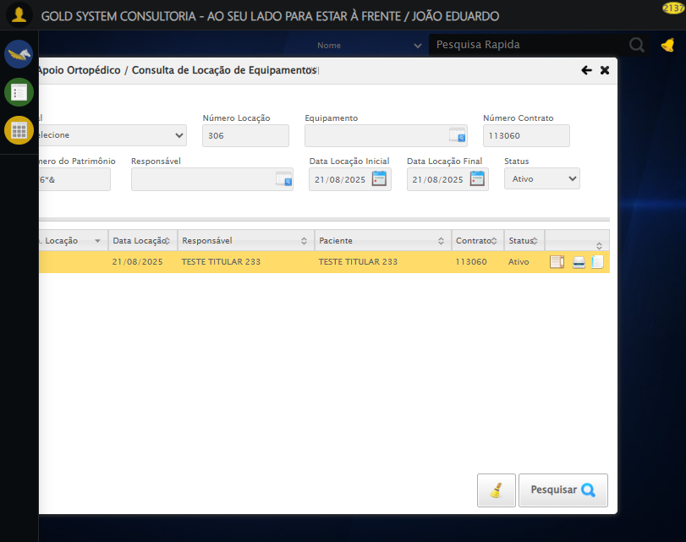

[17:14:51] [INFO] 🔄 Adicionando novo documento...

[17:15:12] [ERROR] ❌ Erro no clique robusto: Message: target frame detached  
 (failed to check if window was closed: disconnected: Unable to receive message from renderer)  
 (Session info: chrome=139.0.7258.128)  
Stacktrace:  
 GetHandleVerifier [0x0x7da8a3+63283]  
 GetHandleVerifier [0x0x7da8e4+63348]  
 (No symbol) [0x0x613ca0]  
 (No symbol) [0x0x6047d0]  
 (No symbol) [0x0x603941]  
 (No symbol) [0x0x621602]  
 (No symbol) [0x0x687cdc]  
 (No symbol) [0x0x6a1ff9]  
 (No symbol) [0x0x681216]  
 (No symbol) [0x0x650855]  
 (No symbol) [0x0x6516f4]  
 GetHandleVerifier [0x0xa4bb43+2623955]  
 GetHandleVerifier [0x0xa46daa+2604090]  
 GetHandleVerifier [0x0x80069a+218410]  
 GetHandleVerifier [0x0x7f0ed8+154984]  
 GetHandleVerifier [0x0x7f742d+180925]  
 GetHandleVerifier [0x0x7e22b8+94536]  
 GetHandleVerifier [0x0x7e2442+94930]  
 GetHandleVerifier [0x0x7cd5ea+9338]  
 BaseThreadInitThunk [0x0x76b1fcc9+25]  
 RtlGetAppContainerNamedObjectPath [0x0x776a82ae+286]  
 RtlGetAppContainerNamedObjectPath [0x0x776a827e+238]

[17:15:12] [INFO] ✅ Adicionando novo documento realizada com sucesso.

[17:15:13] [WARN] Erro ao capturar screenshot adicionando_novo_documento: Message: invalid session id: session deleted as the browser has closed the connection  
from disconnected: not connected to DevTools  
 (Session info: chrome=139.0.7258.128); For documentation on this error, please visit: https://www.selenium.dev/documentation/webdriver/troubleshooting/errors#invalidsessionidexception  
Stacktrace:  
 GetHandleVerifier [0x0x7da8a3+63283]  
 GetHandleVerifier [0x0x7da8e4+63348]  
 (No symbol) [0x0x613e43]  
 (No symbol) [0x0x603790]  
 (No symbol) [0x0x621602]  
 (No symbol) [0x0x687cdc]  
 (No symbol) [0x0x6a1ff9]  
 (No symbol) [0x0x681216]  
 (No symbol) [0x0x650855]  
 (No symbol) [0x0x6516f4]  
 GetHandleVerifier [0x0xa4bb43+2623955]  
 GetHandleVerifier [0x0xa46daa+2604090]  
 GetHandleVerifier [0x0x80069a+218410]  
 GetHandleVerifier [0x0x7f0ed8+154984]  
 GetHandleVerifier [0x0x7f742d+180925]  
 GetHandleVerifier [0x0x7e22b8+94536]  
 GetHandleVerifier [0x0x7e2442+94930]  
 GetHandleVerifier [0x0x7cd5ea+9338]  
 BaseThreadInitThunk [0x0x76b1fcc9+25]  
 RtlGetAppContainerNamedObjectPath [0x0x776a82ae+286]  
 RtlGetAppContainerNamedObjectPath [0x0x776a827e+238]

[17:15:13] [INFO] 🔄 Fazendo upload do arquivo...

[17:15:13] [INFO] 📄 Realizando upload do arquivo.

[17:15:13] [ERROR] ❌ Erro no upload: Message: invalid session id; For documentation on this error, please visit: https://www.selenium.dev/documentation/webdriver/troubleshooting/errors#invalidsessionidexception  
Stacktrace:  
 GetHandleVerifier [0x0x7da8a3+63283]  
 GetHandleVerifier [0x0x7da8e4+63348]  
 (No symbol) [0x0x613ca0]  
 (No symbol) [0x0x64fb48]  
 (No symbol) [0x0x6812d6]  
 (No symbol) [0x0x67ceb5]  
 (No symbol) [0x0x67c436]  
 (No symbol) [0x0x5e5755]  
 (No symbol) [0x0x5e5cae]  
 (No symbol) [0x0x5e613d]  
 GetHandleVerifier [0x0xa4bb43+2623955]  
 GetHandleVerifier [0x0xa46daa+2604090]  
 GetHandleVerifier [0x0x80069a+218410]  
 GetHandleVerifier [0x0x7f0ed8+154984]  
 GetHandleVerifier [0x0x7f742d+180925]  
 (No symbol) [0x0x5e5420]  
 (No symbol) [0x0x5e4c36]  
 GetHandleVerifier [0x0xb868fc+3913612]  
 BaseThreadInitThunk [0x0x76b1fcc9+25]  
 RtlGetAppContainerNamedObjectPath [0x0x776a82ae+286]  
 RtlGetAppContainerNamedObjectPath [0x0x776a827e+238]

[17:15:13] [INFO] ✅ Fazendo upload do arquivo realizada com sucesso.

[17:15:14] [WARN] Erro ao capturar screenshot fazendo_upload_do_arquivo: Message: invalid session id; For documentation on this error, please visit: https://www.selenium.dev/documentation/webdriver/troubleshooting/errors#invalidsessionidexception  
Stacktrace:  
 GetHandleVerifier [0x0x7da8a3+63283]  
 GetHandleVerifier [0x0x7da8e4+63348]  
 (No symbol) [0x0x613ca0]  
 (No symbol) [0x0x64fb48]  
 (No symbol) [0x0x6812d6]  
 (No symbol) [0x0x67ceb5]  
 (No symbol) [0x0x67c436]  
 (No symbol) [0x0x5e5755]  
 (No symbol) [0x0x5e5cae]  
 (No symbol) [0x0x5e613d]  
 GetHandleVerifier [0x0xa4bb43+2623955]  
 GetHandleVerifier [0x0xa46daa+2604090]  
 GetHandleVerifier [0x0x80069a+218410]  
 GetHandleVerifier [0x0x7f0ed8+154984]  
 GetHandleVerifier [0x0x7f742d+180925]  
 (No symbol) [0x0x5e5420]  
 (No symbol) [0x0x5e4c36]  
 GetHandleVerifier [0x0xb868fc+3913612]  
 BaseThreadInitThunk [0x0x76b1fcc9+25]  
 RtlGetAppContainerNamedObjectPath [0x0x776a82ae+286]  
 RtlGetAppContainerNamedObjectPath [0x0x776a827e+238]

[17:15:14] [INFO] 🔄 Salvando arquivo digitalizado...

[17:15:14] [ERROR] ❌ Erro no clique robusto: Message: invalid session id; For documentation on this error, please visit: https://www.selenium.dev/documentation/webdriver/troubleshooting/errors#invalidsessionidexception  
Stacktrace:  
 GetHandleVerifier [0x0x7da8a3+63283]  
 GetHandleVerifier [0x0x7da8e4+63348]  
 (No symbol) [0x0x613ca0]  
 (No symbol) [0x0x64fb48]  
 (No symbol) [0x0x6812d6]  
 (No symbol) [0x0x67ceb5]  
 (No symbol) [0x0x67c436]  
 (No symbol) [0x0x5e5755]  
 (No symbol) [0x0x5e5cae]  
 (No symbol) [0x0x5e613d]  
 GetHandleVerifier [0x0xa4bb43+2623955]  
 GetHandleVerifier [0x0xa46daa+2604090]  
 GetHandleVerifier [0x0x80069a+218410]  
 GetHandleVerifier [0x0x7f0ed8+154984]  
 GetHandleVerifier [0x0x7f742d+180925]  
 (No symbol) [0x0x5e5420]  
 (No symbol) [0x0x5e4c36]  
 GetHandleVerifier [0x0xb868fc+3913612]  
 BaseThreadInitThunk [0x0x76b1fcc9+25]  
 RtlGetAppContainerNamedObjectPath [0x0x776a82ae+286]  
 RtlGetAppContainerNamedObjectPath [0x0x776a827e+238]

[17:15:14] [INFO] ✅ Salvando arquivo digitalizado realizada com sucesso.

[17:15:15] [WARN] Erro ao capturar screenshot salvando_arquivo_digitalizado: Message: invalid session id; For documentation on this error, please visit: https://www.selenium.dev/documentation/webdriver/troubleshooting/errors#invalidsessionidexception  
Stacktrace:  
 GetHandleVerifier [0x0x7da8a3+63283]  
 GetHandleVerifier [0x0x7da8e4+63348]  
 (No symbol) [0x0x613ca0]  
 (No symbol) [0x0x64fb48]  
 (No symbol) [0x0x6812d6]  
 (No symbol) [0x0x67ceb5]  
 (No symbol) [0x0x67c436]  
 (No symbol) [0x0x5e5755]  
 (No symbol) [0x0x5e5cae]  
 (No symbol) [0x0x5e613d]  
 GetHandleVerifier [0x0xa4bb43+2623955]  
 GetHandleVerifier [0x0xa46daa+2604090]  
 GetHandleVerifier [0x0x80069a+218410]  
 GetHandleVerifier [0x0x7f0ed8+154984]  
 GetHandleVerifier [0x0x7f742d+180925]  
 (No symbol) [0x0x5e5420]  
 (No symbol) [0x0x5e4c36]  
 GetHandleVerifier [0x0xb868fc+3913612]  
 BaseThreadInitThunk [0x0x76b1fcc9+25]  
 RtlGetAppContainerNamedObjectPath [0x0x776a82ae+286]  
 RtlGetAppContainerNamedObjectPath [0x0x776a827e+238]

[17:15:15] [INFO] Verificando mensagens de alerta após digitalização...

[17:15:15] [INFO] ℹ️ Nenhuma mensagem de alerta encontrada.

[17:15:15] [INFO] 🔄 Fechando modal de digitalização...

[17:15:15] [ERROR] ❌ Erro no clique robusto: Message: invalid session id; For documentation on this error, please visit: https://www.selenium.dev/documentation/webdriver/troubleshooting/errors#invalidsessionidexception  
Stacktrace:  
 GetHandleVerifier [0x0x7da8a3+63283]  
 GetHandleVerifier [0x0x7da8e4+63348]  
 (No symbol) [0x0x613ca0]  
 (No symbol) [0x0x64fb48]  
 (No symbol) [0x0x6812d6]  
 (No symbol) [0x0x67ceb5]  
 (No symbol) [0x0x67c436]  
 (No symbol) [0x0x5e5755]  
 (No symbol) [0x0x5e5cae]  
 (No symbol) [0x0x5e613d]  
 GetHandleVerifier [0x0xa4bb43+2623955]  
 GetHandleVerifier [0x0xa46daa+2604090]  
 GetHandleVerifier [0x0x80069a+218410]  
 GetHandleVerifier [0x0x7f0ed8+154984]  
 GetHandleVerifier [0x0x7f742d+180925]  
 (No symbol) [0x0x5e5420]  
 (No symbol) [0x0x5e4c36]  
 GetHandleVerifier [0x0xb868fc+3913612]  
 BaseThreadInitThunk [0x0x76b1fcc9+25]  
 RtlGetAppContainerNamedObjectPath [0x0x776a82ae+286]  
 RtlGetAppContainerNamedObjectPath [0x0x776a827e+238]

[17:15:15] [INFO] ✅ Fechando modal de digitalização realizada com sucesso.

[17:15:16] [WARN] Erro ao capturar screenshot fechando_modal_de_digitalização: Message: invalid session id; For documentation on this error, please visit: https://www.selenium.dev/documentation/webdriver/troubleshooting/errors#invalidsessionidexception  
Stacktrace:  
 GetHandleVerifier [0x0x7da8a3+63283]  
 GetHandleVerifier [0x0x7da8e4+63348]  
 (No symbol) [0x0x613ca0]  
 (No symbol) [0x0x64fb48]  
 (No symbol) [0x0x6812d6]  
 (No symbol) [0x0x67ceb5]  
 (No symbol) [0x0x67c436]  
 (No symbol) [0x0x5e5755]  
 (No symbol) [0x0x5e5cae]  
 (No symbol) [0x0x5e613d]  
 GetHandleVerifier [0x0xa4bb43+2623955]  
 GetHandleVerifier [0x0xa46daa+2604090]  
 GetHandleVerifier [0x0x80069a+218410]  
 GetHandleVerifier [0x0x7f0ed8+154984]  
 GetHandleVerifier [0x0x7f742d+180925]  
 (No symbol) [0x0x5e5420]  
 (No symbol) [0x0x5e4c36]  
 GetHandleVerifier [0x0xb868fc+3913612]  
 BaseThreadInitThunk [0x0x76b1fcc9+25]  
 RtlGetAppContainerNamedObjectPath [0x0x776a82ae+286]  
 RtlGetAppContainerNamedObjectPath [0x0x776a827e+238]

[17:15:16] [INFO] 🔄 Fechando tela de consulta...

[17:15:16] [ERROR] ❌ Erro no clique robusto: Message: invalid session id; For documentation on this error, please visit: https://www.selenium.dev/documentation/webdriver/troubleshooting/errors#invalidsessionidexception  
Stacktrace:  
 GetHandleVerifier [0x0x7da8a3+63283]  
 GetHandleVerifier [0x0x7da8e4+63348]  
 (No symbol) [0x0x613ca0]  
 (No symbol) [0x0x64fb48]  
 (No symbol) [0x0x6812d6]  
 (No symbol) [0x0x67ceb5]  
 (No symbol) [0x0x67c436]  
 (No symbol) [0x0x5e5755]  
 (No symbol) [0x0x5e5cae]  
 (No symbol) [0x0x5e613d]  
 GetHandleVerifier [0x0xa4bb43+2623955]  
 GetHandleVerifier [0x0xa46daa+2604090]  
 GetHandleVerifier [0x0x80069a+218410]  
 GetHandleVerifier [0x0x7f0ed8+154984]  
 GetHandleVerifier [0x0x7f742d+180925]  
 (No symbol) [0x0x5e5420]  
 (No symbol) [0x0x5e4c36]  
 GetHandleVerifier [0x0xb868fc+3913612]  
 BaseThreadInitThunk [0x0x76b1fcc9+25]  
 RtlGetAppContainerNamedObjectPath [0x0x776a82ae+286]  
 RtlGetAppContainerNamedObjectPath [0x0x776a827e+238]

[17:15:16] [INFO] ✅ Fechando tela de consulta realizada com sucesso.

[17:15:17] [WARN] Erro ao capturar screenshot fechando_tela_de_consulta: Message: invalid session id; For documentation on this error, please visit: https://www.selenium.dev/documentation/webdriver/troubleshooting/errors#invalidsessionidexception  
Stacktrace:  
 GetHandleVerifier [0x0x7da8a3+63283]  
 GetHandleVerifier [0x0x7da8e4+63348]  
 (No symbol) [0x0x613ca0]  
 (No symbol) [0x0x64fb48]  
 (No symbol) [0x0x6812d6]  
 (No symbol) [0x0x67ceb5]  
 (No symbol) [0x0x67c436]  
 (No symbol) [0x0x5e5755]  
 (No symbol) [0x0x5e5cae]  
 (No symbol) [0x0x5e613d]  
 GetHandleVerifier [0x0xa4bb43+2623955]  
 GetHandleVerifier [0x0xa46daa+2604090]  
 GetHandleVerifier [0x0x80069a+218410]  
 GetHandleVerifier [0x0x7f0ed8+154984]  
 GetHandleVerifier [0x0x7f742d+180925]  
 (No symbol) [0x0x5e5420]  
 (No symbol) [0x0x5e4c36]  
 GetHandleVerifier [0x0xb868fc+3913612]  
 BaseThreadInitThunk [0x0x76b1fcc9+25]  
 RtlGetAppContainerNamedObjectPath [0x0x776a82ae+286]  
 RtlGetAppContainerNamedObjectPath [0x0x776a827e+238]

[17:15:17] [INFO] Teste concluído com sucesso!

[17:15:17] [INFO] Teste executado com sucesso!