RELATÓRIO DO TESTE AUTOMATIZADO

Consulta de Locação de Equipamentos - Apoio Ortopédico – Cenário 1

Data do teste: 28/08/2025 15:33:21

[15:33:21] [INFO] Iniciando teste de Consulta de Locação de Equipamentos

[15:33:24] [INFO] ✅ Driver Chrome inicializado com sucesso

[15:33:24] [INFO] 🚀 Iniciando teste de Consulta de Locação de Equipamentos

[15:33:24] [INFO] 🔄 Acessando sistema...

[15:33:25] [INFO] ✅ Acessando sistema realizada com sucesso.

[15:33:26] [INFO] Screenshot capturada: acessando_sistema

Screenshot: acessando_sistema

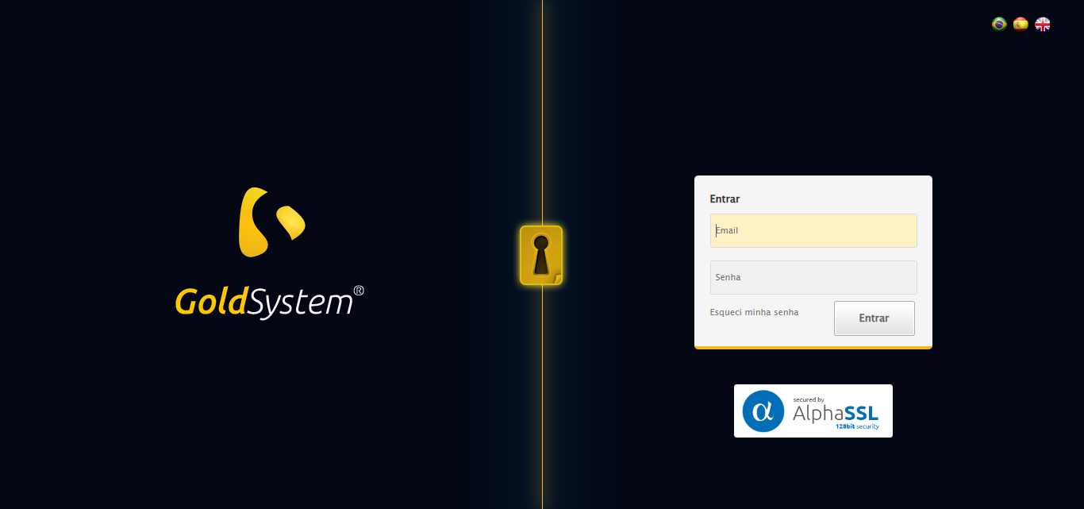

[15:33:26] [INFO] 🔄 Realizando login...

[15:33:31] [INFO] ✅ Realizando login realizada com sucesso.

[15:33:33] [INFO] Screenshot capturada: realizando_login

Screenshot: realizando_login

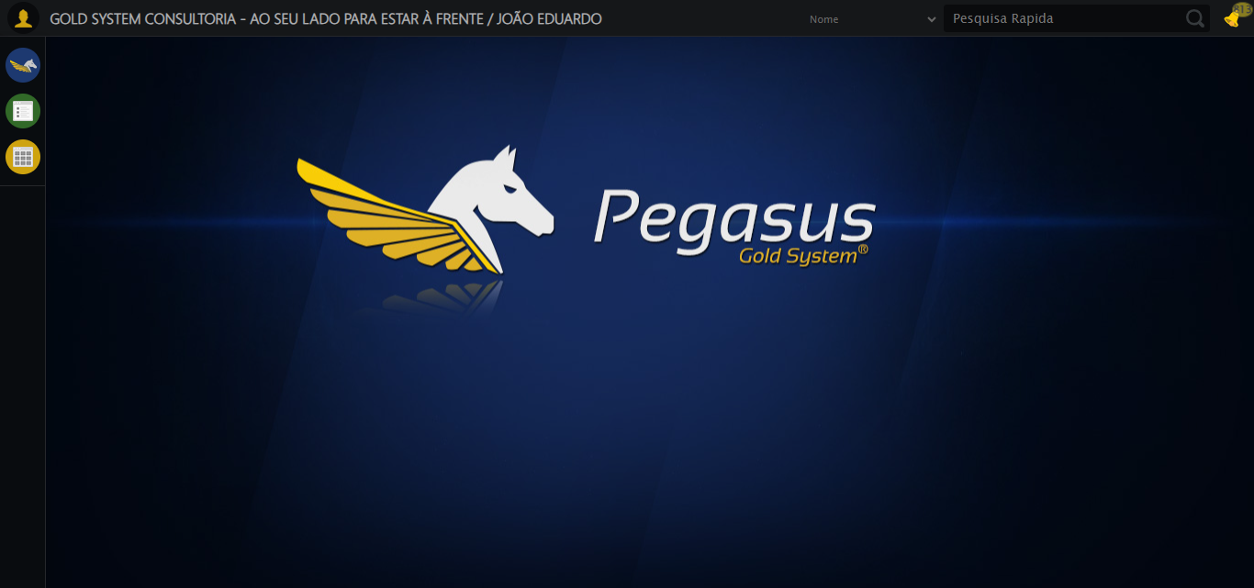

[15:33:33] [INFO] 🔄 Configurando interface...

[15:33:33] [INFO] 🔍 Zoom ajustado para 90%.

[15:33:35] [INFO] ✅ Configurando interface realizada com sucesso.

[15:33:36] [INFO] Screenshot capturada: configurando_interface

Screenshot: configurando_interface

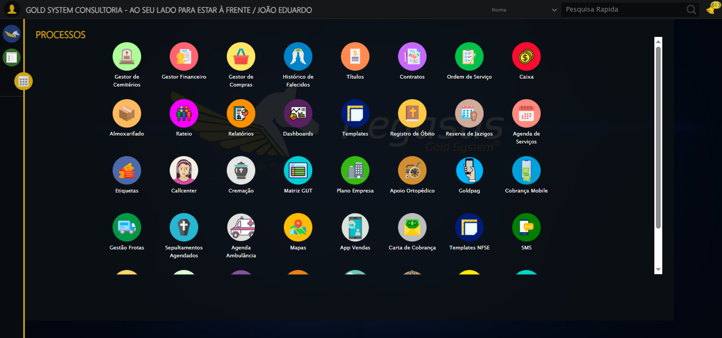

[15:33:36] [INFO] 🔄 Acessando Apoio Ortopédico...

[15:33:38] [INFO] ✅ Clique realizado com estratégia 1

[15:33:38] [INFO] ✅ Acessando Apoio Ortopédico realizada com sucesso.

[15:33:39] [INFO] Screenshot capturada: acessando_apoio_ortopédico

Screenshot: acessando_apoio_ortopédico

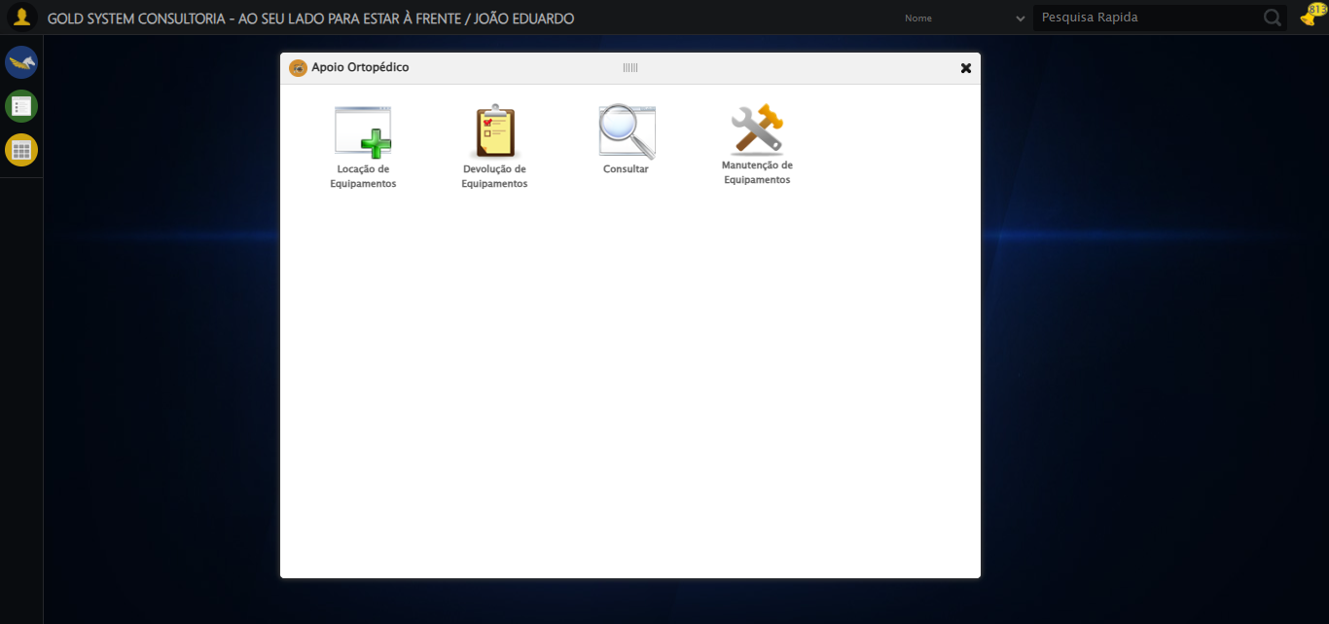

[15:33:39] [INFO] 🔄 Acessando Consulta Locação de Equipamentos...

[15:33:40] [INFO] ✅ Clique realizado com estratégia 1

[15:33:40] [INFO] ✅ Acessando Consulta Locação de Equipamentos realizada com sucesso.

[15:33:41] [INFO] Screenshot capturada: acessando_consulta_locação_de_equipamentos

Screenshot: acessando_consulta_locação_de_equipamentos

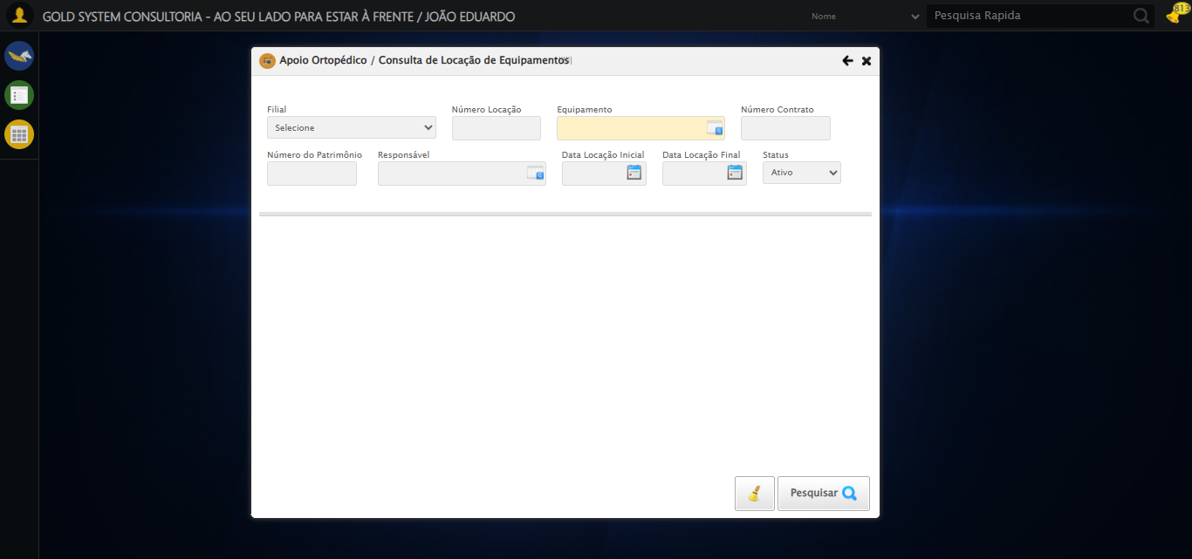

[15:33:44] [INFO] 🔄 Preenchendo Número da Locação...

[15:33:45] [INFO] ✅ Campo preenchido com estratégia 1: '306'

[15:33:45] [INFO] ✅ Preenchendo Número da Locação realizada com sucesso.

[15:33:46] [INFO] Screenshot capturada: preenchendo_número_da_locação

Screenshot: preenchendo_número_da_locação

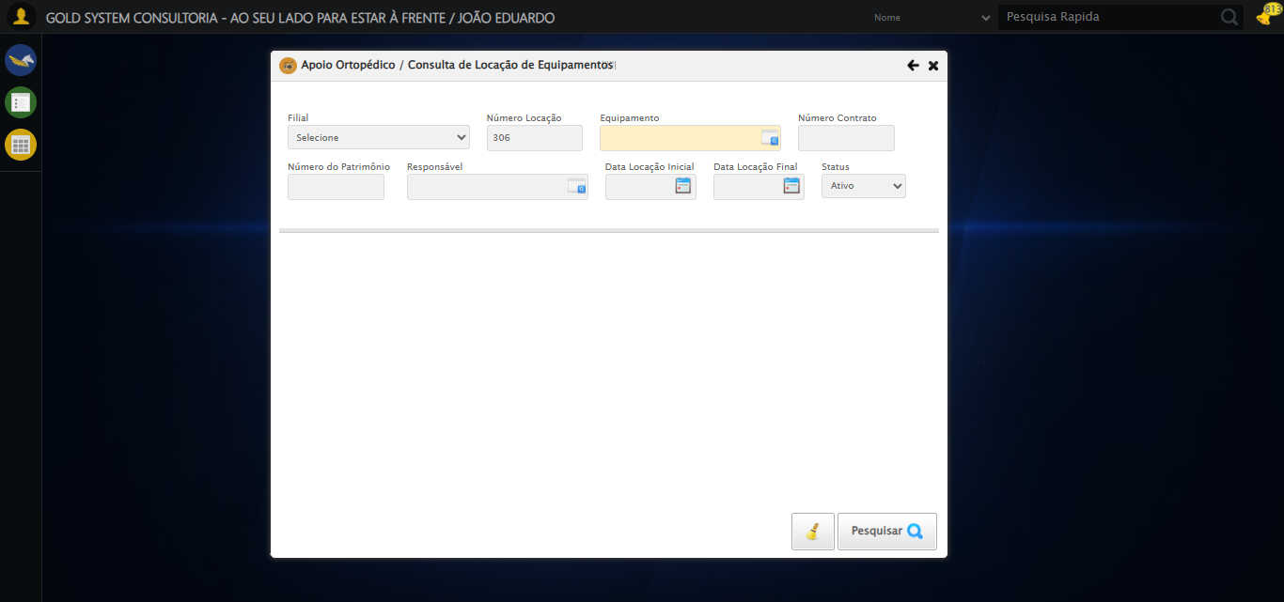

[15:33:46] [INFO] 🔄 Abrindo LOV de Equipamentos...

[15:33:47] [INFO] ✅ Clique realizado com estratégia 1

[15:33:47] [INFO] ✅ Abrindo LOV de Equipamentos realizada com sucesso.

[15:33:48] [INFO] Screenshot capturada: abrindo_lov_de_equipamentos

Screenshot: abrindo_lov_de_equipamentos

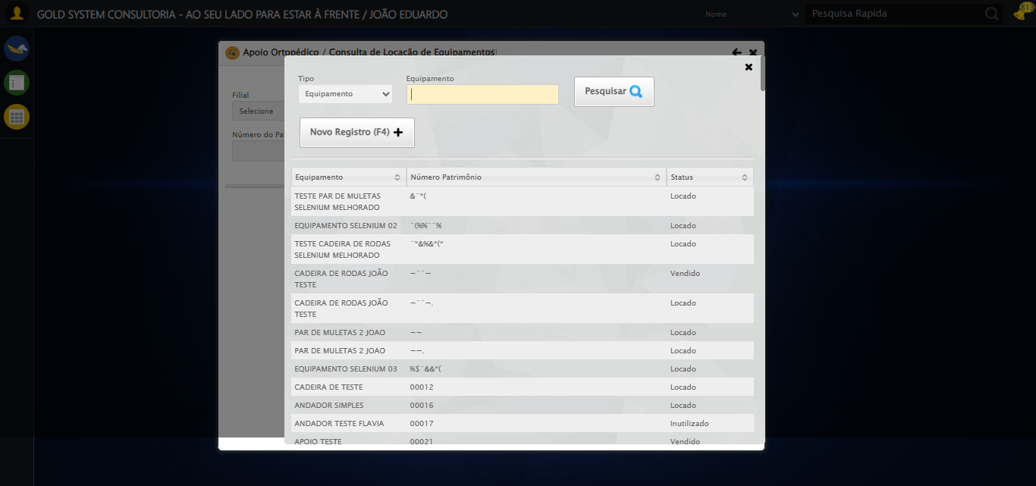

[15:33:50] [INFO] 🔄 Pesquisando equipamento...

[15:34:22] [ERROR] ❌ Timeout aguardando elemento: //tr[td[2][contains(normalize-space(.),'EQUIPAMENTO SELENIUM 01')]] (timeout: 30s)

[15:34:22] [ERROR] ❌ Erro no clique robusto: Message:   
Stacktrace:  
 GetHandleVerifier [0x0x88a8a3+63283]  
 GetHandleVerifier [0x0x88a8e4+63348]  
 (No symbol) [0x0x6c3e43]  
 (No symbol) [0x0x70c8de]  
 (No symbol) [0x0x70cc7b]  
 (No symbol) [0x0x754ef2]  
 (No symbol) [0x0x731464]  
 (No symbol) [0x0x75271a]  
 (No symbol) [0x0x731216]  
 (No symbol) [0x0x700855]  
 (No symbol) [0x0x7016f4]  
 GetHandleVerifier [0x0xafbb43+2623955]  
 GetHandleVerifier [0x0xaf6daa+2604090]  
 GetHandleVerifier [0x0x8b069a+218410]  
 GetHandleVerifier [0x0x8a0ed8+154984]  
 GetHandleVerifier [0x0x8a742d+180925]  
 GetHandleVerifier [0x0x8922b8+94536]  
 GetHandleVerifier [0x0x892442+94930]  
 GetHandleVerifier [0x0x87d5ea+9338]  
 BaseThreadInitThunk [0x0x76b1fcc9+25]  
 RtlGetAppContainerNamedObjectPath [0x0x776a82ae+286]  
 RtlGetAppContainerNamedObjectPath [0x0x776a827e+238]

[15:34:22] [INFO] ✅ Pesquisando equipamento realizada com sucesso.

[15:34:23] [INFO] Screenshot capturada: pesquisando_equipamento

Screenshot: pesquisando_equipamento

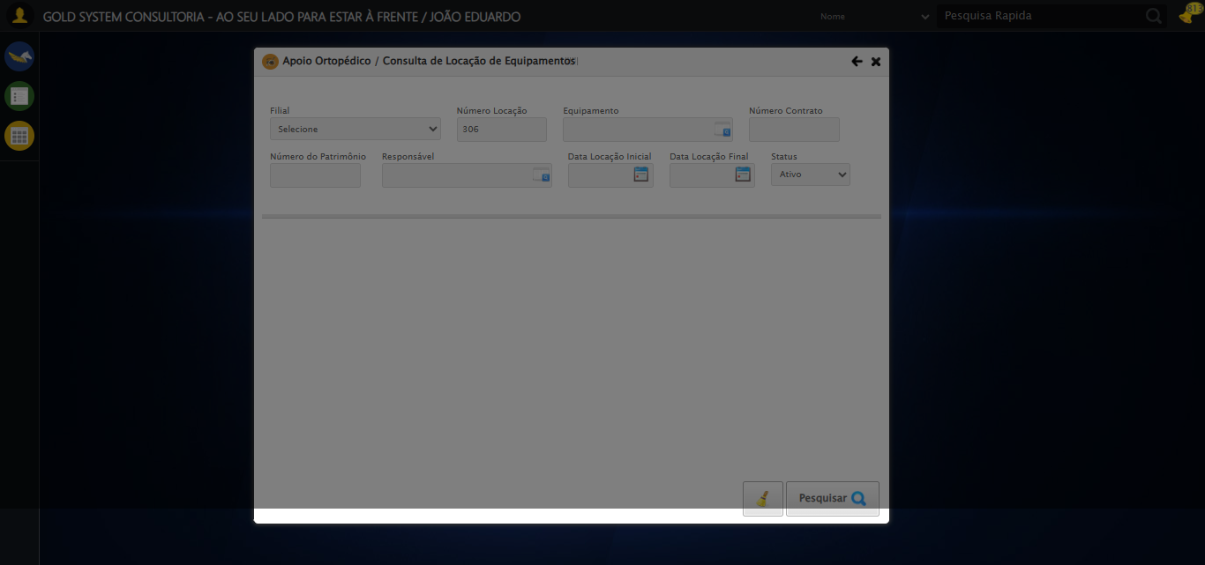

[15:34:33] [INFO] 🔄 Preenchendo Número do Contrato...

[15:34:35] [WARN] ⚠️ Estratégia 1 falhou: Message: element click intercepted: Element <input type="text" maxlength="" class="numeroContrato" style="width: 100px;"> is not clickable at point (900, 146). Other element would receive the click: <div class="blockScreen" style="height: 641px; z-index: 10001; opacity: 0.5;"></div>  
 (Session info: chrome=139.0.7258.128); For documentation on this error, please visit: https://www.selenium.dev/documentation/webdriver/troubleshooting/errors#elementclickinterceptedexception  
Stacktrace:  
 GetHandleVerifier [0x0x88a8a3+63283]  
 GetHandleVerifier [0x0x88a8e4+63348]  
 (No symbol) [0x0x6c3e43]  
 (No symbol) [0x0x712c20]  
 (No symbol) [0x0x710fda]  
 (No symbol) [0x0x70eb37]  
 (No symbol) [0x0x70ddf4]  
 (No symbol) [0x0x7025b5]  
 (No symbol) [0x0x73141c]  
 (No symbol) [0x0x702044]  
 (No symbol) [0x0x731694]  
 (No symbol) [0x0x75271a]  
 (No symbol) [0x0x731216]  
 (No symbol) [0x0x700855]  
 (No symbol) [0x0x7016f4]  
 GetHandleVerifier [0x0xafbb43+2623955]  
 GetHandleVerifier [0x0xaf6daa+2604090]  
 GetHandleVerifier [0x0x8b069a+218410]  
 GetHandleVerifier [0x0x8a0ed8+154984]  
 GetHandleVerifier [0x0x8a742d+180925]  
 GetHandleVerifier [0x0x8922b8+94536]  
 GetHandleVerifier [0x0x892442+94930]  
 GetHandleVerifier [0x0x87d5ea+9338]  
 BaseThreadInitThunk [0x0x76b1fcc9+25]  
 RtlGetAppContainerNamedObjectPath [0x0x776a82ae+286]  
 RtlGetAppContainerNamedObjectPath [0x0x776a827e+238]

[15:34:42] [INFO] ✅ Campo preenchido com estratégia 3: '113060'

[15:34:42] [INFO] ✅ Preenchendo Número do Contrato realizada com sucesso.

[15:34:43] [INFO] Screenshot capturada: preenchendo_número_do_contrato

Screenshot: preenchendo_número_do_contrato

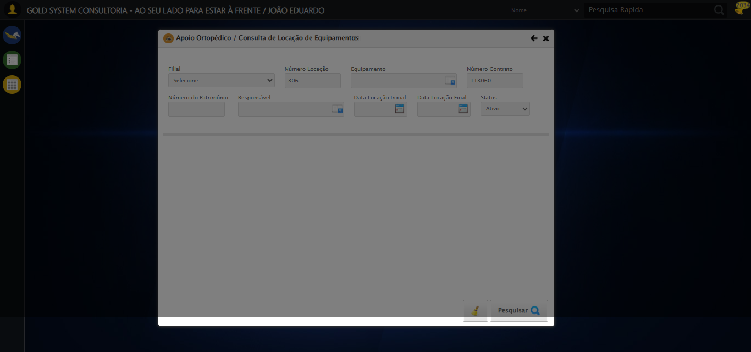

[15:34:43] [INFO] 🔄 Preenchendo Número do Patrimônio...

[15:34:45] [WARN] ⚠️ Estratégia 1 falhou: Message: element click intercepted: Element <input type="text" class="fc numeroPatrimonio" name="numeroPatrimonio" maxlength="20" style="width: 100px; text-align: left;"> is not clickable at point (357, 198). Other element would receive the click: <div class="blockScreen" style="height: 641px; z-index: 10001; opacity: 0.5;"></div>  
 (Session info: chrome=139.0.7258.128); For documentation on this error, please visit: https://www.selenium.dev/documentation/webdriver/troubleshooting/errors#elementclickinterceptedexception  
Stacktrace:  
 GetHandleVerifier [0x0x88a8a3+63283]  
 GetHandleVerifier [0x0x88a8e4+63348]  
 (No symbol) [0x0x6c3e43]  
 (No symbol) [0x0x712c20]  
 (No symbol) [0x0x710fda]  
 (No symbol) [0x0x70eb37]  
 (No symbol) [0x0x70ddf4]  
 (No symbol) [0x0x7025b5]  
 (No symbol) [0x0x73141c]  
 (No symbol) [0x0x702044]  
 (No symbol) [0x0x731694]  
 (No symbol) [0x0x75271a]  
 (No symbol) [0x0x731216]  
 (No symbol) [0x0x700855]  
 (No symbol) [0x0x7016f4]  
 GetHandleVerifier [0x0xafbb43+2623955]  
 GetHandleVerifier [0x0xaf6daa+2604090]  
 GetHandleVerifier [0x0x8b069a+218410]  
 GetHandleVerifier [0x0x8a0ed8+154984]  
 GetHandleVerifier [0x0x8a742d+180925]  
 GetHandleVerifier [0x0x8922b8+94536]  
 GetHandleVerifier [0x0x892442+94930]  
 GetHandleVerifier [0x0x87d5ea+9338]  
 BaseThreadInitThunk [0x0x76b1fcc9+25]  
 RtlGetAppContainerNamedObjectPath [0x0x776a82ae+286]  
 RtlGetAppContainerNamedObjectPath [0x0x776a827e+238]

[15:34:46] [INFO] ✅ Campo preenchido com estratégia 3: '876*&'

[15:34:46] [INFO] ✅ Preenchendo Número do Patrimônio realizada com sucesso.

[15:34:47] [INFO] Screenshot capturada: preenchendo_número_do_patrimônio

Screenshot: preenchendo_número_do_patrimônio

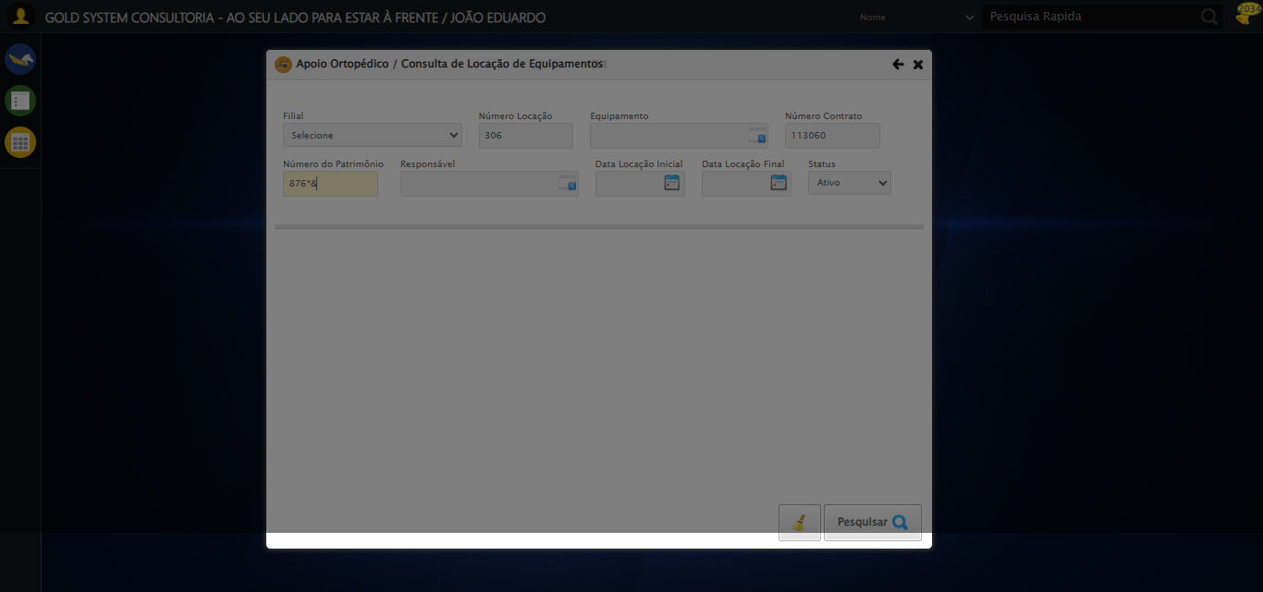

[15:34:47] [INFO] 🔄 Abrindo LOV do Responsável...

[15:34:49] [WARN] ⚠️ Estratégia 1 falhou: Message: element click intercepted: Element <a class="sprites sp-openLov"></a> is not clickable at point (612, 197). Other element would receive the click: <div class="blockScreen" style="height: 641px; z-index: 10001; opacity: 0.5;"></div>  
 (Session info: chrome=139.0.7258.128); For documentation on this error, please visit: https://www.selenium.dev/documentation/webdriver/troubleshooting/errors#elementclickinterceptedexception  
Stacktrace:  
 GetHandleVerifier [0x0x88a8a3+63283]  
 GetHandleVerifier [0x0x88a8e4+63348]  
 (No symbol) [0x0x6c3e43]  
 (No symbol) [0x0x712c20]  
 (No symbol) [0x0x710fda]  
 (No symbol) [0x0x70eb37]  
 (No symbol) [0x0x70ddf4]  
 (No symbol) [0x0x7025b5]  
 (No symbol) [0x0x73141c]  
 (No symbol) [0x0x702044]  
 (No symbol) [0x0x731694]  
 (No symbol) [0x0x75271a]  
 (No symbol) [0x0x731216]  
 (No symbol) [0x0x700855]  
 (No symbol) [0x0x7016f4]  
 GetHandleVerifier [0x0xafbb43+2623955]  
 GetHandleVerifier [0x0xaf6daa+2604090]  
 GetHandleVerifier [0x0x8b069a+218410]  
 GetHandleVerifier [0x0x8a0ed8+154984]  
 GetHandleVerifier [0x0x8a742d+180925]  
 GetHandleVerifier [0x0x8922b8+94536]  
 GetHandleVerifier [0x0x892442+94930]  
 GetHandleVerifier [0x0x87d5ea+9338]  
 BaseThreadInitThunk [0x0x76b1fcc9+25]  
 RtlGetAppContainerNamedObjectPath [0x0x776a82ae+286]  
 RtlGetAppContainerNamedObjectPath [0x0x776a827e+238]

[15:34:49] [INFO] ✅ Clique realizado com estratégia 2

[15:34:49] [INFO] ✅ Abrindo LOV do Responsável realizada com sucesso.

[15:34:50] [INFO] Screenshot capturada: abrindo_lov_do_responsável

Screenshot: abrindo_lov_do_responsável

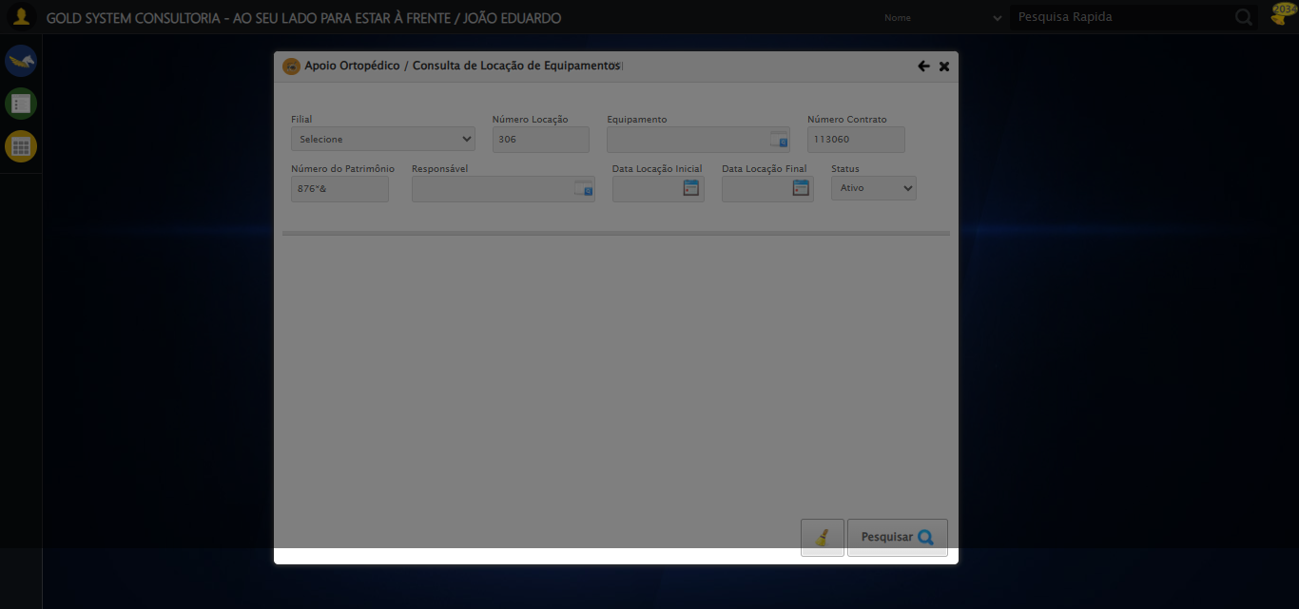

[15:34:52] [INFO] 🔄 Pesquisando responsável...

[15:35:00] [ERROR] ❌ Erro no preenchimento: Message: invalid session id: session deleted as the browser has closed the connection  
from disconnected: not connected to DevTools  
 (Session info: chrome=139.0.7258.128); For documentation on this error, please visit: https://www.selenium.dev/documentation/webdriver/troubleshooting/errors#invalidsessionidexception  
Stacktrace:  
 GetHandleVerifier [0x0x88a8a3+63283]  
 GetHandleVerifier [0x0x88a8e4+63348]  
 (No symbol) [0x0x6c3e43]  
 (No symbol) [0x0x6b3790]  
 (No symbol) [0x0x6d1602]  
 (No symbol) [0x0x737cdc]  
 (No symbol) [0x0x751ff9]  
 (No symbol) [0x0x731216]  
 (No symbol) [0x0x700855]  
 (No symbol) [0x0x7016f4]  
 GetHandleVerifier [0x0xafbb43+2623955]  
 GetHandleVerifier [0x0xaf6daa+2604090]  
 GetHandleVerifier [0x0x8b069a+218410]  
 GetHandleVerifier [0x0x8a0ed8+154984]  
 GetHandleVerifier [0x0x8a742d+180925]  
 GetHandleVerifier [0x0x8922b8+94536]  
 GetHandleVerifier [0x0x892442+94930]  
 GetHandleVerifier [0x0x87d5ea+9338]  
 BaseThreadInitThunk [0x0x76b1fcc9+25]  
 RtlGetAppContainerNamedObjectPath [0x0x776a82ae+286]  
 RtlGetAppContainerNamedObjectPath [0x0x776a827e+238]

[15:35:02] [ERROR] ❌ Erro no clique robusto: Message: invalid session id; For documentation on this error, please visit: https://www.selenium.dev/documentation/webdriver/troubleshooting/errors#invalidsessionidexception  
Stacktrace:  
 GetHandleVerifier [0x0x88a8a3+63283]  
 GetHandleVerifier [0x0x88a8e4+63348]  
 (No symbol) [0x0x6c3ca0]  
 (No symbol) [0x0x6ffb48]  
 (No symbol) [0x0x7312d6]  
 (No symbol) [0x0x72ceb5]  
 (No symbol) [0x0x72c436]  
 (No symbol) [0x0x695755]  
 (No symbol) [0x0x695cae]  
 (No symbol) [0x0x69613d]  
 GetHandleVerifier [0x0xafbb43+2623955]  
 GetHandleVerifier [0x0xaf6daa+2604090]  
 GetHandleVerifier [0x0x8b069a+218410]  
 GetHandleVerifier [0x0x8a0ed8+154984]  
 GetHandleVerifier [0x0x8a742d+180925]  
 (No symbol) [0x0x695420]  
 (No symbol) [0x0x694c36]  
 GetHandleVerifier [0x0xc368fc+3913612]  
 BaseThreadInitThunk [0x0x76b1fcc9+25]  
 RtlGetAppContainerNamedObjectPath [0x0x776a82ae+286]  
 RtlGetAppContainerNamedObjectPath [0x0x776a827e+238]

[15:35:02] [INFO] ✅ Pesquisando responsável realizada com sucesso.

[15:35:03] [WARN] Erro ao capturar screenshot pesquisando_responsável: Message: invalid session id; For documentation on this error, please visit: https://www.selenium.dev/documentation/webdriver/troubleshooting/errors#invalidsessionidexception  
Stacktrace:  
 GetHandleVerifier [0x0x88a8a3+63283]  
 GetHandleVerifier [0x0x88a8e4+63348]  
 (No symbol) [0x0x6c3ca0]  
 (No symbol) [0x0x6ffb48]  
 (No symbol) [0x0x7312d6]  
 (No symbol) [0x0x72ceb5]  
 (No symbol) [0x0x72c436]  
 (No symbol) [0x0x695755]  
 (No symbol) [0x0x695cae]  
 (No symbol) [0x0x69613d]  
 GetHandleVerifier [0x0xafbb43+2623955]  
 GetHandleVerifier [0x0xaf6daa+2604090]  
 GetHandleVerifier [0x0x8b069a+218410]  
 GetHandleVerifier [0x0x8a0ed8+154984]  
 GetHandleVerifier [0x0x8a742d+180925]  
 (No symbol) [0x0x695420]  
 (No symbol) [0x0x694c36]  
 GetHandleVerifier [0x0xc368fc+3913612]  
 BaseThreadInitThunk [0x0x76b1fcc9+25]  
 RtlGetAppContainerNamedObjectPath [0x0x776a82ae+286]  
 RtlGetAppContainerNamedObjectPath [0x0x776a827e+238]

[15:35:13] [INFO] 🔄 Preenchendo Data Locação Inicial...

[15:35:13] [INFO] 🎯 Tentativa 1: Preenchendo datepicker 0 com '21/08/2025'

[15:35:13] [INFO] 📊 Encontrados 0 campos datepicker

[15:35:15] [INFO] 🎯 Tentativa 2: Preenchendo datepicker 0 com '21/08/2025'

[15:35:15] [INFO] 📊 Encontrados 0 campos datepicker