RELATÓRIO DO TESTE AUTOMATIZADO

Consulta de Locação de Equipamentos - Apoio Ortopédico – Cenário 1

Data do teste: 28/08/2025 15:35:24

[15:35:24] [INFO] Iniciando teste de Consulta de Locação de Equipamentos

[15:35:28] [INFO] ✅ Driver Chrome inicializado com sucesso

[15:35:28] [INFO] 🚀 Iniciando teste de Consulta de Locação de Equipamentos

[15:35:28] [INFO] 🔄 Acessando sistema...

[15:35:28] [INFO] ✅ Acessando sistema realizada com sucesso.

[15:35:30] [INFO] Screenshot capturada: acessando_sistema

Screenshot: acessando_sistema

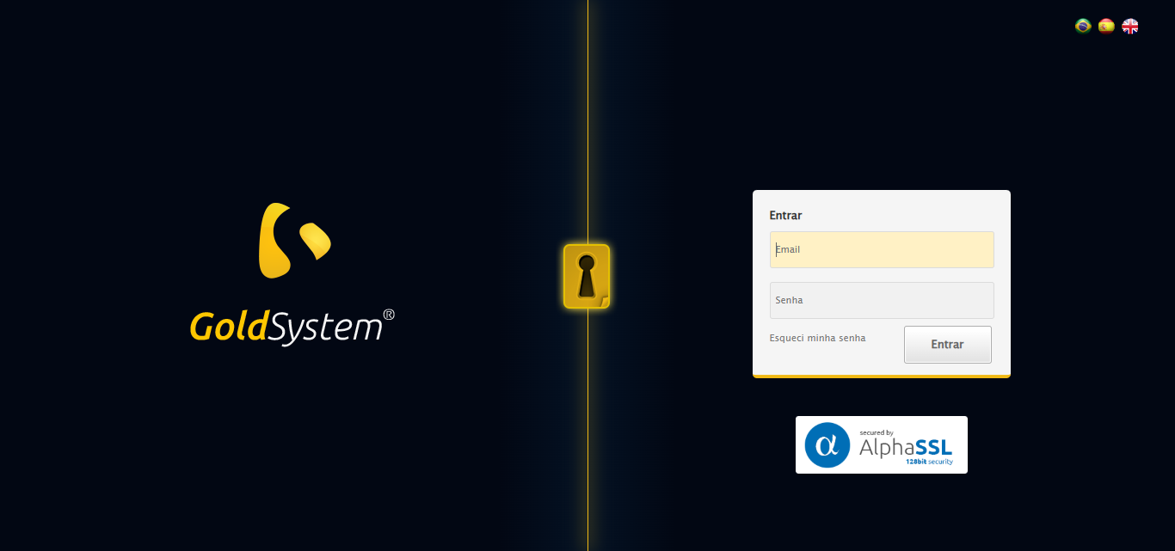

[15:35:30] [INFO] 🔄 Realizando login...

[15:35:35] [INFO] ✅ Realizando login realizada com sucesso.

[15:35:37] [INFO] Screenshot capturada: realizando_login

Screenshot: realizando_login

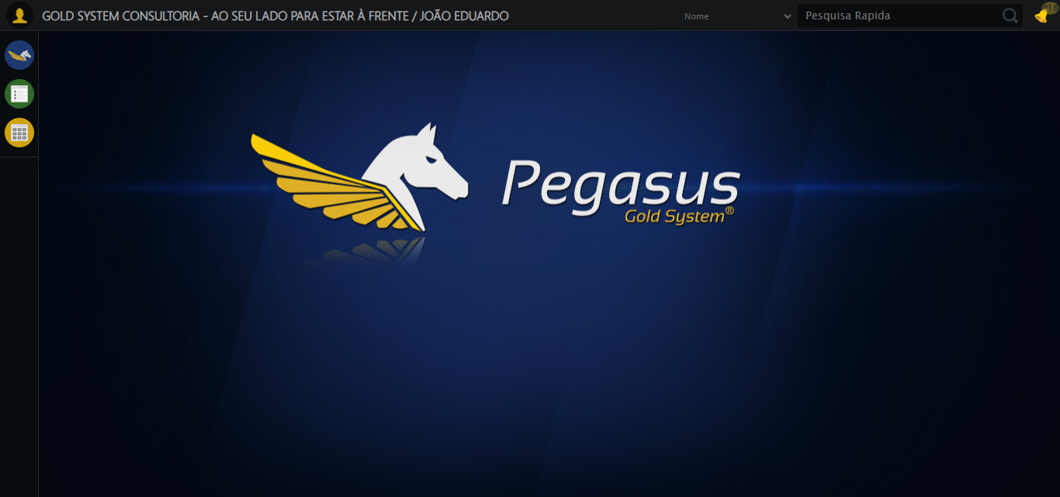

[15:35:37] [INFO] 🔄 Configurando interface...

[15:35:37] [INFO] 🔍 Zoom ajustado para 90%.

[15:35:39] [INFO] ✅ Configurando interface realizada com sucesso.

[15:35:40] [INFO] Screenshot capturada: configurando_interface

Screenshot: configurando_interface

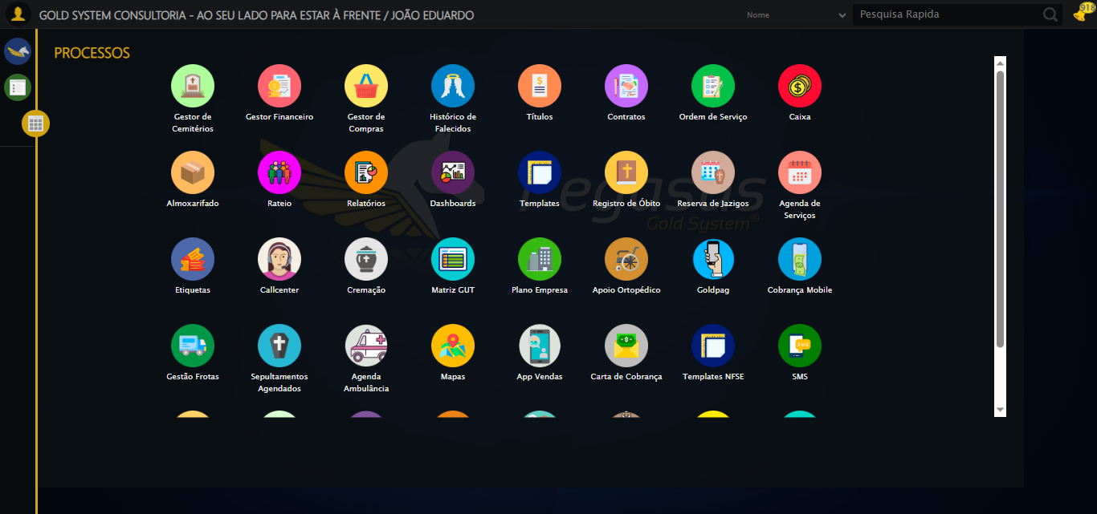

[15:35:40] [INFO] 🔄 Acessando Apoio Ortopédico...

[15:35:41] [INFO] ✅ Clique realizado com estratégia 1

[15:35:41] [INFO] ✅ Acessando Apoio Ortopédico realizada com sucesso.

[15:35:43] [INFO] Screenshot capturada: acessando_apoio_ortopédico

Screenshot: acessando_apoio_ortopédico

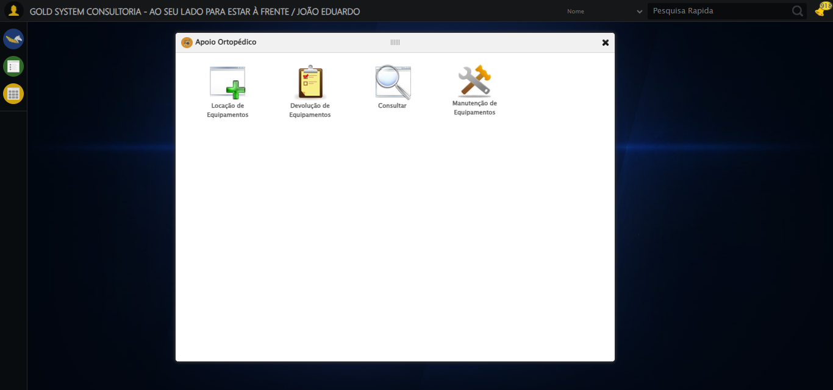

[15:35:43] [INFO] 🔄 Acessando Consulta Locação de Equipamentos...

[15:35:43] [INFO] ✅ Clique realizado com estratégia 1

[15:35:43] [INFO] ✅ Acessando Consulta Locação de Equipamentos realizada com sucesso.

[15:35:45] [INFO] Screenshot capturada: acessando_consulta_locação_de_equipamentos

Screenshot: acessando_consulta_locação_de_equipamentos

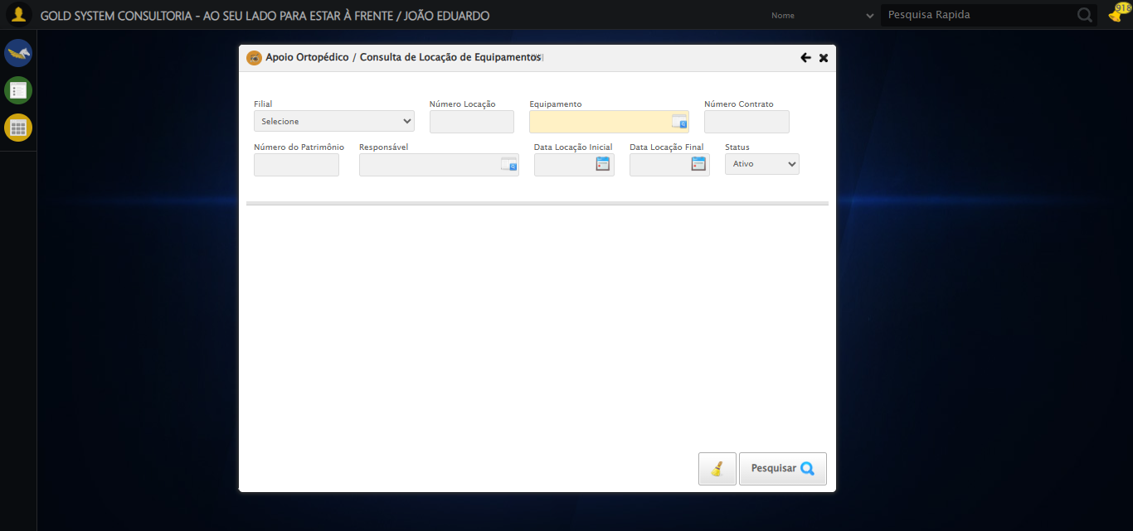

[15:35:48] [INFO] 🔄 Preenchendo Número da Locação...

[15:35:49] [INFO] ✅ Campo preenchido com estratégia 1: '306'

[15:35:49] [INFO] ✅ Preenchendo Número da Locação realizada com sucesso.

[15:35:50] [INFO] Screenshot capturada: preenchendo_número_da_locação

Screenshot: preenchendo_número_da_locação

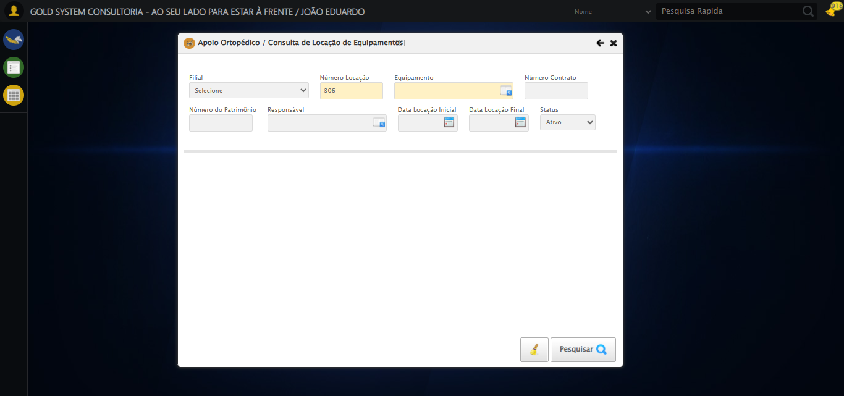

[15:35:50] [INFO] 🔄 Abrindo LOV de Equipamentos...

[15:35:51] [INFO] ✅ Clique realizado com estratégia 1

[15:35:51] [INFO] ✅ Abrindo LOV de Equipamentos realizada com sucesso.

[15:35:52] [INFO] Screenshot capturada: abrindo_lov_de_equipamentos

Screenshot: abrindo_lov_de_equipamentos

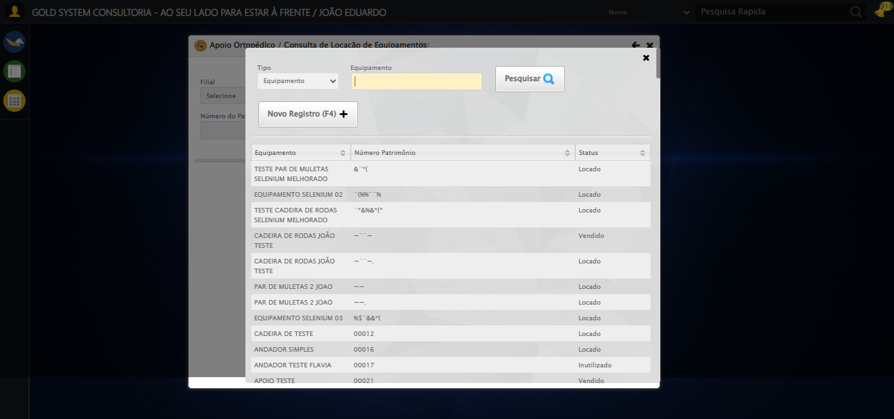

[15:35:54] [INFO] 🔄 Pesquisando equipamento...

[15:36:26] [ERROR] ❌ Timeout aguardando elemento: //tr[td[2][contains(normalize-space(.),'EQUIPAMENTO SELENIUM 01')]] (timeout: 30s)

[15:36:26] [ERROR] ❌ Erro no clique robusto: Message:   
Stacktrace:  
 GetHandleVerifier [0x0x88a8a3+63283]  
 GetHandleVerifier [0x0x88a8e4+63348]  
 (No symbol) [0x0x6c3e43]  
 (No symbol) [0x0x70c8de]  
 (No symbol) [0x0x70cc7b]  
 (No symbol) [0x0x754ef2]  
 (No symbol) [0x0x731464]  
 (No symbol) [0x0x75271a]  
 (No symbol) [0x0x731216]  
 (No symbol) [0x0x700855]  
 (No symbol) [0x0x7016f4]  
 GetHandleVerifier [0x0xafbb43+2623955]  
 GetHandleVerifier [0x0xaf6daa+2604090]  
 GetHandleVerifier [0x0x8b069a+218410]  
 GetHandleVerifier [0x0x8a0ed8+154984]  
 GetHandleVerifier [0x0x8a742d+180925]  
 GetHandleVerifier [0x0x8922b8+94536]  
 GetHandleVerifier [0x0x892442+94930]  
 GetHandleVerifier [0x0x87d5ea+9338]  
 BaseThreadInitThunk [0x0x76b1fcc9+25]  
 RtlGetAppContainerNamedObjectPath [0x0x776a82ae+286]  
 RtlGetAppContainerNamedObjectPath [0x0x776a827e+238]

[15:36:26] [INFO] ✅ Pesquisando equipamento realizada com sucesso.

[15:36:27] [INFO] Screenshot capturada: pesquisando_equipamento

Screenshot: pesquisando_equipamento

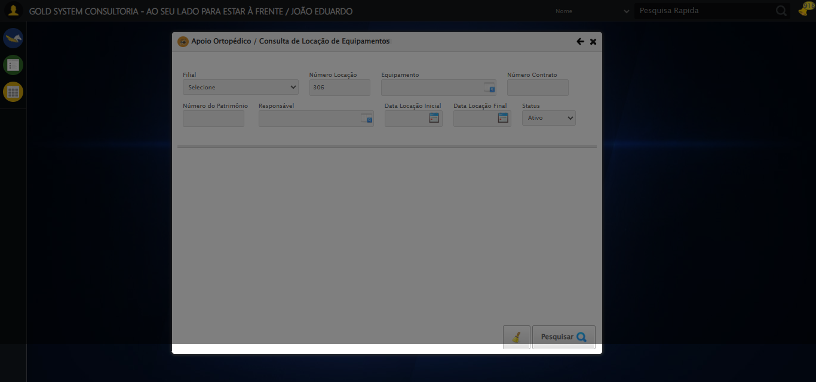

[15:36:37] [INFO] 🔄 Preenchendo Número do Contrato...

[15:36:39] [WARN] ⚠️ Estratégia 1 falhou: Message: element click intercepted: Element <input type="text" maxlength="" class="numeroContrato" style="width: 100px;"> is not clickable at point (900, 146). Other element would receive the click: <div class="blockScreen" style="height: 641px; z-index: 10001; opacity: 0.5;"></div>  
 (Session info: chrome=139.0.7258.128); For documentation on this error, please visit: https://www.selenium.dev/documentation/webdriver/troubleshooting/errors#elementclickinterceptedexception  
Stacktrace:  
 GetHandleVerifier [0x0x88a8a3+63283]  
 GetHandleVerifier [0x0x88a8e4+63348]  
 (No symbol) [0x0x6c3e43]  
 (No symbol) [0x0x712c20]  
 (No symbol) [0x0x710fda]  
 (No symbol) [0x0x70eb37]  
 (No symbol) [0x0x70ddf4]  
 (No symbol) [0x0x7025b5]  
 (No symbol) [0x0x73141c]  
 (No symbol) [0x0x702044]  
 (No symbol) [0x0x731694]  
 (No symbol) [0x0x75271a]  
 (No symbol) [0x0x731216]  
 (No symbol) [0x0x700855]  
 (No symbol) [0x0x7016f4]  
 GetHandleVerifier [0x0xafbb43+2623955]  
 GetHandleVerifier [0x0xaf6daa+2604090]  
 GetHandleVerifier [0x0x8b069a+218410]  
 GetHandleVerifier [0x0x8a0ed8+154984]  
 GetHandleVerifier [0x0x8a742d+180925]  
 GetHandleVerifier [0x0x8922b8+94536]  
 GetHandleVerifier [0x0x892442+94930]  
 GetHandleVerifier [0x0x87d5ea+9338]  
 BaseThreadInitThunk [0x0x76b1fcc9+25]  
 RtlGetAppContainerNamedObjectPath [0x0x776a82ae+286]  
 RtlGetAppContainerNamedObjectPath [0x0x776a827e+238]

[15:36:46] [INFO] ✅ Campo preenchido com estratégia 3: '113060'

[15:36:46] [INFO] ✅ Preenchendo Número do Contrato realizada com sucesso.

[15:36:47] [INFO] Screenshot capturada: preenchendo_número_do_contrato

Screenshot: preenchendo_número_do_contrato

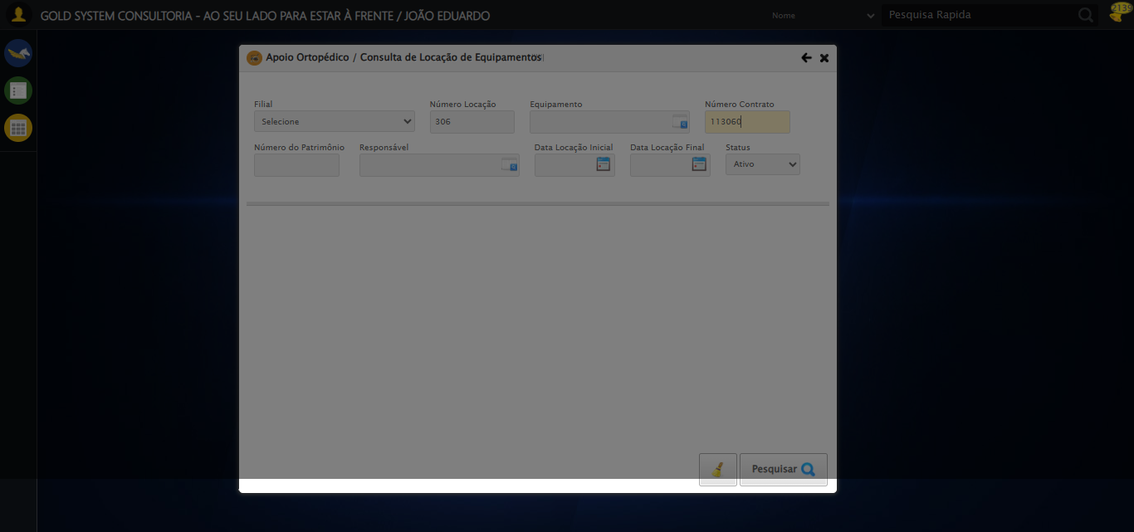

[15:36:47] [INFO] 🔄 Preenchendo Número do Patrimônio...

[15:36:49] [WARN] ⚠️ Estratégia 1 falhou: Message: element click intercepted: Element <input type="text" class="fc numeroPatrimonio" name="numeroPatrimonio" maxlength="20" style="width: 100px; text-align: left;"> is not clickable at point (357, 198). Other element would receive the click: <div class="blockScreen" style="height: 641px; z-index: 10001; opacity: 0.5;"></div>  
 (Session info: chrome=139.0.7258.128); For documentation on this error, please visit: https://www.selenium.dev/documentation/webdriver/troubleshooting/errors#elementclickinterceptedexception  
Stacktrace:  
 GetHandleVerifier [0x0x88a8a3+63283]  
 GetHandleVerifier [0x0x88a8e4+63348]  
 (No symbol) [0x0x6c3e43]  
 (No symbol) [0x0x712c20]  
 (No symbol) [0x0x710fda]  
 (No symbol) [0x0x70eb37]  
 (No symbol) [0x0x70ddf4]  
 (No symbol) [0x0x7025b5]  
 (No symbol) [0x0x73141c]  
 (No symbol) [0x0x702044]  
 (No symbol) [0x0x731694]  
 (No symbol) [0x0x75271a]  
 (No symbol) [0x0x731216]  
 (No symbol) [0x0x700855]  
 (No symbol) [0x0x7016f4]  
 GetHandleVerifier [0x0xafbb43+2623955]  
 GetHandleVerifier [0x0xaf6daa+2604090]  
 GetHandleVerifier [0x0x8b069a+218410]  
 GetHandleVerifier [0x0x8a0ed8+154984]  
 GetHandleVerifier [0x0x8a742d+180925]  
 GetHandleVerifier [0x0x8922b8+94536]  
 GetHandleVerifier [0x0x892442+94930]  
 GetHandleVerifier [0x0x87d5ea+9338]  
 BaseThreadInitThunk [0x0x76b1fcc9+25]  
 RtlGetAppContainerNamedObjectPath [0x0x776a82ae+286]  
 RtlGetAppContainerNamedObjectPath [0x0x776a827e+238]

[15:36:50] [INFO] ✅ Campo preenchido com estratégia 3: '876*&'

[15:36:50] [INFO] ✅ Preenchendo Número do Patrimônio realizada com sucesso.

[15:36:51] [INFO] Screenshot capturada: preenchendo_número_do_patrimônio

Screenshot: preenchendo_número_do_patrimônio

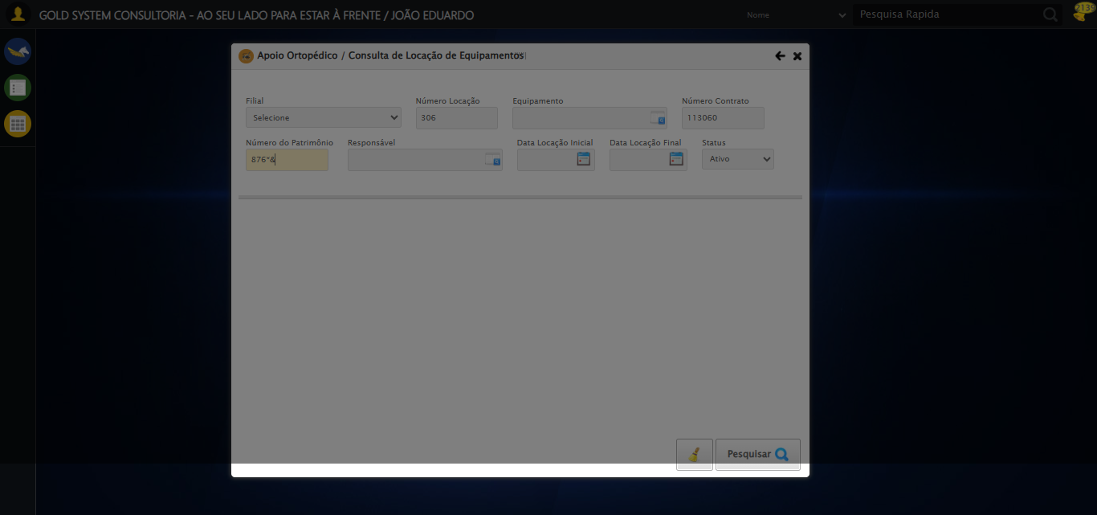

[15:36:51] [INFO] 🔄 Abrindo LOV do Responsável...

[15:36:53] [WARN] ⚠️ Estratégia 1 falhou: Message: element click intercepted: Element <a class="sprites sp-openLov"></a> is not clickable at point (612, 197). Other element would receive the click: <div class="blockScreen" style="height: 641px; z-index: 10001; opacity: 0.5;"></div>  
 (Session info: chrome=139.0.7258.128); For documentation on this error, please visit: https://www.selenium.dev/documentation/webdriver/troubleshooting/errors#elementclickinterceptedexception  
Stacktrace:  
 GetHandleVerifier [0x0x88a8a3+63283]  
 GetHandleVerifier [0x0x88a8e4+63348]  
 (No symbol) [0x0x6c3e43]  
 (No symbol) [0x0x712c20]  
 (No symbol) [0x0x710fda]  
 (No symbol) [0x0x70eb37]  
 (No symbol) [0x0x70ddf4]  
 (No symbol) [0x0x7025b5]  
 (No symbol) [0x0x73141c]  
 (No symbol) [0x0x702044]  
 (No symbol) [0x0x731694]  
 (No symbol) [0x0x75271a]  
 (No symbol) [0x0x731216]  
 (No symbol) [0x0x700855]  
 (No symbol) [0x0x7016f4]  
 GetHandleVerifier [0x0xafbb43+2623955]  
 GetHandleVerifier [0x0xaf6daa+2604090]  
 GetHandleVerifier [0x0x8b069a+218410]  
 GetHandleVerifier [0x0x8a0ed8+154984]  
 GetHandleVerifier [0x0x8a742d+180925]  
 GetHandleVerifier [0x0x8922b8+94536]  
 GetHandleVerifier [0x0x892442+94930]  
 GetHandleVerifier [0x0x87d5ea+9338]  
 BaseThreadInitThunk [0x0x76b1fcc9+25]  
 RtlGetAppContainerNamedObjectPath [0x0x776a82ae+286]  
 RtlGetAppContainerNamedObjectPath [0x0x776a827e+238]

[15:36:53] [INFO] ✅ Clique realizado com estratégia 2

[15:36:53] [INFO] ✅ Abrindo LOV do Responsável realizada com sucesso.

[15:36:55] [INFO] Screenshot capturada: abrindo_lov_do_responsável

Screenshot: abrindo_lov_do_responsável

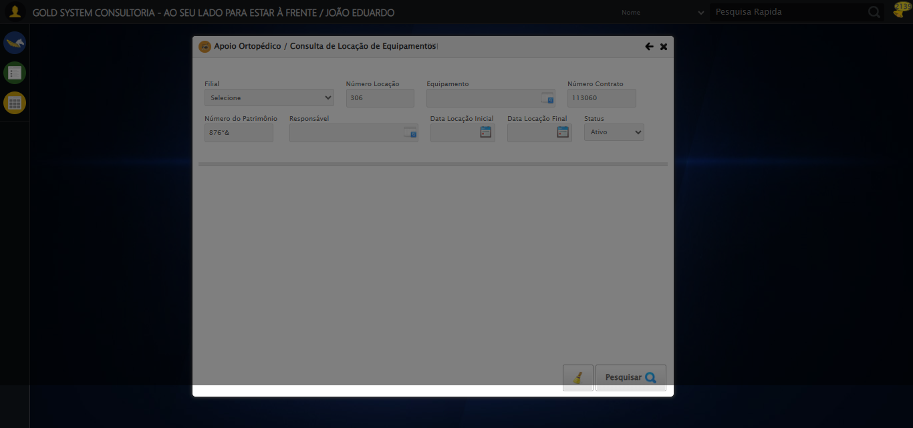

[15:36:57] [INFO] 🔄 Pesquisando responsável...

[15:37:27] [ERROR] ❌ Timeout aguardando elemento: //*[@id='txtPesquisa'] (timeout: 30s)

[15:37:27] [ERROR] ❌ Erro no preenchimento: Message:   
Stacktrace:  
 GetHandleVerifier [0x0x88a8a3+63283]  
 GetHandleVerifier [0x0x88a8e4+63348]  
 (No symbol) [0x0x6c3e43]  
 (No symbol) [0x0x70c8de]  
 (No symbol) [0x0x70cc7b]  
 (No symbol) [0x0x754ef2]  
 (No symbol) [0x0x731464]  
 (No symbol) [0x0x75271a]  
 (No symbol) [0x0x731216]  
 (No symbol) [0x0x700855]  
 (No symbol) [0x0x7016f4]  
 GetHandleVerifier [0x0xafbb43+2623955]  
 GetHandleVerifier [0x0xaf6daa+2604090]  
 GetHandleVerifier [0x0x8b069a+218410]  
 GetHandleVerifier [0x0x8a0ed8+154984]  
 GetHandleVerifier [0x0x8a742d+180925]  
 GetHandleVerifier [0x0x8922b8+94536]  
 GetHandleVerifier [0x0x892442+94930]  
 GetHandleVerifier [0x0x87d5ea+9338]  
 BaseThreadInitThunk [0x0x76b1fcc9+25]  
 RtlGetAppContainerNamedObjectPath [0x0x776a82ae+286]  
 RtlGetAppContainerNamedObjectPath [0x0x776a827e+238]

[15:37:56] [ERROR] ❌ Erro no clique robusto: Message: no such window: target window already closed  
from unknown error: web view not found  
 (Session info: chrome=139.0.7258.128)  
Stacktrace:  
 GetHandleVerifier [0x0x88a8a3+63283]  
 GetHandleVerifier [0x0x88a8e4+63348]  
 (No symbol) [0x0x6c3e43]  
 (No symbol) [0x0x6a2c49]  
 (No symbol) [0x0x737b0e]  
 (No symbol) [0x0x751ff9]  
 (No symbol) [0x0x731216]  
 (No symbol) [0x0x700855]  
 (No symbol) [0x0x7016f4]  
 GetHandleVerifier [0x0xafbb43+2623955]  
 GetHandleVerifier [0x0xaf6daa+2604090]  
 GetHandleVerifier [0x0x8b069a+218410]  
 GetHandleVerifier [0x0x8a0ed8+154984]  
 GetHandleVerifier [0x0x8a742d+180925]  
 GetHandleVerifier [0x0x8922b8+94536]  
 GetHandleVerifier [0x0x892442+94930]  
 GetHandleVerifier [0x0x87d5ea+9338]  
 BaseThreadInitThunk [0x0x76b1fcc9+25]  
 RtlGetAppContainerNamedObjectPath [0x0x776a82ae+286]  
 RtlGetAppContainerNamedObjectPath [0x0x776a827e+238]

[15:37:56] [INFO] ✅ Pesquisando responsável realizada com sucesso.

[15:37:57] [WARN] Erro ao capturar screenshot pesquisando_responsável: Message: no such window: target window already closed  
from unknown error: web view not found  
 (Session info: chrome=139.0.7258.128)  
Stacktrace:  
 GetHandleVerifier [0x0x88a8a3+63283]  
 GetHandleVerifier [0x0x88a8e4+63348]  
 (No symbol) [0x0x6c3e43]  
 (No symbol) [0x0x6a2c49]  
 (No symbol) [0x0x737b0e]  
 (No symbol) [0x0x751ff9]  
 (No symbol) [0x0x731216]  
 (No symbol) [0x0x700855]  
 (No symbol) [0x0x7016f4]  
 GetHandleVerifier [0x0xafbb43+2623955]  
 GetHandleVerifier [0x0xaf6daa+2604090]  
 GetHandleVerifier [0x0x8b069a+218410]  
 GetHandleVerifier [0x0x8a0ed8+154984]  
 GetHandleVerifier [0x0x8a742d+180925]  
 GetHandleVerifier [0x0x8922b8+94536]  
 GetHandleVerifier [0x0x892442+94930]  
 GetHandleVerifier [0x0x87d5ea+9338]  
 BaseThreadInitThunk [0x0x76b1fcc9+25]  
 RtlGetAppContainerNamedObjectPath [0x0x776a82ae+286]  
 RtlGetAppContainerNamedObjectPath [0x0x776a827e+238]

[15:38:07] [INFO] 🔄 Preenchendo Data Locação Inicial...

[15:38:07] [INFO] 🎯 Tentativa 1: Preenchendo datepicker 0 com '21/08/2025'

[15:38:07] [INFO] 📊 Encontrados 0 campos datepicker

[15:38:09] [INFO] 🎯 Tentativa 2: Preenchendo datepicker 0 com '21/08/2025'

[15:38:09] [INFO] 📊 Encontrados 0 campos datepicker

[15:38:11] [INFO] 🎯 Tentativa 3: Preenchendo datepicker 0 com '21/08/2025'

[15:38:11] [INFO] 📊 Encontrados 0 campos datepicker

[15:38:13] [INFO] 🎯 Tentativa 4: Preenchendo datepicker 0 com '21/08/2025'

[15:38:13] [INFO] 📊 Encontrados 0 campos datepicker

[15:38:15] [INFO] 🎯 Tentativa 5: Preenchendo datepicker 0 com '21/08/2025'

[15:38:15] [INFO] 📊 Encontrados 0 campos datepicker

[15:38:15] [WARN] ⚠️ Tentativa 1 falhou: Falha ao preencher datepicker 0 após 5 tentativas: Nenhum campo datepicker encontrado. Tentando novamente...

[15:38:17] [INFO] 🔄 Preenchendo Data Locação Inicial... (Tentativa 2)

[15:38:17] [INFO] 🎯 Tentativa 1: Preenchendo datepicker 0 com '21/08/2025'

[15:38:18] [INFO] 📊 Encontrados 0 campos datepicker

[15:38:20] [INFO] 🎯 Tentativa 2: Preenchendo datepicker 0 com '21/08/2025'

[15:38:20] [INFO] 📊 Encontrados 0 campos datepicker

[15:38:22] [INFO] 🎯 Tentativa 3: Preenchendo datepicker 0 com '21/08/2025'

[15:38:22] [INFO] 📊 Encontrados 0 campos datepicker

[15:38:24] [INFO] 🎯 Tentativa 4: Preenchendo datepicker 0 com '21/08/2025'

[15:38:24] [INFO] 📊 Encontrados 0 campos datepicker

[15:38:26] [INFO] 🎯 Tentativa 5: Preenchendo datepicker 0 com '21/08/2025'

[15:38:26] [INFO] 📊 Encontrados 0 campos datepicker

[15:38:26] [WARN] ⚠️ Tentativa 2 falhou: Falha ao preencher datepicker 0 após 5 tentativas: Nenhum campo datepicker encontrado. Tentando novamente...

[15:38:28] [INFO] 🔄 Preenchendo Data Locação Inicial... (Tentativa 3)

[15:38:28] [INFO] 🎯 Tentativa 1: Preenchendo datepicker 0 com '21/08/2025'

[15:38:28] [INFO] 📊 Encontrados 0 campos datepicker

[15:38:30] [INFO] 🎯 Tentativa 2: Preenchendo datepicker 0 com '21/08/2025'

[15:38:30] [INFO] 📊 Encontrados 0 campos datepicker

[15:38:32] [INFO] 🎯 Tentativa 3: Preenchendo datepicker 0 com '21/08/2025'

[15:38:32] [INFO] 📊 Encontrados 0 campos datepicker

[15:38:34] [INFO] 🎯 Tentativa 4: Preenchendo datepicker 0 com '21/08/2025'

[15:38:34] [INFO] 📊 Encontrados 0 campos datepicker

[15:38:36] [INFO] 🎯 Tentativa 5: Preenchendo datepicker 0 com '21/08/2025'

[15:38:36] [INFO] 📊 Encontrados 0 campos datepicker

[15:38:36] [WARN] Erro ao capturar screenshot erro_preenchendo_data_locação_inicial: Message: no such window: target window already closed  
from unknown error: web view not found  
 (Session info: chrome=139.0.7258.128)  
Stacktrace:  
 GetHandleVerifier [0x0x88a8a3+63283]  
 GetHandleVerifier [0x0x88a8e4+63348]  
 (No symbol) [0x0x6c3e43]  
 (No symbol) [0x0x6a2c49]  
 (No symbol) [0x0x737b0e]  
 (No symbol) [0x0x751ff9]  
 (No symbol) [0x0x731216]  
 (No symbol) [0x0x700855]  
 (No symbol) [0x0x7016f4]  
 GetHandleVerifier [0x0xafbb43+2623955]  
 GetHandleVerifier [0x0xaf6daa+2604090]  
 GetHandleVerifier [0x0x8b069a+218410]  
 GetHandleVerifier [0x0x8a0ed8+154984]  
 GetHandleVerifier [0x0x8a742d+180925]  
 GetHandleVerifier [0x0x8922b8+94536]  
 GetHandleVerifier [0x0x892442+94930]  
 GetHandleVerifier [0x0x87d5ea+9338]  
 BaseThreadInitThunk [0x0x76b1fcc9+25]  
 RtlGetAppContainerNamedObjectPath [0x0x776a82ae+286]  
 RtlGetAppContainerNamedObjectPath [0x0x776a827e+238]

[15:38:36] [ERROR] ❌ Preenchendo Data Locação Inicial falhou após 3 tentativas: Falha ao preencher datepicker 0 após 5 tentativas: Nenhum campo datepicker encontrado

[15:38:36] [WARN] ⚠️ Continuando execução apesar do erro em: Preenchendo Data Locação Inicial

[15:38:36] [INFO] 🔄 Preenchendo Data Locação Final...

[15:38:36] [INFO] 🎯 Tentativa 1: Preenchendo datepicker 1 com '21/08/2025'

[15:38:36] [INFO] 📊 Encontrados 0 campos datepicker

[15:38:38] [INFO] 🎯 Tentativa 2: Preenchendo datepicker 1 com '21/08/2025'

[15:38:38] [INFO] 📊 Encontrados 0 campos datepicker

[15:38:40] [INFO] 🎯 Tentativa 3: Preenchendo datepicker 1 com '21/08/2025'

[15:38:40] [INFO] 📊 Encontrados 0 campos datepicker

[15:38:42] [INFO] 🎯 Tentativa 4: Preenchendo datepicker 1 com '21/08/2025'

[15:38:42] [INFO] 📊 Encontrados 0 campos datepicker

[15:38:44] [INFO] 🎯 Tentativa 5: Preenchendo datepicker 1 com '21/08/2025'

[15:38:44] [INFO] 📊 Encontrados 0 campos datepicker

[15:38:44] [WARN] ⚠️ Tentativa 1 falhou: Falha ao preencher datepicker 1 após 5 tentativas: Nenhum campo datepicker encontrado. Tentando novamente...

[15:38:46] [INFO] 🔄 Preenchendo Data Locação Final... (Tentativa 2)

[15:38:46] [INFO] 🎯 Tentativa 1: Preenchendo datepicker 1 com '21/08/2025'

[15:38:46] [INFO] 📊 Encontrados 0 campos datepicker

[15:38:48] [INFO] 🎯 Tentativa 2: Preenchendo datepicker 1 com '21/08/2025'

[15:38:48] [INFO] 📊 Encontrados 0 campos datepicker

[15:38:50] [INFO] 🎯 Tentativa 3: Preenchendo datepicker 1 com '21/08/2025'

[15:38:50] [INFO] 📊 Encontrados 0 campos datepicker

[15:38:52] [INFO] 🎯 Tentativa 4: Preenchendo datepicker 1 com '21/08/2025'

[15:38:52] [INFO] 📊 Encontrados 0 campos datepicker

[15:38:54] [INFO] 🎯 Tentativa 5: Preenchendo datepicker 1 com '21/08/2025'

[15:38:54] [INFO] 📊 Encontrados 0 campos datepicker

[15:38:54] [WARN] ⚠️ Tentativa 2 falhou: Falha ao preencher datepicker 1 após 5 tentativas: Nenhum campo datepicker encontrado. Tentando novamente...

[15:38:56] [INFO] 🔄 Preenchendo Data Locação Final... (Tentativa 3)

[15:38:56] [INFO] 🎯 Tentativa 1: Preenchendo datepicker 1 com '21/08/2025'

[15:38:56] [INFO] 📊 Encontrados 0 campos datepicker

[15:38:58] [INFO] 🎯 Tentativa 2: Preenchendo datepicker 1 com '21/08/2025'

[15:38:58] [INFO] 📊 Encontrados 0 campos datepicker

[15:39:00] [INFO] 🎯 Tentativa 3: Preenchendo datepicker 1 com '21/08/2025'

[15:39:00] [INFO] 📊 Encontrados 0 campos datepicker

[15:39:02] [INFO] 🎯 Tentativa 4: Preenchendo datepicker 1 com '21/08/2025'

[15:39:02] [INFO] 📊 Encontrados 0 campos datepicker

[15:39:04] [INFO] 🎯 Tentativa 5: Preenchendo datepicker 1 com '21/08/2025'

[15:39:05] [INFO] 📊 Encontrados 0 campos datepicker

[15:39:05] [WARN] Erro ao capturar screenshot erro_preenchendo_data_locação_final: Message: no such window: target window already closed  
from unknown error: web view not found  
 (Session info: chrome=139.0.7258.128)  
Stacktrace:  
 GetHandleVerifier [0x0x88a8a3+63283]  
 GetHandleVerifier [0x0x88a8e4+63348]  
 (No symbol) [0x0x6c3e43]  
 (No symbol) [0x0x6a2c49]  
 (No symbol) [0x0x737b0e]  
 (No symbol) [0x0x751ff9]  
 (No symbol) [0x0x731216]  
 (No symbol) [0x0x700855]  
 (No symbol) [0x0x7016f4]  
 GetHandleVerifier [0x0xafbb43+2623955]  
 GetHandleVerifier [0x0xaf6daa+2604090]  
 GetHandleVerifier [0x0x8b069a+218410]  
 GetHandleVerifier [0x0x8a0ed8+154984]  
 GetHandleVerifier [0x0x8a742d+180925]  
 GetHandleVerifier [0x0x8922b8+94536]  
 GetHandleVerifier [0x0x892442+94930]  
 GetHandleVerifier [0x0x87d5ea+9338]  
 BaseThreadInitThunk [0x0x76b1fcc9+25]  
 RtlGetAppContainerNamedObjectPath [0x0x776a82ae+286]  
 RtlGetAppContainerNamedObjectPath [0x0x776a827e+238]

[15:39:05] [ERROR] ❌ Preenchendo Data Locação Final falhou após 3 tentativas: Falha ao preencher datepicker 1 após 5 tentativas: Nenhum campo datepicker encontrado

[15:39:05] [WARN] ⚠️ Continuando execução apesar do erro em: Preenchendo Data Locação Final

[15:39:05] [INFO] 🔄 Realizando consulta...

[15:39:05] [ERROR] ❌ Erro no clique robusto: Message: no such window: target window already closed  
from unknown error: web view not found  
 (Session info: chrome=139.0.7258.128)  
Stacktrace:  
 GetHandleVerifier [0x0x88a8a3+63283]  
 GetHandleVerifier [0x0x88a8e4+63348]  
 (No symbol) [0x0x6c3e43]  
 (No symbol) [0x0x6a2c49]  
 (No symbol) [0x0x737b0e]  
 (No symbol) [0x0x751ff9]  
 (No symbol) [0x0x731216]  
 (No symbol) [0x0x700855]  
 (No symbol) [0x0x7016f4]  
 GetHandleVerifier [0x0xafbb43+2623955]  
 GetHandleVerifier [0x0xaf6daa+2604090]  
 GetHandleVerifier [0x0x8b069a+218410]  
 GetHandleVerifier [0x0x8a0ed8+154984]  
 GetHandleVerifier [0x0x8a742d+180925]  
 GetHandleVerifier [0x0x8922b8+94536]  
 GetHandleVerifier [0x0x892442+94930]  
 GetHandleVerifier [0x0x87d5ea+9338]  
 BaseThreadInitThunk [0x0x76b1fcc9+25]  
 RtlGetAppContainerNamedObjectPath [0x0x776a82ae+286]  
 RtlGetAppContainerNamedObjectPath [0x0x776a827e+238]

[15:39:15] [INFO] ✅ Realizando consulta realizada com sucesso.

[15:39:16] [WARN] Erro ao capturar screenshot realizando_consulta: Message: no such window: target window already closed  
from unknown error: web view not found  
 (Session info: chrome=139.0.7258.128)  
Stacktrace:  
 GetHandleVerifier [0x0x88a8a3+63283]  
 GetHandleVerifier [0x0x88a8e4+63348]  
 (No symbol) [0x0x6c3e43]  
 (No symbol) [0x0x6a2c49]  
 (No symbol) [0x0x737b0e]  
 (No symbol) [0x0x751ff9]  
 (No symbol) [0x0x731216]  
 (No symbol) [0x0x700855]  
 (No symbol) [0x0x7016f4]  
 GetHandleVerifier [0x0xafbb43+2623955]  
 GetHandleVerifier [0x0xaf6daa+2604090]  
 GetHandleVerifier [0x0x8b069a+218410]  
 GetHandleVerifier [0x0x8a0ed8+154984]  
 GetHandleVerifier [0x0x8a742d+180925]  
 GetHandleVerifier [0x0x8922b8+94536]  
 GetHandleVerifier [0x0x892442+94930]  
 GetHandleVerifier [0x0x87d5ea+9338]  
 BaseThreadInitThunk [0x0x76b1fcc9+25]  
 RtlGetAppContainerNamedObjectPath [0x0x776a82ae+286]  
 RtlGetAppContainerNamedObjectPath [0x0x776a827e+238]

[15:39:16] [INFO] 🔄 Validando resultados da consulta...

[15:39:16] [INFO] 🔍 Validando registros encontrados...

[15:39:21] [WARN] ⚠️ Erro ao verificar tabela com #DataTables_Table_0 tbody tr: Message: no such window: target window already closed  
from unknown error: web view not found  
 (Session info: chrome=139.0.7258.128)  
Stacktrace:  
 GetHandleVerifier [0x0x88a8a3+63283]  
 GetHandleVerifier [0x0x88a8e4+63348]  
 (No symbol) [0x0x6c3e43]  
 (No symbol) [0x0x6a2c49]  
 (No symbol) [0x0x737b0e]  
 (No symbol) [0x0x751ff9]  
 (No symbol) [0x0x731216]  
 (No symbol) [0x0x700855]  
 (No symbol) [0x0x7016f4]  
 GetHandleVerifier [0x0xafbb43+2623955]  
 GetHandleVerifier [0x0xaf6daa+2604090]  
 GetHandleVerifier [0x0x8b069a+218410]  
 GetHandleVerifier [0x0x8a0ed8+154984]  
 GetHandleVerifier [0x0x8a742d+180925]  
 GetHandleVerifier [0x0x8922b8+94536]  
 GetHandleVerifier [0x0x892442+94930]  
 GetHandleVerifier [0x0x87d5ea+9338]  
 BaseThreadInitThunk [0x0x76b1fcc9+25]  
 RtlGetAppContainerNamedObjectPath [0x0x776a82ae+286]  
 RtlGetAppContainerNamedObjectPath [0x0x776a827e+238]

[15:39:21] [WARN] ⚠️ Erro ao verificar tabela com #DataTables_Table_1 tbody tr: Message: no such window: target window already closed  
from unknown error: web view not found  
 (Session info: chrome=139.0.7258.128)  
Stacktrace:  
 GetHandleVerifier [0x0x88a8a3+63283]  
 GetHandleVerifier [0x0x88a8e4+63348]  
 (No symbol) [0x0x6c3e43]  
 (No symbol) [0x0x6a2c49]  
 (No symbol) [0x0x737b0e]  
 (No symbol) [0x0x751ff9]  
 (No symbol) [0x0x731216]  
 (No symbol) [0x0x700855]  
 (No symbol) [0x0x7016f4]  
 GetHandleVerifier [0x0xafbb43+2623955]  
 GetHandleVerifier [0x0xaf6daa+2604090]  
 GetHandleVerifier [0x0x8b069a+218410]  
 GetHandleVerifier [0x0x8a0ed8+154984]  
 GetHandleVerifier [0x0x8a742d+180925]  
 GetHandleVerifier [0x0x8922b8+94536]  
 GetHandleVerifier [0x0x892442+94930]  
 GetHandleVerifier [0x0x87d5ea+9338]  
 BaseThreadInitThunk [0x0x76b1fcc9+25]  
 RtlGetAppContainerNamedObjectPath [0x0x776a82ae+286]  
 RtlGetAppContainerNamedObjectPath [0x0x776a827e+238]

[15:39:21] [WARN] ⚠️ Erro ao verificar tabela com table[id*="DataTables"] tbody tr: Message: no such window: target window already closed  
from unknown error: web view not found  
 (Session info: chrome=139.0.7258.128)  
Stacktrace:  
 GetHandleVerifier [0x0x88a8a3+63283]  
 GetHandleVerifier [0x0x88a8e4+63348]  
 (No symbol) [0x0x6c3e43]  
 (No symbol) [0x0x6a2c49]  
 (No symbol) [0x0x737b0e]  
 (No symbol) [0x0x751ff9]  
 (No symbol) [0x0x731216]  
 (No symbol) [0x0x700855]  
 (No symbol) [0x0x7016f4]  
 GetHandleVerifier [0x0xafbb43+2623955]  
 GetHandleVerifier [0x0xaf6daa+2604090]  
 GetHandleVerifier [0x0x8b069a+218410]  
 GetHandleVerifier [0x0x8a0ed8+154984]  
 GetHandleVerifier [0x0x8a742d+180925]  
 GetHandleVerifier [0x0x8922b8+94536]  
 GetHandleVerifier [0x0x892442+94930]  
 GetHandleVerifier [0x0x87d5ea+9338]  
 BaseThreadInitThunk [0x0x76b1fcc9+25]  
 RtlGetAppContainerNamedObjectPath [0x0x776a82ae+286]  
 RtlGetAppContainerNamedObjectPath [0x0x776a827e+238]

[15:39:21] [WARN] ⚠️ Erro ao verificar tabela com .wdGrid table tbody tr: Message: no such window: target window already closed  
from unknown error: web view not found  
 (Session info: chrome=139.0.7258.128)  
Stacktrace:  
 GetHandleVerifier [0x0x88a8a3+63283]  
 GetHandleVerifier [0x0x88a8e4+63348]  
 (No symbol) [0x0x6c3e43]  
 (No symbol) [0x0x6a2c49]  
 (No symbol) [0x0x737b0e]  
 (No symbol) [0x0x751ff9]  
 (No symbol) [0x0x731216]  
 (No symbol) [0x0x700855]  
 (No symbol) [0x0x7016f4]  
 GetHandleVerifier [0x0xafbb43+2623955]  
 GetHandleVerifier [0x0xaf6daa+2604090]  
 GetHandleVerifier [0x0x8b069a+218410]  
 GetHandleVerifier [0x0x8a0ed8+154984]  
 GetHandleVerifier [0x0x8a742d+180925]  
 GetHandleVerifier [0x0x8922b8+94536]  
 GetHandleVerifier [0x0x892442+94930]  
 GetHandleVerifier [0x0x87d5ea+9338]  
 BaseThreadInitThunk [0x0x76b1fcc9+25]  
 RtlGetAppContainerNamedObjectPath [0x0x776a82ae+286]  
 RtlGetAppContainerNamedObjectPath [0x0x776a827e+238]

[15:39:21] [WARN] ⚠️ Erro ao verificar tabela com table tbody tr: Message: no such window: target window already closed  
from unknown error: web view not found  
 (Session info: chrome=139.0.7258.128)  
Stacktrace:  
 GetHandleVerifier [0x0x88a8a3+63283]  
 GetHandleVerifier [0x0x88a8e4+63348]  
 (No symbol) [0x0x6c3e43]  
 (No symbol) [0x0x6a2c49]  
 (No symbol) [0x0x737b0e]  
 (No symbol) [0x0x751ff9]  
 (No symbol) [0x0x731216]  
 (No symbol) [0x0x700855]  
 (No symbol) [0x0x7016f4]  
 GetHandleVerifier [0x0xafbb43+2623955]  
 GetHandleVerifier [0x0xaf6daa+2604090]  
 GetHandleVerifier [0x0x8b069a+218410]  
 GetHandleVerifier [0x0x8a0ed8+154984]  
 GetHandleVerifier [0x0x8a742d+180925]  
 GetHandleVerifier [0x0x8922b8+94536]  
 GetHandleVerifier [0x0x892442+94930]  
 GetHandleVerifier [0x0x87d5ea+9338]  
 BaseThreadInitThunk [0x0x76b1fcc9+25]  
 RtlGetAppContainerNamedObjectPath [0x0x776a82ae+286]  
 RtlGetAppContainerNamedObjectPath [0x0x776a827e+238]

[15:39:21] [WARN] ⚠️ Não foi possível determinar se há registros

[15:39:21] [INFO] ✅ Validando resultados da consulta realizada com sucesso.

[15:39:22] [WARN] Erro ao capturar screenshot validando_resultados_da_consulta: Message: no such window: target window already closed  
from unknown error: web view not found  
 (Session info: chrome=139.0.7258.128)  
Stacktrace:  
 GetHandleVerifier [0x0x88a8a3+63283]  
 GetHandleVerifier [0x0x88a8e4+63348]  
 (No symbol) [0x0x6c3e43]  
 (No symbol) [0x0x6a2c49]  
 (No symbol) [0x0x737b0e]  
 (No symbol) [0x0x751ff9]  
 (No symbol) [0x0x731216]  
 (No symbol) [0x0x700855]  
 (No symbol) [0x0x7016f4]  
 GetHandleVerifier [0x0xafbb43+2623955]  
 GetHandleVerifier [0x0xaf6daa+2604090]  
 GetHandleVerifier [0x0x8b069a+218410]  
 GetHandleVerifier [0x0x8a0ed8+154984]  
 GetHandleVerifier [0x0x8a742d+180925]  
 GetHandleVerifier [0x0x8922b8+94536]  
 GetHandleVerifier [0x0x892442+94930]  
 GetHandleVerifier [0x0x87d5ea+9338]  
 BaseThreadInitThunk [0x0x76b1fcc9+25]  
 RtlGetAppContainerNamedObjectPath [0x0x776a82ae+286]  
 RtlGetAppContainerNamedObjectPath [0x0x776a827e+238]

[15:39:22] [INFO] Processando 1 registro(s) encontrado(s)

[15:39:22] [INFO] 🔄 Visualizando Detalhes da Locação...

[15:39:22] [ERROR] ❌ Erro no clique robusto: Message: no such window: target window already closed  
from unknown error: web view not found  
 (Session info: chrome=139.0.7258.128)  
Stacktrace:  
 GetHandleVerifier [0x0x88a8a3+63283]  
 GetHandleVerifier [0x0x88a8e4+63348]  
 (No symbol) [0x0x6c3e43]  
 (No symbol) [0x0x6a2c49]  
 (No symbol) [0x0x737b0e]  
 (No symbol) [0x0x751ff9]  
 (No symbol) [0x0x731216]  
 (No symbol) [0x0x700855]  
 (No symbol) [0x0x7016f4]  
 GetHandleVerifier [0x0xafbb43+2623955]  
 GetHandleVerifier [0x0xaf6daa+2604090]  
 GetHandleVerifier [0x0x8b069a+218410]  
 GetHandleVerifier [0x0x8a0ed8+154984]  
 GetHandleVerifier [0x0x8a742d+180925]  
 GetHandleVerifier [0x0x8922b8+94536]  
 GetHandleVerifier [0x0x892442+94930]  
 GetHandleVerifier [0x0x87d5ea+9338]  
 BaseThreadInitThunk [0x0x76b1fcc9+25]  
 RtlGetAppContainerNamedObjectPath [0x0x776a82ae+286]  
 RtlGetAppContainerNamedObjectPath [0x0x776a827e+238]

[15:39:22] [INFO] ✅ Visualizando Detalhes da Locação realizada com sucesso.

[15:39:23] [WARN] Erro ao capturar screenshot visualizando_detalhes_da_locação: Message: no such window: target window already closed  
from unknown error: web view not found  
 (Session info: chrome=139.0.7258.128)  
Stacktrace:  
 GetHandleVerifier [0x0x88a8a3+63283]  
 GetHandleVerifier [0x0x88a8e4+63348]  
 (No symbol) [0x0x6c3e43]  
 (No symbol) [0x0x6a2c49]  
 (No symbol) [0x0x737b0e]  
 (No symbol) [0x0x751ff9]  
 (No symbol) [0x0x731216]  
 (No symbol) [0x0x700855]  
 (No symbol) [0x0x7016f4]  
 GetHandleVerifier [0x0xafbb43+2623955]  
 GetHandleVerifier [0x0xaf6daa+2604090]  
 GetHandleVerifier [0x0x8b069a+218410]  
 GetHandleVerifier [0x0x8a0ed8+154984]  
 GetHandleVerifier [0x0x8a742d+180925]  
 GetHandleVerifier [0x0x8922b8+94536]  
 GetHandleVerifier [0x0x892442+94930]  
 GetHandleVerifier [0x0x87d5ea+9338]  
 BaseThreadInitThunk [0x0x76b1fcc9+25]  
 RtlGetAppContainerNamedObjectPath [0x0x776a82ae+286]  
 RtlGetAppContainerNamedObjectPath [0x0x776a827e+238]

[15:39:25] [INFO] 🔄 Visualizando Títulos...

[15:39:25] [ERROR] ❌ Erro no clique robusto: Message: no such window: target window already closed  
from unknown error: web view not found  
 (Session info: chrome=139.0.7258.128)  
Stacktrace:  
 GetHandleVerifier [0x0x88a8a3+63283]  
 GetHandleVerifier [0x0x88a8e4+63348]  
 (No symbol) [0x0x6c3e43]  
 (No symbol) [0x0x6a2c49]  
 (No symbol) [0x0x737b0e]  
 (No symbol) [0x0x751ff9]  
 (No symbol) [0x0x731216]  
 (No symbol) [0x0x700855]  
 (No symbol) [0x0x7016f4]  
 GetHandleVerifier [0x0xafbb43+2623955]  
 GetHandleVerifier [0x0xaf6daa+2604090]  
 GetHandleVerifier [0x0x8b069a+218410]  
 GetHandleVerifier [0x0x8a0ed8+154984]  
 GetHandleVerifier [0x0x8a742d+180925]  
 GetHandleVerifier [0x0x8922b8+94536]  
 GetHandleVerifier [0x0x892442+94930]  
 GetHandleVerifier [0x0x87d5ea+9338]  
 BaseThreadInitThunk [0x0x76b1fcc9+25]  
 RtlGetAppContainerNamedObjectPath [0x0x776a82ae+286]  
 RtlGetAppContainerNamedObjectPath [0x0x776a827e+238]

[15:39:45] [INFO] ✅ Visualizando Títulos realizada com sucesso.

[15:39:46] [WARN] Erro ao capturar screenshot visualizando_títulos: Message: no such window: target window already closed  
from unknown error: web view not found  
 (Session info: chrome=139.0.7258.128)  
Stacktrace:  
 GetHandleVerifier [0x0x88a8a3+63283]  
 GetHandleVerifier [0x0x88a8e4+63348]  
 (No symbol) [0x0x6c3e43]  
 (No symbol) [0x0x6a2c49]  
 (No symbol) [0x0x737b0e]  
 (No symbol) [0x0x751ff9]  
 (No symbol) [0x0x731216]  
 (No symbol) [0x0x700855]  
 (No symbol) [0x0x7016f4]  
 GetHandleVerifier [0x0xafbb43+2623955]  
 GetHandleVerifier [0x0xaf6daa+2604090]  
 GetHandleVerifier [0x0x8b069a+218410]  
 GetHandleVerifier [0x0x8a0ed8+154984]  
 GetHandleVerifier [0x0x8a742d+180925]  
 GetHandleVerifier [0x0x8922b8+94536]  
 GetHandleVerifier [0x0x892442+94930]  
 GetHandleVerifier [0x0x87d5ea+9338]  
 BaseThreadInitThunk [0x0x76b1fcc9+25]  
 RtlGetAppContainerNamedObjectPath [0x0x776a82ae+286]  
 RtlGetAppContainerNamedObjectPath [0x0x776a827e+238]

[15:39:46] [INFO] 🔄 Capturando screenshot dos títulos...

[15:39:46] [WARN] Erro ao capturar screenshot tela_titulos: Message: no such window: target window already closed  
from unknown error: web view not found  
 (Session info: chrome=139.0.7258.128)  
Stacktrace:  
 GetHandleVerifier [0x0x88a8a3+63283]  
 GetHandleVerifier [0x0x88a8e4+63348]  
 (No symbol) [0x0x6c3e43]  
 (No symbol) [0x0x6a2c49]  
 (No symbol) [0x0x737b0e]  
 (No symbol) [0x0x751ff9]  
 (No symbol) [0x0x731216]  
 (No symbol) [0x0x700855]  
 (No symbol) [0x0x7016f4]  
 GetHandleVerifier [0x0xafbb43+2623955]  
 GetHandleVerifier [0x0xaf6daa+2604090]  
 GetHandleVerifier [0x0x8b069a+218410]  
 GetHandleVerifier [0x0x8a0ed8+154984]  
 GetHandleVerifier [0x0x8a742d+180925]  
 GetHandleVerifier [0x0x8922b8+94536]  
 GetHandleVerifier [0x0x892442+94930]  
 GetHandleVerifier [0x0x87d5ea+9338]  
 BaseThreadInitThunk [0x0x76b1fcc9+25]  
 RtlGetAppContainerNamedObjectPath [0x0x776a82ae+286]  
 RtlGetAppContainerNamedObjectPath [0x0x776a827e+238]

[15:39:46] [INFO] ✅ Capturando screenshot dos títulos realizada com sucesso.

[15:39:47] [WARN] Erro ao capturar screenshot capturando_screenshot_dos_títulos: Message: no such window: target window already closed  
from unknown error: web view not found  
 (Session info: chrome=139.0.7258.128)  
Stacktrace:  
 GetHandleVerifier [0x0x88a8a3+63283]  
 GetHandleVerifier [0x0x88a8e4+63348]  
 (No symbol) [0x0x6c3e43]  
 (No symbol) [0x0x6a2c49]  
 (No symbol) [0x0x737b0e]  
 (No symbol) [0x0x751ff9]  
 (No symbol) [0x0x731216]  
 (No symbol) [0x0x700855]  
 (No symbol) [0x0x7016f4]  
 GetHandleVerifier [0x0xafbb43+2623955]  
 GetHandleVerifier [0x0xaf6daa+2604090]  
 GetHandleVerifier [0x0x8b069a+218410]  
 GetHandleVerifier [0x0x8a0ed8+154984]  
 GetHandleVerifier [0x0x8a742d+180925]  
 GetHandleVerifier [0x0x8922b8+94536]  
 GetHandleVerifier [0x0x892442+94930]  
 GetHandleVerifier [0x0x87d5ea+9338]  
 BaseThreadInitThunk [0x0x76b1fcc9+25]  
 RtlGetAppContainerNamedObjectPath [0x0x776a82ae+286]  
 RtlGetAppContainerNamedObjectPath [0x0x776a827e+238]

[15:39:47] [INFO] 🔄 Fechando aba de títulos...

[15:39:47] [ERROR] ❌ Erro no clique robusto: Message: no such window: target window already closed  
from unknown error: web view not found  
 (Session info: chrome=139.0.7258.128)  
Stacktrace:  
 GetHandleVerifier [0x0x88a8a3+63283]  
 GetHandleVerifier [0x0x88a8e4+63348]  
 (No symbol) [0x0x6c3e43]  
 (No symbol) [0x0x6a2c49]  
 (No symbol) [0x0x737b0e]  
 (No symbol) [0x0x751ff9]  
 (No symbol) [0x0x731216]  
 (No symbol) [0x0x700855]  
 (No symbol) [0x0x7016f4]  
 GetHandleVerifier [0x0xafbb43+2623955]  
 GetHandleVerifier [0x0xaf6daa+2604090]  
 GetHandleVerifier [0x0x8b069a+218410]  
 GetHandleVerifier [0x0x8a0ed8+154984]  
 GetHandleVerifier [0x0x8a742d+180925]  
 GetHandleVerifier [0x0x8922b8+94536]  
 GetHandleVerifier [0x0x892442+94930]  
 GetHandleVerifier [0x0x87d5ea+9338]  
 BaseThreadInitThunk [0x0x76b1fcc9+25]  
 RtlGetAppContainerNamedObjectPath [0x0x776a82ae+286]  
 RtlGetAppContainerNamedObjectPath [0x0x776a827e+238]

[15:39:47] [INFO] ✅ Fechando aba de títulos realizada com sucesso.

[15:39:48] [WARN] Erro ao capturar screenshot fechando_aba_de_títulos: Message: no such window: target window already closed  
from unknown error: web view not found  
 (Session info: chrome=139.0.7258.128)  
Stacktrace:  
 GetHandleVerifier [0x0x88a8a3+63283]  
 GetHandleVerifier [0x0x88a8e4+63348]  
 (No symbol) [0x0x6c3e43]  
 (No symbol) [0x0x6a2c49]  
 (No symbol) [0x0x737b0e]  
 (No symbol) [0x0x751ff9]  
 (No symbol) [0x0x731216]  
 (No symbol) [0x0x700855]  
 (No symbol) [0x0x7016f4]  
 GetHandleVerifier [0x0xafbb43+2623955]  
 GetHandleVerifier [0x0xaf6daa+2604090]  
 GetHandleVerifier [0x0x8b069a+218410]  
 GetHandleVerifier [0x0x8a0ed8+154984]  
 GetHandleVerifier [0x0x8a742d+180925]  
 GetHandleVerifier [0x0x8922b8+94536]  
 GetHandleVerifier [0x0x892442+94930]  
 GetHandleVerifier [0x0x87d5ea+9338]  
 BaseThreadInitThunk [0x0x76b1fcc9+25]  
 RtlGetAppContainerNamedObjectPath [0x0x776a82ae+286]  
 RtlGetAppContainerNamedObjectPath [0x0x776a827e+238]

[15:39:48] [INFO] 🔄 Reabrindo detalhes da locação...

[15:39:48] [ERROR] ❌ Erro no clique robusto: Message: no such window: target window already closed  
from unknown error: web view not found  
 (Session info: chrome=139.0.7258.128)  
Stacktrace:  
 GetHandleVerifier [0x0x88a8a3+63283]  
 GetHandleVerifier [0x0x88a8e4+63348]  
 (No symbol) [0x0x6c3e43]  
 (No symbol) [0x0x6a2c49]  
 (No symbol) [0x0x737b0e]  
 (No symbol) [0x0x751ff9]  
 (No symbol) [0x0x731216]  
 (No symbol) [0x0x700855]  
 (No symbol) [0x0x7016f4]  
 GetHandleVerifier [0x0xafbb43+2623955]  
 GetHandleVerifier [0x0xaf6daa+2604090]  
 GetHandleVerifier [0x0x8b069a+218410]  
 GetHandleVerifier [0x0x8a0ed8+154984]  
 GetHandleVerifier [0x0x8a742d+180925]  
 GetHandleVerifier [0x0x8922b8+94536]  
 GetHandleVerifier [0x0x892442+94930]  
 GetHandleVerifier [0x0x87d5ea+9338]  
 BaseThreadInitThunk [0x0x76b1fcc9+25]  
 RtlGetAppContainerNamedObjectPath [0x0x776a82ae+286]  
 RtlGetAppContainerNamedObjectPath [0x0x776a827e+238]

[15:39:51] [INFO] ✅ Reabrindo detalhes da locação realizada com sucesso.

[15:39:52] [WARN] Erro ao capturar screenshot reabrindo_detalhes_da_locação: Message: no such window: target window already closed  
from unknown error: web view not found  
 (Session info: chrome=139.0.7258.128)  
Stacktrace:  
 GetHandleVerifier [0x0x88a8a3+63283]  
 GetHandleVerifier [0x0x88a8e4+63348]  
 (No symbol) [0x0x6c3e43]  
 (No symbol) [0x0x6a2c49]  
 (No symbol) [0x0x737b0e]  
 (No symbol) [0x0x751ff9]  
 (No symbol) [0x0x731216]  
 (No symbol) [0x0x700855]  
 (No symbol) [0x0x7016f4]  
 GetHandleVerifier [0x0xafbb43+2623955]  
 GetHandleVerifier [0x0xaf6daa+2604090]  
 GetHandleVerifier [0x0x8b069a+218410]  
 GetHandleVerifier [0x0x8a0ed8+154984]  
 GetHandleVerifier [0x0x8a742d+180925]  
 GetHandleVerifier [0x0x8922b8+94536]  
 GetHandleVerifier [0x0x892442+94930]  
 GetHandleVerifier [0x0x87d5ea+9338]  
 BaseThreadInitThunk [0x0x76b1fcc9+25]  
 RtlGetAppContainerNamedObjectPath [0x0x776a82ae+286]  
 RtlGetAppContainerNamedObjectPath [0x0x776a827e+238]

[15:39:52] [INFO] Verificando mensagens de alerta...

[15:39:52] [INFO] ℹ️ Nenhuma mensagem de alerta encontrada.

[15:39:52] [INFO] 🔄 Abrindo digitalização de documentos...

[15:39:52] [ERROR] ❌ Erro no clique robusto: Message: no such window: target window already closed  
from unknown error: web view not found  
 (Session info: chrome=139.0.7258.128)  
Stacktrace:  
 GetHandleVerifier [0x0x88a8a3+63283]  
 GetHandleVerifier [0x0x88a8e4+63348]  
 (No symbol) [0x0x6c3e43]  
 (No symbol) [0x0x6a2c49]  
 (No symbol) [0x0x737b0e]  
 (No symbol) [0x0x751ff9]  
 (No symbol) [0x0x731216]  
 (No symbol) [0x0x700855]  
 (No symbol) [0x0x7016f4]  
 GetHandleVerifier [0x0xafbb43+2623955]  
 GetHandleVerifier [0x0xaf6daa+2604090]  
 GetHandleVerifier [0x0x8b069a+218410]  
 GetHandleVerifier [0x0x8a0ed8+154984]  
 GetHandleVerifier [0x0x8a742d+180925]  
 GetHandleVerifier [0x0x8922b8+94536]  
 GetHandleVerifier [0x0x892442+94930]  
 GetHandleVerifier [0x0x87d5ea+9338]  
 BaseThreadInitThunk [0x0x76b1fcc9+25]  
 RtlGetAppContainerNamedObjectPath [0x0x776a82ae+286]  
 RtlGetAppContainerNamedObjectPath [0x0x776a827e+238]

[15:39:52] [INFO] ✅ Abrindo digitalização de documentos realizada com sucesso.

[15:39:53] [WARN] Erro ao capturar screenshot abrindo_digitalização_de_documentos: Message: no such window: target window already closed  
from unknown error: web view not found  
 (Session info: chrome=139.0.7258.128)  
Stacktrace:  
 GetHandleVerifier [0x0x88a8a3+63283]  
 GetHandleVerifier [0x0x88a8e4+63348]  
 (No symbol) [0x0x6c3e43]  
 (No symbol) [0x0x6a2c49]  
 (No symbol) [0x0x737b0e]  
 (No symbol) [0x0x751ff9]  
 (No symbol) [0x0x731216]  
 (No symbol) [0x0x700855]  
 (No symbol) [0x0x7016f4]  
 GetHandleVerifier [0x0xafbb43+2623955]  
 GetHandleVerifier [0x0xaf6daa+2604090]  
 GetHandleVerifier [0x0x8b069a+218410]  
 GetHandleVerifier [0x0x8a0ed8+154984]  
 GetHandleVerifier [0x0x8a742d+180925]  
 GetHandleVerifier [0x0x8922b8+94536]  
 GetHandleVerifier [0x0x892442+94930]  
 GetHandleVerifier [0x0x87d5ea+9338]  
 BaseThreadInitThunk [0x0x76b1fcc9+25]  
 RtlGetAppContainerNamedObjectPath [0x0x776a82ae+286]  
 RtlGetAppContainerNamedObjectPath [0x0x776a827e+238]

[15:39:53] [INFO] 🔄 Adicionando novo documento...

[15:39:53] [ERROR] ❌ Erro no clique robusto: Message: no such window: target window already closed  
from unknown error: web view not found  
 (Session info: chrome=139.0.7258.128)  
Stacktrace:  
 GetHandleVerifier [0x0x88a8a3+63283]  
 GetHandleVerifier [0x0x88a8e4+63348]  
 (No symbol) [0x0x6c3e43]  
 (No symbol) [0x0x6a2c49]  
 (No symbol) [0x0x737b0e]  
 (No symbol) [0x0x751ff9]  
 (No symbol) [0x0x731216]  
 (No symbol) [0x0x700855]  
 (No symbol) [0x0x7016f4]  
 GetHandleVerifier [0x0xafbb43+2623955]  
 GetHandleVerifier [0x0xaf6daa+2604090]  
 GetHandleVerifier [0x0x8b069a+218410]  
 GetHandleVerifier [0x0x8a0ed8+154984]  
 GetHandleVerifier [0x0x8a742d+180925]  
 GetHandleVerifier [0x0x8922b8+94536]  
 GetHandleVerifier [0x0x892442+94930]  
 GetHandleVerifier [0x0x87d5ea+9338]  
 BaseThreadInitThunk [0x0x76b1fcc9+25]  
 RtlGetAppContainerNamedObjectPath [0x0x776a82ae+286]  
 RtlGetAppContainerNamedObjectPath [0x0x776a827e+238]

[15:39:53] [INFO] ✅ Adicionando novo documento realizada com sucesso.

[15:39:54] [WARN] Erro ao capturar screenshot adicionando_novo_documento: Message: no such window: target window already closed  
from unknown error: web view not found  
 (Session info: chrome=139.0.7258.128)  
Stacktrace:  
 GetHandleVerifier [0x0x88a8a3+63283]  
 GetHandleVerifier [0x0x88a8e4+63348]  
 (No symbol) [0x0x6c3e43]  
 (No symbol) [0x0x6a2c49]  
 (No symbol) [0x0x737b0e]  
 (No symbol) [0x0x751ff9]  
 (No symbol) [0x0x731216]  
 (No symbol) [0x0x700855]  
 (No symbol) [0x0x7016f4]  
 GetHandleVerifier [0x0xafbb43+2623955]  
 GetHandleVerifier [0x0xaf6daa+2604090]  
 GetHandleVerifier [0x0x8b069a+218410]  
 GetHandleVerifier [0x0x8a0ed8+154984]  
 GetHandleVerifier [0x0x8a742d+180925]  
 GetHandleVerifier [0x0x8922b8+94536]  
 GetHandleVerifier [0x0x892442+94930]  
 GetHandleVerifier [0x0x87d5ea+9338]  
 BaseThreadInitThunk [0x0x76b1fcc9+25]  
 RtlGetAppContainerNamedObjectPath [0x0x776a82ae+286]  
 RtlGetAppContainerNamedObjectPath [0x0x776a827e+238]

[15:39:54] [INFO] 🔄 Fazendo upload do arquivo...

[15:39:54] [INFO] 📄 Realizando upload do arquivo.

[15:39:54] [ERROR] ❌ Erro no upload: Message: no such window: target window already closed  
from unknown error: web view not found  
 (Session info: chrome=139.0.7258.128)  
Stacktrace:  
 GetHandleVerifier [0x0x88a8a3+63283]  
 GetHandleVerifier [0x0x88a8e4+63348]  
 (No symbol) [0x0x6c3e43]  
 (No symbol) [0x0x6a2c49]  
 (No symbol) [0x0x737b0e]  
 (No symbol) [0x0x751ff9]  
 (No symbol) [0x0x731216]  
 (No symbol) [0x0x700855]  
 (No symbol) [0x0x7016f4]  
 GetHandleVerifier [0x0xafbb43+2623955]  
 GetHandleVerifier [0x0xaf6daa+2604090]  
 GetHandleVerifier [0x0x8b069a+218410]  
 GetHandleVerifier [0x0x8a0ed8+154984]  
 GetHandleVerifier [0x0x8a742d+180925]  
 GetHandleVerifier [0x0x8922b8+94536]  
 GetHandleVerifier [0x0x892442+94930]  
 GetHandleVerifier [0x0x87d5ea+9338]  
 BaseThreadInitThunk [0x0x76b1fcc9+25]  
 RtlGetAppContainerNamedObjectPath [0x0x776a82ae+286]  
 RtlGetAppContainerNamedObjectPath [0x0x776a827e+238]

[15:39:54] [INFO] ✅ Fazendo upload do arquivo realizada com sucesso.

[15:39:55] [WARN] Erro ao capturar screenshot fazendo_upload_do_arquivo: Message: no such window: target window already closed  
from unknown error: web view not found  
 (Session info: chrome=139.0.7258.128)  
Stacktrace:  
 GetHandleVerifier [0x0x88a8a3+63283]  
 GetHandleVerifier [0x0x88a8e4+63348]  
 (No symbol) [0x0x6c3e43]  
 (No symbol) [0x0x6a2c49]  
 (No symbol) [0x0x737b0e]  
 (No symbol) [0x0x751ff9]  
 (No symbol) [0x0x731216]  
 (No symbol) [0x0x700855]  
 (No symbol) [0x0x7016f4]  
 GetHandleVerifier [0x0xafbb43+2623955]  
 GetHandleVerifier [0x0xaf6daa+2604090]  
 GetHandleVerifier [0x0x8b069a+218410]  
 GetHandleVerifier [0x0x8a0ed8+154984]  
 GetHandleVerifier [0x0x8a742d+180925]  
 GetHandleVerifier [0x0x8922b8+94536]  
 GetHandleVerifier [0x0x892442+94930]  
 GetHandleVerifier [0x0x87d5ea+9338]  
 BaseThreadInitThunk [0x0x76b1fcc9+25]  
 RtlGetAppContainerNamedObjectPath [0x0x776a82ae+286]  
 RtlGetAppContainerNamedObjectPath [0x0x776a827e+238]

[15:39:55] [INFO] 🔄 Salvando arquivo digitalizado...

[15:39:55] [ERROR] ❌ Erro no clique robusto: Message: no such window: target window already closed  
from unknown error: web view not found  
 (Session info: chrome=139.0.7258.128)  
Stacktrace:  
 GetHandleVerifier [0x0x88a8a3+63283]  
 GetHandleVerifier [0x0x88a8e4+63348]  
 (No symbol) [0x0x6c3e43]  
 (No symbol) [0x0x6a2c49]  
 (No symbol) [0x0x737b0e]  
 (No symbol) [0x0x751ff9]  
 (No symbol) [0x0x731216]  
 (No symbol) [0x0x700855]  
 (No symbol) [0x0x7016f4]  
 GetHandleVerifier [0x0xafbb43+2623955]  
 GetHandleVerifier [0x0xaf6daa+2604090]  
 GetHandleVerifier [0x0x8b069a+218410]  
 GetHandleVerifier [0x0x8a0ed8+154984]  
 GetHandleVerifier [0x0x8a742d+180925]  
 GetHandleVerifier [0x0x8922b8+94536]  
 GetHandleVerifier [0x0x892442+94930]  
 GetHandleVerifier [0x0x87d5ea+9338]  
 BaseThreadInitThunk [0x0x76b1fcc9+25]  
 RtlGetAppContainerNamedObjectPath [0x0x776a82ae+286]  
 RtlGetAppContainerNamedObjectPath [0x0x776a827e+238]

[15:39:55] [INFO] ✅ Salvando arquivo digitalizado realizada com sucesso.

[15:39:56] [WARN] Erro ao capturar screenshot salvando_arquivo_digitalizado: Message: no such window: target window already closed  
from unknown error: web view not found  
 (Session info: chrome=139.0.7258.128)  
Stacktrace:  
 GetHandleVerifier [0x0x88a8a3+63283]  
 GetHandleVerifier [0x0x88a8e4+63348]  
 (No symbol) [0x0x6c3e43]  
 (No symbol) [0x0x6a2c49]  
 (No symbol) [0x0x737b0e]  
 (No symbol) [0x0x751ff9]  
 (No symbol) [0x0x731216]  
 (No symbol) [0x0x700855]  
 (No symbol) [0x0x7016f4]  
 GetHandleVerifier [0x0xafbb43+2623955]  
 GetHandleVerifier [0x0xaf6daa+2604090]  
 GetHandleVerifier [0x0x8b069a+218410]  
 GetHandleVerifier [0x0x8a0ed8+154984]  
 GetHandleVerifier [0x0x8a742d+180925]  
 GetHandleVerifier [0x0x8922b8+94536]  
 GetHandleVerifier [0x0x892442+94930]  
 GetHandleVerifier [0x0x87d5ea+9338]  
 BaseThreadInitThunk [0x0x76b1fcc9+25]  
 RtlGetAppContainerNamedObjectPath [0x0x776a82ae+286]  
 RtlGetAppContainerNamedObjectPath [0x0x776a827e+238]

[15:39:56] [INFO] Verificando mensagens de alerta após digitalização...

[15:39:56] [INFO] ℹ️ Nenhuma mensagem de alerta encontrada.

[15:39:56] [INFO] 🔄 Fechando modal de digitalização...

[15:39:56] [ERROR] ❌ Erro no clique robusto: Message: no such window: target window already closed  
from unknown error: web view not found  
 (Session info: chrome=139.0.7258.128)  
Stacktrace:  
 GetHandleVerifier [0x0x88a8a3+63283]  
 GetHandleVerifier [0x0x88a8e4+63348]  
 (No symbol) [0x0x6c3e43]  
 (No symbol) [0x0x6a2c49]  
 (No symbol) [0x0x737b0e]  
 (No symbol) [0x0x751ff9]  
 (No symbol) [0x0x731216]  
 (No symbol) [0x0x700855]  
 (No symbol) [0x0x7016f4]  
 GetHandleVerifier [0x0xafbb43+2623955]  
 GetHandleVerifier [0x0xaf6daa+2604090]  
 GetHandleVerifier [0x0x8b069a+218410]  
 GetHandleVerifier [0x0x8a0ed8+154984]  
 GetHandleVerifier [0x0x8a742d+180925]  
 GetHandleVerifier [0x0x8922b8+94536]  
 GetHandleVerifier [0x0x892442+94930]  
 GetHandleVerifier [0x0x87d5ea+9338]  
 BaseThreadInitThunk [0x0x76b1fcc9+25]  
 RtlGetAppContainerNamedObjectPath [0x0x776a82ae+286]  
 RtlGetAppContainerNamedObjectPath [0x0x776a827e+238]

[15:39:56] [INFO] ✅ Fechando modal de digitalização realizada com sucesso.

[15:39:57] [WARN] Erro ao capturar screenshot fechando_modal_de_digitalização: Message: no such window: target window already closed  
from unknown error: web view not found  
 (Session info: chrome=139.0.7258.128)  
Stacktrace:  
 GetHandleVerifier [0x0x88a8a3+63283]  
 GetHandleVerifier [0x0x88a8e4+63348]  
 (No symbol) [0x0x6c3e43]  
 (No symbol) [0x0x6a2c49]  
 (No symbol) [0x0x737b0e]  
 (No symbol) [0x0x751ff9]  
 (No symbol) [0x0x731216]  
 (No symbol) [0x0x700855]  
 (No symbol) [0x0x7016f4]  
 GetHandleVerifier [0x0xafbb43+2623955]  
 GetHandleVerifier [0x0xaf6daa+2604090]  
 GetHandleVerifier [0x0x8b069a+218410]  
 GetHandleVerifier [0x0x8a0ed8+154984]  
 GetHandleVerifier [0x0x8a742d+180925]  
 GetHandleVerifier [0x0x8922b8+94536]  
 GetHandleVerifier [0x0x892442+94930]  
 GetHandleVerifier [0x0x87d5ea+9338]  
 BaseThreadInitThunk [0x0x76b1fcc9+25]  
 RtlGetAppContainerNamedObjectPath [0x0x776a82ae+286]  
 RtlGetAppContainerNamedObjectPath [0x0x776a827e+238]

[15:39:57] [INFO] 🔄 Limpando campos...

[15:39:57] [ERROR] ❌ Erro no clique robusto: Message: no such window: target window already closed  
from unknown error: web view not found  
 (Session info: chrome=139.0.7258.128)  
Stacktrace:  
 GetHandleVerifier [0x0x88a8a3+63283]  
 GetHandleVerifier [0x0x88a8e4+63348]  
 (No symbol) [0x0x6c3e43]  
 (No symbol) [0x0x6a2c49]  
 (No symbol) [0x0x737b0e]  
 (No symbol) [0x0x751ff9]  
 (No symbol) [0x0x731216]  
 (No symbol) [0x0x700855]  
 (No symbol) [0x0x7016f4]  
 GetHandleVerifier [0x0xafbb43+2623955]  
 GetHandleVerifier [0x0xaf6daa+2604090]  
 GetHandleVerifier [0x0x8b069a+218410]  
 GetHandleVerifier [0x0x8a0ed8+154984]  
 GetHandleVerifier [0x0x8a742d+180925]  
 GetHandleVerifier [0x0x8922b8+94536]  
 GetHandleVerifier [0x0x892442+94930]  
 GetHandleVerifier [0x0x87d5ea+9338]  
 BaseThreadInitThunk [0x0x76b1fcc9+25]  
 RtlGetAppContainerNamedObjectPath [0x0x776a82ae+286]  
 RtlGetAppContainerNamedObjectPath [0x0x776a827e+238]

[15:39:57] [INFO] ✅ Limpando campos realizada com sucesso.

[15:39:58] [WARN] Erro ao capturar screenshot limpando_campos: Message: no such window: target window already closed  
from unknown error: web view not found  
 (Session info: chrome=139.0.7258.128)  
Stacktrace:  
 GetHandleVerifier [0x0x88a8a3+63283]  
 GetHandleVerifier [0x0x88a8e4+63348]  
 (No symbol) [0x0x6c3e43]  
 (No symbol) [0x0x6a2c49]  
 (No symbol) [0x0x737b0e]  
 (No symbol) [0x0x751ff9]  
 (No symbol) [0x0x731216]  
 (No symbol) [0x0x700855]  
 (No symbol) [0x0x7016f4]  
 GetHandleVerifier [0x0xafbb43+2623955]  
 GetHandleVerifier [0x0xaf6daa+2604090]  
 GetHandleVerifier [0x0x8b069a+218410]  
 GetHandleVerifier [0x0x8a0ed8+154984]  
 GetHandleVerifier [0x0x8a742d+180925]  
 GetHandleVerifier [0x0x8922b8+94536]  
 GetHandleVerifier [0x0x892442+94930]  
 GetHandleVerifier [0x0x87d5ea+9338]  
 BaseThreadInitThunk [0x0x76b1fcc9+25]  
 RtlGetAppContainerNamedObjectPath [0x0x776a82ae+286]  
 RtlGetAppContainerNamedObjectPath [0x0x776a827e+238]

[15:39:58] [INFO] 🔄 Fechando tela de consulta...

[15:39:58] [ERROR] ❌ Erro no clique robusto: Message: no such window: target window already closed  
from unknown error: web view not found  
 (Session info: chrome=139.0.7258.128)  
Stacktrace:  
 GetHandleVerifier [0x0x88a8a3+63283]  
 GetHandleVerifier [0x0x88a8e4+63348]  
 (No symbol) [0x0x6c3e43]  
 (No symbol) [0x0x6a2c49]  
 (No symbol) [0x0x737b0e]  
 (No symbol) [0x0x751ff9]  
 (No symbol) [0x0x731216]  
 (No symbol) [0x0x700855]  
 (No symbol) [0x0x7016f4]  
 GetHandleVerifier [0x0xafbb43+2623955]  
 GetHandleVerifier [0x0xaf6daa+2604090]  
 GetHandleVerifier [0x0x8b069a+218410]  
 GetHandleVerifier [0x0x8a0ed8+154984]  
 GetHandleVerifier [0x0x8a742d+180925]  
 GetHandleVerifier [0x0x8922b8+94536]  
 GetHandleVerifier [0x0x892442+94930]  
 GetHandleVerifier [0x0x87d5ea+9338]  
 BaseThreadInitThunk [0x0x76b1fcc9+25]  
 RtlGetAppContainerNamedObjectPath [0x0x776a82ae+286]  
 RtlGetAppContainerNamedObjectPath [0x0x776a827e+238]

[15:39:58] [INFO] ✅ Fechando tela de consulta realizada com sucesso.

[15:39:59] [WARN] Erro ao capturar screenshot fechando_tela_de_consulta: Message: no such window: target window already closed  
from unknown error: web view not found  
 (Session info: chrome=139.0.7258.128)  
Stacktrace:  
 GetHandleVerifier [0x0x88a8a3+63283]  
 GetHandleVerifier [0x0x88a8e4+63348]  
 (No symbol) [0x0x6c3e43]  
 (No symbol) [0x0x6a2c49]  
 (No symbol) [0x0x737b0e]  
 (No symbol) [0x0x751ff9]  
 (No symbol) [0x0x731216]  
 (No symbol) [0x0x700855]  
 (No symbol) [0x0x7016f4]  
 GetHandleVerifier [0x0xafbb43+2623955]  
 GetHandleVerifier [0x0xaf6daa+2604090]  
 GetHandleVerifier [0x0x8b069a+218410]  
 GetHandleVerifier [0x0x8a0ed8+154984]  
 GetHandleVerifier [0x0x8a742d+180925]  
 GetHandleVerifier [0x0x8922b8+94536]  
 GetHandleVerifier [0x0x892442+94930]  
 GetHandleVerifier [0x0x87d5ea+9338]  
 BaseThreadInitThunk [0x0x76b1fcc9+25]  
 RtlGetAppContainerNamedObjectPath [0x0x776a82ae+286]  
 RtlGetAppContainerNamedObjectPath [0x0x776a827e+238]

[15:39:59] [INFO] Teste concluído com sucesso!

[15:39:59] [INFO] Teste executado com sucesso!