RELATÓRIO DO TESTE AUTOMATIZADO

Consulta de Locação de Equipamentos - Apoio Ortopédico – Cenário 1

Data do teste: 28/08/2025 15:45:06

[15:45:06] [INFO] Iniciando teste de Consulta de Locação de Equipamentos

[15:45:10] [INFO] ✅ Driver Chrome inicializado com sucesso

[15:45:10] [INFO] 🚀 Iniciando teste de Consulta de Locação de Equipamentos

[15:45:10] [INFO] 🔄 Acessando sistema...

[15:45:10] [INFO] ✅ Acessando sistema realizada com sucesso.

[15:45:11] [INFO] Screenshot capturada: acessando_sistema

Screenshot: acessando_sistema

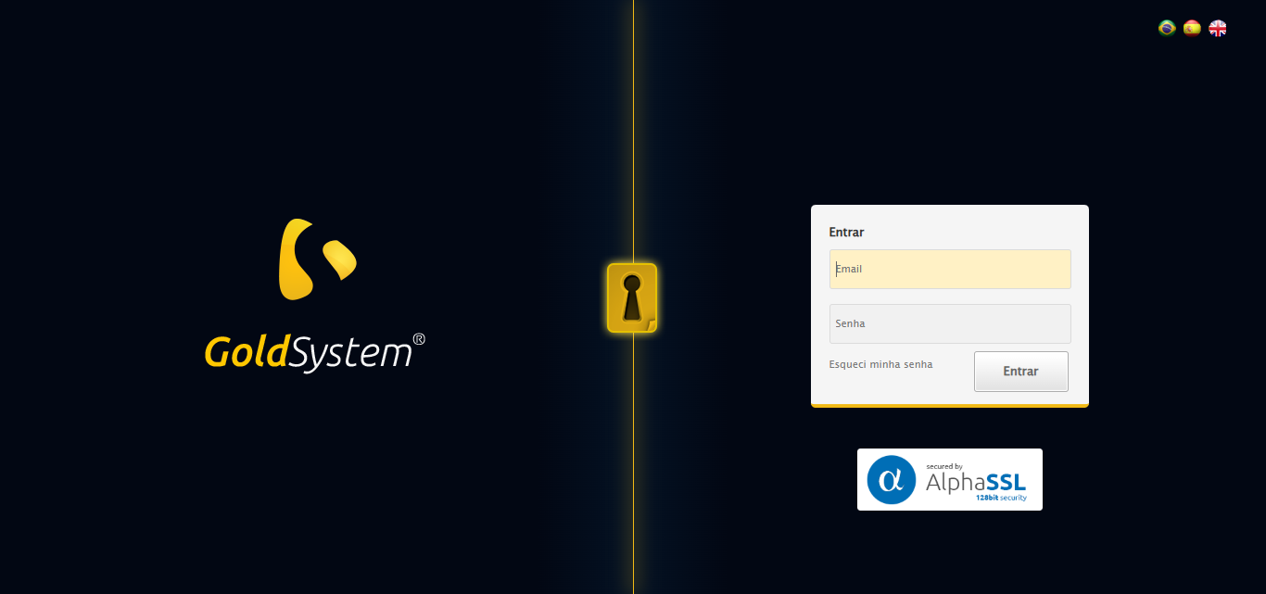

[15:45:11] [INFO] 🔄 Realizando login...

[15:45:17] [INFO] ✅ Realizando login realizada com sucesso.

[15:45:18] [INFO] Screenshot capturada: realizando_login

Screenshot: realizando_login

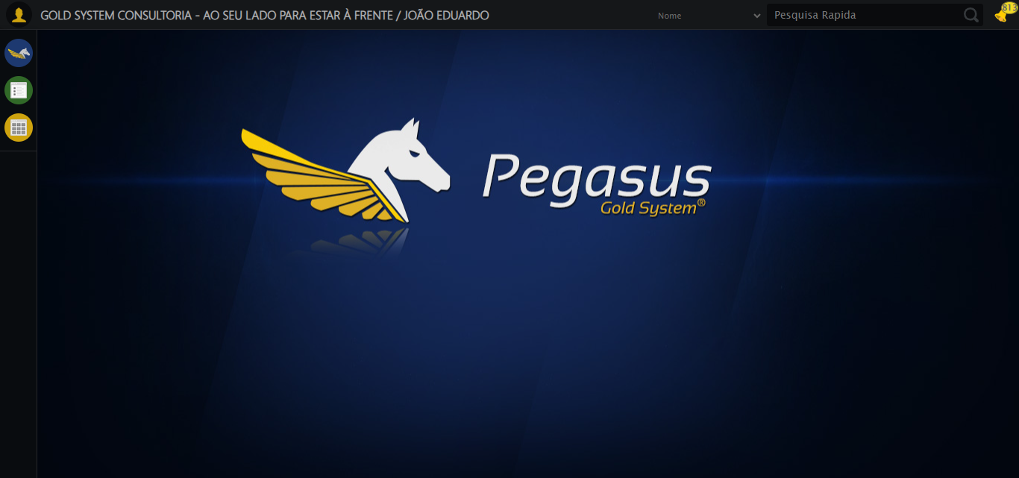

[15:45:18] [INFO] 🔄 Configurando interface...

[15:45:18] [INFO] 🔍 Zoom ajustado para 90%.

[15:45:20] [INFO] ✅ Configurando interface realizada com sucesso.

[15:45:21] [INFO] Screenshot capturada: configurando_interface

Screenshot: configurando_interface

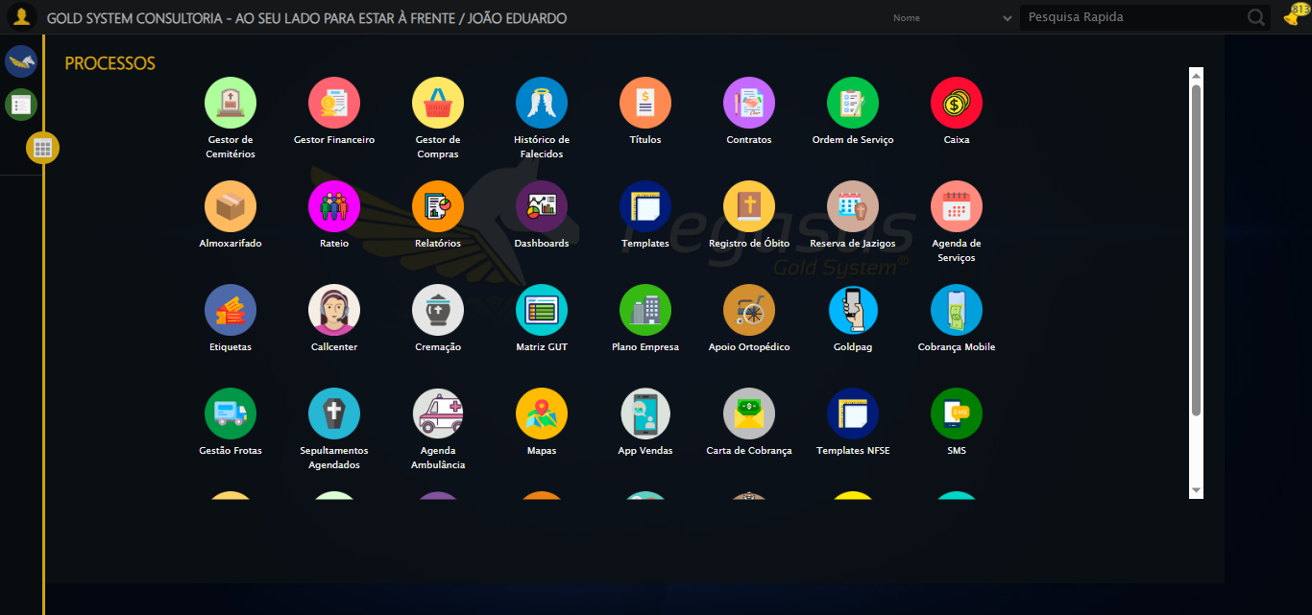

[15:45:21] [INFO] 🔄 Acessando Apoio Ortopédico...

[15:45:23] [INFO] ✅ Clique realizado com estratégia 1

[15:45:23] [INFO] ✅ Acessando Apoio Ortopédico realizada com sucesso.

[15:45:24] [INFO] Screenshot capturada: acessando_apoio_ortopédico

Screenshot: acessando_apoio_ortopédico

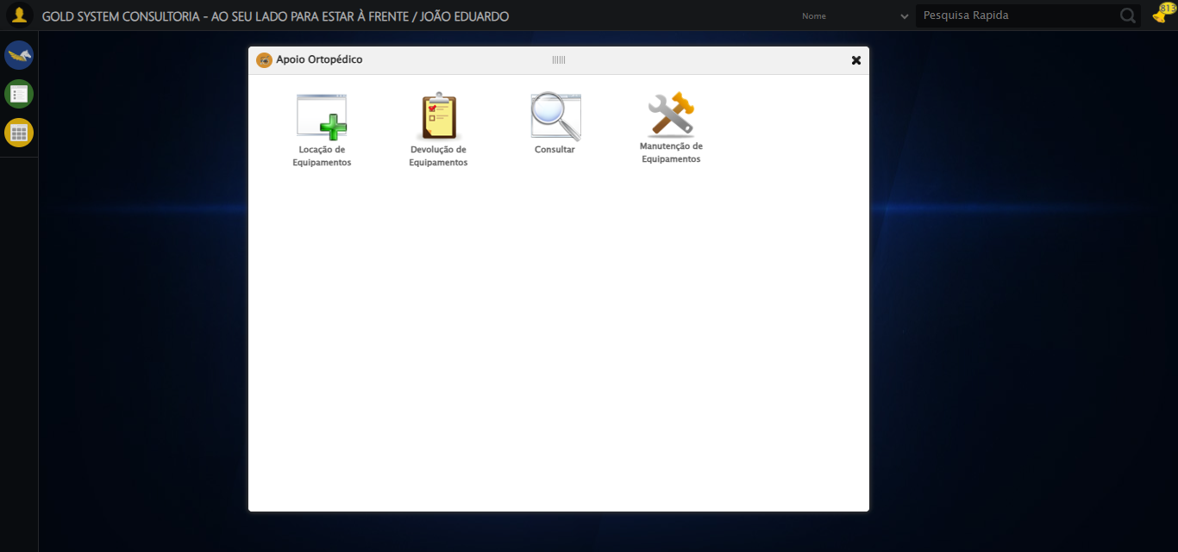

[15:45:24] [INFO] 🔄 Acessando Consulta Locação de Equipamentos...

[15:45:24] [INFO] ✅ Clique realizado com estratégia 1

[15:45:24] [INFO] ✅ Acessando Consulta Locação de Equipamentos realizada com sucesso.

[15:45:26] [INFO] Screenshot capturada: acessando_consulta_locação_de_equipamentos

Screenshot: acessando_consulta_locação_de_equipamentos

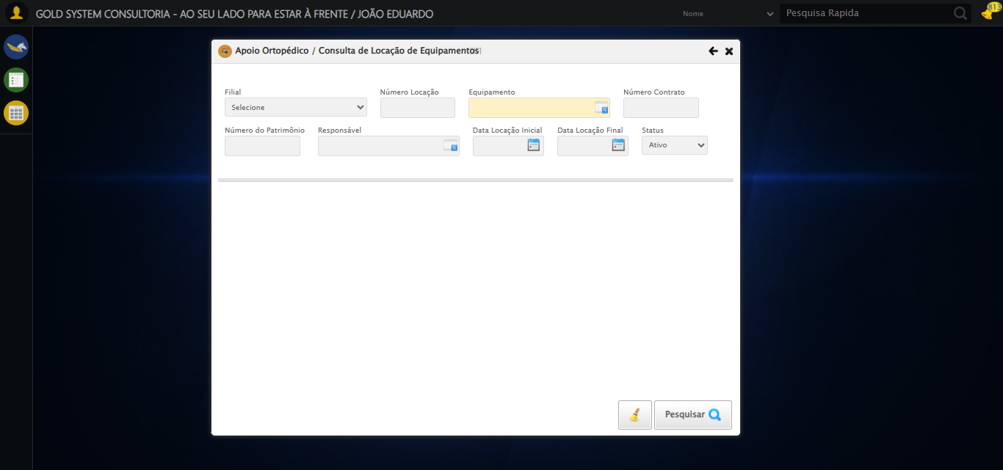

[15:45:29] [INFO] 🔄 Preenchendo Número da Locação...

[15:45:30] [INFO] ✅ Campo preenchido com estratégia 1: '311'

[15:45:30] [INFO] ✅ Preenchendo Número da Locação realizada com sucesso.

[15:45:31] [INFO] Screenshot capturada: preenchendo_número_da_locação

Screenshot: preenchendo_número_da_locação

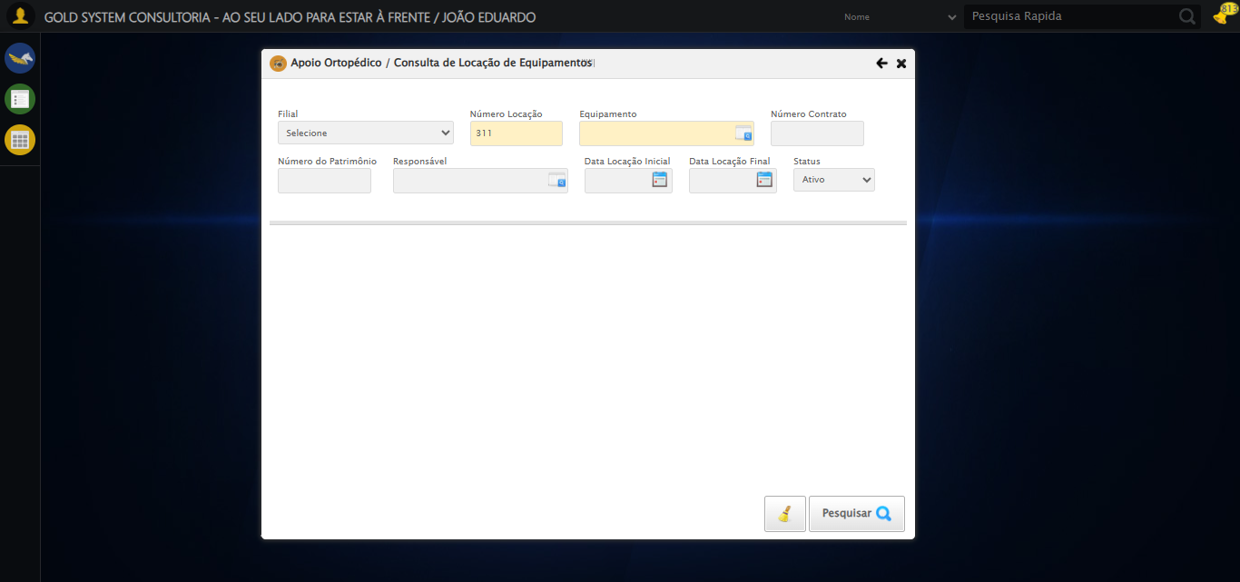

[15:45:31] [INFO] 🔄 Abrindo LOV de Equipamentos...

[15:45:32] [INFO] ✅ Clique realizado com estratégia 1

[15:45:32] [INFO] ✅ Abrindo LOV de Equipamentos realizada com sucesso.

[15:45:33] [INFO] Screenshot capturada: abrindo_lov_de_equipamentos

Screenshot: abrindo_lov_de_equipamentos

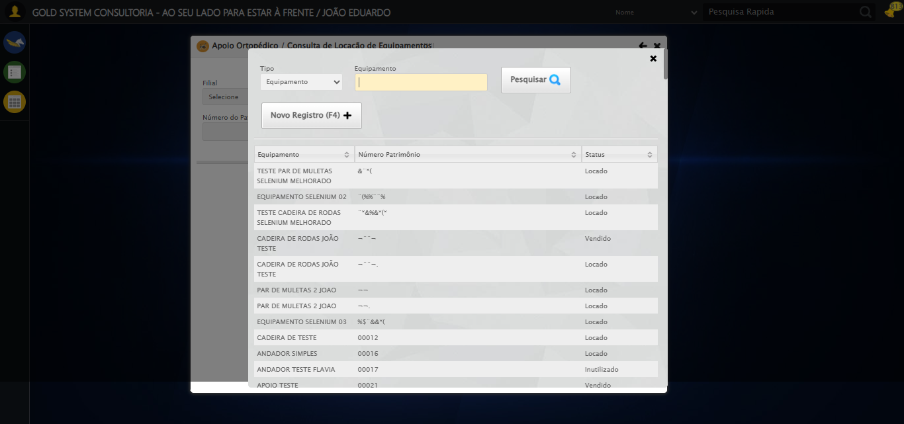

[15:45:35] [INFO] 🔄 Pesquisando equipamento...

[15:46:07] [ERROR] ❌ Timeout aguardando elemento: //tr[td[2][contains(normalize-space(.),'TESTE SELENIUM')]] (timeout: 30s)

[15:46:07] [ERROR] ❌ Erro no clique robusto: Message:   
Stacktrace:  
 GetHandleVerifier [0x0x88a8a3+63283]  
 GetHandleVerifier [0x0x88a8e4+63348]  
 (No symbol) [0x0x6c3e43]  
 (No symbol) [0x0x70c8de]  
 (No symbol) [0x0x70cc7b]  
 (No symbol) [0x0x754ef2]  
 (No symbol) [0x0x731464]  
 (No symbol) [0x0x75271a]  
 (No symbol) [0x0x731216]  
 (No symbol) [0x0x700855]  
 (No symbol) [0x0x7016f4]  
 GetHandleVerifier [0x0xafbb43+2623955]  
 GetHandleVerifier [0x0xaf6daa+2604090]  
 GetHandleVerifier [0x0x8b069a+218410]  
 GetHandleVerifier [0x0x8a0ed8+154984]  
 GetHandleVerifier [0x0x8a742d+180925]  
 GetHandleVerifier [0x0x8922b8+94536]  
 GetHandleVerifier [0x0x892442+94930]  
 GetHandleVerifier [0x0x87d5ea+9338]  
 BaseThreadInitThunk [0x0x76b1fcc9+25]  
 RtlGetAppContainerNamedObjectPath [0x0x776a82ae+286]  
 RtlGetAppContainerNamedObjectPath [0x0x776a827e+238]

[15:46:07] [INFO] ✅ Pesquisando equipamento realizada com sucesso.

[15:46:08] [INFO] Screenshot capturada: pesquisando_equipamento

Screenshot: pesquisando_equipamento

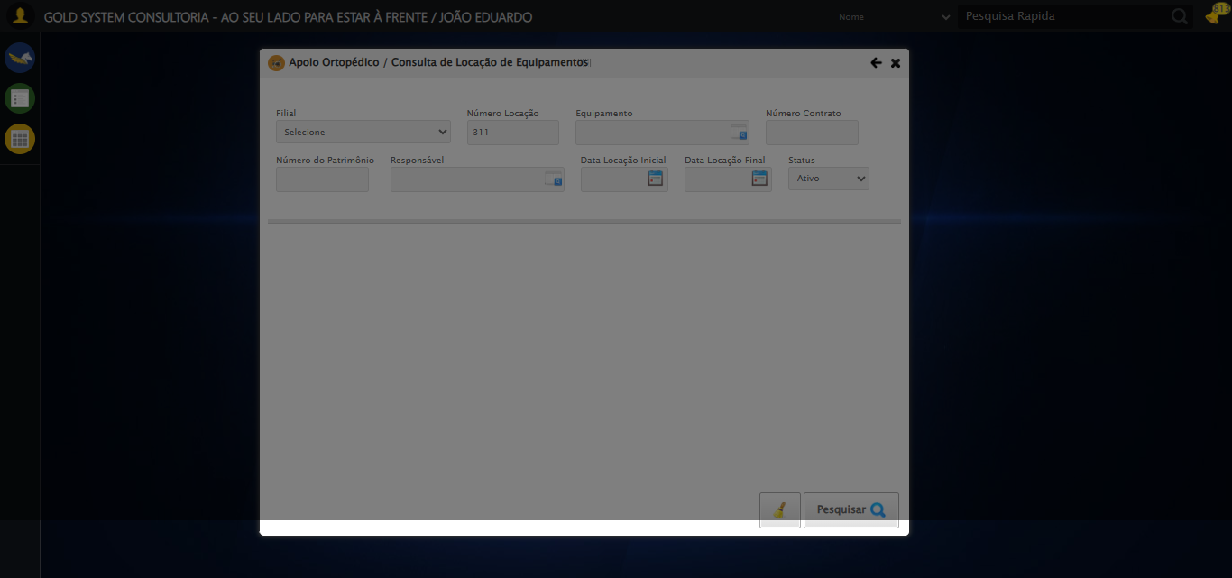

[15:46:18] [INFO] 🔄 Preenchendo Número do Contrato...

[15:46:20] [WARN] ⚠️ Estratégia 1 falhou: Message: element click intercepted: Element <input type="text" maxlength="" class="numeroContrato" style="width: 100px;"> is not clickable at point (900, 146). Other element would receive the click: <div class="blockScreen" style="height: 641px; z-index: 10001; opacity: 0.5;"></div>  
 (Session info: chrome=139.0.7258.128); For documentation on this error, please visit: https://www.selenium.dev/documentation/webdriver/troubleshooting/errors#elementclickinterceptedexception  
Stacktrace:  
 GetHandleVerifier [0x0x88a8a3+63283]  
 GetHandleVerifier [0x0x88a8e4+63348]  
 (No symbol) [0x0x6c3e43]  
 (No symbol) [0x0x712c20]  
 (No symbol) [0x0x710fda]  
 (No symbol) [0x0x70eb37]  
 (No symbol) [0x0x70ddf4]  
 (No symbol) [0x0x7025b5]  
 (No symbol) [0x0x73141c]  
 (No symbol) [0x0x702044]  
 (No symbol) [0x0x731694]  
 (No symbol) [0x0x75271a]  
 (No symbol) [0x0x731216]  
 (No symbol) [0x0x700855]  
 (No symbol) [0x0x7016f4]  
 GetHandleVerifier [0x0xafbb43+2623955]  
 GetHandleVerifier [0x0xaf6daa+2604090]  
 GetHandleVerifier [0x0x8b069a+218410]  
 GetHandleVerifier [0x0x8a0ed8+154984]  
 GetHandleVerifier [0x0x8a742d+180925]  
 GetHandleVerifier [0x0x8922b8+94536]  
 GetHandleVerifier [0x0x892442+94930]  
 GetHandleVerifier [0x0x87d5ea+9338]  
 BaseThreadInitThunk [0x0x76b1fcc9+25]  
 RtlGetAppContainerNamedObjectPath [0x0x776a82ae+286]  
 RtlGetAppContainerNamedObjectPath [0x0x776a827e+238]

[15:46:22] [INFO] ✅ Campo preenchido com estratégia 3: '113060'

[15:46:22] [INFO] ✅ Preenchendo Número do Contrato realizada com sucesso.

[15:46:24] [INFO] Screenshot capturada: preenchendo_número_do_contrato

Screenshot: preenchendo_número_do_contrato

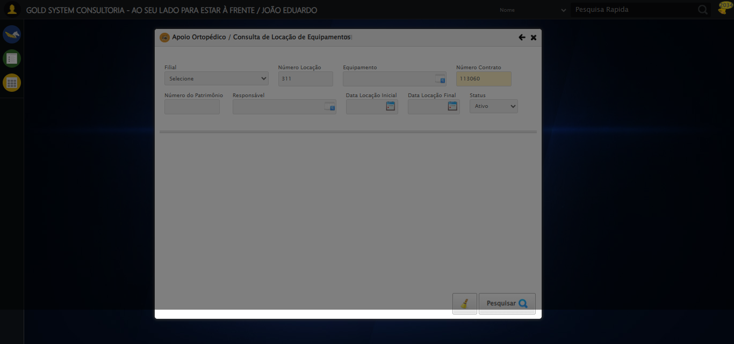

[15:46:24] [INFO] 🔄 Preenchendo Número do Patrimônio...

[15:46:25] [WARN] ⚠️ Estratégia 1 falhou: Message: element click intercepted: Element <input type="text" class="fc numeroPatrimonio" name="numeroPatrimonio" maxlength="20" style="width: 100px; text-align: left;"> is not clickable at point (357, 198). Other element would receive the click: <div class="blockScreen" style="height: 641px; z-index: 10001; opacity: 0.5;"></div>  
 (Session info: chrome=139.0.7258.128); For documentation on this error, please visit: https://www.selenium.dev/documentation/webdriver/troubleshooting/errors#elementclickinterceptedexception  
Stacktrace:  
 GetHandleVerifier [0x0x88a8a3+63283]  
 GetHandleVerifier [0x0x88a8e4+63348]  
 (No symbol) [0x0x6c3e43]  
 (No symbol) [0x0x712c20]  
 (No symbol) [0x0x710fda]  
 (No symbol) [0x0x70eb37]  
 (No symbol) [0x0x70ddf4]  
 (No symbol) [0x0x7025b5]  
 (No symbol) [0x0x73141c]  
 (No symbol) [0x0x702044]  
 (No symbol) [0x0x731694]  
 (No symbol) [0x0x75271a]  
 (No symbol) [0x0x731216]  
 (No symbol) [0x0x700855]  
 (No symbol) [0x0x7016f4]  
 GetHandleVerifier [0x0xafbb43+2623955]  
 GetHandleVerifier [0x0xaf6daa+2604090]  
 GetHandleVerifier [0x0x8b069a+218410]  
 GetHandleVerifier [0x0x8a0ed8+154984]  
 GetHandleVerifier [0x0x8a742d+180925]  
 GetHandleVerifier [0x0x8922b8+94536]  
 GetHandleVerifier [0x0x892442+94930]  
 GetHandleVerifier [0x0x87d5ea+9338]  
 BaseThreadInitThunk [0x0x76b1fcc9+25]  
 RtlGetAppContainerNamedObjectPath [0x0x776a82ae+286]  
 RtlGetAppContainerNamedObjectPath [0x0x776a827e+238]

[15:46:27] [INFO] ✅ Campo preenchido com estratégia 3: '1000'

[15:46:27] [INFO] ✅ Preenchendo Número do Patrimônio realizada com sucesso.

[15:46:28] [INFO] Screenshot capturada: preenchendo_número_do_patrimônio

Screenshot: preenchendo_número_do_patrimônio

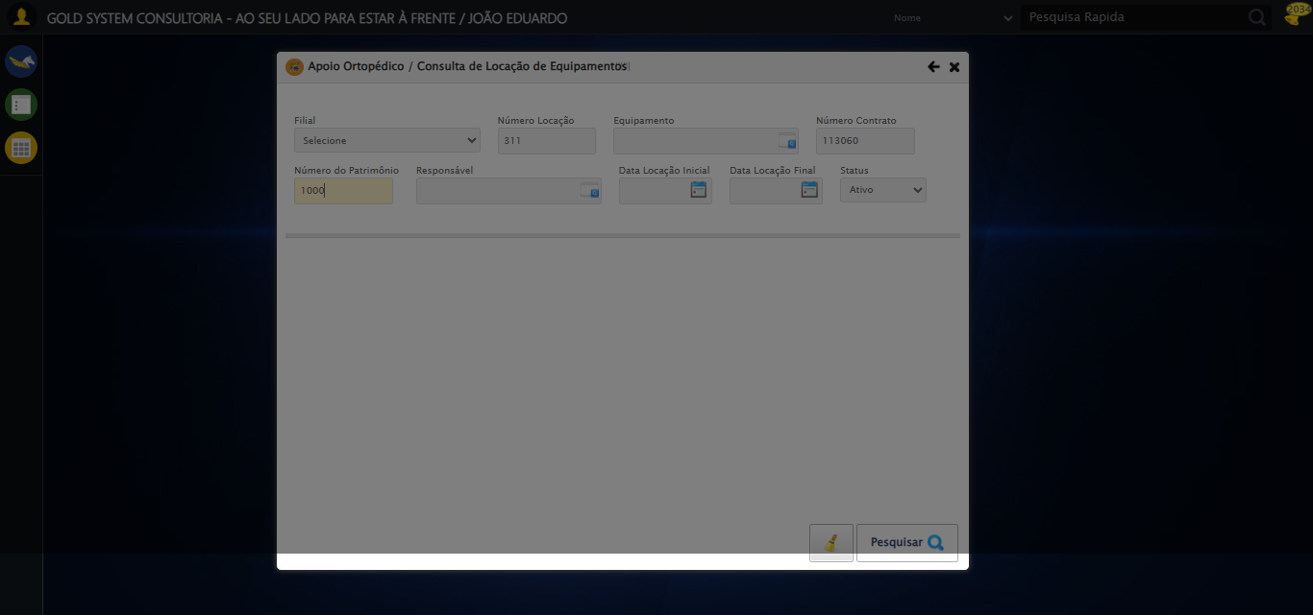

[15:46:28] [INFO] 🔄 Abrindo LOV do Responsável...

[15:46:30] [WARN] ⚠️ Estratégia 1 falhou: Message: element click intercepted: Element <a class="sprites sp-openLov"></a> is not clickable at point (612, 197). Other element would receive the click: <div class="blockScreen" style="height: 641px; z-index: 10001; opacity: 0.5;"></div>  
 (Session info: chrome=139.0.7258.128); For documentation on this error, please visit: https://www.selenium.dev/documentation/webdriver/troubleshooting/errors#elementclickinterceptedexception  
Stacktrace:  
 GetHandleVerifier [0x0x88a8a3+63283]  
 GetHandleVerifier [0x0x88a8e4+63348]  
 (No symbol) [0x0x6c3e43]  
 (No symbol) [0x0x712c20]  
 (No symbol) [0x0x710fda]  
 (No symbol) [0x0x70eb37]  
 (No symbol) [0x0x70ddf4]  
 (No symbol) [0x0x7025b5]  
 (No symbol) [0x0x73141c]  
 (No symbol) [0x0x702044]  
 (No symbol) [0x0x731694]  
 (No symbol) [0x0x75271a]  
 (No symbol) [0x0x731216]  
 (No symbol) [0x0x700855]  
 (No symbol) [0x0x7016f4]  
 GetHandleVerifier [0x0xafbb43+2623955]  
 GetHandleVerifier [0x0xaf6daa+2604090]  
 GetHandleVerifier [0x0x8b069a+218410]  
 GetHandleVerifier [0x0x8a0ed8+154984]  
 GetHandleVerifier [0x0x8a742d+180925]  
 GetHandleVerifier [0x0x8922b8+94536]  
 GetHandleVerifier [0x0x892442+94930]  
 GetHandleVerifier [0x0x87d5ea+9338]  
 BaseThreadInitThunk [0x0x76b1fcc9+25]  
 RtlGetAppContainerNamedObjectPath [0x0x776a82ae+286]  
 RtlGetAppContainerNamedObjectPath [0x0x776a827e+238]

[15:46:30] [INFO] ✅ Clique realizado com estratégia 2

[15:46:30] [INFO] ✅ Abrindo LOV do Responsável realizada com sucesso.

[15:46:31] [INFO] Screenshot capturada: abrindo_lov_do_responsável

Screenshot: abrindo_lov_do_responsável

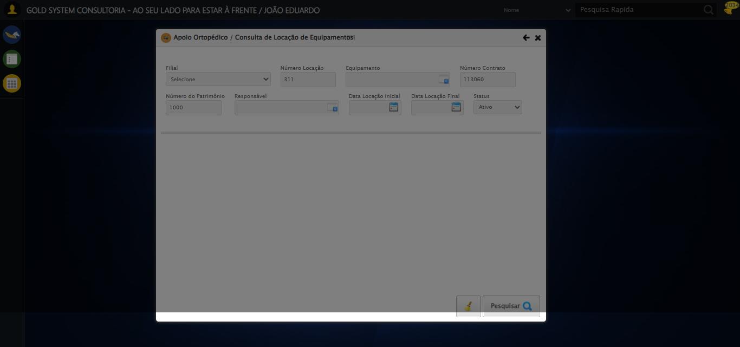

[15:46:33] [INFO] 🔄 Pesquisando responsável...

[15:47:03] [ERROR] ❌ Timeout aguardando elemento: //*[@id='txtPesquisa'] (timeout: 30s)

[15:47:03] [ERROR] ❌ Erro no preenchimento: Message:   
Stacktrace:  
 GetHandleVerifier [0x0x88a8a3+63283]  
 GetHandleVerifier [0x0x88a8e4+63348]  
 (No symbol) [0x0x6c3e43]  
 (No symbol) [0x0x70c8de]  
 (No symbol) [0x0x70cc7b]  
 (No symbol) [0x0x754ef2]  
 (No symbol) [0x0x731464]  
 (No symbol) [0x0x75271a]  
 (No symbol) [0x0x731216]  
 (No symbol) [0x0x700855]  
 (No symbol) [0x0x7016f4]  
 GetHandleVerifier [0x0xafbb43+2623955]  
 GetHandleVerifier [0x0xaf6daa+2604090]  
 GetHandleVerifier [0x0x8b069a+218410]  
 GetHandleVerifier [0x0x8a0ed8+154984]  
 GetHandleVerifier [0x0x8a742d+180925]  
 GetHandleVerifier [0x0x8922b8+94536]  
 GetHandleVerifier [0x0x892442+94930]  
 GetHandleVerifier [0x0x87d5ea+9338]  
 BaseThreadInitThunk [0x0x76b1fcc9+25]  
 RtlGetAppContainerNamedObjectPath [0x0x776a82ae+286]  
 RtlGetAppContainerNamedObjectPath [0x0x776a827e+238]

[15:47:36] [ERROR] ❌ Timeout aguardando elemento: //tr[td[2][contains(normalize-space(.),'TESTE TITULAR 233')]] (timeout: 30s)

[15:47:36] [ERROR] ❌ Erro no clique robusto: Message:   
Stacktrace:  
 GetHandleVerifier [0x0x88a8a3+63283]  
 GetHandleVerifier [0x0x88a8e4+63348]  
 (No symbol) [0x0x6c3e43]  
 (No symbol) [0x0x70c8de]  
 (No symbol) [0x0x70cc7b]  
 (No symbol) [0x0x754ef2]  
 (No symbol) [0x0x731464]  
 (No symbol) [0x0x75271a]  
 (No symbol) [0x0x731216]  
 (No symbol) [0x0x700855]  
 (No symbol) [0x0x7016f4]  
 GetHandleVerifier [0x0xafbb43+2623955]  
 GetHandleVerifier [0x0xaf6daa+2604090]  
 GetHandleVerifier [0x0x8b069a+218410]  
 GetHandleVerifier [0x0x8a0ed8+154984]  
 GetHandleVerifier [0x0x8a742d+180925]  
 GetHandleVerifier [0x0x8922b8+94536]  
 GetHandleVerifier [0x0x892442+94930]  
 GetHandleVerifier [0x0x87d5ea+9338]  
 BaseThreadInitThunk [0x0x76b1fcc9+25]  
 RtlGetAppContainerNamedObjectPath [0x0x776a82ae+286]  
 RtlGetAppContainerNamedObjectPath [0x0x776a827e+238]

[15:47:36] [INFO] ✅ Pesquisando responsável realizada com sucesso.

[15:47:37] [INFO] Screenshot capturada: pesquisando_responsável

Screenshot: pesquisando_responsável

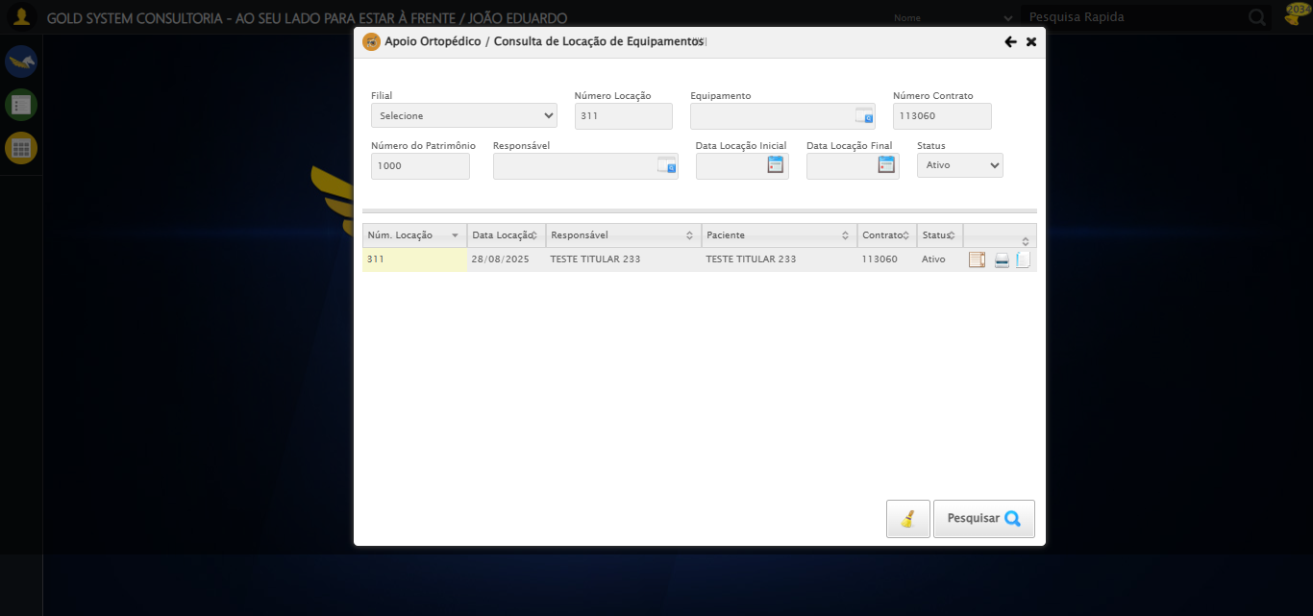

[15:47:47] [INFO] 🔄 Preenchendo Data Locação Inicial...

[15:47:47] [INFO] 🎯 Tentativa 1: Preenchendo datepicker 0 com '28/08/2025'

[15:47:47] [INFO] 📊 Encontrados 2 campos datepicker

[15:47:47] [INFO] Aplicando estratégia 1 para datepicker...

[15:47:48] [INFO] ✅ Datepicker preenchido com estratégia 1: '28/08/2025'

[15:47:48] [INFO] ✅ Preenchendo Data Locação Inicial realizada com sucesso.

[15:47:49] [INFO] Screenshot capturada: preenchendo_data_locação_inicial

Screenshot: preenchendo_data_locação_inicial

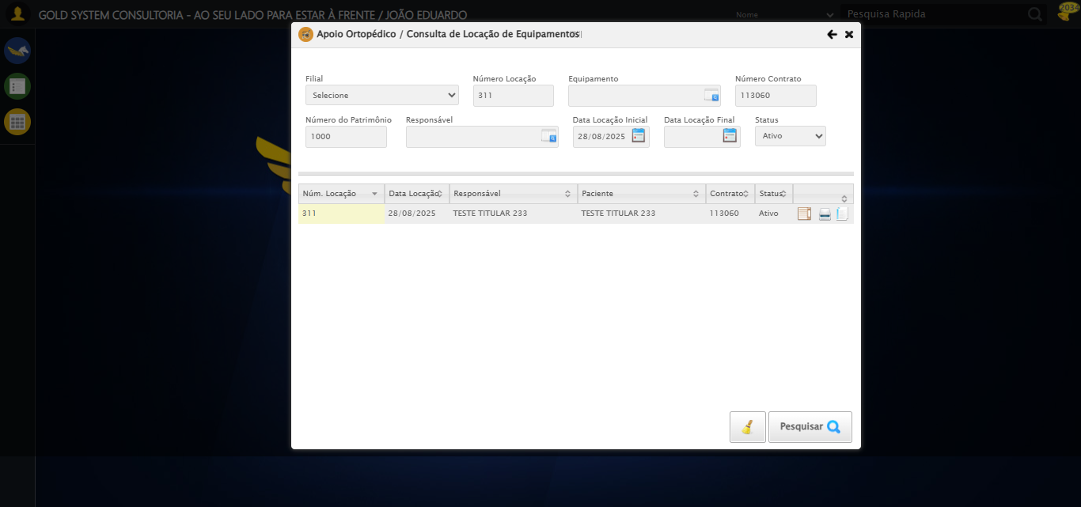

[15:47:49] [INFO] 🔄 Preenchendo Data Locação Final...

[15:47:49] [INFO] 🎯 Tentativa 1: Preenchendo datepicker 1 com '28/08/2025'

[15:47:50] [INFO] 📊 Encontrados 2 campos datepicker

[15:47:50] [INFO] Aplicando estratégia 1 para datepicker...

[15:47:51] [INFO] ✅ Datepicker preenchido com estratégia 1: '28/08/2025'

[15:47:51] [INFO] ✅ Preenchendo Data Locação Final realizada com sucesso.

[15:47:52] [INFO] Screenshot capturada: preenchendo_data_locação_final

Screenshot: preenchendo_data_locação_final

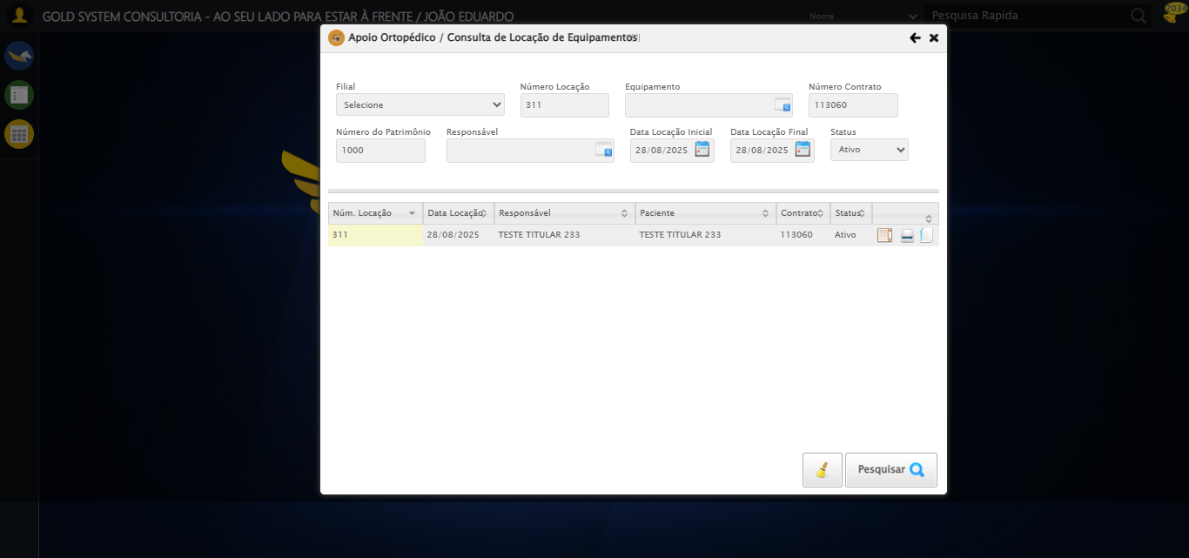

[15:47:52] [INFO] 🔄 Realizando consulta...

[15:47:53] [INFO] ✅ Clique realizado com estratégia 1

[15:48:03] [INFO] ✅ Realizando consulta realizada com sucesso.

[15:48:04] [INFO] Screenshot capturada: realizando_consulta

Screenshot: realizando_consulta

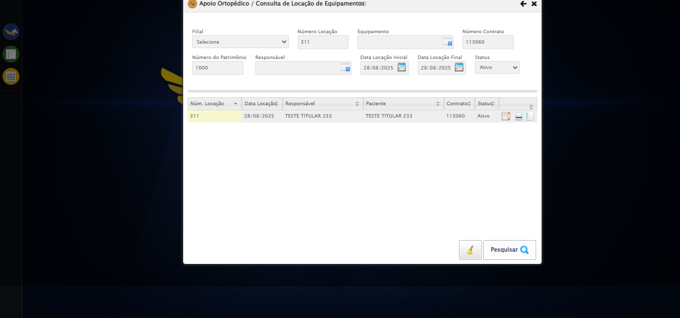

[15:48:04] [INFO] 🔄 Validando resultados da consulta...

[15:48:04] [INFO] 🔍 Validando registros encontrados...

[15:48:12] [INFO] ✅ 1 registro(s) encontrado(s)

[15:48:12] [INFO] Registro 1: 311 28/08/2025 TESTE TITULAR 233 TESTE TITULAR 233 113060 Ativo...

[15:48:12] [INFO] ✅ Validando resultados da consulta realizada com sucesso.

[15:48:14] [INFO] Screenshot capturada: validando_resultados_da_consulta

Screenshot: validando_resultados_da_consulta



[15:48:14] [INFO] Processando 1 registro(s) encontrado(s)

[15:48:14] [INFO] 🔄 Visualizando Detalhes da Locação...

[15:48:14] [INFO] ✅ Clique realizado com estratégia 1

[15:48:14] [INFO] ✅ Visualizando Detalhes da Locação realizada com sucesso.

[15:48:16] [INFO] Screenshot capturada: visualizando_detalhes_da_locação

Screenshot: visualizando_detalhes_da_locação

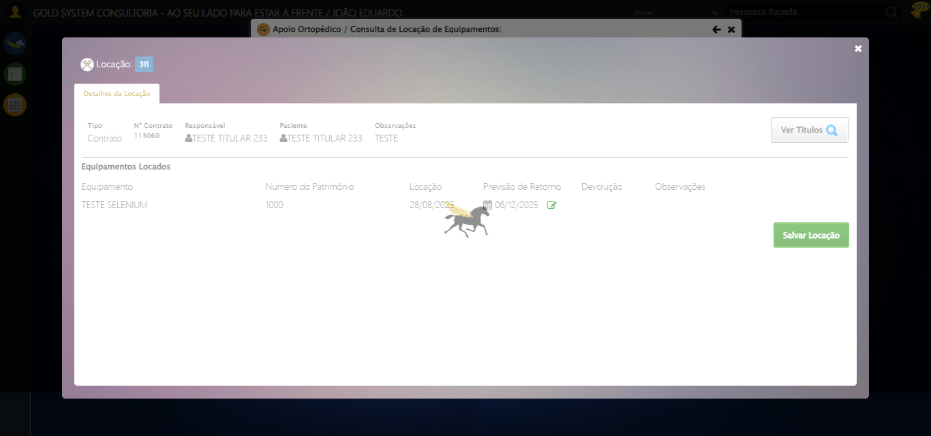

[15:48:18] [INFO] 🔄 Visualizando Títulos...

[15:48:23] [ERROR] ❌ Timeout aguardando elemento: //button[contains(normalize-space(.),'Ver Títulos')] (timeout: 5s)

[15:48:23] [WARN] ⚠️ Estratégia 1 falhou: Message:

[15:48:23] [WARN] ⚠️ Estratégia 2 falhou: Message: element not interactable: [object HTMLButtonElement] has no size and location  
 (Session info: chrome=139.0.7258.128); For documentation on this error, please visit: https://www.selenium.dev/documentation/webdriver/troubleshooting/errors#elementnotinteractableexception  
Stacktrace:  
 GetHandleVerifier [0x0x88a8a3+63283]  
 GetHandleVerifier [0x0x88a8e4+63348]  
 (No symbol) [0x0x6c3e43]  
 (No symbol) [0x0x6ca609]  
 (No symbol) [0x0x6cc97a]  
 (No symbol) [0x0x6cc9f7]  
 (No symbol) [0x0x712334]  
 (No symbol) [0x0x7118a7]  
 (No symbol) [0x0x75b0b8]  
 (No symbol) [0x0x73141c]  
 (No symbol) [0x0x75271a]  
 (No symbol) [0x0x731216]  
 (No symbol) [0x0x700855]  
 (No symbol) [0x0x7016f4]  
 GetHandleVerifier [0x0xafbb43+2623955]  
 GetHandleVerifier [0x0xaf6daa+2604090]  
 GetHandleVerifier [0x0x8b069a+218410]  
 GetHandleVerifier [0x0x8a0ed8+154984]  
 GetHandleVerifier [0x0x8a742d+180925]  
 GetHandleVerifier [0x0x8922b8+94536]  
 GetHandleVerifier [0x0x892442+94930]  
 GetHandleVerifier [0x0x87d5ea+9338]  
 BaseThreadInitThunk [0x0x76b1fcc9+25]  
 RtlGetAppContainerNamedObjectPath [0x0x776a82ae+286]  
 RtlGetAppContainerNamedObjectPath [0x0x776a827e+238]

[15:48:23] [INFO] ✅ Clique realizado com estratégia 3

[15:48:43] [INFO] ✅ Visualizando Títulos realizada com sucesso.

[15:48:45] [INFO] Screenshot capturada: visualizando_títulos

Screenshot: visualizando_títulos

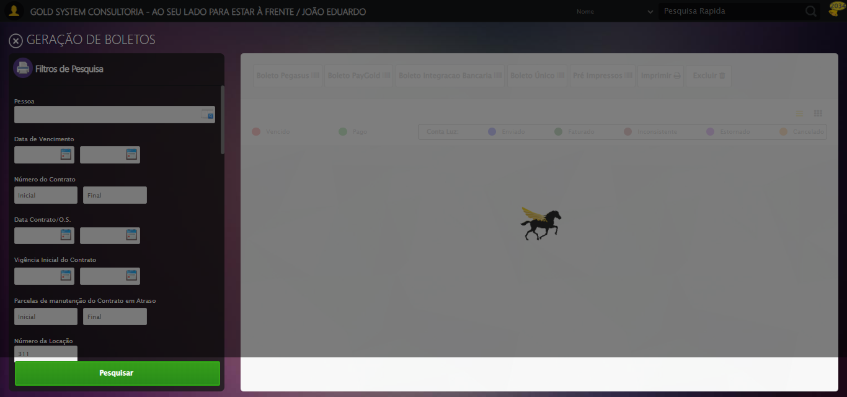

[15:48:45] [INFO] 🔄 Capturando screenshot dos títulos...

[15:48:45] [INFO] Screenshot capturada: tela_titulos

Screenshot: tela_titulos

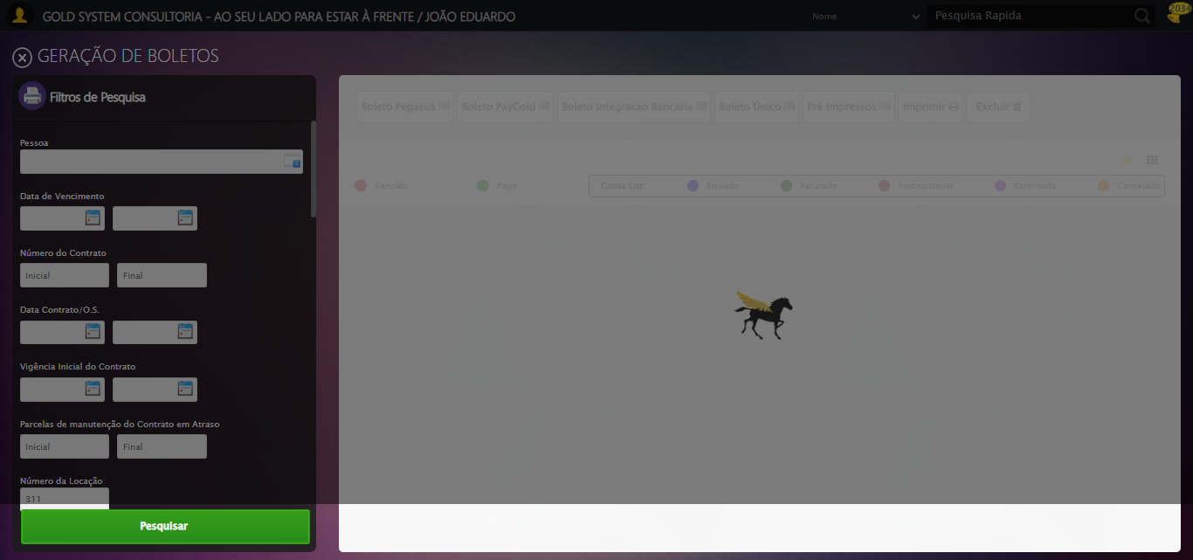

[15:48:45] [INFO] ✅ Capturando screenshot dos títulos realizada com sucesso.

[15:48:46] [INFO] Screenshot capturada: capturando_screenshot_dos_títulos

Screenshot: capturando_screenshot_dos_títulos

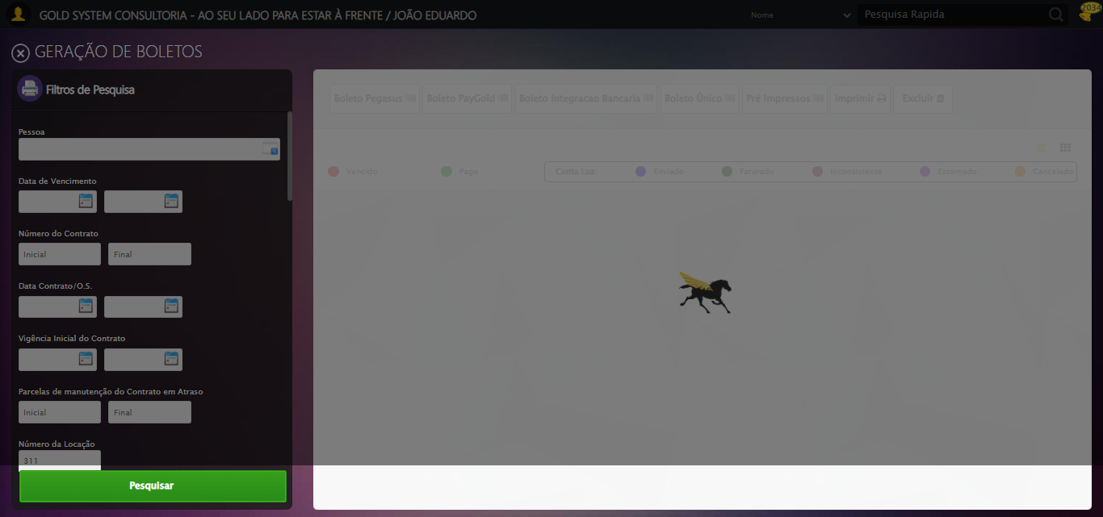

[15:48:46] [INFO] 🔄 Fechando aba de títulos...

[15:48:48] [WARN] ⚠️ Estratégia 1 falhou: Message: element click intercepted: Element <a class="sprites sp-fecharGrande" title="Sair"></a> is not clickable at point (25, 65). Other element would receive the click: <div class="blockScreen" style="height: 641px; z-index: 10001; opacity: 0.5;"></div>  
 (Session info: chrome=139.0.7258.128); For documentation on this error, please visit: https://www.selenium.dev/documentation/webdriver/troubleshooting/errors#elementclickinterceptedexception  
Stacktrace:  
 GetHandleVerifier [0x0x88a8a3+63283]  
 GetHandleVerifier [0x0x88a8e4+63348]  
 (No symbol) [0x0x6c3e43]  
 (No symbol) [0x0x712c20]  
 (No symbol) [0x0x710fda]  
 (No symbol) [0x0x70eb37]  
 (No symbol) [0x0x70ddf4]  
 (No symbol) [0x0x7025b5]  
 (No symbol) [0x0x73141c]  
 (No symbol) [0x0x702044]  
 (No symbol) [0x0x731694]  
 (No symbol) [0x0x75271a]  
 (No symbol) [0x0x731216]  
 (No symbol) [0x0x700855]  
 (No symbol) [0x0x7016f4]  
 GetHandleVerifier [0x0xafbb43+2623955]  
 GetHandleVerifier [0x0xaf6daa+2604090]  
 GetHandleVerifier [0x0x8b069a+218410]  
 GetHandleVerifier [0x0x8a0ed8+154984]  
 GetHandleVerifier [0x0x8a742d+180925]  
 GetHandleVerifier [0x0x8922b8+94536]  
 GetHandleVerifier [0x0x892442+94930]  
 GetHandleVerifier [0x0x87d5ea+9338]  
 BaseThreadInitThunk [0x0x76b1fcc9+25]  
 RtlGetAppContainerNamedObjectPath [0x0x776a82ae+286]  
 RtlGetAppContainerNamedObjectPath [0x0x776a827e+238]

[15:48:48] [INFO] ✅ Clique realizado com estratégia 2

[15:48:48] [INFO] ✅ Fechando aba de títulos realizada com sucesso.

[15:48:49] [INFO] Screenshot capturada: fechando_aba_de_títulos

Screenshot: fechando_aba_de_títulos

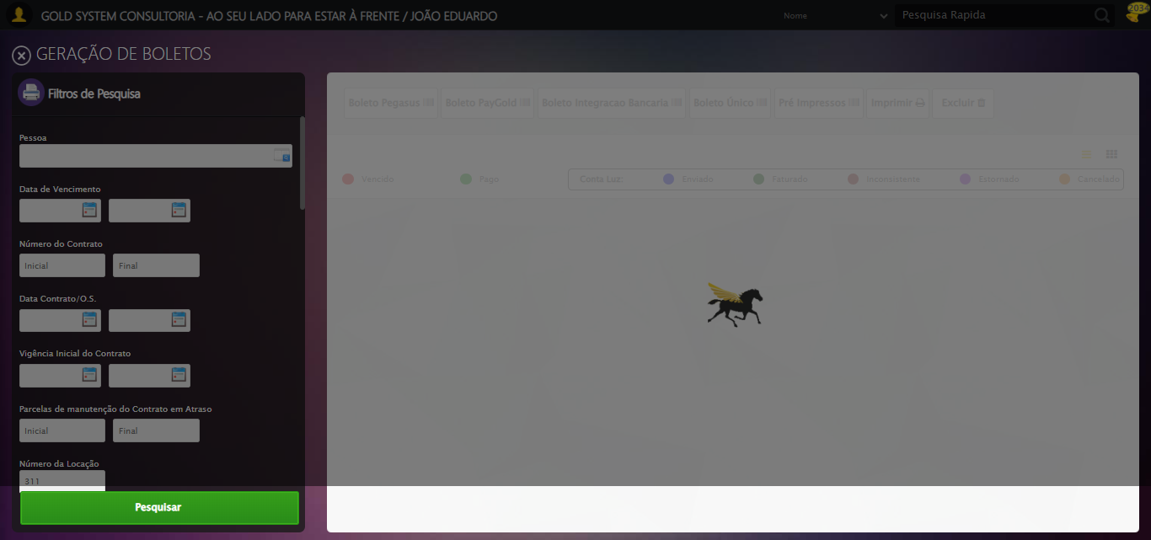

[15:48:49] [INFO] 🔄 Reabrindo detalhes da locação...

[15:48:55] [ERROR] ❌ Timeout aguardando elemento: //span[@title='Detalhes da Locação'] (timeout: 5s)

[15:48:55] [WARN] ⚠️ Estratégia 1 falhou: Message:

[15:48:55] [WARN] ⚠️ Estratégia 2 falhou: Message: element not interactable: [object HTMLSpanElement] has no size and location  
 (Session info: chrome=139.0.7258.128); For documentation on this error, please visit: https://www.selenium.dev/documentation/webdriver/troubleshooting/errors#elementnotinteractableexception  
Stacktrace:  
 GetHandleVerifier [0x0x88a8a3+63283]  
 GetHandleVerifier [0x0x88a8e4+63348]  
 (No symbol) [0x0x6c3e43]  
 (No symbol) [0x0x6ca609]  
 (No symbol) [0x0x6cc97a]  
 (No symbol) [0x0x6cc9f7]  
 (No symbol) [0x0x712334]  
 (No symbol) [0x0x7118a7]  
 (No symbol) [0x0x75b0b8]  
 (No symbol) [0x0x73141c]  
 (No symbol) [0x0x75271a]  
 (No symbol) [0x0x731216]  
 (No symbol) [0x0x700855]  
 (No symbol) [0x0x7016f4]  
 GetHandleVerifier [0x0xafbb43+2623955]  
 GetHandleVerifier [0x0xaf6daa+2604090]  
 GetHandleVerifier [0x0x8b069a+218410]  
 GetHandleVerifier [0x0x8a0ed8+154984]  
 GetHandleVerifier [0x0x8a742d+180925]  
 GetHandleVerifier [0x0x8922b8+94536]  
 GetHandleVerifier [0x0x892442+94930]  
 GetHandleVerifier [0x0x87d5ea+9338]  
 BaseThreadInitThunk [0x0x76b1fcc9+25]  
 RtlGetAppContainerNamedObjectPath [0x0x776a82ae+286]  
 RtlGetAppContainerNamedObjectPath [0x0x776a827e+238]

[15:48:55] [INFO] ✅ Clique realizado com estratégia 3

[15:48:58] [INFO] ✅ Reabrindo detalhes da locação realizada com sucesso.

[15:48:59] [INFO] Screenshot capturada: reabrindo_detalhes_da_locação

Screenshot: reabrindo_detalhes_da_locação

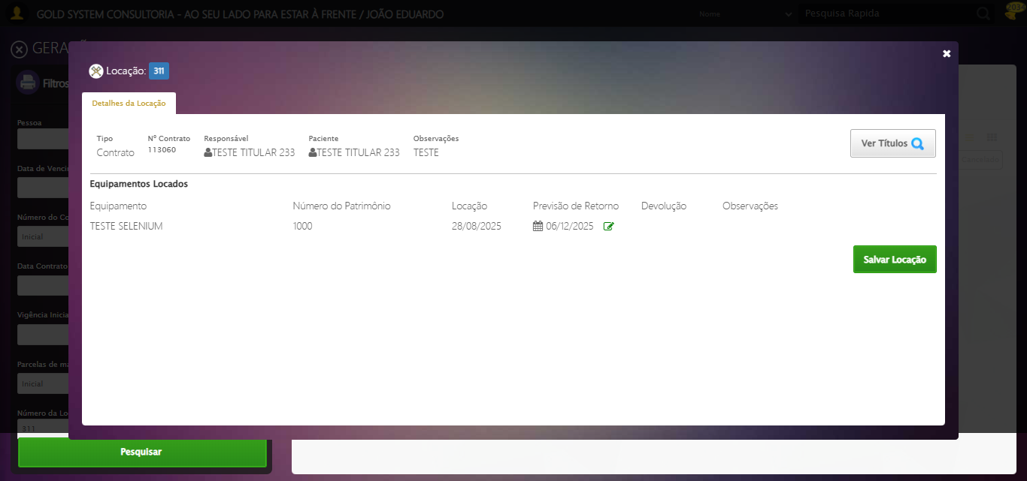

[15:48:59] [INFO] Verificando mensagens de alerta...

[15:48:59] [INFO] ℹ️ Nenhuma mensagem de alerta encontrada.

[15:48:59] [INFO] 🔄 Abrindo digitalização de documentos...

[15:49:04] [ERROR] ❌ Timeout aguardando elemento: //span[@title='Digitalizar documentos' and contains(@class, 'sp-scanner')] (timeout: 5s)

[15:49:04] [WARN] ⚠️ Estratégia 1 falhou: Message:

[15:49:04] [WARN] ⚠️ Estratégia 2 falhou: Message: element not interactable: [object HTMLSpanElement] has no size and location  
 (Session info: chrome=139.0.7258.128); For documentation on this error, please visit: https://www.selenium.dev/documentation/webdriver/troubleshooting/errors#elementnotinteractableexception  
Stacktrace:  
 GetHandleVerifier [0x0x88a8a3+63283]  
 GetHandleVerifier [0x0x88a8e4+63348]  
 (No symbol) [0x0x6c3e43]  
 (No symbol) [0x0x6ca609]  
 (No symbol) [0x0x6cc97a]  
 (No symbol) [0x0x6cc9f7]  
 (No symbol) [0x0x712334]  
 (No symbol) [0x0x7118a7]  
 (No symbol) [0x0x75b0b8]  
 (No symbol) [0x0x73141c]  
 (No symbol) [0x0x75271a]  
 (No symbol) [0x0x731216]  
 (No symbol) [0x0x700855]  
 (No symbol) [0x0x7016f4]  
 GetHandleVerifier [0x0xafbb43+2623955]  
 GetHandleVerifier [0x0xaf6daa+2604090]  
 GetHandleVerifier [0x0x8b069a+218410]  
 GetHandleVerifier [0x0x8a0ed8+154984]  
 GetHandleVerifier [0x0x8a742d+180925]  
 GetHandleVerifier [0x0x8922b8+94536]  
 GetHandleVerifier [0x0x892442+94930]  
 GetHandleVerifier [0x0x87d5ea+9338]  
 BaseThreadInitThunk [0x0x76b1fcc9+25]  
 RtlGetAppContainerNamedObjectPath [0x0x776a82ae+286]  
 RtlGetAppContainerNamedObjectPath [0x0x776a827e+238]

[15:49:05] [INFO] ✅ Clique realizado com estratégia 3

[15:49:05] [INFO] ✅ Abrindo digitalização de documentos realizada com sucesso.

[15:49:06] [INFO] Screenshot capturada: abrindo_digitalização_de_documentos

Screenshot: abrindo_digitalização_de_documentos

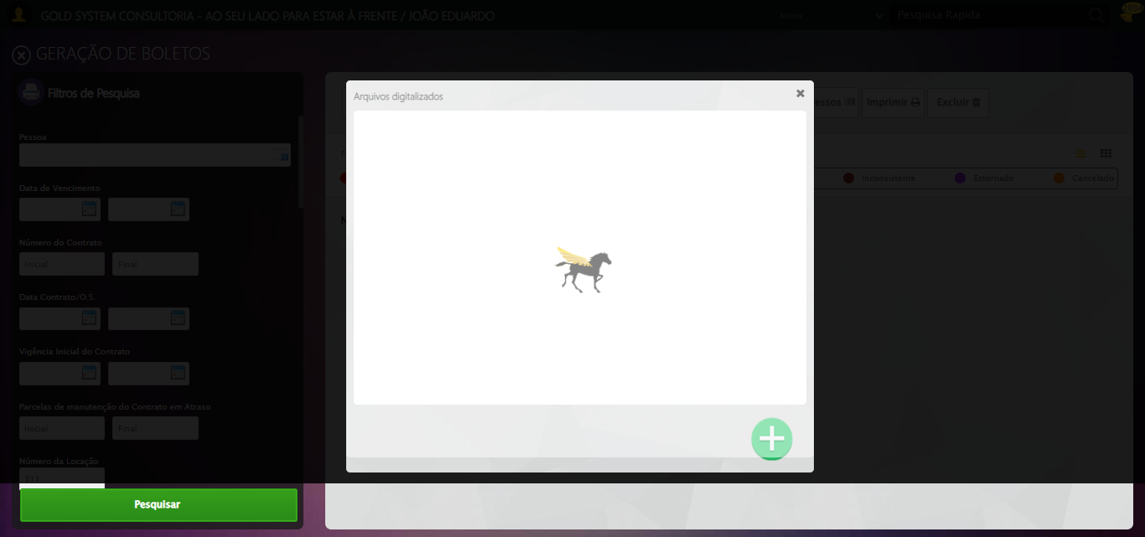

[15:49:06] [INFO] 🔄 Adicionando novo documento...

[15:49:11] [ERROR] ❌ Timeout aguardando elemento: //span[contains(@class, 'sp-addFile')] (timeout: 5s)

[15:49:11] [WARN] ⚠️ Estratégia 1 falhou: Message:

[15:49:11] [WARN] ⚠️ Estratégia 2 falhou: Message: element not interactable: [object HTMLSpanElement] has no size and location  
 (Session info: chrome=139.0.7258.128); For documentation on this error, please visit: https://www.selenium.dev/documentation/webdriver/troubleshooting/errors#elementnotinteractableexception  
Stacktrace:  
 GetHandleVerifier [0x0x88a8a3+63283]  
 GetHandleVerifier [0x0x88a8e4+63348]  
 (No symbol) [0x0x6c3e43]  
 (No symbol) [0x0x6ca609]  
 (No symbol) [0x0x6cc97a]  
 (No symbol) [0x0x6cc9f7]  
 (No symbol) [0x0x712334]  
 (No symbol) [0x0x7118a7]  
 (No symbol) [0x0x75b0b8]  
 (No symbol) [0x0x73141c]  
 (No symbol) [0x0x75271a]  
 (No symbol) [0x0x731216]  
 (No symbol) [0x0x700855]  
 (No symbol) [0x0x7016f4]  
 GetHandleVerifier [0x0xafbb43+2623955]  
 GetHandleVerifier [0x0xaf6daa+2604090]  
 GetHandleVerifier [0x0x8b069a+218410]  
 GetHandleVerifier [0x0x8a0ed8+154984]  
 GetHandleVerifier [0x0x8a742d+180925]  
 GetHandleVerifier [0x0x8922b8+94536]  
 GetHandleVerifier [0x0x892442+94930]  
 GetHandleVerifier [0x0x87d5ea+9338]  
 BaseThreadInitThunk [0x0x76b1fcc9+25]  
 RtlGetAppContainerNamedObjectPath [0x0x776a82ae+286]  
 RtlGetAppContainerNamedObjectPath [0x0x776a827e+238]

[15:49:11] [INFO] ✅ Clique realizado com estratégia 3

[15:49:11] [INFO] ✅ Adicionando novo documento realizada com sucesso.

[15:49:12] [INFO] Screenshot capturada: adicionando_novo_documento

Screenshot: adicionando_novo_documento

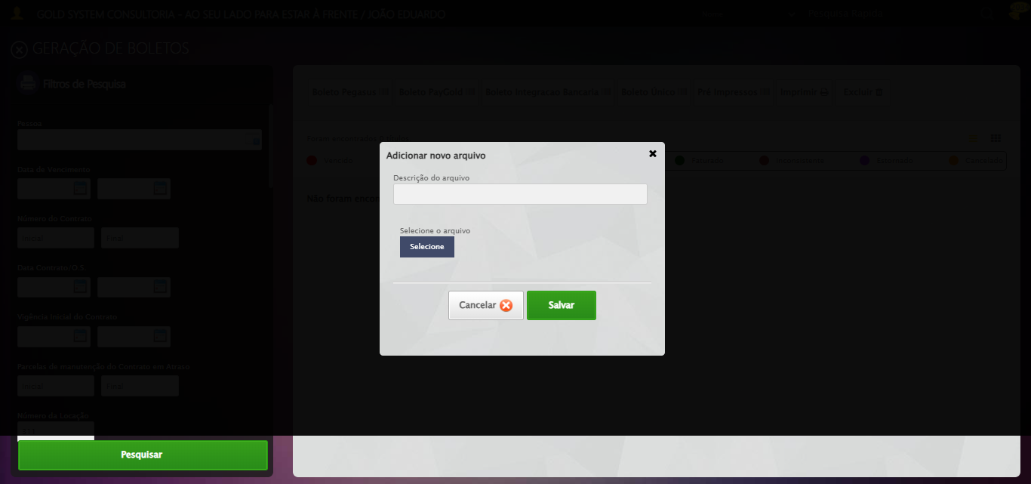

[15:49:12] [INFO] 🔄 Fazendo upload do arquivo...

[15:49:12] [INFO] 📄 Realizando upload do arquivo.

[15:49:12] [INFO] ✅ Upload realizado via input direto.

[15:49:15] [INFO] ✅ Fazendo upload do arquivo realizada com sucesso.

[15:49:16] [INFO] Screenshot capturada: fazendo_upload_do_arquivo

Screenshot: fazendo_upload_do_arquivo

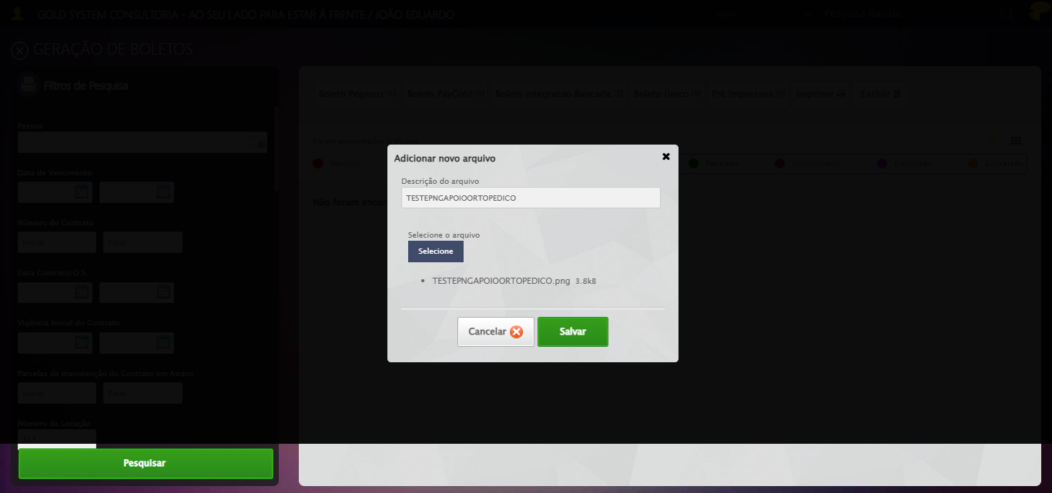

[15:49:16] [INFO] 🔄 Salvando arquivo digitalizado...

[15:49:22] [ERROR] ❌ Timeout aguardando elemento: //a[contains(@class,'btModel') and contains(@class,'btGreen') and normalize-space(.)='Salvar'] (timeout: 5s)

[15:49:22] [WARN] ⚠️ Estratégia 1 falhou: Message:

[15:49:22] [WARN] ⚠️ Estratégia 2 falhou: Message: element not interactable: has no size and location  
 (Session info: chrome=139.0.7258.128); For documentation on this error, please visit: https://www.selenium.dev/documentation/webdriver/troubleshooting/errors#elementnotinteractableexception  
Stacktrace:  
 GetHandleVerifier [0x0x88a8a3+63283]  
 GetHandleVerifier [0x0x88a8e4+63348]  
 (No symbol) [0x0x6c3e43]  
 (No symbol) [0x0x6ca609]  
 (No symbol) [0x0x6cc97a]  
 (No symbol) [0x0x6cc9f7]  
 (No symbol) [0x0x712334]  
 (No symbol) [0x0x7118a7]  
 (No symbol) [0x0x75b0b8]  
 (No symbol) [0x0x73141c]  
 (No symbol) [0x0x75271a]  
 (No symbol) [0x0x731216]  
 (No symbol) [0x0x700855]  
 (No symbol) [0x0x7016f4]  
 GetHandleVerifier [0x0xafbb43+2623955]  
 GetHandleVerifier [0x0xaf6daa+2604090]  
 GetHandleVerifier [0x0x8b069a+218410]  
 GetHandleVerifier [0x0x8a0ed8+154984]  
 GetHandleVerifier [0x0x8a742d+180925]  
 GetHandleVerifier [0x0x8922b8+94536]  
 GetHandleVerifier [0x0x892442+94930]  
 GetHandleVerifier [0x0x87d5ea+9338]  
 BaseThreadInitThunk [0x0x76b1fcc9+25]  
 RtlGetAppContainerNamedObjectPath [0x0x776a82ae+286]  
 RtlGetAppContainerNamedObjectPath [0x0x776a827e+238]

[15:49:22] [INFO] ✅ Clique realizado com estratégia 3

[15:49:22] [INFO] ✅ Salvando arquivo digitalizado realizada com sucesso.

[15:49:23] [INFO] Screenshot capturada: salvando_arquivo_digitalizado

Screenshot: salvando_arquivo_digitalizado

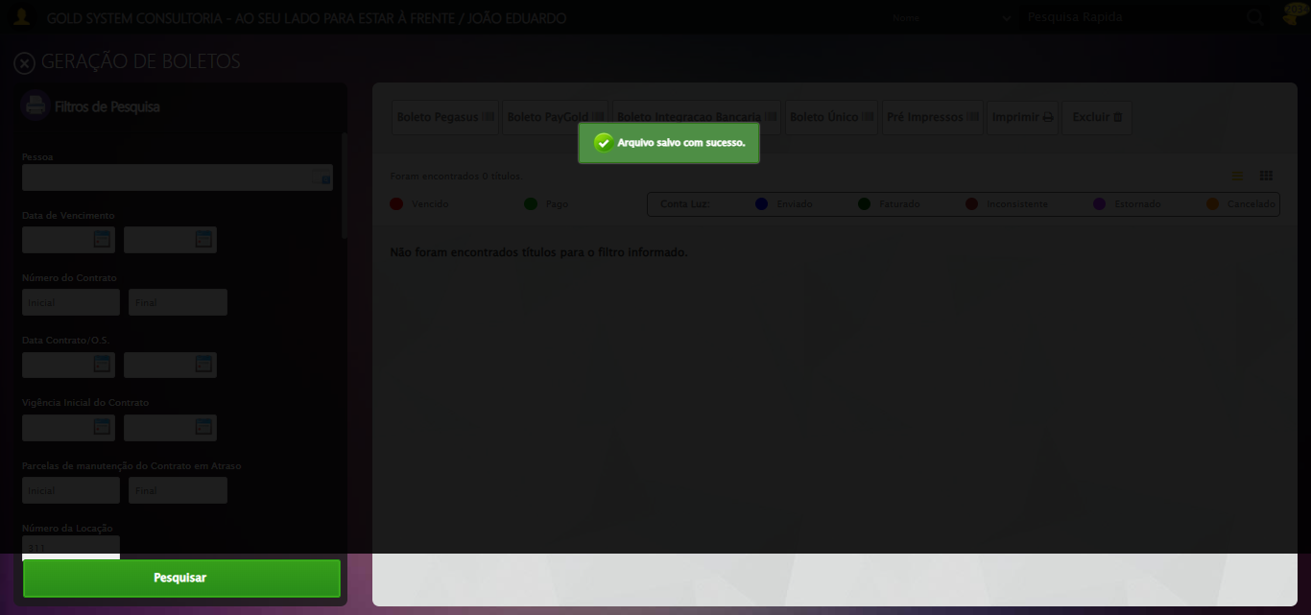

[15:49:23] [INFO] Verificando mensagens de alerta após digitalização...

[15:49:23] [INFO] ✅ Sucesso: Arquivo salvo com sucesso.

[15:49:23] [INFO] 🔄 Fechando modal de digitalização...

[15:49:29] [ERROR] ❌ Timeout aguardando elemento: //a[contains(@class,'fa') and contains(@class,'fa-close')] (timeout: 5s)

[15:49:29] [WARN] ⚠️ Estratégia 1 falhou: Message:

[15:49:29] [WARN] ⚠️ Estratégia 2 falhou: Message: element not interactable: has no size and location  
 (Session info: chrome=139.0.7258.128); For documentation on this error, please visit: https://www.selenium.dev/documentation/webdriver/troubleshooting/errors#elementnotinteractableexception  
Stacktrace:  
 GetHandleVerifier [0x0x88a8a3+63283]  
 GetHandleVerifier [0x0x88a8e4+63348]  
 (No symbol) [0x0x6c3e43]  
 (No symbol) [0x0x6ca609]  
 (No symbol) [0x0x6cc97a]  
 (No symbol) [0x0x6cc9f7]  
 (No symbol) [0x0x712334]  
 (No symbol) [0x0x7118a7]  
 (No symbol) [0x0x75b0b8]  
 (No symbol) [0x0x73141c]  
 (No symbol) [0x0x75271a]  
 (No symbol) [0x0x731216]  
 (No symbol) [0x0x700855]  
 (No symbol) [0x0x7016f4]  
 GetHandleVerifier [0x0xafbb43+2623955]  
 GetHandleVerifier [0x0xaf6daa+2604090]  
 GetHandleVerifier [0x0x8b069a+218410]  
 GetHandleVerifier [0x0x8a0ed8+154984]  
 GetHandleVerifier [0x0x8a742d+180925]  
 GetHandleVerifier [0x0x8922b8+94536]  
 GetHandleVerifier [0x0x892442+94930]  
 GetHandleVerifier [0x0x87d5ea+9338]  
 BaseThreadInitThunk [0x0x76b1fcc9+25]  
 RtlGetAppContainerNamedObjectPath [0x0x776a82ae+286]  
 RtlGetAppContainerNamedObjectPath [0x0x776a827e+238]

[15:49:29] [INFO] ✅ Clique realizado com estratégia 3

[15:49:29] [INFO] ✅ Fechando modal de digitalização realizada com sucesso.

[15:49:30] [INFO] Screenshot capturada: fechando_modal_de_digitalização

Screenshot: fechando_modal_de_digitalização

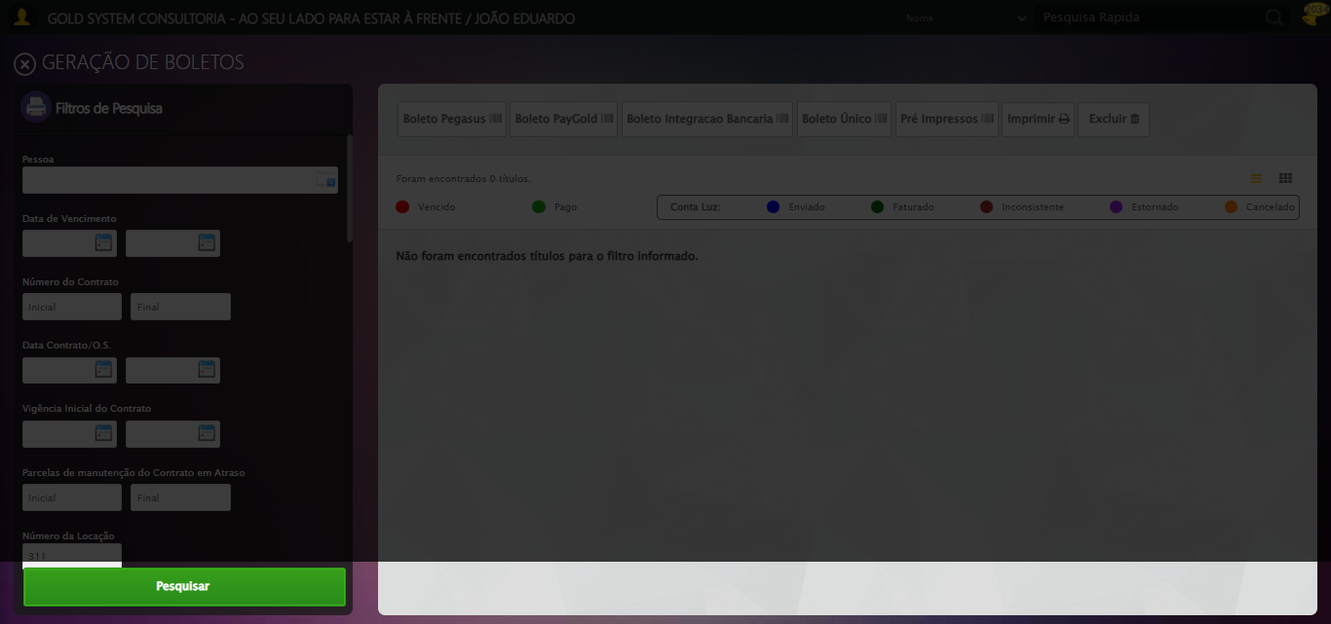

[15:49:30] [INFO] 🔄 Limpando campos...

[15:49:36] [ERROR] ❌ Timeout aguardando elemento: #gsApoioOrtopedico > div.wdTelas > div.telaConsulta > div > div.btnHolder > a.btModel.btGray.btclear (timeout: 5s)

[15:49:36] [WARN] ⚠️ Estratégia 1 falhou: Message:

[15:49:36] [WARN] ⚠️ Estratégia 2 falhou: Message: element not interactable: has no size and location  
 (Session info: chrome=139.0.7258.128); For documentation on this error, please visit: https://www.selenium.dev/documentation/webdriver/troubleshooting/errors#elementnotinteractableexception  
Stacktrace:  
 GetHandleVerifier [0x0x88a8a3+63283]  
 GetHandleVerifier [0x0x88a8e4+63348]  
 (No symbol) [0x0x6c3e43]  
 (No symbol) [0x0x6ca609]  
 (No symbol) [0x0x6cc97a]  
 (No symbol) [0x0x6cc9f7]  
 (No symbol) [0x0x712334]  
 (No symbol) [0x0x7118a7]  
 (No symbol) [0x0x75b0b8]  
 (No symbol) [0x0x73141c]  
 (No symbol) [0x0x75271a]  
 (No symbol) [0x0x731216]  
 (No symbol) [0x0x700855]  
 (No symbol) [0x0x7016f4]  
 GetHandleVerifier [0x0xafbb43+2623955]  
 GetHandleVerifier [0x0xaf6daa+2604090]  
 GetHandleVerifier [0x0x8b069a+218410]  
 GetHandleVerifier [0x0x8a0ed8+154984]  
 GetHandleVerifier [0x0x8a742d+180925]  
 GetHandleVerifier [0x0x8922b8+94536]  
 GetHandleVerifier [0x0x892442+94930]  
 GetHandleVerifier [0x0x87d5ea+9338]  
 BaseThreadInitThunk [0x0x76b1fcc9+25]  
 RtlGetAppContainerNamedObjectPath [0x0x776a82ae+286]  
 RtlGetAppContainerNamedObjectPath [0x0x776a827e+238]

[15:49:36] [INFO] ✅ Clique realizado com estratégia 3

[15:49:36] [INFO] ✅ Limpando campos realizada com sucesso.

[15:49:37] [INFO] Screenshot capturada: limpando_campos

Screenshot: limpando_campos



[15:49:37] [INFO] 🔄 Fechando tela de consulta...

[15:49:42] [ERROR] ❌ Timeout aguardando elemento: #gsApoioOrtopedico > div.wdTop.ui-draggable-handle > div.wdClose > a (timeout: 5s)

[15:49:42] [WARN] ⚠️ Estratégia 1 falhou: Message:

[15:49:42] [WARN] ⚠️ Estratégia 2 falhou: Message: element not interactable: has no size and location  
 (Session info: chrome=139.0.7258.128); For documentation on this error, please visit: https://www.selenium.dev/documentation/webdriver/troubleshooting/errors#elementnotinteractableexception  
Stacktrace:  
 GetHandleVerifier [0x0x88a8a3+63283]  
 GetHandleVerifier [0x0x88a8e4+63348]  
 (No symbol) [0x0x6c3e43]  
 (No symbol) [0x0x6ca609]  
 (No symbol) [0x0x6cc97a]  
 (No symbol) [0x0x6cc9f7]  
 (No symbol) [0x0x712334]  
 (No symbol) [0x0x7118a7]  
 (No symbol) [0x0x75b0b8]  
 (No symbol) [0x0x73141c]  
 (No symbol) [0x0x75271a]  
 (No symbol) [0x0x731216]  
 (No symbol) [0x0x700855]  
 (No symbol) [0x0x7016f4]  
 GetHandleVerifier [0x0xafbb43+2623955]  
 GetHandleVerifier [0x0xaf6daa+2604090]  
 GetHandleVerifier [0x0x8b069a+218410]  
 GetHandleVerifier [0x0x8a0ed8+154984]  
 GetHandleVerifier [0x0x8a742d+180925]  
 GetHandleVerifier [0x0x8922b8+94536]  
 GetHandleVerifier [0x0x892442+94930]  
 GetHandleVerifier [0x0x87d5ea+9338]  
 BaseThreadInitThunk [0x0x76b1fcc9+25]  
 RtlGetAppContainerNamedObjectPath [0x0x776a82ae+286]  
 RtlGetAppContainerNamedObjectPath [0x0x776a827e+238]

[15:49:42] [INFO] ✅ Clique realizado com estratégia 3

[15:49:42] [INFO] ✅ Fechando tela de consulta realizada com sucesso.

[15:49:43] [INFO] Screenshot capturada: fechando_tela_de_consulta

Screenshot: fechando_tela_de_consulta

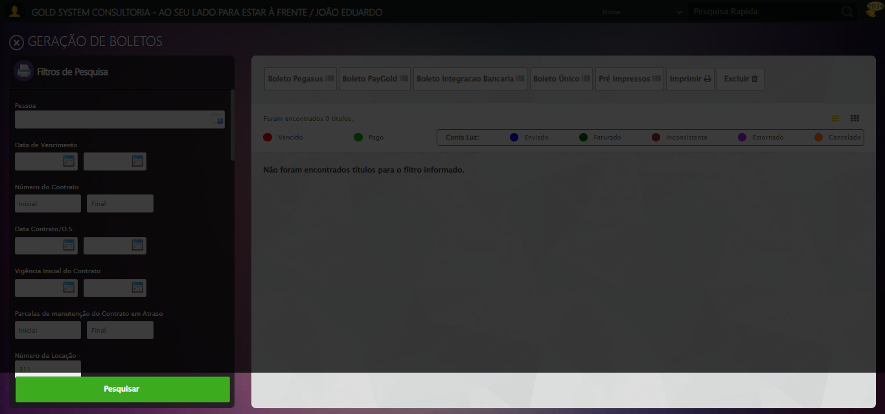

[15:49:43] [INFO] Teste concluído com sucesso!

[15:49:43] [INFO] Teste executado com sucesso!