RELATÓRIO DO TESTE

Consulta de Locação de Equipamentos - Apoio Ortopédico – Cenário 1: Preenchimento e realização da Consulta

Data do teste: 25/08/2025 15:56:28

[15:56:28] [INFO] Iniciando teste de Consulta de Locação de Equipamentos

[15:56:34] [INFO] Executando: Acessando sistema...

[15:56:35] [INFO] Sucesso: Acessando sistema

[15:56:36] [INFO] Screenshot capturada: acessando_sistema

Screenshot: acessando_sistema

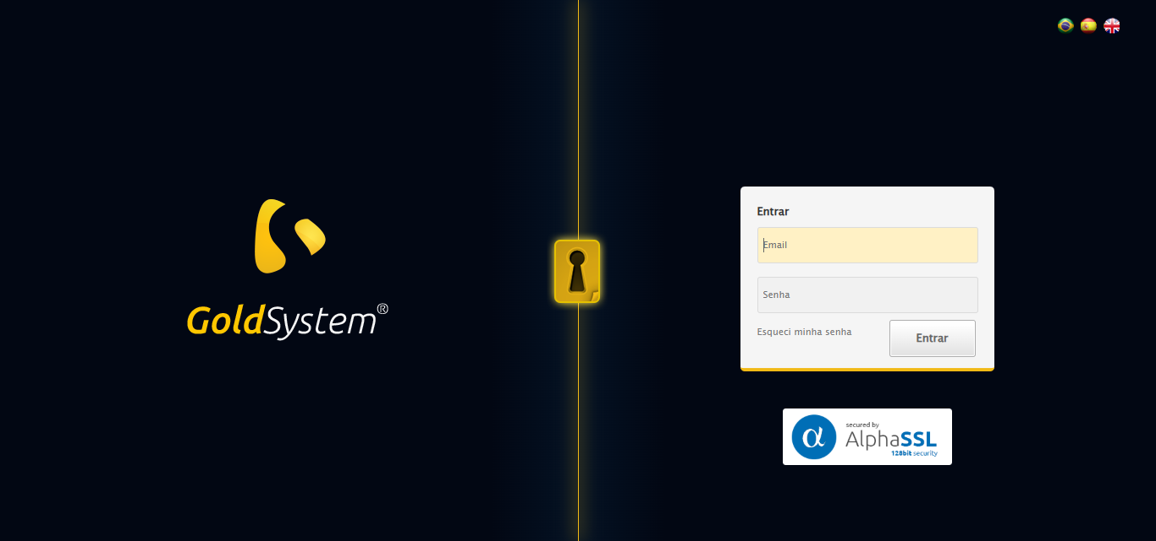

[15:56:36] [INFO] Executando: Realizando login...

[15:56:41] [INFO] Sucesso: Realizando login

[15:56:43] [INFO] Screenshot capturada: realizando_login

Screenshot: realizando_login

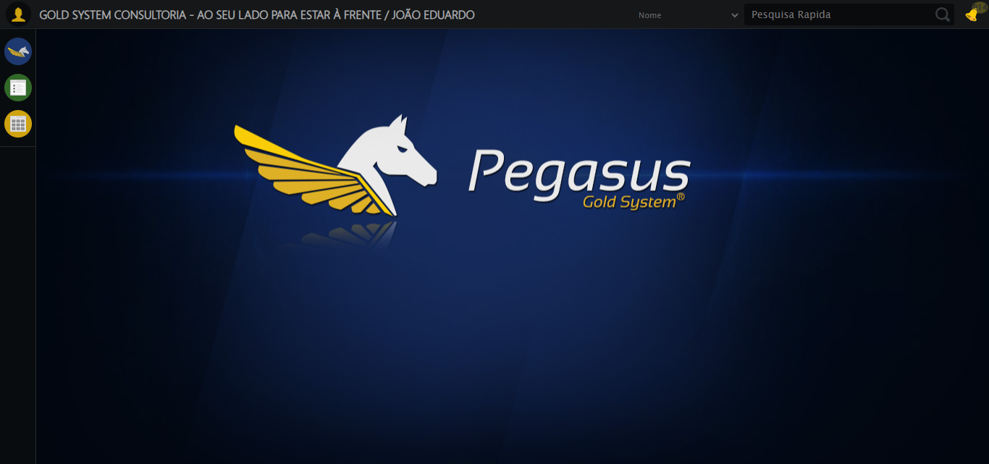

[15:56:43] [INFO] Executando: Ajustando zoom e abrindo menu...

[15:56:43] [INFO] Zoom ajustado para 90%.

[15:56:44] [INFO] Sucesso: Ajustando zoom e abrindo menu

[15:56:45] [INFO] Screenshot capturada: ajustando_zoom_e_abrindo_menu

Screenshot: ajustando_zoom_e_abrindo_menu

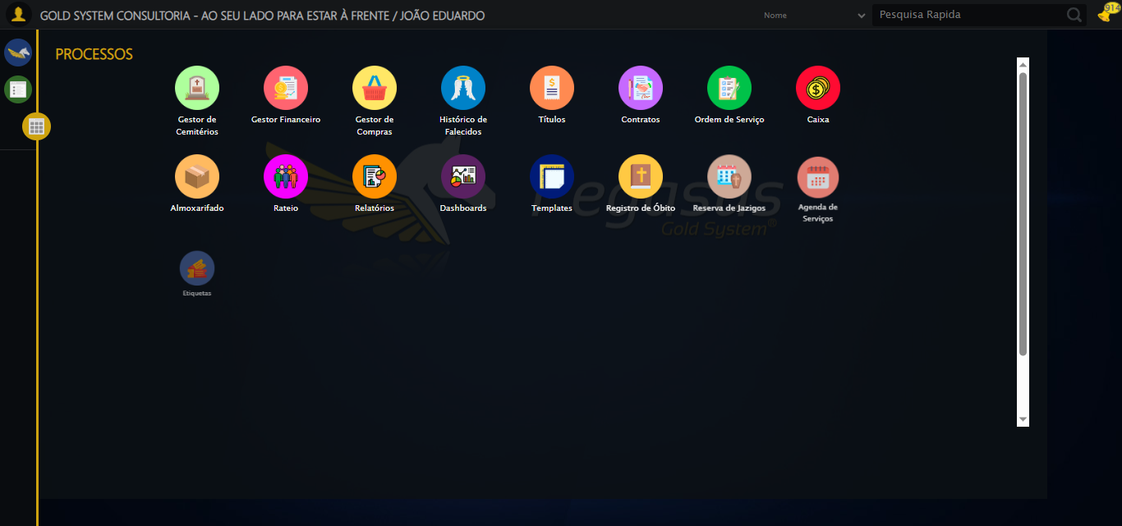

[15:56:45] [INFO] Executando: Acessando Apoio Ortopédico...

[15:56:45] [INFO] Sucesso: Acessando Apoio Ortopédico

[15:56:46] [INFO] Screenshot capturada: acessando_apoio_ortopédico

Screenshot: acessando_apoio_ortopédico

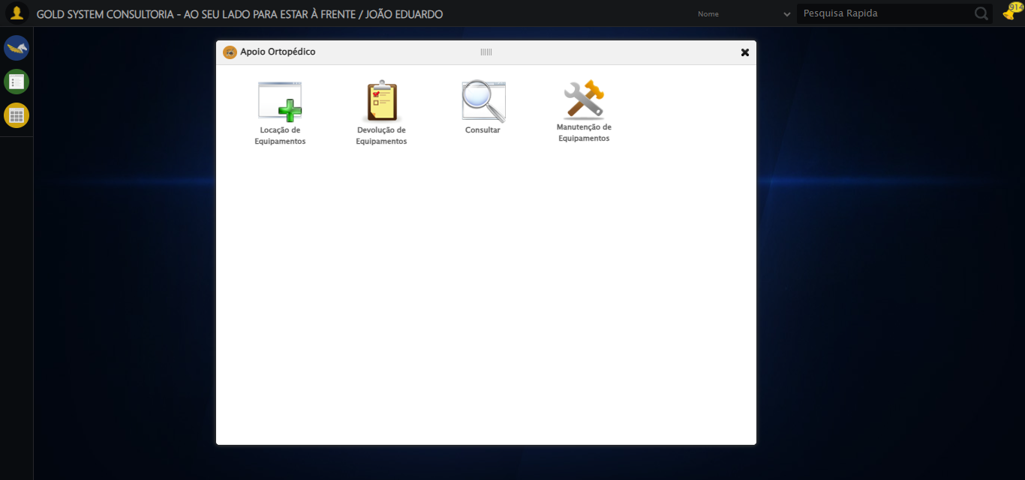

[15:56:46] [INFO] Executando: Clicando em Consulta Locação de Equipamentos...

[15:56:47] [INFO] Sucesso: Clicando em Consulta Locação de Equipamentos

[15:56:48] [INFO] Screenshot capturada: clicando_em_consulta_locação_de_equipamentos

Screenshot: clicando_em_consulta_locação_de_equipamentos

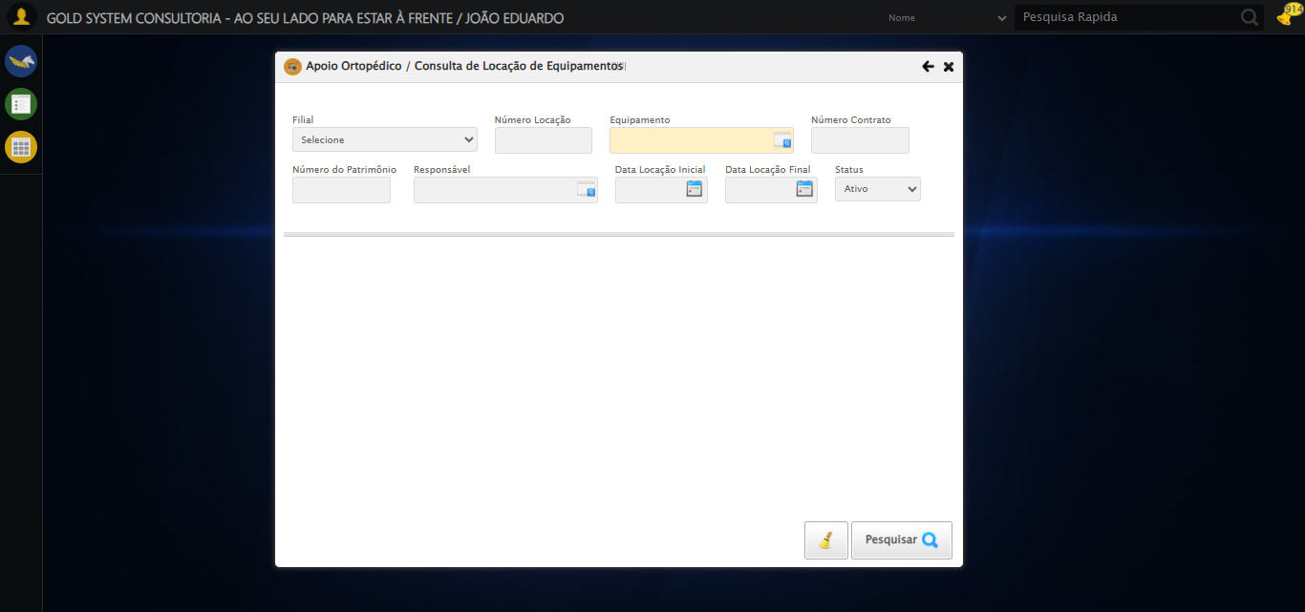

[15:56:53] [INFO] Executando: Preenchendo o Número da Locação...

[15:56:54] [INFO] Sucesso: Preenchendo o Número da Locação

[15:56:55] [INFO] Screenshot capturada: preenchendo_o_número_da_locação

Screenshot: preenchendo_o_número_da_locação

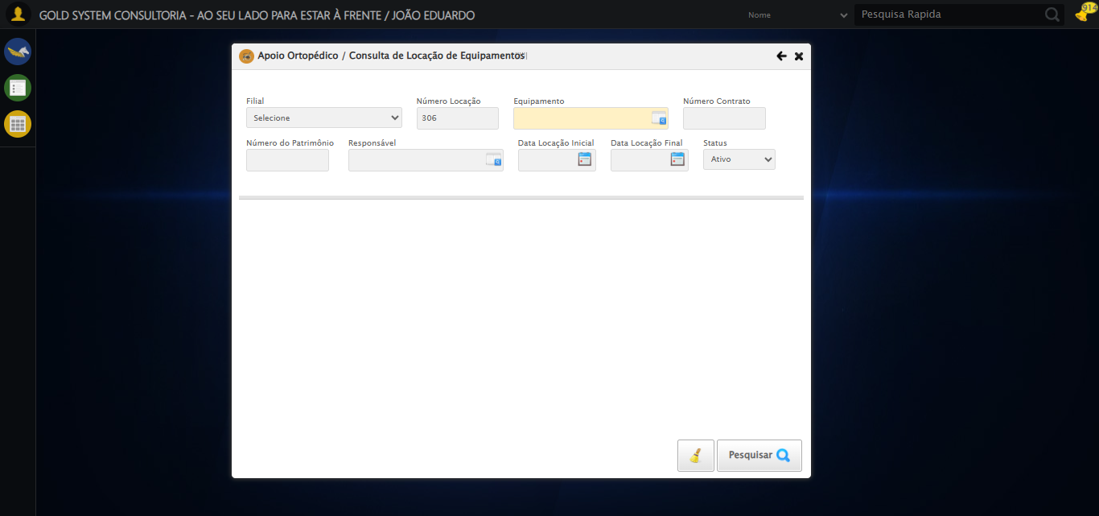

[15:56:55] [INFO] Executando: Selecionando Equipamento...

[15:57:16] [INFO] Erro ao clicar robusto: Message:   
Stacktrace:  
 GetHandleVerifier [0x0x39ffc3+65331]  
 GetHandleVerifier [0x0x3a0004+65396]  
 (No symbol) [0x0x193f63]  
 (No symbol) [0x0x1dc99e]  
 (No symbol) [0x0x1dcd3b]  
 (No symbol) [0x0x2253d2]  
 (No symbol) [0x0x201524]  
 (No symbol) [0x0x222bcb]  
 (No symbol) [0x0x2012d6]  
 (No symbol) [0x0x1d0910]  
 (No symbol) [0x0x1d1784]  
 GetHandleVerifier [0x0x5e38b3+2439203]  
 GetHandleVerifier [0x0x5deae2+2419282]  
 GetHandleVerifier [0x0x3c712a+225434]  
 GetHandleVerifier [0x0x3b6e08+159096]  
 GetHandleVerifier [0x0x3bdd5d+187597]  
 GetHandleVerifier [0x0x3a7ad8+96840]  
 GetHandleVerifier [0x0x3a7c62+97234]  
 GetHandleVerifier [0x0x39277a+9962]  
 BaseThreadInitThunk [0x0x76b1fcc9+25]  
 RtlGetAppContainerNamedObjectPath [0x0x776a82ae+286]  
 RtlGetAppContainerNamedObjectPath [0x0x776a827e+238]  
 (No symbol) [0x0]

[15:57:37] [INFO] Screenshot capturada: erro_selecionando_equipamento

Screenshot: erro_selecionando_equipamento

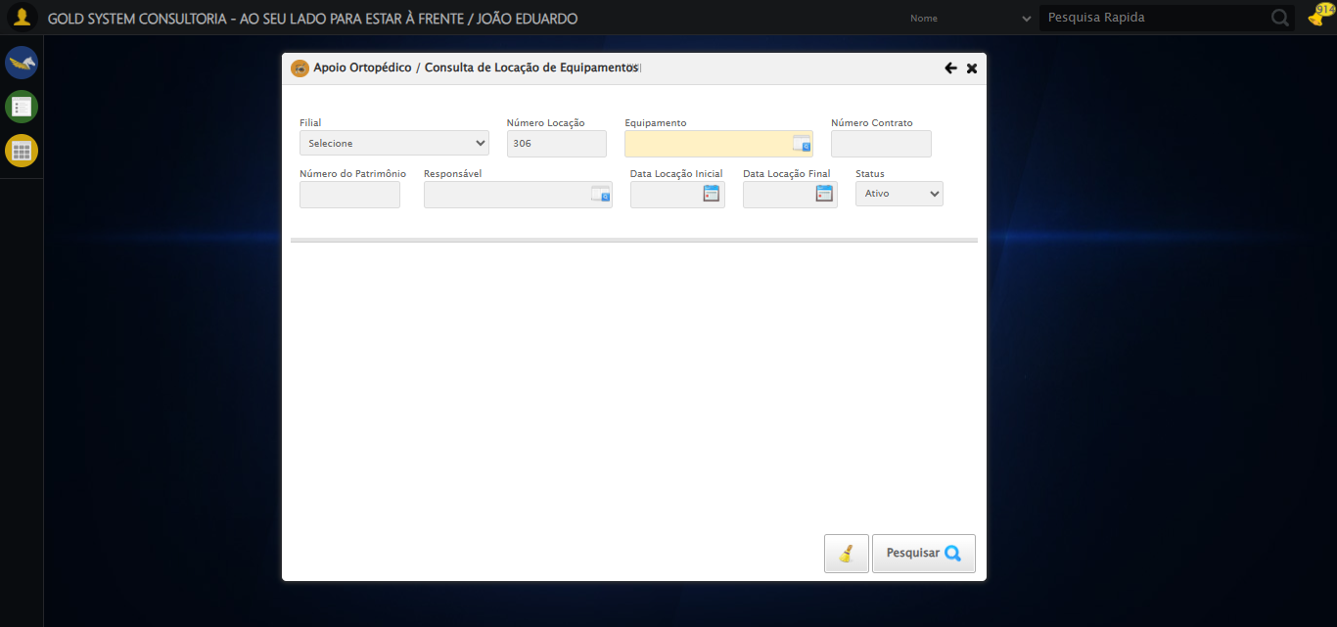

[15:57:37] [ERROR] Falha em Selecionando Equipamento: TimeoutException: Message:   
Stacktrace:  
 GetHandleVerifier [0x0x39ffc3+65331]  
 GetHandleVerifier [0x0x3a0004+65396]  
 (No symbol) [0x0x193f63]  
 (No symbol) [0x0x1dc99e]  
 (No symbol) [0x0x1dcd3b]  
 (No symbol) [0x0x2253d2]  
 (No symbol) [0x0x201524]  
 (No symbol) [0x0x222bcb]  
 (No symbol) [0x0x2012d6]  
 (No symbol) [0x0x1d0910]  
 (No symbol) [0x0x1d1784]  
 GetHandleVerifier [0x0x5e38b3+2439203]  
 GetHandleVerifier [0x0x5deae2+2419282]  
 GetHandleVerifier [0x0x3c712a+225434]  
 GetHandleVerifier [0x0x3b6e08+159096]  
 GetHandleVerifier [0x0x3bdd5d+187597]  
 GetHandleVerifier [0x0x3a7ad8+96840]  
 GetHandleVerifier [0x0x3a7c62+97234]  
 GetHandleVerifier [0x0x39277a+9962]  
 BaseThreadInitThunk [0x0x76b1fcc9+25]  
 RtlGetAppContainerNamedObjectPath [0x0x776a82ae+286]  
 RtlGetAppContainerNamedObjectPath [0x0x776a827e+238]  
 (No symbol) [0x0]

[15:57:37] [WARN] Tentando novamente Selecionando Equipamento em 2 segundos...

[15:57:39] [INFO] Executando: Selecionando Equipamento... (Tentativa 2)

[15:58:00] [INFO] Erro ao clicar robusto: Message:   
Stacktrace:  
 GetHandleVerifier [0x0x39ffc3+65331]  
 GetHandleVerifier [0x0x3a0004+65396]  
 (No symbol) [0x0x193f63]  
 (No symbol) [0x0x1dc99e]  
 (No symbol) [0x0x1dcd3b]  
 (No symbol) [0x0x2253d2]  
 (No symbol) [0x0x201524]  
 (No symbol) [0x0x222bcb]  
 (No symbol) [0x0x2012d6]  
 (No symbol) [0x0x1d0910]  
 (No symbol) [0x0x1d1784]  
 GetHandleVerifier [0x0x5e38b3+2439203]  
 GetHandleVerifier [0x0x5deae2+2419282]  
 GetHandleVerifier [0x0x3c712a+225434]  
 GetHandleVerifier [0x0x3b6e08+159096]  
 GetHandleVerifier [0x0x3bdd5d+187597]  
 GetHandleVerifier [0x0x3a7ad8+96840]  
 GetHandleVerifier [0x0x3a7c62+97234]  
 GetHandleVerifier [0x0x39277a+9962]  
 BaseThreadInitThunk [0x0x76b1fcc9+25]  
 RtlGetAppContainerNamedObjectPath [0x0x776a82ae+286]  
 RtlGetAppContainerNamedObjectPath [0x0x776a827e+238]  
 (No symbol) [0x0]

[15:58:21] [ERROR] Falha em Selecionando Equipamento: TimeoutException: Message:   
Stacktrace:  
 GetHandleVerifier [0x0x39ffc3+65331]  
 GetHandleVerifier [0x0x3a0004+65396]  
 (No symbol) [0x0x193f63]  
 (No symbol) [0x0x1dc99e]  
 (No symbol) [0x0x1dcd3b]  
 (No symbol) [0x0x2253d2]  
 (No symbol) [0x0x201524]  
 (No symbol) [0x0x222bcb]  
 (No symbol) [0x0x2012d6]  
 (No symbol) [0x0x1d0910]  
 (No symbol) [0x0x1d1784]  
 GetHandleVerifier [0x0x5e38b3+2439203]  
 GetHandleVerifier [0x0x5deae2+2419282]  
 GetHandleVerifier [0x0x3c712a+225434]  
 GetHandleVerifier [0x0x3b6e08+159096]  
 GetHandleVerifier [0x0x3bdd5d+187597]  
 GetHandleVerifier [0x0x3a7ad8+96840]  
 GetHandleVerifier [0x0x3a7c62+97234]  
 GetHandleVerifier [0x0x39277a+9962]  
 BaseThreadInitThunk [0x0x76b1fcc9+25]  
 RtlGetAppContainerNamedObjectPath [0x0x776a82ae+286]  
 RtlGetAppContainerNamedObjectPath [0x0x776a827e+238]  
 (No symbol) [0x0]

[15:58:21] [WARN] Tentando novamente Selecionando Equipamento em 2 segundos...

[15:58:23] [INFO] Executando: Selecionando Equipamento... (Tentativa 3)

[15:58:43] [INFO] Erro ao clicar robusto: Message:   
Stacktrace:  
 GetHandleVerifier [0x0x39ffc3+65331]  
 GetHandleVerifier [0x0x3a0004+65396]  
 (No symbol) [0x0x193f63]  
 (No symbol) [0x0x1dc99e]  
 (No symbol) [0x0x1dcd3b]  
 (No symbol) [0x0x2253d2]  
 (No symbol) [0x0x201524]  
 (No symbol) [0x0x222bcb]  
 (No symbol) [0x0x2012d6]  
 (No symbol) [0x0x1d0910]  
 (No symbol) [0x0x1d1784]  
 GetHandleVerifier [0x0x5e38b3+2439203]  
 GetHandleVerifier [0x0x5deae2+2419282]  
 GetHandleVerifier [0x0x3c712a+225434]  
 GetHandleVerifier [0x0x3b6e08+159096]  
 GetHandleVerifier [0x0x3bdd5d+187597]  
 GetHandleVerifier [0x0x3a7ad8+96840]  
 GetHandleVerifier [0x0x3a7c62+97234]  
 GetHandleVerifier [0x0x39277a+9962]  
 BaseThreadInitThunk [0x0x76b1fcc9+25]  
 RtlGetAppContainerNamedObjectPath [0x0x776a82ae+286]  
 RtlGetAppContainerNamedObjectPath [0x0x776a827e+238]  
 (No symbol) [0x0]

[15:59:04] [ERROR] Falha em Selecionando Equipamento: TimeoutException: Message:   
Stacktrace:  
 GetHandleVerifier [0x0x39ffc3+65331]  
 GetHandleVerifier [0x0x3a0004+65396]  
 (No symbol) [0x0x193f63]  
 (No symbol) [0x0x1dc99e]  
 (No symbol) [0x0x1dcd3b]  
 (No symbol) [0x0x2253d2]  
 (No symbol) [0x0x201524]  
 (No symbol) [0x0x222bcb]  
 (No symbol) [0x0x2012d6]  
 (No symbol) [0x0x1d0910]  
 (No symbol) [0x0x1d1784]  
 GetHandleVerifier [0x0x5e38b3+2439203]  
 GetHandleVerifier [0x0x5deae2+2419282]  
 GetHandleVerifier [0x0x3c712a+225434]  
 GetHandleVerifier [0x0x3b6e08+159096]  
 GetHandleVerifier [0x0x3bdd5d+187597]  
 GetHandleVerifier [0x0x3a7ad8+96840]  
 GetHandleVerifier [0x0x3a7c62+97234]  
 GetHandleVerifier [0x0x39277a+9962]  
 BaseThreadInitThunk [0x0x76b1fcc9+25]  
 RtlGetAppContainerNamedObjectPath [0x0x776a82ae+286]  
 RtlGetAppContainerNamedObjectPath [0x0x776a827e+238]  
 (No symbol) [0x0]

[15:59:04] [INFO] ERRO FATAL: Message:   
Stacktrace:  
 GetHandleVerifier [0x0x39ffc3+65331]  
 GetHandleVerifier [0x0x3a0004+65396]  
 (No symbol) [0x0x193f63]  
 (No symbol) [0x0x1dc99e]  
 (No symbol) [0x0x1dcd3b]  
 (No symbol) [0x0x2253d2]  
 (No symbol) [0x0x201524]  
 (No symbol) [0x0x222bcb]  
 (No symbol) [0x0x2012d6]  
 (No symbol) [0x0x1d0910]  
 (No symbol) [0x0x1d1784]  
 GetHandleVerifier [0x0x5e38b3+2439203]  
 GetHandleVerifier [0x0x5deae2+2419282]  
 GetHandleVerifier [0x0x3c712a+225434]  
 GetHandleVerifier [0x0x3b6e08+159096]  
 GetHandleVerifier [0x0x3bdd5d+187597]  
 GetHandleVerifier [0x0x3a7ad8+96840]  
 GetHandleVerifier [0x0x3a7c62+97234]  
 GetHandleVerifier [0x0x39277a+9962]  
 BaseThreadInitThunk [0x0x76b1fcc9+25]  
 RtlGetAppContainerNamedObjectPath [0x0x776a82ae+286]  
 RtlGetAppContainerNamedObjectPath [0x0x776a827e+238]  
 (No symbol) [0x0]

[15:59:05] [INFO] Screenshot capturada: erro_fatal

Screenshot: erro_fatal

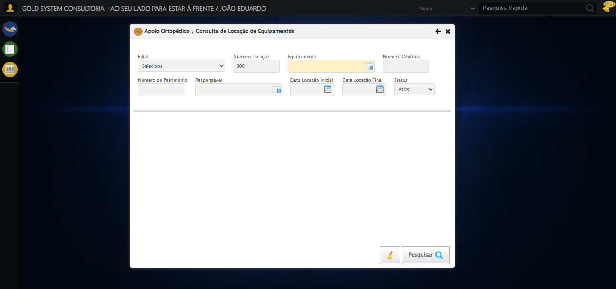

[15:59:05] [INFO] Teste concluído.

[15:59:05] [INFO] Teste finalizado com erros.