RELATÓRIO DO TESTE

Consulta de Locação de Equipamentos - Apoio Ortopédico – Cenário 1: Preenchimento e realização da Consulta

Data do teste: 27/08/2025 16:35:29

[16:35:29] [INFO] 🚀 Iniciando teste de Cadastro de Locação de Equipamentos

[16:35:35] [INFO] 🔄 Acessando sistema...

[16:35:36] [INFO] ✅ Acessando sistema realizada com sucesso.

Screenshot: acessando sistema

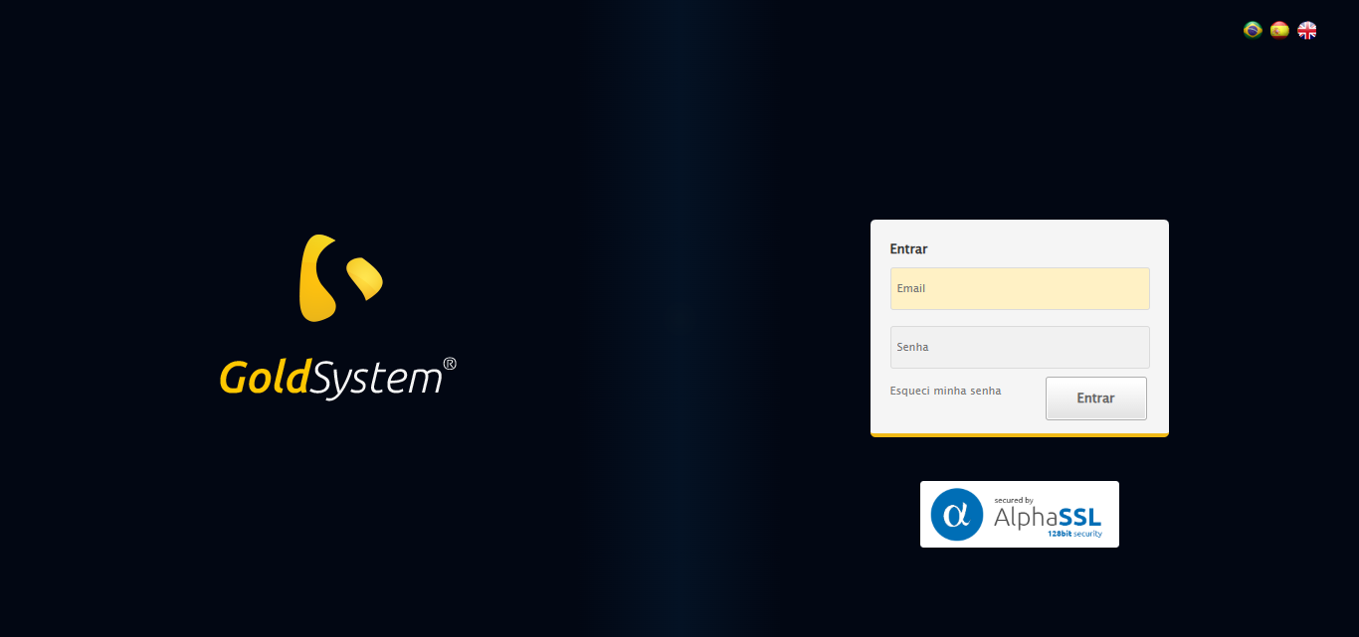

[16:35:37] [INFO] 🔄 Realizando login...

[16:35:42] [INFO] ✅ Realizando login realizada com sucesso.

Screenshot: realizando login

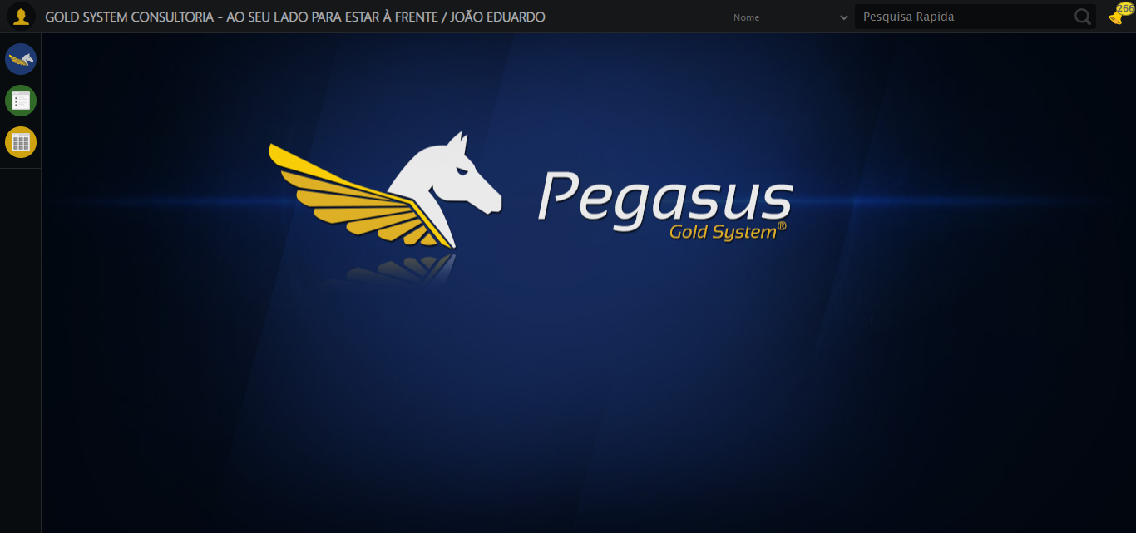

[16:35:47] [INFO] 🔄 Ajustando zoom e abrindo menu...

[16:35:47] [INFO] 🔍 Zoom ajustado para 90%.

[16:35:47] [INFO] ✅ Ajustando zoom e abrindo menu realizada com sucesso.

Screenshot: ajustando zoom e abrindo menu

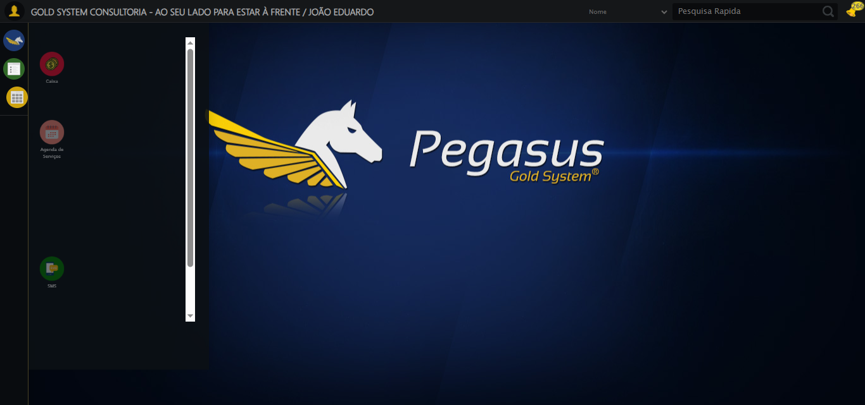

[16:35:47] [INFO] 🔄 Acessando Apoio Ortopédico...

[16:35:49] [INFO] ✅ Acessando Apoio Ortopédico realizada com sucesso.

Screenshot: acessando apoio ortopédico

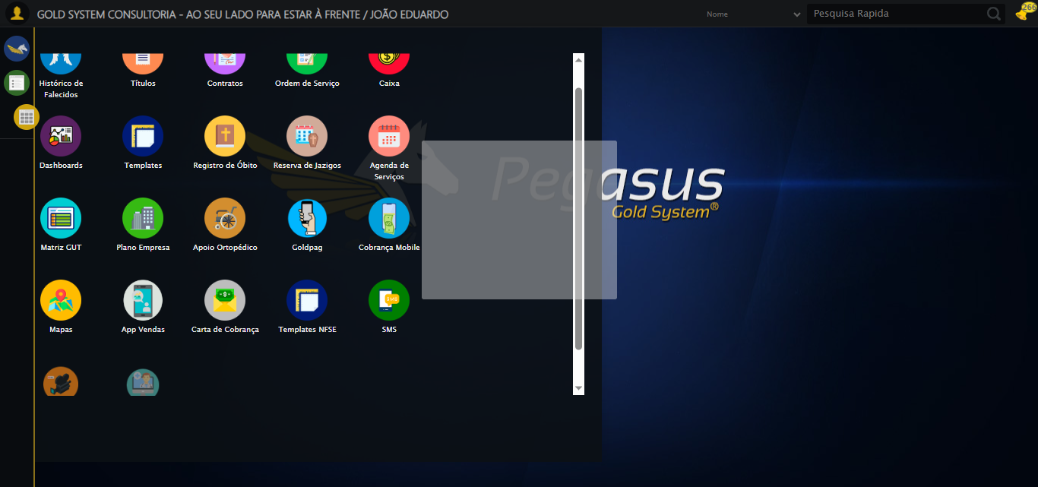

[16:35:49] [INFO] 🔄 Clicando em Consulta Locação de Equipamentos...

[16:35:50] [INFO] ✅ Clicando em Consulta Locação de Equipamentos realizada com sucesso.

Screenshot: clicando em consulta locação de equipamentos

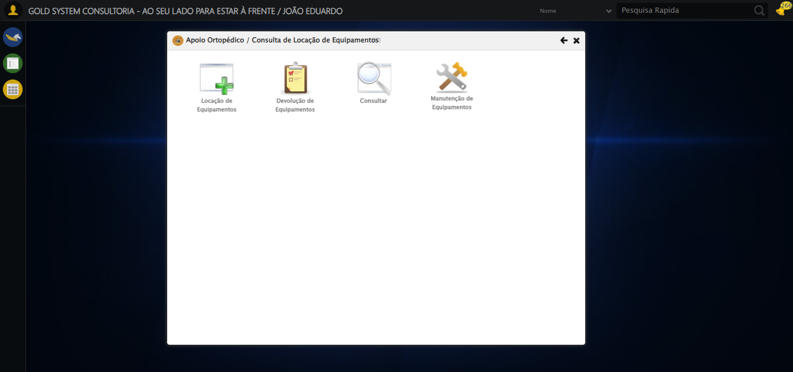

[16:35:55] [INFO] 🔄 Preenchendo o Número da Locação...

[16:35:56] [INFO] ✅ Preenchendo o Número da Locação realizada com sucesso.

Screenshot: preenchendo o número da locação

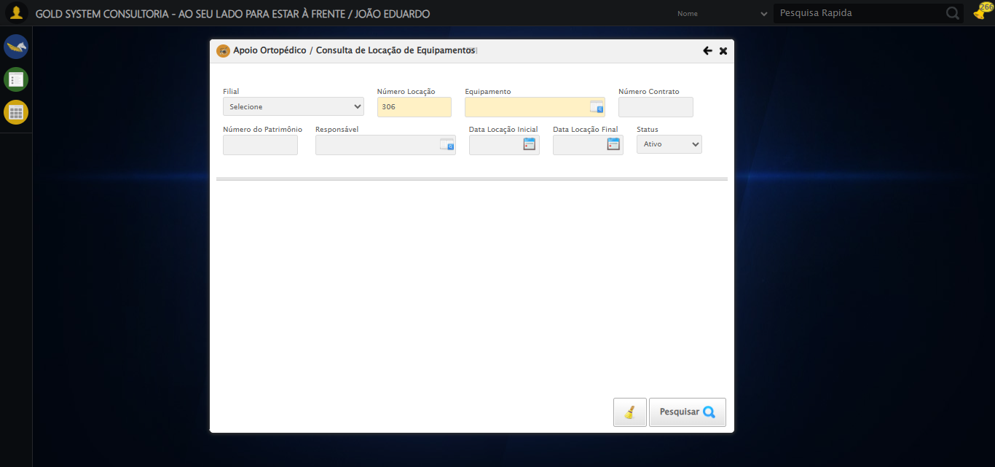

[16:35:56] [INFO] 🔄 Abrindo Lov de Equipamentos...

[16:35:56] [INFO] ✅ Abrindo Lov de Equipamentos realizada com sucesso.

Screenshot: abrindo lov de equipamentos

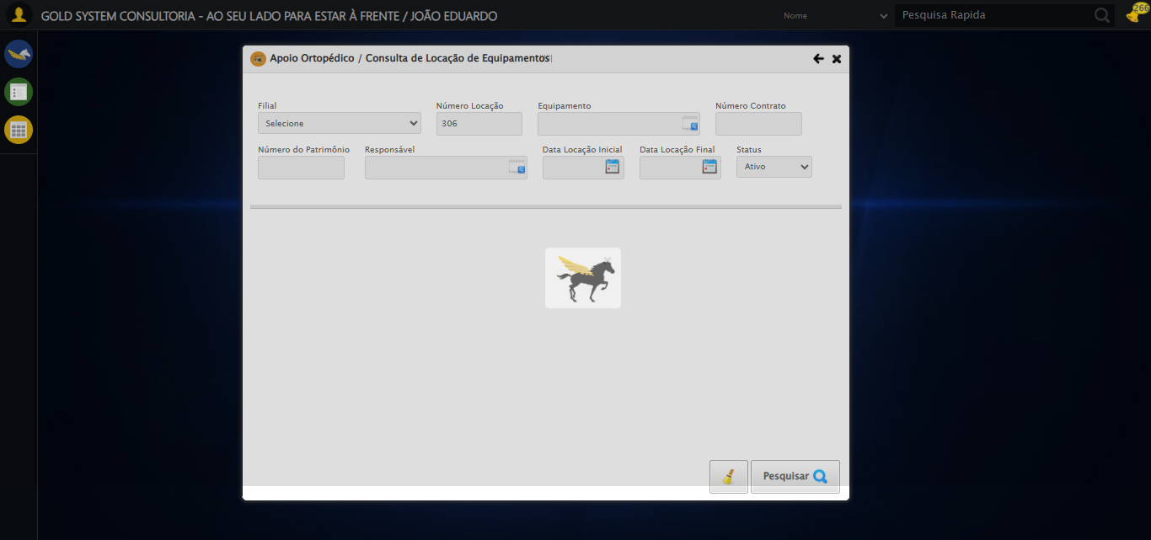

[16:35:57] [INFO] 🔄 Inserindo nome do equipamento...

[16:35:58] [INFO] ✅ Inserindo nome do equipamento realizada com sucesso.

Screenshot: inserindo nome do equipamento

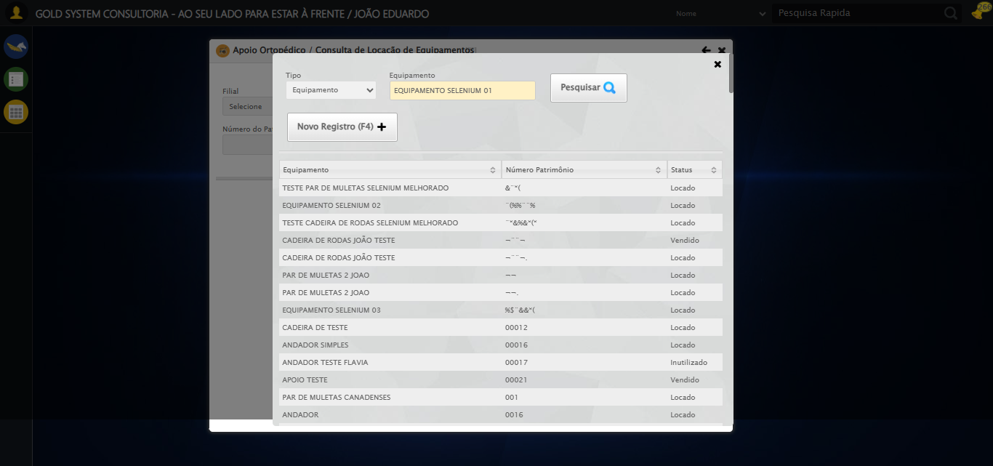

[16:35:58] [INFO] 🔄 Pesquisando Equipamento...

[16:36:09] [INFO] ✅ Pesquisando Equipamento realizada com sucesso.

Screenshot: pesquisando equipamento

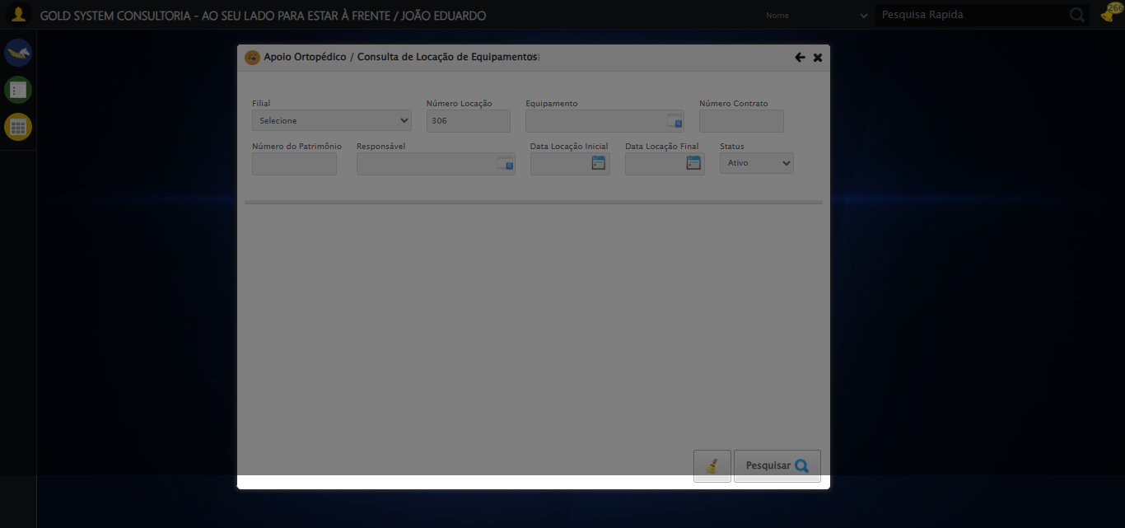

[16:36:09] [INFO] 🔄 Selecionando Equipamento...

[16:36:19] [INFO] ❌ Erro ao clicar robusto: Message:   
Stacktrace:  
 GetHandleVerifier [0x0x7da8a3+63283]  
 GetHandleVerifier [0x0x7da8e4+63348]  
 (No symbol) [0x0x613e43]  
 (No symbol) [0x0x65c8de]  
 (No symbol) [0x0x65cc7b]  
 (No symbol) [0x0x6a4ef2]  
 (No symbol) [0x0x681464]  
 (No symbol) [0x0x6a271a]  
 (No symbol) [0x0x681216]  
 (No symbol) [0x0x650855]  
 (No symbol) [0x0x6516f4]  
 GetHandleVerifier [0x0xa4bb43+2623955]  
 GetHandleVerifier [0x0xa46daa+2604090]  
 GetHandleVerifier [0x0x80069a+218410]  
 GetHandleVerifier [0x0x7f0ed8+154984]  
 GetHandleVerifier [0x0x7f742d+180925]  
 GetHandleVerifier [0x0x7e22b8+94536]  
 GetHandleVerifier [0x0x7e2442+94930]  
 GetHandleVerifier [0x0x7cd5ea+9338]  
 BaseThreadInitThunk [0x0x76b1fcc9+25]  
 RtlGetAppContainerNamedObjectPath [0x0x776a82ae+286]  
 RtlGetAppContainerNamedObjectPath [0x0x776a827e+238]

[16:36:19] [INFO] ✅ Selecionando Equipamento realizada com sucesso.

Screenshot: selecionando equipamento



[16:36:20] [INFO] 🔄 Preenchendo o Número do Contrato...

[16:36:21] [INFO] ⚠️ Tentativa 1 falhou: Message: element click intercepted: Element <input type="text" maxlength="" class="numeroContrato" style="width: 100px;"> is not clickable at point (900, 146). Other element would receive the click: <div class="blockScreen" style="height: 641px; z-index: 10001; opacity: 0.5;"></div>  
 (Session info: chrome=139.0.7258.128); For documentation on this error, please visit: https://www.selenium.dev/documentation/webdriver/troubleshooting/errors#elementclickinterceptedexception  
Stacktrace:  
 GetHandleVerifier [0x0x7da8a3+63283]  
 GetHandleVerifier [0x0x7da8e4+63348]  
 (No symbol) [0x0x613e43]  
 (No symbol) [0x0x662c20]  
 (No symbol) [0x0x660fda]  
 (No symbol) [0x0x65eb37]  
 (No symbol) [0x0x65ddf4]  
 (No symbol) [0x0x6525b5]  
 (No symbol) [0x0x68141c]  
 (No symbol) [0x0x652044]  
 (No symbol) [0x0x681694]  
 (No symbol) [0x0x6a271a]  
 (No symbol) [0x0x681216]  
 (No symbol) [0x0x650855]  
 (No symbol) [0x0x6516f4]  
 GetHandleVerifier [0x0xa4bb43+2623955]  
 GetHandleVerifier [0x0xa46daa+2604090]  
 GetHandleVerifier [0x0x80069a+218410]  
 GetHandleVerifier [0x0x7f0ed8+154984]  
 GetHandleVerifier [0x0x7f742d+180925]  
 GetHandleVerifier [0x0x7e22b8+94536]  
 GetHandleVerifier [0x0x7e2442+94930]  
 GetHandleVerifier [0x0x7cd5ea+9338]  
 BaseThreadInitThunk [0x0x76b1fcc9+25]  
 RtlGetAppContainerNamedObjectPath [0x0x776a82ae+286]  
 RtlGetAppContainerNamedObjectPath [0x0x776a827e+238]

[16:36:24] [INFO] ✅ Preenchendo o Número do Contrato realizada com sucesso.

Screenshot: preenchendo o número do contrato

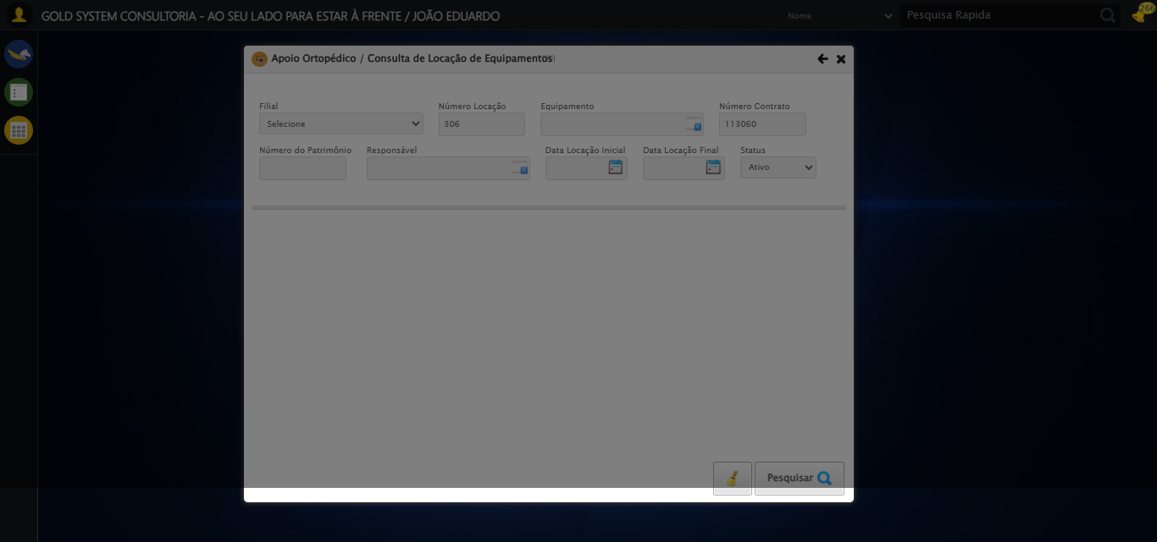

[16:36:24] [INFO] 🔄 Preenchendo o Número do Patrimônio...

[16:36:25] [INFO] ⚠️ Tentativa 1 falhou: Message: element click intercepted: Element <input type="text" class="fc numeroPatrimonio" name="numeroPatrimonio" maxlength="20" style="width: 100px; text-align: left;"> is not clickable at point (357, 198). Other element would receive the click: <div class="blockScreen" style="height: 641px; z-index: 10001; opacity: 0.5;"></div>  
 (Session info: chrome=139.0.7258.128); For documentation on this error, please visit: https://www.selenium.dev/documentation/webdriver/troubleshooting/errors#elementclickinterceptedexception  
Stacktrace:  
 GetHandleVerifier [0x0x7da8a3+63283]  
 GetHandleVerifier [0x0x7da8e4+63348]  
 (No symbol) [0x0x613e43]  
 (No symbol) [0x0x662c20]  
 (No symbol) [0x0x660fda]  
 (No symbol) [0x0x65eb37]  
 (No symbol) [0x0x65ddf4]  
 (No symbol) [0x0x6525b5]  
 (No symbol) [0x0x68141c]  
 (No symbol) [0x0x652044]  
 (No symbol) [0x0x681694]  
 (No symbol) [0x0x6a271a]  
 (No symbol) [0x0x681216]  
 (No symbol) [0x0x650855]  
 (No symbol) [0x0x6516f4]  
 GetHandleVerifier [0x0xa4bb43+2623955]  
 GetHandleVerifier [0x0xa46daa+2604090]  
 GetHandleVerifier [0x0x80069a+218410]  
 GetHandleVerifier [0x0x7f0ed8+154984]  
 GetHandleVerifier [0x0x7f742d+180925]  
 GetHandleVerifier [0x0x7e22b8+94536]  
 GetHandleVerifier [0x0x7e2442+94930]  
 GetHandleVerifier [0x0x7cd5ea+9338]  
 BaseThreadInitThunk [0x0x76b1fcc9+25]  
 RtlGetAppContainerNamedObjectPath [0x0x776a82ae+286]  
 RtlGetAppContainerNamedObjectPath [0x0x776a827e+238]

[16:36:29] [INFO] ✅ Preenchendo o Número do Patrimônio realizada com sucesso.

Screenshot: preenchendo o número do patrimônio

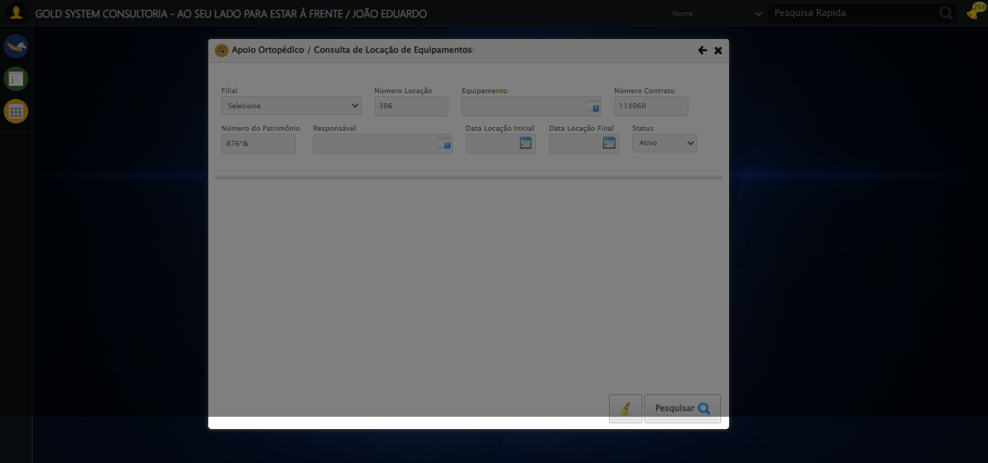

[16:36:29] [INFO] 🔄 Abrindo Lov do Responsável...

[16:36:31] [INFO] ✅ Abrindo Lov do Responsável realizada com sucesso.

Screenshot: abrindo lov do responsável



[16:36:31] [INFO] 🔄 Inserindo nome do Responsável...

[16:36:51] [INFO] ⚠️ Tentativa 1 falhou: Message:   
Stacktrace:  
 GetHandleVerifier [0x0x7da8a3+63283]  
 GetHandleVerifier [0x0x7da8e4+63348]  
 (No symbol) [0x0x613e43]  
 (No symbol) [0x0x65c8de]  
 (No symbol) [0x0x65cc7b]  
 (No symbol) [0x0x6a4ef2]  
 (No symbol) [0x0x681464]  
 (No symbol) [0x0x6a271a]  
 (No symbol) [0x0x681216]  
 (No symbol) [0x0x650855]  
 (No symbol) [0x0x6516f4]  
 GetHandleVerifier [0x0xa4bb43+2623955]  
 GetHandleVerifier [0x0xa46daa+2604090]  
 GetHandleVerifier [0x0x80069a+218410]  
 GetHandleVerifier [0x0x7f0ed8+154984]  
 GetHandleVerifier [0x0x7f742d+180925]  
 GetHandleVerifier [0x0x7e22b8+94536]  
 GetHandleVerifier [0x0x7e2442+94930]  
 GetHandleVerifier [0x0x7cd5ea+9338]  
 BaseThreadInitThunk [0x0x76b1fcc9+25]  
 RtlGetAppContainerNamedObjectPath [0x0x776a82ae+286]  
 RtlGetAppContainerNamedObjectPath [0x0x776a827e+238]

[16:37:12] [INFO] ⚠️ Tentativa 2 falhou: Message:   
Stacktrace:  
 GetHandleVerifier [0x0x7da8a3+63283]  
 GetHandleVerifier [0x0x7da8e4+63348]  
 (No symbol) [0x0x613e43]  
 (No symbol) [0x0x65c8de]  
 (No symbol) [0x0x65cc7b]  
 (No symbol) [0x0x6a4ef2]  
 (No symbol) [0x0x681464]  
 (No symbol) [0x0x6a271a]  
 (No symbol) [0x0x681216]  
 (No symbol) [0x0x650855]  
 (No symbol) [0x0x6516f4]  
 GetHandleVerifier [0x0xa4bb43+2623955]  
 GetHandleVerifier [0x0xa46daa+2604090]  
 GetHandleVerifier [0x0x80069a+218410]  
 GetHandleVerifier [0x0x7f0ed8+154984]  
 GetHandleVerifier [0x0x7f742d+180925]  
 GetHandleVerifier [0x0x7e22b8+94536]  
 GetHandleVerifier [0x0x7e2442+94930]  
 GetHandleVerifier [0x0x7cd5ea+9338]  
 BaseThreadInitThunk [0x0x76b1fcc9+25]  
 RtlGetAppContainerNamedObjectPath [0x0x776a82ae+286]  
 RtlGetAppContainerNamedObjectPath [0x0x776a827e+238]

[16:37:33] [INFO] ⚠️ Tentativa 3 falhou: Message:   
Stacktrace:  
 GetHandleVerifier [0x0x7da8a3+63283]  
 GetHandleVerifier [0x0x7da8e4+63348]  
 (No symbol) [0x0x613e43]  
 (No symbol) [0x0x65c8de]  
 (No symbol) [0x0x65cc7b]  
 (No symbol) [0x0x6a4ef2]  
 (No symbol) [0x0x681464]  
 (No symbol) [0x0x6a271a]  
 (No symbol) [0x0x681216]  
 (No symbol) [0x0x650855]  
 (No symbol) [0x0x6516f4]  
 GetHandleVerifier [0x0xa4bb43+2623955]  
 GetHandleVerifier [0x0xa46daa+2604090]  
 GetHandleVerifier [0x0x80069a+218410]  
 GetHandleVerifier [0x0x7f0ed8+154984]  
 GetHandleVerifier [0x0x7f742d+180925]  
 GetHandleVerifier [0x0x7e22b8+94536]  
 GetHandleVerifier [0x0x7e2442+94930]  
 GetHandleVerifier [0x0x7cd5ea+9338]  
 BaseThreadInitThunk [0x0x76b1fcc9+25]  
 RtlGetAppContainerNamedObjectPath [0x0x776a82ae+286]  
 RtlGetAppContainerNamedObjectPath [0x0x776a827e+238]

[16:37:34] [INFO] ✅ Inserindo nome do Responsável realizada com sucesso.

Screenshot: inserindo nome do responsável

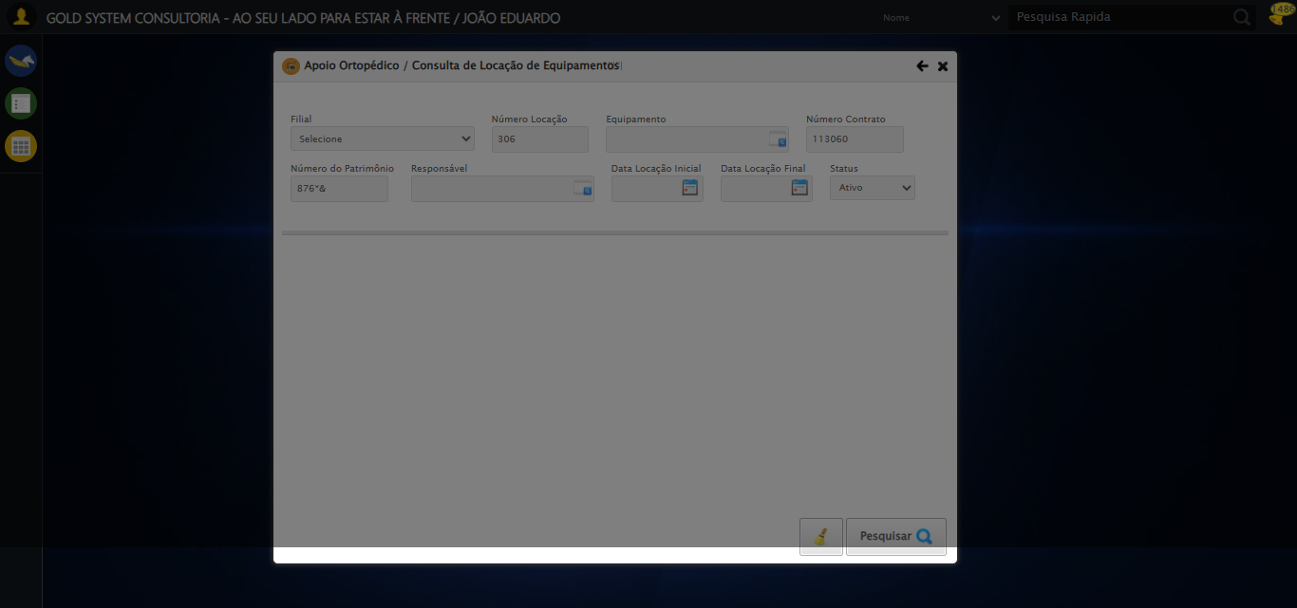

[16:37:34] [INFO] 🔄 Pesquisando Responsável...

[16:37:44] [INFO] ❌ Erro ao clicar robusto: Message:   
Stacktrace:  
 GetHandleVerifier [0x0x7da8a3+63283]  
 GetHandleVerifier [0x0x7da8e4+63348]  
 (No symbol) [0x0x613e43]  
 (No symbol) [0x0x65c8de]  
 (No symbol) [0x0x65cc7b]  
 (No symbol) [0x0x6a4ef2]  
 (No symbol) [0x0x681464]  
 (No symbol) [0x0x6a271a]  
 (No symbol) [0x0x681216]  
 (No symbol) [0x0x650855]  
 (No symbol) [0x0x6516f4]  
 GetHandleVerifier [0x0xa4bb43+2623955]  
 GetHandleVerifier [0x0xa46daa+2604090]  
 GetHandleVerifier [0x0x80069a+218410]  
 GetHandleVerifier [0x0x7f0ed8+154984]  
 GetHandleVerifier [0x0x7f742d+180925]  
 GetHandleVerifier [0x0x7e22b8+94536]  
 GetHandleVerifier [0x0x7e2442+94930]  
 GetHandleVerifier [0x0x7cd5ea+9338]  
 BaseThreadInitThunk [0x0x76b1fcc9+25]  
 RtlGetAppContainerNamedObjectPath [0x0x776a82ae+286]  
 RtlGetAppContainerNamedObjectPath [0x0x776a827e+238]

[16:37:44] [INFO] ✅ Pesquisando Responsável realizada com sucesso.

Screenshot: pesquisando responsável



[16:37:45] [INFO] 🔄 Selecionando Responsável...

[16:37:55] [INFO] ❌ Erro ao clicar robusto: Message:   
Stacktrace:  
 GetHandleVerifier [0x0x7da8a3+63283]  
 GetHandleVerifier [0x0x7da8e4+63348]  
 (No symbol) [0x0x613e43]  
 (No symbol) [0x0x65c8de]  
 (No symbol) [0x0x65cc7b]  
 (No symbol) [0x0x6a4ef2]  
 (No symbol) [0x0x681464]  
 (No symbol) [0x0x6a271a]  
 (No symbol) [0x0x681216]  
 (No symbol) [0x0x650855]  
 (No symbol) [0x0x6516f4]  
 GetHandleVerifier [0x0xa4bb43+2623955]  
 GetHandleVerifier [0x0xa46daa+2604090]  
 GetHandleVerifier [0x0x80069a+218410]  
 GetHandleVerifier [0x0x7f0ed8+154984]  
 GetHandleVerifier [0x0x7f742d+180925]  
 GetHandleVerifier [0x0x7e22b8+94536]  
 GetHandleVerifier [0x0x7e2442+94930]  
 GetHandleVerifier [0x0x7cd5ea+9338]  
 BaseThreadInitThunk [0x0x76b1fcc9+25]  
 RtlGetAppContainerNamedObjectPath [0x0x776a82ae+286]  
 RtlGetAppContainerNamedObjectPath [0x0x776a827e+238]

[16:37:55] [INFO] ✅ Selecionando Responsável realizada com sucesso.

Screenshot: selecionando responsável



[16:37:56] [INFO] 🔄 Preenchendo Data Locação Inicial...

[16:37:56] [INFO] 📊 Encontrados 2 campos datepicker

[16:37:56] [INFO] 🎯 Tentativa 1: Preenchendo datepicker 0 (ID: dp1756323340761) com '21/08/2025'

[16:37:56] [INFO] Aplicando estratégia 1 para datepicker...

[16:37:57] [INFO] ✅ Datepicker preenchido com estratégia 1: '21/08/2025'

[16:37:57] [INFO] ✅ Preenchendo Data Locação Inicial realizada com sucesso.

Screenshot: preenchendo data locação inicial

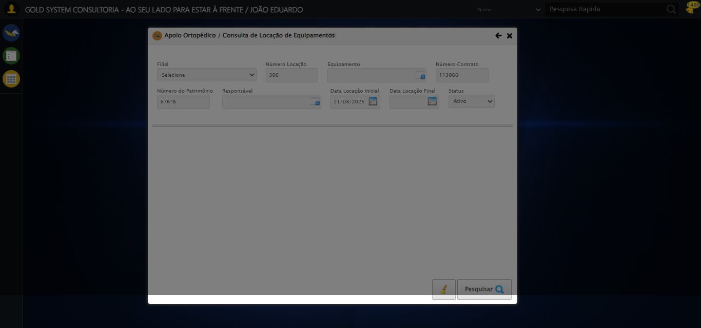

[16:37:57] [INFO] 🔄 Preenchendo Data Locação Final...

[16:37:57] [INFO] 📊 Encontrados 2 campos datepicker

[16:37:57] [INFO] 🎯 Tentativa 1: Preenchendo datepicker 1 (ID: dp1756323340762) com '21/08/2025'

[16:37:57] [INFO] Aplicando estratégia 1 para datepicker...

[16:37:58] [INFO] ✅ Datepicker preenchido com estratégia 1: '21/08/2025'

[16:37:58] [INFO] ✅ Preenchendo Data Locação Final realizada com sucesso.

Screenshot: preenchendo data locação final

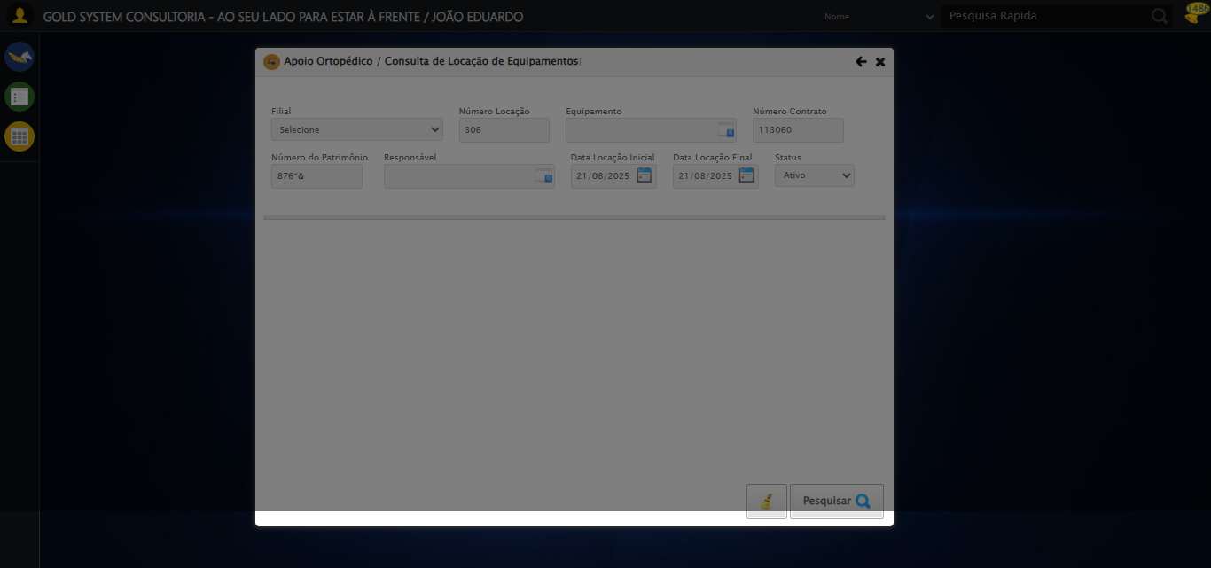

[16:37:58] [INFO] 🔄 Realizando consulta...

[16:38:00] [INFO] ❌ Erro inesperado ao realizando consulta: Message: element click intercepted: Element <a class="btModel btGray btfind">...</a> is not clickable at point (944, 566). Other element would receive the click: <div class="blockScreen" style="height: 641px; z-index: 10001; opacity: 0.5;"></div>  
 (Session info: chrome=139.0.7258.128); For documentation on this error, please visit: https://www.selenium.dev/documentation/webdriver/troubleshooting/errors#elementclickinterceptedexception  
Stacktrace:  
 GetHandleVerifier [0x0x7da8a3+63283]  
 GetHandleVerifier [0x0x7da8e4+63348]  
 (No symbol) [0x0x613e43]  
 (No symbol) [0x0x662c20]  
 (No symbol) [0x0x660fda]  
 (No symbol) [0x0x65eb37]  
 (No symbol) [0x0x65ddf4]  
 (No symbol) [0x0x6525b5]  
 (No symbol) [0x0x68141c]  
 (No symbol) [0x0x652044]  
 (No symbol) [0x0x681694]  
 (No symbol) [0x0x6a271a]  
 (No symbol) [0x0x681216]  
 (No symbol) [0x0x650855]  
 (No symbol) [0x0x6516f4]  
 GetHandleVerifier [0x0xa4bb43+2623955]  
 GetHandleVerifier [0x0xa46daa+2604090]  
 GetHandleVerifier [0x0x80069a+218410]  
 GetHandleVerifier [0x0x7f0ed8+154984]  
 GetHandleVerifier [0x0x7f742d+180925]  
 GetHandleVerifier [0x0x7e22b8+94536]  
 GetHandleVerifier [0x0x7e2442+94930]  
 GetHandleVerifier [0x0x7cd5ea+9338]  
 BaseThreadInitThunk [0x0x76b1fcc9+25]  
 RtlGetAppContainerNamedObjectPath [0x0x776a82ae+286]  
 RtlGetAppContainerNamedObjectPath [0x0x776a827e+238]

Screenshot: erro_realizando consulta



[16:38:10] [INFO] 🔄 Validando resultados da consulta...

[16:38:10] [INFO] ✅ Validando resultados da consulta realizada com sucesso.

Screenshot: validando resultados da consulta



[16:38:10] [WARN] ℹ️ Nenhum registro encontrado - Finalizando consulta

[16:38:10] [INFO] 🔄 Fechando tela (sem registros)...

[16:38:13] [INFO] ✅ Fechando tela (sem registros) realizada com sucesso.

Screenshot: fechando tela (sem registros)



[16:38:13] [INFO] ✅ Teste concluído.

[16:38:13] [INFO] ✅ Teste executado com sucesso!