RELATÓRIO DO TESTE

Cadastro de Fechamento de Rateios - Rateio – Cenário 1: Nesse teste, será realizado um fechamento de Rateio.

Data do teste: 29/08/2025 14:41:23

2025-08-29 14:41:23 ℹ️ [INFO] 🚀 Iniciando teste de Fechamento de Rateio

2025-08-29 14:41:27 ℹ️ [INFO] 🔄 Acessando sistema...

2025-08-29 14:41:27 ℹ️ [INFO] ✅ Acessando sistema realizada com sucesso.

Screenshot: acessando sistema

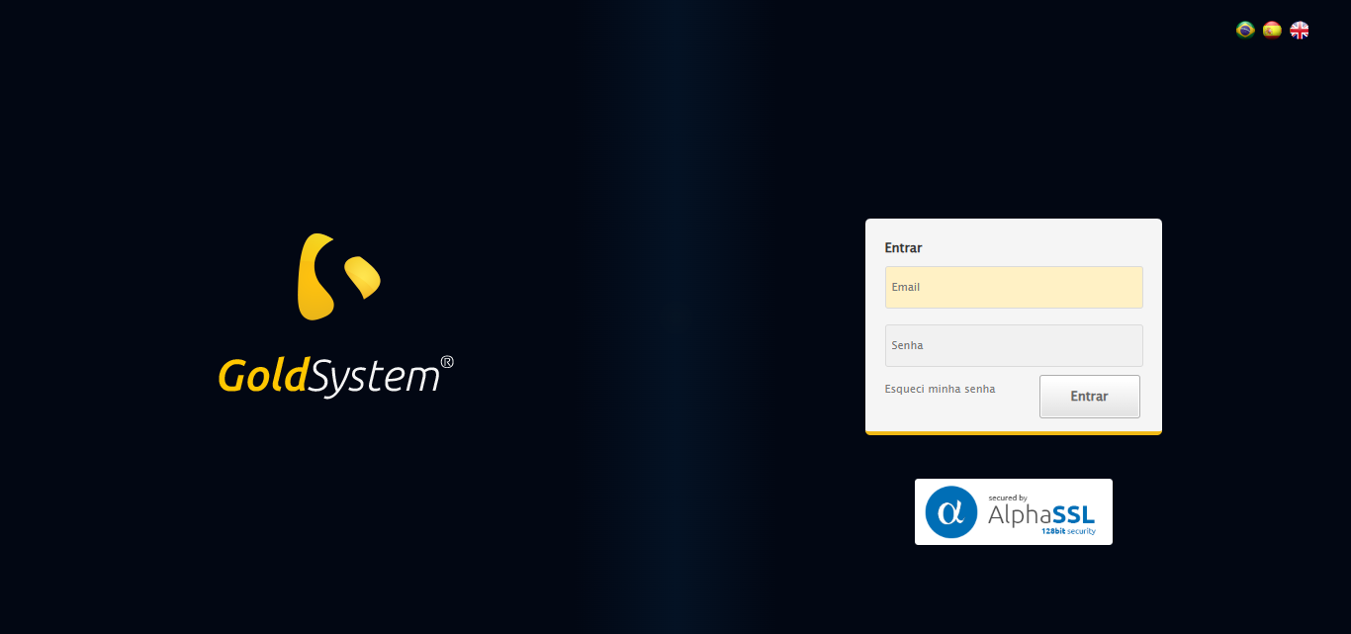

2025-08-29 14:41:28 ℹ️ [INFO] 🔄 Realizando login...

2025-08-29 14:41:33 ℹ️ [INFO] ✅ Realizando login realizada com sucesso.

Screenshot: realizando login

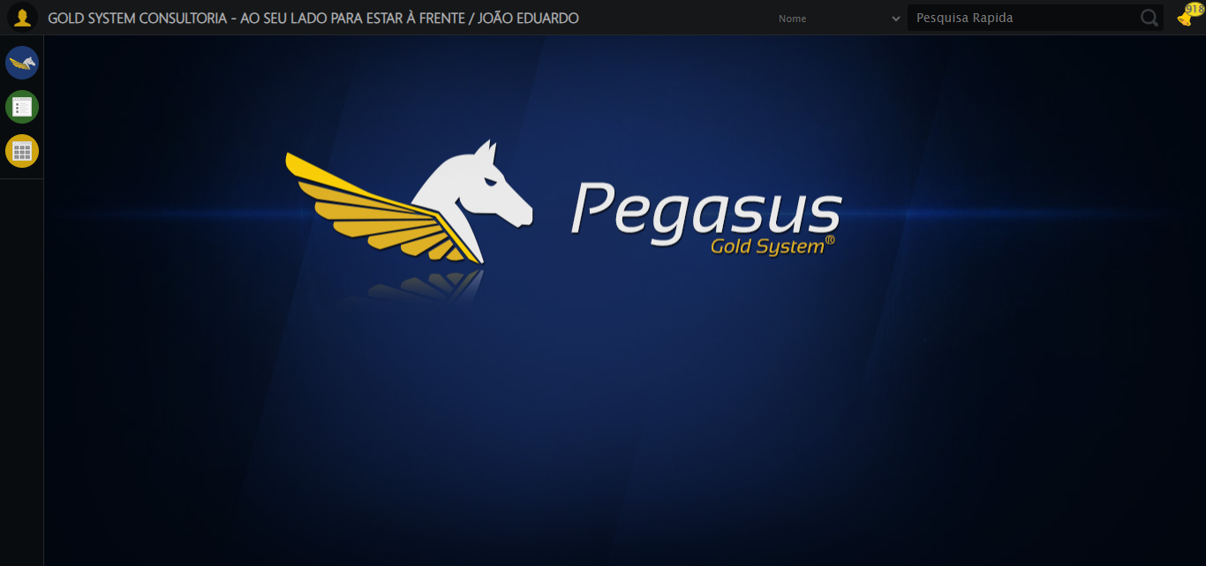

2025-08-29 14:41:38 ℹ️ [INFO] 🔄 Ajustando zoom e abrindo menu...

2025-08-29 14:41:38 ℹ️ [INFO] 🔍 Zoom ajustado para 90%.

2025-08-29 14:41:38 ℹ️ [INFO] ✅ Ajustando zoom e abrindo menu realizada com sucesso.

Screenshot: ajustando zoom e abrindo menu

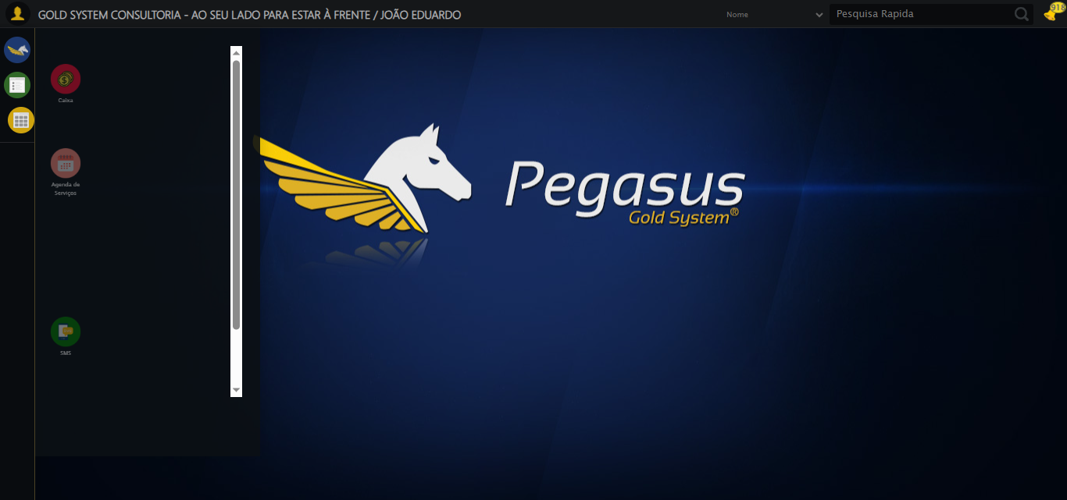

2025-08-29 14:41:38 ℹ️ [INFO] 🔄 Acessando Rateio...

2025-08-29 14:41:39 ℹ️ [INFO] ✅ Acessando Rateio realizada com sucesso.

Screenshot: acessando rateio

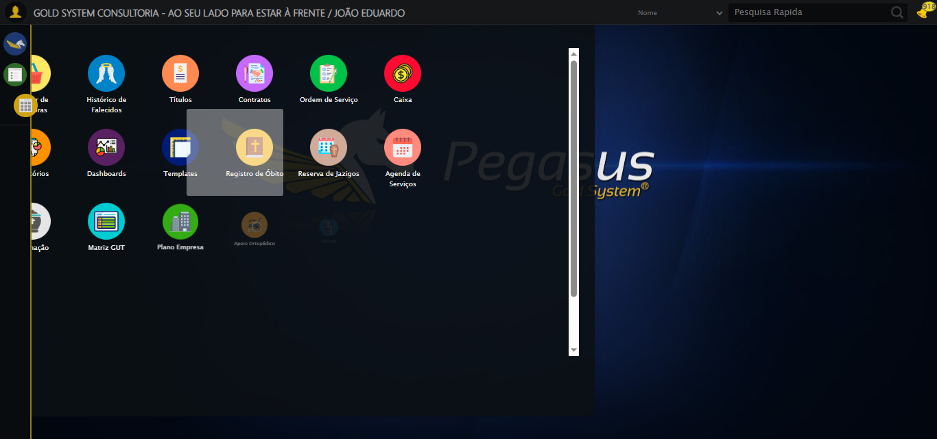

2025-08-29 14:41:39 ℹ️ [INFO] 🔄 Clicando em Fechamento de Rateio...

2025-08-29 14:41:40 ℹ️ [INFO] ✅ Clicando em Fechamento de Rateio realizada com sucesso.

Screenshot: clicando em fechamento de rateio

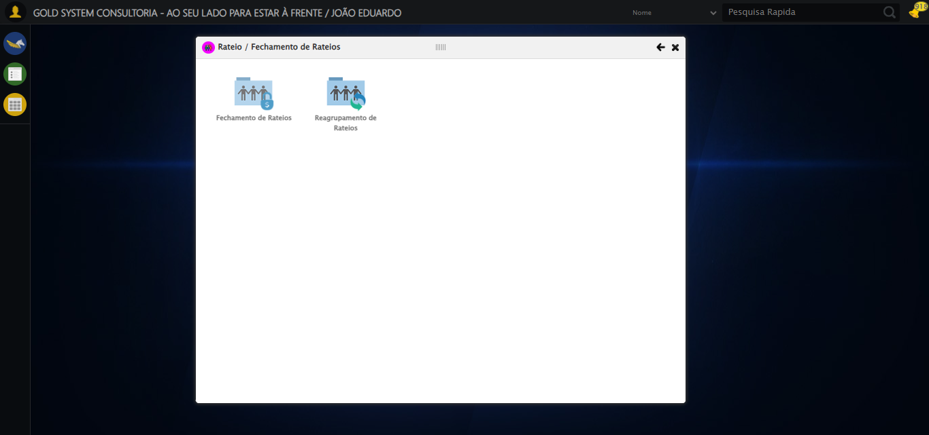

2025-08-29 14:41:45 ℹ️ [INFO] 🔄 Abrindo Lov de Grupos de Rateio...

2025-08-29 14:41:46 ℹ️ [INFO] ✅ Abrindo Lov de Grupos de Rateio realizada com sucesso.

Screenshot: abrindo lov de grupos de rateio

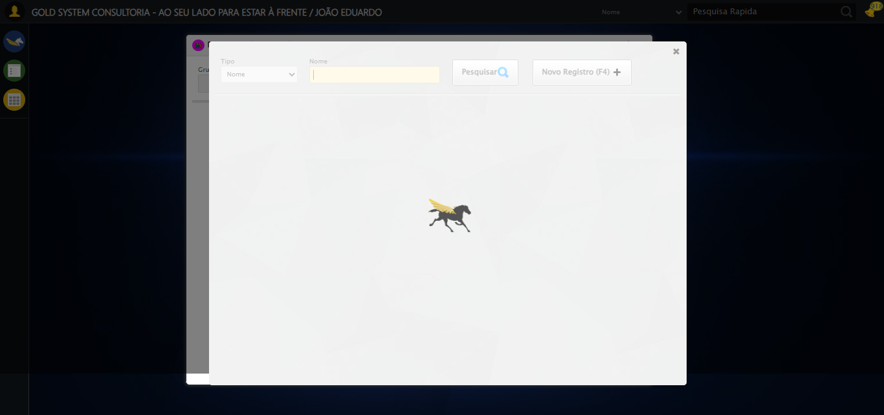

2025-08-29 14:41:47 ℹ️ [INFO] 🔄 Preenchendo Grupo de Rateio...

2025-08-29 14:41:48 ℹ️ [INFO] ✅ Preenchendo Grupo de Rateio realizada com sucesso.

Screenshot: preenchendo grupo de rateio

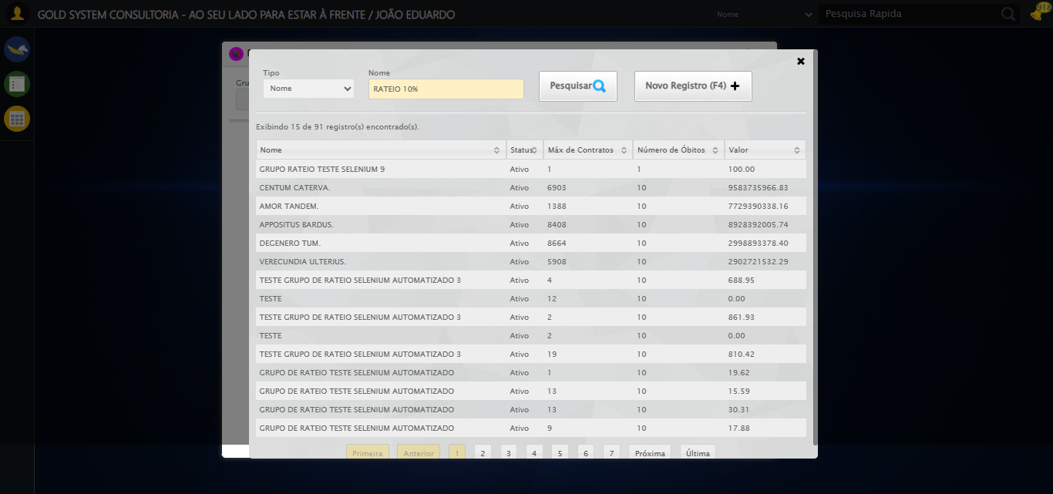

2025-08-29 14:41:48 ℹ️ [INFO] 🔄 Pesquisando Grupo de Rateio...

2025-08-29 14:41:49 ℹ️ [INFO] ✅ Pesquisando Grupo de Rateio realizada com sucesso.

Screenshot: pesquisando grupo de rateio

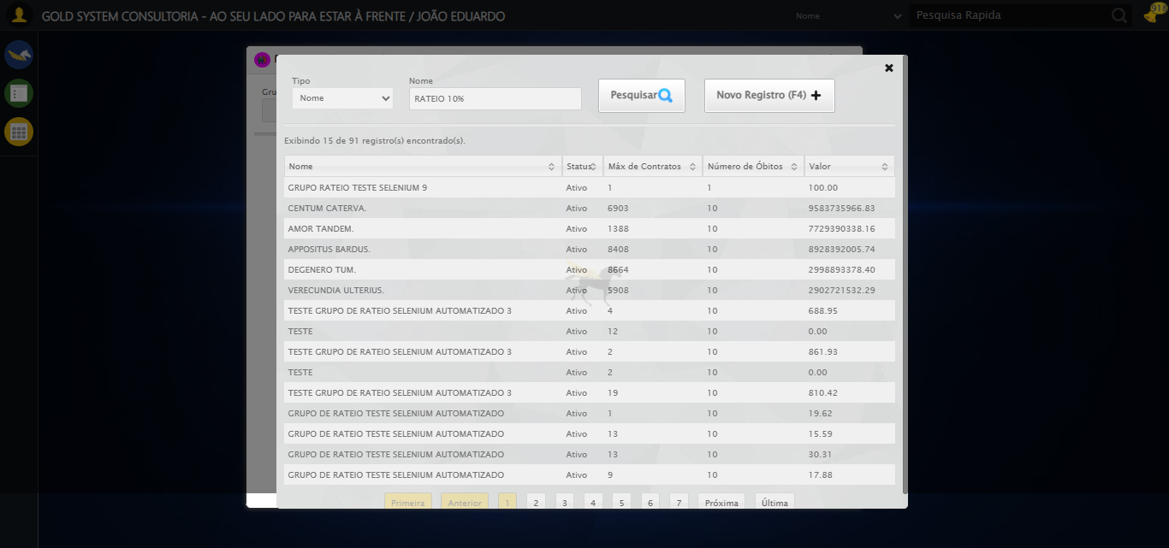

2025-08-29 14:41:49 ℹ️ [INFO] 🔄 Selecionando Grupo de Rateio...

2025-08-29 14:41:50 ℹ️ [INFO] ✅ Selecionando Grupo de Rateio realizada com sucesso.

Screenshot: selecionando grupo de rateio

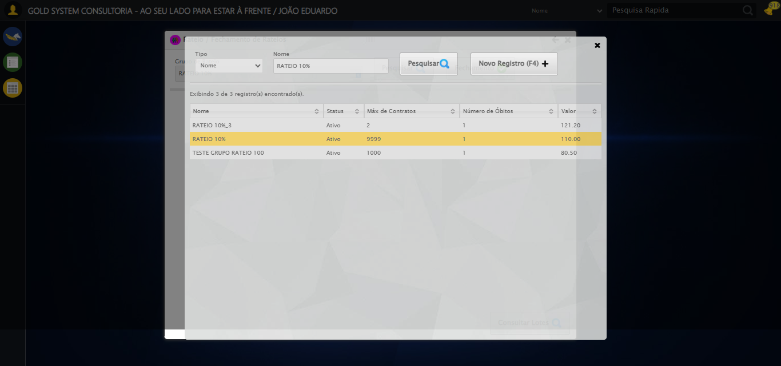

2025-08-29 14:41:50 ℹ️ [INFO] 🔄 Pesquisando Grupo de Rateio...

2025-08-29 14:41:51 ℹ️ [INFO] ✅ Pesquisando Grupo de Rateio realizada com sucesso.

2025-08-29 14:41:51 ℹ️ [INFO] 🔄 Consultando Lotes e capturando Screenshot...

2025-08-29 14:41:51 ℹ️ [INFO] ✅ Consultando Lotes e capturando Screenshot realizada com sucesso.

Screenshot: consultando lotes e capturando screenshot

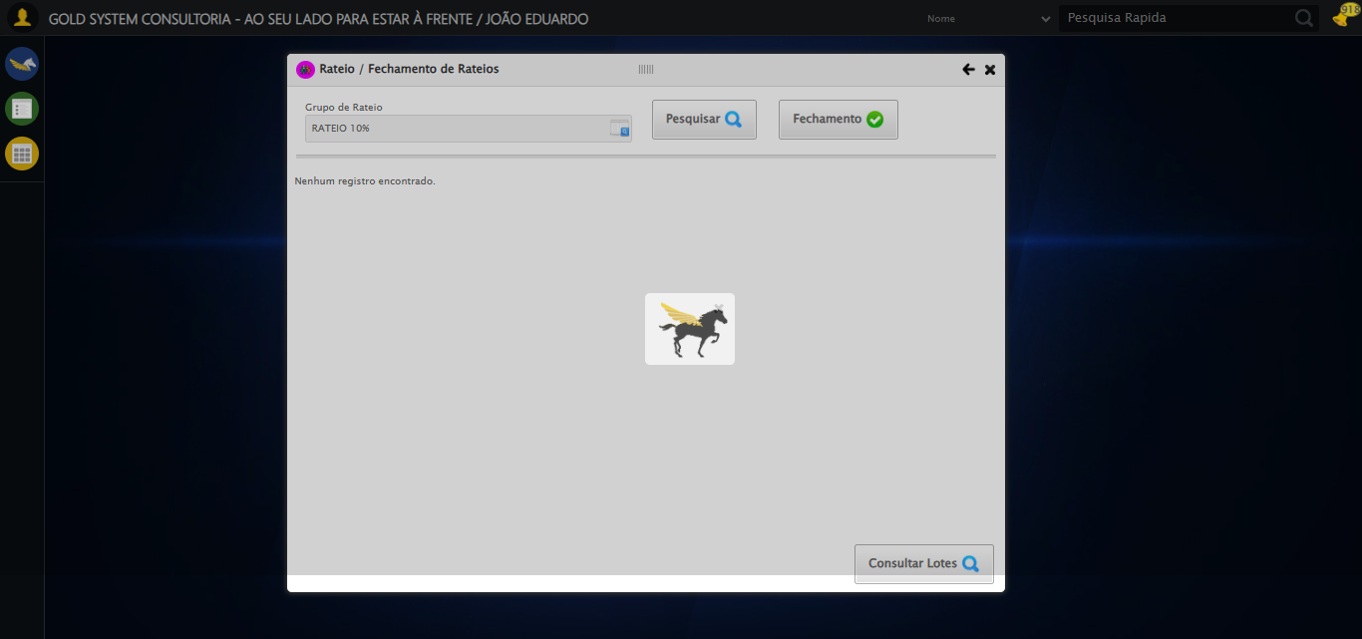

2025-08-29 14:41:52 ℹ️ [INFO] 🔄 Fechando Consulta de Lotes...

2025-08-29 14:41:53 ℹ️ [INFO] ✅ Fechando Consulta de Lotes realizada com sucesso.

Screenshot: fechando consulta de lotes

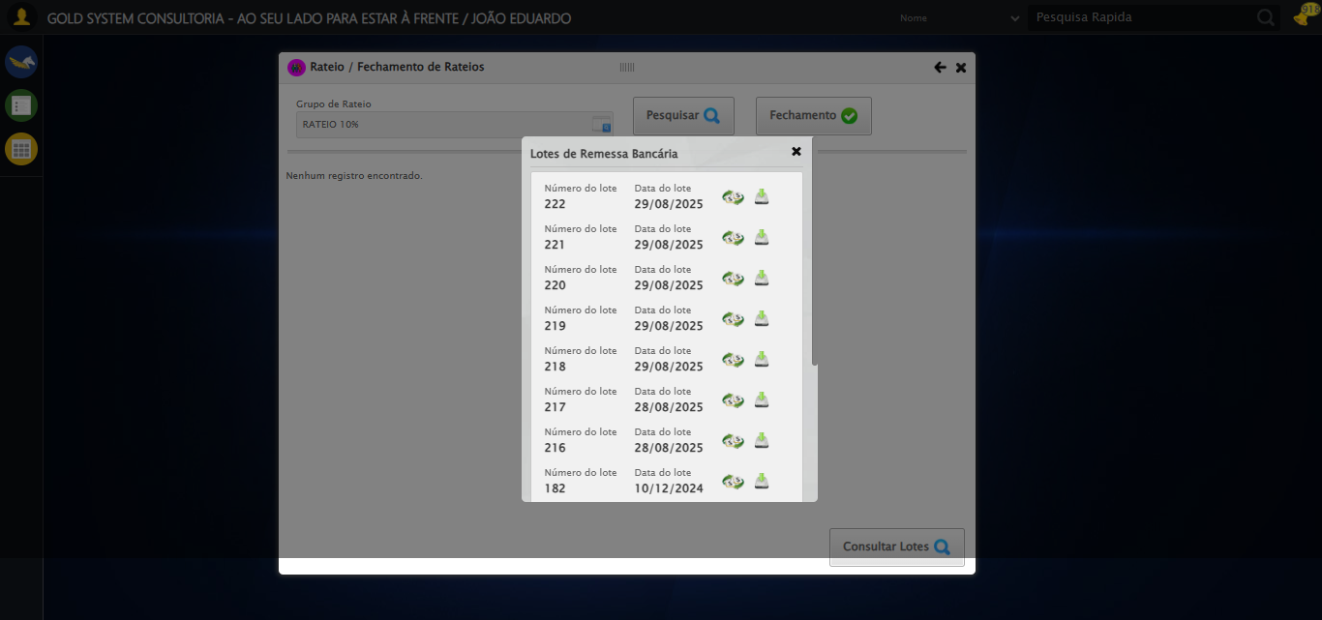

2025-08-29 14:41:55 ℹ️ [INFO] 🔄 Selecionando Falecido...

2025-08-29 14:42:15 ℹ️ [INFO] ⚠️ Tentativa 1 falhou para Selecionando Falecido, tentando novamente...

2025-08-29 14:42:17 ℹ️ [INFO] 🔄 Selecionando Falecido... (Tentativa 2)

2025-08-29 14:42:20 ℹ️ [INFO] ❌ Erro inesperado ao selecionando falecido: Message: invalid session id: session deleted as the browser has closed the connection  
from disconnected: not connected to DevTools  
 (Session info: chrome=139.0.7258.128)  
Stacktrace:  
 GetHandleVerifier [0x0xbea8a3+63283]  
 GetHandleVerifier [0x0xbea8e4+63348]  
 (No symbol) [0x0xa23e43]  
 (No symbol) [0x0xa13790]  
 (No symbol) [0x0xa31602]  
 (No symbol) [0x0xa97cdc]  
 (No symbol) [0x0xab1ff9]  
 (No symbol) [0x0xa91216]  
 (No symbol) [0x0xa60855]  
 (No symbol) [0x0xa616f4]  
 GetHandleVerifier [0x0xe5bb43+2623955]  
 GetHandleVerifier [0x0xe56daa+2604090]  
 GetHandleVerifier [0x0xc1069a+218410]  
 GetHandleVerifier [0x0xc00ed8+154984]  
 GetHandleVerifier [0x0xc0742d+180925]  
 GetHandleVerifier [0x0xbf22b8+94536]  
 GetHandleVerifier [0x0xbf2442+94930]  
 GetHandleVerifier [0x0xbdd5ea+9338]  
 BaseThreadInitThunk [0x0x76b1fcc9+25]  
 RtlGetAppContainerNamedObjectPath [0x0x776a82ae+286]  
 RtlGetAppContainerNamedObjectPath [0x0x776a827e+238]

2025-08-29 14:42:20 ℹ️ [INFO] ⚠️ Erro ao tirar screenshot erro_selecionando falecido: Message: invalid session id  
Stacktrace:  
 GetHandleVerifier [0x0xbea8a3+63283]  
 GetHandleVerifier [0x0xbea8e4+63348]  
 (No symbol) [0x0xa23ca0]  
 (No symbol) [0x0xa5fb48]  
 (No symbol) [0x0xa912d6]  
 (No symbol) [0x0xa8ceb5]  
 (No symbol) [0x0xa8c436]  
 (No symbol) [0x0x9f5755]  
 (No symbol) [0x0x9f5cae]  
 (No symbol) [0x0x9f613d]  
 GetHandleVerifier [0x0xe5bb43+2623955]  
 GetHandleVerifier [0x0xe56daa+2604090]  
 GetHandleVerifier [0x0xc1069a+218410]  
 GetHandleVerifier [0x0xc00ed8+154984]  
 GetHandleVerifier [0x0xc0742d+180925]  
 (No symbol) [0x0x9f5420]  
 (No symbol) [0x0x9f4c36]  
 GetHandleVerifier [0x0xf968fc+3913612]  
 BaseThreadInitThunk [0x0x76b1fcc9+25]  
 RtlGetAppContainerNamedObjectPath [0x0x776a82ae+286]  
 RtlGetAppContainerNamedObjectPath [0x0x776a827e+238]

2025-08-29 14:42:22 ℹ️ [INFO] 🔄 Realizando Fechamento...

2025-08-29 14:42:22 ℹ️ [INFO] ❌ Erro inesperado ao realizando fechamento: Message: invalid session id  
Stacktrace:  
 GetHandleVerifier [0x0xbea8a3+63283]  
 GetHandleVerifier [0x0xbea8e4+63348]  
 (No symbol) [0x0xa23ca0]  
 (No symbol) [0x0xa5fb48]  
 (No symbol) [0x0xa912d6]  
 (No symbol) [0x0xa8ceb5]  
 (No symbol) [0x0xa8c436]  
 (No symbol) [0x0x9f5755]  
 (No symbol) [0x0x9f5cae]  
 (No symbol) [0x0x9f613d]  
 GetHandleVerifier [0x0xe5bb43+2623955]  
 GetHandleVerifier [0x0xe56daa+2604090]  
 GetHandleVerifier [0x0xc1069a+218410]  
 GetHandleVerifier [0x0xc00ed8+154984]  
 GetHandleVerifier [0x0xc0742d+180925]  
 (No symbol) [0x0x9f5420]  
 (No symbol) [0x0x9f4c36]  
 GetHandleVerifier [0x0xf968fc+3913612]  
 BaseThreadInitThunk [0x0x76b1fcc9+25]  
 RtlGetAppContainerNamedObjectPath [0x0x776a82ae+286]  
 RtlGetAppContainerNamedObjectPath [0x0x776a827e+238]

2025-08-29 14:42:22 ℹ️ [INFO] ⚠️ Erro ao tirar screenshot erro_realizando fechamento: Message: invalid session id  
Stacktrace:  
 GetHandleVerifier [0x0xbea8a3+63283]  
 GetHandleVerifier [0x0xbea8e4+63348]  
 (No symbol) [0x0xa23ca0]  
 (No symbol) [0x0xa5fb48]  
 (No symbol) [0x0xa912d6]  
 (No symbol) [0x0xa8ceb5]  
 (No symbol) [0x0xa8c436]  
 (No symbol) [0x0x9f5755]  
 (No symbol) [0x0x9f5cae]  
 (No symbol) [0x0x9f613d]  
 GetHandleVerifier [0x0xe5bb43+2623955]  
 GetHandleVerifier [0x0xe56daa+2604090]  
 GetHandleVerifier [0x0xc1069a+218410]  
 GetHandleVerifier [0x0xc00ed8+154984]  
 GetHandleVerifier [0x0xc0742d+180925]  
 (No symbol) [0x0x9f5420]  
 (No symbol) [0x0x9f4c36]  
 GetHandleVerifier [0x0xf968fc+3913612]  
 BaseThreadInitThunk [0x0x76b1fcc9+25]  
 RtlGetAppContainerNamedObjectPath [0x0x776a82ae+286]  
 RtlGetAppContainerNamedObjectPath [0x0x776a827e+238]

2025-08-29 14:42:22 ℹ️ [INFO] 🔄 Preenchendo Data Vencimento...

2025-08-29 14:42:22 ⚠️ [WARN] ⚠️ Erro ao buscar campos datepicker com input.hasDatepicker: Message: invalid session id  
Stacktrace:  
 GetHandleVerifier [0x0xbea8a3+63283]  
 GetHandleVerifier [0x0xbea8e4+63348]  
 (No symbol) [0x0xa23ca0]  
 (No symbol) [0x0xa5fb48]  
 (No symbol) [0x0xa912d6]  
 (No symbol) [0x0xa8ceb5]  
 (No symbol) [0x0xa8c436]  
 (No symbol) [0x0x9f5755]  
 (No symbol) [0x0x9f5cae]  
 (No symbol) [0x0x9f613d]  
 GetHandleVerifier [0x0xe5bb43+2623955]  
 GetHandleVerifier [0x0xe56daa+2604090]  
 GetHandleVerifier [0x0xc1069a+218410]  
 GetHandleVerifier [0x0xc00ed8+154984]  
 GetHandleVerifier [0x0xc0742d+180925]  
 (No symbol) [0x0x9f5420]  
 (No symbol) [0x0x9f4c36]  
 GetHandleVerifier [0x0xf968fc+3913612]  
 BaseThreadInitThunk [0x0x76b1fcc9+25]  
 RtlGetAppContainerNamedObjectPath [0x0x776a82ae+286]  
 RtlGetAppContainerNamedObjectPath [0x0x776a827e+238]

2025-08-29 14:42:22 ⚠️ [WARN] ⚠️ Erro ao buscar campos datepicker com input[id^='dp']: Message: invalid session id  
Stacktrace:  
 GetHandleVerifier [0x0xbea8a3+63283]  
 GetHandleVerifier [0x0xbea8e4+63348]  
 (No symbol) [0x0xa23ca0]  
 (No symbol) [0x0xa5fb48]  
 (No symbol) [0x0xa912d6]  
 (No symbol) [0x0xa8ceb5]  
 (No symbol) [0x0xa8c436]  
 (No symbol) [0x0x9f5755]  
 (No symbol) [0x0x9f5cae]  
 (No symbol) [0x0x9f613d]  
 GetHandleVerifier [0x0xe5bb43+2623955]  
 GetHandleVerifier [0x0xe56daa+2604090]  
 GetHandleVerifier [0x0xc1069a+218410]  
 GetHandleVerifier [0x0xc00ed8+154984]  
 GetHandleVerifier [0x0xc0742d+180925]  
 (No symbol) [0x0x9f5420]  
 (No symbol) [0x0x9f4c36]  
 GetHandleVerifier [0x0xf968fc+3913612]  
 BaseThreadInitThunk [0x0x76b1fcc9+25]  
 RtlGetAppContainerNamedObjectPath [0x0x776a82ae+286]  
 RtlGetAppContainerNamedObjectPath [0x0x776a827e+238]

2025-08-29 14:42:22 ⚠️ [WARN] ⚠️ Erro ao buscar campos datepicker com input[maxlength='10'][grupo='']: Message: invalid session id  
Stacktrace:  
 GetHandleVerifier [0x0xbea8a3+63283]  
 GetHandleVerifier [0x0xbea8e4+63348]  
 (No symbol) [0x0xa23ca0]  
 (No symbol) [0x0xa5fb48]  
 (No symbol) [0x0xa912d6]  
 (No symbol) [0x0xa8ceb5]  
 (No symbol) [0x0xa8c436]  
 (No symbol) [0x0x9f5755]  
 (No symbol) [0x0x9f5cae]  
 (No symbol) [0x0x9f613d]  
 GetHandleVerifier [0x0xe5bb43+2623955]  
 GetHandleVerifier [0x0xe56daa+2604090]  
 GetHandleVerifier [0x0xc1069a+218410]  
 GetHandleVerifier [0x0xc00ed8+154984]  
 GetHandleVerifier [0x0xc0742d+180925]  
 (No symbol) [0x0x9f5420]  
 (No symbol) [0x0x9f4c36]  
 GetHandleVerifier [0x0xf968fc+3913612]  
 BaseThreadInitThunk [0x0x76b1fcc9+25]  
 RtlGetAppContainerNamedObjectPath [0x0x776a82ae+286]  
 RtlGetAppContainerNamedObjectPath [0x0x776a827e+238]

2025-08-29 14:42:22 ⚠️ [WARN] ⚠️ Erro ao buscar campos datepicker com input[type='text'][maxlength='10']: Message: invalid session id  
Stacktrace:  
 GetHandleVerifier [0x0xbea8a3+63283]  
 GetHandleVerifier [0x0xbea8e4+63348]  
 (No symbol) [0x0xa23ca0]  
 (No symbol) [0x0xa5fb48]  
 (No symbol) [0x0xa912d6]  
 (No symbol) [0x0xa8ceb5]  
 (No symbol) [0x0xa8c436]  
 (No symbol) [0x0x9f5755]  
 (No symbol) [0x0x9f5cae]  
 (No symbol) [0x0x9f613d]  
 GetHandleVerifier [0x0xe5bb43+2623955]  
 GetHandleVerifier [0x0xe56daa+2604090]  
 GetHandleVerifier [0x0xc1069a+218410]  
 GetHandleVerifier [0x0xc00ed8+154984]  
 GetHandleVerifier [0x0xc0742d+180925]  
 (No symbol) [0x0x9f5420]  
 (No symbol) [0x0x9f4c36]  
 GetHandleVerifier [0x0xf968fc+3913612]  
 BaseThreadInitThunk [0x0x76b1fcc9+25]  
 RtlGetAppContainerNamedObjectPath [0x0x776a82ae+286]  
 RtlGetAppContainerNamedObjectPath [0x0x776a827e+238]

2025-08-29 14:42:22 ⚠️ [WARN] ⚠️ Erro ao buscar campos datepicker com input[class*='datepicker']: Message: invalid session id  
Stacktrace:  
 GetHandleVerifier [0x0xbea8a3+63283]  
 GetHandleVerifier [0x0xbea8e4+63348]  
 (No symbol) [0x0xa23ca0]  
 (No symbol) [0x0xa5fb48]  
 (No symbol) [0x0xa912d6]  
 (No symbol) [0x0xa8ceb5]  
 (No symbol) [0x0xa8c436]  
 (No symbol) [0x0x9f5755]  
 (No symbol) [0x0x9f5cae]  
 (No symbol) [0x0x9f613d]  
 GetHandleVerifier [0x0xe5bb43+2623955]  
 GetHandleVerifier [0x0xe56daa+2604090]  
 GetHandleVerifier [0x0xc1069a+218410]  
 GetHandleVerifier [0x0xc00ed8+154984]  
 GetHandleVerifier [0x0xc0742d+180925]  
 (No symbol) [0x0x9f5420]  
 (No symbol) [0x0x9f4c36]  
 GetHandleVerifier [0x0xf968fc+3913612]  
 BaseThreadInitThunk [0x0x76b1fcc9+25]  
 RtlGetAppContainerNamedObjectPath [0x0x776a82ae+286]  
 RtlGetAppContainerNamedObjectPath [0x0x776a827e+238]

2025-08-29 14:42:22 ⚠️ [WARN] ⚠️ Erro ao buscar campos datepicker com .hasDatepicker: Message: invalid session id  
Stacktrace:  
 GetHandleVerifier [0x0xbea8a3+63283]  
 GetHandleVerifier [0x0xbea8e4+63348]  
 (No symbol) [0x0xa23ca0]  
 (No symbol) [0x0xa5fb48]  
 (No symbol) [0x0xa912d6]  
 (No symbol) [0x0xa8ceb5]  
 (No symbol) [0x0xa8c436]  
 (No symbol) [0x0x9f5755]  
 (No symbol) [0x0x9f5cae]  
 (No symbol) [0x0x9f613d]  
 GetHandleVerifier [0x0xe5bb43+2623955]  
 GetHandleVerifier [0x0xe56daa+2604090]  
 GetHandleVerifier [0x0xc1069a+218410]  
 GetHandleVerifier [0x0xc00ed8+154984]  
 GetHandleVerifier [0x0xc0742d+180925]  
 (No symbol) [0x0x9f5420]  
 (No symbol) [0x0x9f4c36]  
 GetHandleVerifier [0x0xf968fc+3913612]  
 BaseThreadInitThunk [0x0x76b1fcc9+25]  
 RtlGetAppContainerNamedObjectPath [0x0x776a82ae+286]  
 RtlGetAppContainerNamedObjectPath [0x0x776a827e+238]

2025-08-29 14:42:22 ℹ️ [INFO] 📊 Encontrados 0 campos datepicker

2025-08-29 14:42:22 ⚠️ [WARN] ⚠️ Nenhum campo datepicker encontrado, tentativa 1/5

2025-08-29 14:42:24 ⚠️ [WARN] ⚠️ Erro ao buscar campos datepicker com input.hasDatepicker: Message: invalid session id  
Stacktrace:  
 GetHandleVerifier [0x0xbea8a3+63283]  
 GetHandleVerifier [0x0xbea8e4+63348]  
 (No symbol) [0x0xa23ca0]  
 (No symbol) [0x0xa5fb48]  
 (No symbol) [0x0xa912d6]  
 (No symbol) [0x0xa8ceb5]  
 (No symbol) [0x0xa8c436]  
 (No symbol) [0x0x9f5755]  
 (No symbol) [0x0x9f5cae]  
 (No symbol) [0x0x9f613d]  
 GetHandleVerifier [0x0xe5bb43+2623955]  
 GetHandleVerifier [0x0xe56daa+2604090]  
 GetHandleVerifier [0x0xc1069a+218410]  
 GetHandleVerifier [0x0xc00ed8+154984]  
 GetHandleVerifier [0x0xc0742d+180925]  
 (No symbol) [0x0x9f5420]  
 (No symbol) [0x0x9f4c36]  
 GetHandleVerifier [0x0xf968fc+3913612]  
 BaseThreadInitThunk [0x0x76b1fcc9+25]  
 RtlGetAppContainerNamedObjectPath [0x0x776a82ae+286]  
 RtlGetAppContainerNamedObjectPath [0x0x776a827e+238]

2025-08-29 14:42:24 ⚠️ [WARN] ⚠️ Erro ao buscar campos datepicker com input[id^='dp']: Message: invalid session id  
Stacktrace:  
 GetHandleVerifier [0x0xbea8a3+63283]  
 GetHandleVerifier [0x0xbea8e4+63348]  
 (No symbol) [0x0xa23ca0]  
 (No symbol) [0x0xa5fb48]  
 (No symbol) [0x0xa912d6]  
 (No symbol) [0x0xa8ceb5]  
 (No symbol) [0x0xa8c436]  
 (No symbol) [0x0x9f5755]  
 (No symbol) [0x0x9f5cae]  
 (No symbol) [0x0x9f613d]  
 GetHandleVerifier [0x0xe5bb43+2623955]  
 GetHandleVerifier [0x0xe56daa+2604090]  
 GetHandleVerifier [0x0xc1069a+218410]  
 GetHandleVerifier [0x0xc00ed8+154984]  
 GetHandleVerifier [0x0xc0742d+180925]  
 (No symbol) [0x0x9f5420]  
 (No symbol) [0x0x9f4c36]  
 GetHandleVerifier [0x0xf968fc+3913612]  
 BaseThreadInitThunk [0x0x76b1fcc9+25]  
 RtlGetAppContainerNamedObjectPath [0x0x776a82ae+286]  
 RtlGetAppContainerNamedObjectPath [0x0x776a827e+238]

2025-08-29 14:42:24 ⚠️ [WARN] ⚠️ Erro ao buscar campos datepicker com input[maxlength='10'][grupo='']: Message: invalid session id  
Stacktrace:  
 GetHandleVerifier [0x0xbea8a3+63283]  
 GetHandleVerifier [0x0xbea8e4+63348]  
 (No symbol) [0x0xa23ca0]  
 (No symbol) [0x0xa5fb48]  
 (No symbol) [0x0xa912d6]  
 (No symbol) [0x0xa8ceb5]  
 (No symbol) [0x0xa8c436]  
 (No symbol) [0x0x9f5755]  
 (No symbol) [0x0x9f5cae]  
 (No symbol) [0x0x9f613d]  
 GetHandleVerifier [0x0xe5bb43+2623955]  
 GetHandleVerifier [0x0xe56daa+2604090]  
 GetHandleVerifier [0x0xc1069a+218410]  
 GetHandleVerifier [0x0xc00ed8+154984]  
 GetHandleVerifier [0x0xc0742d+180925]  
 (No symbol) [0x0x9f5420]  
 (No symbol) [0x0x9f4c36]  
 GetHandleVerifier [0x0xf968fc+3913612]  
 BaseThreadInitThunk [0x0x76b1fcc9+25]  
 RtlGetAppContainerNamedObjectPath [0x0x776a82ae+286]  
 RtlGetAppContainerNamedObjectPath [0x0x776a827e+238]

2025-08-29 14:42:24 ⚠️ [WARN] ⚠️ Erro ao buscar campos datepicker com input[type='text'][maxlength='10']: Message: invalid session id  
Stacktrace:  
 GetHandleVerifier [0x0xbea8a3+63283]  
 GetHandleVerifier [0x0xbea8e4+63348]  
 (No symbol) [0x0xa23ca0]  
 (No symbol) [0x0xa5fb48]  
 (No symbol) [0x0xa912d6]  
 (No symbol) [0x0xa8ceb5]  
 (No symbol) [0x0xa8c436]  
 (No symbol) [0x0x9f5755]  
 (No symbol) [0x0x9f5cae]  
 (No symbol) [0x0x9f613d]  
 GetHandleVerifier [0x0xe5bb43+2623955]  
 GetHandleVerifier [0x0xe56daa+2604090]  
 GetHandleVerifier [0x0xc1069a+218410]  
 GetHandleVerifier [0x0xc00ed8+154984]  
 GetHandleVerifier [0x0xc0742d+180925]  
 (No symbol) [0x0x9f5420]  
 (No symbol) [0x0x9f4c36]  
 GetHandleVerifier [0x0xf968fc+3913612]  
 BaseThreadInitThunk [0x0x76b1fcc9+25]  
 RtlGetAppContainerNamedObjectPath [0x0x776a82ae+286]  
 RtlGetAppContainerNamedObjectPath [0x0x776a827e+238]

2025-08-29 14:42:24 ⚠️ [WARN] ⚠️ Erro ao buscar campos datepicker com input[class*='datepicker']: Message: invalid session id  
Stacktrace:  
 GetHandleVerifier [0x0xbea8a3+63283]  
 GetHandleVerifier [0x0xbea8e4+63348]  
 (No symbol) [0x0xa23ca0]  
 (No symbol) [0x0xa5fb48]  
 (No symbol) [0x0xa912d6]  
 (No symbol) [0x0xa8ceb5]  
 (No symbol) [0x0xa8c436]  
 (No symbol) [0x0x9f5755]  
 (No symbol) [0x0x9f5cae]  
 (No symbol) [0x0x9f613d]  
 GetHandleVerifier [0x0xe5bb43+2623955]  
 GetHandleVerifier [0x0xe56daa+2604090]  
 GetHandleVerifier [0x0xc1069a+218410]  
 GetHandleVerifier [0x0xc00ed8+154984]  
 GetHandleVerifier [0x0xc0742d+180925]  
 (No symbol) [0x0x9f5420]  
 (No symbol) [0x0x9f4c36]  
 GetHandleVerifier [0x0xf968fc+3913612]  
 BaseThreadInitThunk [0x0x76b1fcc9+25]  
 RtlGetAppContainerNamedObjectPath [0x0x776a82ae+286]  
 RtlGetAppContainerNamedObjectPath [0x0x776a827e+238]

2025-08-29 14:42:24 ⚠️ [WARN] ⚠️ Erro ao buscar campos datepicker com .hasDatepicker: Message: invalid session id  
Stacktrace:  
 GetHandleVerifier [0x0xbea8a3+63283]  
 GetHandleVerifier [0x0xbea8e4+63348]  
 (No symbol) [0x0xa23ca0]  
 (No symbol) [0x0xa5fb48]  
 (No symbol) [0x0xa912d6]  
 (No symbol) [0x0xa8ceb5]  
 (No symbol) [0x0xa8c436]  
 (No symbol) [0x0x9f5755]  
 (No symbol) [0x0x9f5cae]  
 (No symbol) [0x0x9f613d]  
 GetHandleVerifier [0x0xe5bb43+2623955]  
 GetHandleVerifier [0x0xe56daa+2604090]  
 GetHandleVerifier [0x0xc1069a+218410]  
 GetHandleVerifier [0x0xc00ed8+154984]  
 GetHandleVerifier [0x0xc0742d+180925]  
 (No symbol) [0x0x9f5420]  
 (No symbol) [0x0x9f4c36]  
 GetHandleVerifier [0x0xf968fc+3913612]  
 BaseThreadInitThunk [0x0x76b1fcc9+25]  
 RtlGetAppContainerNamedObjectPath [0x0x776a82ae+286]  
 RtlGetAppContainerNamedObjectPath [0x0x776a827e+238]

2025-08-29 14:42:24 ℹ️ [INFO] 📊 Encontrados 0 campos datepicker

2025-08-29 14:42:24 ⚠️ [WARN] ⚠️ Nenhum campo datepicker encontrado, tentativa 2/5

2025-08-29 14:42:26 ⚠️ [WARN] ⚠️ Erro ao buscar campos datepicker com input.hasDatepicker: Message: invalid session id  
Stacktrace:  
 GetHandleVerifier [0x0xbea8a3+63283]  
 GetHandleVerifier [0x0xbea8e4+63348]  
 (No symbol) [0x0xa23ca0]  
 (No symbol) [0x0xa5fb48]  
 (No symbol) [0x0xa912d6]  
 (No symbol) [0x0xa8ceb5]  
 (No symbol) [0x0xa8c436]  
 (No symbol) [0x0x9f5755]  
 (No symbol) [0x0x9f5cae]  
 (No symbol) [0x0x9f613d]  
 GetHandleVerifier [0x0xe5bb43+2623955]  
 GetHandleVerifier [0x0xe56daa+2604090]  
 GetHandleVerifier [0x0xc1069a+218410]  
 GetHandleVerifier [0x0xc00ed8+154984]  
 GetHandleVerifier [0x0xc0742d+180925]  
 (No symbol) [0x0x9f5420]  
 (No symbol) [0x0x9f4c36]  
 GetHandleVerifier [0x0xf968fc+3913612]  
 BaseThreadInitThunk [0x0x76b1fcc9+25]  
 RtlGetAppContainerNamedObjectPath [0x0x776a82ae+286]  
 RtlGetAppContainerNamedObjectPath [0x0x776a827e+238]

2025-08-29 14:42:26 ⚠️ [WARN] ⚠️ Erro ao buscar campos datepicker com input[id^='dp']: Message: invalid session id  
Stacktrace:  
 GetHandleVerifier [0x0xbea8a3+63283]  
 GetHandleVerifier [0x0xbea8e4+63348]  
 (No symbol) [0x0xa23ca0]  
 (No symbol) [0x0xa5fb48]  
 (No symbol) [0x0xa912d6]  
 (No symbol) [0x0xa8ceb5]  
 (No symbol) [0x0xa8c436]  
 (No symbol) [0x0x9f5755]  
 (No symbol) [0x0x9f5cae]  
 (No symbol) [0x0x9f613d]  
 GetHandleVerifier [0x0xe5bb43+2623955]  
 GetHandleVerifier [0x0xe56daa+2604090]  
 GetHandleVerifier [0x0xc1069a+218410]  
 GetHandleVerifier [0x0xc00ed8+154984]  
 GetHandleVerifier [0x0xc0742d+180925]  
 (No symbol) [0x0x9f5420]  
 (No symbol) [0x0x9f4c36]  
 GetHandleVerifier [0x0xf968fc+3913612]  
 BaseThreadInitThunk [0x0x76b1fcc9+25]  
 RtlGetAppContainerNamedObjectPath [0x0x776a82ae+286]  
 RtlGetAppContainerNamedObjectPath [0x0x776a827e+238]

2025-08-29 14:42:26 ⚠️ [WARN] ⚠️ Erro ao buscar campos datepicker com input[maxlength='10'][grupo='']: Message: invalid session id  
Stacktrace:  
 GetHandleVerifier [0x0xbea8a3+63283]  
 GetHandleVerifier [0x0xbea8e4+63348]  
 (No symbol) [0x0xa23ca0]  
 (No symbol) [0x0xa5fb48]  
 (No symbol) [0x0xa912d6]  
 (No symbol) [0x0xa8ceb5]  
 (No symbol) [0x0xa8c436]  
 (No symbol) [0x0x9f5755]  
 (No symbol) [0x0x9f5cae]  
 (No symbol) [0x0x9f613d]  
 GetHandleVerifier [0x0xe5bb43+2623955]  
 GetHandleVerifier [0x0xe56daa+2604090]  
 GetHandleVerifier [0x0xc1069a+218410]  
 GetHandleVerifier [0x0xc00ed8+154984]  
 GetHandleVerifier [0x0xc0742d+180925]  
 (No symbol) [0x0x9f5420]  
 (No symbol) [0x0x9f4c36]  
 GetHandleVerifier [0x0xf968fc+3913612]  
 BaseThreadInitThunk [0x0x76b1fcc9+25]  
 RtlGetAppContainerNamedObjectPath [0x0x776a82ae+286]  
 RtlGetAppContainerNamedObjectPath [0x0x776a827e+238]

2025-08-29 14:42:26 ⚠️ [WARN] ⚠️ Erro ao buscar campos datepicker com input[type='text'][maxlength='10']: Message: invalid session id  
Stacktrace:  
 GetHandleVerifier [0x0xbea8a3+63283]  
 GetHandleVerifier [0x0xbea8e4+63348]  
 (No symbol) [0x0xa23ca0]  
 (No symbol) [0x0xa5fb48]  
 (No symbol) [0x0xa912d6]  
 (No symbol) [0x0xa8ceb5]  
 (No symbol) [0x0xa8c436]  
 (No symbol) [0x0x9f5755]  
 (No symbol) [0x0x9f5cae]  
 (No symbol) [0x0x9f613d]  
 GetHandleVerifier [0x0xe5bb43+2623955]  
 GetHandleVerifier [0x0xe56daa+2604090]  
 GetHandleVerifier [0x0xc1069a+218410]  
 GetHandleVerifier [0x0xc00ed8+154984]  
 GetHandleVerifier [0x0xc0742d+180925]  
 (No symbol) [0x0x9f5420]  
 (No symbol) [0x0x9f4c36]  
 GetHandleVerifier [0x0xf968fc+3913612]  
 BaseThreadInitThunk [0x0x76b1fcc9+25]  
 RtlGetAppContainerNamedObjectPath [0x0x776a82ae+286]  
 RtlGetAppContainerNamedObjectPath [0x0x776a827e+238]

2025-08-29 14:42:26 ⚠️ [WARN] ⚠️ Erro ao buscar campos datepicker com input[class*='datepicker']: Message: invalid session id  
Stacktrace:  
 GetHandleVerifier [0x0xbea8a3+63283]  
 GetHandleVerifier [0x0xbea8e4+63348]  
 (No symbol) [0x0xa23ca0]  
 (No symbol) [0x0xa5fb48]  
 (No symbol) [0x0xa912d6]  
 (No symbol) [0x0xa8ceb5]  
 (No symbol) [0x0xa8c436]  
 (No symbol) [0x0x9f5755]  
 (No symbol) [0x0x9f5cae]  
 (No symbol) [0x0x9f613d]  
 GetHandleVerifier [0x0xe5bb43+2623955]  
 GetHandleVerifier [0x0xe56daa+2604090]  
 GetHandleVerifier [0x0xc1069a+218410]  
 GetHandleVerifier [0x0xc00ed8+154984]  
 GetHandleVerifier [0x0xc0742d+180925]  
 (No symbol) [0x0x9f5420]  
 (No symbol) [0x0x9f4c36]  
 GetHandleVerifier [0x0xf968fc+3913612]  
 BaseThreadInitThunk [0x0x76b1fcc9+25]  
 RtlGetAppContainerNamedObjectPath [0x0x776a82ae+286]  
 RtlGetAppContainerNamedObjectPath [0x0x776a827e+238]

2025-08-29 14:42:26 ⚠️ [WARN] ⚠️ Erro ao buscar campos datepicker com .hasDatepicker: Message: invalid session id  
Stacktrace:  
 GetHandleVerifier [0x0xbea8a3+63283]  
 GetHandleVerifier [0x0xbea8e4+63348]  
 (No symbol) [0x0xa23ca0]  
 (No symbol) [0x0xa5fb48]  
 (No symbol) [0x0xa912d6]  
 (No symbol) [0x0xa8ceb5]  
 (No symbol) [0x0xa8c436]  
 (No symbol) [0x0x9f5755]  
 (No symbol) [0x0x9f5cae]  
 (No symbol) [0x0x9f613d]  
 GetHandleVerifier [0x0xe5bb43+2623955]  
 GetHandleVerifier [0x0xe56daa+2604090]  
 GetHandleVerifier [0x0xc1069a+218410]  
 GetHandleVerifier [0x0xc00ed8+154984]  
 GetHandleVerifier [0x0xc0742d+180925]  
 (No symbol) [0x0x9f5420]  
 (No symbol) [0x0x9f4c36]  
 GetHandleVerifier [0x0xf968fc+3913612]  
 BaseThreadInitThunk [0x0x76b1fcc9+25]  
 RtlGetAppContainerNamedObjectPath [0x0x776a82ae+286]  
 RtlGetAppContainerNamedObjectPath [0x0x776a827e+238]

2025-08-29 14:42:26 ℹ️ [INFO] 📊 Encontrados 0 campos datepicker

2025-08-29 14:42:26 ⚠️ [WARN] ⚠️ Nenhum campo datepicker encontrado, tentativa 3/5

2025-08-29 14:42:28 ⚠️ [WARN] ⚠️ Erro ao buscar campos datepicker com input.hasDatepicker: Message: invalid session id  
Stacktrace:  
 GetHandleVerifier [0x0xbea8a3+63283]  
 GetHandleVerifier [0x0xbea8e4+63348]  
 (No symbol) [0x0xa23ca0]  
 (No symbol) [0x0xa5fb48]  
 (No symbol) [0x0xa912d6]  
 (No symbol) [0x0xa8ceb5]  
 (No symbol) [0x0xa8c436]  
 (No symbol) [0x0x9f5755]  
 (No symbol) [0x0x9f5cae]  
 (No symbol) [0x0x9f613d]  
 GetHandleVerifier [0x0xe5bb43+2623955]  
 GetHandleVerifier [0x0xe56daa+2604090]  
 GetHandleVerifier [0x0xc1069a+218410]  
 GetHandleVerifier [0x0xc00ed8+154984]  
 GetHandleVerifier [0x0xc0742d+180925]  
 (No symbol) [0x0x9f5420]  
 (No symbol) [0x0x9f4c36]  
 GetHandleVerifier [0x0xf968fc+3913612]  
 BaseThreadInitThunk [0x0x76b1fcc9+25]  
 RtlGetAppContainerNamedObjectPath [0x0x776a82ae+286]  
 RtlGetAppContainerNamedObjectPath [0x0x776a827e+238]

2025-08-29 14:42:28 ⚠️ [WARN] ⚠️ Erro ao buscar campos datepicker com input[id^='dp']: Message: invalid session id  
Stacktrace:  
 GetHandleVerifier [0x0xbea8a3+63283]  
 GetHandleVerifier [0x0xbea8e4+63348]  
 (No symbol) [0x0xa23ca0]  
 (No symbol) [0x0xa5fb48]  
 (No symbol) [0x0xa912d6]  
 (No symbol) [0x0xa8ceb5]  
 (No symbol) [0x0xa8c436]  
 (No symbol) [0x0x9f5755]  
 (No symbol) [0x0x9f5cae]  
 (No symbol) [0x0x9f613d]  
 GetHandleVerifier [0x0xe5bb43+2623955]  
 GetHandleVerifier [0x0xe56daa+2604090]  
 GetHandleVerifier [0x0xc1069a+218410]  
 GetHandleVerifier [0x0xc00ed8+154984]  
 GetHandleVerifier [0x0xc0742d+180925]  
 (No symbol) [0x0x9f5420]  
 (No symbol) [0x0x9f4c36]  
 GetHandleVerifier [0x0xf968fc+3913612]  
 BaseThreadInitThunk [0x0x76b1fcc9+25]  
 RtlGetAppContainerNamedObjectPath [0x0x776a82ae+286]  
 RtlGetAppContainerNamedObjectPath [0x0x776a827e+238]

2025-08-29 14:42:28 ⚠️ [WARN] ⚠️ Erro ao buscar campos datepicker com input[maxlength='10'][grupo='']: Message: invalid session id  
Stacktrace:  
 GetHandleVerifier [0x0xbea8a3+63283]  
 GetHandleVerifier [0x0xbea8e4+63348]  
 (No symbol) [0x0xa23ca0]  
 (No symbol) [0x0xa5fb48]  
 (No symbol) [0x0xa912d6]  
 (No symbol) [0x0xa8ceb5]  
 (No symbol) [0x0xa8c436]  
 (No symbol) [0x0x9f5755]  
 (No symbol) [0x0x9f5cae]  
 (No symbol) [0x0x9f613d]  
 GetHandleVerifier [0x0xe5bb43+2623955]  
 GetHandleVerifier [0x0xe56daa+2604090]  
 GetHandleVerifier [0x0xc1069a+218410]  
 GetHandleVerifier [0x0xc00ed8+154984]  
 GetHandleVerifier [0x0xc0742d+180925]  
 (No symbol) [0x0x9f5420]  
 (No symbol) [0x0x9f4c36]  
 GetHandleVerifier [0x0xf968fc+3913612]  
 BaseThreadInitThunk [0x0x76b1fcc9+25]  
 RtlGetAppContainerNamedObjectPath [0x0x776a82ae+286]  
 RtlGetAppContainerNamedObjectPath [0x0x776a827e+238]

2025-08-29 14:42:28 ⚠️ [WARN] ⚠️ Erro ao buscar campos datepicker com input[type='text'][maxlength='10']: Message: invalid session id  
Stacktrace:  
 GetHandleVerifier [0x0xbea8a3+63283]  
 GetHandleVerifier [0x0xbea8e4+63348]  
 (No symbol) [0x0xa23ca0]  
 (No symbol) [0x0xa5fb48]  
 (No symbol) [0x0xa912d6]  
 (No symbol) [0x0xa8ceb5]  
 (No symbol) [0x0xa8c436]  
 (No symbol) [0x0x9f5755]  
 (No symbol) [0x0x9f5cae]  
 (No symbol) [0x0x9f613d]  
 GetHandleVerifier [0x0xe5bb43+2623955]  
 GetHandleVerifier [0x0xe56daa+2604090]  
 GetHandleVerifier [0x0xc1069a+218410]  
 GetHandleVerifier [0x0xc00ed8+154984]  
 GetHandleVerifier [0x0xc0742d+180925]  
 (No symbol) [0x0x9f5420]  
 (No symbol) [0x0x9f4c36]  
 GetHandleVerifier [0x0xf968fc+3913612]  
 BaseThreadInitThunk [0x0x76b1fcc9+25]  
 RtlGetAppContainerNamedObjectPath [0x0x776a82ae+286]  
 RtlGetAppContainerNamedObjectPath [0x0x776a827e+238]

2025-08-29 14:42:28 ⚠️ [WARN] ⚠️ Erro ao buscar campos datepicker com input[class*='datepicker']: Message: invalid session id  
Stacktrace:  
 GetHandleVerifier [0x0xbea8a3+63283]  
 GetHandleVerifier [0x0xbea8e4+63348]  
 (No symbol) [0x0xa23ca0]  
 (No symbol) [0x0xa5fb48]  
 (No symbol) [0x0xa912d6]  
 (No symbol) [0x0xa8ceb5]  
 (No symbol) [0x0xa8c436]  
 (No symbol) [0x0x9f5755]  
 (No symbol) [0x0x9f5cae]  
 (No symbol) [0x0x9f613d]  
 GetHandleVerifier [0x0xe5bb43+2623955]  
 GetHandleVerifier [0x0xe56daa+2604090]  
 GetHandleVerifier [0x0xc1069a+218410]  
 GetHandleVerifier [0x0xc00ed8+154984]  
 GetHandleVerifier [0x0xc0742d+180925]  
 (No symbol) [0x0x9f5420]  
 (No symbol) [0x0x9f4c36]  
 GetHandleVerifier [0x0xf968fc+3913612]  
 BaseThreadInitThunk [0x0x76b1fcc9+25]  
 RtlGetAppContainerNamedObjectPath [0x0x776a82ae+286]  
 RtlGetAppContainerNamedObjectPath [0x0x776a827e+238]

2025-08-29 14:42:28 ⚠️ [WARN] ⚠️ Erro ao buscar campos datepicker com .hasDatepicker: Message: invalid session id  
Stacktrace:  
 GetHandleVerifier [0x0xbea8a3+63283]  
 GetHandleVerifier [0x0xbea8e4+63348]  
 (No symbol) [0x0xa23ca0]  
 (No symbol) [0x0xa5fb48]  
 (No symbol) [0x0xa912d6]  
 (No symbol) [0x0xa8ceb5]  
 (No symbol) [0x0xa8c436]  
 (No symbol) [0x0x9f5755]  
 (No symbol) [0x0x9f5cae]  
 (No symbol) [0x0x9f613d]  
 GetHandleVerifier [0x0xe5bb43+2623955]  
 GetHandleVerifier [0x0xe56daa+2604090]  
 GetHandleVerifier [0x0xc1069a+218410]  
 GetHandleVerifier [0x0xc00ed8+154984]  
 GetHandleVerifier [0x0xc0742d+180925]  
 (No symbol) [0x0x9f5420]  
 (No symbol) [0x0x9f4c36]  
 GetHandleVerifier [0x0xf968fc+3913612]  
 BaseThreadInitThunk [0x0x76b1fcc9+25]  
 RtlGetAppContainerNamedObjectPath [0x0x776a82ae+286]  
 RtlGetAppContainerNamedObjectPath [0x0x776a827e+238]

2025-08-29 14:42:28 ℹ️ [INFO] 📊 Encontrados 0 campos datepicker

2025-08-29 14:42:28 ⚠️ [WARN] ⚠️ Nenhum campo datepicker encontrado, tentativa 4/5

2025-08-29 14:42:30 ⚠️ [WARN] ⚠️ Erro ao buscar campos datepicker com input.hasDatepicker: Message: invalid session id  
Stacktrace:  
 GetHandleVerifier [0x0xbea8a3+63283]  
 GetHandleVerifier [0x0xbea8e4+63348]  
 (No symbol) [0x0xa23ca0]  
 (No symbol) [0x0xa5fb48]  
 (No symbol) [0x0xa912d6]  
 (No symbol) [0x0xa8ceb5]  
 (No symbol) [0x0xa8c436]  
 (No symbol) [0x0x9f5755]  
 (No symbol) [0x0x9f5cae]  
 (No symbol) [0x0x9f613d]  
 GetHandleVerifier [0x0xe5bb43+2623955]  
 GetHandleVerifier [0x0xe56daa+2604090]  
 GetHandleVerifier [0x0xc1069a+218410]  
 GetHandleVerifier [0x0xc00ed8+154984]  
 GetHandleVerifier [0x0xc0742d+180925]  
 (No symbol) [0x0x9f5420]  
 (No symbol) [0x0x9f4c36]  
 GetHandleVerifier [0x0xf968fc+3913612]  
 BaseThreadInitThunk [0x0x76b1fcc9+25]  
 RtlGetAppContainerNamedObjectPath [0x0x776a82ae+286]  
 RtlGetAppContainerNamedObjectPath [0x0x776a827e+238]

2025-08-29 14:42:30 ⚠️ [WARN] ⚠️ Erro ao buscar campos datepicker com input[id^='dp']: Message: invalid session id  
Stacktrace:  
 GetHandleVerifier [0x0xbea8a3+63283]  
 GetHandleVerifier [0x0xbea8e4+63348]  
 (No symbol) [0x0xa23ca0]  
 (No symbol) [0x0xa5fb48]  
 (No symbol) [0x0xa912d6]  
 (No symbol) [0x0xa8ceb5]  
 (No symbol) [0x0xa8c436]  
 (No symbol) [0x0x9f5755]  
 (No symbol) [0x0x9f5cae]  
 (No symbol) [0x0x9f613d]  
 GetHandleVerifier [0x0xe5bb43+2623955]  
 GetHandleVerifier [0x0xe56daa+2604090]  
 GetHandleVerifier [0x0xc1069a+218410]  
 GetHandleVerifier [0x0xc00ed8+154984]  
 GetHandleVerifier [0x0xc0742d+180925]  
 (No symbol) [0x0x9f5420]  
 (No symbol) [0x0x9f4c36]  
 GetHandleVerifier [0x0xf968fc+3913612]  
 BaseThreadInitThunk [0x0x76b1fcc9+25]  
 RtlGetAppContainerNamedObjectPath [0x0x776a82ae+286]  
 RtlGetAppContainerNamedObjectPath [0x0x776a827e+238]

2025-08-29 14:42:30 ⚠️ [WARN] ⚠️ Erro ao buscar campos datepicker com input[maxlength='10'][grupo='']: Message: invalid session id  
Stacktrace:  
 GetHandleVerifier [0x0xbea8a3+63283]  
 GetHandleVerifier [0x0xbea8e4+63348]  
 (No symbol) [0x0xa23ca0]  
 (No symbol) [0x0xa5fb48]  
 (No symbol) [0x0xa912d6]  
 (No symbol) [0x0xa8ceb5]  
 (No symbol) [0x0xa8c436]  
 (No symbol) [0x0x9f5755]  
 (No symbol) [0x0x9f5cae]  
 (No symbol) [0x0x9f613d]  
 GetHandleVerifier [0x0xe5bb43+2623955]  
 GetHandleVerifier [0x0xe56daa+2604090]  
 GetHandleVerifier [0x0xc1069a+218410]  
 GetHandleVerifier [0x0xc00ed8+154984]  
 GetHandleVerifier [0x0xc0742d+180925]  
 (No symbol) [0x0x9f5420]  
 (No symbol) [0x0x9f4c36]  
 GetHandleVerifier [0x0xf968fc+3913612]  
 BaseThreadInitThunk [0x0x76b1fcc9+25]  
 RtlGetAppContainerNamedObjectPath [0x0x776a82ae+286]  
 RtlGetAppContainerNamedObjectPath [0x0x776a827e+238]

2025-08-29 14:42:30 ⚠️ [WARN] ⚠️ Erro ao buscar campos datepicker com input[type='text'][maxlength='10']: Message: invalid session id  
Stacktrace:  
 GetHandleVerifier [0x0xbea8a3+63283]  
 GetHandleVerifier [0x0xbea8e4+63348]  
 (No symbol) [0x0xa23ca0]  
 (No symbol) [0x0xa5fb48]  
 (No symbol) [0x0xa912d6]  
 (No symbol) [0x0xa8ceb5]  
 (No symbol) [0x0xa8c436]  
 (No symbol) [0x0x9f5755]  
 (No symbol) [0x0x9f5cae]  
 (No symbol) [0x0x9f613d]  
 GetHandleVerifier [0x0xe5bb43+2623955]  
 GetHandleVerifier [0x0xe56daa+2604090]  
 GetHandleVerifier [0x0xc1069a+218410]  
 GetHandleVerifier [0x0xc00ed8+154984]  
 GetHandleVerifier [0x0xc0742d+180925]  
 (No symbol) [0x0x9f5420]  
 (No symbol) [0x0x9f4c36]  
 GetHandleVerifier [0x0xf968fc+3913612]  
 BaseThreadInitThunk [0x0x76b1fcc9+25]  
 RtlGetAppContainerNamedObjectPath [0x0x776a82ae+286]  
 RtlGetAppContainerNamedObjectPath [0x0x776a827e+238]

2025-08-29 14:42:30 ⚠️ [WARN] ⚠️ Erro ao buscar campos datepicker com input[class*='datepicker']: Message: invalid session id  
Stacktrace:  
 GetHandleVerifier [0x0xbea8a3+63283]  
 GetHandleVerifier [0x0xbea8e4+63348]  
 (No symbol) [0x0xa23ca0]  
 (No symbol) [0x0xa5fb48]  
 (No symbol) [0x0xa912d6]  
 (No symbol) [0x0xa8ceb5]  
 (No symbol) [0x0xa8c436]  
 (No symbol) [0x0x9f5755]  
 (No symbol) [0x0x9f5cae]  
 (No symbol) [0x0x9f613d]  
 GetHandleVerifier [0x0xe5bb43+2623955]  
 GetHandleVerifier [0x0xe56daa+2604090]  
 GetHandleVerifier [0x0xc1069a+218410]  
 GetHandleVerifier [0x0xc00ed8+154984]  
 GetHandleVerifier [0x0xc0742d+180925]  
 (No symbol) [0x0x9f5420]  
 (No symbol) [0x0x9f4c36]  
 GetHandleVerifier [0x0xf968fc+3913612]  
 BaseThreadInitThunk [0x0x76b1fcc9+25]  
 RtlGetAppContainerNamedObjectPath [0x0x776a82ae+286]  
 RtlGetAppContainerNamedObjectPath [0x0x776a827e+238]

2025-08-29 14:42:30 ⚠️ [WARN] ⚠️ Erro ao buscar campos datepicker com .hasDatepicker: Message: invalid session id  
Stacktrace:  
 GetHandleVerifier [0x0xbea8a3+63283]  
 GetHandleVerifier [0x0xbea8e4+63348]  
 (No symbol) [0x0xa23ca0]  
 (No symbol) [0x0xa5fb48]  
 (No symbol) [0x0xa912d6]  
 (No symbol) [0x0xa8ceb5]  
 (No symbol) [0x0xa8c436]  
 (No symbol) [0x0x9f5755]  
 (No symbol) [0x0x9f5cae]  
 (No symbol) [0x0x9f613d]  
 GetHandleVerifier [0x0xe5bb43+2623955]  
 GetHandleVerifier [0x0xe56daa+2604090]  
 GetHandleVerifier [0x0xc1069a+218410]  
 GetHandleVerifier [0x0xc00ed8+154984]  
 GetHandleVerifier [0x0xc0742d+180925]  
 (No symbol) [0x0x9f5420]  
 (No symbol) [0x0x9f4c36]  
 GetHandleVerifier [0x0xf968fc+3913612]  
 BaseThreadInitThunk [0x0x76b1fcc9+25]  
 RtlGetAppContainerNamedObjectPath [0x0x776a82ae+286]  
 RtlGetAppContainerNamedObjectPath [0x0x776a827e+238]

2025-08-29 14:42:30 ℹ️ [INFO] 📊 Encontrados 0 campos datepicker

2025-08-29 14:42:30 ℹ️ [INFO] ❌ Erro inesperado ao preenchendo data vencimento: Nenhum campo datepicker encontrado na página

2025-08-29 14:42:30 ℹ️ [INFO] ⚠️ Erro ao tirar screenshot erro_preenchendo data vencimento: Message: invalid session id  
Stacktrace:  
 GetHandleVerifier [0x0xbea8a3+63283]  
 GetHandleVerifier [0x0xbea8e4+63348]  
 (No symbol) [0x0xa23ca0]  
 (No symbol) [0x0xa5fb48]  
 (No symbol) [0x0xa912d6]  
 (No symbol) [0x0xa8ceb5]  
 (No symbol) [0x0xa8c436]  
 (No symbol) [0x0x9f5755]  
 (No symbol) [0x0x9f5cae]  
 (No symbol) [0x0x9f613d]  
 GetHandleVerifier [0x0xe5bb43+2623955]  
 GetHandleVerifier [0x0xe56daa+2604090]  
 GetHandleVerifier [0x0xc1069a+218410]  
 GetHandleVerifier [0x0xc00ed8+154984]  
 GetHandleVerifier [0x0xc0742d+180925]  
 (No symbol) [0x0x9f5420]  
 (No symbol) [0x0x9f4c36]  
 GetHandleVerifier [0x0xf968fc+3913612]  
 BaseThreadInitThunk [0x0x76b1fcc9+25]  
 RtlGetAppContainerNamedObjectPath [0x0x776a82ae+286]  
 RtlGetAppContainerNamedObjectPath [0x0x776a827e+238]

2025-08-29 14:42:30 ℹ️ [INFO] 🔄 Concluindo Fechamento...

2025-08-29 14:42:30 ℹ️ [INFO] ❌ Erro ao clicar robusto: Message: invalid session id  
Stacktrace:  
 GetHandleVerifier [0x0xbea8a3+63283]  
 GetHandleVerifier [0x0xbea8e4+63348]  
 (No symbol) [0x0xa23ca0]  
 (No symbol) [0x0xa5fb48]  
 (No symbol) [0x0xa912d6]  
 (No symbol) [0x0xa8ceb5]  
 (No symbol) [0x0xa8c436]  
 (No symbol) [0x0x9f5755]  
 (No symbol) [0x0x9f5cae]  
 (No symbol) [0x0x9f613d]  
 GetHandleVerifier [0x0xe5bb43+2623955]  
 GetHandleVerifier [0x0xe56daa+2604090]  
 GetHandleVerifier [0x0xc1069a+218410]  
 GetHandleVerifier [0x0xc00ed8+154984]  
 GetHandleVerifier [0x0xc0742d+180925]  
 (No symbol) [0x0x9f5420]  
 (No symbol) [0x0x9f4c36]  
 GetHandleVerifier [0x0xf968fc+3913612]  
 BaseThreadInitThunk [0x0x76b1fcc9+25]  
 RtlGetAppContainerNamedObjectPath [0x0x776a82ae+286]  
 RtlGetAppContainerNamedObjectPath [0x0x776a827e+238]

2025-08-29 14:42:30 ℹ️ [INFO] ✅ Concluindo Fechamento realizada com sucesso.

2025-08-29 14:42:30 ℹ️ [INFO] ⚠️ Erro ao tirar screenshot concluindo fechamento: Message: invalid session id  
Stacktrace:  
 GetHandleVerifier [0x0xbea8a3+63283]  
 GetHandleVerifier [0x0xbea8e4+63348]  
 (No symbol) [0x0xa23ca0]  
 (No symbol) [0x0xa5fb48]  
 (No symbol) [0x0xa912d6]  
 (No symbol) [0x0xa8ceb5]  
 (No symbol) [0x0xa8c436]  
 (No symbol) [0x0x9f5755]  
 (No symbol) [0x0x9f5cae]  
 (No symbol) [0x0x9f613d]  
 GetHandleVerifier [0x0xe5bb43+2623955]  
 GetHandleVerifier [0x0xe56daa+2604090]  
 GetHandleVerifier [0x0xc1069a+218410]  
 GetHandleVerifier [0x0xc00ed8+154984]  
 GetHandleVerifier [0x0xc0742d+180925]  
 (No symbol) [0x0x9f5420]  
 (No symbol) [0x0x9f4c36]  
 GetHandleVerifier [0x0xf968fc+3913612]  
 BaseThreadInitThunk [0x0x76b1fcc9+25]  
 RtlGetAppContainerNamedObjectPath [0x0x776a82ae+286]  
 RtlGetAppContainerNamedObjectPath [0x0x776a827e+238]

2025-08-29 14:42:30 ℹ️ [INFO] ❌ ERRO FATAL: Message: invalid session id  
Stacktrace:  
 GetHandleVerifier [0x0xbea8a3+63283]  
 GetHandleVerifier [0x0xbea8e4+63348]  
 (No symbol) [0x0xa23ca0]  
 (No symbol) [0x0xa5fb48]  
 (No symbol) [0x0xa912d6]  
 (No symbol) [0x0xa8ceb5]  
 (No symbol) [0x0xa8c436]  
 (No symbol) [0x0x9f5755]  
 (No symbol) [0x0x9f5cae]  
 (No symbol) [0x0x9f613d]  
 GetHandleVerifier [0x0xe5bb43+2623955]  
 GetHandleVerifier [0x0xe56daa+2604090]  
 GetHandleVerifier [0x0xc1069a+218410]  
 GetHandleVerifier [0x0xc00ed8+154984]  
 GetHandleVerifier [0x0xc0742d+180925]  
 (No symbol) [0x0x9f5420]  
 (No symbol) [0x0x9f4c36]  
 GetHandleVerifier [0x0xf968fc+3913612]  
 BaseThreadInitThunk [0x0x76b1fcc9+25]  
 RtlGetAppContainerNamedObjectPath [0x0x776a82ae+286]  
 RtlGetAppContainerNamedObjectPath [0x0x776a827e+238]

2025-08-29 14:42:30 ℹ️ [INFO] ⚠️ Erro ao tirar screenshot erro_fatal: Message: invalid session id  
Stacktrace:  
 GetHandleVerifier [0x0xbea8a3+63283]  
 GetHandleVerifier [0x0xbea8e4+63348]  
 (No symbol) [0x0xa23ca0]  
 (No symbol) [0x0xa5fb48]  
 (No symbol) [0x0xa912d6]  
 (No symbol) [0x0xa8ceb5]  
 (No symbol) [0x0xa8c436]  
 (No symbol) [0x0x9f5755]  
 (No symbol) [0x0x9f5cae]  
 (No symbol) [0x0x9f613d]  
 GetHandleVerifier [0x0xe5bb43+2623955]  
 GetHandleVerifier [0x0xe56daa+2604090]  
 GetHandleVerifier [0x0xc1069a+218410]  
 GetHandleVerifier [0x0xc00ed8+154984]  
 GetHandleVerifier [0x0xc0742d+180925]  
 (No symbol) [0x0x9f5420]  
 (No symbol) [0x0x9f4c36]  
 GetHandleVerifier [0x0xf968fc+3913612]  
 BaseThreadInitThunk [0x0x76b1fcc9+25]  
 RtlGetAppContainerNamedObjectPath [0x0x776a82ae+286]  
 RtlGetAppContainerNamedObjectPath [0x0x776a827e+238]

2025-08-29 14:42:30 ℹ️ [INFO] ✅ Teste concluído.

2025-08-29 14:42:30 ℹ️ [INFO] ❌ Teste finalizado com erros.