RELATÓRIO DO TESTE

Cadastro de Registro de Óbito – Cenário 1: Preenchimento completo e salvamento.

Data do teste: 05/08/2025 16:36:58

🔄 Acessando sistema...

✅ Acessando sistema realizada com sucesso.

Screenshot: acessando_sistema

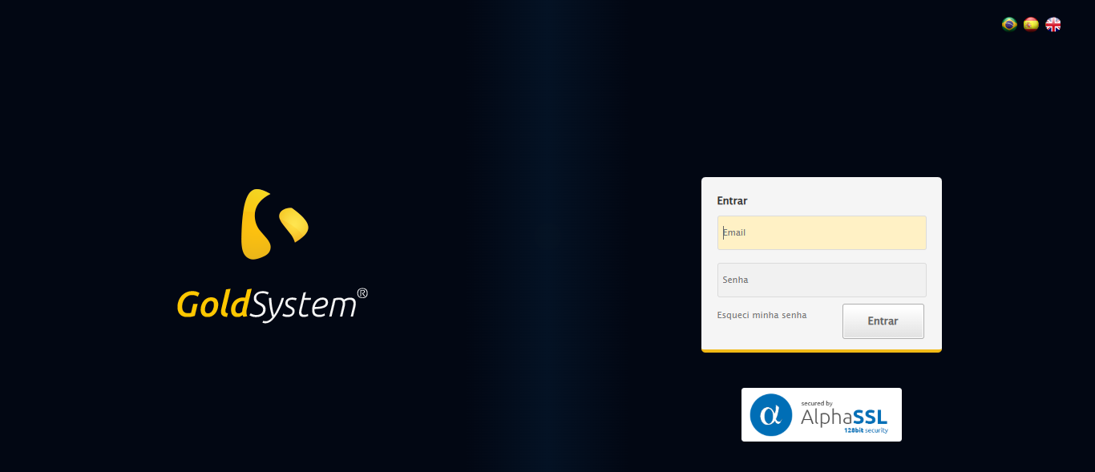

🔄 Realizando login...

✅ Realizando login realizada com sucesso.

Screenshot: realizando_login

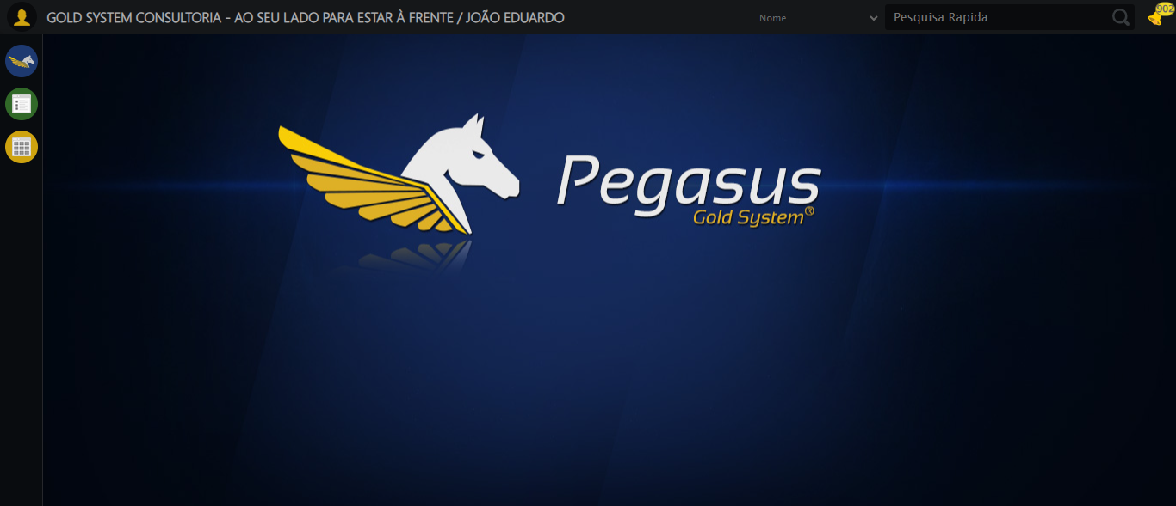

🔄 Ajustando zoom e abrindo menu...

🔍 Zoom ajustado para 90%.

✅ Ajustando zoom e abrindo menu realizada com sucesso.

Screenshot: ajustando_zoom_e_abrindo_menu

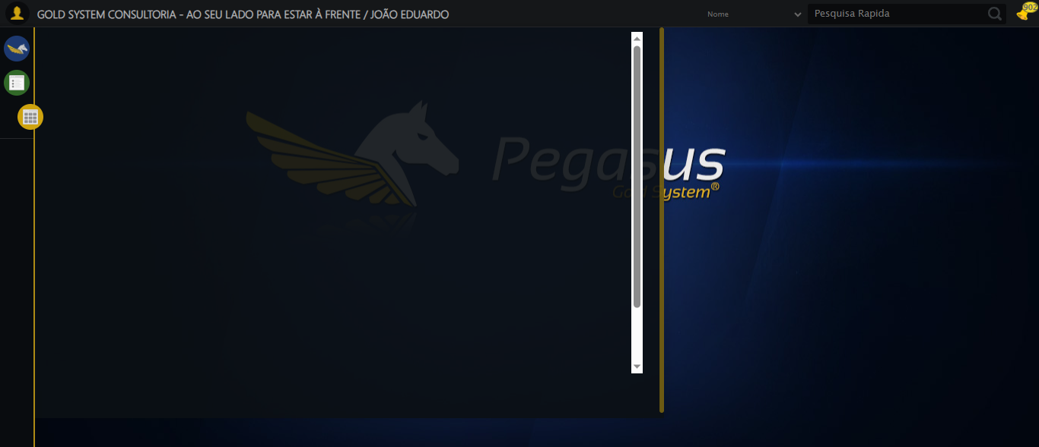

🔄 Acessando Registro de Óbito...

✅ Acessando Registro de Óbito realizada com sucesso.

Screenshot: acessando_registro_de_óbito

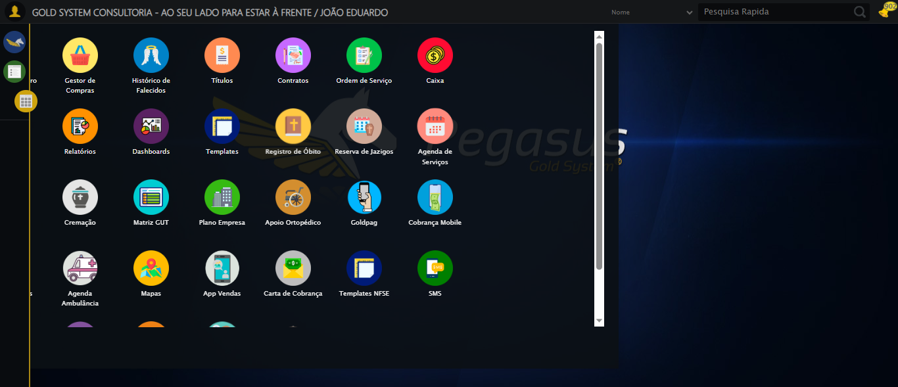

🔄 Clicando em Cadastrar...

✅ Clicando em Cadastrar realizada com sucesso.

Screenshot: clicando_em_cadastrar

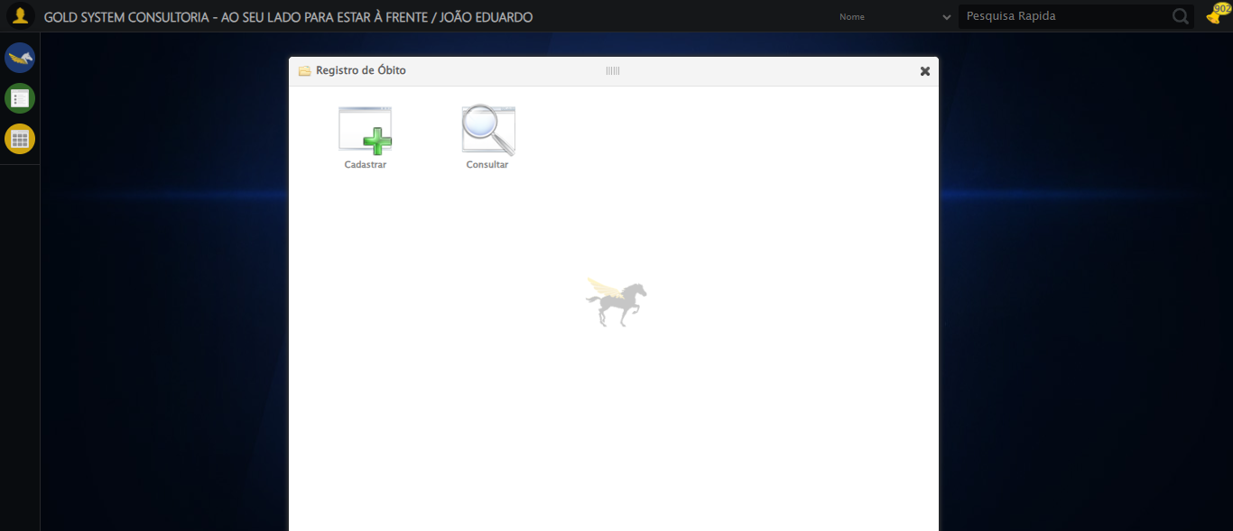

🔄 Selecionando Cartório...

❌ Erro ao selecionando cartório: Message: target frame detached  
 (failed to check if window was closed: disconnected: unable to send message to renderer)  
 (Session info: chrome=138.0.7204.184)  
Stacktrace:  
 GetHandleVerifier [0x0x66ba83+63395]  
 GetHandleVerifier [0x0x66bac4+63460]  
 (No symbol) [0x0x4b1f70]  
 (No symbol) [0x0x4a2b60]  
 (No symbol) [0x0x4a1cd1]  
 (No symbol) [0x0x4bf922]  
 (No symbol) [0x0x525c9c]  
 (No symbol) [0x0x540099]  
 (No symbol) [0x0x51f1a6]  
 (No symbol) [0x0x4ee7b2]  
 (No symbol) [0x0x4ef654]  
 GetHandleVerifier [0x0x8e8883+2672035]  
 GetHandleVerifier [0x0x8e3cba+2652634]  
 GetHandleVerifier [0x0x692bca+223466]  
 GetHandleVerifier [0x0x682cb8+158168]  
 GetHandleVerifier [0x0x68978d+185517]  
 GetHandleVerifier [0x0x673b78+96408]  
 GetHandleVerifier [0x0x673d02+96802]  
 GetHandleVerifier [0x0x65e90a+9770]  
 BaseThreadInitThunk [0x0x773dfcc9+25]  
 RtlGetAppContainerNamedObjectPath [0x0x77ba82ae+286]  
 RtlGetAppContainerNamedObjectPath [0x0x77ba827e+238]

❌ ERRO FATAL: Message: invalid session id: session deleted as the browser has closed the connection  
from disconnected: not connected to DevTools  
 (Session info: chrome=138.0.7204.184)  
Stacktrace:  
 GetHandleVerifier [0x0x66ba83+63395]  
 GetHandleVerifier [0x0x66bac4+63460]  
 (No symbol) [0x0x4b2113]  
 (No symbol) [0x0x4a1b20]  
 (No symbol) [0x0x4bf922]  
 (No symbol) [0x0x525c9c]  
 (No symbol) [0x0x540099]  
 (No symbol) [0x0x51f1a6]  
 (No symbol) [0x0x4ee7b2]  
 (No symbol) [0x0x4ef654]  
 GetHandleVerifier [0x0x8e8883+2672035]  
 GetHandleVerifier [0x0x8e3cba+2652634]  
 GetHandleVerifier [0x0x692bca+223466]  
 GetHandleVerifier [0x0x682cb8+158168]  
 GetHandleVerifier [0x0x68978d+185517]  
 GetHandleVerifier [0x0x673b78+96408]  
 GetHandleVerifier [0x0x673d02+96802]  
 GetHandleVerifier [0x0x65e90a+9770]  
 BaseThreadInitThunk [0x0x773dfcc9+25]  
 RtlGetAppContainerNamedObjectPath [0x0x77ba82ae+286]  
 RtlGetAppContainerNamedObjectPath [0x0x77ba827e+238]

✅ Teste concluído com sucesso.