RELATÓRIO DO TESTE

Cadastro de Registro de Óbito – Cenário 3: Preenchimento dos campos obrigatórios e salvamento.

Data do teste: 06/08/2025 15:55:57

🚀 Iniciando teste de cadastro de registro de óbito...

🔄 Acessando sistema...

✅ Acessando sistema realizada com sucesso.

Screenshot: acessando_sistema



🔄 Realizando login...

✅ Realizando login realizada com sucesso.

Screenshot: realizando_login

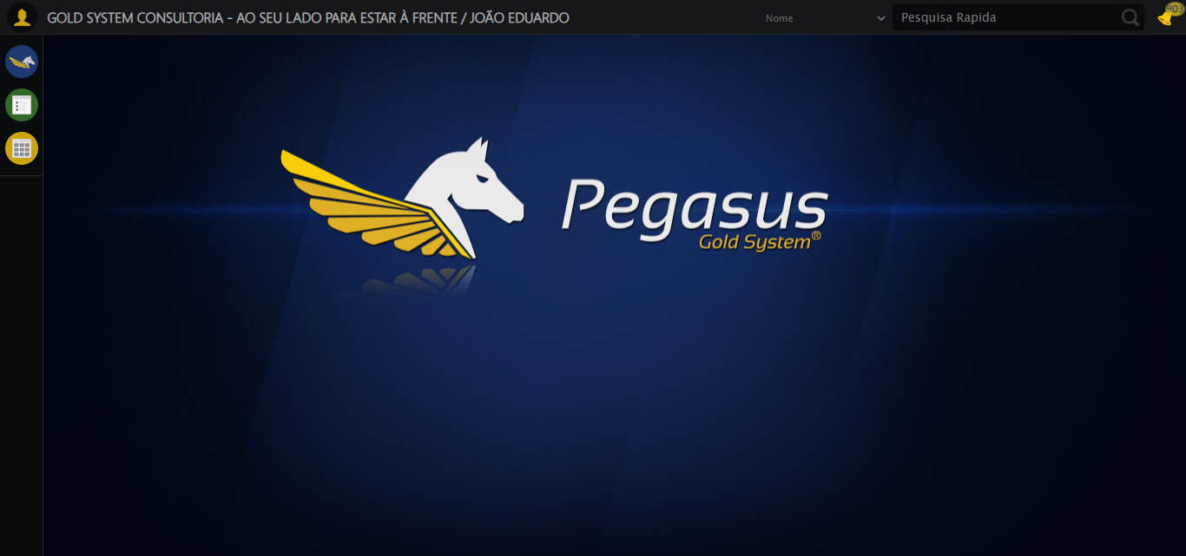

🔄 Ajustando zoom e abrindo menu...

🔍 Zoom ajustado para 90%.

✅ Ajustando zoom e abrindo menu realizada com sucesso.

Screenshot: ajustando_zoom_e_abrindo_menu

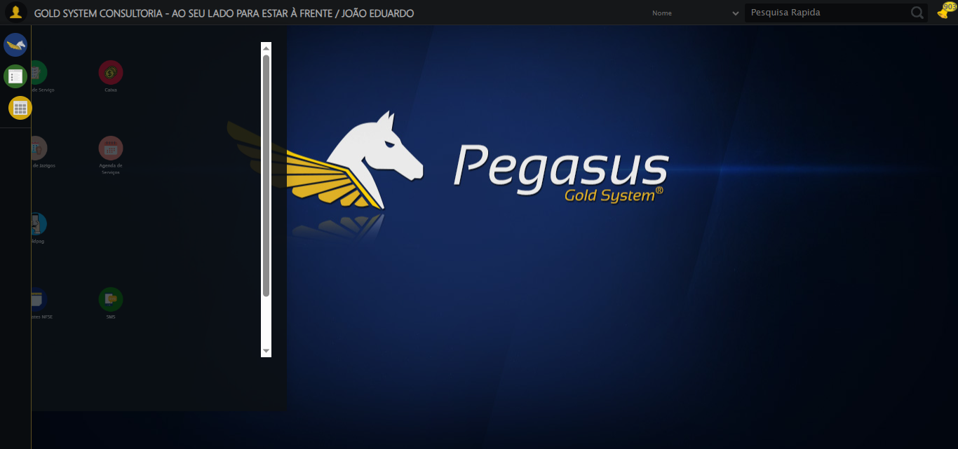

🔄 Acessando Registro de Óbito...

✅ Acessando Registro de Óbito realizada com sucesso.

Screenshot: acessando_registro_de_óbito

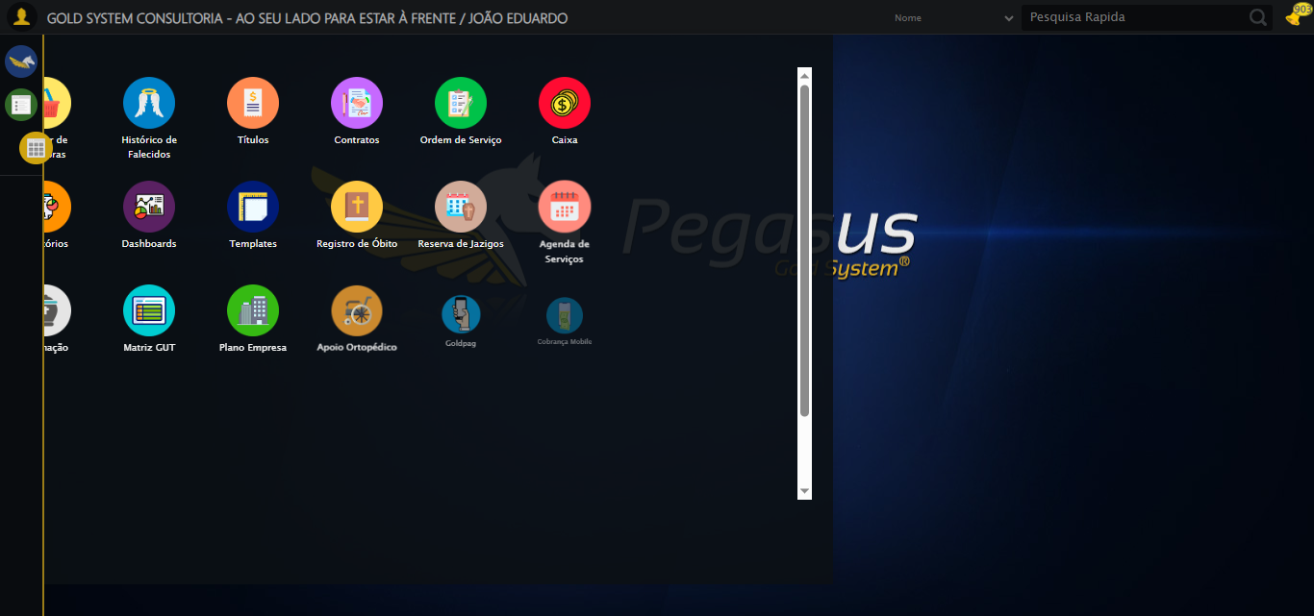

🔄 Clicando em Cadastrar...

✅ Clicando em Cadastrar realizada com sucesso.

Screenshot: clicando_em_cadastrar

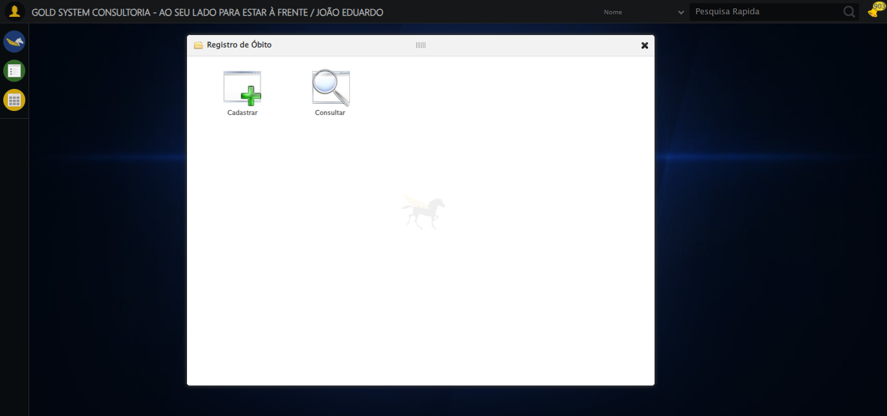

🔄 Selecionando pessoa falecida...

✅ Selecionando pessoa falecida realizada com sucesso.

Screenshot: selecionando_pessoa_falecida

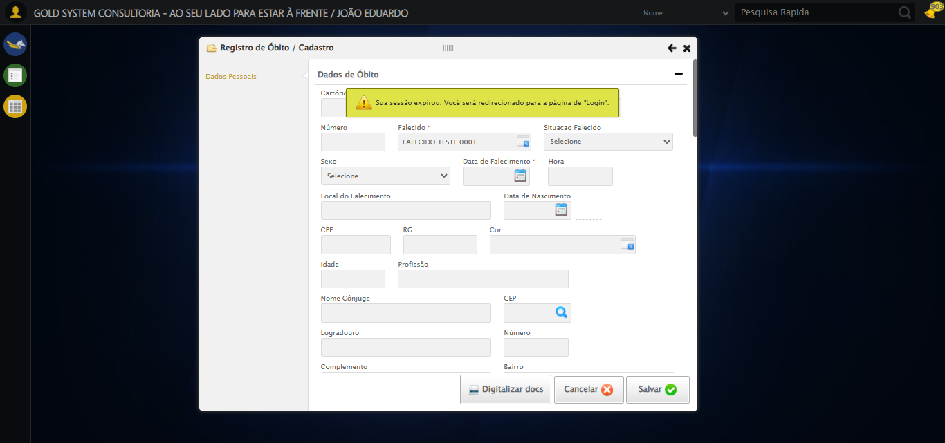

🔄 Preenchendo Data do falecimento...

⚠️ Tentativa 2 falhou: Message: stale element reference: stale element not found  
 (Session info: chrome=138.0.7204.185); For documentation on this error, please visit: https://www.selenium.dev/documentation/webdriver/troubleshooting/errors#stale-element-reference-exception  
Stacktrace:  
 GetHandleVerifier [0x0x10dba83+63395]  
 GetHandleVerifier [0x0x10dbac4+63460]  
 (No symbol) [0x0xf22113]  
 (No symbol) [0x0xf33c61]  
 (No symbol) [0x0xf32d40]  
 (No symbol) [0x0xf29400]  
 (No symbol) [0x0xf278da]  
 (No symbol) [0x0xf2ac7a]  
 (No symbol) [0x0xf2acf7]  
 (No symbol) [0x0xf702b4]  
 (No symbol) [0x0xf6f827]  
 (No symbol) [0x0xfb917f]  
 (No symbol) [0x0xf8f3ac]  
 (No symbol) [0x0xfb07ba]  
 (No symbol) [0x0xf8f1a6]  
 (No symbol) [0x0xf5e7b2]  
 (No symbol) [0x0xf5f654]  
 GetHandleVerifier [0x0x1358883+2672035]  
 GetHandleVerifier [0x0x1353cba+2652634]  
 GetHandleVerifier [0x0x1102bca+223466]  
 GetHandleVerifier [0x0x10f2cb8+158168]  
 GetHandleVerifier [0x0x10f978d+185517]  
 GetHandleVerifier [0x0x10e3b78+96408]  
 GetHandleVerifier [0x0x10e3d02+96802]  
 GetHandleVerifier [0x0x10ce90a+9770]  
 BaseThreadInitThunk [0x0x773dfcc9+25]  
 RtlGetAppContainerNamedObjectPath [0x0x77ba82ae+286]  
 RtlGetAppContainerNamedObjectPath [0x0x77ba827e+238]

⚠️ Tentativa 3 falhou: Message: target frame detached  
 (failed to check if window was closed: disconnected: Unable to receive message from renderer)  
 (Session info: chrome=138.0.7204.185)  
Stacktrace:  
 GetHandleVerifier [0x0x10dba83+63395]  
 GetHandleVerifier [0x0x10dbac4+63460]  
 (No symbol) [0x0xf21f70]  
 (No symbol) [0x0xf12b60]  
 (No symbol) [0x0xf11cd1]  
 (No symbol) [0x0xf2f922]  
 (No symbol) [0x0xf95c9c]  
 (No symbol) [0x0xfb0099]  
 (No symbol) [0x0xf8f1a6]  
 (No symbol) [0x0xf5e7b2]  
 (No symbol) [0x0xf5f654]  
 GetHandleVerifier [0x0x1358883+2672035]  
 GetHandleVerifier [0x0x1353cba+2652634]  
 GetHandleVerifier [0x0x1102bca+223466]  
 GetHandleVerifier [0x0x10f2cb8+158168]  
 GetHandleVerifier [0x0x10f978d+185517]  
 GetHandleVerifier [0x0x10e3b78+96408]  
 GetHandleVerifier [0x0x10e3d02+96802]  
 GetHandleVerifier [0x0x10ce90a+9770]  
 BaseThreadInitThunk [0x0x773dfcc9+25]  
 RtlGetAppContainerNamedObjectPath [0x0x77ba82ae+286]  
 RtlGetAppContainerNamedObjectPath [0x0x77ba827e+238]

✅ Preenchendo Data do falecimento realizada com sucesso.

⚠️ Erro ao tirar screenshot preenchendo_data_do_falecimento: Message: invalid session id: session deleted as the browser has closed the connection  
from disconnected: not connected to DevTools  
 (Session info: chrome=138.0.7204.185)  
Stacktrace:  
 GetHandleVerifier [0x0x10dba83+63395]  
 GetHandleVerifier [0x0x10dbac4+63460]  
 (No symbol) [0x0xf22113]  
 (No symbol) [0x0xf11b20]  
 (No symbol) [0x0xf2f922]  
 (No symbol) [0x0xf95c9c]  
 (No symbol) [0x0xfb0099]  
 (No symbol) [0x0xf8f1a6]  
 (No symbol) [0x0xf5e7b2]  
 (No symbol) [0x0xf5f654]  
 GetHandleVerifier [0x0x1358883+2672035]  
 GetHandleVerifier [0x0x1353cba+2652634]  
 GetHandleVerifier [0x0x1102bca+223466]  
 GetHandleVerifier [0x0x10f2cb8+158168]  
 GetHandleVerifier [0x0x10f978d+185517]  
 GetHandleVerifier [0x0x10e3b78+96408]  
 GetHandleVerifier [0x0x10e3d02+96802]  
 GetHandleVerifier [0x0x10ce90a+9770]  
 BaseThreadInitThunk [0x0x773dfcc9+25]  
 RtlGetAppContainerNamedObjectPath [0x0x77ba82ae+286]  
 RtlGetAppContainerNamedObjectPath [0x0x77ba827e+238]

🔄 Pressionando a tecla Tab para evitar erros...

❌ Erro inesperado ao pressionando a tecla tab para evitar erros: Message: invalid session id  
Stacktrace:  
 GetHandleVerifier [0x0x10dba83+63395]  
 GetHandleVerifier [0x0x10dbac4+63460]  
 (No symbol) [0x0xf21f70]  
 (No symbol) [0x0xf5daa8]  
 (No symbol) [0x0xf8f266]  
 (No symbol) [0x0xf8ae65]  
 (No symbol) [0x0xf8a3e6]  
 (No symbol) [0x0xef3a45]  
 (No symbol) [0x0xef3f9e]  
 (No symbol) [0x0xef442d]  
 GetHandleVerifier [0x0x1358883+2672035]  
 GetHandleVerifier [0x0x1353cba+2652634]  
 GetHandleVerifier [0x0x1102bca+223466]  
 GetHandleVerifier [0x0x10f2cb8+158168]  
 GetHandleVerifier [0x0x10f978d+185517]  
 (No symbol) [0x0xef3710]  
 (No symbol) [0x0xef2f1d]  
 GetHandleVerifier [0x0x148db9c+3938492]  
 BaseThreadInitThunk [0x0x773dfcc9+25]  
 RtlGetAppContainerNamedObjectPath [0x0x77ba82ae+286]  
 RtlGetAppContainerNamedObjectPath [0x0x77ba827e+238]

⚠️ Erro ao tirar screenshot erro_pressionando_a_tecla_tab_para_evitar_erros: Message: invalid session id  
Stacktrace:  
 GetHandleVerifier [0x0x10dba83+63395]  
 GetHandleVerifier [0x0x10dbac4+63460]  
 (No symbol) [0x0xf21f70]  
 (No symbol) [0x0xf5daa8]  
 (No symbol) [0x0xf8f266]  
 (No symbol) [0x0xf8ae65]  
 (No symbol) [0x0xf8a3e6]  
 (No symbol) [0x0xef3a45]  
 (No symbol) [0x0xef3f9e]  
 (No symbol) [0x0xef442d]  
 GetHandleVerifier [0x0x1358883+2672035]  
 GetHandleVerifier [0x0x1353cba+2652634]  
 GetHandleVerifier [0x0x1102bca+223466]  
 GetHandleVerifier [0x0x10f2cb8+158168]  
 GetHandleVerifier [0x0x10f978d+185517]  
 (No symbol) [0x0xef3710]  
 (No symbol) [0x0xef2f1d]  
 GetHandleVerifier [0x0x148db9c+3938492]  
 BaseThreadInitThunk [0x0x773dfcc9+25]  
 RtlGetAppContainerNamedObjectPath [0x0x77ba82ae+286]  
 RtlGetAppContainerNamedObjectPath [0x0x77ba827e+238]

🔄 Preenchendo Data de Sepultamento...

⚠️ Tentativa 1 falhou: Message: invalid session id  
Stacktrace:  
 GetHandleVerifier [0x0x10dba83+63395]  
 GetHandleVerifier [0x0x10dbac4+63460]  
 (No symbol) [0x0xf21f70]  
 (No symbol) [0x0xf5daa8]  
 (No symbol) [0x0xf8f266]  
 (No symbol) [0x0xf8ae65]  
 (No symbol) [0x0xf8a3e6]  
 (No symbol) [0x0xef3a45]  
 (No symbol) [0x0xef3f9e]  
 (No symbol) [0x0xef442d]  
 GetHandleVerifier [0x0x1358883+2672035]  
 GetHandleVerifier [0x0x1353cba+2652634]  
 GetHandleVerifier [0x0x1102bca+223466]  
 GetHandleVerifier [0x0x10f2cb8+158168]  
 GetHandleVerifier [0x0x10f978d+185517]  
 (No symbol) [0x0xef3710]  
 (No symbol) [0x0xef2f1d]  
 GetHandleVerifier [0x0x148db9c+3938492]  
 BaseThreadInitThunk [0x0x773dfcc9+25]  
 RtlGetAppContainerNamedObjectPath [0x0x77ba82ae+286]  
 RtlGetAppContainerNamedObjectPath [0x0x77ba827e+238]

⚠️ Tentativa 2 falhou: Message: invalid session id  
Stacktrace:  
 GetHandleVerifier [0x0x10dba83+63395]  
 GetHandleVerifier [0x0x10dbac4+63460]  
 (No symbol) [0x0xf21f70]  
 (No symbol) [0x0xf5daa8]  
 (No symbol) [0x0xf8f266]  
 (No symbol) [0x0xf8ae65]  
 (No symbol) [0x0xf8a3e6]  
 (No symbol) [0x0xef3a45]  
 (No symbol) [0x0xef3f9e]  
 (No symbol) [0x0xef442d]  
 GetHandleVerifier [0x0x1358883+2672035]  
 GetHandleVerifier [0x0x1353cba+2652634]  
 GetHandleVerifier [0x0x1102bca+223466]  
 GetHandleVerifier [0x0x10f2cb8+158168]  
 GetHandleVerifier [0x0x10f978d+185517]  
 (No symbol) [0x0xef3710]  
 (No symbol) [0x0xef2f1d]  
 GetHandleVerifier [0x0x148db9c+3938492]  
 BaseThreadInitThunk [0x0x773dfcc9+25]  
 RtlGetAppContainerNamedObjectPath [0x0x77ba82ae+286]  
 RtlGetAppContainerNamedObjectPath [0x0x77ba827e+238]

⚠️ Tentativa 3 falhou: Message: invalid session id  
Stacktrace:  
 GetHandleVerifier [0x0x10dba83+63395]  
 GetHandleVerifier [0x0x10dbac4+63460]  
 (No symbol) [0x0xf21f70]  
 (No symbol) [0x0xf5daa8]  
 (No symbol) [0x0xf8f266]  
 (No symbol) [0x0xf8ae65]  
 (No symbol) [0x0xf8a3e6]  
 (No symbol) [0x0xef3a45]  
 (No symbol) [0x0xef3f9e]  
 (No symbol) [0x0xef442d]  
 GetHandleVerifier [0x0x1358883+2672035]  
 GetHandleVerifier [0x0x1353cba+2652634]  
 GetHandleVerifier [0x0x1102bca+223466]  
 GetHandleVerifier [0x0x10f2cb8+158168]  
 GetHandleVerifier [0x0x10f978d+185517]  
 (No symbol) [0x0xef3710]  
 (No symbol) [0x0xef2f1d]  
 GetHandleVerifier [0x0x148db9c+3938492]  
 BaseThreadInitThunk [0x0x773dfcc9+25]  
 RtlGetAppContainerNamedObjectPath [0x0x77ba82ae+286]  
 RtlGetAppContainerNamedObjectPath [0x0x77ba827e+238]

✅ Preenchendo Data de Sepultamento realizada com sucesso.

⚠️ Erro ao tirar screenshot preenchendo__data_de_sepultamento: Message: invalid session id  
Stacktrace:  
 GetHandleVerifier [0x0x10dba83+63395]  
 GetHandleVerifier [0x0x10dbac4+63460]  
 (No symbol) [0x0xf21f70]  
 (No symbol) [0x0xf5daa8]  
 (No symbol) [0x0xf8f266]  
 (No symbol) [0x0xf8ae65]  
 (No symbol) [0x0xf8a3e6]  
 (No symbol) [0x0xef3a45]  
 (No symbol) [0x0xef3f9e]  
 (No symbol) [0x0xef442d]  
 GetHandleVerifier [0x0x1358883+2672035]  
 GetHandleVerifier [0x0x1353cba+2652634]  
 GetHandleVerifier [0x0x1102bca+223466]  
 GetHandleVerifier [0x0x10f2cb8+158168]  
 GetHandleVerifier [0x0x10f978d+185517]  
 (No symbol) [0x0xef3710]  
 (No symbol) [0x0xef2f1d]  
 GetHandleVerifier [0x0x148db9c+3938492]  
 BaseThreadInitThunk [0x0x773dfcc9+25]  
 RtlGetAppContainerNamedObjectPath [0x0x77ba82ae+286]  
 RtlGetAppContainerNamedObjectPath [0x0x77ba827e+238]

🔄 Pressionando a tecla Tab para evitar erros...

❌ Erro inesperado ao pressionando a tecla tab para evitar erros: Message: invalid session id  
Stacktrace:  
 GetHandleVerifier [0x0x10dba83+63395]  
 GetHandleVerifier [0x0x10dbac4+63460]  
 (No symbol) [0x0xf21f70]  
 (No symbol) [0x0xf5daa8]  
 (No symbol) [0x0xf8f266]  
 (No symbol) [0x0xf8ae65]  
 (No symbol) [0x0xf8a3e6]  
 (No symbol) [0x0xef3a45]  
 (No symbol) [0x0xef3f9e]  
 (No symbol) [0x0xef442d]  
 GetHandleVerifier [0x0x1358883+2672035]  
 GetHandleVerifier [0x0x1353cba+2652634]  
 GetHandleVerifier [0x0x1102bca+223466]  
 GetHandleVerifier [0x0x10f2cb8+158168]  
 GetHandleVerifier [0x0x10f978d+185517]  
 (No symbol) [0x0xef3710]  
 (No symbol) [0x0xef2f1d]  
 GetHandleVerifier [0x0x148db9c+3938492]  
 BaseThreadInitThunk [0x0x773dfcc9+25]  
 RtlGetAppContainerNamedObjectPath [0x0x77ba82ae+286]  
 RtlGetAppContainerNamedObjectPath [0x0x77ba827e+238]

⚠️ Erro ao tirar screenshot erro_pressionando_a_tecla_tab_para_evitar_erros: Message: invalid session id  
Stacktrace:  
 GetHandleVerifier [0x0x10dba83+63395]  
 GetHandleVerifier [0x0x10dbac4+63460]  
 (No symbol) [0x0xf21f70]  
 (No symbol) [0x0xf5daa8]  
 (No symbol) [0x0xf8f266]  
 (No symbol) [0x0xf8ae65]  
 (No symbol) [0x0xf8a3e6]  
 (No symbol) [0x0xef3a45]  
 (No symbol) [0x0xef3f9e]  
 (No symbol) [0x0xef442d]  
 GetHandleVerifier [0x0x1358883+2672035]  
 GetHandleVerifier [0x0x1353cba+2652634]  
 GetHandleVerifier [0x0x1102bca+223466]  
 GetHandleVerifier [0x0x10f2cb8+158168]  
 GetHandleVerifier [0x0x10f978d+185517]  
 (No symbol) [0x0xef3710]  
 (No symbol) [0x0xef2f1d]  
 GetHandleVerifier [0x0x148db9c+3938492]  
 BaseThreadInitThunk [0x0x773dfcc9+25]  
 RtlGetAppContainerNamedObjectPath [0x0x77ba82ae+286]  
 RtlGetAppContainerNamedObjectPath [0x0x77ba827e+238]

🔄 Preenchendo Declaração de Óbito...

❌ Erro ao interagir com elemento #fmod_23 > div.wdTelas > div.telaCadastro.clearfix > div.catWrapper > div > div > div:nth-child(1) > div > div:nth-child(45) > input: Message: invalid session id  
Stacktrace:  
 GetHandleVerifier [0x0x10dba83+63395]  
 GetHandleVerifier [0x0x10dbac4+63460]  
 (No symbol) [0x0xf21f70]  
 (No symbol) [0x0xf5daa8]  
 (No symbol) [0x0xf8f266]  
 (No symbol) [0x0xf8ae65]  
 (No symbol) [0x0xf8a3e6]  
 (No symbol) [0x0xef3a45]  
 (No symbol) [0x0xef3f9e]  
 (No symbol) [0x0xef442d]  
 GetHandleVerifier [0x0x1358883+2672035]  
 GetHandleVerifier [0x0x1353cba+2652634]  
 GetHandleVerifier [0x0x1102bca+223466]  
 GetHandleVerifier [0x0x10f2cb8+158168]  
 GetHandleVerifier [0x0x10f978d+185517]  
 (No symbol) [0x0xef3710]  
 (No symbol) [0x0xef2f1d]  
 GetHandleVerifier [0x0x148db9c+3938492]  
 BaseThreadInitThunk [0x0x773dfcc9+25]  
 RtlGetAppContainerNamedObjectPath [0x0x77ba82ae+286]  
 RtlGetAppContainerNamedObjectPath [0x0x77ba827e+238]

❌ Erro inesperado ao preenchendo declaração de óbito: Não foi possível encontrar o elemento: #fmod_23 > div.wdTelas > div.telaCadastro.clearfix > div.catWrapper > div > div > div:nth-child(1) > div > div:nth-child(45) > input

⚠️ Erro ao tirar screenshot erro_preenchendo_declaração_de_óbito: Message: invalid session id  
Stacktrace:  
 GetHandleVerifier [0x0x10dba83+63395]  
 GetHandleVerifier [0x0x10dbac4+63460]  
 (No symbol) [0x0xf21f70]  
 (No symbol) [0x0xf5daa8]  
 (No symbol) [0x0xf8f266]  
 (No symbol) [0x0xf8ae65]  
 (No symbol) [0x0xf8a3e6]  
 (No symbol) [0x0xef3a45]  
 (No symbol) [0x0xef3f9e]  
 (No symbol) [0x0xef442d]  
 GetHandleVerifier [0x0x1358883+2672035]  
 GetHandleVerifier [0x0x1353cba+2652634]  
 GetHandleVerifier [0x0x1102bca+223466]  
 GetHandleVerifier [0x0x10f2cb8+158168]  
 GetHandleVerifier [0x0x10f978d+185517]  
 (No symbol) [0x0xef3710]  
 (No symbol) [0x0xef2f1d]  
 GetHandleVerifier [0x0x148db9c+3938492]  
 BaseThreadInitThunk [0x0x773dfcc9+25]  
 RtlGetAppContainerNamedObjectPath [0x0x77ba82ae+286]  
 RtlGetAppContainerNamedObjectPath [0x0x77ba827e+238]

🔄 Selecionando a opção para o Tipo de Óbito ser Particular...

❌ Erro ao interagir com elemento #fmod_23 > div.wdTelas > div.telaCadastro.clearfix > div.catWrapper > div > div > div:nth-child(1) > div > div:nth-child(46) > select: Message: invalid session id  
Stacktrace:  
 GetHandleVerifier [0x0x10dba83+63395]  
 GetHandleVerifier [0x0x10dbac4+63460]  
 (No symbol) [0x0xf21f70]  
 (No symbol) [0x0xf5daa8]  
 (No symbol) [0x0xf8f266]  
 (No symbol) [0x0xf8ae65]  
 (No symbol) [0x0xf8a3e6]  
 (No symbol) [0x0xef3a45]  
 (No symbol) [0x0xef3f9e]  
 (No symbol) [0x0xef442d]  
 GetHandleVerifier [0x0x1358883+2672035]  
 GetHandleVerifier [0x0x1353cba+2652634]  
 GetHandleVerifier [0x0x1102bca+223466]  
 GetHandleVerifier [0x0x10f2cb8+158168]  
 GetHandleVerifier [0x0x10f978d+185517]  
 (No symbol) [0x0xef3710]  
 (No symbol) [0x0xef2f1d]  
 GetHandleVerifier [0x0x148db9c+3938492]  
 BaseThreadInitThunk [0x0x773dfcc9+25]  
 RtlGetAppContainerNamedObjectPath [0x0x77ba82ae+286]  
 RtlGetAppContainerNamedObjectPath [0x0x77ba827e+238]

❌ Erro inesperado ao selecionando a opção para o tipo de óbito ser particular: Não foi possível encontrar o select: #fmod_23 > div.wdTelas > div.telaCadastro.clearfix > div.catWrapper > div > div > div:nth-child(1) > div > div:nth-child(46) > select

⚠️ Erro ao tirar screenshot erro_selecionando_a_opção_para_o_tipo_de_óbito_ser_particular: Message: invalid session id  
Stacktrace:  
 GetHandleVerifier [0x0x10dba83+63395]  
 GetHandleVerifier [0x0x10dbac4+63460]  
 (No symbol) [0x0xf21f70]  
 (No symbol) [0x0xf5daa8]  
 (No symbol) [0x0xf8f266]  
 (No symbol) [0x0xf8ae65]  
 (No symbol) [0x0xf8a3e6]  
 (No symbol) [0x0xef3a45]  
 (No symbol) [0x0xef3f9e]  
 (No symbol) [0x0xef442d]  
 GetHandleVerifier [0x0x1358883+2672035]  
 GetHandleVerifier [0x0x1353cba+2652634]  
 GetHandleVerifier [0x0x1102bca+223466]  
 GetHandleVerifier [0x0x10f2cb8+158168]  
 GetHandleVerifier [0x0x10f978d+185517]  
 (No symbol) [0x0xef3710]  
 (No symbol) [0x0xef2f1d]  
 GetHandleVerifier [0x0x148db9c+3938492]  
 BaseThreadInitThunk [0x0x773dfcc9+25]  
 RtlGetAppContainerNamedObjectPath [0x0x77ba82ae+286]  
 RtlGetAppContainerNamedObjectPath [0x0x77ba827e+238]

🔄 Selecionando Grau de Parentesco...

❌ Erro ao interagir com elemento #fmod_23 > div.wdTelas > div.telaCadastro.clearfix > div.catWrapper > div > div > div:nth-child(1) > div > div:nth-child(49) > select: Message: invalid session id  
Stacktrace:  
 GetHandleVerifier [0x0x10dba83+63395]  
 GetHandleVerifier [0x0x10dbac4+63460]  
 (No symbol) [0x0xf21f70]  
 (No symbol) [0x0xf5daa8]  
 (No symbol) [0x0xf8f266]  
 (No symbol) [0x0xf8ae65]  
 (No symbol) [0x0xf8a3e6]  
 (No symbol) [0x0xef3a45]  
 (No symbol) [0x0xef3f9e]  
 (No symbol) [0x0xef442d]  
 GetHandleVerifier [0x0x1358883+2672035]  
 GetHandleVerifier [0x0x1353cba+2652634]  
 GetHandleVerifier [0x0x1102bca+223466]  
 GetHandleVerifier [0x0x10f2cb8+158168]  
 GetHandleVerifier [0x0x10f978d+185517]  
 (No symbol) [0x0xef3710]  
 (No symbol) [0x0xef2f1d]  
 GetHandleVerifier [0x0x148db9c+3938492]  
 BaseThreadInitThunk [0x0x773dfcc9+25]  
 RtlGetAppContainerNamedObjectPath [0x0x77ba82ae+286]  
 RtlGetAppContainerNamedObjectPath [0x0x77ba827e+238]

❌ Erro inesperado ao selecionando grau de parentesco: Não foi possível encontrar o select: #fmod_23 > div.wdTelas > div.telaCadastro.clearfix > div.catWrapper > div > div > div:nth-child(1) > div > div:nth-child(49) > select

⚠️ Erro ao tirar screenshot erro_selecionando_grau_de_parentesco: Message: invalid session id  
Stacktrace:  
 GetHandleVerifier [0x0x10dba83+63395]  
 GetHandleVerifier [0x0x10dbac4+63460]  
 (No symbol) [0x0xf21f70]  
 (No symbol) [0x0xf5daa8]  
 (No symbol) [0x0xf8f266]  
 (No symbol) [0x0xf8ae65]  
 (No symbol) [0x0xf8a3e6]  
 (No symbol) [0x0xef3a45]  
 (No symbol) [0x0xef3f9e]  
 (No symbol) [0x0xef442d]  
 GetHandleVerifier [0x0x1358883+2672035]  
 GetHandleVerifier [0x0x1353cba+2652634]  
 GetHandleVerifier [0x0x1102bca+223466]  
 GetHandleVerifier [0x0x10f2cb8+158168]  
 GetHandleVerifier [0x0x10f978d+185517]  
 (No symbol) [0x0xef3710]  
 (No symbol) [0x0xef2f1d]  
 GetHandleVerifier [0x0x148db9c+3938492]  
 BaseThreadInitThunk [0x0x773dfcc9+25]  
 RtlGetAppContainerNamedObjectPath [0x0x77ba82ae+286]  
 RtlGetAppContainerNamedObjectPath [0x0x77ba827e+238]

🔄 Selecionando Declarante...

❌ Erro ao interagir com elemento #fmod_23 > div.wdTelas > div.telaCadastro.clearfix > div.catWrapper > div > div > div:nth-child(2) > div > div:nth-child(2) > div > a: Message: invalid session id  
Stacktrace:  
 GetHandleVerifier [0x0x10dba83+63395]  
 GetHandleVerifier [0x0x10dbac4+63460]  
 (No symbol) [0x0xf21f70]  
 (No symbol) [0x0xf5daa8]  
 (No symbol) [0x0xf8f266]  
 (No symbol) [0x0xf8ae65]  
 (No symbol) [0x0xf8a3e6]  
 (No symbol) [0x0xef3a45]  
 (No symbol) [0x0xef3f9e]  
 (No symbol) [0x0xef442d]  
 GetHandleVerifier [0x0x1358883+2672035]  
 GetHandleVerifier [0x0x1353cba+2652634]  
 GetHandleVerifier [0x0x1102bca+223466]  
 GetHandleVerifier [0x0x10f2cb8+158168]  
 GetHandleVerifier [0x0x10f978d+185517]  
 (No symbol) [0x0xef3710]  
 (No symbol) [0x0xef2f1d]  
 GetHandleVerifier [0x0x148db9c+3938492]  
 BaseThreadInitThunk [0x0x773dfcc9+25]  
 RtlGetAppContainerNamedObjectPath [0x0x77ba82ae+286]  
 RtlGetAppContainerNamedObjectPath [0x0x77ba827e+238]

❌ Erro inesperado ao selecionando declarante: Message: invalid session id  
Stacktrace:  
 GetHandleVerifier [0x0x10dba83+63395]  
 GetHandleVerifier [0x0x10dbac4+63460]  
 (No symbol) [0x0xf21f70]  
 (No symbol) [0x0xf5daa8]  
 (No symbol) [0x0xf8f266]  
 (No symbol) [0x0xf8ae65]  
 (No symbol) [0x0xf8a3e6]  
 (No symbol) [0x0xef3a45]  
 (No symbol) [0x0xef3f9e]  
 (No symbol) [0x0xef442d]  
 GetHandleVerifier [0x0x1358883+2672035]  
 GetHandleVerifier [0x0x1353cba+2652634]  
 GetHandleVerifier [0x0x1102bca+223466]  
 GetHandleVerifier [0x0x10f2cb8+158168]  
 GetHandleVerifier [0x0x10f978d+185517]  
 (No symbol) [0x0xef3710]  
 (No symbol) [0x0xef2f1d]  
 GetHandleVerifier [0x0x148db9c+3938492]  
 BaseThreadInitThunk [0x0x773dfcc9+25]  
 RtlGetAppContainerNamedObjectPath [0x0x77ba82ae+286]  
 RtlGetAppContainerNamedObjectPath [0x0x77ba827e+238]

⚠️ Erro ao tirar screenshot erro_selecionando_declarante: Message: invalid session id  
Stacktrace:  
 GetHandleVerifier [0x0x10dba83+63395]  
 GetHandleVerifier [0x0x10dbac4+63460]  
 (No symbol) [0x0xf21f70]  
 (No symbol) [0x0xf5daa8]  
 (No symbol) [0x0xf8f266]  
 (No symbol) [0x0xf8ae65]  
 (No symbol) [0x0xf8a3e6]  
 (No symbol) [0x0xef3a45]  
 (No symbol) [0x0xef3f9e]  
 (No symbol) [0x0xef442d]  
 GetHandleVerifier [0x0x1358883+2672035]  
 GetHandleVerifier [0x0x1353cba+2652634]  
 GetHandleVerifier [0x0x1102bca+223466]  
 GetHandleVerifier [0x0x10f2cb8+158168]  
 GetHandleVerifier [0x0x10f978d+185517]  
 (No symbol) [0x0xef3710]  
 (No symbol) [0x0xef2f1d]  
 GetHandleVerifier [0x0x148db9c+3938492]  
 BaseThreadInitThunk [0x0x773dfcc9+25]  
 RtlGetAppContainerNamedObjectPath [0x0x77ba82ae+286]  
 RtlGetAppContainerNamedObjectPath [0x0x77ba827e+238]

🔄 Salvando cadastro...

❌ Erro ao interagir com elemento #fmod_23 > div.wdTelas > div.telaCadastro.clearfix > div.btnHolder > a.btModel.btGray.btsave: Message: invalid session id  
Stacktrace:  
 GetHandleVerifier [0x0x10dba83+63395]  
 GetHandleVerifier [0x0x10dbac4+63460]  
 (No symbol) [0x0xf21f70]  
 (No symbol) [0x0xf5daa8]  
 (No symbol) [0x0xf8f266]  
 (No symbol) [0x0xf8ae65]  
 (No symbol) [0x0xf8a3e6]  
 (No symbol) [0x0xef3a45]  
 (No symbol) [0x0xef3f9e]  
 (No symbol) [0x0xef442d]  
 GetHandleVerifier [0x0x1358883+2672035]  
 GetHandleVerifier [0x0x1353cba+2652634]  
 GetHandleVerifier [0x0x1102bca+223466]  
 GetHandleVerifier [0x0x10f2cb8+158168]  
 GetHandleVerifier [0x0x10f978d+185517]  
 (No symbol) [0x0xef3710]  
 (No symbol) [0x0xef2f1d]  
 GetHandleVerifier [0x0x148db9c+3938492]  
 BaseThreadInitThunk [0x0x773dfcc9+25]  
 RtlGetAppContainerNamedObjectPath [0x0x77ba82ae+286]  
 RtlGetAppContainerNamedObjectPath [0x0x77ba827e+238]

❌ Erro inesperado ao salvando cadastro: Não foi possível clicar no elemento: #fmod_23 > div.wdTelas > div.telaCadastro.clearfix > div.btnHolder > a.btModel.btGray.btsave

⚠️ Erro ao tirar screenshot erro_salvando_cadastro: Message: invalid session id  
Stacktrace:  
 GetHandleVerifier [0x0x10dba83+63395]  
 GetHandleVerifier [0x0x10dbac4+63460]  
 (No symbol) [0x0xf21f70]  
 (No symbol) [0x0xf5daa8]  
 (No symbol) [0x0xf8f266]  
 (No symbol) [0x0xf8ae65]  
 (No symbol) [0x0xf8a3e6]  
 (No symbol) [0x0xef3a45]  
 (No symbol) [0x0xef3f9e]  
 (No symbol) [0x0xef442d]  
 GetHandleVerifier [0x0x1358883+2672035]  
 GetHandleVerifier [0x0x1353cba+2652634]  
 GetHandleVerifier [0x0x1102bca+223466]  
 GetHandleVerifier [0x0x10f2cb8+158168]  
 GetHandleVerifier [0x0x10f978d+185517]  
 (No symbol) [0x0xef3710]  
 (No symbol) [0x0xef2f1d]  
 GetHandleVerifier [0x0x148db9c+3938492]  
 BaseThreadInitThunk [0x0x773dfcc9+25]  
 RtlGetAppContainerNamedObjectPath [0x0x77ba82ae+286]  
 RtlGetAppContainerNamedObjectPath [0x0x77ba827e+238]

🔄 Fechando modal após o salvamento...

❌ Erro ao interagir com elemento #fmod_23 > div.wdTop.ui-draggable-handle > div.wdClose > a: Message: invalid session id  
Stacktrace:  
 GetHandleVerifier [0x0x10dba83+63395]  
 GetHandleVerifier [0x0x10dbac4+63460]  
 (No symbol) [0x0xf21f70]  
 (No symbol) [0x0xf5daa8]  
 (No symbol) [0x0xf8f266]  
 (No symbol) [0x0xf8ae65]  
 (No symbol) [0x0xf8a3e6]  
 (No symbol) [0x0xef3a45]  
 (No symbol) [0x0xef3f9e]  
 (No symbol) [0x0xef442d]  
 GetHandleVerifier [0x0x1358883+2672035]  
 GetHandleVerifier [0x0x1353cba+2652634]  
 GetHandleVerifier [0x0x1102bca+223466]  
 GetHandleVerifier [0x0x10f2cb8+158168]  
 GetHandleVerifier [0x0x10f978d+185517]  
 (No symbol) [0x0xef3710]  
 (No symbol) [0x0xef2f1d]  
 GetHandleVerifier [0x0x148db9c+3938492]  
 BaseThreadInitThunk [0x0x773dfcc9+25]  
 RtlGetAppContainerNamedObjectPath [0x0x77ba82ae+286]  
 RtlGetAppContainerNamedObjectPath [0x0x77ba827e+238]

❌ Erro inesperado ao fechando modal após o salvamento: Não foi possível clicar no elemento: #fmod_23 > div.wdTop.ui-draggable-handle > div.wdClose > a

⚠️ Erro ao tirar screenshot erro_fechando_modal_após_o_salvamento: Message: invalid session id  
Stacktrace:  
 GetHandleVerifier [0x0x10dba83+63395]  
 GetHandleVerifier [0x0x10dbac4+63460]  
 (No symbol) [0x0xf21f70]  
 (No symbol) [0x0xf5daa8]  
 (No symbol) [0x0xf8f266]  
 (No symbol) [0x0xf8ae65]  
 (No symbol) [0x0xf8a3e6]  
 (No symbol) [0x0xef3a45]  
 (No symbol) [0x0xef3f9e]  
 (No symbol) [0x0xef442d]  
 GetHandleVerifier [0x0x1358883+2672035]  
 GetHandleVerifier [0x0x1353cba+2652634]  
 GetHandleVerifier [0x0x1102bca+223466]  
 GetHandleVerifier [0x0x10f2cb8+158168]  
 GetHandleVerifier [0x0x10f978d+185517]  
 (No symbol) [0x0xef3710]  
 (No symbol) [0x0xef2f1d]  
 GetHandleVerifier [0x0x148db9c+3938492]  
 BaseThreadInitThunk [0x0x773dfcc9+25]  
 RtlGetAppContainerNamedObjectPath [0x0x77ba82ae+286]  
 RtlGetAppContainerNamedObjectPath [0x0x77ba827e+238]

🔍 Verificando mensagens de alerta...

ℹ️ Nenhuma mensagem de alerta encontrada.

🔄 Recusando a solicitação da criação da Ordem de Serviço...

❌ Erro inesperado ao recusando a solicitação da criação da ordem de serviço: Message: invalid session id  
Stacktrace:  
 GetHandleVerifier [0x0x10dba83+63395]  
 GetHandleVerifier [0x0x10dbac4+63460]  
 (No symbol) [0x0xf21f70]  
 (No symbol) [0x0xf5daa8]  
 (No symbol) [0x0xf8f266]  
 (No symbol) [0x0xf8ae65]  
 (No symbol) [0x0xf8a3e6]  
 (No symbol) [0x0xef3a45]  
 (No symbol) [0x0xef3f9e]  
 (No symbol) [0x0xef442d]  
 GetHandleVerifier [0x0x1358883+2672035]  
 GetHandleVerifier [0x0x1353cba+2652634]  
 GetHandleVerifier [0x0x1102bca+223466]  
 GetHandleVerifier [0x0x10f2cb8+158168]  
 GetHandleVerifier [0x0x10f978d+185517]  
 (No symbol) [0x0xef3710]  
 (No symbol) [0x0xef2f1d]  
 GetHandleVerifier [0x0x148db9c+3938492]  
 BaseThreadInitThunk [0x0x773dfcc9+25]  
 RtlGetAppContainerNamedObjectPath [0x0x77ba82ae+286]  
 RtlGetAppContainerNamedObjectPath [0x0x77ba827e+238]

⚠️ Erro ao tirar screenshot erro_recusando_a_solicitação_da_criação_da_ordem_de_serviço: Message: invalid session id  
Stacktrace:  
 GetHandleVerifier [0x0x10dba83+63395]  
 GetHandleVerifier [0x0x10dbac4+63460]  
 (No symbol) [0x0xf21f70]  
 (No symbol) [0x0xf5daa8]  
 (No symbol) [0x0xf8f266]  
 (No symbol) [0x0xf8ae65]  
 (No symbol) [0x0xf8a3e6]  
 (No symbol) [0x0xef3a45]  
 (No symbol) [0x0xef3f9e]  
 (No symbol) [0x0xef442d]  
 GetHandleVerifier [0x0x1358883+2672035]  
 GetHandleVerifier [0x0x1353cba+2652634]  
 GetHandleVerifier [0x0x1102bca+223466]  
 GetHandleVerifier [0x0x10f2cb8+158168]  
 GetHandleVerifier [0x0x10f978d+185517]  
 (No symbol) [0x0xef3710]  
 (No symbol) [0x0xef2f1d]  
 GetHandleVerifier [0x0x148db9c+3938492]  
 BaseThreadInitThunk [0x0x773dfcc9+25]  
 RtlGetAppContainerNamedObjectPath [0x0x77ba82ae+286]  
 RtlGetAppContainerNamedObjectPath [0x0x77ba827e+238]

✅ Teste concluído.

✅ Teste executado com sucesso!