RELATÓRIO DO TESTE

Pedido de Compra - Gestor de Compras – Cenário 1: Preenchimento completo e realização da Consulta

Data do teste: 09/10/2025 17:08:11

🚀 Iniciando teste de Autorização de PIMS

🔄 Acessando sistema...

✅ Acessando sistema realizada com sucesso.

Screenshot: acessando sistema

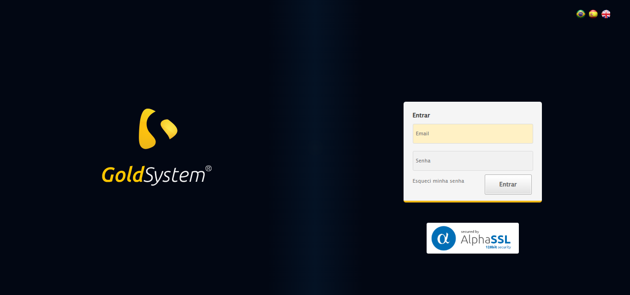

🔄 Realizando login...

✅ Realizando login realizada com sucesso.

Screenshot: realizando login

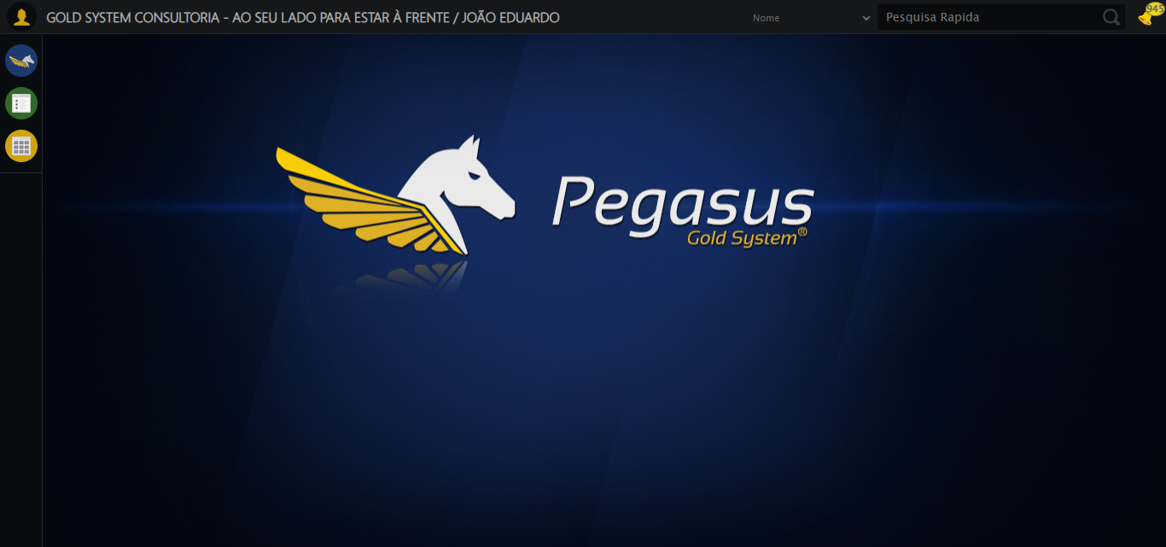

🔄 Ajustando zoom e abrindo menu...

🔍 Zoom ajustado para 90%.

✅ Ajustando zoom e abrindo menu realizada com sucesso.

Screenshot: ajustando zoom e abrindo menu

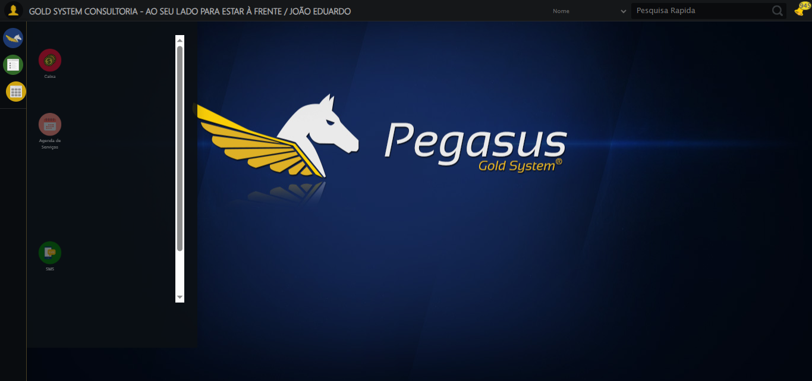

🔄 Acessando Gestor de Compras...

✅ Acessando Gestor de Compras realizada com sucesso.

Screenshot: acessando gestor de compras

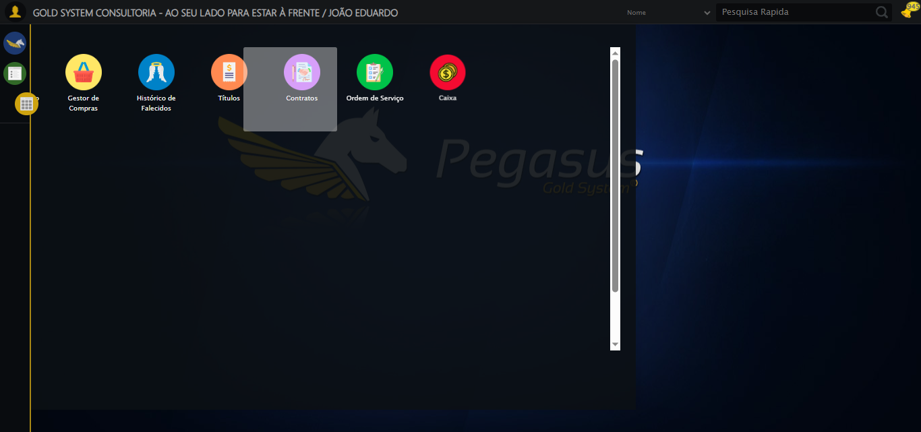

🔄 Clicando em Pedido de Compra...

✅ Clicando em Pedido de Compra realizada com sucesso.

Screenshot: clicando em pedido de compra

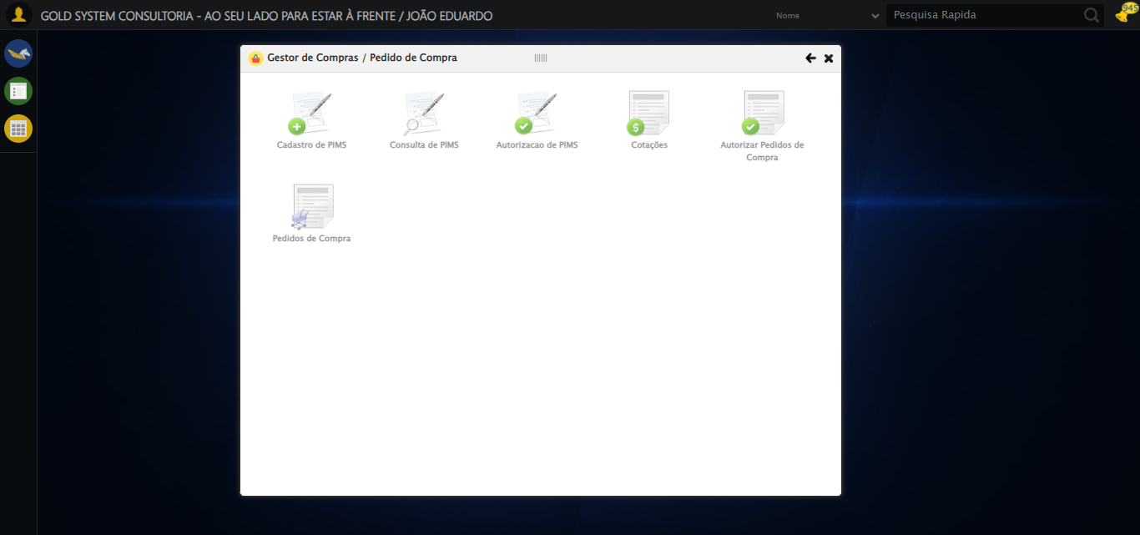

🔄 Preenchendo Data Pedido Inicial...

📊 Encontrados 3 campos datepicker

🎯 Tentativa 1: Preenchendo datepicker 0 (ID: dp1760040501314) com '09/03/2025'

Aplicando estratégia 1 para datepicker...

✅ Datepicker preenchido com estratégia 1: '09/03/2025'

✅ Preenchendo Data Pedido Inicial realizada com sucesso.

Screenshot: preenchendo data pedido inicial

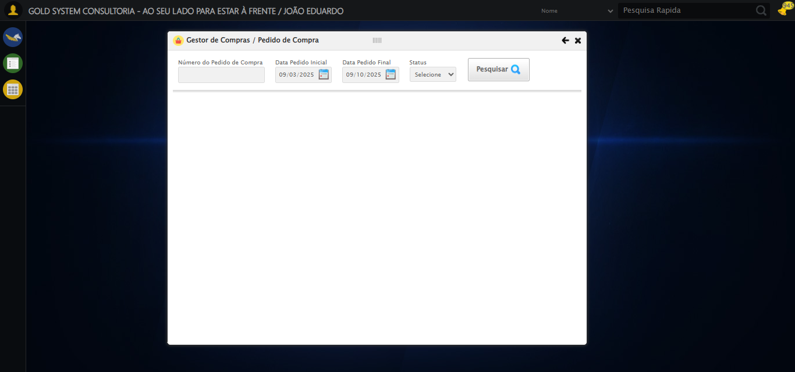

🔄 Preenchendo Data Pedido Final...

📊 Encontrados 3 campos datepicker

🎯 Tentativa 1: Preenchendo datepicker 1 (ID: dp1760040501315) com '09/10/2025'

✅ Campo 1 já está preenchido corretamente!

✅ Preenchendo Data Pedido Final realizada com sucesso.

Screenshot: preenchendo data pedido final



🔄 Pesquisando......

✅ Pesquisando... realizada com sucesso.

Screenshot: pesquisando...

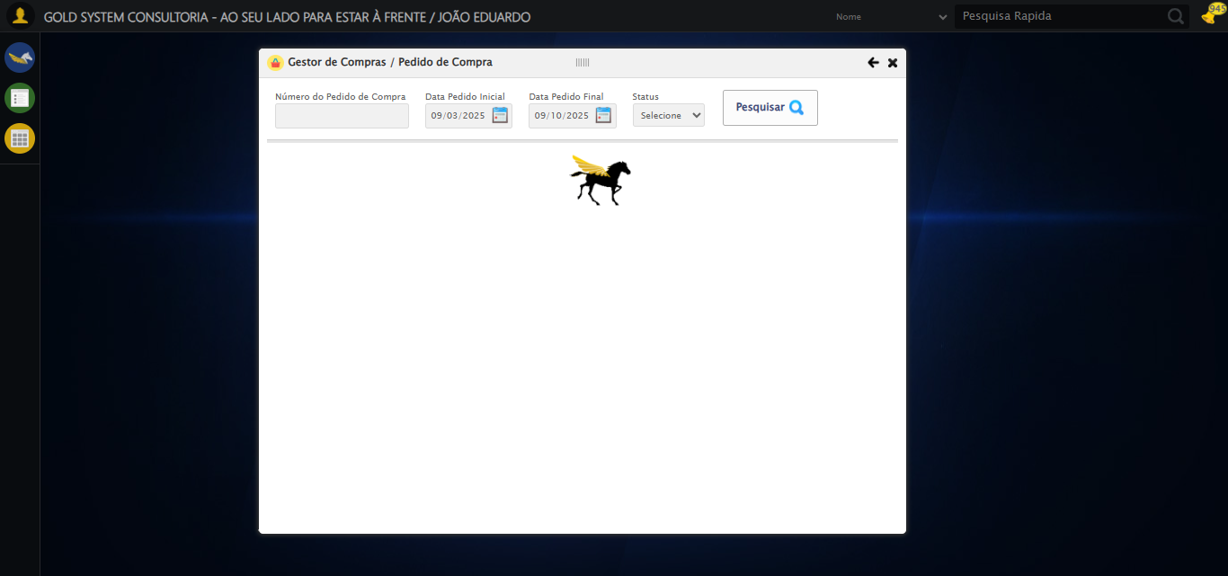

🔄 Realizando consulta...

✅ Realizando consulta realizada com sucesso.

Screenshot: realizando consulta

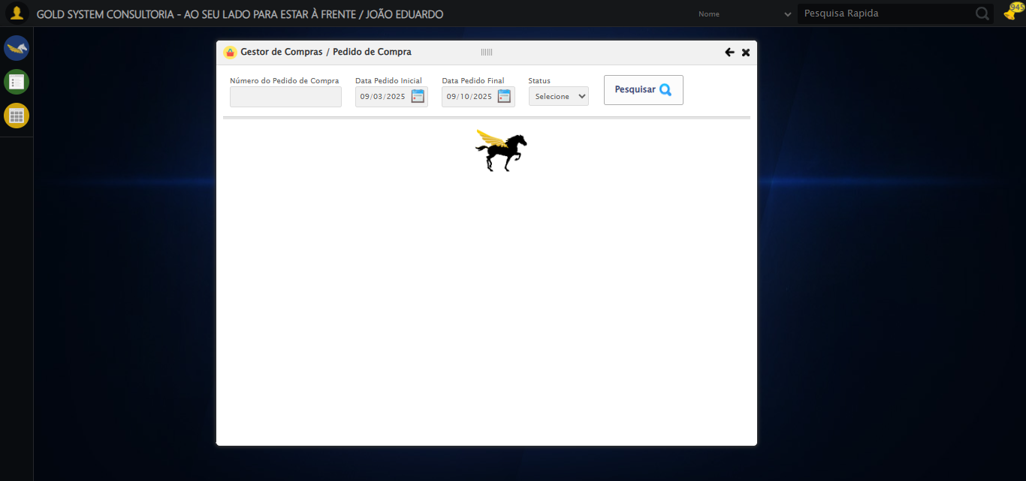

🔄 Validando resultados da consulta...

🔍 Validando registros encontrados...

✅ 10 registro(s) encontrado(s)

Registro 1: 200443 09/10/2025 SR. EDUARDO DA COSTA Cancelado...

Registro 2: 200442 29/05/2025 FORNECEDOR URNAS CS Cancelado...

Registro 3: 200441 29/04/2025 FORNECEDOR JOÃO TESTE 2 Cancelado...

Processando 10 registro(s) encontrado(s)

🔄 Abrindo Detalhes do Pedido e Capturando screenshot...

✅ Abrindo Detalhes do Pedido e Capturando screenshot realizada com sucesso.

Screenshot: abrindo detalhes do pedido e capturando screenshot

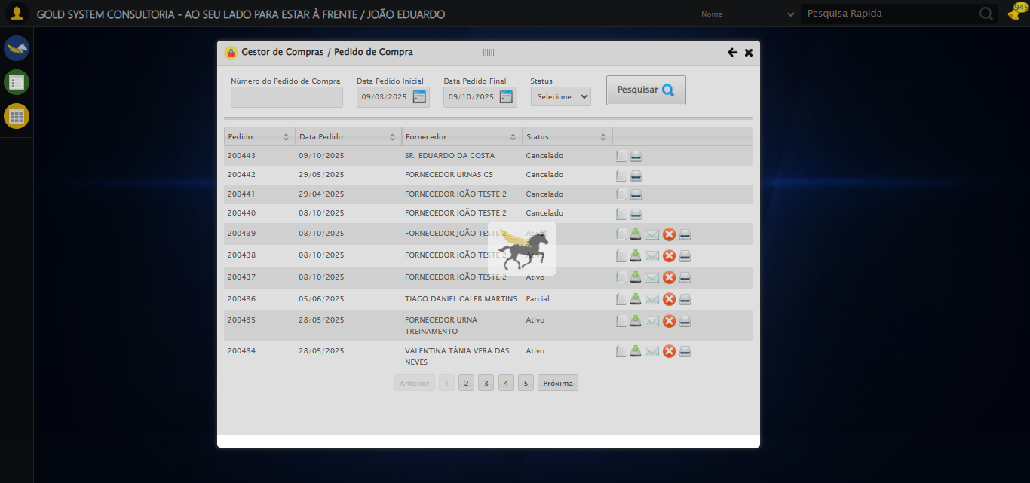

🔄 Fechando......

✅ Fechando... realizada com sucesso.

Screenshot: fechando...

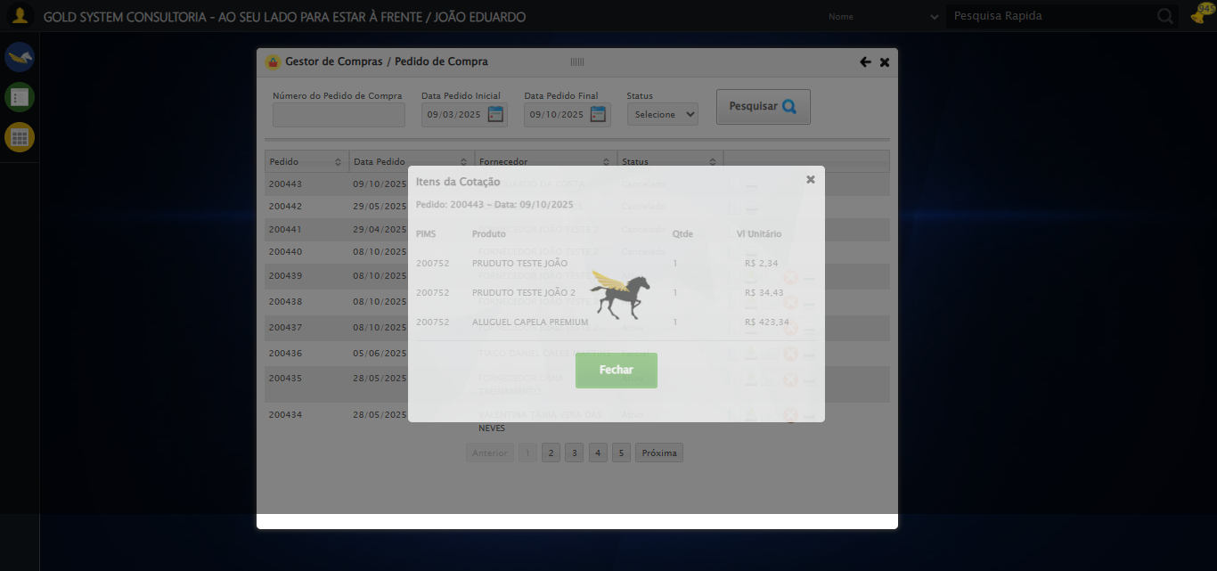

🔄 Realizando Download do PIMS...

✅ Realizando Download do PIMS realizada com sucesso.

Screenshot: realizando download do pims

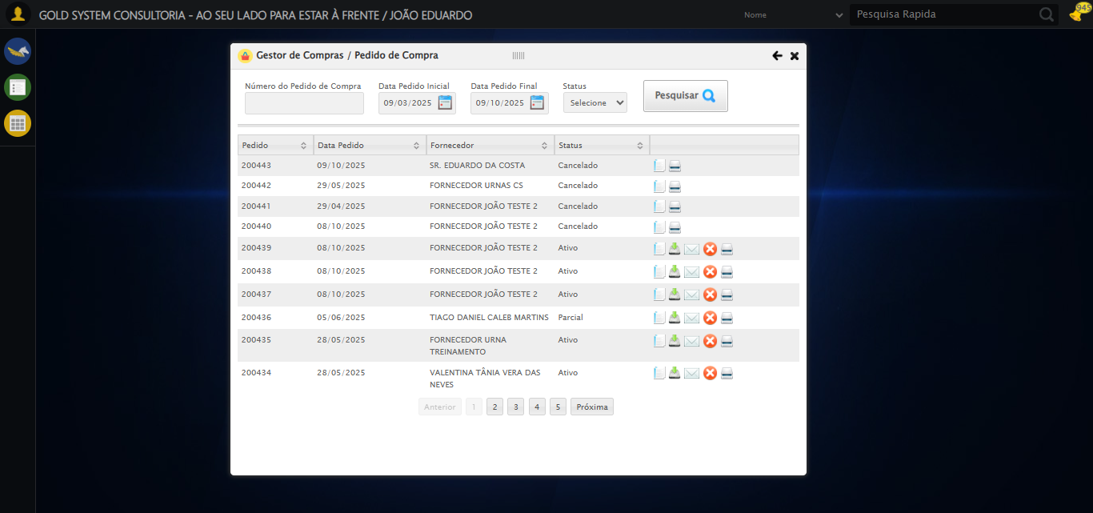

🔄 Enviando por E-mail...

✅ Enviando por E-mail realizada com sucesso.

Screenshot: enviando por e-mail



🔄 Abrindo digitalização de documentos...

⚠️ Tentativa 1 falhou para Abrindo digitalização de documentos, tentando novamente...

🔄 Abrindo digitalização de documentos... (Tentativa 2)

❌ Erro inesperado ao abrindo digitalização de documentos: Message: no such window: target window already closed  
from unknown error: web view not found  
 (Session info: chrome=140.0.7339.208)  
Stacktrace:  
 GetHandleVerifier [0x0xfbc333+65459]  
 GetHandleVerifier [0x0xfbc374+65524]  
 (No symbol) [0x0xddd973]  
 (No symbol) [0x0xdbc19d]  
 (No symbol) [0x0xe5059e]  
 (No symbol) [0x0xe6aef9]  
 (No symbol) [0x0xe49bf6]  
 (No symbol) [0x0xe1b38e]  
 (No symbol) [0x0xe1c274]  
 GetHandleVerifier [0x0x123eda3+2697763]  
 GetHandleVerifier [0x0x1239ec7+2677575]  
 GetHandleVerifier [0x0xfe4194+228884]  
 GetHandleVerifier [0x0xfd49f8+165496]  
 GetHandleVerifier [0x0xfdb18d+192013]  
 GetHandleVerifier [0x0xfc47d8+99416]  
 GetHandleVerifier [0x0xfc4972+99826]  
 GetHandleVerifier [0x0xfaebea+10346]  
 BaseThreadInitThunk [0x0x755bfcc9+25]  
 RtlGetAppContainerNamedObjectPath [0x0x773a82ae+286]  
 RtlGetAppContainerNamedObjectPath [0x0x773a827e+238]

⚠️ Erro ao tirar screenshot erro_abrindo digitalização de documentos: Message: no such window: target window already closed  
from unknown error: web view not found  
 (Session info: chrome=140.0.7339.208)  
Stacktrace:  
 GetHandleVerifier [0x0xfbc333+65459]  
 GetHandleVerifier [0x0xfbc374+65524]  
 (No symbol) [0x0xddd973]  
 (No symbol) [0x0xdbc19d]  
 (No symbol) [0x0xe5059e]  
 (No symbol) [0x0xe6aef9]  
 (No symbol) [0x0xe49bf6]  
 (No symbol) [0x0xe1b38e]  
 (No symbol) [0x0xe1c274]  
 GetHandleVerifier [0x0x123eda3+2697763]  
 GetHandleVerifier [0x0x1239ec7+2677575]  
 GetHandleVerifier [0x0xfe4194+228884]  
 GetHandleVerifier [0x0xfd49f8+165496]  
 GetHandleVerifier [0x0xfdb18d+192013]  
 GetHandleVerifier [0x0xfc47d8+99416]  
 GetHandleVerifier [0x0xfc4972+99826]  
 GetHandleVerifier [0x0xfaebea+10346]  
 BaseThreadInitThunk [0x0x755bfcc9+25]  
 RtlGetAppContainerNamedObjectPath [0x0x773a82ae+286]  
 RtlGetAppContainerNamedObjectPath [0x0x773a827e+238]

🔄 Adicionando novo documento...

❌ Erro inesperado ao adicionando novo documento: Message: no such window: target window already closed  
from unknown error: web view not found  
 (Session info: chrome=140.0.7339.208)  
Stacktrace:  
 GetHandleVerifier [0x0xfbc333+65459]  
 GetHandleVerifier [0x0xfbc374+65524]  
 (No symbol) [0x0xddd973]  
 (No symbol) [0x0xdbc19d]  
 (No symbol) [0x0xe5059e]  
 (No symbol) [0x0xe6aef9]  
 (No symbol) [0x0xe49bf6]  
 (No symbol) [0x0xe1b38e]  
 (No symbol) [0x0xe1c274]  
 GetHandleVerifier [0x0x123eda3+2697763]  
 GetHandleVerifier [0x0x1239ec7+2677575]  
 GetHandleVerifier [0x0xfe4194+228884]  
 GetHandleVerifier [0x0xfd49f8+165496]  
 GetHandleVerifier [0x0xfdb18d+192013]  
 GetHandleVerifier [0x0xfc47d8+99416]  
 GetHandleVerifier [0x0xfc4972+99826]  
 GetHandleVerifier [0x0xfaebea+10346]  
 BaseThreadInitThunk [0x0x755bfcc9+25]  
 RtlGetAppContainerNamedObjectPath [0x0x773a82ae+286]  
 RtlGetAppContainerNamedObjectPath [0x0x773a827e+238]

⚠️ Erro ao tirar screenshot erro_adicionando novo documento: Message: no such window: target window already closed  
from unknown error: web view not found  
 (Session info: chrome=140.0.7339.208)  
Stacktrace:  
 GetHandleVerifier [0x0xfbc333+65459]  
 GetHandleVerifier [0x0xfbc374+65524]  
 (No symbol) [0x0xddd973]  
 (No symbol) [0x0xdbc19d]  
 (No symbol) [0x0xe5059e]  
 (No symbol) [0x0xe6aef9]  
 (No symbol) [0x0xe49bf6]  
 (No symbol) [0x0xe1b38e]  
 (No symbol) [0x0xe1c274]  
 GetHandleVerifier [0x0x123eda3+2697763]  
 GetHandleVerifier [0x0x1239ec7+2677575]  
 GetHandleVerifier [0x0xfe4194+228884]  
 GetHandleVerifier [0x0xfd49f8+165496]  
 GetHandleVerifier [0x0xfdb18d+192013]  
 GetHandleVerifier [0x0xfc47d8+99416]  
 GetHandleVerifier [0x0xfc4972+99826]  
 GetHandleVerifier [0x0xfaebea+10346]  
 BaseThreadInitThunk [0x0x755bfcc9+25]  
 RtlGetAppContainerNamedObjectPath [0x0x773a82ae+286]  
 RtlGetAppContainerNamedObjectPath [0x0x773a827e+238]

🔄 Fazendo upload do arquivo...

📄 Realizando upload do arquivo.

❌ Erro inesperado ao fazendo upload do arquivo: log() takes 2 positional arguments but 3 were given

⚠️ Erro ao tirar screenshot erro_fazendo upload do arquivo: Message: no such window: target window already closed  
from unknown error: web view not found  
 (Session info: chrome=140.0.7339.208)  
Stacktrace:  
 GetHandleVerifier [0x0xfbc333+65459]  
 GetHandleVerifier [0x0xfbc374+65524]  
 (No symbol) [0x0xddd973]  
 (No symbol) [0x0xdbc19d]  
 (No symbol) [0x0xe5059e]  
 (No symbol) [0x0xe6aef9]  
 (No symbol) [0x0xe49bf6]  
 (No symbol) [0x0xe1b38e]  
 (No symbol) [0x0xe1c274]  
 GetHandleVerifier [0x0x123eda3+2697763]  
 GetHandleVerifier [0x0x1239ec7+2677575]  
 GetHandleVerifier [0x0xfe4194+228884]  
 GetHandleVerifier [0x0xfd49f8+165496]  
 GetHandleVerifier [0x0xfdb18d+192013]  
 GetHandleVerifier [0x0xfc47d8+99416]  
 GetHandleVerifier [0x0xfc4972+99826]  
 GetHandleVerifier [0x0xfaebea+10346]  
 BaseThreadInitThunk [0x0x755bfcc9+25]  
 RtlGetAppContainerNamedObjectPath [0x0x773a82ae+286]  
 RtlGetAppContainerNamedObjectPath [0x0x773a827e+238]

🔄 Salvando arquivo digitalizado...

❌ Erro inesperado ao salvando arquivo digitalizado: Message: no such window: target window already closed  
from unknown error: web view not found  
 (Session info: chrome=140.0.7339.208)  
Stacktrace:  
 GetHandleVerifier [0x0xfbc333+65459]  
 GetHandleVerifier [0x0xfbc374+65524]  
 (No symbol) [0x0xddd973]  
 (No symbol) [0x0xdbc19d]  
 (No symbol) [0x0xe5059e]  
 (No symbol) [0x0xe6aef9]  
 (No symbol) [0x0xe49bf6]  
 (No symbol) [0x0xe1b38e]  
 (No symbol) [0x0xe1c274]  
 GetHandleVerifier [0x0x123eda3+2697763]  
 GetHandleVerifier [0x0x1239ec7+2677575]  
 GetHandleVerifier [0x0xfe4194+228884]  
 GetHandleVerifier [0x0xfd49f8+165496]  
 GetHandleVerifier [0x0xfdb18d+192013]  
 GetHandleVerifier [0x0xfc47d8+99416]  
 GetHandleVerifier [0x0xfc4972+99826]  
 GetHandleVerifier [0x0xfaebea+10346]  
 BaseThreadInitThunk [0x0x755bfcc9+25]  
 RtlGetAppContainerNamedObjectPath [0x0x773a82ae+286]  
 RtlGetAppContainerNamedObjectPath [0x0x773a827e+238]

⚠️ Erro ao tirar screenshot erro_salvando arquivo digitalizado: Message: no such window: target window already closed  
from unknown error: web view not found  
 (Session info: chrome=140.0.7339.208)  
Stacktrace:  
 GetHandleVerifier [0x0xfbc333+65459]  
 GetHandleVerifier [0x0xfbc374+65524]  
 (No symbol) [0x0xddd973]  
 (No symbol) [0x0xdbc19d]  
 (No symbol) [0x0xe5059e]  
 (No symbol) [0x0xe6aef9]  
 (No symbol) [0x0xe49bf6]  
 (No symbol) [0x0xe1b38e]  
 (No symbol) [0x0xe1c274]  
 GetHandleVerifier [0x0x123eda3+2697763]  
 GetHandleVerifier [0x0x1239ec7+2677575]  
 GetHandleVerifier [0x0xfe4194+228884]  
 GetHandleVerifier [0x0xfd49f8+165496]  
 GetHandleVerifier [0x0xfdb18d+192013]  
 GetHandleVerifier [0x0xfc47d8+99416]  
 GetHandleVerifier [0x0xfc4972+99826]  
 GetHandleVerifier [0x0xfaebea+10346]  
 BaseThreadInitThunk [0x0x755bfcc9+25]  
 RtlGetAppContainerNamedObjectPath [0x0x773a82ae+286]  
 RtlGetAppContainerNamedObjectPath [0x0x773a827e+238]

Verificando mensagens de alerta após digitalização

ℹ️ Nenhuma mensagem de alerta encontrada.

🔄 Fechando modal de digitalização...

❌ Erro inesperado ao fechando modal de digitalização: Message: no such window: target window already closed  
from unknown error: web view not found  
 (Session info: chrome=140.0.7339.208)  
Stacktrace:  
 GetHandleVerifier [0x0xfbc333+65459]  
 GetHandleVerifier [0x0xfbc374+65524]  
 (No symbol) [0x0xddd973]  
 (No symbol) [0x0xdbc19d]  
 (No symbol) [0x0xe5059e]  
 (No symbol) [0x0xe6aef9]  
 (No symbol) [0x0xe49bf6]  
 (No symbol) [0x0xe1b38e]  
 (No symbol) [0x0xe1c274]  
 GetHandleVerifier [0x0x123eda3+2697763]  
 GetHandleVerifier [0x0x1239ec7+2677575]  
 GetHandleVerifier [0x0xfe4194+228884]  
 GetHandleVerifier [0x0xfd49f8+165496]  
 GetHandleVerifier [0x0xfdb18d+192013]  
 GetHandleVerifier [0x0xfc47d8+99416]  
 GetHandleVerifier [0x0xfc4972+99826]  
 GetHandleVerifier [0x0xfaebea+10346]  
 BaseThreadInitThunk [0x0x755bfcc9+25]  
 RtlGetAppContainerNamedObjectPath [0x0x773a82ae+286]  
 RtlGetAppContainerNamedObjectPath [0x0x773a827e+238]

⚠️ Erro ao tirar screenshot erro_fechando modal de digitalização: Message: no such window: target window already closed  
from unknown error: web view not found  
 (Session info: chrome=140.0.7339.208)  
Stacktrace:  
 GetHandleVerifier [0x0xfbc333+65459]  
 GetHandleVerifier [0x0xfbc374+65524]  
 (No symbol) [0x0xddd973]  
 (No symbol) [0x0xdbc19d]  
 (No symbol) [0x0xe5059e]  
 (No symbol) [0x0xe6aef9]  
 (No symbol) [0x0xe49bf6]  
 (No symbol) [0x0xe1b38e]  
 (No symbol) [0x0xe1c274]  
 GetHandleVerifier [0x0x123eda3+2697763]  
 GetHandleVerifier [0x0x1239ec7+2677575]  
 GetHandleVerifier [0x0xfe4194+228884]  
 GetHandleVerifier [0x0xfd49f8+165496]  
 GetHandleVerifier [0x0xfdb18d+192013]  
 GetHandleVerifier [0x0xfc47d8+99416]  
 GetHandleVerifier [0x0xfc4972+99826]  
 GetHandleVerifier [0x0xfaebea+10346]  
 BaseThreadInitThunk [0x0x755bfcc9+25]  
 RtlGetAppContainerNamedObjectPath [0x0x773a82ae+286]  
 RtlGetAppContainerNamedObjectPath [0x0x773a827e+238]

🔄 Fechando modal de digitalização...

❌ Erro ao clicar robusto: Message: no such window: target window already closed  
from unknown error: web view not found  
 (Session info: chrome=140.0.7339.208)  
Stacktrace:  
 GetHandleVerifier [0x0xfbc333+65459]  
 GetHandleVerifier [0x0xfbc374+65524]  
 (No symbol) [0x0xddd973]  
 (No symbol) [0x0xdbc19d]  
 (No symbol) [0x0xe5059e]  
 (No symbol) [0x0xe6aef9]  
 (No symbol) [0x0xe49bf6]  
 (No symbol) [0x0xe1b38e]  
 (No symbol) [0x0xe1c274]  
 GetHandleVerifier [0x0x123eda3+2697763]  
 GetHandleVerifier [0x0x1239ec7+2677575]  
 GetHandleVerifier [0x0xfe4194+228884]  
 GetHandleVerifier [0x0xfd49f8+165496]  
 GetHandleVerifier [0x0xfdb18d+192013]  
 GetHandleVerifier [0x0xfc47d8+99416]  
 GetHandleVerifier [0x0xfc4972+99826]  
 GetHandleVerifier [0x0xfaebea+10346]  
 BaseThreadInitThunk [0x0x755bfcc9+25]  
 RtlGetAppContainerNamedObjectPath [0x0x773a82ae+286]  
 RtlGetAppContainerNamedObjectPath [0x0x773a827e+238]

✅ Fechando modal de digitalização realizada com sucesso.

⚠️ Erro ao tirar screenshot fechando modal de digitalização: Message: no such window: target window already closed  
from unknown error: web view not found  
 (Session info: chrome=140.0.7339.208)  
Stacktrace:  
 GetHandleVerifier [0x0xfbc333+65459]  
 GetHandleVerifier [0x0xfbc374+65524]  
 (No symbol) [0x0xddd973]  
 (No symbol) [0x0xdbc19d]  
 (No symbol) [0x0xe5059e]  
 (No symbol) [0x0xe6aef9]  
 (No symbol) [0x0xe49bf6]  
 (No symbol) [0x0xe1b38e]  
 (No symbol) [0x0xe1c274]  
 GetHandleVerifier [0x0x123eda3+2697763]  
 GetHandleVerifier [0x0x1239ec7+2677575]  
 GetHandleVerifier [0x0xfe4194+228884]  
 GetHandleVerifier [0x0xfd49f8+165496]  
 GetHandleVerifier [0x0xfdb18d+192013]  
 GetHandleVerifier [0x0xfc47d8+99416]  
 GetHandleVerifier [0x0xfc4972+99826]  
 GetHandleVerifier [0x0xfaebea+10346]  
 BaseThreadInitThunk [0x0x755bfcc9+25]  
 RtlGetAppContainerNamedObjectPath [0x0x773a82ae+286]  
 RtlGetAppContainerNamedObjectPath [0x0x773a827e+238]

🔄 Clicando em Cancelar Pedido...

❌ Erro inesperado ao clicando em cancelar pedido: Message: no such window: target window already closed  
from unknown error: web view not found  
 (Session info: chrome=140.0.7339.208)  
Stacktrace:  
 GetHandleVerifier [0x0xfbc333+65459]  
 GetHandleVerifier [0x0xfbc374+65524]  
 (No symbol) [0x0xddd973]  
 (No symbol) [0x0xdbc19d]  
 (No symbol) [0x0xe5059e]  
 (No symbol) [0x0xe6aef9]  
 (No symbol) [0x0xe49bf6]  
 (No symbol) [0x0xe1b38e]  
 (No symbol) [0x0xe1c274]  
 GetHandleVerifier [0x0x123eda3+2697763]  
 GetHandleVerifier [0x0x1239ec7+2677575]  
 GetHandleVerifier [0x0xfe4194+228884]  
 GetHandleVerifier [0x0xfd49f8+165496]  
 GetHandleVerifier [0x0xfdb18d+192013]  
 GetHandleVerifier [0x0xfc47d8+99416]  
 GetHandleVerifier [0x0xfc4972+99826]  
 GetHandleVerifier [0x0xfaebea+10346]  
 BaseThreadInitThunk [0x0x755bfcc9+25]  
 RtlGetAppContainerNamedObjectPath [0x0x773a82ae+286]  
 RtlGetAppContainerNamedObjectPath [0x0x773a827e+238]

⚠️ Erro ao tirar screenshot erro_clicando em cancelar pedido: Message: no such window: target window already closed  
from unknown error: web view not found  
 (Session info: chrome=140.0.7339.208)  
Stacktrace:  
 GetHandleVerifier [0x0xfbc333+65459]  
 GetHandleVerifier [0x0xfbc374+65524]  
 (No symbol) [0x0xddd973]  
 (No symbol) [0x0xdbc19d]  
 (No symbol) [0x0xe5059e]  
 (No symbol) [0x0xe6aef9]  
 (No symbol) [0x0xe49bf6]  
 (No symbol) [0x0xe1b38e]  
 (No symbol) [0x0xe1c274]  
 GetHandleVerifier [0x0x123eda3+2697763]  
 GetHandleVerifier [0x0x1239ec7+2677575]  
 GetHandleVerifier [0x0xfe4194+228884]  
 GetHandleVerifier [0x0xfd49f8+165496]  
 GetHandleVerifier [0x0xfdb18d+192013]  
 GetHandleVerifier [0x0xfc47d8+99416]  
 GetHandleVerifier [0x0xfc4972+99826]  
 GetHandleVerifier [0x0xfaebea+10346]  
 BaseThreadInitThunk [0x0x755bfcc9+25]  
 RtlGetAppContainerNamedObjectPath [0x0x773a82ae+286]  
 RtlGetAppContainerNamedObjectPath [0x0x773a827e+238]

🔄 Confirmando...

❌ Erro inesperado ao confirmando: Message: no such window: target window already closed  
from unknown error: web view not found  
 (Session info: chrome=140.0.7339.208)  
Stacktrace:  
 GetHandleVerifier [0x0xfbc333+65459]  
 GetHandleVerifier [0x0xfbc374+65524]  
 (No symbol) [0x0xddd973]  
 (No symbol) [0x0xdbc19d]  
 (No symbol) [0x0xe5059e]  
 (No symbol) [0x0xe6aef9]  
 (No symbol) [0x0xe49bf6]  
 (No symbol) [0x0xe1b38e]  
 (No symbol) [0x0xe1c274]  
 GetHandleVerifier [0x0x123eda3+2697763]  
 GetHandleVerifier [0x0x1239ec7+2677575]  
 GetHandleVerifier [0x0xfe4194+228884]  
 GetHandleVerifier [0x0xfd49f8+165496]  
 GetHandleVerifier [0x0xfdb18d+192013]  
 GetHandleVerifier [0x0xfc47d8+99416]  
 GetHandleVerifier [0x0xfc4972+99826]  
 GetHandleVerifier [0x0xfaebea+10346]  
 BaseThreadInitThunk [0x0x755bfcc9+25]  
 RtlGetAppContainerNamedObjectPath [0x0x773a82ae+286]  
 RtlGetAppContainerNamedObjectPath [0x0x773a827e+238]

⚠️ Erro ao tirar screenshot erro_confirmando: Message: no such window: target window already closed  
from unknown error: web view not found  
 (Session info: chrome=140.0.7339.208)  
Stacktrace:  
 GetHandleVerifier [0x0xfbc333+65459]  
 GetHandleVerifier [0x0xfbc374+65524]  
 (No symbol) [0x0xddd973]  
 (No symbol) [0x0xdbc19d]  
 (No symbol) [0x0xe5059e]  
 (No symbol) [0x0xe6aef9]  
 (No symbol) [0x0xe49bf6]  
 (No symbol) [0x0xe1b38e]  
 (No symbol) [0x0xe1c274]  
 GetHandleVerifier [0x0x123eda3+2697763]  
 GetHandleVerifier [0x0x1239ec7+2677575]  
 GetHandleVerifier [0x0xfe4194+228884]  
 GetHandleVerifier [0x0xfd49f8+165496]  
 GetHandleVerifier [0x0xfdb18d+192013]  
 GetHandleVerifier [0x0xfc47d8+99416]  
 GetHandleVerifier [0x0xfc4972+99826]  
 GetHandleVerifier [0x0xfaebea+10346]  
 BaseThreadInitThunk [0x0x755bfcc9+25]  
 RtlGetAppContainerNamedObjectPath [0x0x773a82ae+286]  
 RtlGetAppContainerNamedObjectPath [0x0x773a827e+238]

🔍 Verificando mensagens de alerta

ℹ️ Nenhuma mensagem de alerta encontrada.

🔄 Fechando modal Gestor de Compras...

❌ Erro ao clicar robusto: Message: no such window: target window already closed  
from unknown error: web view not found  
 (Session info: chrome=140.0.7339.208)  
Stacktrace:  
 GetHandleVerifier [0x0xfbc333+65459]  
 GetHandleVerifier [0x0xfbc374+65524]  
 (No symbol) [0x0xddd973]  
 (No symbol) [0x0xdbc19d]  
 (No symbol) [0x0xe5059e]  
 (No symbol) [0x0xe6aef9]  
 (No symbol) [0x0xe49bf6]  
 (No symbol) [0x0xe1b38e]  
 (No symbol) [0x0xe1c274]  
 GetHandleVerifier [0x0x123eda3+2697763]  
 GetHandleVerifier [0x0x1239ec7+2677575]  
 GetHandleVerifier [0x0xfe4194+228884]  
 GetHandleVerifier [0x0xfd49f8+165496]  
 GetHandleVerifier [0x0xfdb18d+192013]  
 GetHandleVerifier [0x0xfc47d8+99416]  
 GetHandleVerifier [0x0xfc4972+99826]  
 GetHandleVerifier [0x0xfaebea+10346]  
 BaseThreadInitThunk [0x0x755bfcc9+25]  
 RtlGetAppContainerNamedObjectPath [0x0x773a82ae+286]  
 RtlGetAppContainerNamedObjectPath [0x0x773a827e+238]

✅ Fechando modal Gestor de Compras realizada com sucesso.

⚠️ Erro ao tirar screenshot fechando modal gestor de compras: Message: no such window: target window already closed  
from unknown error: web view not found  
 (Session info: chrome=140.0.7339.208)  
Stacktrace:  
 GetHandleVerifier [0x0xfbc333+65459]  
 GetHandleVerifier [0x0xfbc374+65524]  
 (No symbol) [0x0xddd973]  
 (No symbol) [0x0xdbc19d]  
 (No symbol) [0x0xe5059e]  
 (No symbol) [0x0xe6aef9]  
 (No symbol) [0x0xe49bf6]  
 (No symbol) [0x0xe1b38e]  
 (No symbol) [0x0xe1c274]  
 GetHandleVerifier [0x0x123eda3+2697763]  
 GetHandleVerifier [0x0x1239ec7+2677575]  
 GetHandleVerifier [0x0xfe4194+228884]  
 GetHandleVerifier [0x0xfd49f8+165496]  
 GetHandleVerifier [0x0xfdb18d+192013]  
 GetHandleVerifier [0x0xfc47d8+99416]  
 GetHandleVerifier [0x0xfc4972+99826]  
 GetHandleVerifier [0x0xfaebea+10346]  
 BaseThreadInitThunk [0x0x755bfcc9+25]  
 RtlGetAppContainerNamedObjectPath [0x0x773a82ae+286]  
 RtlGetAppContainerNamedObjectPath [0x0x773a827e+238]

✅ Teste concluído.

✅ Teste executado com sucesso!