RELATÓRIO DO TESTE

Cadastro de Raças – Cenário 1: Preenchimento completo e salvamento.

Data do teste: 15/09/2025 17:36:55

🔄 Acessando sistema...

✅ Acessando sistema realizada com sucesso.

Screenshot: acessando_sistema

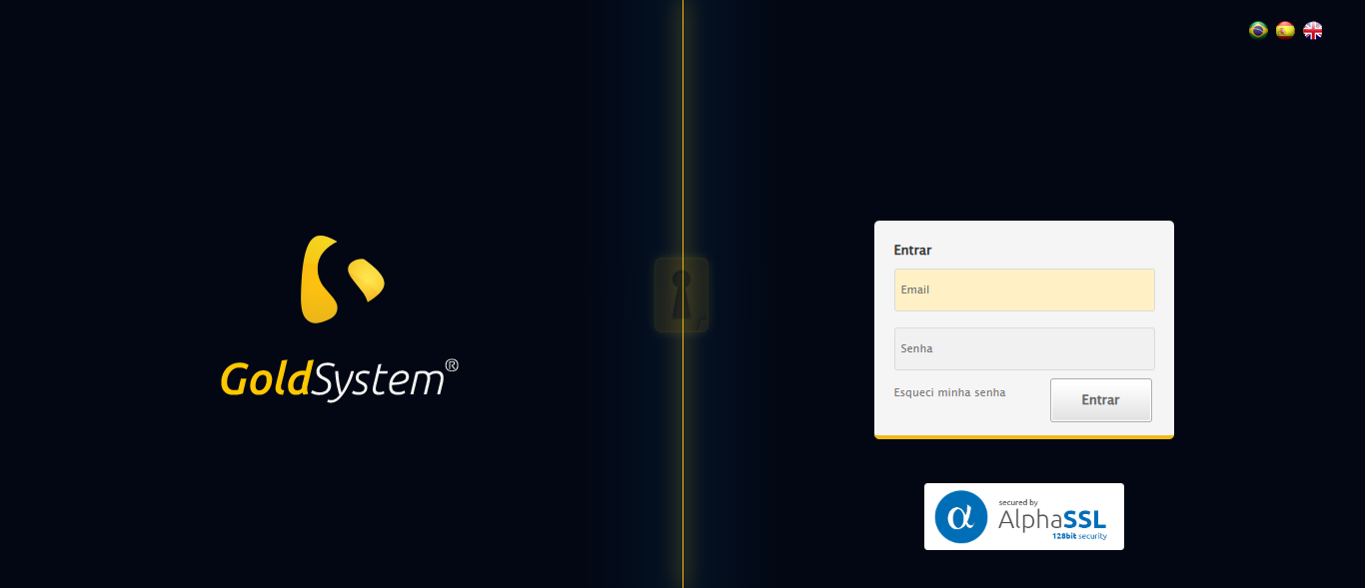

🔄 Realizando login...

✅ Realizando login realizada com sucesso.

Screenshot: realizando_login

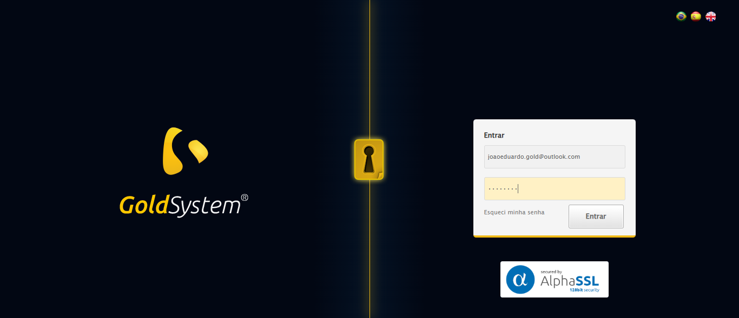

🔄 Esperando sistema carregar e ajustando zoom...

🔍 Zoom ajustado para 90%.

✅ Esperando sistema carregar e ajustando zoom realizada com sucesso.

Screenshot: esperando_sistema_carregar_e_ajustando_zoom

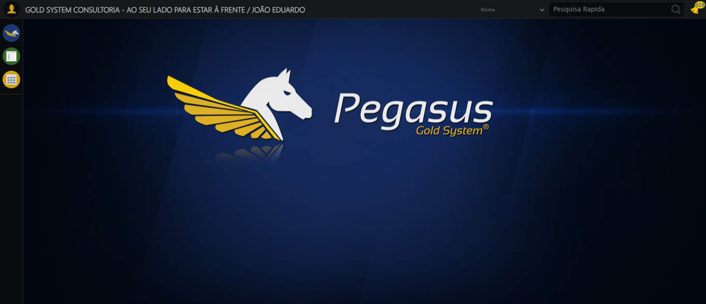

🔄 Abrindo menu Raças...

✅ Abrindo menu Raças realizada com sucesso.

Screenshot: abrindo_menu_raças

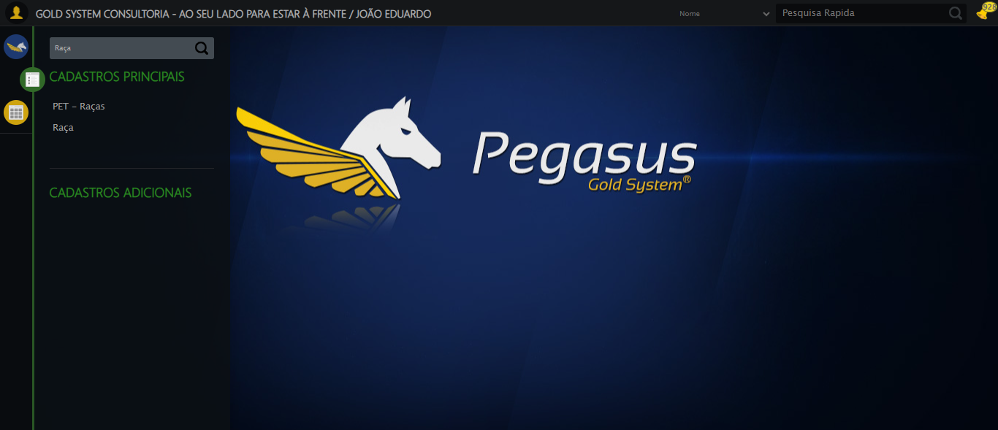

🔄 Selecionando opção Raça no menu...

❌ Erro ao selecionando opção raça no menu: Message:

Screenshot: erro_selecionando_opção_raça_no_menu



🔄 Clicando em Cadastrar...

❌ Erro ao clicando em cadastrar: Message:   
Stacktrace:  
 GetHandleVerifier [0x0xb2a8a3+63283]  
 GetHandleVerifier [0x0xb2a8e4+63348]  
 (No symbol) [0x0x963e43]  
 (No symbol) [0x0x9ac8de]  
 (No symbol) [0x0x9acc7b]  
 (No symbol) [0x0x9f4ef2]  
 (No symbol) [0x0x9d1464]  
 (No symbol) [0x0x9f271a]  
 (No symbol) [0x0x9d1216]  
 (No symbol) [0x0x9a0855]  
 (No symbol) [0x0x9a16f4]  
 GetHandleVerifier [0x0xd9bb43+2623955]  
 GetHandleVerifier [0x0xd96daa+2604090]  
 GetHandleVerifier [0x0xb5069a+218410]  
 GetHandleVerifier [0x0xb40ed8+154984]  
 GetHandleVerifier [0x0xb4742d+180925]  
 GetHandleVerifier [0x0xb322b8+94536]  
 GetHandleVerifier [0x0xb32442+94930]  
 GetHandleVerifier [0x0xb1d5ea+9338]  
 BaseThreadInitThunk [0x0x76b1fcc9+25]  
 RtlGetAppContainerNamedObjectPath [0x0x776a82ae+286]  
 RtlGetAppContainerNamedObjectPath [0x0x776a827e+238]

Screenshot: erro_clicando_em_cadastrar

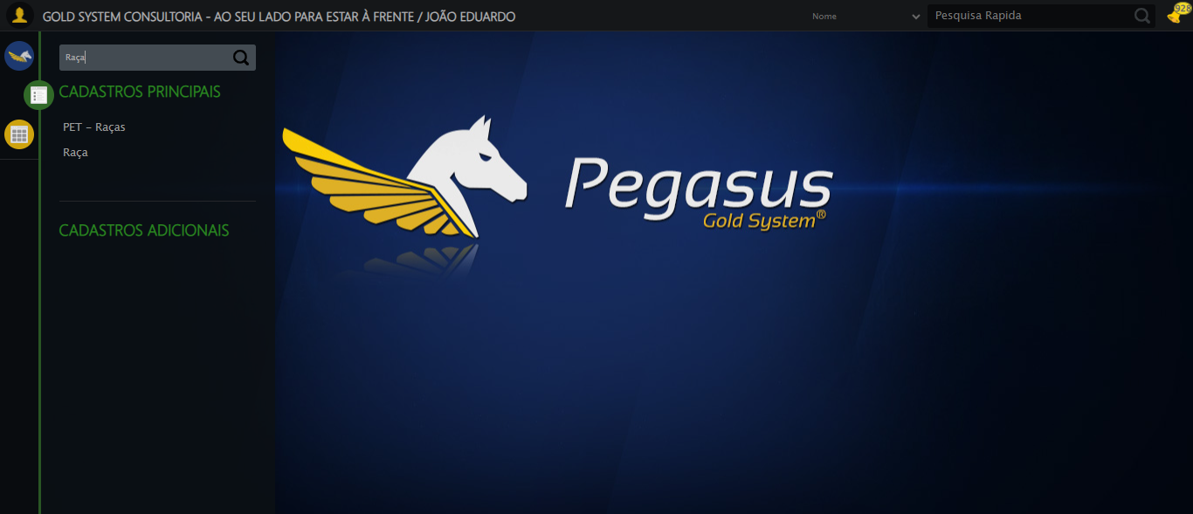

🔄 Preenchendo Nome da Raça...

❌ Erro ao preenchendo nome da raça: Message:   
Stacktrace:  
 GetHandleVerifier [0x0xb2a8a3+63283]  
 GetHandleVerifier [0x0xb2a8e4+63348]  
 (No symbol) [0x0x963e43]  
 (No symbol) [0x0x9ac8de]  
 (No symbol) [0x0x9acc7b]  
 (No symbol) [0x0x9f4ef2]  
 (No symbol) [0x0x9d1464]  
 (No symbol) [0x0x9f271a]  
 (No symbol) [0x0x9d1216]  
 (No symbol) [0x0x9a0855]  
 (No symbol) [0x0x9a16f4]  
 GetHandleVerifier [0x0xd9bb43+2623955]  
 GetHandleVerifier [0x0xd96daa+2604090]  
 GetHandleVerifier [0x0xb5069a+218410]  
 GetHandleVerifier [0x0xb40ed8+154984]  
 GetHandleVerifier [0x0xb4742d+180925]  
 GetHandleVerifier [0x0xb322b8+94536]  
 GetHandleVerifier [0x0xb32442+94930]  
 GetHandleVerifier [0x0xb1d5ea+9338]  
 BaseThreadInitThunk [0x0x76b1fcc9+25]  
 RtlGetAppContainerNamedObjectPath [0x0x776a82ae+286]  
 RtlGetAppContainerNamedObjectPath [0x0x776a827e+238]

Screenshot: erro_preenchendo_nome_da_raça

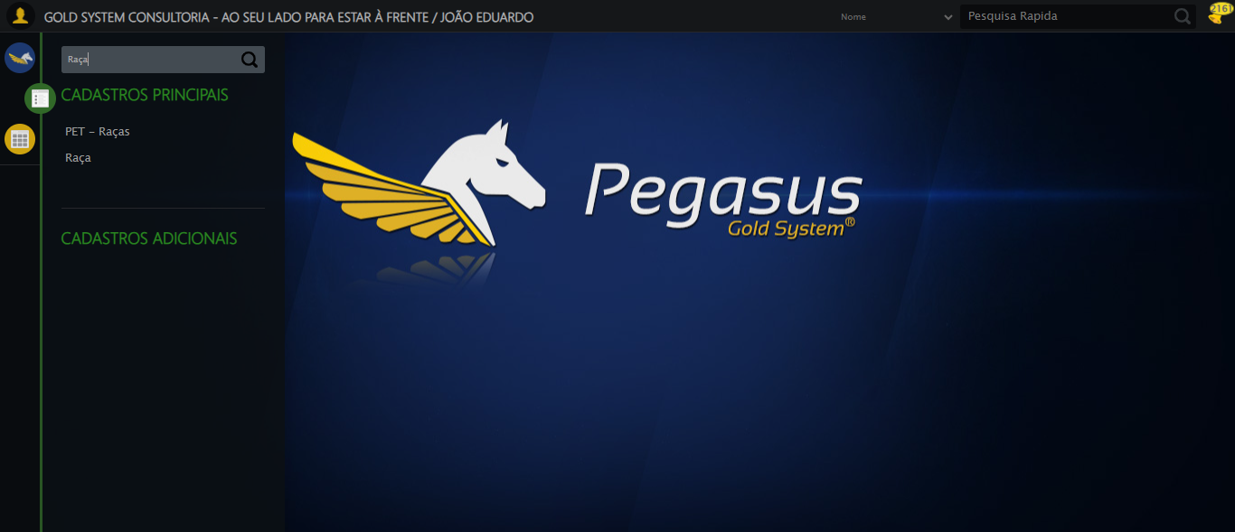

🔄 Salvando cadastro...

❌ Erro ao salvando cadastro: Message: invalid session id: session deleted as the browser has closed the connection  
from disconnected: not connected to DevTools  
 (Session info: chrome=139.0.7258.155); For documentation on this error, please visit: https://www.selenium.dev/documentation/webdriver/troubleshooting/errors#invalidsessionidexception  
Stacktrace:  
 GetHandleVerifier [0x0xb2a8a3+63283]  
 GetHandleVerifier [0x0xb2a8e4+63348]  
 (No symbol) [0x0x963e43]  
 (No symbol) [0x0x953790]  
 (No symbol) [0x0x971602]  
 (No symbol) [0x0x9d7cdc]  
 (No symbol) [0x0x9f1ff9]  
 (No symbol) [0x0x9d1216]  
 (No symbol) [0x0x9a0855]  
 (No symbol) [0x0x9a16f4]  
 GetHandleVerifier [0x0xd9bb43+2623955]  
 GetHandleVerifier [0x0xd96daa+2604090]  
 GetHandleVerifier [0x0xb5069a+218410]  
 GetHandleVerifier [0x0xb40ed8+154984]  
 GetHandleVerifier [0x0xb4742d+180925]  
 GetHandleVerifier [0x0xb322b8+94536]  
 GetHandleVerifier [0x0xb32442+94930]  
 GetHandleVerifier [0x0xb1d5ea+9338]  
 BaseThreadInitThunk [0x0x76b1fcc9+25]  
 RtlGetAppContainerNamedObjectPath [0x0x776a82ae+286]  
 RtlGetAppContainerNamedObjectPath [0x0x776a827e+238]

❌ ERRO FATAL: Message: invalid session id; For documentation on this error, please visit: https://www.selenium.dev/documentation/webdriver/troubleshooting/errors#invalidsessionidexception  
Stacktrace:  
 GetHandleVerifier [0x0xb2a8a3+63283]  
 GetHandleVerifier [0x0xb2a8e4+63348]  
 (No symbol) [0x0x963ca0]  
 (No symbol) [0x0x99fb48]  
 (No symbol) [0x0x9d12d6]  
 (No symbol) [0x0x9cceb5]  
 (No symbol) [0x0x9cc436]  
 (No symbol) [0x0x935755]  
 (No symbol) [0x0x935cae]  
 (No symbol) [0x0x93613d]  
 GetHandleVerifier [0x0xd9bb43+2623955]  
 GetHandleVerifier [0x0xd96daa+2604090]  
 GetHandleVerifier [0x0xb5069a+218410]  
 GetHandleVerifier [0x0xb40ed8+154984]  
 GetHandleVerifier [0x0xb4742d+180925]  
 (No symbol) [0x0x935420]  
 (No symbol) [0x0x934c36]  
 GetHandleVerifier [0x0xed68fc+3913612]  
 BaseThreadInitThunk [0x0x76b1fcc9+25]  
 RtlGetAppContainerNamedObjectPath [0x0x776a82ae+286]  
 RtlGetAppContainerNamedObjectPath [0x0x776a827e+238]

✅ Teste concluído com sucesso.