RELATÓRIO DO TESTE

Cadastro de Tipo de Mensalidade – Cenário 1: Preenchimento completo e salvamento.

Data do teste: 02/10/2025 14:10:49

🔄 Acessando sistema...

✅ Acessando sistema realizada com sucesso.

Screenshot: acessando_sistema

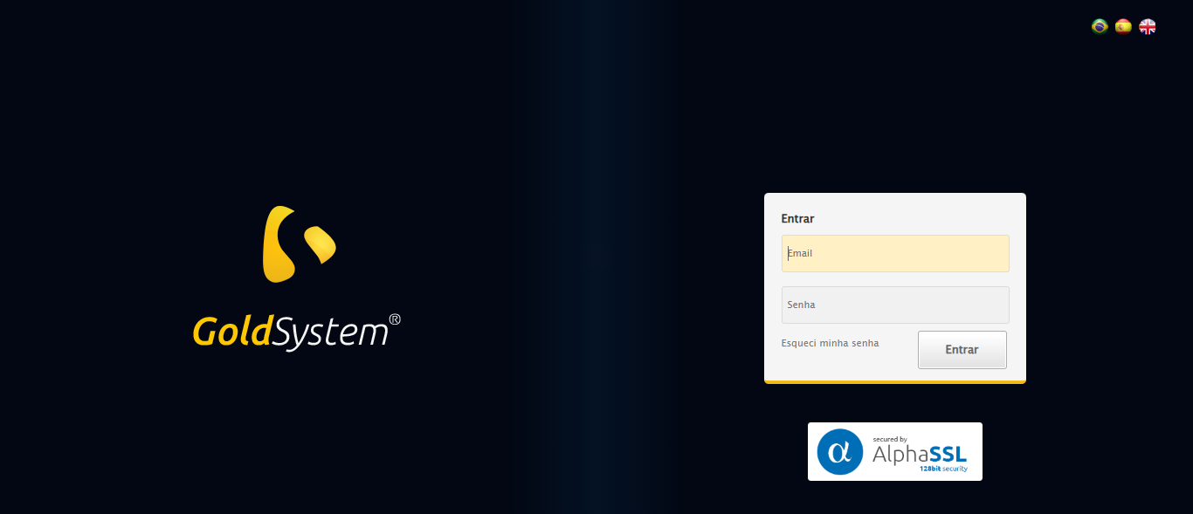

🔄 Realizando login...

✅ Realizando login realizada com sucesso.

Screenshot: realizando_login

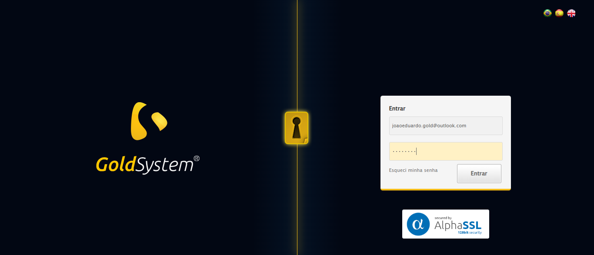

🔄 Esperando sistema carregar e ajustando zoom...

🔍 Zoom ajustado para 90%.

✅ Esperando sistema carregar e ajustando zoom realizada com sucesso.

Screenshot: esperando_sistema_carregar_e_ajustando_zoom

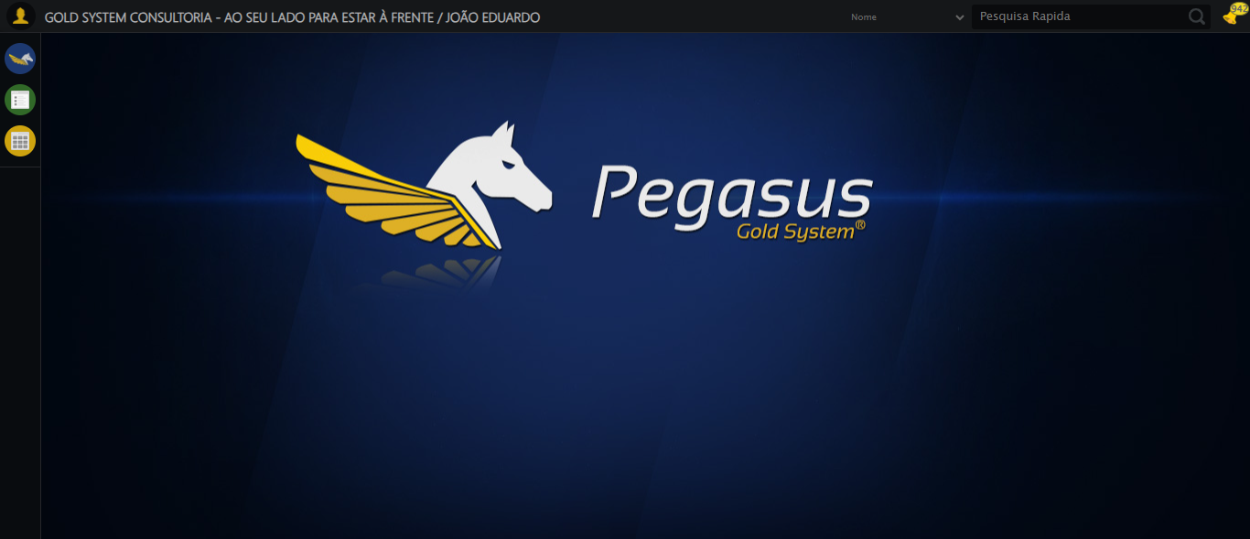

🔄 Abrindo menu Tipo de Mensalidade...

✅ Abrindo menu Tipo de Mensalidade realizada com sucesso.

Screenshot: abrindo_menu_tipo_de_mensalidade

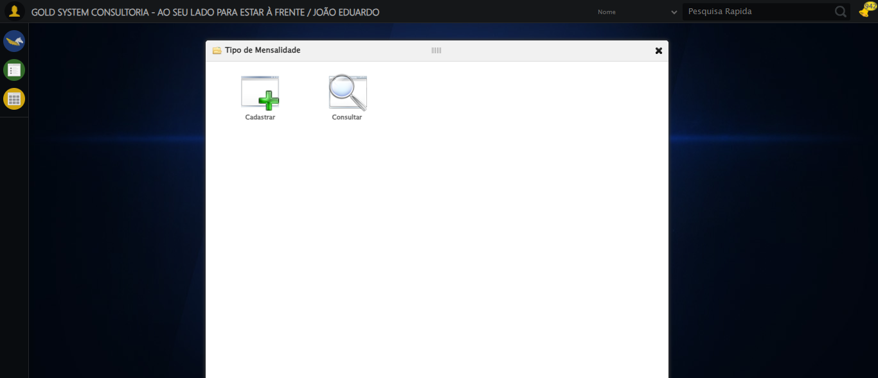

🔄 Clicando em Cadastrar...

✅ Clicando em Cadastrar realizada com sucesso.

Screenshot: clicando_em_cadastrar

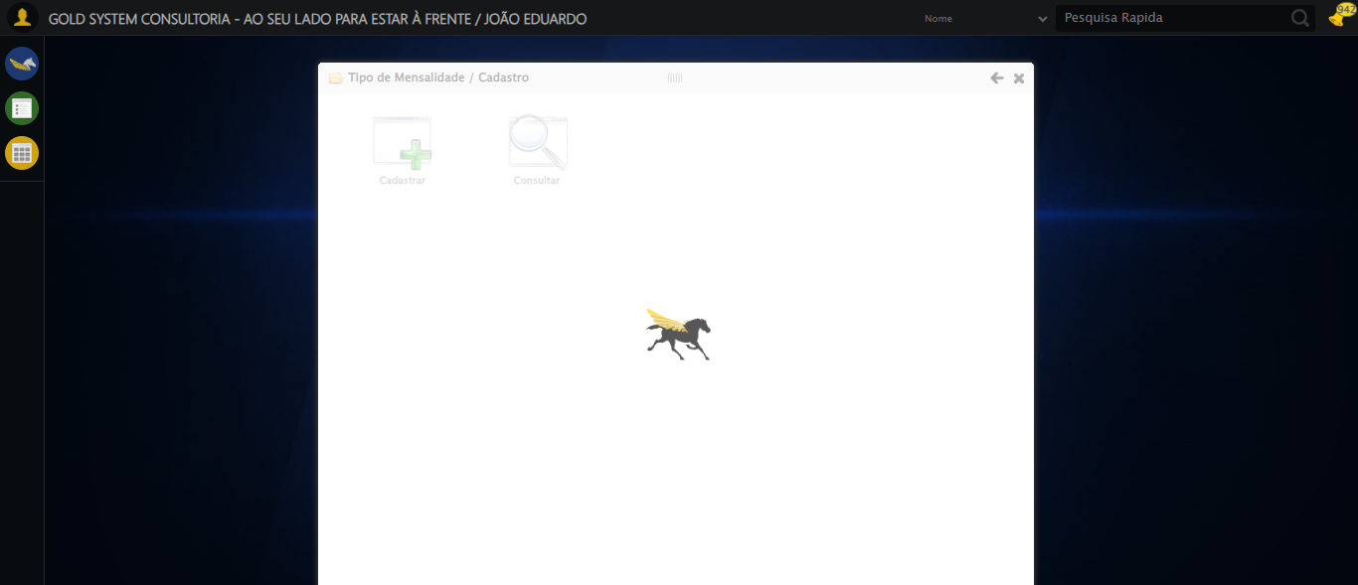

🔄 Preenchendo Nome...

✅ Preenchendo Nome realizada com sucesso.

Screenshot: preenchendo_nome

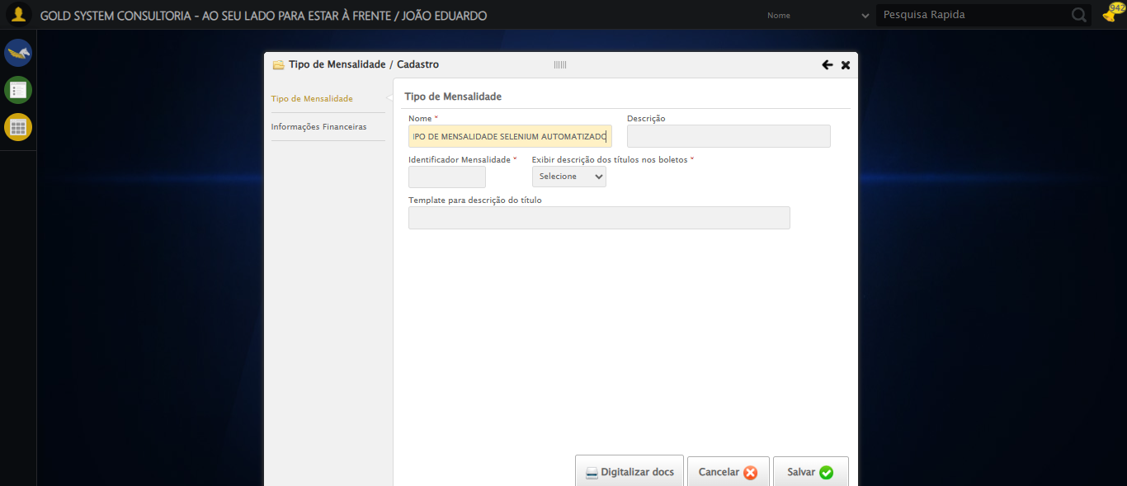

🔄 Preenchendo Descrição...

✅ Preenchendo Descrição realizada com sucesso.

Screenshot: preenchendo_descrição

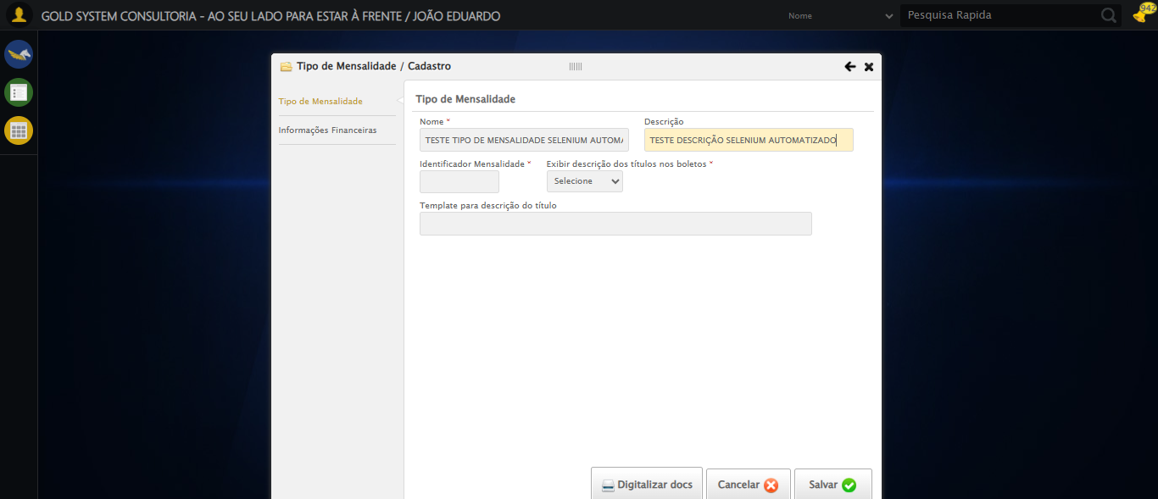

🔄 Preenchendo Identificador...

✅ Preenchendo Identificador realizada com sucesso.

Screenshot: preenchendo_identificador

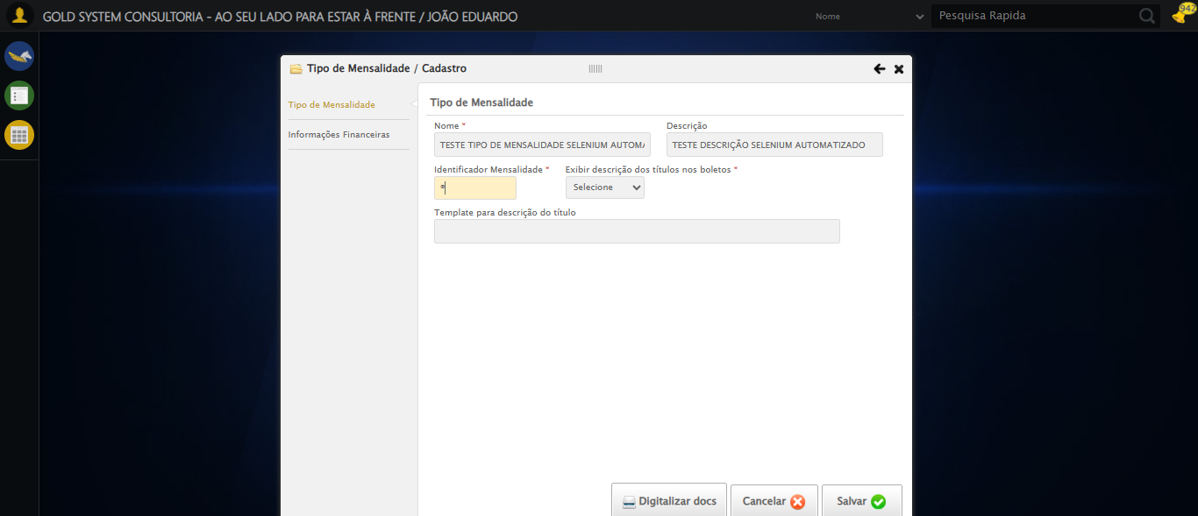

🔄 Selecionando a opção para Exibir descrição dos títulos nos boletos...

✅ Selecionando a opção para Exibir descrição dos títulos nos boletos realizada com sucesso.

Screenshot: selecionando_a_opção_para_exibir_descrição_dos_títulos_nos_boletos

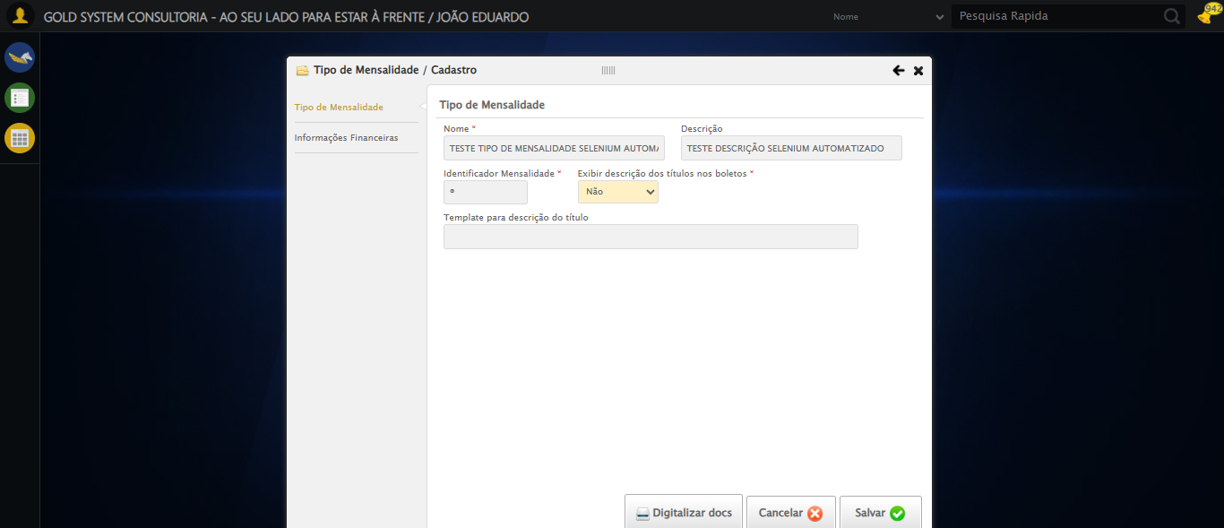

🔄 Preenchendo Template...

✅ Preenchendo Template realizada com sucesso.

Screenshot: preenchendo_template

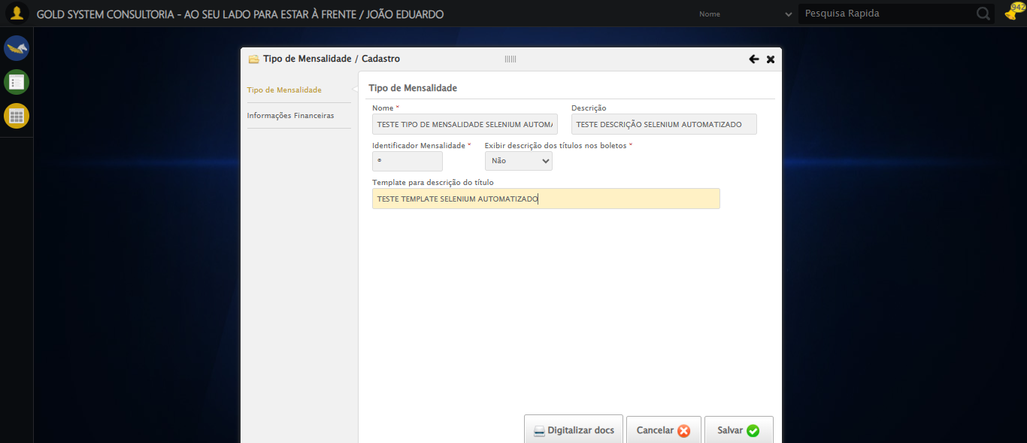

🔄 Clicando aba Informações Financeiras...

✅ Clicando aba Informações Financeiras realizada com sucesso.

Screenshot: clicando_aba_informações_financeiras

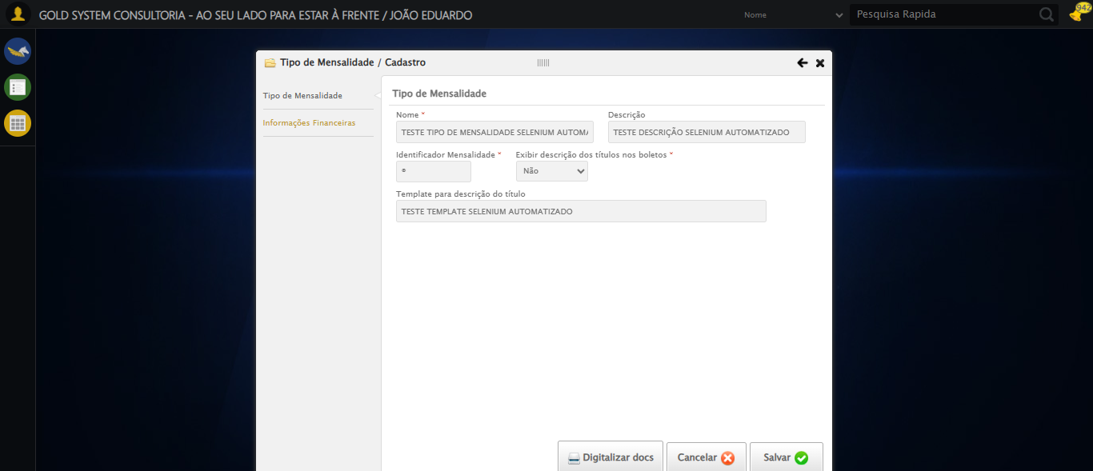

🔄 Selecionando Conta Crédito 1...

❌ Erro ao selecionando conta crédito 1: Message: invalid selector: No selector specified  
 (Session info: chrome=140.0.7339.208); For documentation on this error, please visit: https://www.selenium.dev/documentation/webdriver/troubleshooting/errors#invalidselectorexception  
Stacktrace:  
 GetHandleVerifier [0x0x3bc333+65459]  
 GetHandleVerifier [0x0x3bc374+65524]  
 (No symbol) [0x0x1dd973]  
 (No symbol) [0x0x1e4330]  
 (No symbol) [0x0x1e6734]  
 (No symbol) [0x0x1e67c8]  
 (No symbol) [0x0x226f74]  
 (No symbol) [0x0x227a8b]  
 (No symbol) [0x0x26dea2]  
 (No symbol) [0x0x249e44]  
 (No symbol) [0x0x26b606]  
 (No symbol) [0x0x249bf6]  
 (No symbol) [0x0x21b38e]  
 (No symbol) [0x0x21c274]  
 GetHandleVerifier [0x0x63eda3+2697763]  
 GetHandleVerifier [0x0x639ec7+2677575]  
 GetHandleVerifier [0x0x3e4194+228884]  
 GetHandleVerifier [0x0x3d49f8+165496]  
 GetHandleVerifier [0x0x3db18d+192013]  
 GetHandleVerifier [0x0x3c47d8+99416]  
 GetHandleVerifier [0x0x3c4972+99826]  
 GetHandleVerifier [0x0x3aebea+10346]  
 BaseThreadInitThunk [0x0x755bfcc9+25]  
 RtlGetAppContainerNamedObjectPath [0x0x773a82ae+286]  
 RtlGetAppContainerNamedObjectPath [0x0x773a827e+238]

Screenshot: erro_selecionando_conta_crédito_1

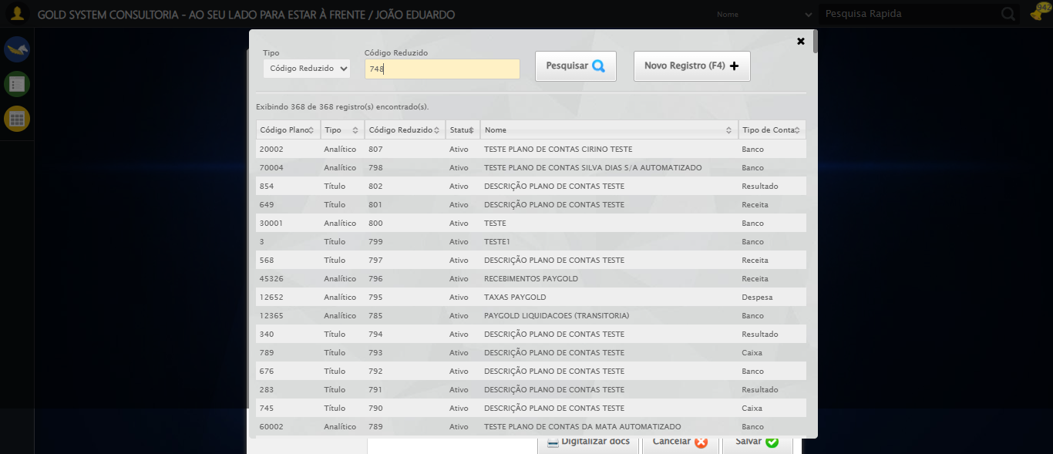

🔄 Selecionando Conta Débito 1...

❌ Erro ao selecionando conta débito 1: Message: element click intercepted: Element <a class="sprites sp-openLov"></a> is not clickable at point (836, 163). Other element would receive the click: <div class="DataTables_sort_wrapper">...</div>  
 (Session info: chrome=140.0.7339.208); For documentation on this error, please visit: https://www.selenium.dev/documentation/webdriver/troubleshooting/errors#elementclickinterceptedexception  
Stacktrace:  
 GetHandleVerifier [0x0x3bc333+65459]  
 GetHandleVerifier [0x0x3bc374+65524]  
 (No symbol) [0x0x1dd973]  
 (No symbol) [0x0x22dbc0]  
 (No symbol) [0x0x22bf23]  
 (No symbol) [0x0x2299c7]  
 (No symbol) [0x0x228c66]  
 (No symbol) [0x0x21d195]  
 (No symbol) [0x0x249dfc]  
 (No symbol) [0x0x21cbf4]  
 (No symbol) [0x0x249fb4]  
 (No symbol) [0x0x26b606]  
 (No symbol) [0x0x249bf6]  
 (No symbol) [0x0x21b38e]  
 (No symbol) [0x0x21c274]  
 GetHandleVerifier [0x0x63eda3+2697763]  
 GetHandleVerifier [0x0x639ec7+2677575]  
 GetHandleVerifier [0x0x3e4194+228884]  
 GetHandleVerifier [0x0x3d49f8+165496]  
 GetHandleVerifier [0x0x3db18d+192013]  
 GetHandleVerifier [0x0x3c47d8+99416]  
 GetHandleVerifier [0x0x3c4972+99826]  
 GetHandleVerifier [0x0x3aebea+10346]  
 BaseThreadInitThunk [0x0x755bfcc9+25]  
 RtlGetAppContainerNamedObjectPath [0x0x773a82ae+286]  
 RtlGetAppContainerNamedObjectPath [0x0x773a827e+238]

Screenshot: erro_selecionando_conta_débito_1



🔄 Selecionando Histórico Padrão 1...

❌ Erro ao selecionando histórico padrão 1: Message: element click intercepted: Element <a class="sprites sp-openLov"></a> is not clickable at point (572, 213). Other element would receive the click: <a class="linkAlterar" style="height: 25.8889px;"></a>  
 (Session info: chrome=140.0.7339.208); For documentation on this error, please visit: https://www.selenium.dev/documentation/webdriver/troubleshooting/errors#elementclickinterceptedexception  
Stacktrace:  
 GetHandleVerifier [0x0x3bc333+65459]  
 GetHandleVerifier [0x0x3bc374+65524]  
 (No symbol) [0x0x1dd973]  
 (No symbol) [0x0x22dbc0]  
 (No symbol) [0x0x22bf23]  
 (No symbol) [0x0x2299c7]  
 (No symbol) [0x0x228c66]  
 (No symbol) [0x0x21d195]  
 (No symbol) [0x0x249dfc]  
 (No symbol) [0x0x21cbf4]  
 (No symbol) [0x0x249fb4]  
 (No symbol) [0x0x26b606]  
 (No symbol) [0x0x249bf6]  
 (No symbol) [0x0x21b38e]  
 (No symbol) [0x0x21c274]  
 GetHandleVerifier [0x0x63eda3+2697763]  
 GetHandleVerifier [0x0x639ec7+2677575]  
 GetHandleVerifier [0x0x3e4194+228884]  
 GetHandleVerifier [0x0x3d49f8+165496]  
 GetHandleVerifier [0x0x3db18d+192013]  
 GetHandleVerifier [0x0x3c47d8+99416]  
 GetHandleVerifier [0x0x3c4972+99826]  
 GetHandleVerifier [0x0x3aebea+10346]  
 BaseThreadInitThunk [0x0x755bfcc9+25]  
 RtlGetAppContainerNamedObjectPath [0x0x773a82ae+286]  
 RtlGetAppContainerNamedObjectPath [0x0x773a827e+238]

Screenshot: erro_selecionando_histórico_padrão_1

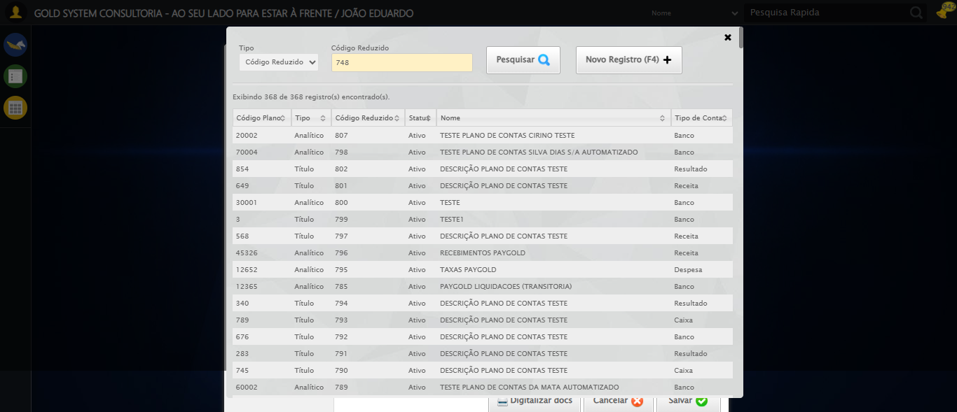

🔄 Selecionando Centro de Custo 1...

❌ Erro ao selecionando centro de custo 1: Message: element click intercepted: Element <a class="sprites sp-openLov"></a> is not clickable at point (836, 213). Other element would receive the click: <a class="linkAlterar" style="height: 25.8889px;"></a>  
 (Session info: chrome=140.0.7339.208); For documentation on this error, please visit: https://www.selenium.dev/documentation/webdriver/troubleshooting/errors#elementclickinterceptedexception  
Stacktrace:  
 GetHandleVerifier [0x0x3bc333+65459]  
 GetHandleVerifier [0x0x3bc374+65524]  
 (No symbol) [0x0x1dd973]  
 (No symbol) [0x0x22dbc0]  
 (No symbol) [0x0x22bf23]  
 (No symbol) [0x0x2299c7]  
 (No symbol) [0x0x228c66]  
 (No symbol) [0x0x21d195]  
 (No symbol) [0x0x249dfc]  
 (No symbol) [0x0x21cbf4]  
 (No symbol) [0x0x249fb4]  
 (No symbol) [0x0x26b606]  
 (No symbol) [0x0x249bf6]  
 (No symbol) [0x0x21b38e]  
 (No symbol) [0x0x21c274]  
 GetHandleVerifier [0x0x63eda3+2697763]  
 GetHandleVerifier [0x0x639ec7+2677575]  
 GetHandleVerifier [0x0x3e4194+228884]  
 GetHandleVerifier [0x0x3d49f8+165496]  
 GetHandleVerifier [0x0x3db18d+192013]  
 GetHandleVerifier [0x0x3c47d8+99416]  
 GetHandleVerifier [0x0x3c4972+99826]  
 GetHandleVerifier [0x0x3aebea+10346]  
 BaseThreadInitThunk [0x0x755bfcc9+25]  
 RtlGetAppContainerNamedObjectPath [0x0x773a82ae+286]  
 RtlGetAppContainerNamedObjectPath [0x0x773a827e+238]

Screenshot: erro_selecionando_centro_de_custo_1



🔄 Selecionando Conta Crédito 2...

❌ Erro ao selecionando conta crédito 2: Message: element click intercepted: Element <a class="sprites sp-openLov"></a> is not clickable at point (572, 299). Other element would receive the click: <a class="linkAlterar" style="height: 25.8889px;"></a>  
 (Session info: chrome=140.0.7339.208); For documentation on this error, please visit: https://www.selenium.dev/documentation/webdriver/troubleshooting/errors#elementclickinterceptedexception  
Stacktrace:  
 GetHandleVerifier [0x0x3bc333+65459]  
 GetHandleVerifier [0x0x3bc374+65524]  
 (No symbol) [0x0x1dd973]  
 (No symbol) [0x0x22dbc0]  
 (No symbol) [0x0x22bf23]  
 (No symbol) [0x0x2299c7]  
 (No symbol) [0x0x228c66]  
 (No symbol) [0x0x21d195]  
 (No symbol) [0x0x249dfc]  
 (No symbol) [0x0x21cbf4]  
 (No symbol) [0x0x249fb4]  
 (No symbol) [0x0x26b606]  
 (No symbol) [0x0x249bf6]  
 (No symbol) [0x0x21b38e]  
 (No symbol) [0x0x21c274]  
 GetHandleVerifier [0x0x63eda3+2697763]  
 GetHandleVerifier [0x0x639ec7+2677575]  
 GetHandleVerifier [0x0x3e4194+228884]  
 GetHandleVerifier [0x0x3d49f8+165496]  
 GetHandleVerifier [0x0x3db18d+192013]  
 GetHandleVerifier [0x0x3c47d8+99416]  
 GetHandleVerifier [0x0x3c4972+99826]  
 GetHandleVerifier [0x0x3aebea+10346]  
 BaseThreadInitThunk [0x0x755bfcc9+25]  
 RtlGetAppContainerNamedObjectPath [0x0x773a82ae+286]  
 RtlGetAppContainerNamedObjectPath [0x0x773a827e+238]

Screenshot: erro_selecionando_conta_crédito_2



🔄 Selecionando Conta Débito 2...

❌ Erro ao selecionando conta débito 2: Message: element click intercepted: Element <a class="sprites sp-openLov"></a> is not clickable at point (836, 299). Other element would receive the click: <a class="linkAlterar" style="height: 25.8889px;"></a>  
 (Session info: chrome=140.0.7339.208); For documentation on this error, please visit: https://www.selenium.dev/documentation/webdriver/troubleshooting/errors#elementclickinterceptedexception  
Stacktrace:  
 GetHandleVerifier [0x0x3bc333+65459]  
 GetHandleVerifier [0x0x3bc374+65524]  
 (No symbol) [0x0x1dd973]  
 (No symbol) [0x0x22dbc0]  
 (No symbol) [0x0x22bf23]  
 (No symbol) [0x0x2299c7]  
 (No symbol) [0x0x228c66]  
 (No symbol) [0x0x21d195]  
 (No symbol) [0x0x249dfc]  
 (No symbol) [0x0x21cbf4]  
 (No symbol) [0x0x249fb4]  
 (No symbol) [0x0x26b606]  
 (No symbol) [0x0x249bf6]  
 (No symbol) [0x0x21b38e]  
 (No symbol) [0x0x21c274]  
 GetHandleVerifier [0x0x63eda3+2697763]  
 GetHandleVerifier [0x0x639ec7+2677575]  
 GetHandleVerifier [0x0x3e4194+228884]  
 GetHandleVerifier [0x0x3d49f8+165496]  
 GetHandleVerifier [0x0x3db18d+192013]  
 GetHandleVerifier [0x0x3c47d8+99416]  
 GetHandleVerifier [0x0x3c4972+99826]  
 GetHandleVerifier [0x0x3aebea+10346]  
 BaseThreadInitThunk [0x0x755bfcc9+25]  
 RtlGetAppContainerNamedObjectPath [0x0x773a82ae+286]  
 RtlGetAppContainerNamedObjectPath [0x0x773a827e+238]

Screenshot: erro_selecionando_conta_débito_2



🔄 Selecionando Histórico Padrão 2...

❌ Erro ao selecionando histórico padrão 2: Message: element click intercepted: Element <a class="sprites sp-openLov"></a> is not clickable at point (572, 349). Other element would receive the click: <a class="linkAlterar" style="height: 25.8889px;"></a>  
 (Session info: chrome=140.0.7339.208); For documentation on this error, please visit: https://www.selenium.dev/documentation/webdriver/troubleshooting/errors#elementclickinterceptedexception  
Stacktrace:  
 GetHandleVerifier [0x0x3bc333+65459]  
 GetHandleVerifier [0x0x3bc374+65524]  
 (No symbol) [0x0x1dd973]  
 (No symbol) [0x0x22dbc0]  
 (No symbol) [0x0x22bf23]  
 (No symbol) [0x0x2299c7]  
 (No symbol) [0x0x228c66]  
 (No symbol) [0x0x21d195]  
 (No symbol) [0x0x249dfc]  
 (No symbol) [0x0x21cbf4]  
 (No symbol) [0x0x249fb4]  
 (No symbol) [0x0x26b606]  
 (No symbol) [0x0x249bf6]  
 (No symbol) [0x0x21b38e]  
 (No symbol) [0x0x21c274]  
 GetHandleVerifier [0x0x63eda3+2697763]  
 GetHandleVerifier [0x0x639ec7+2677575]  
 GetHandleVerifier [0x0x3e4194+228884]  
 GetHandleVerifier [0x0x3d49f8+165496]  
 GetHandleVerifier [0x0x3db18d+192013]  
 GetHandleVerifier [0x0x3c47d8+99416]  
 GetHandleVerifier [0x0x3c4972+99826]  
 GetHandleVerifier [0x0x3aebea+10346]  
 BaseThreadInitThunk [0x0x755bfcc9+25]  
 RtlGetAppContainerNamedObjectPath [0x0x773a82ae+286]  
 RtlGetAppContainerNamedObjectPath [0x0x773a827e+238]

Screenshot: erro_selecionando_histórico_padrão_2



🔄 Selecionando Centro de Custo 2...

❌ Erro ao selecionando centro de custo 2: Message: element click intercepted: Element <a class="sprites sp-openLov"></a> is not clickable at point (836, 349). Other element would receive the click: <a class="linkAlterar" style="height: 25.8889px;"></a>  
 (Session info: chrome=140.0.7339.208); For documentation on this error, please visit: https://www.selenium.dev/documentation/webdriver/troubleshooting/errors#elementclickinterceptedexception  
Stacktrace:  
 GetHandleVerifier [0x0x3bc333+65459]  
 GetHandleVerifier [0x0x3bc374+65524]  
 (No symbol) [0x0x1dd973]  
 (No symbol) [0x0x22dbc0]  
 (No symbol) [0x0x22bf23]  
 (No symbol) [0x0x2299c7]  
 (No symbol) [0x0x228c66]  
 (No symbol) [0x0x21d195]  
 (No symbol) [0x0x249dfc]  
 (No symbol) [0x0x21cbf4]  
 (No symbol) [0x0x249fb4]  
 (No symbol) [0x0x26b606]  
 (No symbol) [0x0x249bf6]  
 (No symbol) [0x0x21b38e]  
 (No symbol) [0x0x21c274]  
 GetHandleVerifier [0x0x63eda3+2697763]  
 GetHandleVerifier [0x0x639ec7+2677575]  
 GetHandleVerifier [0x0x3e4194+228884]  
 GetHandleVerifier [0x0x3d49f8+165496]  
 GetHandleVerifier [0x0x3db18d+192013]  
 GetHandleVerifier [0x0x3c47d8+99416]  
 GetHandleVerifier [0x0x3c4972+99826]  
 GetHandleVerifier [0x0x3aebea+10346]  
 BaseThreadInitThunk [0x0x755bfcc9+25]  
 RtlGetAppContainerNamedObjectPath [0x0x773a82ae+286]  
 RtlGetAppContainerNamedObjectPath [0x0x773a827e+238]

Screenshot: erro_selecionando_centro_de_custo_2



🔄 Selecionando Conta Crédito 3...

❌ Erro ao selecionando conta crédito 3: Message: element click intercepted: Element <a class="sprites sp-openLov"></a> is not clickable at point (572, 435). Other element would receive the click: <a class="linkAlterar" style="height: 25.8889px;"></a>  
 (Session info: chrome=140.0.7339.208); For documentation on this error, please visit: https://www.selenium.dev/documentation/webdriver/troubleshooting/errors#elementclickinterceptedexception  
Stacktrace:  
 GetHandleVerifier [0x0x3bc333+65459]  
 GetHandleVerifier [0x0x3bc374+65524]  
 (No symbol) [0x0x1dd973]  
 (No symbol) [0x0x22dbc0]  
 (No symbol) [0x0x22bf23]  
 (No symbol) [0x0x2299c7]  
 (No symbol) [0x0x228c66]  
 (No symbol) [0x0x21d195]  
 (No symbol) [0x0x249dfc]  
 (No symbol) [0x0x21cbf4]  
 (No symbol) [0x0x249fb4]  
 (No symbol) [0x0x26b606]  
 (No symbol) [0x0x249bf6]  
 (No symbol) [0x0x21b38e]  
 (No symbol) [0x0x21c274]  
 GetHandleVerifier [0x0x63eda3+2697763]  
 GetHandleVerifier [0x0x639ec7+2677575]  
 GetHandleVerifier [0x0x3e4194+228884]  
 GetHandleVerifier [0x0x3d49f8+165496]  
 GetHandleVerifier [0x0x3db18d+192013]  
 GetHandleVerifier [0x0x3c47d8+99416]  
 GetHandleVerifier [0x0x3c4972+99826]  
 GetHandleVerifier [0x0x3aebea+10346]  
 BaseThreadInitThunk [0x0x755bfcc9+25]  
 RtlGetAppContainerNamedObjectPath [0x0x773a82ae+286]  
 RtlGetAppContainerNamedObjectPath [0x0x773a827e+238]

Screenshot: erro_selecionando_conta_crédito_3

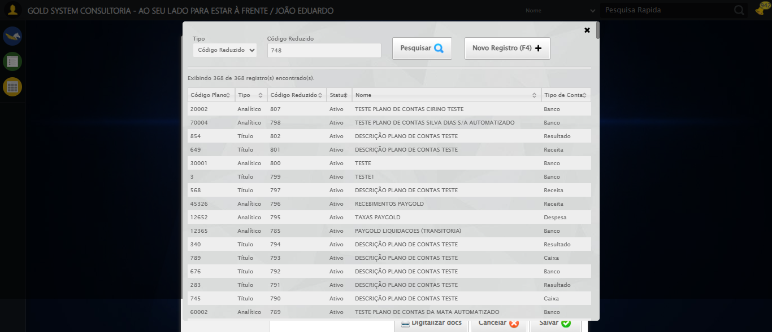

🔄 Selecionando Conta Débito 3...

❌ Erro ao selecionando conta débito 3: Message: element click intercepted: Element <a class="sprites sp-openLov"></a> is not clickable at point (836, 435). Other element would receive the click: <a class="linkAlterar" style="height: 25.8889px;"></a>  
 (Session info: chrome=140.0.7339.208); For documentation on this error, please visit: https://www.selenium.dev/documentation/webdriver/troubleshooting/errors#elementclickinterceptedexception  
Stacktrace:  
 GetHandleVerifier [0x0x3bc333+65459]  
 GetHandleVerifier [0x0x3bc374+65524]  
 (No symbol) [0x0x1dd973]  
 (No symbol) [0x0x22dbc0]  
 (No symbol) [0x0x22bf23]  
 (No symbol) [0x0x2299c7]  
 (No symbol) [0x0x228c66]  
 (No symbol) [0x0x21d195]  
 (No symbol) [0x0x249dfc]  
 (No symbol) [0x0x21cbf4]  
 (No symbol) [0x0x249fb4]  
 (No symbol) [0x0x26b606]  
 (No symbol) [0x0x249bf6]  
 (No symbol) [0x0x21b38e]  
 (No symbol) [0x0x21c274]  
 GetHandleVerifier [0x0x63eda3+2697763]  
 GetHandleVerifier [0x0x639ec7+2677575]  
 GetHandleVerifier [0x0x3e4194+228884]  
 GetHandleVerifier [0x0x3d49f8+165496]  
 GetHandleVerifier [0x0x3db18d+192013]  
 GetHandleVerifier [0x0x3c47d8+99416]  
 GetHandleVerifier [0x0x3c4972+99826]  
 GetHandleVerifier [0x0x3aebea+10346]  
 BaseThreadInitThunk [0x0x755bfcc9+25]  
 RtlGetAppContainerNamedObjectPath [0x0x773a82ae+286]  
 RtlGetAppContainerNamedObjectPath [0x0x773a827e+238]

Screenshot: erro_selecionando_conta_débito_3

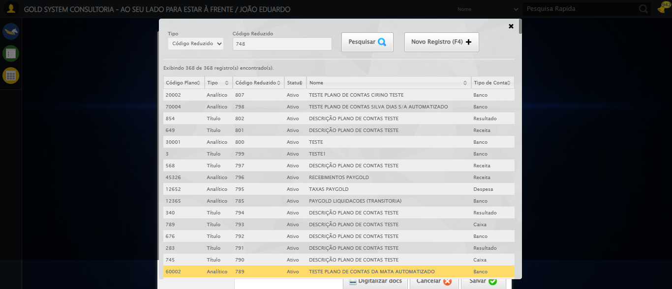

🔄 Selecionando Histórico Padrão 3...

❌ Erro ao selecionando histórico padrão 3: Message: element click intercepted: Element <a class="sprites sp-openLov"></a> is not clickable at point (572, 485). Other element would receive the click: <a class="linkAlterar" style="height: 25.8889px;"></a>  
 (Session info: chrome=140.0.7339.208); For documentation on this error, please visit: https://www.selenium.dev/documentation/webdriver/troubleshooting/errors#elementclickinterceptedexception  
Stacktrace:  
 GetHandleVerifier [0x0x3bc333+65459]  
 GetHandleVerifier [0x0x3bc374+65524]  
 (No symbol) [0x0x1dd973]  
 (No symbol) [0x0x22dbc0]  
 (No symbol) [0x0x22bf23]  
 (No symbol) [0x0x2299c7]  
 (No symbol) [0x0x228c66]  
 (No symbol) [0x0x21d195]  
 (No symbol) [0x0x249dfc]  
 (No symbol) [0x0x21cbf4]  
 (No symbol) [0x0x249fb4]  
 (No symbol) [0x0x26b606]  
 (No symbol) [0x0x249bf6]  
 (No symbol) [0x0x21b38e]  
 (No symbol) [0x0x21c274]  
 GetHandleVerifier [0x0x63eda3+2697763]  
 GetHandleVerifier [0x0x639ec7+2677575]  
 GetHandleVerifier [0x0x3e4194+228884]  
 GetHandleVerifier [0x0x3d49f8+165496]  
 GetHandleVerifier [0x0x3db18d+192013]  
 GetHandleVerifier [0x0x3c47d8+99416]  
 GetHandleVerifier [0x0x3c4972+99826]  
 GetHandleVerifier [0x0x3aebea+10346]  
 BaseThreadInitThunk [0x0x755bfcc9+25]  
 RtlGetAppContainerNamedObjectPath [0x0x773a82ae+286]  
 RtlGetAppContainerNamedObjectPath [0x0x773a827e+238]

Screenshot: erro_selecionando_histórico_padrão_3



🔄 Selecionando Centro de Custo 3...

❌ Erro ao selecionando centro de custo 3: Message: element click intercepted: Element <a class="sprites sp-openLov"></a> is not clickable at point (836, 485). Other element would receive the click: <a class="linkAlterar" style="height: 25.8889px;"></a>  
 (Session info: chrome=140.0.7339.208); For documentation on this error, please visit: https://www.selenium.dev/documentation/webdriver/troubleshooting/errors#elementclickinterceptedexception  
Stacktrace:  
 GetHandleVerifier [0x0x3bc333+65459]  
 GetHandleVerifier [0x0x3bc374+65524]  
 (No symbol) [0x0x1dd973]  
 (No symbol) [0x0x22dbc0]  
 (No symbol) [0x0x22bf23]  
 (No symbol) [0x0x2299c7]  
 (No symbol) [0x0x228c66]  
 (No symbol) [0x0x21d195]  
 (No symbol) [0x0x249dfc]  
 (No symbol) [0x0x21cbf4]  
 (No symbol) [0x0x249fb4]  
 (No symbol) [0x0x26b606]  
 (No symbol) [0x0x249bf6]  
 (No symbol) [0x0x21b38e]  
 (No symbol) [0x0x21c274]  
 GetHandleVerifier [0x0x63eda3+2697763]  
 GetHandleVerifier [0x0x639ec7+2677575]  
 GetHandleVerifier [0x0x3e4194+228884]  
 GetHandleVerifier [0x0x3d49f8+165496]  
 GetHandleVerifier [0x0x3db18d+192013]  
 GetHandleVerifier [0x0x3c47d8+99416]  
 GetHandleVerifier [0x0x3c4972+99826]  
 GetHandleVerifier [0x0x3aebea+10346]  
 BaseThreadInitThunk [0x0x755bfcc9+25]  
 RtlGetAppContainerNamedObjectPath [0x0x773a82ae+286]  
 RtlGetAppContainerNamedObjectPath [0x0x773a827e+238]

Screenshot: erro_selecionando_centro_de_custo_3

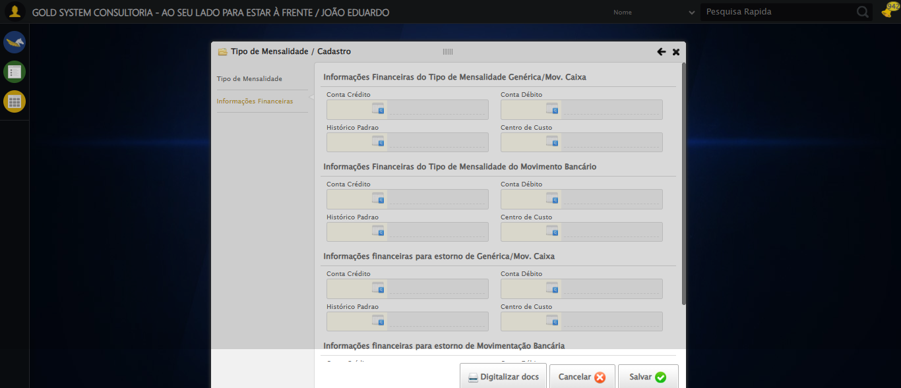

🔄 Fazendo scroll para seção 4...

✅ Fazendo scroll para seção 4 realizada com sucesso.

Screenshot: fazendo_scroll_para_seção_4

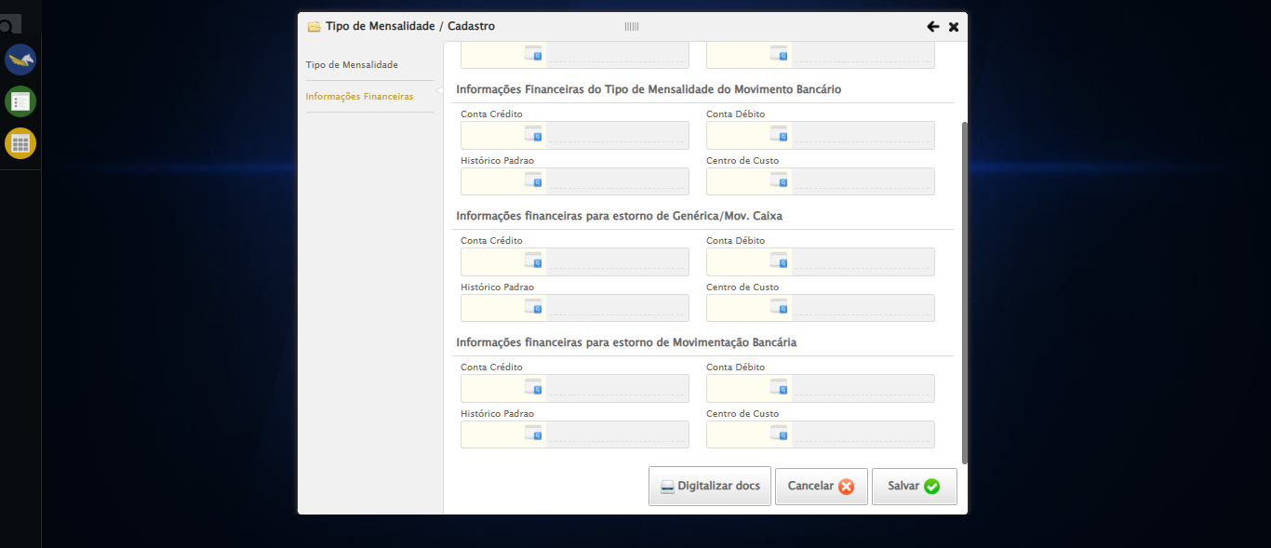

🔄 Selecionando Conta Crédito 4...

❌ Erro ao selecionando conta crédito 4: Message: invalid selector: No selector specified  
 (Session info: chrome=140.0.7339.208); For documentation on this error, please visit: https://www.selenium.dev/documentation/webdriver/troubleshooting/errors#invalidselectorexception  
Stacktrace:  
 GetHandleVerifier [0x0x3bc333+65459]  
 GetHandleVerifier [0x0x3bc374+65524]  
 (No symbol) [0x0x1dd973]  
 (No symbol) [0x0x1e4330]  
 (No symbol) [0x0x1e6734]  
 (No symbol) [0x0x1e67c8]  
 (No symbol) [0x0x226f74]  
 (No symbol) [0x0x227a8b]  
 (No symbol) [0x0x26dea2]  
 (No symbol) [0x0x249e44]  
 (No symbol) [0x0x26b606]  
 (No symbol) [0x0x249bf6]  
 (No symbol) [0x0x21b38e]  
 (No symbol) [0x0x21c274]  
 GetHandleVerifier [0x0x63eda3+2697763]  
 GetHandleVerifier [0x0x639ec7+2677575]  
 GetHandleVerifier [0x0x3e4194+228884]  
 GetHandleVerifier [0x0x3d49f8+165496]  
 GetHandleVerifier [0x0x3db18d+192013]  
 GetHandleVerifier [0x0x3c47d8+99416]  
 GetHandleVerifier [0x0x3c4972+99826]  
 GetHandleVerifier [0x0x3aebea+10346]  
 BaseThreadInitThunk [0x0x755bfcc9+25]  
 RtlGetAppContainerNamedObjectPath [0x0x773a82ae+286]  
 RtlGetAppContainerNamedObjectPath [0x0x773a827e+238]

Screenshot: erro_selecionando_conta_crédito_4

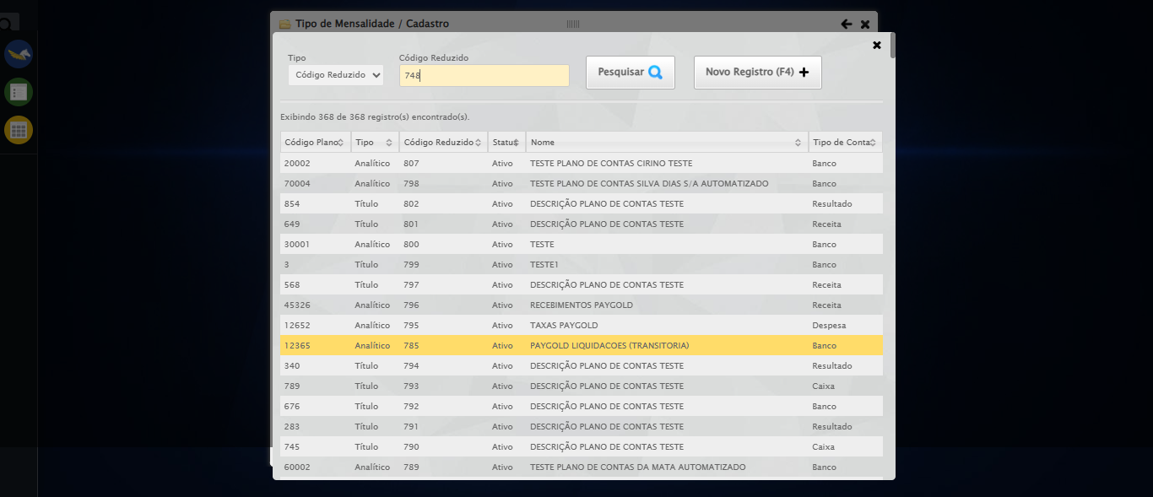

🔄 Selecionando Conta Débito 4...

❌ Erro ao selecionando conta débito 4: Message: element click intercepted: Element <a class="sprites sp-openLov"></a> is not clickable at point (836, 414). Other element would receive the click: <a class="linkAlterar" style="height: 25.8889px;"></a>  
 (Session info: chrome=140.0.7339.208); For documentation on this error, please visit: https://www.selenium.dev/documentation/webdriver/troubleshooting/errors#elementclickinterceptedexception  
Stacktrace:  
 GetHandleVerifier [0x0x3bc333+65459]  
 GetHandleVerifier [0x0x3bc374+65524]  
 (No symbol) [0x0x1dd973]  
 (No symbol) [0x0x22dbc0]  
 (No symbol) [0x0x22bf23]  
 (No symbol) [0x0x2299c7]  
 (No symbol) [0x0x228c66]  
 (No symbol) [0x0x21d195]  
 (No symbol) [0x0x249dfc]  
 (No symbol) [0x0x21cbf4]  
 (No symbol) [0x0x249fb4]  
 (No symbol) [0x0x26b606]  
 (No symbol) [0x0x249bf6]  
 (No symbol) [0x0x21b38e]  
 (No symbol) [0x0x21c274]  
 GetHandleVerifier [0x0x63eda3+2697763]  
 GetHandleVerifier [0x0x639ec7+2677575]  
 GetHandleVerifier [0x0x3e4194+228884]  
 GetHandleVerifier [0x0x3d49f8+165496]  
 GetHandleVerifier [0x0x3db18d+192013]  
 GetHandleVerifier [0x0x3c47d8+99416]  
 GetHandleVerifier [0x0x3c4972+99826]  
 GetHandleVerifier [0x0x3aebea+10346]  
 BaseThreadInitThunk [0x0x755bfcc9+25]  
 RtlGetAppContainerNamedObjectPath [0x0x773a82ae+286]  
 RtlGetAppContainerNamedObjectPath [0x0x773a827e+238]

Screenshot: erro_selecionando_conta_débito_4



🔄 Selecionando Histórico Padrão 4...

❌ Erro ao selecionando histórico padrão 4: Message: element click intercepted: Element <a class="sprites sp-openLov"></a> is not clickable at point (572, 464). Other element would receive the click: <a class="linkAlterar" style="height: 25.8889px;"></a>  
 (Session info: chrome=140.0.7339.208); For documentation on this error, please visit: https://www.selenium.dev/documentation/webdriver/troubleshooting/errors#elementclickinterceptedexception  
Stacktrace:  
 GetHandleVerifier [0x0x3bc333+65459]  
 GetHandleVerifier [0x0x3bc374+65524]  
 (No symbol) [0x0x1dd973]  
 (No symbol) [0x0x22dbc0]  
 (No symbol) [0x0x22bf23]  
 (No symbol) [0x0x2299c7]  
 (No symbol) [0x0x228c66]  
 (No symbol) [0x0x21d195]  
 (No symbol) [0x0x249dfc]  
 (No symbol) [0x0x21cbf4]  
 (No symbol) [0x0x249fb4]  
 (No symbol) [0x0x26b606]  
 (No symbol) [0x0x249bf6]  
 (No symbol) [0x0x21b38e]  
 (No symbol) [0x0x21c274]  
 GetHandleVerifier [0x0x63eda3+2697763]  
 GetHandleVerifier [0x0x639ec7+2677575]  
 GetHandleVerifier [0x0x3e4194+228884]  
 GetHandleVerifier [0x0x3d49f8+165496]  
 GetHandleVerifier [0x0x3db18d+192013]  
 GetHandleVerifier [0x0x3c47d8+99416]  
 GetHandleVerifier [0x0x3c4972+99826]  
 GetHandleVerifier [0x0x3aebea+10346]  
 BaseThreadInitThunk [0x0x755bfcc9+25]  
 RtlGetAppContainerNamedObjectPath [0x0x773a82ae+286]  
 RtlGetAppContainerNamedObjectPath [0x0x773a827e+238]

Screenshot: erro_selecionando_histórico_padrão_4



🔄 Selecionando Centro de Custo 4...

❌ Erro ao selecionando centro de custo 4: ('Connection aborted.', ConnectionResetError(10054, 'Foi forçado o cancelamento de uma conexão existente pelo host remoto', None, 10054, None))

❌ ERRO FATAL: HTTPConnectionPool(host='localhost', port=61990): Max retries exceeded with url: /session/dd214b0a7a54e238e47f9e017ef552ba/screenshot (Caused by NewConnectionError('<urllib3.connection.HTTPConnection object at 0x0000012BB65D4180>: Failed to establish a new connection: [WinError 10061] Nenhuma conexão pôde ser feita porque a máquina de destino as recusou ativamente'))

✅ Teste concluído com sucesso.