RELATÓRIO DO TESTE

Cadastro de Tipo de Mensalidade – Cenário 1: Preenchimento completo e salvamento.

Data do teste: 02/10/2025 14:29:38

🔄 Acessando sistema...

✅ Acessando sistema realizada com sucesso.

Screenshot: acessando_sistema

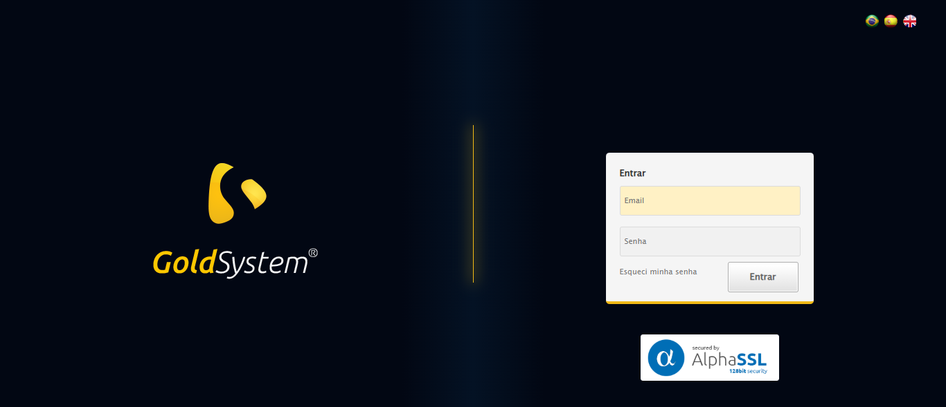

🔄 Realizando login...

✅ Realizando login realizada com sucesso.

Screenshot: realizando_login

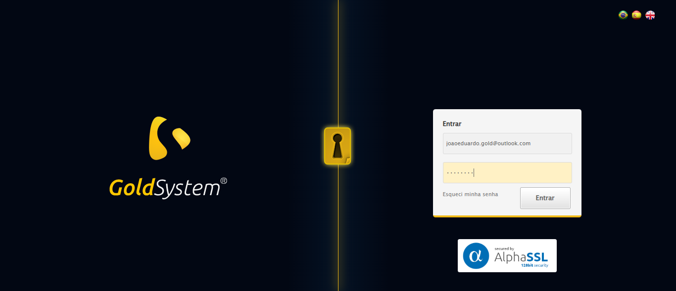

🔄 Esperando sistema carregar e ajustando zoom...

🔍 Zoom ajustado para 90%.

✅ Esperando sistema carregar e ajustando zoom realizada com sucesso.

Screenshot: esperando_sistema_carregar_e_ajustando_zoom

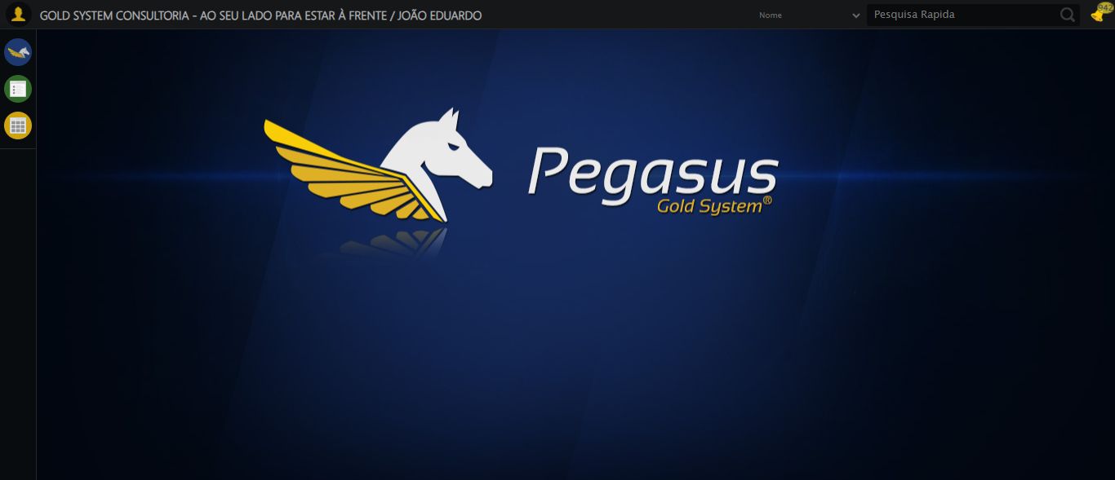

🔄 Abrindo menu Tipo de Mensalidade...

✅ Abrindo menu Tipo de Mensalidade realizada com sucesso.

Screenshot: abrindo_menu_tipo_de_mensalidade

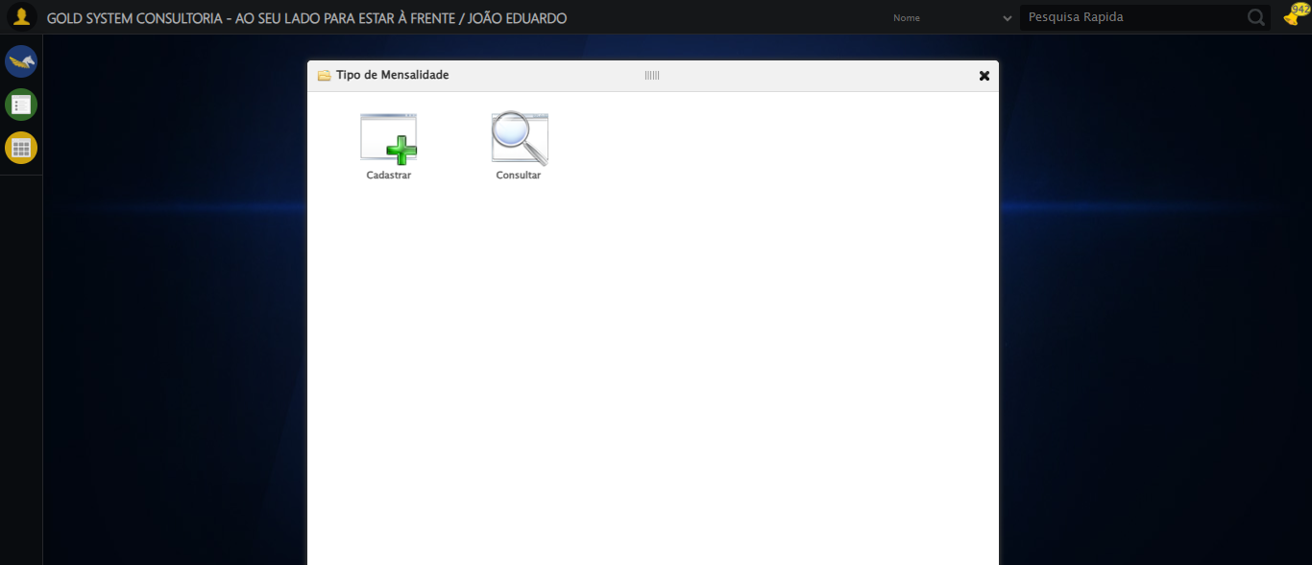

🔄 Clicando em Cadastrar...

✅ Clicando em Cadastrar realizada com sucesso.

Screenshot: clicando_em_cadastrar

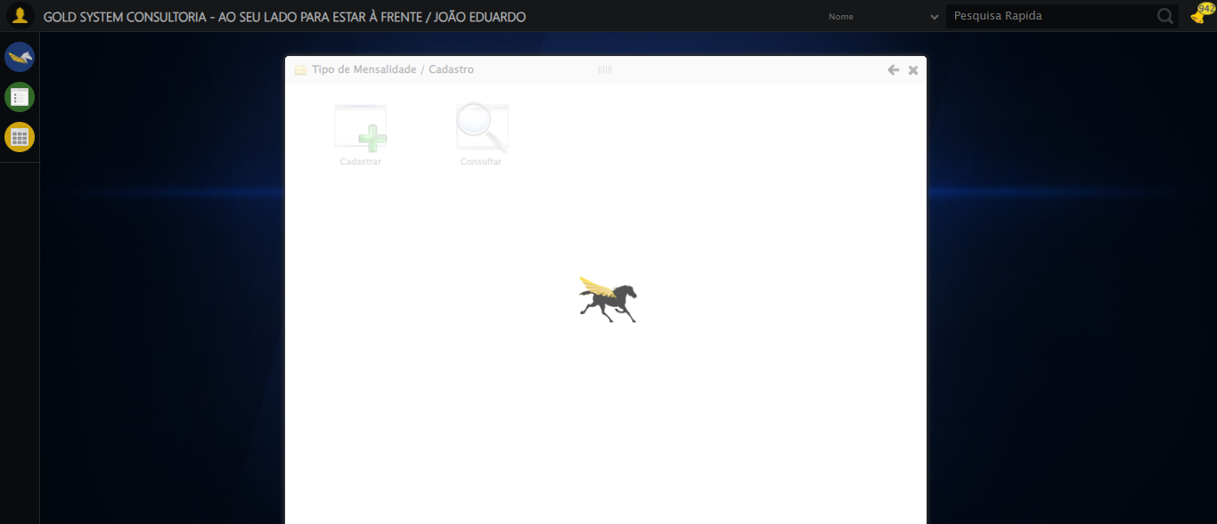

🔄 Preenchendo Nome...

✅ Preenchendo Nome realizada com sucesso.

Screenshot: preenchendo_nome

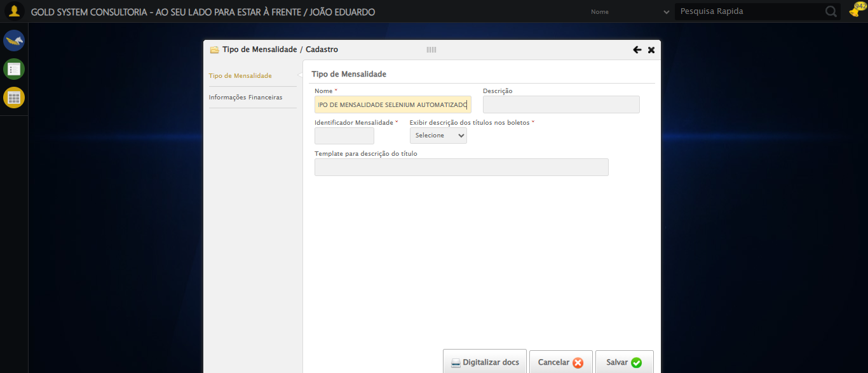

🔄 Preenchendo Descrição...

✅ Preenchendo Descrição realizada com sucesso.

Screenshot: preenchendo_descrição

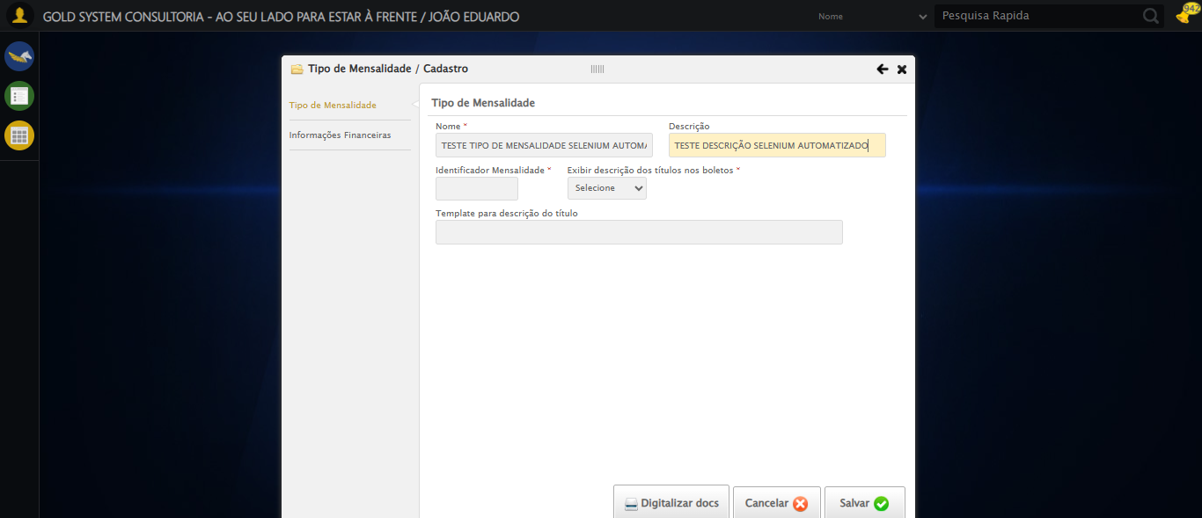

🔄 Preenchendo Identificador...

✅ Preenchendo Identificador realizada com sucesso.

Screenshot: preenchendo_identificador

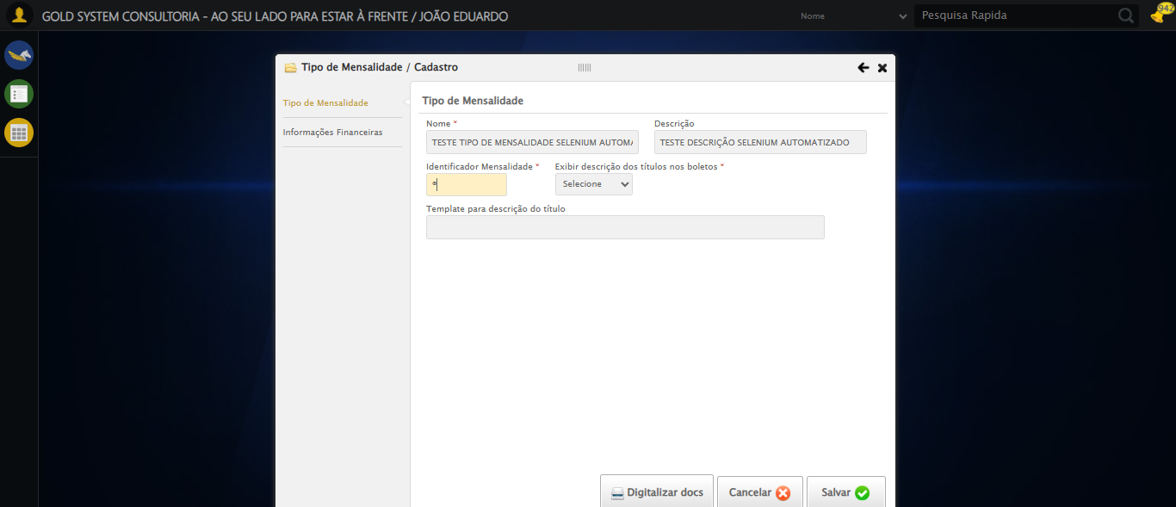

🔄 Selecionando a opção para Exibir descrição dos títulos nos boletos...

✅ Selecionando a opção para Exibir descrição dos títulos nos boletos realizada com sucesso.

Screenshot: selecionando_a_opção_para_exibir_descrição_dos_títulos_nos_boletos

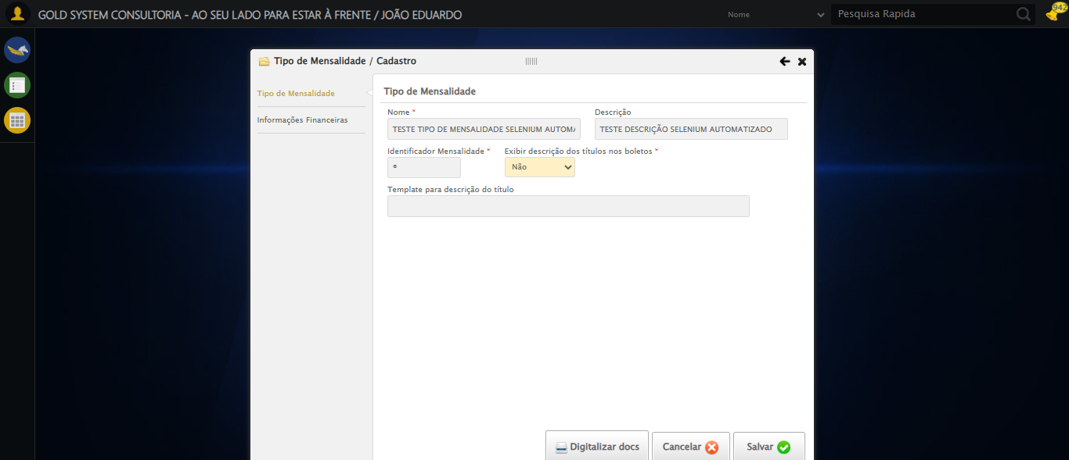

🔄 Preenchendo Template...

✅ Preenchendo Template realizada com sucesso.

Screenshot: preenchendo_template

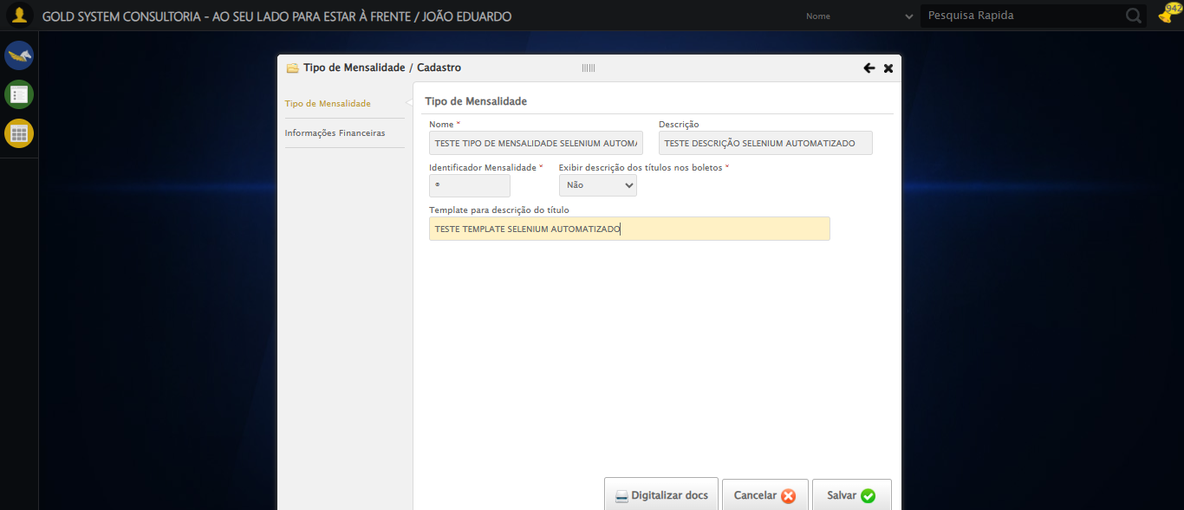

🔄 Clicando aba Informações Financeiras...

✅ Clicando aba Informações Financeiras realizada com sucesso.

Screenshot: clicando_aba_informações_financeiras

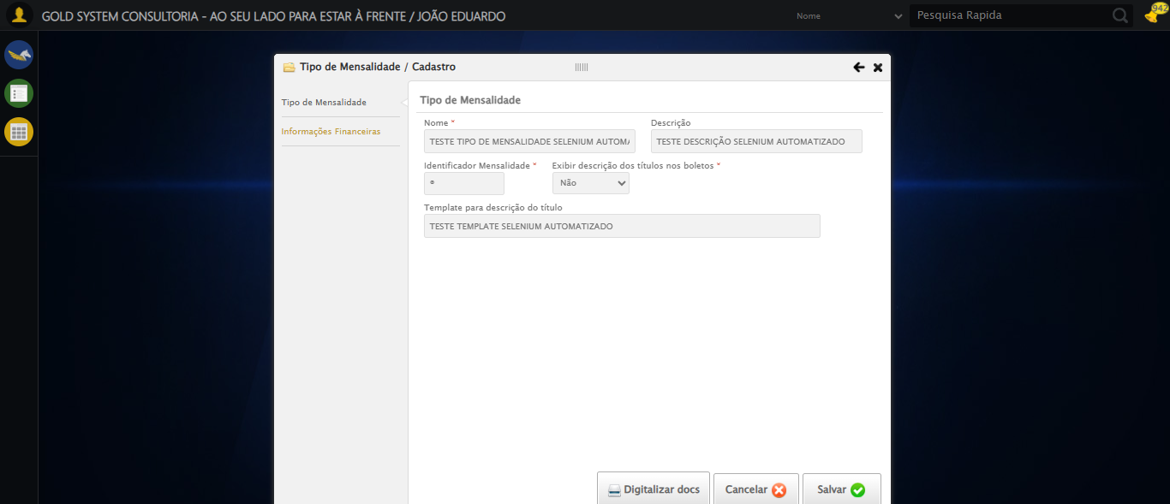

🔄 Selecionando Conta Crédito 1...

❌ Erro ao selecionando conta crédito 1: Message: stale element reference: stale element not found in the current frame  
 (Session info: chrome=140.0.7339.208); For documentation on this error, please visit: https://www.selenium.dev/documentation/webdriver/troubleshooting/errors#staleelementreferenceexception  
Stacktrace:  
 GetHandleVerifier [0x0x10fc333+65459]  
 GetHandleVerifier [0x0x10fc374+65524]  
 (No symbol) [0x0xf1d973]  
 (No symbol) [0x0xf24330]  
 (No symbol) [0x0xf26734]  
 (No symbol) [0x0xf267c8]  
 (No symbol) [0x0xf6daf2]  
 (No symbol) [0x0xf6b9bd]  
 (No symbol) [0x0xf699c7]  
 (No symbol) [0x0xf68c66]  
 (No symbol) [0x0xf5d195]  
 (No symbol) [0x0xf89dfc]  
 (No symbol) [0x0xf5cbf4]  
 (No symbol) [0x0xf89fb4]  
 (No symbol) [0x0xfab606]  
 (No symbol) [0x0xf89bf6]  
 (No symbol) [0x0xf5b38e]  
 (No symbol) [0x0xf5c274]  
 GetHandleVerifier [0x0x137eda3+2697763]  
 GetHandleVerifier [0x0x1379ec7+2677575]  
 GetHandleVerifier [0x0x1124194+228884]  
 GetHandleVerifier [0x0x11149f8+165496]  
 GetHandleVerifier [0x0x111b18d+192013]  
 GetHandleVerifier [0x0x11047d8+99416]  
 GetHandleVerifier [0x0x1104972+99826]  
 GetHandleVerifier [0x0x10eebea+10346]  
 BaseThreadInitThunk [0x0x755bfcc9+25]  
 RtlGetAppContainerNamedObjectPath [0x0x773a82ae+286]  
 RtlGetAppContainerNamedObjectPath [0x0x773a827e+238]

Screenshot: erro_selecionando_conta_crédito_1

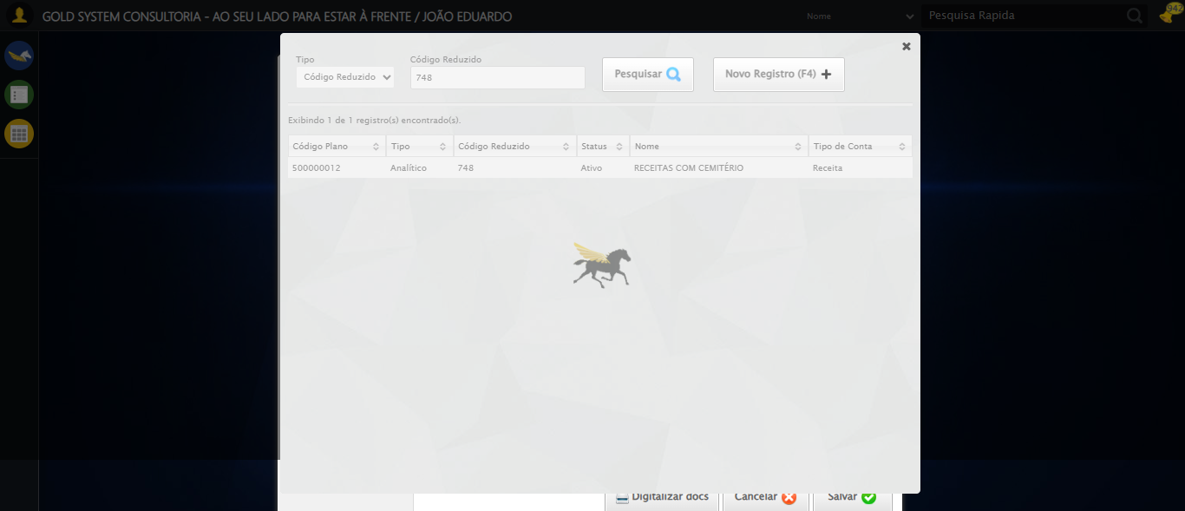

🔄 Selecionando Conta Débito 1...

❌ Erro ao selecionando conta débito 1: Message: element click intercepted: Element <a class="sprites sp-openLov"></a> is not clickable at point (836, 163). Other element would receive the click: <div class="DataTables_sort_wrapper">...</div>  
 (Session info: chrome=140.0.7339.208); For documentation on this error, please visit: https://www.selenium.dev/documentation/webdriver/troubleshooting/errors#elementclickinterceptedexception  
Stacktrace:  
 GetHandleVerifier [0x0x10fc333+65459]  
 GetHandleVerifier [0x0x10fc374+65524]  
 (No symbol) [0x0xf1d973]  
 (No symbol) [0x0xf6dbc0]  
 (No symbol) [0x0xf6bf23]  
 (No symbol) [0x0xf699c7]  
 (No symbol) [0x0xf68c66]  
 (No symbol) [0x0xf5d195]  
 (No symbol) [0x0xf89dfc]  
 (No symbol) [0x0xf5cbf4]  
 (No symbol) [0x0xf89fb4]  
 (No symbol) [0x0xfab606]  
 (No symbol) [0x0xf89bf6]  
 (No symbol) [0x0xf5b38e]  
 (No symbol) [0x0xf5c274]  
 GetHandleVerifier [0x0x137eda3+2697763]  
 GetHandleVerifier [0x0x1379ec7+2677575]  
 GetHandleVerifier [0x0x1124194+228884]  
 GetHandleVerifier [0x0x11149f8+165496]  
 GetHandleVerifier [0x0x111b18d+192013]  
 GetHandleVerifier [0x0x11047d8+99416]  
 GetHandleVerifier [0x0x1104972+99826]  
 GetHandleVerifier [0x0x10eebea+10346]  
 BaseThreadInitThunk [0x0x755bfcc9+25]  
 RtlGetAppContainerNamedObjectPath [0x0x773a82ae+286]  
 RtlGetAppContainerNamedObjectPath [0x0x773a827e+238]

Screenshot: erro_selecionando_conta_débito_1

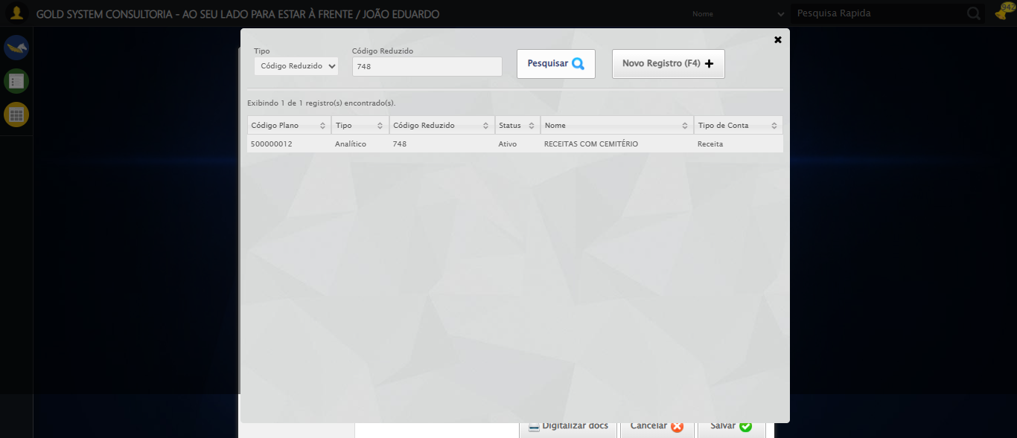

🔄 Selecionando Histórico Padrão 1...

❌ Erro ao selecionando histórico padrão 1: Message: element click intercepted: Element <a class="sprites sp-openLov"></a> is not clickable at point (572, 213). Other element would receive the click: <div class="fg-toolbar ui-toolbar ui-widget-header ui-helper-clearfix ui-corner-bl ui-corner-br"></div>  
 (Session info: chrome=140.0.7339.208); For documentation on this error, please visit: https://www.selenium.dev/documentation/webdriver/troubleshooting/errors#elementclickinterceptedexception  
Stacktrace:  
 GetHandleVerifier [0x0x10fc333+65459]  
 GetHandleVerifier [0x0x10fc374+65524]  
 (No symbol) [0x0xf1d973]  
 (No symbol) [0x0xf6dbc0]  
 (No symbol) [0x0xf6bf23]  
 (No symbol) [0x0xf699c7]  
 (No symbol) [0x0xf68c66]  
 (No symbol) [0x0xf5d195]  
 (No symbol) [0x0xf89dfc]  
 (No symbol) [0x0xf5cbf4]  
 (No symbol) [0x0xf89fb4]  
 (No symbol) [0x0xfab606]  
 (No symbol) [0x0xf89bf6]  
 (No symbol) [0x0xf5b38e]  
 (No symbol) [0x0xf5c274]  
 GetHandleVerifier [0x0x137eda3+2697763]  
 GetHandleVerifier [0x0x1379ec7+2677575]  
 GetHandleVerifier [0x0x1124194+228884]  
 GetHandleVerifier [0x0x11149f8+165496]  
 GetHandleVerifier [0x0x111b18d+192013]  
 GetHandleVerifier [0x0x11047d8+99416]  
 GetHandleVerifier [0x0x1104972+99826]  
 GetHandleVerifier [0x0x10eebea+10346]  
 BaseThreadInitThunk [0x0x755bfcc9+25]  
 RtlGetAppContainerNamedObjectPath [0x0x773a82ae+286]  
 RtlGetAppContainerNamedObjectPath [0x0x773a827e+238]

Screenshot: erro_selecionando_histórico_padrão_1



🔄 Selecionando Centro de Custo 1...

❌ Erro ao selecionando centro de custo 1: Message: element click intercepted: Element <a class="sprites sp-openLov"></a> is not clickable at point (836, 213). Other element would receive the click: <div class="fg-toolbar ui-toolbar ui-widget-header ui-helper-clearfix ui-corner-bl ui-corner-br"></div>  
 (Session info: chrome=140.0.7339.208); For documentation on this error, please visit: https://www.selenium.dev/documentation/webdriver/troubleshooting/errors#elementclickinterceptedexception  
Stacktrace:  
 GetHandleVerifier [0x0x10fc333+65459]  
 GetHandleVerifier [0x0x10fc374+65524]  
 (No symbol) [0x0xf1d973]  
 (No symbol) [0x0xf6dbc0]  
 (No symbol) [0x0xf6bf23]  
 (No symbol) [0x0xf699c7]  
 (No symbol) [0x0xf68c66]  
 (No symbol) [0x0xf5d195]  
 (No symbol) [0x0xf89dfc]  
 (No symbol) [0x0xf5cbf4]  
 (No symbol) [0x0xf89fb4]  
 (No symbol) [0x0xfab606]  
 (No symbol) [0x0xf89bf6]  
 (No symbol) [0x0xf5b38e]  
 (No symbol) [0x0xf5c274]  
 GetHandleVerifier [0x0x137eda3+2697763]  
 GetHandleVerifier [0x0x1379ec7+2677575]  
 GetHandleVerifier [0x0x1124194+228884]  
 GetHandleVerifier [0x0x11149f8+165496]  
 GetHandleVerifier [0x0x111b18d+192013]  
 GetHandleVerifier [0x0x11047d8+99416]  
 GetHandleVerifier [0x0x1104972+99826]  
 GetHandleVerifier [0x0x10eebea+10346]  
 BaseThreadInitThunk [0x0x755bfcc9+25]  
 RtlGetAppContainerNamedObjectPath [0x0x773a82ae+286]  
 RtlGetAppContainerNamedObjectPath [0x0x773a827e+238]

Screenshot: erro_selecionando_centro_de_custo_1



🔄 Selecionando Conta Crédito 2...

❌ Erro ao selecionando conta crédito 2: Message: element click intercepted: Element <a class="sprites sp-openLov"></a> is not clickable at point (572, 299). Other element would receive the click: <div class="modal overflow" style="z-index: 99606; left: 50%; top: 50%; width: 800px; height: 570px; margin-left: -400px; margin-top: -285px;">...</div>  
 (Session info: chrome=140.0.7339.208); For documentation on this error, please visit: https://www.selenium.dev/documentation/webdriver/troubleshooting/errors#elementclickinterceptedexception  
Stacktrace:  
 GetHandleVerifier [0x0x10fc333+65459]  
 GetHandleVerifier [0x0x10fc374+65524]  
 (No symbol) [0x0xf1d973]  
 (No symbol) [0x0xf6dbc0]  
 (No symbol) [0x0xf6bf23]  
 (No symbol) [0x0xf699c7]  
 (No symbol) [0x0xf68c66]  
 (No symbol) [0x0xf5d195]  
 (No symbol) [0x0xf89dfc]  
 (No symbol) [0x0xf5cbf4]  
 (No symbol) [0x0xf89fb4]  
 (No symbol) [0x0xfab606]  
 (No symbol) [0x0xf89bf6]  
 (No symbol) [0x0xf5b38e]  
 (No symbol) [0x0xf5c274]  
 GetHandleVerifier [0x0x137eda3+2697763]  
 GetHandleVerifier [0x0x1379ec7+2677575]  
 GetHandleVerifier [0x0x1124194+228884]  
 GetHandleVerifier [0x0x11149f8+165496]  
 GetHandleVerifier [0x0x111b18d+192013]  
 GetHandleVerifier [0x0x11047d8+99416]  
 GetHandleVerifier [0x0x1104972+99826]  
 GetHandleVerifier [0x0x10eebea+10346]  
 BaseThreadInitThunk [0x0x755bfcc9+25]  
 RtlGetAppContainerNamedObjectPath [0x0x773a82ae+286]  
 RtlGetAppContainerNamedObjectPath [0x0x773a827e+238]

Screenshot: erro_selecionando_conta_crédito_2



🔄 Selecionando Conta Débito 2...

❌ Erro ao selecionando conta débito 2: Message: element click intercepted: Element <a class="sprites sp-openLov"></a> is not clickable at point (836, 299). Other element would receive the click: <div class="modal overflow" style="z-index: 99606; left: 50%; top: 50%; width: 800px; height: 570px; margin-left: -400px; margin-top: -285px;">...</div>  
 (Session info: chrome=140.0.7339.208); For documentation on this error, please visit: https://www.selenium.dev/documentation/webdriver/troubleshooting/errors#elementclickinterceptedexception  
Stacktrace:  
 GetHandleVerifier [0x0x10fc333+65459]  
 GetHandleVerifier [0x0x10fc374+65524]  
 (No symbol) [0x0xf1d973]  
 (No symbol) [0x0xf6dbc0]  
 (No symbol) [0x0xf6bf23]  
 (No symbol) [0x0xf699c7]  
 (No symbol) [0x0xf68c66]  
 (No symbol) [0x0xf5d195]  
 (No symbol) [0x0xf89dfc]  
 (No symbol) [0x0xf5cbf4]  
 (No symbol) [0x0xf89fb4]  
 (No symbol) [0x0xfab606]  
 (No symbol) [0x0xf89bf6]  
 (No symbol) [0x0xf5b38e]  
 (No symbol) [0x0xf5c274]  
 GetHandleVerifier [0x0x137eda3+2697763]  
 GetHandleVerifier [0x0x1379ec7+2677575]  
 GetHandleVerifier [0x0x1124194+228884]  
 GetHandleVerifier [0x0x11149f8+165496]  
 GetHandleVerifier [0x0x111b18d+192013]  
 GetHandleVerifier [0x0x11047d8+99416]  
 GetHandleVerifier [0x0x1104972+99826]  
 GetHandleVerifier [0x0x10eebea+10346]  
 BaseThreadInitThunk [0x0x755bfcc9+25]  
 RtlGetAppContainerNamedObjectPath [0x0x773a82ae+286]  
 RtlGetAppContainerNamedObjectPath [0x0x773a827e+238]

Screenshot: erro_selecionando_conta_débito_2



🔄 Selecionando Histórico Padrão 2...

❌ Erro ao selecionando histórico padrão 2: Message: element click intercepted: Element <a class="sprites sp-openLov"></a> is not clickable at point (572, 349). Other element would receive the click: <div class="modal overflow" style="z-index: 99606; left: 50%; top: 50%; width: 800px; height: 570px; margin-left: -400px; margin-top: -285px;">...</div>  
 (Session info: chrome=140.0.7339.208); For documentation on this error, please visit: https://www.selenium.dev/documentation/webdriver/troubleshooting/errors#elementclickinterceptedexception  
Stacktrace:  
 GetHandleVerifier [0x0x10fc333+65459]  
 GetHandleVerifier [0x0x10fc374+65524]  
 (No symbol) [0x0xf1d973]  
 (No symbol) [0x0xf6dbc0]  
 (No symbol) [0x0xf6bf23]  
 (No symbol) [0x0xf699c7]  
 (No symbol) [0x0xf68c66]  
 (No symbol) [0x0xf5d195]  
 (No symbol) [0x0xf89dfc]  
 (No symbol) [0x0xf5cbf4]  
 (No symbol) [0x0xf89fb4]  
 (No symbol) [0x0xfab606]  
 (No symbol) [0x0xf89bf6]  
 (No symbol) [0x0xf5b38e]  
 (No symbol) [0x0xf5c274]  
 GetHandleVerifier [0x0x137eda3+2697763]  
 GetHandleVerifier [0x0x1379ec7+2677575]  
 GetHandleVerifier [0x0x1124194+228884]  
 GetHandleVerifier [0x0x11149f8+165496]  
 GetHandleVerifier [0x0x111b18d+192013]  
 GetHandleVerifier [0x0x11047d8+99416]  
 GetHandleVerifier [0x0x1104972+99826]  
 GetHandleVerifier [0x0x10eebea+10346]  
 BaseThreadInitThunk [0x0x755bfcc9+25]  
 RtlGetAppContainerNamedObjectPath [0x0x773a82ae+286]  
 RtlGetAppContainerNamedObjectPath [0x0x773a827e+238]

Screenshot: erro_selecionando_histórico_padrão_2



🔄 Selecionando Centro de Custo 2...

❌ Erro ao selecionando centro de custo 2: Message: element click intercepted: Element <a class="sprites sp-openLov"></a> is not clickable at point (836, 349). Other element would receive the click: <div class="modal overflow" style="z-index: 99606; left: 50%; top: 50%; width: 800px; height: 570px; margin-left: -400px; margin-top: -285px;">...</div>  
 (Session info: chrome=140.0.7339.208); For documentation on this error, please visit: https://www.selenium.dev/documentation/webdriver/troubleshooting/errors#elementclickinterceptedexception  
Stacktrace:  
 GetHandleVerifier [0x0x10fc333+65459]  
 GetHandleVerifier [0x0x10fc374+65524]  
 (No symbol) [0x0xf1d973]  
 (No symbol) [0x0xf6dbc0]  
 (No symbol) [0x0xf6bf23]  
 (No symbol) [0x0xf699c7]  
 (No symbol) [0x0xf68c66]  
 (No symbol) [0x0xf5d195]  
 (No symbol) [0x0xf89dfc]  
 (No symbol) [0x0xf5cbf4]  
 (No symbol) [0x0xf89fb4]  
 (No symbol) [0x0xfab606]  
 (No symbol) [0x0xf89bf6]  
 (No symbol) [0x0xf5b38e]  
 (No symbol) [0x0xf5c274]  
 GetHandleVerifier [0x0x137eda3+2697763]  
 GetHandleVerifier [0x0x1379ec7+2677575]  
 GetHandleVerifier [0x0x1124194+228884]  
 GetHandleVerifier [0x0x11149f8+165496]  
 GetHandleVerifier [0x0x111b18d+192013]  
 GetHandleVerifier [0x0x11047d8+99416]  
 GetHandleVerifier [0x0x1104972+99826]  
 GetHandleVerifier [0x0x10eebea+10346]  
 BaseThreadInitThunk [0x0x755bfcc9+25]  
 RtlGetAppContainerNamedObjectPath [0x0x773a82ae+286]  
 RtlGetAppContainerNamedObjectPath [0x0x773a827e+238]

Screenshot: erro_selecionando_centro_de_custo_2



🔄 Selecionando Conta Crédito 3...

❌ Erro ao selecionando conta crédito 3: Message: element click intercepted: Element <a class="sprites sp-openLov"></a> is not clickable at point (572, 435). Other element would receive the click: <div class="modal overflow" style="z-index: 99606; left: 50%; top: 50%; width: 800px; height: 570px; margin-left: -400px; margin-top: -285px;">...</div>  
 (Session info: chrome=140.0.7339.208); For documentation on this error, please visit: https://www.selenium.dev/documentation/webdriver/troubleshooting/errors#elementclickinterceptedexception  
Stacktrace:  
 GetHandleVerifier [0x0x10fc333+65459]  
 GetHandleVerifier [0x0x10fc374+65524]  
 (No symbol) [0x0xf1d973]  
 (No symbol) [0x0xf6dbc0]  
 (No symbol) [0x0xf6bf23]  
 (No symbol) [0x0xf699c7]  
 (No symbol) [0x0xf68c66]  
 (No symbol) [0x0xf5d195]  
 (No symbol) [0x0xf89dfc]  
 (No symbol) [0x0xf5cbf4]  
 (No symbol) [0x0xf89fb4]  
 (No symbol) [0x0xfab606]  
 (No symbol) [0x0xf89bf6]  
 (No symbol) [0x0xf5b38e]  
 (No symbol) [0x0xf5c274]  
 GetHandleVerifier [0x0x137eda3+2697763]  
 GetHandleVerifier [0x0x1379ec7+2677575]  
 GetHandleVerifier [0x0x1124194+228884]  
 GetHandleVerifier [0x0x11149f8+165496]  
 GetHandleVerifier [0x0x111b18d+192013]  
 GetHandleVerifier [0x0x11047d8+99416]  
 GetHandleVerifier [0x0x1104972+99826]  
 GetHandleVerifier [0x0x10eebea+10346]  
 BaseThreadInitThunk [0x0x755bfcc9+25]  
 RtlGetAppContainerNamedObjectPath [0x0x773a82ae+286]  
 RtlGetAppContainerNamedObjectPath [0x0x773a827e+238]

Screenshot: erro_selecionando_conta_crédito_3

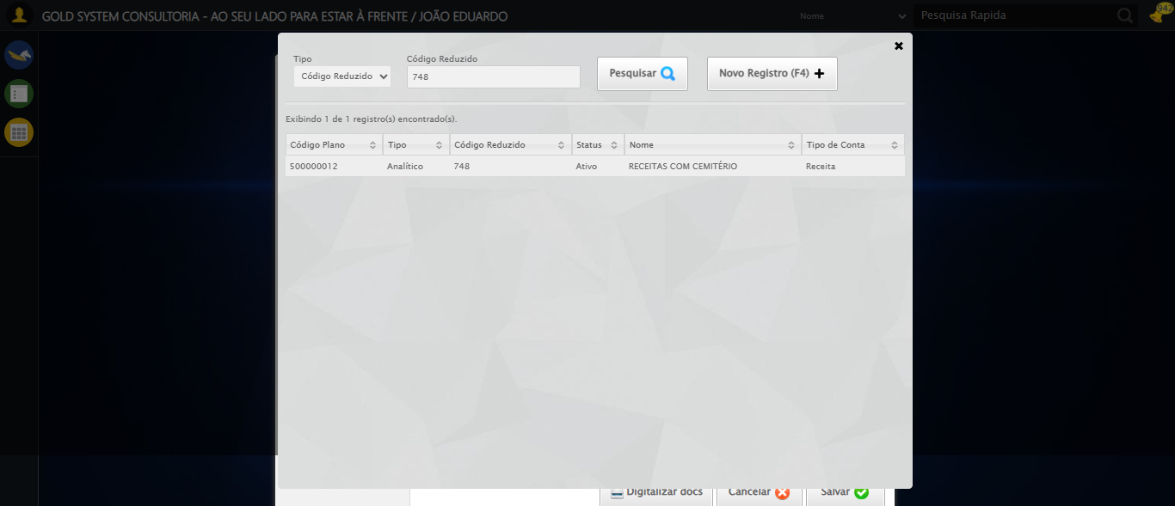

🔄 Selecionando Conta Débito 3...

❌ Erro ao selecionando conta débito 3: Message: element click intercepted: Element <a class="sprites sp-openLov"></a> is not clickable at point (836, 435). Other element would receive the click: <div class="modal overflow" style="z-index: 99606; left: 50%; top: 50%; width: 800px; height: 570px; margin-left: -400px; margin-top: -285px;">...</div>  
 (Session info: chrome=140.0.7339.208); For documentation on this error, please visit: https://www.selenium.dev/documentation/webdriver/troubleshooting/errors#elementclickinterceptedexception  
Stacktrace:  
 GetHandleVerifier [0x0x10fc333+65459]  
 GetHandleVerifier [0x0x10fc374+65524]  
 (No symbol) [0x0xf1d973]  
 (No symbol) [0x0xf6dbc0]  
 (No symbol) [0x0xf6bf23]  
 (No symbol) [0x0xf699c7]  
 (No symbol) [0x0xf68c66]  
 (No symbol) [0x0xf5d195]  
 (No symbol) [0x0xf89dfc]  
 (No symbol) [0x0xf5cbf4]  
 (No symbol) [0x0xf89fb4]  
 (No symbol) [0x0xfab606]  
 (No symbol) [0x0xf89bf6]  
 (No symbol) [0x0xf5b38e]  
 (No symbol) [0x0xf5c274]  
 GetHandleVerifier [0x0x137eda3+2697763]  
 GetHandleVerifier [0x0x1379ec7+2677575]  
 GetHandleVerifier [0x0x1124194+228884]  
 GetHandleVerifier [0x0x11149f8+165496]  
 GetHandleVerifier [0x0x111b18d+192013]  
 GetHandleVerifier [0x0x11047d8+99416]  
 GetHandleVerifier [0x0x1104972+99826]  
 GetHandleVerifier [0x0x10eebea+10346]  
 BaseThreadInitThunk [0x0x755bfcc9+25]  
 RtlGetAppContainerNamedObjectPath [0x0x773a82ae+286]  
 RtlGetAppContainerNamedObjectPath [0x0x773a827e+238]

Screenshot: erro_selecionando_conta_débito_3



🔄 Selecionando Histórico Padrão 3...

❌ Erro ao selecionando histórico padrão 3: Message: element click intercepted: Element <a class="sprites sp-openLov"></a> is not clickable at point (572, 485). Other element would receive the click: <div class="modal overflow" style="z-index: 99606; left: 50%; top: 50%; width: 800px; height: 570px; margin-left: -400px; margin-top: -285px;">...</div>  
 (Session info: chrome=140.0.7339.208); For documentation on this error, please visit: https://www.selenium.dev/documentation/webdriver/troubleshooting/errors#elementclickinterceptedexception  
Stacktrace:  
 GetHandleVerifier [0x0x10fc333+65459]  
 GetHandleVerifier [0x0x10fc374+65524]  
 (No symbol) [0x0xf1d973]  
 (No symbol) [0x0xf6dbc0]  
 (No symbol) [0x0xf6bf23]  
 (No symbol) [0x0xf699c7]  
 (No symbol) [0x0xf68c66]  
 (No symbol) [0x0xf5d195]  
 (No symbol) [0x0xf89dfc]  
 (No symbol) [0x0xf5cbf4]  
 (No symbol) [0x0xf89fb4]  
 (No symbol) [0x0xfab606]  
 (No symbol) [0x0xf89bf6]  
 (No symbol) [0x0xf5b38e]  
 (No symbol) [0x0xf5c274]  
 GetHandleVerifier [0x0x137eda3+2697763]  
 GetHandleVerifier [0x0x1379ec7+2677575]  
 GetHandleVerifier [0x0x1124194+228884]  
 GetHandleVerifier [0x0x11149f8+165496]  
 GetHandleVerifier [0x0x111b18d+192013]  
 GetHandleVerifier [0x0x11047d8+99416]  
 GetHandleVerifier [0x0x1104972+99826]  
 GetHandleVerifier [0x0x10eebea+10346]  
 BaseThreadInitThunk [0x0x755bfcc9+25]  
 RtlGetAppContainerNamedObjectPath [0x0x773a82ae+286]  
 RtlGetAppContainerNamedObjectPath [0x0x773a827e+238]

Screenshot: erro_selecionando_histórico_padrão_3



🔄 Selecionando Centro de Custo 3...

❌ Erro ao selecionando centro de custo 3: Message: element click intercepted: Element <a class="sprites sp-openLov"></a> is not clickable at point (836, 485). Other element would receive the click: <div class="modal overflow" style="z-index: 99606; left: 50%; top: 50%; width: 800px; height: 570px; margin-left: -400px; margin-top: -285px;">...</div>  
 (Session info: chrome=140.0.7339.208); For documentation on this error, please visit: https://www.selenium.dev/documentation/webdriver/troubleshooting/errors#elementclickinterceptedexception  
Stacktrace:  
 GetHandleVerifier [0x0x10fc333+65459]  
 GetHandleVerifier [0x0x10fc374+65524]  
 (No symbol) [0x0xf1d973]  
 (No symbol) [0x0xf6dbc0]  
 (No symbol) [0x0xf6bf23]  
 (No symbol) [0x0xf699c7]  
 (No symbol) [0x0xf68c66]  
 (No symbol) [0x0xf5d195]  
 (No symbol) [0x0xf89dfc]  
 (No symbol) [0x0xf5cbf4]  
 (No symbol) [0x0xf89fb4]  
 (No symbol) [0x0xfab606]  
 (No symbol) [0x0xf89bf6]  
 (No symbol) [0x0xf5b38e]  
 (No symbol) [0x0xf5c274]  
 GetHandleVerifier [0x0x137eda3+2697763]  
 GetHandleVerifier [0x0x1379ec7+2677575]  
 GetHandleVerifier [0x0x1124194+228884]  
 GetHandleVerifier [0x0x11149f8+165496]  
 GetHandleVerifier [0x0x111b18d+192013]  
 GetHandleVerifier [0x0x11047d8+99416]  
 GetHandleVerifier [0x0x1104972+99826]  
 GetHandleVerifier [0x0x10eebea+10346]  
 BaseThreadInitThunk [0x0x755bfcc9+25]  
 RtlGetAppContainerNamedObjectPath [0x0x773a82ae+286]  
 RtlGetAppContainerNamedObjectPath [0x0x773a827e+238]

Screenshot: erro_selecionando_centro_de_custo_3



🔄 Fazendo scroll para seção 4...

✅ Fazendo scroll para seção 4 realizada com sucesso.

Screenshot: fazendo_scroll_para_seção_4

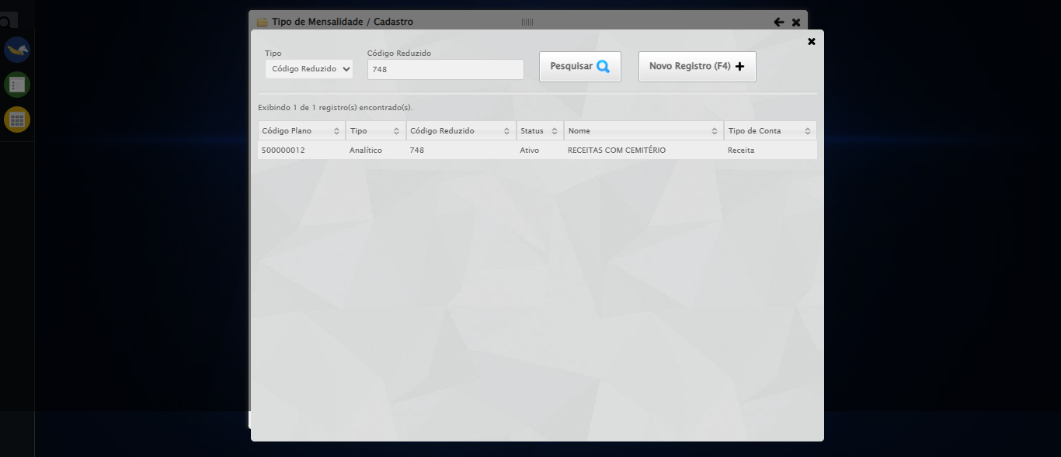

🔄 Selecionando Conta Crédito 4...

❌ Erro ao selecionando conta crédito 4: Message: element click intercepted: Element <a class="sprites sp-openLov"></a> is not clickable at point (572, 414). Other element would receive the click: <div class="modal overflow" style="z-index: 99606; left: 50%; top: 50%; width: 800px; height: 570px; margin-left: -400px; margin-top: -285px;">...</div>  
 (Session info: chrome=140.0.7339.208); For documentation on this error, please visit: https://www.selenium.dev/documentation/webdriver/troubleshooting/errors#elementclickinterceptedexception  
Stacktrace:  
 GetHandleVerifier [0x0x10fc333+65459]  
 GetHandleVerifier [0x0x10fc374+65524]  
 (No symbol) [0x0xf1d973]  
 (No symbol) [0x0xf6dbc0]  
 (No symbol) [0x0xf6bf23]  
 (No symbol) [0x0xf699c7]  
 (No symbol) [0x0xf68c66]  
 (No symbol) [0x0xf5d195]  
 (No symbol) [0x0xf89dfc]  
 (No symbol) [0x0xf5cbf4]  
 (No symbol) [0x0xf89fb4]  
 (No symbol) [0x0xfab606]  
 (No symbol) [0x0xf89bf6]  
 (No symbol) [0x0xf5b38e]  
 (No symbol) [0x0xf5c274]  
 GetHandleVerifier [0x0x137eda3+2697763]  
 GetHandleVerifier [0x0x1379ec7+2677575]  
 GetHandleVerifier [0x0x1124194+228884]  
 GetHandleVerifier [0x0x11149f8+165496]  
 GetHandleVerifier [0x0x111b18d+192013]  
 GetHandleVerifier [0x0x11047d8+99416]  
 GetHandleVerifier [0x0x1104972+99826]  
 GetHandleVerifier [0x0x10eebea+10346]  
 BaseThreadInitThunk [0x0x755bfcc9+25]  
 RtlGetAppContainerNamedObjectPath [0x0x773a82ae+286]  
 RtlGetAppContainerNamedObjectPath [0x0x773a827e+238]

Screenshot: erro_selecionando_conta_crédito_4



🔄 Selecionando Conta Débito 4...

❌ Erro ao selecionando conta débito 4: Message: element click intercepted: Element <a class="sprites sp-openLov"></a> is not clickable at point (836, 414). Other element would receive the click: <div class="modal overflow" style="z-index: 99606; left: 50%; top: 50%; width: 800px; height: 570px; margin-left: -400px; margin-top: -285px;">...</div>  
 (Session info: chrome=140.0.7339.208); For documentation on this error, please visit: https://www.selenium.dev/documentation/webdriver/troubleshooting/errors#elementclickinterceptedexception  
Stacktrace:  
 GetHandleVerifier [0x0x10fc333+65459]  
 GetHandleVerifier [0x0x10fc374+65524]  
 (No symbol) [0x0xf1d973]  
 (No symbol) [0x0xf6dbc0]  
 (No symbol) [0x0xf6bf23]  
 (No symbol) [0x0xf699c7]  
 (No symbol) [0x0xf68c66]  
 (No symbol) [0x0xf5d195]  
 (No symbol) [0x0xf89dfc]  
 (No symbol) [0x0xf5cbf4]  
 (No symbol) [0x0xf89fb4]  
 (No symbol) [0x0xfab606]  
 (No symbol) [0x0xf89bf6]  
 (No symbol) [0x0xf5b38e]  
 (No symbol) [0x0xf5c274]  
 GetHandleVerifier [0x0x137eda3+2697763]  
 GetHandleVerifier [0x0x1379ec7+2677575]  
 GetHandleVerifier [0x0x1124194+228884]  
 GetHandleVerifier [0x0x11149f8+165496]  
 GetHandleVerifier [0x0x111b18d+192013]  
 GetHandleVerifier [0x0x11047d8+99416]  
 GetHandleVerifier [0x0x1104972+99826]  
 GetHandleVerifier [0x0x10eebea+10346]  
 BaseThreadInitThunk [0x0x755bfcc9+25]  
 RtlGetAppContainerNamedObjectPath [0x0x773a82ae+286]  
 RtlGetAppContainerNamedObjectPath [0x0x773a827e+238]

Screenshot: erro_selecionando_conta_débito_4



🔄 Selecionando Histórico Padrão 4...

❌ Erro ao selecionando histórico padrão 4: Message: element click intercepted: Element <a class="sprites sp-openLov"></a> is not clickable at point (572, 464). Other element would receive the click: <div class="modal overflow" style="z-index: 99606; left: 50%; top: 50%; width: 800px; height: 570px; margin-left: -400px; margin-top: -285px;">...</div>  
 (Session info: chrome=140.0.7339.208); For documentation on this error, please visit: https://www.selenium.dev/documentation/webdriver/troubleshooting/errors#elementclickinterceptedexception  
Stacktrace:  
 GetHandleVerifier [0x0x10fc333+65459]  
 GetHandleVerifier [0x0x10fc374+65524]  
 (No symbol) [0x0xf1d973]  
 (No symbol) [0x0xf6dbc0]  
 (No symbol) [0x0xf6bf23]  
 (No symbol) [0x0xf699c7]  
 (No symbol) [0x0xf68c66]  
 (No symbol) [0x0xf5d195]  
 (No symbol) [0x0xf89dfc]  
 (No symbol) [0x0xf5cbf4]  
 (No symbol) [0x0xf89fb4]  
 (No symbol) [0x0xfab606]  
 (No symbol) [0x0xf89bf6]  
 (No symbol) [0x0xf5b38e]  
 (No symbol) [0x0xf5c274]  
 GetHandleVerifier [0x0x137eda3+2697763]  
 GetHandleVerifier [0x0x1379ec7+2677575]  
 GetHandleVerifier [0x0x1124194+228884]  
 GetHandleVerifier [0x0x11149f8+165496]  
 GetHandleVerifier [0x0x111b18d+192013]  
 GetHandleVerifier [0x0x11047d8+99416]  
 GetHandleVerifier [0x0x1104972+99826]  
 GetHandleVerifier [0x0x10eebea+10346]  
 BaseThreadInitThunk [0x0x755bfcc9+25]  
 RtlGetAppContainerNamedObjectPath [0x0x773a82ae+286]  
 RtlGetAppContainerNamedObjectPath [0x0x773a827e+238]

Screenshot: erro_selecionando_histórico_padrão_4



🔄 Selecionando Centro de Custo 4...

❌ Erro ao selecionando centro de custo 4: Message: element click intercepted: Element <a class="sprites sp-openLov"></a> is not clickable at point (836, 464). Other element would receive the click: <div class="modal overflow" style="z-index: 99606; left: 50%; top: 50%; width: 800px; height: 570px; margin-left: -400px; margin-top: -285px;">...</div>  
 (Session info: chrome=140.0.7339.208); For documentation on this error, please visit: https://www.selenium.dev/documentation/webdriver/troubleshooting/errors#elementclickinterceptedexception  
Stacktrace:  
 GetHandleVerifier [0x0x10fc333+65459]  
 GetHandleVerifier [0x0x10fc374+65524]  
 (No symbol) [0x0xf1d973]  
 (No symbol) [0x0xf6dbc0]  
 (No symbol) [0x0xf6bf23]  
 (No symbol) [0x0xf699c7]  
 (No symbol) [0x0xf68c66]  
 (No symbol) [0x0xf5d195]  
 (No symbol) [0x0xf89dfc]  
 (No symbol) [0x0xf5cbf4]  
 (No symbol) [0x0xf89fb4]  
 (No symbol) [0x0xfab606]  
 (No symbol) [0x0xf89bf6]  
 (No symbol) [0x0xf5b38e]  
 (No symbol) [0x0xf5c274]  
 GetHandleVerifier [0x0x137eda3+2697763]  
 GetHandleVerifier [0x0x1379ec7+2677575]  
 GetHandleVerifier [0x0x1124194+228884]  
 GetHandleVerifier [0x0x11149f8+165496]  
 GetHandleVerifier [0x0x111b18d+192013]  
 GetHandleVerifier [0x0x11047d8+99416]  
 GetHandleVerifier [0x0x1104972+99826]  
 GetHandleVerifier [0x0x10eebea+10346]  
 BaseThreadInitThunk [0x0x755bfcc9+25]  
 RtlGetAppContainerNamedObjectPath [0x0x773a82ae+286]  
 RtlGetAppContainerNamedObjectPath [0x0x773a827e+238]

Screenshot: erro_selecionando_centro_de_custo_4



🔄 Salvando cadastro...

❌ Erro ao salvando cadastro: Message: element click intercepted: Element <a class="btModel btGray btsave">...</a> is not clickable at point (982, 522). Other element would receive the click: <div class="modal overflow" style="z-index: 99606; left: 50%; top: 50%; width: 800px; height: 570px; margin-left: -400px; margin-top: -285px;">...</div>  
 (Session info: chrome=140.0.7339.208); For documentation on this error, please visit: https://www.selenium.dev/documentation/webdriver/troubleshooting/errors#elementclickinterceptedexception  
Stacktrace:  
 GetHandleVerifier [0x0x10fc333+65459]  
 GetHandleVerifier [0x0x10fc374+65524]  
 (No symbol) [0x0xf1d973]  
 (No symbol) [0x0xf6dbc0]  
 (No symbol) [0x0xf6bf23]  
 (No symbol) [0x0xf699c7]  
 (No symbol) [0x0xf68c66]  
 (No symbol) [0x0xf5d195]  
 (No symbol) [0x0xf89dfc]  
 (No symbol) [0x0xf5cbf4]  
 (No symbol) [0x0xf89fb4]  
 (No symbol) [0x0xfab606]  
 (No symbol) [0x0xf89bf6]  
 (No symbol) [0x0xf5b38e]  
 (No symbol) [0x0xf5c274]  
 GetHandleVerifier [0x0x137eda3+2697763]  
 GetHandleVerifier [0x0x1379ec7+2677575]  
 GetHandleVerifier [0x0x1124194+228884]  
 GetHandleVerifier [0x0x11149f8+165496]  
 GetHandleVerifier [0x0x111b18d+192013]  
 GetHandleVerifier [0x0x11047d8+99416]  
 GetHandleVerifier [0x0x1104972+99826]  
 GetHandleVerifier [0x0x10eebea+10346]  
 BaseThreadInitThunk [0x0x755bfcc9+25]  
 RtlGetAppContainerNamedObjectPath [0x0x773a82ae+286]  
 RtlGetAppContainerNamedObjectPath [0x0x773a827e+238]

Screenshot: erro_salvando_cadastro



🔄 Fechando modal após salvamento...

❌ Erro ao fechando modal após salvamento: Message: element click intercepted: Element <a class="sprites sp-close">...</a> is not clickable at point (1025, 28). Other element would receive the click: <div class="blockScreen" style="height: 589px; z-index: 99605; opacity: 0.5;"></div>  
 (Session info: chrome=140.0.7339.208); For documentation on this error, please visit: https://www.selenium.dev/documentation/webdriver/troubleshooting/errors#elementclickinterceptedexception  
Stacktrace:  
 GetHandleVerifier [0x0x10fc333+65459]  
 GetHandleVerifier [0x0x10fc374+65524]  
 (No symbol) [0x0xf1d973]  
 (No symbol) [0x0xf6dbc0]  
 (No symbol) [0x0xf6bf23]  
 (No symbol) [0x0xf699c7]  
 (No symbol) [0x0xf68c66]  
 (No symbol) [0x0xf5d195]  
 (No symbol) [0x0xf89dfc]  
 (No symbol) [0x0xf5cbf4]  
 (No symbol) [0x0xf89fb4]  
 (No symbol) [0x0xfab606]  
 (No symbol) [0x0xf89bf6]  
 (No symbol) [0x0xf5b38e]  
 (No symbol) [0x0xf5c274]  
 GetHandleVerifier [0x0x137eda3+2697763]  
 GetHandleVerifier [0x0x1379ec7+2677575]  
 GetHandleVerifier [0x0x1124194+228884]  
 GetHandleVerifier [0x0x11149f8+165496]  
 GetHandleVerifier [0x0x111b18d+192013]  
 GetHandleVerifier [0x0x11047d8+99416]  
 GetHandleVerifier [0x0x1104972+99826]  
 GetHandleVerifier [0x0x10eebea+10346]  
 BaseThreadInitThunk [0x0x755bfcc9+25]  
 RtlGetAppContainerNamedObjectPath [0x0x773a82ae+286]  
 RtlGetAppContainerNamedObjectPath [0x0x773a827e+238]

Screenshot: erro_fechando_modal_após_salvamento



ℹ️ Nenhuma mensagem de alerta encontrada.

✅ Teste concluído com sucesso.