RELATÓRIO DO TESTE

Cadastro de Velórios - Cenário 2: Preenchimento completo e cancelamento

Data do teste: 11/07/2025 08:42:26

🔄 Acessando sistema...

✅ Acessando sistema realizada com sucesso.

Screenshot: acessando_sistema

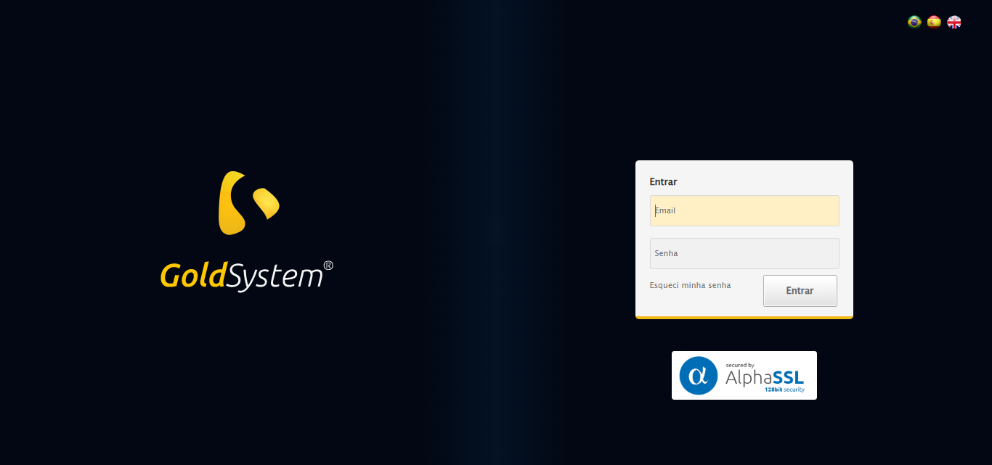

🔄 Realizando login...

✅ Realizando login realizada com sucesso.

Screenshot: realizando_login



🔄 Esperando sistema carregar e ajustando zoom...

🔍 Zoom ajustado para 90%.

✅ Esperando sistema carregar e ajustando zoom realizada com sucesso.

Screenshot: esperando_sistema_carregar_e_ajustando_zoom

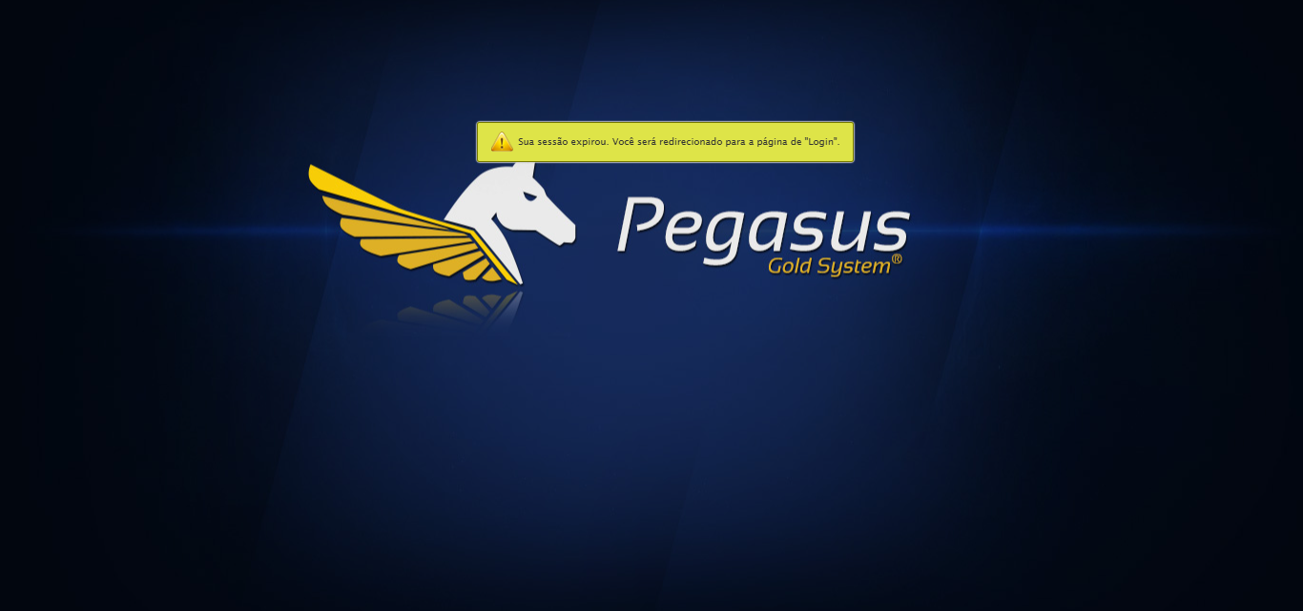

🔄 Abrindo menu Velórios...

❌ Erro ao abrindo menu velórios: Message: invalid session id: session deleted as the browser has closed the connection  
from disconnected: not connected to DevTools  
 (Session info: chrome=138.0.7204.97); For documentation on this error, please visit: https://www.selenium.dev/documentation/webdriver/troubleshooting/errors#invalidsessionidexception  
Stacktrace:  
 GetHandleVerifier [0x0xc644a3+62419]  
 GetHandleVerifier [0x0xc644e4+62484]  
 (No symbol) [0x0xaa2133]  
 (No symbol) [0x0xa91b40]  
 (No symbol) [0x0xaaf912]  
 (No symbol) [0x0xb15d6c]  
 (No symbol) [0x0xb30159]  
 (No symbol) [0x0xb0f266]  
 (No symbol) [0x0xade852]  
 (No symbol) [0x0xadf6f4]  
 GetHandleVerifier [0x0xed4793+2619075]  
 GetHandleVerifier [0x0xecfbaa+2599642]  
 GetHandleVerifier [0x0xc8b04a+221050]  
 GetHandleVerifier [0x0xc7b2c8+156152]  
 GetHandleVerifier [0x0xc81c7d+183213]  
 GetHandleVerifier [0x0xc6c388+94904]  
 GetHandleVerifier [0x0xc6c512+95298]  
 GetHandleVerifier [0x0xc5766a+9626]  
 BaseThreadInitThunk [0x0x773dfcc9+25]  
 RtlGetAppContainerNamedObjectPath [0x0x77ba82ae+286]  
 RtlGetAppContainerNamedObjectPath [0x0x77ba827e+238]

❌ ERRO FATAL: Message: invalid session id; For documentation on this error, please visit: https://www.selenium.dev/documentation/webdriver/troubleshooting/errors#invalidsessionidexception  
Stacktrace:  
 GetHandleVerifier [0x0xc644a3+62419]  
 GetHandleVerifier [0x0xc644e4+62484]  
 (No symbol) [0x0xaa1f90]  
 (No symbol) [0x0xaddb48]  
 (No symbol) [0x0xb0f326]  
 (No symbol) [0x0xb0af15]  
 (No symbol) [0x0xb0a496]  
 (No symbol) [0x0xa73a45]  
 (No symbol) [0x0xa73f9e]  
 (No symbol) [0x0xa7442d]  
 GetHandleVerifier [0x0xed4793+2619075]  
 GetHandleVerifier [0x0xecfbaa+2599642]  
 GetHandleVerifier [0x0xc8b04a+221050]  
 GetHandleVerifier [0x0xc7b2c8+156152]  
 GetHandleVerifier [0x0xc81c7d+183213]  
 (No symbol) [0x0xa73710]  
 (No symbol) [0x0xa72f1d]  
 GetHandleVerifier [0x0x1008aec+3881500]  
 BaseThreadInitThunk [0x0x773dfcc9+25]  
 RtlGetAppContainerNamedObjectPath [0x0x77ba82ae+286]  
 RtlGetAppContainerNamedObjectPath [0x0x77ba827e+238]

✅ Teste concluído.