RELATÓRIO DO TESTE

Cadastro de Vendedores – Cenário 1: Preenchimento completo e salvamento.

Data do teste: 11/07/2025 08:55:47

🔄 Acessando sistema...

✅ Acessando sistema realizada com sucesso.

Screenshot: acessando_sistema



🔄 Realizando login...

✅ Realizando login realizada com sucesso.

Screenshot: realizando_login



🔄 Esperando sistema carregar e ajustando zoom...

🔍 Zoom ajustado para 90%.

✅ Esperando sistema carregar e ajustando zoom realizada com sucesso.

Screenshot: esperando_sistema_carregar_e_ajustando_zoom

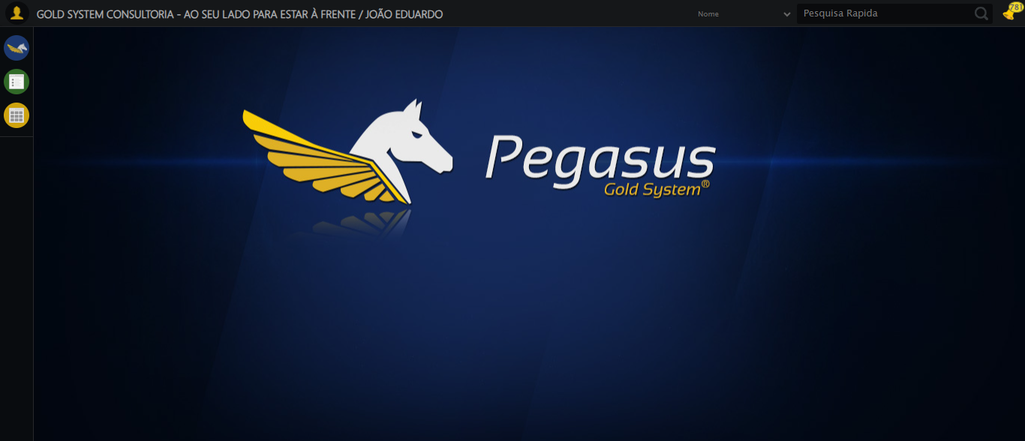

🔄 Abrindo menu Vendedor...

❌ Erro ao abrindo menu vendedor: Message:

Screenshot: erro_abrindo_menu_vendedor

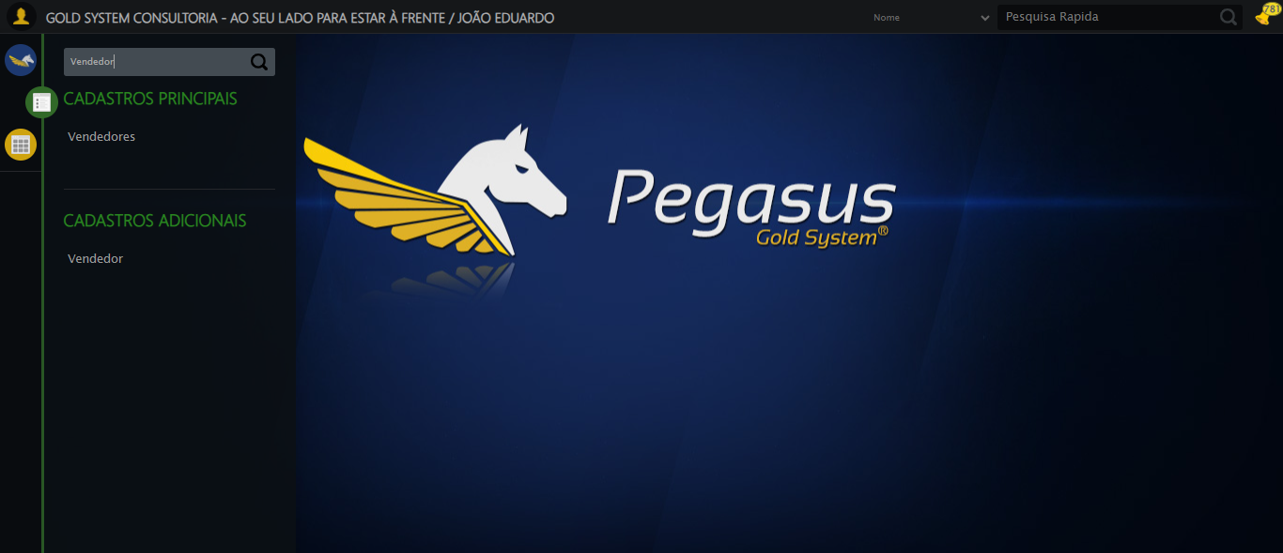

🔄 Clicando em Cadastrar...

❌ Erro ao clicando em cadastrar: Message: target frame detached  
 (failed to check if window was closed: disconnected: unable to send message to renderer)  
 (Session info: chrome=138.0.7204.97)  
Stacktrace:  
 GetHandleVerifier [0x0xc644a3+62419]  
 GetHandleVerifier [0x0xc644e4+62484]  
 (No symbol) [0x0xaa1f90]  
 (No symbol) [0x0xa92b80]  
 (No symbol) [0x0xa91cf1]  
 (No symbol) [0x0xaaf912]  
 (No symbol) [0x0xb15d6c]  
 (No symbol) [0x0xb30159]  
 (No symbol) [0x0xb0f266]  
 (No symbol) [0x0xade852]  
 (No symbol) [0x0xadf6f4]  
 GetHandleVerifier [0x0xed4793+2619075]  
 GetHandleVerifier [0x0xecfbaa+2599642]  
 GetHandleVerifier [0x0xc8b04a+221050]  
 GetHandleVerifier [0x0xc7b2c8+156152]  
 GetHandleVerifier [0x0xc81c7d+183213]  
 GetHandleVerifier [0x0xc6c388+94904]  
 GetHandleVerifier [0x0xc6c512+95298]  
 GetHandleVerifier [0x0xc5766a+9626]  
 BaseThreadInitThunk [0x0x773dfcc9+25]  
 RtlGetAppContainerNamedObjectPath [0x0x77ba82ae+286]  
 RtlGetAppContainerNamedObjectPath [0x0x77ba827e+238]

❌ ERRO FATAL: Message: invalid session id: session deleted as the browser has closed the connection  
from disconnected: not connected to DevTools  
 (Session info: chrome=138.0.7204.97); For documentation on this error, please visit: https://www.selenium.dev/documentation/webdriver/troubleshooting/errors#invalidsessionidexception  
Stacktrace:  
 GetHandleVerifier [0x0xc644a3+62419]  
 GetHandleVerifier [0x0xc644e4+62484]  
 (No symbol) [0x0xaa2133]  
 (No symbol) [0x0xa91b40]  
 (No symbol) [0x0xaaf912]  
 (No symbol) [0x0xb15d6c]  
 (No symbol) [0x0xb30159]  
 (No symbol) [0x0xb0f266]  
 (No symbol) [0x0xade852]  
 (No symbol) [0x0xadf6f4]  
 GetHandleVerifier [0x0xed4793+2619075]  
 GetHandleVerifier [0x0xecfbaa+2599642]  
 GetHandleVerifier [0x0xc8b04a+221050]  
 GetHandleVerifier [0x0xc7b2c8+156152]  
 GetHandleVerifier [0x0xc81c7d+183213]  
 GetHandleVerifier [0x0xc6c388+94904]  
 GetHandleVerifier [0x0xc6c512+95298]  
 GetHandleVerifier [0x0xc5766a+9626]  
 BaseThreadInitThunk [0x0x773dfcc9+25]  
 RtlGetAppContainerNamedObjectPath [0x0x77ba82ae+286]  
 RtlGetAppContainerNamedObjectPath [0x0x77ba827e+238]

✅ Teste concluído com sucesso.