RELATÓRIO DO TESTE

Processo: Fechamento Plano Empresa – Cenário 1: Nesse teste, o usuário irá realizar o fechamento de um Plano Empresa.

Data do teste: 18/08/2025 17:59:38

ℹ️ 🚀 Iniciando teste de fechamento de Plano Empresa

✅ Driver inicializado com sucesso

❌ Falha na etapa: Acessando sistema

ℹ️ 🔄 Realizando login...

✅ Realizando login realizada com sucesso

📸 Screenshot: realizando_login

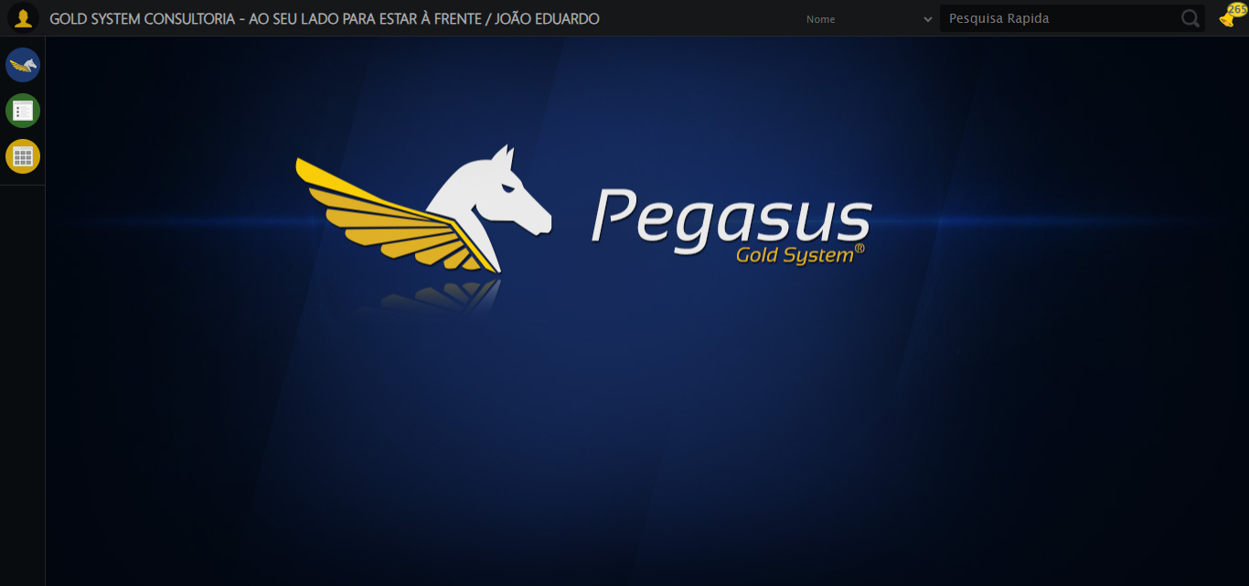

ℹ️ Zoom ajustado para 90%

ℹ️ 🔄 Acessando menu Plano Empresa...

✅ Acessando menu Plano Empresa realizada com sucesso

📸 Screenshot: acessando_menu_plano_empresa

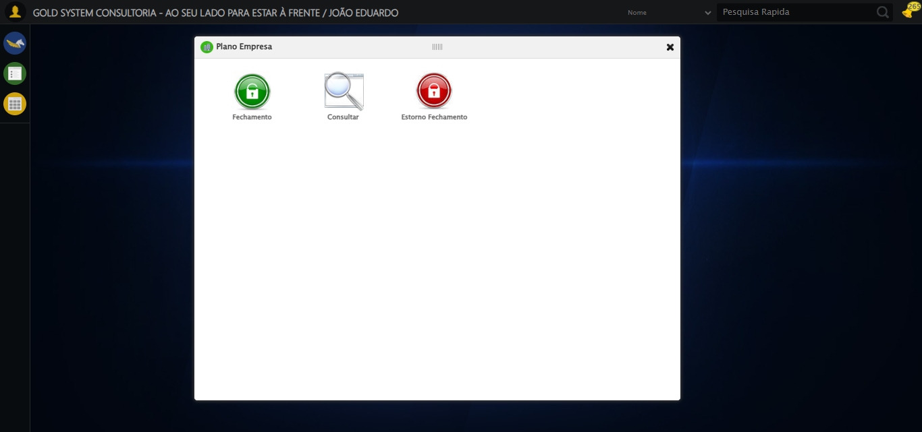

ℹ️ 🔄 Clicando em Consulta...

✅ Clicando em Consulta realizada com sucesso

📸 Screenshot: clicando_em_consulta

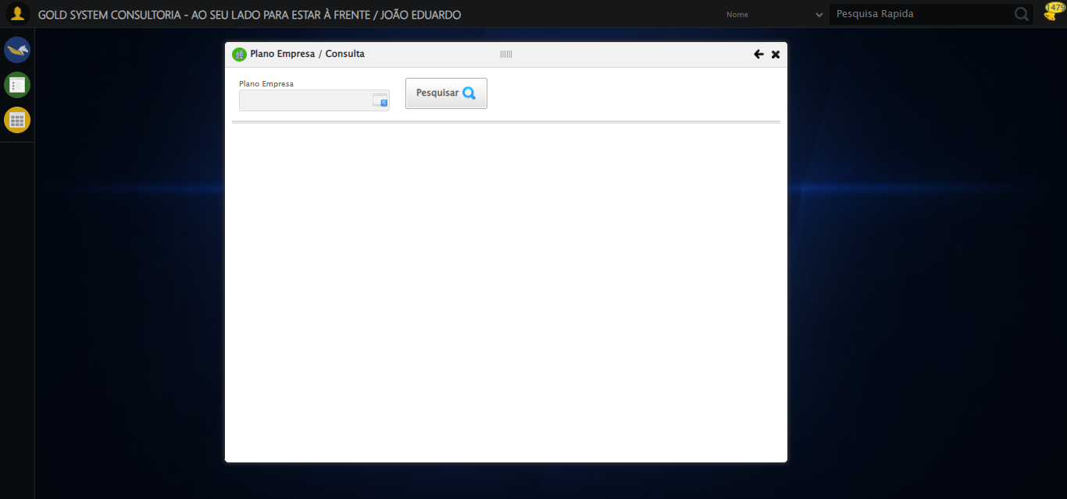

ℹ️ 🔄 Selecionando Plano Empresa...

❌ Falha ao clicar em ('xpath', "//td[contains(text(), 'PLANO EMPRESA TESTE SELENIUM AUTOMATIZADO')]"): Message: stale element reference: stale element not found in the current frame  
 (Session info: chrome=138.0.7204.185); For documentation on this error, please visit: https://www.selenium.dev/documentation/webdriver/troubleshooting/errors#staleelementreferenceexception  
Stacktrace:  
 GetHandleVerifier [0x0x33ba83+63395]  
 GetHandleVerifier [0x0x33bac4+63460]  
 (No symbol) [0x0x182113]  
 (No symbol) [0x0x1888e9]  
 (No symbol) [0x0x18aec3]  
 (No symbol) [0x0x2117b4]  
 (No symbol) [0x0x1ef3ac]  
 (No symbol) [0x0x2107ba]  
 (No symbol) [0x0x1ef1a6]  
 (No symbol) [0x0x1be7b2]  
 (No symbol) [0x0x1bf654]  
 GetHandleVerifier [0x0x5b8883+2672035]  
 GetHandleVerifier [0x0x5b3cba+2652634]  
 GetHandleVerifier [0x0x362bca+223466]  
 GetHandleVerifier [0x0x352cb8+158168]  
 GetHandleVerifier [0x0x35978d+185517]  
 GetHandleVerifier [0x0x343b78+96408]  
 GetHandleVerifier [0x0x343d02+96802]  
 GetHandleVerifier [0x0x32e90a+9770]  
 BaseThreadInitThunk [0x0x75abfcc9+25]  
 RtlGetAppContainerNamedObjectPath [0x0x776d82ae+286]  
 RtlGetAppContainerNamedObjectPath [0x0x776d827e+238]  
 (No symbol) [0x0]

✅ Selecionando Plano Empresa realizada com sucesso

📸 Screenshot: selecionando_plano_empresa

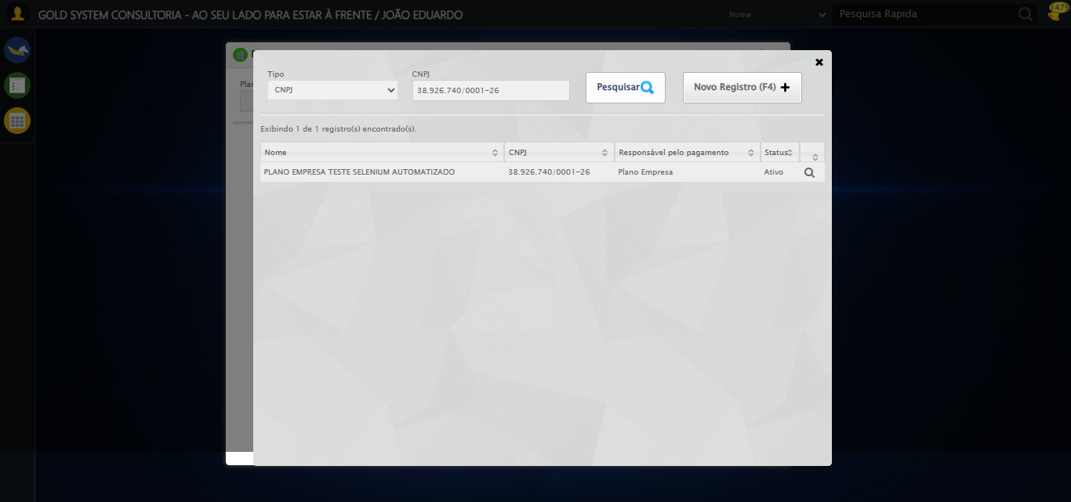

ℹ️ 🔄 Pesquisando Plano Empresa...

✅ Pesquisando Plano Empresa realizada com sucesso

📸 Screenshot: pesquisando_plano_empresa

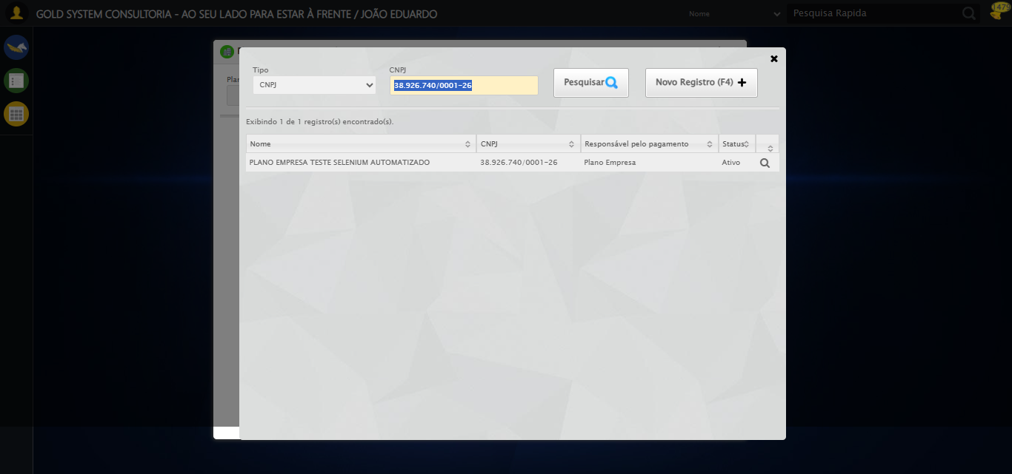

ℹ️ 🔄 Clicando na aba Contratos e tirando print...

❌ Falha ao clicar em ('xpath', "//*[@id='gsPlanoEmpresa']/div[2]/div[2]/div[2]/ul/li[1]/a"): Message: Elemento não encontrado: ('xpath', "//*[@id='gsPlanoEmpresa']/div[2]/div[2]/div[2]/ul/li[1]/a") (condição: present, timeout: 30s)

✅ Clicando na aba Contratos e tirando print realizada com sucesso

📸 Screenshot: clicando_na_aba_contratos_e_tirando_print



ℹ️ 🔄 Clicando na aba Títulos e tirando print...

❌ Falha ao clicar em ('xpath', "//*[@id='gsPlanoEmpresa']/div[2]/div[2]/div[2]/ul/li[2]/a"): Message: invalid session id: session deleted as the browser has closed the connection  
from disconnected: not connected to DevTools  
 (Session info: chrome=138.0.7204.185); For documentation on this error, please visit: https://www.selenium.dev/documentation/webdriver/troubleshooting/errors#invalidsessionidexception  
Stacktrace:  
 GetHandleVerifier [0x0x33ba83+63395]  
 GetHandleVerifier [0x0x33bac4+63460]  
 (No symbol) [0x0x182113]  
 (No symbol) [0x0x171b20]  
 (No symbol) [0x0x18f922]  
 (No symbol) [0x0x1f5c9c]  
 (No symbol) [0x0x210099]  
 (No symbol) [0x0x1ef1a6]  
 (No symbol) [0x0x1be7b2]  
 (No symbol) [0x0x1bf654]  
 GetHandleVerifier [0x0x5b8883+2672035]  
 GetHandleVerifier [0x0x5b3cba+2652634]  
 GetHandleVerifier [0x0x362bca+223466]  
 GetHandleVerifier [0x0x352cb8+158168]  
 GetHandleVerifier [0x0x35978d+185517]  
 GetHandleVerifier [0x0x343b78+96408]  
 GetHandleVerifier [0x0x343d02+96802]  
 GetHandleVerifier [0x0x32e90a+9770]  
 BaseThreadInitThunk [0x0x75abfcc9+25]  
 RtlGetAppContainerNamedObjectPath [0x0x776d82ae+286]  
 RtlGetAppContainerNamedObjectPath [0x0x776d827e+238]  
 (No symbol) [0x0]

✅ Clicando na aba Títulos e tirando print realizada com sucesso

❌ Erro ao tirar screenshot clicando_na_aba_títulos_e_tirando_print: Message: invalid session id; For documentation on this error, please visit: https://www.selenium.dev/documentation/webdriver/troubleshooting/errors#invalidsessionidexception  
Stacktrace:  
 GetHandleVerifier [0x0x33ba83+63395]  
 GetHandleVerifier [0x0x33bac4+63460]  
 (No symbol) [0x0x181f70]  
 (No symbol) [0x0x1bdaa8]  
 (No symbol) [0x0x1ef266]  
 (No symbol) [0x0x1eae65]  
 (No symbol) [0x0x1ea3e6]  
 (No symbol) [0x0x153a45]  
 (No symbol) [0x0x153f9e]  
 (No symbol) [0x0x15442d]  
 GetHandleVerifier [0x0x5b8883+2672035]  
 GetHandleVerifier [0x0x5b3cba+2652634]  
 GetHandleVerifier [0x0x362bca+223466]  
 GetHandleVerifier [0x0x352cb8+158168]  
 GetHandleVerifier [0x0x35978d+185517]  
 (No symbol) [0x0x153710]  
 (No symbol) [0x0x152f1d]  
 GetHandleVerifier [0x0x6edb9c+3938492]  
 BaseThreadInitThunk [0x0x75abfcc9+25]  
 RtlGetAppContainerNamedObjectPath [0x0x776d82ae+286]  
 RtlGetAppContainerNamedObjectPath [0x0x776d827e+238]  
 (No symbol) [0x0]

ℹ️ 🔄 Fechando modal...

❌ Falha ao clicar em ('css selector', '#gsPlanoEmpresa > div.wdTop.ui-draggable-handle > div.wdClose > a'): Message: invalid session id; For documentation on this error, please visit: https://www.selenium.dev/documentation/webdriver/troubleshooting/errors#invalidsessionidexception  
Stacktrace:  
 GetHandleVerifier [0x0x33ba83+63395]  
 GetHandleVerifier [0x0x33bac4+63460]  
 (No symbol) [0x0x181f70]  
 (No symbol) [0x0x1bdaa8]  
 (No symbol) [0x0x1ef266]  
 (No symbol) [0x0x1eae65]  
 (No symbol) [0x0x1ea3e6]  
 (No symbol) [0x0x153a45]  
 (No symbol) [0x0x153f9e]  
 (No symbol) [0x0x15442d]  
 GetHandleVerifier [0x0x5b8883+2672035]  
 GetHandleVerifier [0x0x5b3cba+2652634]  
 GetHandleVerifier [0x0x362bca+223466]  
 GetHandleVerifier [0x0x352cb8+158168]  
 GetHandleVerifier [0x0x35978d+185517]  
 (No symbol) [0x0x153710]  
 (No symbol) [0x0x152f1d]  
 GetHandleVerifier [0x0x6edb9c+3938492]  
 BaseThreadInitThunk [0x0x75abfcc9+25]  
 RtlGetAppContainerNamedObjectPath [0x0x776d82ae+286]  
 RtlGetAppContainerNamedObjectPath [0x0x776d827e+238]  
 (No symbol) [0x0]

✅ Fechando modal realizada com sucesso

❌ Erro ao tirar screenshot fechando_modal: Message: invalid session id; For documentation on this error, please visit: https://www.selenium.dev/documentation/webdriver/troubleshooting/errors#invalidsessionidexception  
Stacktrace:  
 GetHandleVerifier [0x0x33ba83+63395]  
 GetHandleVerifier [0x0x33bac4+63460]  
 (No symbol) [0x0x181f70]  
 (No symbol) [0x0x1bdaa8]  
 (No symbol) [0x0x1ef266]  
 (No symbol) [0x0x1eae65]  
 (No symbol) [0x0x1ea3e6]  
 (No symbol) [0x0x153a45]  
 (No symbol) [0x0x153f9e]  
 (No symbol) [0x0x15442d]  
 GetHandleVerifier [0x0x5b8883+2672035]  
 GetHandleVerifier [0x0x5b3cba+2652634]  
 GetHandleVerifier [0x0x362bca+223466]  
 GetHandleVerifier [0x0x352cb8+158168]  
 GetHandleVerifier [0x0x35978d+185517]  
 (No symbol) [0x0x153710]  
 (No symbol) [0x0x152f1d]  
 GetHandleVerifier [0x0x6edb9c+3938492]  
 BaseThreadInitThunk [0x0x75abfcc9+25]  
 RtlGetAppContainerNamedObjectPath [0x0x776d82ae+286]  
 RtlGetAppContainerNamedObjectPath [0x0x776d827e+238]  
 (No symbol) [0x0]

ℹ️ 🔍 Verificando mensagens de alerta...

ℹ️ ℹ️ Nenhuma mensagem de alerta encontrada

ℹ️ 📊 Taxa de sucesso: 90.0% (9/10 etapas)

❌ ❌ Teste finalizado com erros.

ℹ️ ✅ Teste concluído.

# RESUMO FINAL

Teste finalizado em: 18/08/2025 18:07:25