RELATÓRIO DO TESTE - FECHAMENTO PLANO EMPRESA

Processo: Fechamento Plano Empresa – Cenário 1: Nesse teste, o usuário irá realizar o fechamento de um Plano Empresa.

Data do teste: 18/08/2025 15:01:12

ℹ️ 🚀 Iniciando teste de fechamento de Plano Empresa

✅ Driver inicializado com sucesso

❌ Falha na etapa: Acessando sistema

ℹ️ 🔄 Realizando login...

✅ Realizando login realizada com sucesso

📸 Screenshot: realizando_login

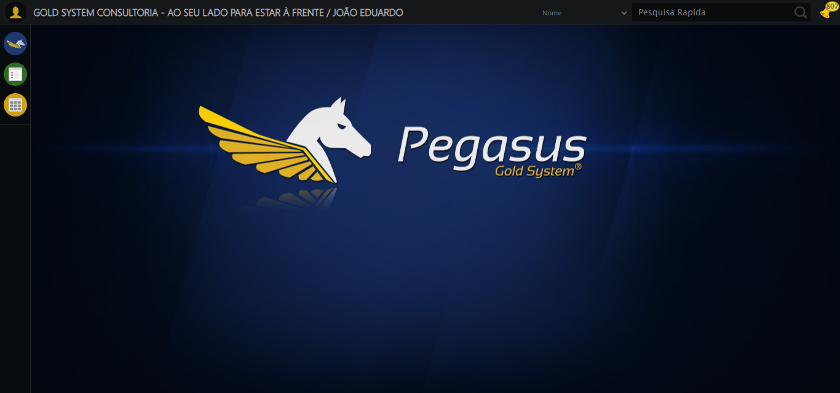

ℹ️ Zoom ajustado para 90%

ℹ️ 🔄 Acessando menu Plano Empresa...

✅ Acessando menu Plano Empresa realizada com sucesso

📸 Screenshot: acessando_menu_plano_empresa

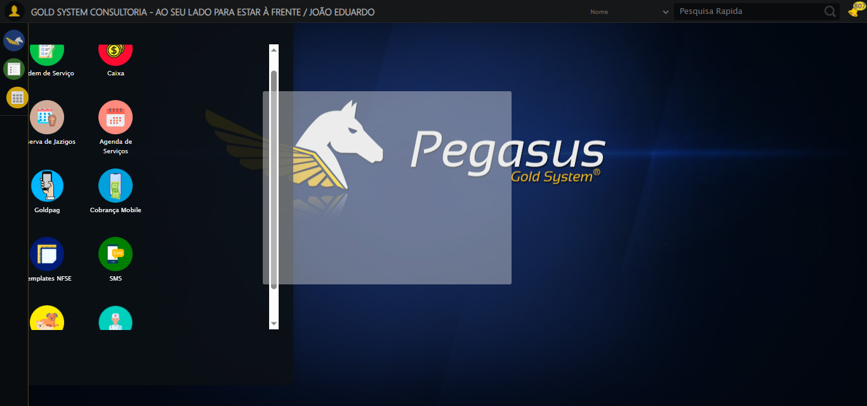

ℹ️ 🔄 Clicando em Fechamento...

✅ Clicando em Fechamento realizada com sucesso

📸 Screenshot: clicando_em_fechamento

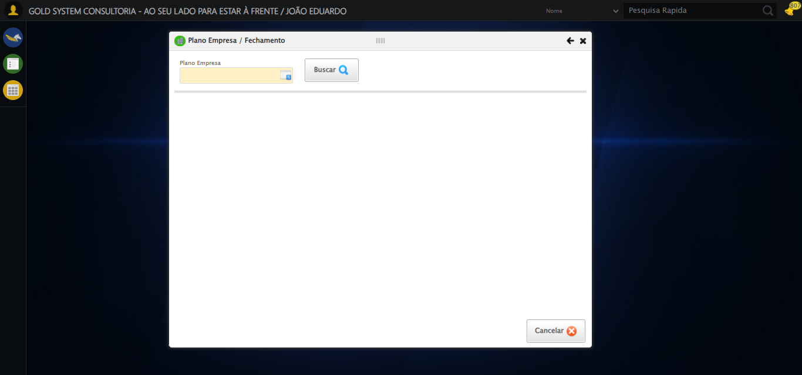

ℹ️ 🔄 Selecionando Plano Empresa...

✅ Selecionando Plano Empresa realizada com sucesso

📸 Screenshot: selecionando_plano_empresa

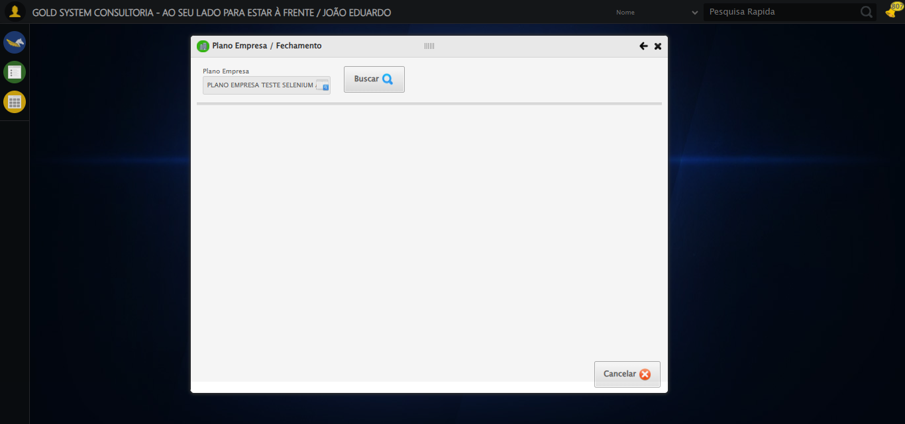

ℹ️ 🔄 Buscando Plano Empresa...

✅ Buscando Plano Empresa realizada com sucesso

📸 Screenshot: buscando_plano_empresa

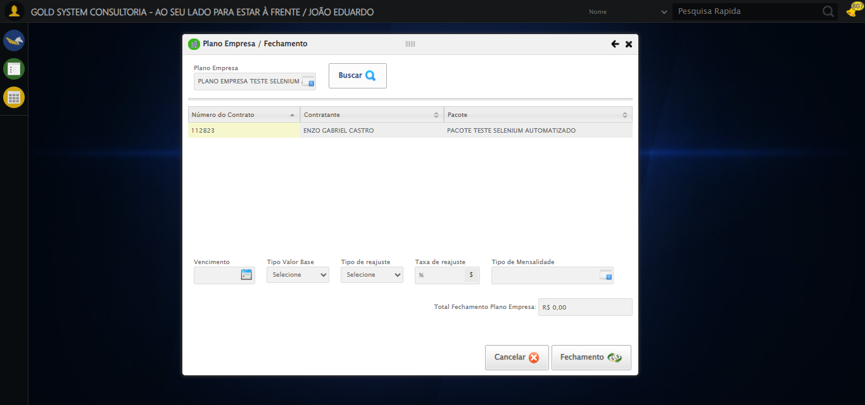

ℹ️ 🔄 Preenchendo dados do fechamento...

ℹ️ Encontrados 1 campos datepicker

ℹ️ Preenchendo datepicker 0 (ID: dp1755540106723) com '17/08/2025'

⚠️ Tentativa 1 falhou, tentando novamente...

ℹ️ Encontrados 1 campos datepicker

ℹ️ Preenchendo datepicker 0 (ID: dp1755540106723) com '17/08/2025'

⚠️ Tentativa 2 falhou, tentando novamente...

ℹ️ Encontrados 1 campos datepicker

ℹ️ Preenchendo datepicker 0 (ID: dp1755540106723) com '17/08/2025'

⚠️ Tentativa 3 falhou, tentando novamente...

ℹ️ Encontrados 0 campos datepicker

⚠️ Nenhum campo datepicker encontrado, tentativa 4

ℹ️ Encontrados 0 campos datepicker

❌ Erro ao tirar screenshot erro_preenchendo_dados_do_fechamento: Message: invalid session id  
Stacktrace:  
 GetHandleVerifier [0x0x59ba83+63395]  
 GetHandleVerifier [0x0x59bac4+63460]  
 (No symbol) [0x0x3e1f70]  
 (No symbol) [0x0x41daa8]  
 (No symbol) [0x0x44f266]  
 (No symbol) [0x0x44ae65]  
 (No symbol) [0x0x44a3e6]  
 (No symbol) [0x0x3b3a45]  
 (No symbol) [0x0x3b3f9e]  
 (No symbol) [0x0x3b442d]  
 GetHandleVerifier [0x0x818883+2672035]  
 GetHandleVerifier [0x0x813cba+2652634]  
 GetHandleVerifier [0x0x5c2bca+223466]  
 GetHandleVerifier [0x0x5b2cb8+158168]  
 GetHandleVerifier [0x0x5b978d+185517]  
 (No symbol) [0x0x3b3710]  
 (No symbol) [0x0x3b2f1d]  
 GetHandleVerifier [0x0x94db9c+3938492]  
 BaseThreadInitThunk [0x0x75abfcc9+25]  
 RtlGetAppContainerNamedObjectPath [0x0x776d82ae+286]  
 RtlGetAppContainerNamedObjectPath [0x0x776d827e+238]

❌ Preenchendo dados do fechamento falhou: Exception: Falha ao preencher datepicker 0 após 5 tentativas

❌ Falha na etapa: Preenchimento dos dados

ℹ️ 🔄 Selecionando Tipo Mensalidade...

❌ Falha ao clicar em ('css selector', '#gsPlanoEmpresa > div.wdTelas > div:nth-child(4) > div.contentHolder.clearfix.overflow.overflowY > div:nth-child(2) > div:nth-child(5) > div > a'): Message: invalid session id  
Stacktrace:  
 GetHandleVerifier [0x0x59ba83+63395]  
 GetHandleVerifier [0x0x59bac4+63460]  
 (No symbol) [0x0x3e1f70]  
 (No symbol) [0x0x41daa8]  
 (No symbol) [0x0x44f266]  
 (No symbol) [0x0x44ae65]  
 (No symbol) [0x0x44a3e6]  
 (No symbol) [0x0x3b3a45]  
 (No symbol) [0x0x3b3f9e]  
 (No symbol) [0x0x3b442d]  
 GetHandleVerifier [0x0x818883+2672035]  
 GetHandleVerifier [0x0x813cba+2652634]  
 GetHandleVerifier [0x0x5c2bca+223466]  
 GetHandleVerifier [0x0x5b2cb8+158168]  
 GetHandleVerifier [0x0x5b978d+185517]  
 (No symbol) [0x0x3b3710]  
 (No symbol) [0x0x3b2f1d]  
 GetHandleVerifier [0x0x94db9c+3938492]  
 BaseThreadInitThunk [0x0x75abfcc9+25]  
 RtlGetAppContainerNamedObjectPath [0x0x776d82ae+286]  
 RtlGetAppContainerNamedObjectPath [0x0x776d827e+238]

❌ Falha ao preencher campo ('css selector', 'body > div.modalHolder > div.modal.overflow > div:nth-child(1) > div.formRow.formLastLine > div:nth-child(2) > input'): Message: invalid session id  
Stacktrace:  
 GetHandleVerifier [0x0x59ba83+63395]  
 GetHandleVerifier [0x0x59bac4+63460]  
 (No symbol) [0x0x3e1f70]  
 (No symbol) [0x0x41daa8]  
 (No symbol) [0x0x44f266]  
 (No symbol) [0x0x44ae65]  
 (No symbol) [0x0x44a3e6]  
 (No symbol) [0x0x3b3a45]  
 (No symbol) [0x0x3b3f9e]  
 (No symbol) [0x0x3b442d]  
 GetHandleVerifier [0x0x818883+2672035]  
 GetHandleVerifier [0x0x813cba+2652634]  
 GetHandleVerifier [0x0x5c2bca+223466]  
 GetHandleVerifier [0x0x5b2cb8+158168]  
 GetHandleVerifier [0x0x5b978d+185517]  
 (No symbol) [0x0x3b3710]  
 (No symbol) [0x0x3b2f1d]  
 GetHandleVerifier [0x0x94db9c+3938492]  
 BaseThreadInitThunk [0x0x75abfcc9+25]  
 RtlGetAppContainerNamedObjectPath [0x0x776d82ae+286]  
 RtlGetAppContainerNamedObjectPath [0x0x776d827e+238]

❌ Falha ao clicar em ('css selector', 'body > div.modalHolder > div.modal.overflow > div:nth-child(1) > div.formRow.formLastLine > div:nth-child(4) > a'): Message: invalid session id  
Stacktrace:  
 GetHandleVerifier [0x0x59ba83+63395]  
 GetHandleVerifier [0x0x59bac4+63460]  
 (No symbol) [0x0x3e1f70]  
 (No symbol) [0x0x41daa8]  
 (No symbol) [0x0x44f266]  
 (No symbol) [0x0x44ae65]  
 (No symbol) [0x0x44a3e6]  
 (No symbol) [0x0x3b3a45]  
 (No symbol) [0x0x3b3f9e]  
 (No symbol) [0x0x3b442d]  
 GetHandleVerifier [0x0x818883+2672035]  
 GetHandleVerifier [0x0x813cba+2652634]  
 GetHandleVerifier [0x0x5c2bca+223466]  
 GetHandleVerifier [0x0x5b2cb8+158168]  
 GetHandleVerifier [0x0x5b978d+185517]  
 (No symbol) [0x0x3b3710]  
 (No symbol) [0x0x3b2f1d]  
 GetHandleVerifier [0x0x94db9c+3938492]  
 BaseThreadInitThunk [0x0x75abfcc9+25]  
 RtlGetAppContainerNamedObjectPath [0x0x776d82ae+286]  
 RtlGetAppContainerNamedObjectPath [0x0x776d827e+238]

❌ Falha ao clicar em ('xpath', "//td[contains(text(), 'TESTE TIPO DE MENSALIDADE SELENIUM AUTOMATIZADO')]"): Message: invalid session id  
Stacktrace:  
 GetHandleVerifier [0x0x59ba83+63395]  
 GetHandleVerifier [0x0x59bac4+63460]  
 (No symbol) [0x0x3e1f70]  
 (No symbol) [0x0x41daa8]  
 (No symbol) [0x0x44f266]  
 (No symbol) [0x0x44ae65]  
 (No symbol) [0x0x44a3e6]  
 (No symbol) [0x0x3b3a45]  
 (No symbol) [0x0x3b3f9e]  
 (No symbol) [0x0x3b442d]  
 GetHandleVerifier [0x0x818883+2672035]  
 GetHandleVerifier [0x0x813cba+2652634]  
 GetHandleVerifier [0x0x5c2bca+223466]  
 GetHandleVerifier [0x0x5b2cb8+158168]  
 GetHandleVerifier [0x0x5b978d+185517]  
 (No symbol) [0x0x3b3710]  
 (No symbol) [0x0x3b2f1d]  
 GetHandleVerifier [0x0x94db9c+3938492]  
 BaseThreadInitThunk [0x0x75abfcc9+25]  
 RtlGetAppContainerNamedObjectPath [0x0x776d82ae+286]  
 RtlGetAppContainerNamedObjectPath [0x0x776d827e+238]

✅ Selecionando Tipo Mensalidade realizada com sucesso

❌ Erro ao tirar screenshot selecionando_tipo_mensalidade: Message: invalid session id  
Stacktrace:  
 GetHandleVerifier [0x0x59ba83+63395]  
 GetHandleVerifier [0x0x59bac4+63460]  
 (No symbol) [0x0x3e1f70]  
 (No symbol) [0x0x41daa8]  
 (No symbol) [0x0x44f266]  
 (No symbol) [0x0x44ae65]  
 (No symbol) [0x0x44a3e6]  
 (No symbol) [0x0x3b3a45]  
 (No symbol) [0x0x3b3f9e]  
 (No symbol) [0x0x3b442d]  
 GetHandleVerifier [0x0x818883+2672035]  
 GetHandleVerifier [0x0x813cba+2652634]  
 GetHandleVerifier [0x0x5c2bca+223466]  
 GetHandleVerifier [0x0x5b2cb8+158168]  
 GetHandleVerifier [0x0x5b978d+185517]  
 (No symbol) [0x0x3b3710]  
 (No symbol) [0x0x3b2f1d]  
 GetHandleVerifier [0x0x94db9c+3938492]  
 BaseThreadInitThunk [0x0x75abfcc9+25]  
 RtlGetAppContainerNamedObjectPath [0x0x776d82ae+286]  
 RtlGetAppContainerNamedObjectPath [0x0x776d827e+238]

ℹ️ 🔄 Realizando fechamento de Plano Empresa...

❌ Falha ao clicar em ('css selector', '#gsPlanoEmpresa > div.wdTelas > div:nth-child(4) > div.btnHolder > a:nth-child(2)'): Message: invalid session id  
Stacktrace:  
 GetHandleVerifier [0x0x59ba83+63395]  
 GetHandleVerifier [0x0x59bac4+63460]  
 (No symbol) [0x0x3e1f70]  
 (No symbol) [0x0x41daa8]  
 (No symbol) [0x0x44f266]  
 (No symbol) [0x0x44ae65]  
 (No symbol) [0x0x44a3e6]  
 (No symbol) [0x0x3b3a45]  
 (No symbol) [0x0x3b3f9e]  
 (No symbol) [0x0x3b442d]  
 GetHandleVerifier [0x0x818883+2672035]  
 GetHandleVerifier [0x0x813cba+2652634]  
 GetHandleVerifier [0x0x5c2bca+223466]  
 GetHandleVerifier [0x0x5b2cb8+158168]  
 GetHandleVerifier [0x0x5b978d+185517]  
 (No symbol) [0x0x3b3710]  
 (No symbol) [0x0x3b2f1d]  
 GetHandleVerifier [0x0x94db9c+3938492]  
 BaseThreadInitThunk [0x0x75abfcc9+25]  
 RtlGetAppContainerNamedObjectPath [0x0x776d82ae+286]  
 RtlGetAppContainerNamedObjectPath [0x0x776d827e+238]

✅ Realizando fechamento de Plano Empresa realizada com sucesso

❌ Erro ao tirar screenshot realizando_fechamento_de_plano_empresa: Message: invalid session id  
Stacktrace:  
 GetHandleVerifier [0x0x59ba83+63395]  
 GetHandleVerifier [0x0x59bac4+63460]  
 (No symbol) [0x0x3e1f70]  
 (No symbol) [0x0x41daa8]  
 (No symbol) [0x0x44f266]  
 (No symbol) [0x0x44ae65]  
 (No symbol) [0x0x44a3e6]  
 (No symbol) [0x0x3b3a45]  
 (No symbol) [0x0x3b3f9e]  
 (No symbol) [0x0x3b442d]  
 GetHandleVerifier [0x0x818883+2672035]  
 GetHandleVerifier [0x0x813cba+2652634]  
 GetHandleVerifier [0x0x5c2bca+223466]  
 GetHandleVerifier [0x0x5b2cb8+158168]  
 GetHandleVerifier [0x0x5b978d+185517]  
 (No symbol) [0x0x3b3710]  
 (No symbol) [0x0x3b2f1d]  
 GetHandleVerifier [0x0x94db9c+3938492]  
 BaseThreadInitThunk [0x0x75abfcc9+25]  
 RtlGetAppContainerNamedObjectPath [0x0x776d82ae+286]  
 RtlGetAppContainerNamedObjectPath [0x0x776d827e+238]

ℹ️ 🔄 Fechando modal...

❌ Falha ao clicar em ('css selector', '#gsPlanoEmpresa > div.wdTop.ui-draggable-handle > div.wdClose > a'): Message: invalid session id  
Stacktrace:  
 GetHandleVerifier [0x0x59ba83+63395]  
 GetHandleVerifier [0x0x59bac4+63460]  
 (No symbol) [0x0x3e1f70]  
 (No symbol) [0x0x41daa8]  
 (No symbol) [0x0x44f266]  
 (No symbol) [0x0x44ae65]  
 (No symbol) [0x0x44a3e6]  
 (No symbol) [0x0x3b3a45]  
 (No symbol) [0x0x3b3f9e]  
 (No symbol) [0x0x3b442d]  
 GetHandleVerifier [0x0x818883+2672035]  
 GetHandleVerifier [0x0x813cba+2652634]  
 GetHandleVerifier [0x0x5c2bca+223466]  
 GetHandleVerifier [0x0x5b2cb8+158168]  
 GetHandleVerifier [0x0x5b978d+185517]  
 (No symbol) [0x0x3b3710]  
 (No symbol) [0x0x3b2f1d]  
 GetHandleVerifier [0x0x94db9c+3938492]  
 BaseThreadInitThunk [0x0x75abfcc9+25]  
 RtlGetAppContainerNamedObjectPath [0x0x776d82ae+286]  
 RtlGetAppContainerNamedObjectPath [0x0x776d827e+238]

✅ Fechando modal realizada com sucesso

❌ Erro ao tirar screenshot fechando_modal: Message: invalid session id  
Stacktrace:  
 GetHandleVerifier [0x0x59ba83+63395]  
 GetHandleVerifier [0x0x59bac4+63460]  
 (No symbol) [0x0x3e1f70]  
 (No symbol) [0x0x41daa8]  
 (No symbol) [0x0x44f266]  
 (No symbol) [0x0x44ae65]  
 (No symbol) [0x0x44a3e6]  
 (No symbol) [0x0x3b3a45]  
 (No symbol) [0x0x3b3f9e]  
 (No symbol) [0x0x3b442d]  
 GetHandleVerifier [0x0x818883+2672035]  
 GetHandleVerifier [0x0x813cba+2652634]  
 GetHandleVerifier [0x0x5c2bca+223466]  
 GetHandleVerifier [0x0x5b2cb8+158168]  
 GetHandleVerifier [0x0x5b978d+185517]  
 (No symbol) [0x0x3b3710]  
 (No symbol) [0x0x3b2f1d]  
 GetHandleVerifier [0x0x94db9c+3938492]  
 BaseThreadInitThunk [0x0x75abfcc9+25]  
 RtlGetAppContainerNamedObjectPath [0x0x776d82ae+286]  
 RtlGetAppContainerNamedObjectPath [0x0x776d827e+238]

ℹ️ 🔍 Verificando mensagens de alerta...

ℹ️ ℹ️ Nenhuma mensagem de alerta encontrada

ℹ️ 📊 Taxa de sucesso: 81.8% (9/11 etapas)

❌ ❌ Teste finalizado com erros.

ℹ️ ✅ Teste concluído.

# RESUMO FINAL

Teste finalizado em: 18/08/2025 15:03:24