RELATÓRIO DE TESTE AUTOMATIZADO

Sistema: Devolução de Equipamentos - Apoio Ortopédico

Data: 22/08/2025 17:48:21

--------------------------------------------------

[17:48:28] ✅ Driver inicializado com sucesso

[17:48:28] 🚀 Iniciando teste de Devolução de Equipamentos

[17:48:28] 🔄 Acessando sistema

[17:48:29] ✅ Acessando sistema - Sucesso

📸 Screenshot: sucesso_acessando sistema

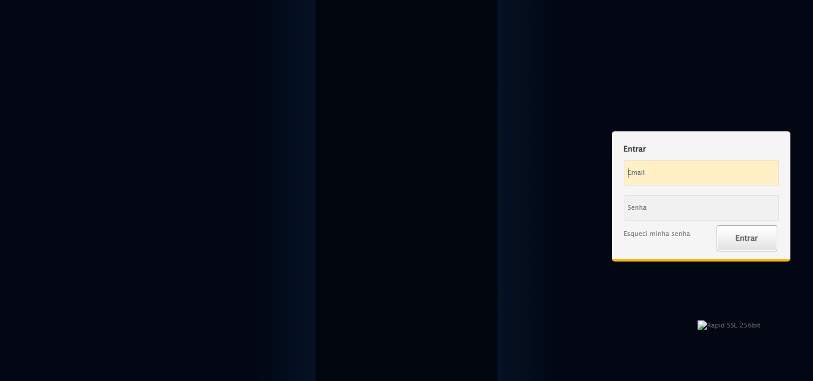

[17:48:29] 🔄 Realizando login

[17:48:34] ✅ Realizando login - Sucesso

📸 Screenshot: sucesso_realizando login

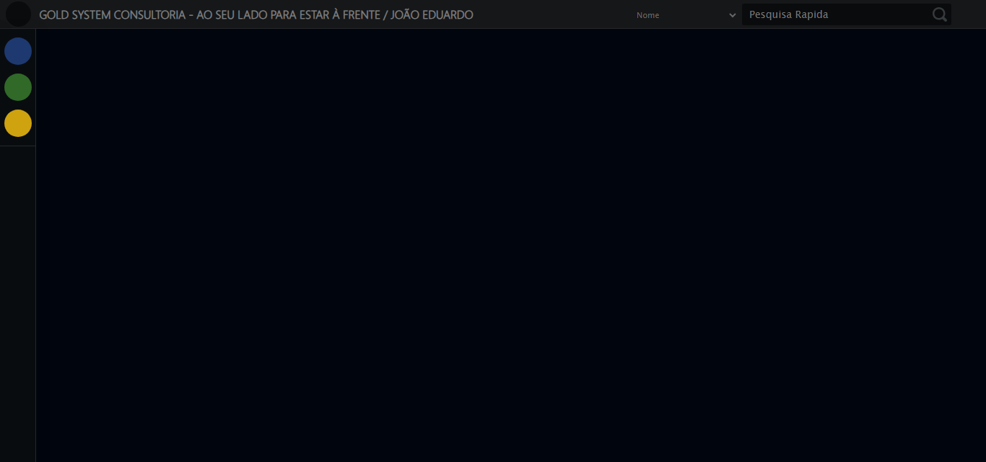

[17:48:36] 🔄 Configurando interface

[17:48:38] ✅ Configurando interface - Sucesso

📸 Screenshot: sucesso_configurando interface

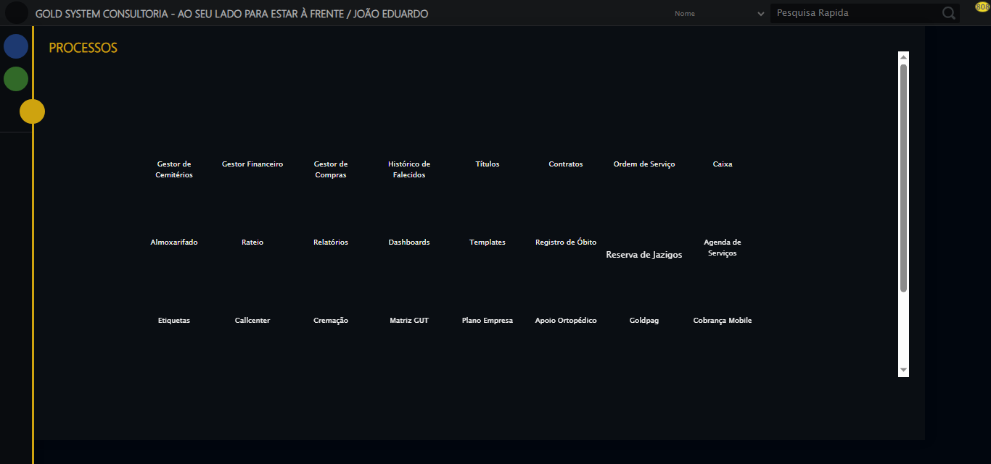

[17:48:39] 🔄 Acessando Apoio Ortopédico

[17:48:39] ✅ Acessando Apoio Ortopédico - Sucesso

📸 Screenshot: sucesso_acessando apoio ortopédico

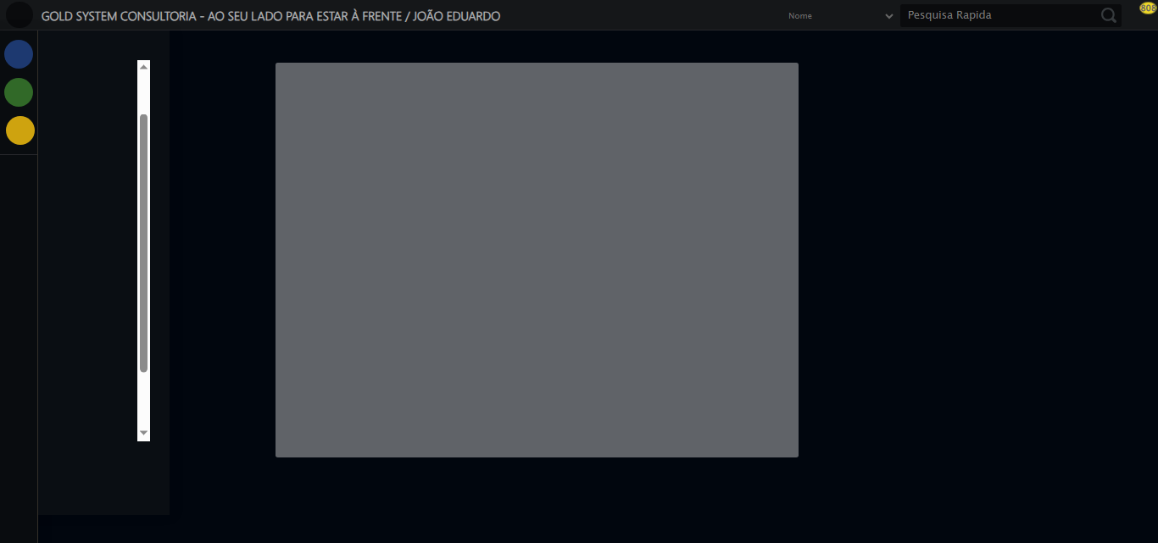

[17:48:40] 🔄 Abrindo Devolução de Equipamentos

[17:48:46] ✅ Abrindo Devolução de Equipamentos - Sucesso

📸 Screenshot: sucesso_abrindo devolução de equipamentos

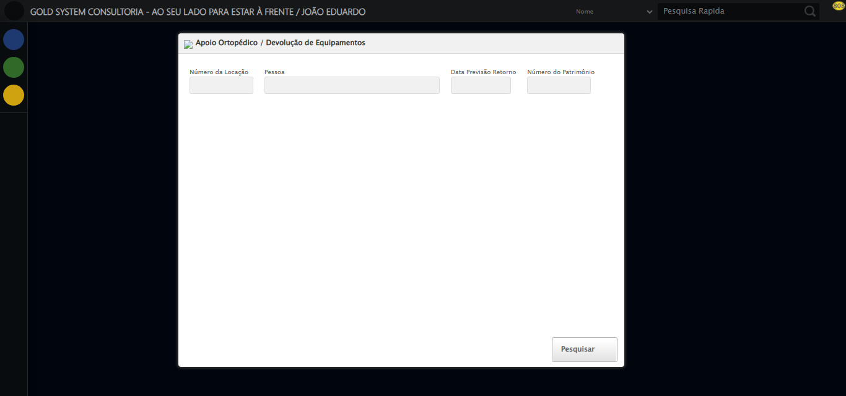

[17:48:47] 🔄 Preenchendo formulário

[17:49:13] Erro na seleção de pessoa: Message: target frame detached  
 (failed to check if window was closed: disconnected: not connected to DevTools)  
 (Session info: chrome=139.0.7258.128)  
Stacktrace:  
 GetHandleVerifier [0x0xf6ffc3+65331]  
 GetHandleVerifier [0x0xf70004+65396]  
 (No symbol) [0x0xd63dc0]  
 (No symbol) [0x0xd54920]  
 (No symbol) [0x0xd53a91]  
 (No symbol) [0x0xd71709]  
 (No symbol) [0x0xdd7e4c]  
 (No symbol) [0x0xdf24d9]  
 (No symbol) [0x0xdd12d6]  
 (No symbol) [0x0xda0910]  
 (No symbol) [0x0xda1784]  
 GetHandleVerifier [0x0x11b38b3+2439203]  
 GetHandleVerifier [0x0x11aeae2+2419282]  
 GetHandleVerifier [0x0xf9712a+225434]  
 GetHandleVerifier [0x0xf86e08+159096]  
 GetHandleVerifier [0x0xf8dd5d+187597]  
 GetHandleVerifier [0x0xf77ad8+96840]  
 GetHandleVerifier [0x0xf77c62+97234]  
 GetHandleVerifier [0x0xf6277a+9962]  
 BaseThreadInitThunk [0x0x76b1fcc9+25]  
 RtlGetAppContainerNamedObjectPath [0x0x776a82ae+286]  
 RtlGetAppContainerNamedObjectPath [0x0x776a827e+238]

[17:49:13] ❌ Falha na etapa: Preenchendo formulário

[17:49:14] ✅ Preenchendo formulário - Sucesso

[17:49:14] ⚠️ Erro ao capturar screenshot sucesso_preenchendo formulário: Message: invalid session id: session deleted as the browser has closed the connection  
from disconnected: not connected to DevTools  
 (Session info: chrome=139.0.7258.128)  
Stacktrace:  
 GetHandleVerifier [0x0xf6ffc3+65331]  
 GetHandleVerifier [0x0xf70004+65396]  
 (No symbol) [0x0xd63f63]  
 (No symbol) [0x0xd538e0]  
 (No symbol) [0x0xd71709]  
 (No symbol) [0x0xdd7e4c]  
 (No symbol) [0x0xdf24d9]  
 (No symbol) [0x0xdd12d6]  
 (No symbol) [0x0xda0910]  
 (No symbol) [0x0xda1784]  
 GetHandleVerifier [0x0x11b38b3+2439203]  
 GetHandleVerifier [0x0x11aeae2+2419282]  
 GetHandleVerifier [0x0xf9712a+225434]  
 GetHandleVerifier [0x0xf86e08+159096]  
 GetHandleVerifier [0x0xf8dd5d+187597]  
 GetHandleVerifier [0x0xf77ad8+96840]  
 GetHandleVerifier [0x0xf77c62+97234]  
 GetHandleVerifier [0x0xf6277a+9962]  
 BaseThreadInitThunk [0x0x76b1fcc9+25]  
 RtlGetAppContainerNamedObjectPath [0x0x776a82ae+286]  
 RtlGetAppContainerNamedObjectPath [0x0x776a827e+238]

[17:49:17] 🔒 Driver finalizado