GDD

TapTap

Indice

1. **Gameplay**
   1. Name of the game
   2. Objective
2. **Menus**
   1. Game menu
      1. Components
      2. Draws (Life, Money, damage, etc...)
   2. Smelting menu
      1. Concept
      2. Behaviour
      3. Components
      4. Draws
   3. Shop menu
      1. Selling itens
   4. Blacksmith menu
3. **Ore rocks**
   1. Clay
   2. Rock
   3. Tin
   4. Coppper
   5. Iron
   6. Coal
   7. Gems
      1. Saphire
      2. Esmerald
      3. Ruby
      4. Diamond
   8. Gold
   9. Granite
   10. Mithril
   11. Adamantite
   12. Runite
4. **Bars**
   1. Clay
   2. Rock
   3. Bronze bar
   4. Iron bar
   5. Mithril bar
   6. Adamantium bar
   7. Runic bar
5. Shop Itens
   1. Pickaxes
      1. Clay pickaxe
      2. Rock pickaxe
      3. Bronze pickaxe
      4. Iron pickaxe
      5. Mithril pickaxe
      6. Adamantium pickaxe
      7. Rune pickaxe
   2. Autoclickers
   3. Furnaces
      1. Bonfire
      2. Furnace
   4. Boosters
      1. Heat booster
      2. Pickaxe damage booster
      3. More ore drop booster
6. **Gameplay**
   1. **Name of the game:** TapTap
   2. **Objectives:** You will start with just a hand. Catch some other ores, transform then on bars and build a more efficient pickaxe! In the game, your objective is: upgrade your currently pickaxe to extract more hardener ore and consequently, earn more cash!
7. **Menus** 
   1. **Game menu**
      1. **Components**
         1. OBJ_ore
         2. Black boxes
         3. Left hidden menu
         4. Change screen button
         5. Arrows
      2. **Draws**
         1. Name
         2. Money
         3. Ore life
         4. Atual damage
   2. Smelting Menu
      1. Concept: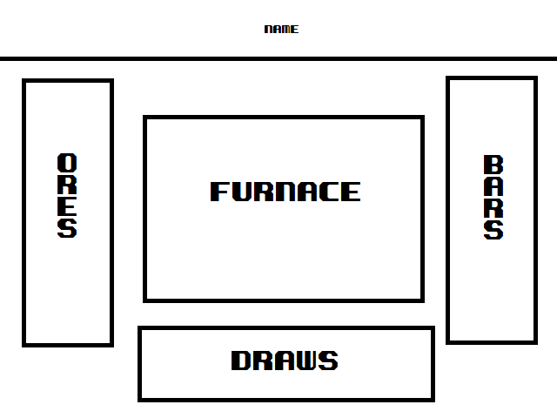
      2. Behavior: Click on the ore -> smelt in the furnace -> go to the bar menu
      3. Components
         1. Furnace
         2. Ores
         3. Bars
      4. Draws
         1. Heat: temperature of the furnace
         2. Bars per minute
   3. Shop Menu
      1. Selling itens
         1. Autoclicker
         2. Fuel (heat)
   4. Blacksmith menu
8. Ore rocks
   1. Clay
      1. Name: “Clay ore”
      2. Life: “x”
      3. Money drop: “x”
      4. Description: “Clay soft enough to mould”
   2. Rock
      1. Name: “Rock ore”
      2. Life: “x”
      3. Money drop: “x”
      4. Description: “Minerals conglomerate without much value”
   3. Tin
      1. Name: “Tin ore”
      2. Life: “x”
      3. Money drop: “x”
      4. Description: “A mineral”
   4. Cooper
      1. Name: “Cooper ore”
      2. Life: “x”
      3. Money drop: “x”
      4. Description: “A mineral”
   5. Coal
      1. Name: “Clay ore”
      2. Life: “x”
      3. Money drop: “x”
      4. Description: “Clay soft enough to mould”