Metadata Description
Project Mudbrick
Project name: Project Mudbrick
Authors: Heidi Barten, João Silva, Marcia Pound, and Tobias Verwoert
Affiliation: University of Amsterdam
Date of creation: 27 March 2026
Description: This project is part of research that uses a combination of techniques, including Geographic Information Systems (GIS) and spatial proximity analysis, to examine how modern human disturbances affect the preservation of Hellenistic (310-30 BCE) and Roman (30 BCE – 4th century CE) tombs and graves across Cyprus.
Coordinate Reference System (CRS): EPSG:32636
Spatial resolution: CORINE Land Cover 2018 (vector/raster 100 m), Europe, 6-yearly - GDB (NUTS: Kýpros)
Dataset
CORINE: https://land.copernicus.eu/en/products/corine-land-cover
OpenStreetMap: https://download.geofabrik.de/europe/cyprus.html
Tombs and Necropoleis: https://ktisis.cut.ac.cy/handle/20.500.14279/32477
Data reliability: For the Tombs and Necropoleis data, note that some geolocations are missing in the original dataset; therefore, they are missing here as well. In addition, according to the authors, there is also a positional uncertainty of up to 100–200 meters. Therefore, the points used in this dataset might not be fully consistent.
Repository location: https://github.com/joaomessiah/project_mudbrick
Processing
QGIS (version 3.44.8 LTR)

Folder Structure
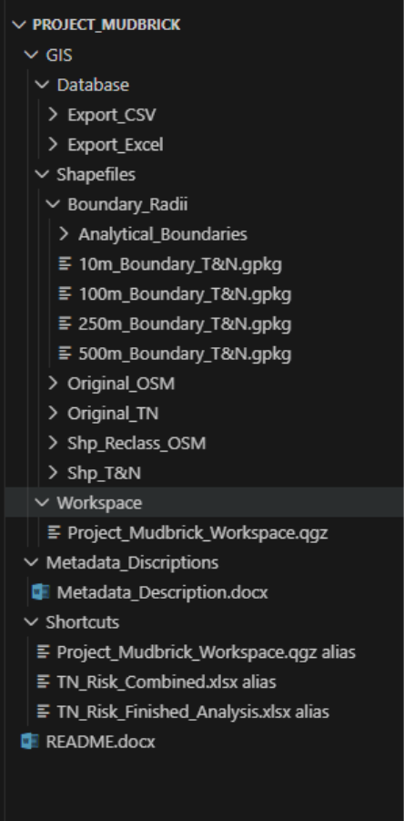
How to navigate the project
- If the goal is to open the GIS project: go to GIS > Database > Workspace > Project_Mudbrick_Workspace.qgz and open this file in QGIS.
- If the goal is to inspect the original raw data: go to GIS > Database > Shapefiles > Original_OSM or GIS > Database > Shapefiles > Original_TN.
- If the goal is to inspect the final processed GIS layers: go to GIS > Database > Shapefiles > Shp_Reclass_OSM and GIS > Database > Shapefiles > Shp_T&N.
- If the goal is to inspect the buffer-based outputs: go to GIS > Database > Shapefiles > Boundary_Radii.
- If the goal is to use tabular results: go to GIS > Database > Export_Excel or GIS > Database > Export_CSV.
Recommended workflow for a new user
- Open the main QGIS project from the Workspace folder.
- Check the cleaned Tombs & Necropoleis layer in Shp_T&N.
- Review the reclassified disturbance layers in Shp_Reclass_OSM.
- Review the buffer outputs in Boundary_Radii.
- Use the Excel files in Export_Excel for the final analytical tables.
Data Processing, Cleaning, and Analysis
1. Source data collection
The workflow started with the collection of the Tombs & Necropoleis dataset and the OpenStreetMap-based modern disturbance layers for Cyprus. The archaeological dataset provided the site records, while the OpenStreetMap layers provided the modern land-use and infrastructure information used to model present-day disturbance.
2. Data standardisation in QGIS
All main layers were imported into QGIS and checked for geometry, attribute structure, and coordinate reference system. The archaeological layer was standardised so that the main identifiers, especially SerialNo and GISNo, could be used consistently in joins, exports, and later aggregation steps. All working layers were harmonised to a projected metric CRS, EPSG:32636 (WGS 84 / UTM Zone 36N), so that distances, buffers, and area calculations could be carried out correctly.
3. Reclassification of disturbance data
The OpenStreetMap-derived layers were not used in their raw form. The original tags were too detailed and inconsistent for direct analytical comparison. The data were therefore reclassified into the project’s main disturbance categories: Urban, Infrastructure, and Agriculture. Non-built land-cover classes such as forest, scrub, and water were excluded from the main disturbance model because they were not treated as direct modern anthropogenic pressure variables.
4. Preparation of thematic layers
Separate thematic layers were prepared for the reclassified classes, including urban, agriculture, and infrastructure. In the case of infrastructure, the initial line-based transport data had to be converted into a polygon-based layer before percentage calculations could be performed, because the analysis required surface area rather than line length.
5. Buffer generation
A multi-buffer approach was used around each Tombs & Necropoleis record. Three analytical radii were created: 100 m, 250 m, and 500 m. This was done in QGIS using the Buffer tool. These radii were used to capture disturbance at multiple spatial scales.
6. Overlay and intersection
Each buffer layer was intersected with the reclassified modern disturbance layers. This step produced new polygon features representing the overlap between archaeological site buffers and disturbance classes. The main QGIS tools used here were Intersection and, where necessary, Merge Vector Layers and Join Attributes by Field/Value.
7. Area calculation
After the intersections were created, the area of each overlapping polygon was calculated in square metres using the Field Calculator. The total area of each buffer was also calculated separately. This made it possible to compare the area occupied by each disturbance class with the total buffer area.
8. Percentage measurement workflow
For each analytical radius, percentage measurements were calculated in QGIS using an area-based overlay workflow. First, the 100 m, 250 m, and 500 m buffer layers were intersected with the reclassified disturbance layers. This produced new features containing only the portions of each disturbance class located inside each buffer. Next, the area of each intersected polygon was measured in square metres using the Field Calculator. The total area of each buffer was also measured. The percentage of each class was then calculated by dividing the class area inside the buffer by the total buffer area and multiplying the result by 100. The formula used was: percentage = (class area within buffer / total buffer area) × 100. This procedure was repeated for all radii and all site records. Later in the workflow, a residual category called not_classified was added to account for parts of the buffer not covered by the main analytical classes. The resulting percentage values formed the basis for the later Excel tables and comparative analysis. For the methodological reasoning behind this step, see Chapter 4, “Methods and Techniques”.
9. Tabular export and Excel preparation
The GIS outputs were exported from QGIS into tabular form so they could be used for structured comparison in Excel. Wide-format tables were created for the different radii. These exports preserved the identifiers needed for site-level and GISNo-level comparison.
10. Merging duplicate location records
Because multiple Tombs & Necropoleis records could belong to the same broader location, duplicate entries were merged on GISNo where appropriate. This created a cleaner location-based dataset for comparison while retaining the original analytical values.
11. Data cleaning
Data cleaning was conducted in Excel so that the QGIS project file retained all sites in a comprehensive list. This reduced confusion in the analysis and aided when cross-reference for all sites was necessary. The data was cleaned by removing all sites in the "clearly urban" and strongly developed/semi-urbanized" urbanization categories. This cleaning was conducted to mitigate biases in our urbanization categories due to the +/- 100 m margin of error in the original dataset, and as a project specific effort to look at analyze the risk level of sites not yet in urban areas.
12. Final digital outputs
The final outputs consisted of QGIS project files, GeoPackages and shapefiles for spatial use, and Excel workbooks containing the percentage tables and later derived comparison fields. Together, these outputs formed the digital basis for the final analytical stage of the project.
In summary, the digital workflow moved from raw source data, to standardised GIS layers, to reclassified disturbance categories, to multi-radius buffer analysis, and finally to structured spreadsheet outputs. The purpose of this section is to document the practical digital sequence; the broader methodological reasoning behind these steps is discussed in Chapter 4, Methods and Techniques.

Risk Classification (Website)
- Risk classification was derived from the Multi-Criteria Analysis (MCA) points score calculated for each site.
- First, the percentage of each disturbance type within the buffers (100 m, 250 m, 500 m) was used as input.
- A weighted scoring system was applied based on the assumed intensity of impact:
- Agriculture = ×1
- Infrastructure = ×2
- Urban = ×3
- The points score was calculated using the formula:
- (Agriculture % × 100 × 1) + (Infrastructure % × 100 × 2) + (Urban % × 100 × 3)
- This produced a single numerical value representing the overall level of exposure to modern disturbances.
- To make interpretation clearer, the scores were then averaged across the three buffer distances (100 m, 250 m, 500 m).
- This step reduced variability between distances and provided a more stable indicator of exposure.
- The distribution of these average values was used to define thresholds:
- < 74 points → Below Median Risk
- 74 – 99 points → Above Median Risk
- > 99 points → Strongly Above Median Risk
- The median value (74 points) acted as the central reference point for classification.
- As a result, each site was assigned to one of the three categories, allowing:
- Direct comparison between sites
- Identification of higher-risk locations
- Clear visualisation in the map and dataset
This classification does not measure actual damage, but rather the relative exposure of sites to modern human disturbances.

