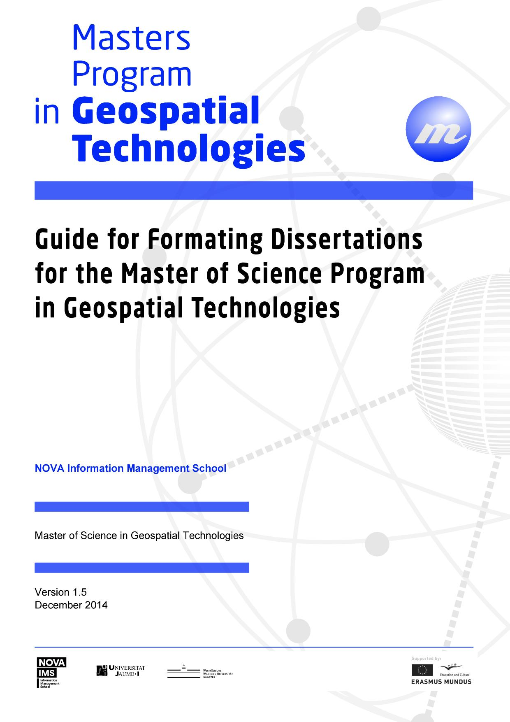
March 2018
Universitat Jaume I

INDEX

1. INTRODUCTION 3
1.1. Objectives of the Curricular Unit 3
2. KEY STEPS TO DELIVER THE DISSERTATION 3
3. STRUCTURE OF THE DISSERTATION’S PROPOSAL 3TATION FORMAT 34. STANDARD DISSERError! No index entries found.
4.1 Content 3
4.2 Margins and limit of pages 3
4.3 Paging 3
4.4 Title 3
4.5 Figures, tables, graphics and cartograms 3
4.6 Cover and binding 3
4.7 Preliminary pages 3
4.8 Bibliographic references 3
4.9 Attachments 3
4.10 Examples of paging and formatting 3
5. FREQUENTLY ASKED QUESTIONS 3

1. INTRODUCTION
The essence of academic research is the ability to share results. Every scientific discipline has its own methods to present research results so that other researchers can work from the results of the past.
ISEGIUNL requires the delivery to the Academic Services of 3 (three) CDs with a single digital file of the dissertation in a non-editable format. The 3 CDs will be distributed as follows: one copy to ISEGIUNL Documentation Services (for publication on Internet), one for the Legal Deposit of the National Library and another for the Center for Science and Higher Education. This document should be written in English or another language of relevant importance for the topic area, however subject to a priori permission.

1.1. Objectives of the Dissertation Curricular Unit
This Curricular Unit has as its main objective the development of a research project leading to the preparation of a dissertation, with a scientific nature, about a subject area of the Masters Program. The dissertation document must be specifically written for this purpose, constituting a privileged moment of proof of scientific capacity of the master student and formalized at the end of the third semester. The research should involve components of theoretical and / or experimental nature, promoting understanding and solving problems in new or unfamiliar situations, the collection and careful selection of appropriate information and literature, the adoption of appropriate methodological approaches, the design of a solution to the proposed problem and their implementation, and the critical analysis of results. The Masters dissertation must demonstrate that the candidate is an expert in the subject area and must also demonstrate that the student acquired knowledge in the frontier of knowledge in the area where the thesis falls.

2. KEY STEPS TO DELIVER THE DISSERTATION
- Define an area of interest within the Masters covered topics.
- Contact a supervisor. The dissertation supervisor should be a Professor of the Master of Science in Geospatial Technologies. Students may contact external supervisors, if they hold PhDs, and with the approval of the Coordinator of the Masters Program. The guidance can be provided in co-orientation. Please see Erasmus Mundus regulations about this topic
- Prepare a thesis proposal together with the supervisor(s) (see structure of the dissertation’s proposal on page 5).
- Submit the proposal for approval of the coordinator of the Master of Science Program in Geospatial Technologies and the Scientific Council of the ISEGIUNL.
- Write the dissertation. This should be developed in interaction with the supervisor and co-supervisors and its formatting must follow the rules described in this document (see rules for the dissertation’s formatting on the page 5) and following the submission schedule.
- Fill out the Library Forms repository form for UJI.
- Prepare a PowerPoint 20 (twenty) minute presentation with a structure that may have the following topics: objectives, methodology, results and conclusions. On the day of your public dissertation defense you should test the presentation, with at least 1 hour in advance in the room where the discussion is scheduled to take place.
- Public defense of the dissertation. You should have with you an annotated and indexed copy of the dissertation, sheets of paper to take notes, pencil or pen.
- In special cases the dissertation can be presented using a means of synchronous communication with image and sound.

3. STRUCTURE OF THE DISSERTATION’S PROPOSAL
An example for the structure of the dissertation’s proposal may be as follows:
1 - Title (provisional, should indicate the name of the supervisor and co-supervisors)
2 – Theoretical Framework (2 pages)
3 - Objectives (1 page)
4 – Assumptions / Work hypothesis (1 page)
5 - Methodology (2 pages)
6 – Draft of the dissertation organization (index)
7 – Initial Bibliography
8 - Chronogram

4. STANDARD DISSERTATION FORMAT

4.1 Content
The responsibility of the dissertation’s contents is yours and should be approved by your supervisor. The organization, presentation and documentation of your research should meet the requirements of scientific journals in your area. For information about your specific topic, contact your supervisor or the publishing rules of a magazine from your discipline, for example, the International Journal of Geographical Information Science.

4.2 Margins and page limits
The margin on the left side should be at least 3.5 cm. The other margins should be 3 cm. you cannot write any text on the blank space, including page numbers. The body text must be centered in pages in A4 format. It should not exceed 60 pages, including figures and tables, and excluding the bibliographic references and attachments.

4.3 Paging
All pages, except the title page, must be numbered. The preliminary pages are numbered with regular Roman numerals and all the other in Arabic numerals. The Arabic numbering begins in the Introduction, with page number 1. See the example provided.

4.4 Title
The dissertation‘s title should be descriptive of research, with key words easily identifiable. The title of the manuscript should use specific words and be unambiguous, so as to facilitate electronic search. For the title, use words to replace formulas, symbols, letters of the Greek alphabet, or other non-alphabetic symbols.
The title of the dissertation should summarize its content and should not be too long. Titles with more than 50 words are usually considered too long. Sub-titles should be used only when strictly necessary.

4.5 Figures, tables, graphics and cartograms
All figures and tables must be subtitled below, numbered in Arabic numerals and referred to in the text. These must include a description and a source. The tables and figures should have an adequate size for easy reading.
Figures and tables should not, whenever possible, exceed one page. They should respect the margins defined. The folding sheets inserted in the text should be minimized to enable easy reading. Figures and tables of large dimension can be placed in the annexes.
Tables, graphs and cartogram of large dimension can be placed in the larger folding sheets on the right side of the document. In this case, the margins should always be respected.
When using folding sheets, the number of the page should be placed in the position where it would appear on the page in normal size. The oversized page should be continuous and should not have anything glued.
You can include maps of a large dimension at the end of your document. If you do this, you’ll have to indicate it in the index.
In the Annexes, you should place documents, lists, intermediate maps, figures and tables that are not essential in the body of the text.

4.6 Cover and binding
The copies should be bound. The cover should contain the title of the dissertation, the name, the candidate’s degree and an indication of the degree to which regards the defense of the dissertation (page 12).
The cover, spine and back cover should follow the example given on pages 12, 28, 29 and 30. The binding must be made with glue, in Cardboard Cromolux at least 180g printed in color.

4.7 Preliminary pages
The first page should be a copy of the cover. This is page “i”, but should not appear numbered. The first page with the numbering visible is page ii (page of the supervisor).
The second page should contain the title of the dissertation, the name of the supervisor and the delivery date (page 13). If you have co-supervising, the name of the co-supervisor may appear, provided that is a PhD or specialist of merit recognized as such by the Scientific Council of ISEGIUNL.
The pages that follow should include:
• Acknowledgements
• Abstracts in English and another relevant language (optional) (about 200 words each)
• Key words in English and another relevant language (optional)
• Indexes
The bibliographic references and annexes should be included at the end of the dissertation.

4.8 Bibliographic references
- In the bibliographic references section you can only include documents that were cited in the text;
- There must be a single list of references, regardless of the type of paper, sorted by Name, Year;
- The citation of documents in the text should be made by Name, Year;
- Reference elements should be written in a consistent way;
- You should use a consistent reference format for the various types of documents;
- The titles and subtitles of books, edited books, proceedings, journals, websites and so on. should be placed in italic, bold or underlined (consistently);
- The references to books, edited books and proceedings should always include the edition (when it is not the first) and Publisher (and, if possible, the Place of Edition);
- The references to articles published in edited books, periodicals or proceedings, should indicate the pages of the cited article;
- References to documents on the Internet: to be cited as the other reference types and placed in alphabetical order of author (eg the name of the agency to which the page belongs); the Year may be, in the absence of other information, the date of the last revision of the page; the date of consultation and URL are essential elements (see examples 6.1 and 6.2. of this Guide);
- When a work of reference (dictionary, encyclopedia, atlas, etc.) does not have a scientific editor or compiler, the community which publishes the work should be treated as its author.

4.9 Annexes
- The dimensions of the paper and margins should be equal to the pages of the main text;
- It should be numbered in Arabic numerals
- It should be paged sequentially with the body of text;
- It must have title;
- It should be listed in the index;
- Numbering of figures and tables of the Annexes should be different from the main text;
- Numbering of figures and tables should be sequentially in the same annex and should change when the annex is changed.

4.10 Examples of paging and formatting
Pages 12 through 30 show examples of:
- Cover (p. 12 and 28);
- First page (p. 12 and 28);
- Second page (p. 13);
- First page in other language (p. 14) - to be used only in the case of writing the dissertation in other language (optional).
- Second page in other language (p. 15) - to be used only in the case of writing the dissertation in other language (optional).
- Acknowledgments (p. 16);
- Summary (p. 17);
- Abstract (p. 18);
- Keywords (p. 19);
- Acronyms (p. 20);
- Index of the text (p. 21);
- Index of tables (p. 22);
- Index of figures (p. 23);
- Chapter (p. 24);
- Bibliographic References (p. 25);
- Spine (p. 29);
- Back cover (p. 30)

5. FREQUENTLY ASKED QUESTIONS

Its possible to submit photocopies?
Yes. The photocopies must be on paper, with the margins specified, in a machine that produces clean copies and with good contrast. Note that some machines produce copies with text areas slightly increased. To ensure that the copies are made keeping the limits of margin required, it is recommended that you run the copies to 98% of its original size.
Is it possible to print on both sides of the page?
The preliminary pages should be printed only on one side. The main text can be printed on both sides. The Documentation Services encourage printing on both sides, therefore facilitates the storage and spend less paper. However, if you choose to print your dissertation on both sides of the page, you should remember that you must adjust the margins as well as the placement of the paging so that it is always visible. The simplest way to overcome this problem is to consider 3.5 cm to the left and right margin and put the paging in the middle bottom of the page.
Is it possible to use text with single line spacing?
For the body of the text you should use text with 1.5 line spacing. You can use text with single line spacing in the footnotes and legends of figures and tables.
What kind of text font should be used?
Any type of text font is acceptable as long as it is legible. The fonts "script", "Calligraphy", italics and other types of artistic types are not acceptable for the main text. Italics can be used to highlight titles of other works, scientific names and other cases where appropriated.
What is the font size to be used?
Again, the goal is the readability of the text. For laser printing, the preferred sizes are 10 or 12 points. Titles of chapters or sections may have larger sizes. Footnotes and legends of pictures and tables may be 9 points. If you have questions about the font size to be used in specific situations, consult the Documentation Services.
Is it possible to submit the dissertation in a foreign language?
Yes, provided it is a significant language in your study area. If you intend to deliver your dissertation in a foreign language consult your supervisor first.
It is possible to use interviews as information source?
Yes, provided they are structured interviews, conducted with an Interview Script, and preferably recorded. The using of this methodology should be relevant to the dissertation’s objectives and authorized by your dissertation supervisor. In an annex, you must show the Interview Script and a complete list of interviewees, their affiliations, and date of the interview. The references in the text should specify the type of information source used or, alternatively, you must built references to each interview mentioned in the text (see example of bibliographic reference on page 25)
Is it compulsory to submit the dissertation in digital format?
Yes, but is not enough. You always have to deliver five bound copies.
The bound copies may have corrections?
Correction fluid and adhesive tape are not allowed in bound copies since they quickly degrade with time. Interspaces and corrections are not acceptable. Please double check your document before you deliver it.
Where can I get information?
About the text content, talk to your supervisor. For questions about formatting, type of paper, margins, etc., see the Documentation Services.

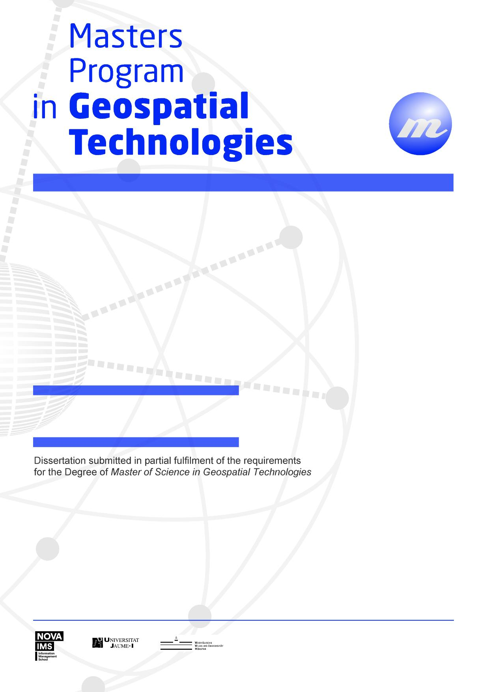
TITLE
Subtitle
Complete Author’s Name

TITLE
Sub-title

Dissertation supervised by
PhD ....

July de 2008
TITLE
Subtitle
Complete Author’s Name

TITLE
Sub-title

Dissertation supervised by
PhD ...

July 2008
Acknowledgments

To Professor ….

TITLE

Sub-title

ABSTRACT

With the recent developments in Geographical Information Systems, environmental decision makers increasingly have available information systems with more accessible, easily combined and flexible data that meet the requirements of environmental decision making…..

TITLE

Sub-title

ABSTRACT (In other language)

With the recent developments in Geographical Information Systems, environmental decision makers increasingly have available information systems with more accessible, easily combined and flexible data that meet the requirements of environmental decision making…..

KEYWORDS

GIS Applications
Environmental Constraints
Licensing Support System
Decision Support Systems
Geographical Information Systems
Spatial Decision Support Systems

KEYWORDS (In other language)

GIS Applications
Environmental Constraints
Licensing Support System
Decision Support Systems
Geographical Information Systems
Spatial Decision Support Systems

ACRONYMS

COM – Modelo de Objectos de Componentes (Component Object Model)
DDM – Dados, Diálogos e Modelos (Data, Dialog and Models)
DL – Decreto-Lei
DH – Domínio Hídrico
DRA-Alentejo – Direcção Regional do Ambiente do Alentejo
IGeoE – Instituto Geográfico do Exército
ISEGI – Instituto Superior de Estatística e Gestão de Informação
PCSA – Áreas de Serviço de Cuidados Primários (Primary Care Service Areas)
RAN – Reserva Agrícola Nacional
REN – Reserva Ecológica Nacional
SAD – Sistema de Apoio à Decisão
SEAD – Sistema Espacial de Apoio à Decisão
SEAD-MC - Sistema Espacial de Apoio à Decisão Multi-Critério
SEBC – Sistemas Espaciais Baseados em Conhecimento

INDEX OF THE TEXT
Pág.

ACKNOWLEDGMENTS............................................................................................. i
ABSTRACT.................................................................................................................. ii
ABSTRACT ................................................................................................................ iii
KEYWORDS………................................................................................................... iv
KEYWORDS……………………………………………………..…….…..……….. iv
ACRONYMS............................................................................................................... vi
INDEX OF TABLES…………………………………………………………..……viii
INDEX OF FIGURES ………………………………………………………………xi
1 INTRODUCTION…………………………………………………………………...1
1.1 Theoretical Framework…...…………………………………………………...1
1.2 Objectives………………………………………………………………………
1.3 Assumptions………………………………………………………………..…..
1.4 General Methodology…………………………………………………………..
1.5 Dissertation Organization………………………………………………………

2 SPATIAL DECISION SUPPORT SYSTEMS
2.1 Chapter objectives…………………………………………………………......
2.2 Introduction to the Decision Support Systems………………………………..

….

BIBLIOGRAPHIC REFERENCES…........................................................................ 90

ATTACHMENTS........................................................................................................95

1. Summary table with the environmental constraints in agreement with legislation in force. ………………………………………………………………………………. 96
2. .........

INDEX OF TABLES

Table 1. Functions of a SEAD (adapted from Malczewski, 1999) ….…..………… 17
Table 2. Table that summarizes the balance between the client and the server (Lopes, 2000).......................................................................................................................... 34
Table 3. Expected constraints in the PDM of Aljustrel and Beja or in general legislation in force (Santana, 1998)............................................................................. 67

INDEX OF FIGURES

Figure 1. Stages of decision-making process in agreement with Simon (Malczewski, 1997) 34
Figure 2. Structure of the degree of decision problems in agreement with Simon (adaptado de Malczewski, 1997) 45
Figure 3. Types of decision problems, types of systems and activities of problems resolution (adaptado de Sprague e Watson, 1996) 56

1. INTRODUCTION

1.1 Theoretical Framework

Establishing the balance between the proper use of natural resources and current environmental legislation is one of the functions that the institutions of the Environment area play with obvious increase of the complexity degree, citing the need for automation of analysis processes that help the decision-making, in order to utilize the resources available, by definition limited, in a more efficient and also to halt the process of environmental assessment typically lengthy and difficult to implement.
……

Examples of bibliographic references

You can use any bibliographic referencing system, provided that:
- It is relevant in the area of the dissertation;
- It is used consistently;
- all elements of the identification document (by document type) are present;
- all references removed from the Internet indicate, in addition to other factors, the URL and the date of appointment.
Here are some examples:

1) Articles of periodicals
Egenhoffer, M. J., e Franzosa, R. D., 1991, Point-set topological spatial relations. International Journal of Geographical Information Systems, 5, 161-174.

1.1) Articles of periodicals in press
Egenhoffer, M. J., e Franzosa, R. D., in press, Point-set topological spatial relations. International Journal of Geographical Information Systems.

1.2) Summaries of periodicals
Medyckyj-Scott, D., Cuthbertson, M., e Newman, I., 1996, Discovering environmental data [Resumo]: metadabases, network information resource tools and the GENIE system. International Journal of Geographical Information Systems, 10, 65-84.

2) Books
Heywood, I., Cornelius, S., e Carver, S., 2002, An introduction to geographical information systems (2ª ed.) (Harlow: Prentice Hall).

2.1) Published Books
Dykes, J.; MacEacren, A.M.; Kraak, M.-J. (Ed.s), 2005, Exploring geovisualization (Amsterdam: Elsevier).

3) Articles / book chapters
Openshaw, S., 1991, Developing appropriate spatial analysis methods for GIS. In Geographical Information Systems: Principles and Applications, editado por D. J. Maguire, M. F. Goodchild e D. W. Rhind (London: Longman), pp. 389-402.

4) Articles in proceedings
Miller, D., 1992, Analysis of vegetation succession within an expert system. In Proceedings of the 5th International Symposium on Spatial Data Handling (Columbia: International Geographical Union), pp. 381-400.

4.1) Contributions not published in conferences
Ruby, J., e Fulton, C., 1993, Beyond redlining: editing software that works. Poster presented in 5th International Symposium on Spatial Data Handling (Columbia: International Geographical Union).

5) Reports, PhD dissertations, Master dissertations
Hearnshaw, H., 1991, Mental models of spatial databases. Research report 27, Midlands Regional Research Laboratory, Leicester.

Caldeira, P., 1999, Influência da informação hipermédia na aprendizagem e satisfação: impacto do formato de apresentação da informação na aprendizagem e na satisfação em sujeitos com orientações contrastantes para o estudo. PhD dissertation, ISEGI-UNL, Lisboa.

Bação, F., 1997, Os sistemas de informação geográfica e as empresas. Master dissertation, ISEGI-UNL, Lisboa.

6) electronic resources

6.1) Websites
Gittings, B., 1995, Digital evaluation data catalogue (URL: http//www.geo.ed.ac.uk/home/ded.html, consulta em 04-02-2004).

6.1.1) Institutional websites
ISEGI-UNL, 2003, Página do Instituto Superior de Estatística e Gestão de Informação da Universidade Nova de Lisboa (URL: www.isegi.unl.pt, consulta em 08-02-2007)

6.2) Periodicals on Internet
Egenhoffer, M. J., e Franzosa, R. D., 1991, Point-set topological spatial relations [Electronic version]. International Journal of Geographical Information Systems, 5, 161-174.

Järvelin, K., e Wilson, T., 2003, On conceptual models for information seeking and retrieval research. Information Research, 9 (1) (URL: http://informationr.net/ir/9-1/paper163.html, Retrieved 09-02-2004).
6.3) “Books” on CD-ROM
Clark, I., e Harper, W., 2000, Pratical geostatistics [CD-ROM] (Columbus, Ohio: Ecosse North America).

6.4) Software
Miller, M. E., 1993, The Interactive Tester (Versão 4.0) [Software] (Westminster, CA: Psytek Services).

7) Legislation
Reis, J. A. (Anot.), 1980, Código do processo civil anotado (3ª ed. reimp.) (Coimbra: Coimbra Editora).

Decreto-Lei n.º 192/89. D.R. I Série, 131 (08-06-1989), 2254-2257.

8) Maps
Missão Hidrográfica de Angola e São Tomé, 1958, [Carta de São Tomé: Ribeira Afonso: levantamento aerofotogramétrico], Scale 1:25000, 1 carta ([Lisboa]: Ministério do Ultramar).

Instituto da Água, 2001, [Planta de condicionantes: plano de ordenamento da orla costeira: troço Alcobaça-Mafra], Scale 1:25000, 1 carta ([Lisboa]: Instituto da Água).

8.1) Map series
Serviços Cartográficos do Exército, 1970, [Carta militar de Portugal, Évora-Monte (Estremoz)], Escala 1:25000, 1 carta ([Lisboa]: Serviços Cartográficos do Exército). (Série M 888, Folha 439).

9) Interviews
Painho, M., 2004, [Título do guião da entrevista] [Sound record, dd-mm-aaaa] (Lisboa: ISEGI - UNL).

Note:
The elements in square brackets, [ ], are elements “built” by the author of the bibliographic references, that is not on the information sources but are important for its proper identification.
In the case of electronic resources, information between [] seeks to explain the type of the resource.
For maps, as they often don’t have title, the title is "built" from the information available on them.
Complete Author’s Name
TITLE
Subtitle


2008
TITLE

Subtitle
Complete Author’s Name
