Lesson 2

João Fonseca -103154

Diogo Paiva - 103183

Information Visualization, 2023 (MSc Computer Science and Engineering, University of Aveiro)

Introduction

This report addresses the exercises done in Lesson 2 of Three.js.

# Exercise 1

We were asked to change the first example from the first class to visualize the cube in wireframe and use the Orthographic Camera.

Result with perspective camera:

Result with Orthographic Camera:

var aspectRatio = window.innerWidth / window.innerHeight;

var top = 3 / aspectRatio;

var bottom = -3 / aspectRatio;

var camera = new THREE.OrthographicCamera( -3, 3, top, bottom, 1, 1000 );

The result is what we expected.

# Exercise 2

Add OrbitControls to the previous example.

const controls = new OrbitControls(camera, renderer.domElement);

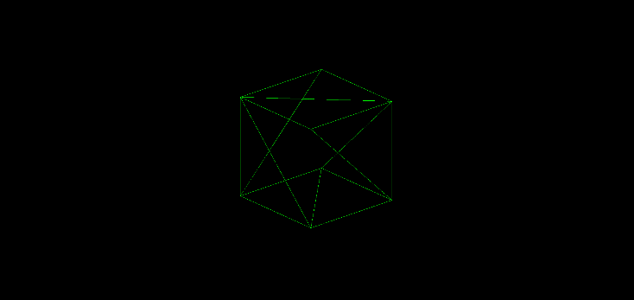controls.update();

We also tried other controls as shown in the code.

# Exercise 3

Add lights to the scene.

const light = new THREE.DirectionalLight(0xffffff, 1.0);

light.position.set(0, 5, 0);

scene.add(light);

//AmbientLight

const alight = new THREE.AmbientLight(0xffffff);

scene.add(alight);

# Exercise 4

widthSegments — Number of horizontal segments

heightSegments — Number of vertical segments

Modify the flatShading option of one of the materials by toggling between true and false and observe the result – Instead of using Phong shading will use flatshading.

# Exercise 5

Add spheres with a slightly larger size around original spheres and use material provided by the professor.

**Exercise 6**

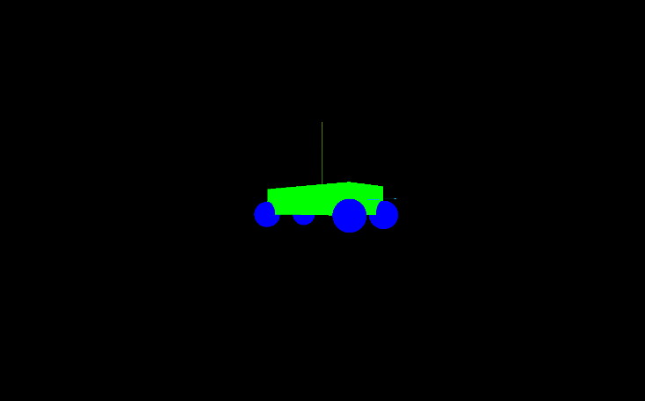Create a new scene consisting of four spheres (radius 0.5) centered on its lower. Add multiple meshes into a single THREE.Object3D().

View the transformation matrices of the parallelepiped and of one of the spheres on the console, accessing the matrix (matrix) with the transformations of the objects.

**Exercise 7**

Replace the spheres with cylinders with radius 0.5 and height 0.2 and move the “car”.

object.position.z += 0.01;

    if (object.position.z >= 6) {

        object.position.z = -6;

    }