Code Smell 1: Comments and Dead Code

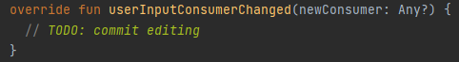

**Location of the code smell from repository root:**

ganttproject\src\main\java\biz\ganttproject\ganttview, line number 433.

**Explanation:**

This function is currently doing nothing and has a reminder that some work will be done here in the future

**Refactoring proposal:**

Remove this function