Code Smell 2: Shotgun surgery

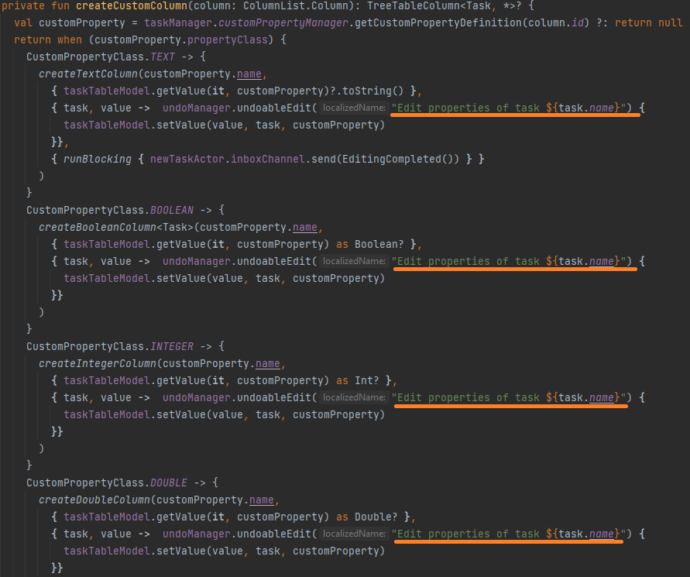

**Location of the code smell from repository root:**

ganttproject\src\main\java\biz\ganttproject\ganttview, line number 566.

**Explanation:**

This function has a lot of repeated code, if for example, we wanted to change the message we would need to change it individually for each line

**Refactoring proposal:**

Create a constant for the message and when showing the message use that constant instead of the whole string.