Pattern 1: Chain of Responsibility Pattern (Behavioral)

**Localization**:

ganttproject\src\main\java\net\sourceforge\ganttproject\ganttproject.java,   line 595 -> 604

ganttproject\src\main\java\net\sourceforge\ganttproject\ganttoprtions.java, line 196 -> 204

java/io/FilterOutputStream.java                              , line 196

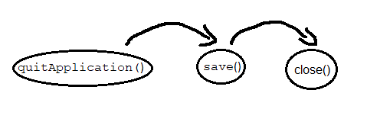

**Explanation**:

The chain of responsibility pattern allows the client object to send a request, the first handler in the chain will try to process it. If the handler can process the request, then the request ends with this handler. However, if the handler cannot handle the request, then the

request is sent to the next handler in the chain. This process will continue until a handler can process the request. If the entire chain is unable to handle the request, then the request is not satisfied.

In this example, the code is trying to quit the application but before that he needs to save the data, for that he calls the function save(), however the function save() needs to close the File Writer, so she calls the function close(). If any of this requests fail, the application will not end properly