### Code Smell 3: Shotgun Surgery

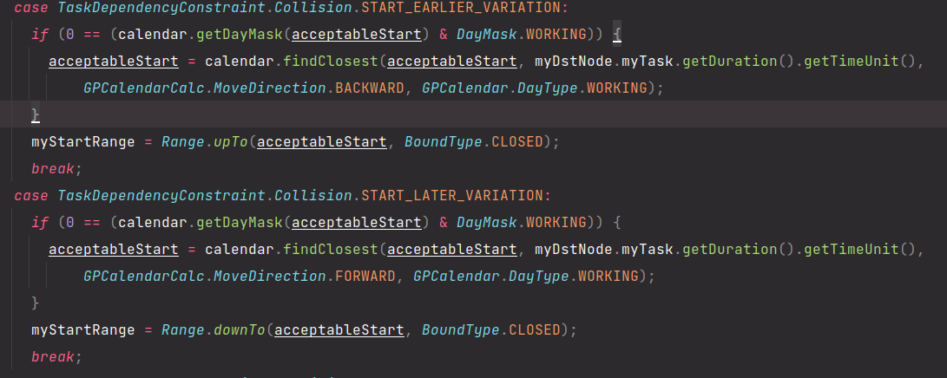

**Location:**

\ganttproject\src\main\java\net\sourceforge\ganttproject\task\algorithm\DependecyGraph\ExplicitdependecyImpl

**Explanation:**

This method has repeated code and if we want to change some of this code we need to change everywhere it’s used.

**Refactoring Proposal:**

A solution is to create methods to put this code and that way if we want to change the code we just need to change the method.