# Design Pattern

### **Pattern 3: Singleton Method (Creational)**

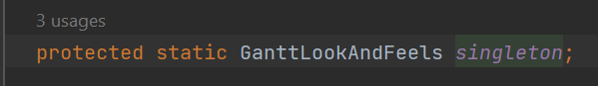

**Location of the design pattern from repository root:**

* ganttproject\src\main\java\net\sourceforge\ganttproject\gui\GanttLookAndFeels.java

**Explanation:**

This is a Singleton design pattern. The class has a protected constructor and a protected static instance of this class as displayed above. This instance is only accessed through the method GanttLookAndFeels() and this method certificates that there’s a single instance of this class because it makes a new one only if this instance is null, otherwise returns the previous created one.