Code Smell 3: Dead code and Long parameter list

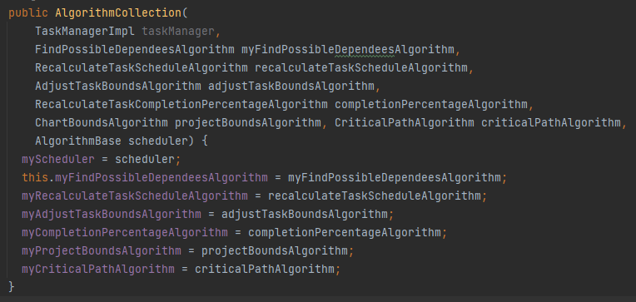

**Location of the code smell from repository root:**

ganttproject\src\main\java\net\sourceforge\ganttproject\task\algorithm

**Explanation:**

This function has a dead variable(“taskManager”) and has a pretty long parameter list.

**Refactoring proposal:**

Remove the variable taskManager from the parameter list and create parameter objects