Pattern 2: Builder Pattern(creational)

**Localization**:

ganttproject\src\main\java\biz\ganttproject\lib\fx\Components.kt, line 88

**Used in**:

ganttproject\src\main\java\biz\ganttproject\storage\cloud\GPCloudSignupPane.kt, line 54

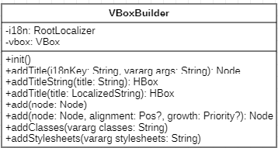

**Explanation**:

A Builder is a creational design pattern that lets the user construct objectives in a more personalized way. This is possible because this pattern separates the code the normally would be in the constructor method in to other “sub” methods

In this example, we have a VBoxBuilder that allows the creation of a personalized panel for the SignUp panel of the GanttProject Cloud