Pattern 3: Iterator

**Localization**:

ganttproject\src\main\java\biz\ganttproject\impex\csv\CSVImport.kt,line55

ganttproject\src\main\java\biz\ganttproject\impex\csv\Spreadsheet.kt

**Usase**:

ganttproject-tester\test\biz\ganttproject\impex\csv, line 107

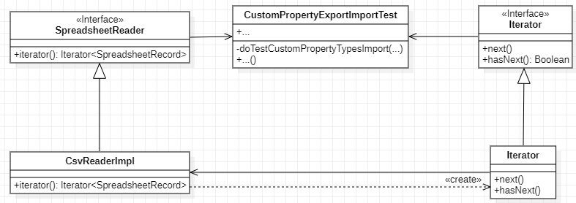

**Explanation**:

An Iterator provides a way to traverse a collection of objects without exposing its implementation.

In this example, we have an Iterator that allow us to navigate through all the Spreadsheet Records without exposing its implementation to the main system