### Code Smell 2: Comments and Dead Code

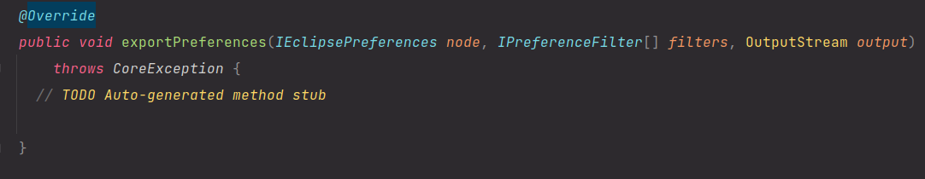

**Location:**

\ganttproject\src\main\java\net\sourceforge\ganttproject\PreferenceServiceImpl

**Explanation:**

This method is dead code because it’s not being used and it also has a comment to remind of some unfinished work.

**Refactoring proposal:**

Since the code is not being used, a simple solution is to remove it from the code.