**Intro Page**

Data Science for Social Impact and Management

Data-Driven Planning for Sustainable Tourism in Portugal

Mass tourism is at a tipping point. High-speed trains and low-cost airlines allow larger amounts of people to travel faster, and more frequently than ever before. Tourism is of great economic benefit to communities worldwide, however many touristic destinations are insufficiently equipped to react to the increasing flux of visitors.

New methods combining data mining, machine learning, and data science are beginning to be used to understand the impact of mass tourism on cities and find solutions to better accommodate tourists. Data Science for Social Impact and Management is a Nova SBE's Research Group oriented to the use of such techniques to tackle key issues with a social and business impact. Throughout this academic year, A junior data science researcher, João Fonseca, assisted Turismo de Portugal in shedding light on tourism patterns in Portugal, and specifically Lisbon. This work using digital traces created by tourists aims to provide tools that can improve both the management of crowds and the quality experience for tourists and residents alike.

This report is part of the collaboration between Nova School of Business and Economics and Turismo de Portugal. We are grateful for the financial support of Turismo de Portugal, and their continuous support.

Special thanks:

* This report is part of the collaboration between Nova School of Business and Economics and Turismo de Portugal. We are grateful for the financial support of Turismo de Portugal, and their continuous support.
* Data Science for Social Good 2017’s team responsible for the “Data-Driven Planning for Sustainable Tourism in Tuscany” project, composed by Io Flament, Momim Malik and Cristina Lozano, for the support provided throughout the development of the project, as well as the sharing of the code and website report developed for their project. This website’s formatting is an adapted version of their original website report.
* Leid Zejnilovic, Qiwei Han and Margarida Novais for their invaluable advisory and management of the project, as well as providing the expertise and perspectives in the fields of management, data science and tourism.
* Professor Miguel Neto, for his irreplaceable advice, guidance and expertise on smart cities and smart tourism.

Created by João Fonseca

**Airbnb**

**Introduction**

Airbnb is an online (consumer to consumer) marketplace and hospitality service, where customers publicise, explore and book accommodation for short term periods such as holiday cottages, apartments, homestays, hostel beds and hotel rooms, where typically listings represent property owned by individuals. In a broad sense, Airbnb intends to facilitate experiences related to tourism, allowing to enrol in tourism related activities such as walking tours and make reservations at restaurants. As a broker, Airbnb doesn’t own any real estate, making it a very well-known example of a sharing economy.

Four datasets were used for this analysis, containing information about all properties listed in the platform and located in Portugal, booking activities (which includes Accepted Bookings, Blocked Bookings and Cancelled/Unanswered bookings), monthly details for each property’s bookings (revenue, occupancy rate and number of bookings) and Public Reviews’ information associated to basic user information (review text, non standardized customer’s country of origin and job). However, it is not possible to link a public review with the corresponding booking.

As the platform continues to grow exponentially in users and number of listings, it represents a major pillar of the tourism industry. Airbnb, allied with the continuously decreasing costs of mobility and Information and Communication Technologies, have allowed individuals with a lower income to contribute to this industry as a low cost segment. A study conducted by Bankwest Curtin Economics Centre: “The Impact of Airbnb on Western Australia’s Tourism” (October 2017, page 67-68) suggests that tourists (Holidaymakers) using Airbnb spend on average less in most categories when compared to non-Airbnb users, especially food & accommodation (≈ -880 AUD) and transportation (≈ -270 AUD).

Although Airbnb data can provide valuable information, a few limitations to this study must be pointed out beforehand. It is impossible to assess whether the reviews data is accurate, given that Airbnb's accuracy in their own data is not certain. Furthermore, Airbnb's reviews can be either public or private. As we are only using publicly available data, we do not have access to user data that left a private review, or no review at all. So, we are analysing user profiles that represent about 10% of the total bookings (≈ 1.2 million public reviews) that were actually completed. Although the user data sample extracted from the overall reviews was not randomly generated, it is highly representative. The number of total completed bookings made between September 1st 2014 and December 31st 2017 is 11.550 million Bookings which implies a minimum sample size of 16564 for a 99% confidence level and 1% margin of error. As our dataset has a depth of 1.2 million observations, it is statistically significant (although, we cannot conclude that it is an unbiased sample, as it was not randomly selected).

A second limitation would be the accuracy of data scraped by the data provider, AirDNA. In these datasets, some of the data is not very consistent. For instance, in these datasets the variables regarding monetary value (Daily rates, listing monthly incomes, etc.) are not always directly convertible between USD currency and native currency (euros), where it was found that in these situations variables with USD currency turned out to be more trustworthy than native currency. Same inconsistency applies to variables such as Booked Date, where in situations that the booking was completed this field was still left blank. Aside from these type of situations, some clear outliers were found, as is the case of some bookings that exceeded the price of $100 000 (with a maximum value of $540 954).

Finally, in this analysis the following questions will be addressed:

* Who is booking Airbnb rooms in Portugal? (Profiling)
* Where do they choose to stay? (Geographic analysis)
* When do they do it? (Time Series analysis)

All the data was provided by Nova School of Business and Economics' research centre: **Data Science for Business and Society**.

This analysis is focused on Smart Tourism Management in Portugal and was developed for Turismo de Portugal, a public national institution responsible for the promotion, enrichment and sustainability of Tourism in the country.

**Property Listings**

We’ll start off by analysing the location of the properties listed in Airbnb. Listings are mainly concentrated in in the coastal region of Portugal, especially Lisbon, Porto and Algarve regions.

(first map here)

Listings’ Distribution across cities is highly heterogeneous. The city with most property listings is Lisbon, with over 25 thousand listings. Porto comes second with about 10 thousand listings, where the remaining cities have less than half the number of listings existent in Porto. Although, it is important to mention that at this point there are many listings without a city associated to it (missing values). This challenge will be fixed in the geographic clustering process.

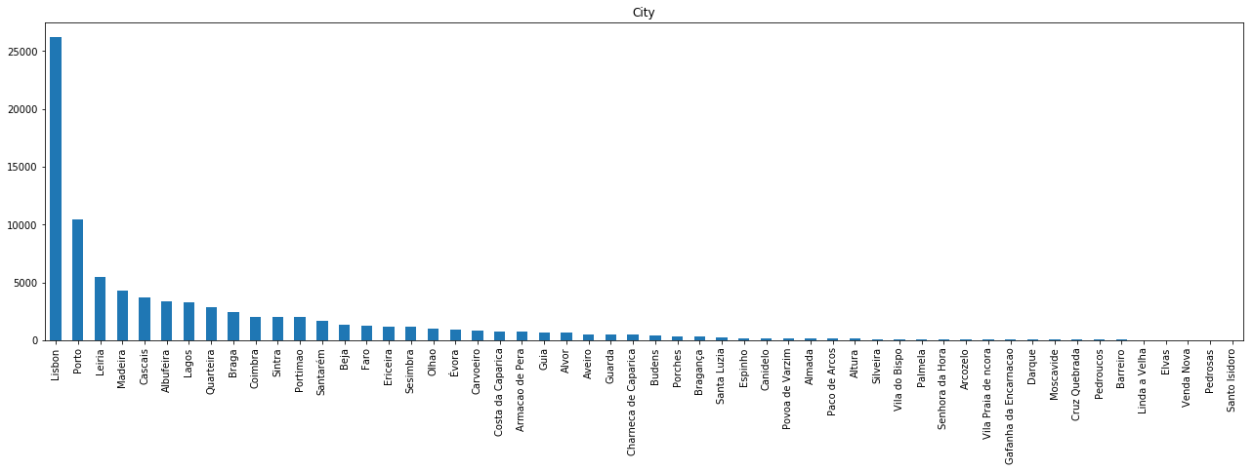

Most of these listings are referring to entire home/apartments, as the number of private rooms represent less than half the number of the former type.

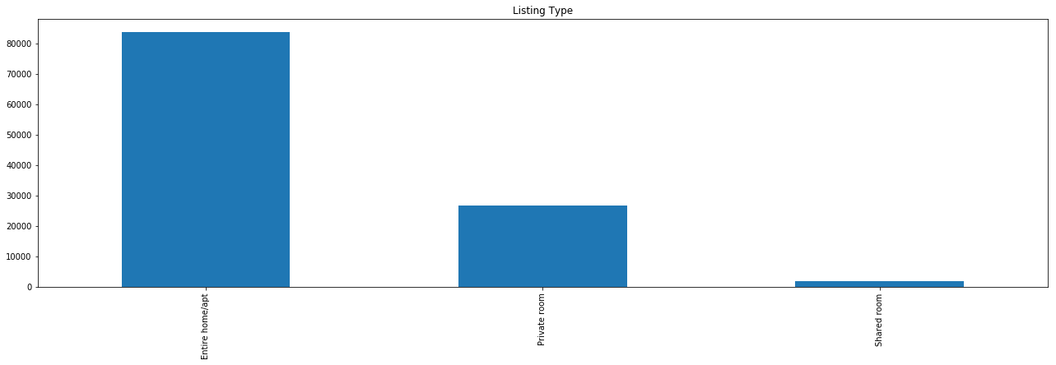

**Daily Bookings**

The daily bookings table contains information of daily booking activities. Although, aside from completed bookings, this table also includes data from blocked bookings, as well as requested bookings, which include the unanswered requests (or still awaiting an answer). So, in the graph below is depicted the daily count of overall activity in this operation.

Booking activity done in Airbnb has grown exponentially over time. This might be because of two main factors: The growing popularity of Airbnb’s platform, and the growing popularity of Portugal as touristic destination.

Booking activity can mean either a booking request (which means such request is waiting for approval or has been blocked), a cancelled booking, or a booking that was actually completed and went through (which amounts to approximately 21% of the overall booking events). In the plot below is presented booking activity over time between September 2014 and December 2017.

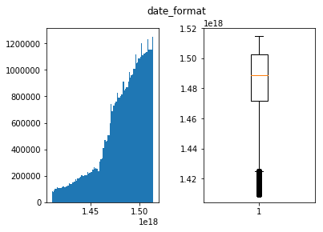

**Monthly bookings**

We can conclude that although hosting supply is increasing exponentially, there are suggestions of market distortions, as there are many listings do not receive any reservation in several months:

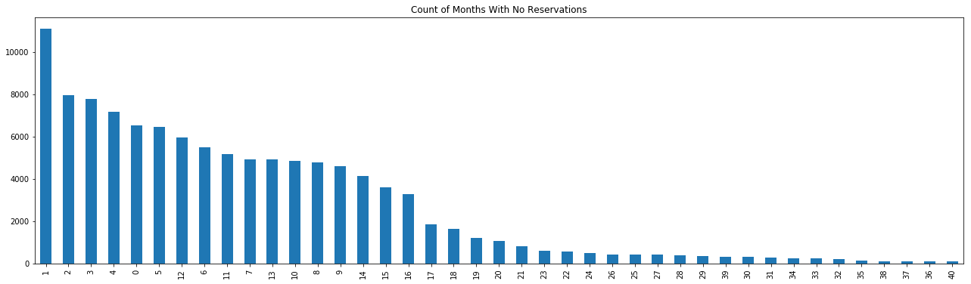

The causes for this factor must be looked into more thoroughly, as it is important to assess whether there are specificities in these listings that cause a low demand for these offers, or there is too much supply in certain regions. This will be studied in the Value analysis presented below.

**Listing Reviews**

To extract information from this dataset some basic Text Mining techniques were required. This is because none of the data regarding user information is standardized. Although we have some details regarding the user's profile, namely its first name, country of origin, state (if applicable), city of origin, a brief user description, last attended teaching institution and occupation, none of it can be directly used for analysis without prior pre-processing (for the goal of this analysis, the priority was given to the parsing of the country of origin out of the non-standardized text fields: Country and City). This was done by developing a script to detect names of cities and countries out of these two variables. Then, the cities were associated to the corresponding country. Finally, the results from the two parsing processes were merged into a final solution. Out of approximately 1.2 million reviews’ country of origin, 118 thousand were left unparsed (i.e., unsuccessful parse). Finally, this is the top 50 countries of origin for tourists in Portugal:

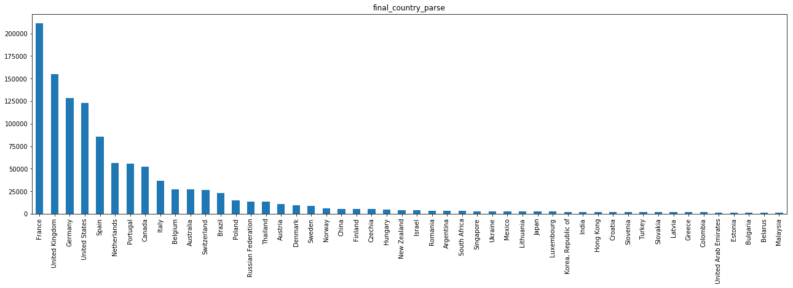

It becomes clear that the number of French Airbnb users in Portugal is extremely high, which might be caused by two factors: 1) the seasonal immigrant flows from France into Portugal throughout the summer; 2) Airbnb’s popularity in France, which according to Google trends it is in fact, the country in which Airbnb is most popular:

<script type="text/javascript" src="https://ssl.gstatic.com/trends_nrtr/1328_RC04/embed_loader.js"></script> <script type="text/javascript"> trends.embed.renderExploreWidget("GEO_MAP", {"comparisonItem":[{"keyword":"airbnb","geo":"","time":"today 12-m"}],"category":0,"property":""}, {"exploreQuery":"q=airbnb&date=today 12-m","guestPath":"https://trends.google.pt:443/trends/embed/"}); </script>

**Modelling**

To analyse patterns in the data, we will start by segmenting Property Listings by geographic location and value. Afterwards, we will associate the generated clusters to the customer data and bookings data.

From the correlation matrix in the Listings table we can extract some insights regarding what can affect Airbnb listing value:

**(correlation matrix here)**

At this point we can assess some interesting correlations across variables, as is the case with the relationship between the number of Bookings with number of Reviews (-0.77 correlation), and the number of Reviews and Average Daily Rate (-0.24 correlation).

**Clustering**

Geographic Clustering

We started by clustering listings geographically using the borders of each district in Portugal. To do this, we only used the variables Latitude and Longitude. We started by using a shapefile (source: GADM -> http://gadm.org/) to determine to which district each listing belonged to. Afterwards, facing the existence of listings with inaccurate location which because of this reason were not included in any district (e.g., listings located in a river or the sea), we used the K-nearest neighbours algorithm (with K=3) to classify these listings.

We will analyse the characteristics of the defined regions:

(map plot with geographic clustering)

Value Clustering

We will use all variables that relate to the listing’s value as a tourism hosting, which in this case would be the Annual Revenue, Average Daily Rate, Occupancy Rate and Number of Bookings. The reason we did not pick the Number of Reviews for a listing is because it is highly correlated with the number of bookings. Hence, in order to avoid a bias in the clustering process, this variable was discarded. Additionally, we also filtered out listings whose annual revenues were clear outliers (>$10 million) and also listings whose number of reservations was lower than 5 (as these will correspond either to overly recent listings, or inactive listings).

The elbow method will be applied to determine the number of K:

(inertia plot here)

Along the increase of K, the decrease rate of inertia becomes lower when K=5. Considering the classification intuition behind value clustering (distinguish between high, medium-high, medium, medium-low and low value listings) 5 clusters will represent our preferred number of clusters.

When analysing the geographic distribution of the value clustering, we can see that

**(any possible insights about results here)**

(map plot with value clustering)

(table plot with profile data here)

**Geographic Analysis**

As expected, the number of reservations throughout the time frame available are highly seasonal and has increased greatly over time. However, this increase is believed to be attributed to the rise in popularity of Airbnb, instead of Portugal as a touristic destination. The data analysed refers solely to bookings in Airbnb’s platform. As concluded previously, Lisbon yields a very high percentage of total bookings, whereas the second main destination corresponds to Greater Porto region and the third most booked region is Faro. Although, due to Faro’s high touristic seasonality, in August 2017 Faro was the second most booked region in Portugal.

Finally, one can also conclude that the two regions with the overall lowest number of bookings are the districts in the interior of Portugal.

(Number of Reservations per cluster plot)

Although Porto district is well ranked in the number of bookings, it falls behind significantly on the sum of generated revenue, when considering the exponential growth of generated revenue by Lisbon and Faro. We can see that although Faro had a lower number of reservations, it is the region with most revenue generated in the high season (June to September).

This suggests that although Porto is frequently chosen as a touristic destination, the value of listings is lower than expected. This can be caused by either (or both) excessive supply or low demand. Although, given the above analysis, one could discard the second hypothesis. Additionally, considering market distortions, it is also possible that bookings’ Daily Rates are not yet well adjusted to the market.

(Revenue Growth per cluster plot)

When analysing the plot presented below, we can conclude that in fact Porto region yields one of the lowest revenue per reservation rates. On the same note, Lisbon has this same ratio as relatively average.

It comes to confirm Algarve region’s previously perceived Airbnb value that its value for the above mentioned ratio is the highest of all regions since March 2016. There are some reasons that can explain this fact. Namely, being Algarve highly sought after as a summer touristic destination by northern European countries and English speaking countries with medium to high purchasing power the price level in this region is usually higher, which will reflect on the accommodation’s daily rates. Additionally, the accommodations existing in this area are typically villas, which are significantly more expensive than entire apartments or rooms (given the size of accommodation). Lastly, the existence of more villas when opposed to buildings (when compared to regions like Greater Lisbon and Greater Porto) can also lead to less accommodation supply in a region with high demand, which will drive daily rates up.

Additionally, we can can see another region whose Revenue/Reservation ratio is very interesting: Setubal. As a region known for having good quality bathing regions and also being peripheral to Lisbon, it becomes an attractive region for tourism.

(Revenue per reservation plot)

Using the average occupancy rate for each district, we can now analyse the balance between Demand and supply of Airbnb bookings, considering the number of days each listing has been booked. One can see that the demand in Faro district in August last year represents one of the regions with the highest occupancy rate, alongside with Azores, Porto, Setubal and Lisbon. When analysing the plot presented below alongside the ones presented above, this data suggests that overall demand is growing disproportionally given the supply in the market.

On a different analysis, we can see that Porto region did have a high amount of reservations throughout last year and is one of the regions with the highest occupancy rate throughout the year. When checking Porto region’s revenue per reservation, which is one of the lowest of all districts, as well as its number of reservations, which is only lower than Greater Lisbon’s, the study generates two possible outcomes: Either this region has a higher Supply/Demand ratio when compared to the remaining regions, or tourists tend to stay for shorter periods in this region, or both.

(Average Occupancy Rate plot)

The following graphic depicts the representation of tourists from each country of origin in each cluster. As the French are the ones using Airbnb the most in Portugal, they end up ranking first in many regions. When filtering out France and “others” nationality, some clear differences become clear from cluster to cluster. Portuguese tourists take a significant share in the regions with least yearly bookings, namely in the districts of Castelo Branco, Guarda, Portalegre, Viana do Castelo and Viseu. These clusters are also the least popular ones as a destination for Airbnb tourists.

(Nationality Representation plot)

Below is represented the estimated length of stay per Airbnb tourist in each district:

(Average Length of stay for each region plot)

**Country of Origin Analysis**

The existent data regarding country of origin was extracted from the reviews table. This table contains public reviews made by users after their stay in the listed offer. One must bear in mind that Airbnb differentiates reviews by public and private feedback, both for hosts and guests. So, in this situation we are analysing a sample of user profiles that represent 10% of the total bookings that were actually completed. Although this sample is statistically significant (even though it was not randomly generated), it is important to be aware that the analysis of profiles by country of origin are being made from a sample, instead of the overall bookings.

In the presented plot we can analyse the number of reviews for each month through the available years in the provided data.

We can see that tourist behaviour regarding month of visit is relatively equal across different nationalities, being the peak of tourists in the summer period, comprehended between June and October. Although, three different tourist patterns arise.

Tourists coming from mainly southern Europe countries such as Portugal, Spain, France and Italy are highly concentrated in the month of August, with a local maximum in the months between March and May.

Tourists from Australia, Belgium, Canada, United Kingdom and United States register similar visiting periods. These visitors, unlike the ones previously mentioned, have their booking peaks in two different months, July and September.

As a third pattern, we can see Germany and Poland with their local maxima in September, with relatively high booking counts in the remaining months of the high season.

(Count of booking reviews per nationality plot)

Below is presented the Average Daily Rate paid by the average tourist from each country of origin. We can see that eastern countries represent the ones with the least purchasing power, whereas central European tourists spend an average amount of money on Airbnb Bookings. Additionally, we can also see that western tourists from the countries Portugal, Spain and France are spending above the average.

(Average Daily Rates for each origin plot)

Below is depicted the estimated average length of stay for each origin. It is possible to assess that the time of stay does not vary significantly across country of origin:

(Average Length of stay for each origin)

**Value Analysis**

Below is presented the weighted average daily rate for each region. The average daily rate was weighted using the number of reservations for each listing in each month. By doing this, we are attributing more weight to the houses with most listings, less weight to the ones with least listings and no weight to the ones without listings.

(formula here)

(Weighted Average Daily Rate per region)

Finally, we calculated the ratio between Demand represented as the number of reservation, and supply, represented as the number of listings at each given period of time for each region. Additionally, in order to avoid a bias in the supply side, we filtered out listings with less than 5 listings in total, as these can either represent inactive listings or overly recent listings. We can see that Porto has a very high number of reservations per listing, which indicates that it is very sought after, suggesting the the Average Daily Rates in the region might be too low for the existing demand, when compared to the remaining regions.

Simultaneously, we can see that although Évora and Coimbra have low sums of revenue and reservations and a relatively average occupancy rate, they receive an unbalanced number of bookings for the existing number of bookings in the high season. This implies that Airbnb tourists will spend short periods of time in these areas, which is supported by the plot Average Length of Stay in the geographic analysis section.

In opposition, we can see that Madeira island’s Demand/Supply ratio is below average in the high season, having an average daily rate on par with the remaining regions, as well as occupancy rate. Although, Madeira is the region with the highest average length of stay, which explains the low number of bookings. We can also see that this region is one of the regions that least suffers from seasonality.

(Demand/Supply Ratio)

**1 LISBON ANALYSIS**

**Airbnb**

**Introduction**

In this analysis the following questions will be addressed:

* Who is booking Airbnb rooms in Lisbon? (Profiling)
* Where do they choose to stay? (Geographic analysis)
* When do they do it? (Time Series analysis)

All the data was provided by Nova School of Business and Economics' research centre: **Data Science for Business and Society**.

This analysis is focused on Smart Tourism Management in Portugal and was developed for Turismo de Portugal, a public national institution responsible for the promotion, enrichment and sustainability of Tourism in the country.

**Property Listings**

We’ll start off by analysing the location of the properties listed in Airbnb. Listings are mainly concentrated in the central region of Lisbon municipality. Additionally, it is important to note the low concentration of listings around the region of Marvila, although it is close to the historic centre.

(first map here)

Most of these listings are referring to entire home/apartments, as the number of private rooms represent less than half the number of the former type.

(listing type)

**Listing Reviews**

To extract information from this dataset some basic Text Mining techniques were required. This is because none of the data regarding user information is standardized. Although we have some details regarding the user's profile, namely its first name, country of origin, state (if applicable), city of origin, a brief user description, last attended teaching institution and occupation, none of it can be directly used for analysis without prior pre-processing (for the goal of this analysis, the priority was given to the parsing of the country of origin out of the non-standardized text fields: Country and City). This was done by developing a script to detect names of cities and countries out of these two variables. Then, the cities were associated to the corresponding country, followed by a final correction of wrongly assigned countries. Finally, the results from the two parsing processes were merged into a final solution. Out of approximately 600 thousand reviews’ country of origin, 10 thousand were left unparsed (i.e., unsuccessful parse). Finally, this is the top 50 countries of origin for tourists in Lisbon:

(final country parse)

It becomes clear that the number of French Airbnb users in Lisbon is extremely high, which might be caused by two factors: 1) the seasonal immigrant flows from France into Portugal throughout the summer; 2) Airbnb’s popularity in France, which according to Google trends it is in fact, the country in which Airbnb is most popular:

<script type="text/javascript" src="https://ssl.gstatic.com/trends_nrtr/1328_RC04/embed_loader.js"></script> <script type="text/javascript"> trends.embed.renderExploreWidget("GEO_MAP", {"comparisonItem":[{"keyword":"airbnb","geo":"","time":"today 12-m"}],"category":0,"property":""}, {"exploreQuery":"q=airbnb&date=today 12-m","guestPath":"https://trends.google.pt:443/trends/embed/"}); </script>

**Modelling**

To analyse patterns in the data, we will start by segmenting Property Listings by geographic location and value. Afterwards, we will associate the generated clusters to the customer data and bookings data.

From the correlation matrix in the Listings table we can extract some insights regarding how variables can (with causality or not) affect Airbnb listing value:

**(correlation matrix here)**

**Clustering**

Geographic Clustering

We started by clustering listings geographically using the borders of each Municipality in Lisbon. To do this, we only used the variables Latitude and Longitude. We started by using a shapefile (source: <a href="http://gadm.org/" style="color: #E54D42" target="_blank">GADM</a>) to determine to which district each listing belonged to. Afterwards, facing the existence of listings with inaccurate location which because of this reason were not included in any municipality (e.g., listings located in a river or the sea), we used the K-nearest neighbours algorithm (with K=3) to classify these listings.

We will analyse the characteristics of the defined regions:

(map plot with geographic clustering)

Value Clustering

We will use all variables that relate to the listing’s value as a tourism hosting, which in this case would be the Annual Revenue, Average Daily Rate, Occupancy Rate and Number of Bookings. The reason we did not pick the Number of Reviews for a listing is because it is highly correlated with the number of bookings. Hence, in order to avoid a bias in the clustering process, this variable was discarded. Additionally, we also filtered out listings whose annual revenues were clear outliers (>$10 million) and also listings whose number of reservations in the last twelve months was lower than 5 (as these will correspond either to overly recent listings, or inactive listings).

The elbow method will be applied to determine the number of K:

(inertia plot here)

Along the increase of K, the decrease rate of inertia becomes lower when K=5. Considering the classification intuition behind value clustering (distinguish between high, medium-high, medium, medium-low and low value listings) 5 clusters will represent our preferred number of clusters.

When analysing results of the value clustering, we can see that the 5 clusters have very heterogeneous characteristics, where clusters 1 and 2 (i.e., the clusters with the lowest generated revenue) have a wider geographic distribution when compared to the remaining clusters.

(map plot with value clustering)

(table plot with profile data here)

**Geographic Analysis**

The number of reservations throughout the time frame available are highly seasonal and has increased greatly over time. However, this increase can be attributed to both the rise in popularity of Airbnb as well as Portugal as a touristic destination, being impossible to distinguish how the two factors impact this behaviour. The data analysed refers solely to bookings in Airbnb’s platform. Lisbon yields a crushing majority of the total bookings in the region, whereas the second main destination corresponds to Cascais.

Finally, one can also conclude that the most outer regions of Lisbon yield the lowest number of bookings.

(Number of Reservations per cluster plot)

Regarding the generated revenue by each municipality, one can see that Cascais, Sintra and Mafra although having a low count of reservations, they demonstrate a higher relevance regarding the generated revenue. This inequality in proportion can be caused by the length of stay in each reservation and/or the Average Daily Rate of each region.

(Revenue Growth per cluster plot)

(REMOVE Revenue per reservation plot)

Using the average occupancy rate for each district, we can now analyse the balance between Demand and supply of Airbnb bookings, considering the number of days each listing has been booked. One can see that the occupancy rates are extremely seasonal, having Lisbon municipality the smallest seasonality in this variable. Furthermore, Cascais and Sintra are the 2 other municipalities with the highest occupancy rates in the high season (one must take into account that regions like Alenquer are nearly irrelevant for this analysis, given the low number of listings located in this area).

(Average Occupancy Rate plot)

Below is represented the estimated length of stay per Airbnb tourist in each district. As previously mentioned, the of length of stay in regions with low Airbnb activity can vary inexplicably given such fact.

(Average Length of stay for each region plot)

**Country of Origin Analysis**

The existent data regarding country of origin was extracted from the reviews table. This table contains public reviews made by users after their stay in the listed offer. One must bear in mind that Airbnb differentiates reviews by public and private feedback, both for hosts and guests. So, in this situation we are analysing a sample of user profiles that represent 10% of the total bookings that were actually completed. Although this sample is statistically significant (even though it was not randomly generated), it is important to be aware that the analysis of profiles by country of origin are being made from a sample, instead of the overall bookings.

In the presented plot we can analyse the number of reviews for each month through the available years in the provided data.

We can see that tourist behaviour regarding month of visit is relatively equal across different nationalities, being the peak of tourists in the summer period, comprehended between June and October. Although, three different tourist patterns arise.

Tourists coming from mainly southern Europe countries such as Portugal, Spain, France and Italy are highly concentrated in the month of August, with a local maximum in the months between March and May.

Tourists from Australia, Belgium, Canada, United Kingdom and United States register similar visiting periods. These visitors, unlike the ones previously mentioned, have their booking peaks in two different months, July and September.

As a third pattern, we can see Germany and Poland with their local maxima in September, with relatively high booking counts in the remaining months of the high season.

(Count of booking reviews per nationality plot)

Below is presented the Average Daily Rate paid by the average tourist from each country of origin. We can see that eastern countries represent the ones with the least purchasing power, whereas central European tourists spend an average amount of money on Airbnb Bookings.

(Average Daily Rates for each origin plot)

Below is depicted the estimated average length of stay for each origin. It is possible to assess that the time of stay does not vary significantly across country of origin:

(Average Length of stay for each origin)

**Value Analysis**

In the plot presented below is represented the RevPAR (Revenue Per Available Room) of each municipality. In the last year’s high season Cascais, Sintra and Mafra had the highest ranks for this variable. Although, Lisbon presents a more constant RevPAR throughout the period of analysis, while still being one of the municipalities with the highest values.

ADD REVPAR

Finally, the growth of Bedroom supply in each municipality has grown, especially in Lisbon. One must mention that given the available data (until January 2018 in the case of listing data in Airbnb’s platform), the growth of bedroom supply from 2017 to 2018 is yet to be known.

ADD BEDROOM SUPPLY

**2 PORTO ANALYSIS**

**Airbnb**

**Introduction**

In this analysis the following questions will be addressed:

* Who is booking Airbnb rooms in Lisbon? (Profiling)
* Where do they choose to stay? (Geographic analysis)
* When do they do it? (Time Series analysis)

All the data was provided by Nova School of Business and Economics' research centre: **Data Science for Business and Society**.

This analysis is focused on Smart Tourism Management in Portugal and was developed for Turismo de Portugal, a public national institution responsible for the promotion, enrichment and sustainability of Tourism in the country.

**Property Listings**

We’ll start off by analysing the location of the properties listed in Airbnb. Listings are mainly concentrated in the central region of Porto municipality. Additionally, it is important to note the low concentration of listings around the region of Gaia, although it is close to the historic centre.

(first map here)

Most of these listings are referring to entire home/apartments, as the number of private rooms represent less than half the number of the former type.

(listing type)

**Listing Reviews**

To extract information from this dataset some basic Text Mining techniques were required. This is because none of the data regarding user information is standardized. Although we have some details regarding the user's profile, namely its first name, country of origin, state (if applicable), city of origin, a brief user description, last attended teaching institution and occupation, none of it can be directly used for analysis without prior pre-processing (for the goal of this analysis, the priority was given to the parsing of the country of origin out of the non-standardized text fields: Country and City). This was done by developing a script to detect names of cities and countries out of these two variables. Then, the cities were associated to the corresponding country, followed by a final correction of wrongly assigned countries. Finally, the results from the two parsing processes were merged into a final solution. Out of approximately 245 thousand reviews’ country of origin, 6 thousand were left unparsed (i.e., unsuccessful parse). Finally, this is the top 50 countries of origin for tourists in Porto:

(final country parse)

It becomes clear that the number of French Airbnb users in Lisbon is extremely high, which might be caused by two factors: 1) the seasonal immigrant flows from France into Portugal throughout the summer; 2) Airbnb’s popularity in France, which according to Google trends it is in fact, the country in which Airbnb is most popular:

<script type="text/javascript" src="https://ssl.gstatic.com/trends_nrtr/1328_RC04/embed_loader.js"></script> <script type="text/javascript"> trends.embed.renderExploreWidget("GEO_MAP", {"comparisonItem":[{"keyword":"airbnb","geo":"","time":"today 12-m"}],"category":0,"property":""}, {"exploreQuery":"q=airbnb&date=today 12-m","guestPath":"https://trends.google.pt:443/trends/embed/"}); </script>

Additionally, the distribution of tourists’ countries of origin in Porto is considerably different than the one from Lisbon and Portugal.

**Modelling**

To analyse patterns in the data, we will start by segmenting Property Listings by geographic location and value. Afterwards, we will associate the generated clusters to the customer data and bookings data.

From the correlation matrix in the Listings table we can extract some insights regarding how variables can (with causality or not) affect Airbnb listing value:

**(correlation matrix here)**

**Clustering**

Geographic Clustering

We started by clustering listings geographically using the borders of each Municipality in Lisbon. To do this, we only used the variables Latitude and Longitude. We started by using a shapefile (source: <a href="http://gadm.org/" style="color: #E54D42" target="_blank">GADM</a>) to determine to which district each listing belonged to. Afterwards, facing the existence of listings with inaccurate location which because of this reason were not included in any municipality (e.g., listings located in a river or the sea), we used the K-nearest neighbours algorithm (with K=3) to classify these listings.

We will analyse the characteristics of the defined regions:

(map plot with geographic clustering)

Value Clustering

We will use all variables that relate to the listing’s value as a tourism hosting, which in this case would be the Annual Revenue, Average Daily Rate, Occupancy Rate and Number of Bookings. The reason we did not pick the Number of Reviews for a listing is because it is highly correlated with the number of bookings. Hence, in order to avoid a bias in the clustering process, this variable was discarded. Additionally, we also filtered out listings whose annual revenues were clear outliers (>$10 million) and also listings whose number of reservations in the last twelve months was lower than 5 (as these will correspond either to overly recent listings, or inactive listings).

The elbow method will be applied to determine the number of K:

(inertia plot here)

Along the increase of K, the decrease rate of inertia becomes lower when K=5. Considering the classification intuition behind value clustering (distinguish between high, medium-high, medium, medium-low and low value listings) 5 clusters will represent our preferred number of clusters.

When analysing results of the value clustering, we can see that the 5 clusters have very heterogeneous characteristics.

(map plot with value clustering)

(table plot with profile data here)

**Geographic Analysis**

The number of reservations throughout the time frame available are highly seasonal and has increased greatly over time. However, this increase can be attributed to both the rise in popularity of Airbnb as well as Portugal as a touristic destination, being impossible to distinguish how the two factors impact this behaviour. The data analysed refers solely to bookings in Airbnb’s platform. Porto yields a crushing majority of the total bookings in the region, whereas the second main destination corresponds to Vila Nova de Gaia.

Finally, one can also conclude that the most outer regions of Porto yield the lowest number of bookings.

(Number of Reservations per cluster plot)

Regarding the generated revenue by each municipality, one can see that the proportion is relatively similar to the number of bookings across municipalities.

(Revenue Growth per cluster plot)

(REMOVE Revenue per reservation plot)

Using the average occupancy rate for each district, we can now analyse the balance between Demand and supply of Airbnb bookings, considering the number of days each listing has been booked. One can see that the occupancy rates are extremely seasonal, having Porto municipality the smallest seasonality in this variable. Furthermore, Vila Nova de Gaia is second municipality with the highest occupancy rates in the high season (one must take into account that regions like Alenquer are nearly irrelevant for this analysis, given the low number of listings located in this area).

(Average Occupancy Rate plot)

Below is represented the estimated length of stay per Airbnb tourist in each district. As previously mentioned, the of length of stay in regions with low Airbnb activity can vary inexplicably given such fact. Although, it is visible that the length of stay in Porto municipality is considerably lower when compared to the other regions.

(Average Length of stay for each region plot)

**Country of Origin Analysis**

The existent data regarding country of origin was extracted from the reviews table. This table contains public reviews made by users after their stay in the listed offer. One must bear in mind that Airbnb differentiates reviews by public and private feedback, both for hosts and guests. So, in this situation we are analysing a sample of user profiles that represent 10% of the total bookings that were actually completed. Although this sample is statistically significant (even though it was not randomly generated), it is important to be aware that the analysis of profiles by country of origin are being made from a sample, instead of the overall bookings.

In the presented plot we can analyse the number of reviews for each month through the available years in the provided data.

We can see that tourist behaviour regarding month of visit is relatively equal across different nationalities, being the peak of tourists in the summer period, comprehended between June and October. Although, three different tourist patterns arise.

Tourists coming from mainly southern Europe countries such as Portugal, Spain, France and Italy are highly concentrated in the month of August, with a local maximum in the months between March and May.

Tourists from Australia, Belgium, Canada, United Kingdom and United States register similar visiting periods. These visitors, unlike the ones previously mentioned, have their booking peaks in two different months, July and September.

As a third pattern, we can see Germany and Poland with their local maxima in September, with relatively high booking counts in the remaining months of the high season.

(Count of booking reviews per nationality plot)

Below is presented the Average Daily Rate paid by the average tourist from each country of origin. We can see that eastern countries represent the ones with the least purchasing power, whereas central European tourists spend an average amount of money on Airbnb Bookings.

(Average Daily Rates for each origin plot)

Below is depicted the estimated average length of stay for each origin. It is possible to assess that the time of stay does not vary significantly across country of origin:

(Average Length of stay for each origin)

**Value Analysis**

In the plot presented below is represented the RevPAR (Revenue Per Available Room) of each municipality. Although Porto municipality does not possess one of the highest values in the high season, it presents the least varying RevPAR throughout the period of analysis, while still being one of the municipalities with the highest values.

ADD REVPAR

Finally, the growth of Bedroom supply in each municipality has grown, especially in Porto. One must mention that given the available data (until January 2018 in the case of listing data in Airbnb’s platform), the growth of bedroom supply from 2017 to 2018 is yet to be known.

ADD BEDROOM SUPPLY

TELECOM

The data provided for this analysis consists in a mixture of various protocols and network events, both active and passive, to which we will refer to as Network Events (or simply events). It contains information regarding the mentioned Network Events for individuals connected to NOS’ network with a foreign SIM card for the whole Portuguese territory between August 1st of 2017 and August 30th of the same year, period in which the following exploratory analysis is based.

The access to said data was granted by the Portuguese telecom company NOS, being one of the project partners along with Turismo de Portugal.

The data contains:

- The anonymized user identifier for the customer

- The nationality of the user’s SIM Card

- The date and time of the event

- Coordinates of the Network Tower’s cell associated to the Network Event

**Daily presences of foreign visitors**

The total presences per day for each tourist's country of origin in Portugal during August 2017 that connected to NOS' network. Breaks are done between the highest number of visitors for each country of origin, with the remaining countries listed as 'others'.

**(stacked histogram with nationality per day)**

Total number of visitors, grouped by nationality.

**(bar chart of number of tourists per origin)**

The total number of tourists in August were counted for each district between August 1st 2017 and August 30th 2017. The shade of blue represents the number of visitors (darker shade = more tourists).

**(total number of tourists in August image)**

For each day, unique visitors for each district were also counted.

**(gif of daily tourists per district)**

Finally, the percentage of arrivals and departures per day of week was calculated.

**(weekday analysis bar chart)**

**Duration of stay of foreign visitors**

The estimates for how many days foreign visitors stay in Portugal during the mentioned period, by nationality.

**(length of stay per origin bar chart)**

The number of tourists grouped by days of stay:

**(days of stay bar chart)**