Atana Index — Latin America's Creative Economies in the Agentic Era
João Roque · Atana
Atana Index · Vol. 1.7 · May 2026 (cross-source extension — UNCTAD × CSCM × SInCA × DANE × CSCCR)
Latin America's Cultural Economies in the Agentic Era
An executive briefing for cultural, economic, and trade policymakers across the region — built on UNCTAD 2024 trade data, OECD AI projections, the Atana AI Exposure × Readiness Index, and validated by the 2026 IFPI Global Music Report and Spotify Loud & Clear.
Atana — evidence-based AI policy for creative economies in Latin America.
Download full PDF Read briefing
Executive Summary

Six findings.
- Latin America starts behind. Projected enterprise AI adoption in 2034 is 2–10% in LATAM versus 30–60% in OECD frontier economies (OECD, 2026). The annual income gain from AI is projected at 0.03–0.20 percentage points for LATAM versus 0.4–1.2 p.p. for adopters.
- Governance is the binding constraint. Latin America posts the lowest responsible-AI maturity score globally (2.2/4.0; McKinsey 2026). Only 23% of regional organizations meet level 3 on AI agent governance, against 41% in Asia-Pacific.
- The region operates in two creative time zones. A digital-services bloc (Brazil, Costa Rica, Uruguay, Colombia) faces direct AI displacement risk. An artisanal-goods bloc (Bolivia, Peru, Honduras, Guatemala) faces a quieter risk: exclusion from agent-mediated discovery channels.
- Authenticity becomes the scarcest input. As generic creative content commoditizes toward zero marginal cost, what cannot be replicated by machines — territorial identity, lived heritage, embodied performance — gains value. Latin America has these assets in abundance and undervalues them in its current trade and policy posture.
- The window is three to five years. Frontier countries are setting the rules of agent-mediated cultural commerce now. The cost of catching up after consolidation is structurally higher than the cost of acting before it.
- The thesis is already being validated empirically. The 2026 IFPI Global Music Report and Spotify Loud & Clear show Latin America as the fastest-growing recorded-music region globally (+17.1% YoY in 2025), Brazil now #8 worldwide (+14.1%), and Brazilian Funk as the single fastest-growing $50M+ genre on Spotify (+36% YoY). Zone 1's high digital exposure is also Zone 1's growth engine — exactly the asymmetry the framework predicted.
The remainder of this briefing translates these findings into the Atana Strategic Quadrant Map and four concrete policy lines decision-makers can put into motion this calendar year.
01 — The Agentic Inflection

From advice to action.
Until 2024, most organizations used AI instrumentally — tools that accelerated existing tasks. From 2025 onward, the inflection becomes qualitative. Agentic systems no longer only advise; they act. They issue autonomous recommendations, trigger actions, interact with other systems, and coordinate end-to-end workflows without continuous human intervention.
For the creative economy, the transition is structurally disruptive for two reasons.

Generic creative content commoditizes toward zero
AI agents can produce text, images, music, and design at near-zero marginal cost. The market for functional content — produced to fulfill a standardized demand — enters accelerated price deflation. The OECD estimates total productivity gains of up to 8–9% over ten years in publishing and audiovisual, which translates into equivalent global price compression.

Cultural intermediaries face the Coasian Singularity
Ronald Coase showed that firms and markets exist because coordination and transaction have costs. When AI agents reduce those costs to near zero — searching, comparing, negotiating, delivering — intermediaries who lived by managing that friction lose their reason to be. Galleries, distributors, publishers, licensing agencies: business models anchored in transaction costs that AI is now compressing.
What this means for cultural policy
AI does not destroy creative value. It redistributes it — moving value from those who managed friction toward those who control the customer interface, the behavioral data, or the capacity to orchestrate ecosystems. Cultural policy that focuses only on production support, without addressing distribution and orchestration, will protect the wrong link in the chain.
The Global Creative Economy Council, in its April 2026 Global AI Agenda for the Cultural and Creative Industries (Creative PEC / British Council), frames these dynamics as 11 principle-level actions structured around skills, IP, infrastructure, and international cooperation. This briefing takes those principles as a global floor and proposes four LATAM-specific operational lines that fit current regulatory authority.
UNESCO's 2025 Framework for Cultural Statistics (launched at MONDIACULT Barcelona, September 2025) provides the second framework anchor. The 2025 FCS introduces the Cultural and Creative Ecosystem (CCE) concept — replacing the older "cultural industries" framing — and a value-generation model with four capitals (economic, natural, human, social) across three stages (Creation/Production, Dissemination/Consumption, Preservation/Transmission). Atana operationalizes that structure for LATAM through the public atana-data corpus; the cross-walk is published as Atana Note #05. Together with the GCEC agenda, the two anchors triangulate Atana's positioning: GCEC names the actions; UNESCO names the categories; this briefing names the operational lines.
02 — Where Latin America Stands

The starting position is unforgiving.
The OECD models AI adoption along an S-curve, anchored in the historical patterns of general-purpose technologies. Applied to Latin America, the model is unforgiving.

Adoption gap
Group | Projected enterprise AI adoption (2034)
Frontier (US, Ireland, Israel, Korea) | 30 – 60%
Developed Europe | 20 – 40%
Latin America (Mexico, Colombia) | 2 – 10%
Source: OECD AI Papers No. 57, Filippucci et al. (2026), Fig. 4.

Governance gap
Region | Maturity 2025 | 2026
Asia-Pacific | 2.2 | 2.5
Europe | 2.0 | 2.3
North America | 2.1 | 2.2
Latin America | 1.8 | 2.2
Source: McKinsey AI Trust Maturity Survey 2026 (n = 496; LATAM sub-sample = 43).
On the specific dimension of AI agent governance, only 23% of LATAM organizations reach level 3 or above, against 41% in Asia-Pacific. This is a structural barrier to capturing the technological spillovers that make AI a regional growth engine elsewhere.
03 — Two Creative Time Zones

A bifurcated region.
UNCTAD 2024 data, read against OECD adoption projections, reveals that Latin America's creative economy operates in two structurally distinct time zones. They face different risks, different opportunities, and require different policy responses.

Zone 1 — High Digital Exposure
Brazil, Colombia, Costa Rica, Uruguay. These economies export predominantly digital creative services — software, audiovisual, advertising, publishing — and have relatively high capacity for technological absorption. They are simultaneously the most exposed to AI competitive pressure and the best positioned to capture productivity gains if they adopt fast.
Country | Services exports (2024, US$ B) | Services share | Atana Readiness | Source
Brazil | 7.2 | 84% | 87 | UNCTAD 2024
Costa Rica | 1.59 | 96% · CSCCR refines to 86% (band 83-91%) | 82 | UNCTAD + CSCCR cross-check
Uruguay | 0.60 | 98% | 78 | UNCTAD 2024
Colombia | 1.28 | 75% · DANE confirms 81% (band 79-82%) | 75 | UNCTAD + DANE cross-check
Mexico ‡ | n/a (UNCTAD) · est. US$ 5.0 B | n/a (UNCTAD) · CSCM 78% (band 36-90%) | 70 | CSCM 2024 (cross-source)
Argentina ‡ | n/a (UNCTAD) · est. US$ 0.3 B | n/a (UNCTAD) · SInCA 81% (band 64-93%) | 65 | SInCA 2020-2022 (cross-source)
‡ Cross-source extension (v1.7). Mexico and Argentina lack creative-services data in UNCTAD 2024 — the v1.6 table listed only the 4 countries with UNCTAD services coverage. Re-reading the same underlying reality through the national cultural-satellite accounts (CSCM for Mexico, SInCA for Argentina) reveals two more services-dominated cultural economies that the UNCTAD-only view did not see. The methodology — services share computed from puros-servicios + mistos (SCIAN/elasticity-weighted) + puros-bienes buckets — is detailed in Atana Note #07 (atana.studio/notes/07). The same cross-source pass was run on Colombia (DANE) and Costa Rica (CSCCR), which already have UNCTAD services: DANE confirms UNCTAD with a +6 pp refinement upward; CSCCR refines UNCTAD downward by −11 pp. Pluralismo metodológico cuts both ways.

Zone 2 — Concentrated Artisanal Goods
Bolivia, Peru, Honduras, Dominican Republic, Guatemala, El Salvador, Paraguay. These economies export predominantly physical goods — jewelry, textiles, handicraft — with very low direct AI substitution risk (jewelry and textile sectors show less than 2% projected total productivity gain).
The risk here is more subtle. A Bolivian silver necklace cannot be generated by an algorithm. But if global buyers use AI agents to discover, evaluate, and acquire cultural products, and those agents work from databases in which Bolivian or Peruvian artisans are not present, verified, or ranked — the physical product simply ceases to be findable.
The HHI warning
Bolivia (HHI = 0.952, 98% jewelry concentration), Dominican Republic (HHI = 0.822, 90% jewelry), and Paraguay (99% craft goods) show extreme export concentration. This amplifies risk of sectoral shocks — including the entry of digitally generated 'aesthetic jewelry' produced industrially as a low-price competitor.
04 — The Authenticity Paradox

As content becomes cheap, identity becomes scarce.
There is a contradiction at the center of the AI era that most economic analyses fail to capture.
As AI agents produce generic creative content at industrial scale, scarcity shifts from content to authenticity. What cannot be replicated by algorithms acquires value: specific cultural identity, living memory, the body as instrument, territory as inspiration.
For Latin America's creative economies, these assets exist — and are systematically undervalued and under-digitized.
- Brazil. One of the world's largest cultural diversities, with internationally recognized music, graphic design, and audiovisual production.
- Mexico. Handicraft with unique aesthetic grammars, industrial design with Mesoamerican identity, the largest Spanish-language content market in the world.
- Peru. Textile jewelry with centuries of design tradition; viable candidate for cultural Protected Designation of Origin status.
- Bolivia, Guatemala, Honduras. Textiles with irreplaceable regional identities — and high vulnerability to digital design-washing.
The problem is not the absence of cultural value. It is the inability to position that value within AI-mediated ecosystems. As product discovery migrates from traditional search to agents that curate, recommend, and negotiate autonomously, producers who are not digitally indexed and verifiable simply disappear from the market.
05 — Music: the agentic-era validation

The thesis is being confirmed in real time.
Three months after Atana Index Vol. 1 went to print, the 2026 cycle of music-industry releases — IFPI Global Music Report 2026 and Spotify Loud & Clear 2026 — delivered the most unusual outcome any framework can hope for: empirical confirmation within its own publication window. The Two Creative Time Zones thesis predicted that Zone 1 economies, services-led and AI-exposed, would either accelerate or fall behind depending on whether they could convert that exposure into capture. The 2025 data shows them accelerating, and Latin America as a region is the fastest-growing on Earth.
Indicator (2025 data) | Value | What it confirms
LATAM recorded-music growth, 2025 | +17.1% YoY | Fastest of any region globally; 16th consecutive year of growth
LATAM streaming share of revenue | 88.1% | Highest streaming dependence of any region — Zone 1's defining structural feature
Brazil global ranking | #8 (+14.1% YoY) | Up from #9; Mexico moves to #10 (+13.3%). The Readiness Index leaders are the empirical winners.
Brazilian Funk on Spotify ($50M+ tier) | +36% YoY | Single fastest-growing genre globally; Latin Trap +29%, Reggaeton +24%. The Authenticity Paradox, made measurable.
New $100K Spotify earners outside US | 85% of new earners | Songs in 16 languages in Spotify Global Top 50 (vs 8 in 2020). Globalisation of music is now the present, not the projection.
Read alongside §3 (Two Creative Time Zones) and §4 (Authenticity Paradox), the 2026 music data does two things at once: it confirms that Zone 1's high digital exposure is also Zone 1's growth engine, and it illustrates the authenticity paradox in concrete form. Brazilian Funk being the single fastest-growing $50-million-plus genre on Spotify globally is precisely the empirical pattern the framework predicted — cultural specificity, rooted in territory and language, gains scarcity value as generic content commoditizes toward zero marginal cost.
What this means for policy
For Zone 1 ministries, the upside is real and already materialising — but capture depends on AI adoption inside the cultural sector itself, paired with the IP and creator-data protections that travel with the work to international markets. For Zone 2 ministries, the music data is not the comparable benchmark; the bottleneck for handicraft and textile economies is digital discovery infrastructure, not streaming uptake. The 2026 release of OBITEL Anuario Iberoamericano (pending) is expected to extend this analysis to LATAM audiovisual production; v1.2 of this Index will fold it in.
06 — The Atana Strategic Quadrant Map

Four positions, four playbooks.
The 15 mapped countries distribute across four quadrants defined by two indices derived from UNCTAD 2024 data: the AI Exposure Index (X axis) and the Readiness Index (Y axis). Cut points are 40% on both axes.
These quadrants describe statistical situations in 2024 — they do not prescribe development trajectories or future positioning. Q1 is not the destination Q4 countries "should" reach; the quadrants name distinct starting points, each with its own playbook (§7). A full methodological review of the framework's strengths and limits is on file as an internal audit and available on request.
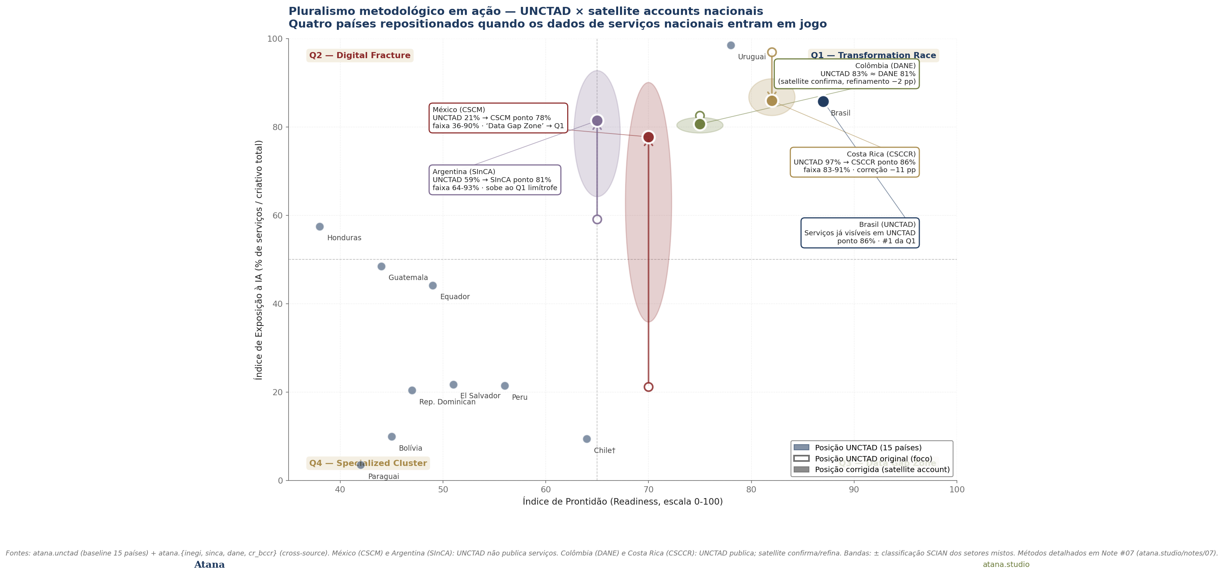
Figure 1 — The Atana Strategic Quadrant Map (v1.7 cross-source revision). 15 LATAM countries by AI Exposure Index (X) and Readiness Index (Y). Open rings = UNCTAD-only baseline; filled colored dots = position after cross-source with the country's cultural-satellite account; ellipses = uncertainty bands from sectoral classification. Sources: UNCTADstat 2024 + atana.{inegi, sinca, dane, cr_bccr}. The quadrants describe situations, not trajectories. Q3 (Data Gap Zone) is empty after v1.7 — preserved as a methodological reminder. Q4 holds the strongest cards for the Authenticity Paradox playbook (§4, §7).

The four quadrants
Quadrant I

Transformation Race
Brazil · Colombia · Costa Rica · Uruguay · Mexico ‡ · Argentina ‡
The most exposed economies are also the best positioned to win the agentic transition — if they move fast. The OECD is unambiguous: countries cannot wait for foreign productivity gains without domestic adoption.
‡ Cross-source (v1.7). Mexico and Argentina join Q1 once the analysis is run through national cultural-satellite accounts (CSCM and SInCA) rather than UNCTAD alone. UNCTAD does not publish creative-services trade for these two countries, which placed Mexico in the v1.0–v1.6 Q3 Data Gap Zone and Argentina in Q2 Digital Fracture. The satellite accounts reveal both as services-dominated cultural economies: Mexico CSCM ponto 78% (band 36-90%), Argentina SInCA ponto 81% (band 64-93%). The shift is the volume's largest update.
Quadrant II

Digital Fracture
Honduras · Guatemala · Ecuador
Strategically the most concerning: high disruption exposure combined with low absorption capacity. Small creative-service exporters risk being substituted by global content-generation platforms before they can consolidate.
Argentina, which appeared here through v1.6, moves to Q1 in v1.7 via the SInCA cross-source.
Quadrant III

Data Gap Zone
Empty after v1.7 cross-source
Q3 named a structural data gap in UNCTAD coverage — not a positive finding. Through v1.6, Mexico appeared here alone because UNCTAD does not report Mexican creative services. The v1.7 cross-source pass (UNCTAD × CSCM) closes the gap for Mexico, moving it to Q1. Q3 is preserved as an explicit reminder that the underlying methodological choice — which classification system to read the data through — materially changes the conclusion. Q3 becomes populated again whenever a country with creative-services trade lacks both UNCTAD coverage and a national satellite account.
Quadrant IV

Specialized Tangible Cluster
El Salvador · Peru · Dom. Rep. · Chile† · Bolivia · Paraguay
Predominantly physical creative exports — jewelry, textiles, handicraft — with concentrated production clusters of recognized international identity. AI does not directly substitute these; on the contrary, the Authenticity Paradox (§4) suggests their territorial specificity gains scarcity value as generic content commoditizes. The risk is narrower and specific: as discovery and curation migrate to agents, artisanal producers without verifiable digital presence become invisible. These countries hold the strongest cards for Strategic Bet 2 (Authenticity Certification), not for migration toward Q1.

Composition of creative exports by AI exposure
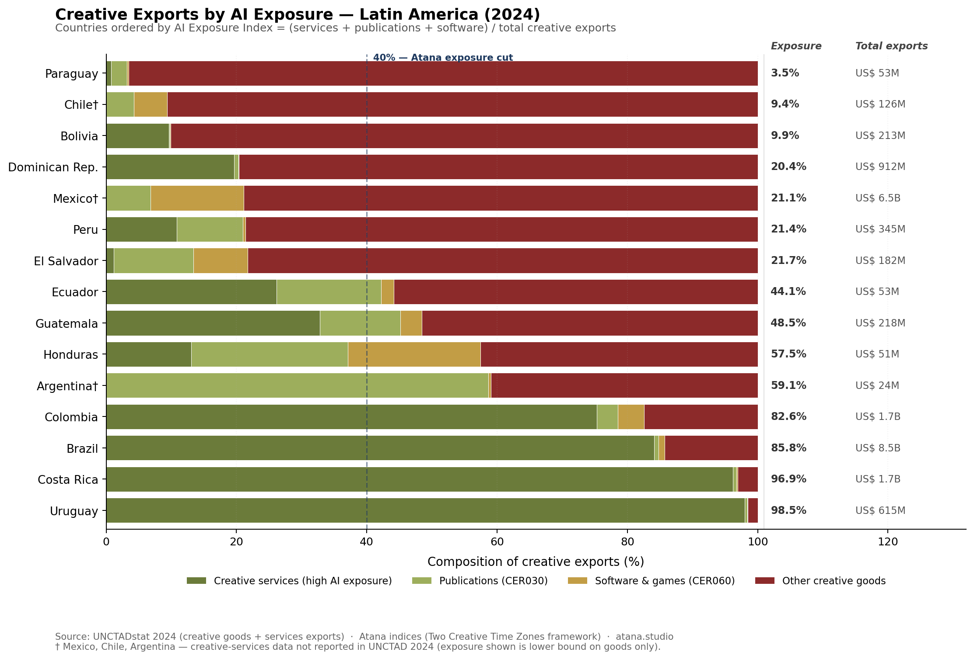
Figure 2 — Composition of creative exports by country and category, ordered by AI Exposure Index. Source: UNCTADstat 2024; Atana indices.

Concentration risk (HHI)
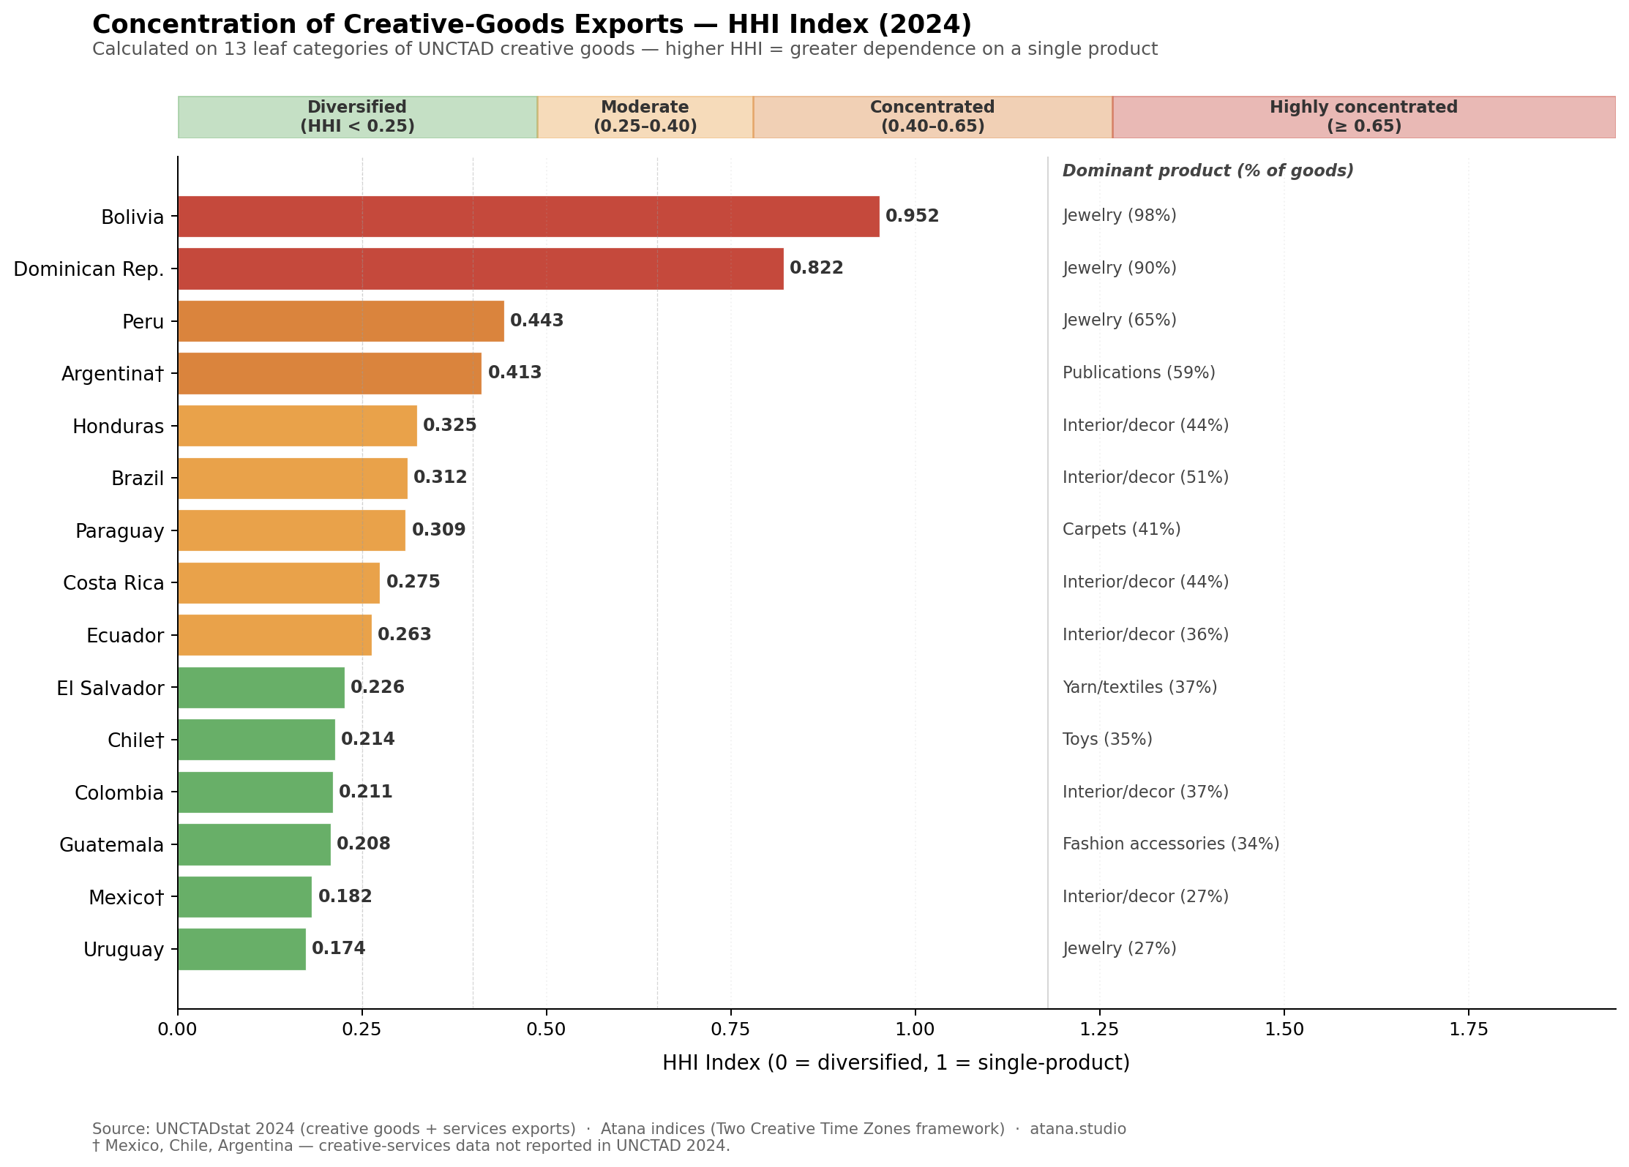
Figure 3 — Herfindahl–Hirschman concentration index (HHI) on 13 leaf categories of creative exports. Higher HHI = greater single-product dependence. Source: UNCTADstat 2024.
07 — Three Strategic Bets

Mapped to country positions.

Bet 1 — Urgent Domestic Adoption (Zone 1 countries)
For Brazil, Colombia, Costa Rica, Uruguay, and Mexico (probable Q1), domestic adoption is now condition-precedent for export competitiveness. Cultural-sector priority: AI deployment in production and distribution — not only administration — combined with simultaneous investment in AI governance. Intellectual-property risk is binding: 51% of organizations rate IP infringement as highly relevant.

Bet 2 — Digital Authenticity Certification (Zone 2 countries)
For Peru, Bolivia, Guatemala, Honduras, the path is not to compete on digital services. It is to become irreplaceable within AI ecosystems. Three components: verifiable indexing (structured digital presence in formats agents can read); provenance certification (the cultural equivalent of geographic indications for wine and cheese); differentiation narrative (the artisan's story is the asset that gains value with use).

Bet 3 — Governance as Competitive Advantage (cross-cutting)
McKinsey's 2026 finding that AI trust is increasingly perceived as a business enabler rather than a compliance cost has direct implications. Building responsible-AI governance — IP protection, data protection, traditional-knowledge safeguards — is not only risk management; it is the entry condition for international markets that will demand evidence of responsible AI in their creative supply chains.
08 — Four Policy Lines

Deployable this calendar year.
The agentic era requires cultural policy to evolve from a posture focused on protection and production support toward one that integrates competitiveness and positioning within AI-mediated ecosystems. Four concrete lines emerge from the analysis. None requires a new ministry. All are deployable within current regulatory authority in most LATAM jurisdictions.
These four lines operationalize, for Latin American jurisdictions, principles consistent with the 11 actions of the GCEC Global AI Agenda (Creative PEC / British Council, 2026). Cross-walk: Atana 1 ↔ GCEC 7 · 4 · 5 | Atana 2 ↔ GCEC 5 · 4 · 11 | Atana 3 ↔ GCEC 1 · 2 | Atana 4 ↔ GCEC 3 · 6 · 9.

Policy line 1
Digital infrastructure for cultural identity
Build national catalog, verification, and indexing systems for cultural goods and creators in formats readable by AI agents — analogous to what the geographic-indications registry already does for agri-food products. Owner: ministry of culture in cooperation with intellectual-property authority. Time to first deployment: 12–18 months. Estimated cost: USD 3–8M.

Policy line 2
Traditional-knowledge protection in the AI context
Explicit regulation on the use of traditional cultural expressions in AI model training, with compensation mechanisms for community holders. Build on existing UNESCO and WIPO frameworks. Owner: ministry of culture and indigenous-affairs authority. Time to first regulatory draft: 6–12 months.

Policy line 3
AI literacy for creative workers
Programs that go beyond tool use to cover how agentic ecosystems work, how cultural products are discovered and ranked by agents, and how to build verifiable digital presence. Owner: ministry of culture in cooperation with labor and education ministries. Pilot scale: 5,000 creators in year 1. Estimated cost: USD 1.5–4M per pilot cohort.

Policy line 4
Responsible-AI maturity inside cultural-sector funding
Progressive integration of AI governance criteria into credit lines and cultural-industry support — particularly IP protection and creator-data protection. Owner: cultural-financing institutions in coordination with culture ministry. Time to first credit line update: 6–9 months.
09 — Methodology

Reproducible, open, citable.

Sources
- UNCTADstat. Creative goods (US_CreativeGoodsValue) and creative services (US_CreativeServ_Indiv_Tot), 2024, USD current, partner = World, flow = exports.
- OECD AI Papers No. 57. Filippucci et al. (2026), "AI meets trade." Adoption projections, productivity-gain estimates, three-channel transmission framework.
- McKinsey 2026 publications. AI Trust Maturity Survey (n = 496); "Where AI will create value — and where it won't"; "The rise of the human–AI workforce."
- IFPI Global Music Report 2026 (covering 2025 data). LATAM regional growth, streaming share, country rankings. Used in §5 (v1.1 refresh).
- Spotify Loud & Clear 2026 (covering 2025 data). Artist-earnings tiers, genre growth on the $50M+ list, language diversity on the Global Top 50. Used in §5 (v1.1 refresh).
- GCEC (Creative PEC / British Council, 2026). "A Global AI Agenda for the Cultural and Creative Industries." DOI: 10.5281/zenodo.19333828. Used in §1 and §8 as the global principle-level frame against which Atana's four LATAM-operational lines are positioned.
- UNESCO Institute for Statistics (2025). 2025 UNESCO Framework for Cultural Statistics — Part I: Concepts and Definitions. unesdoc 395490. Launched at MONDIACULT Barcelona, September 2025. Used in §1 as the international-statistical-standard anchor against which the atana-data corpus is cross-walked. Full cross-walk published as Atana Note #05; operational application in Atana's internal FCS Consulting Playbook (available on request).

Methodological note — pluralism as analytical commitment
This briefing reads identical underlying reality through multiple legitimate methodological lenses, and treats the differences between framings as analytical signal rather than as noise to reconcile. Five instances in the corpus that prefigure or instantiate this volume: Note #03 reads Brazilian cultural trade through UNCTAD × IBGE/SECEX (the sino-dependence finding); Análise 6 reads LATAM creative trade through UNCTAD × OECD AI × McKinsey (the Two Creative Time Zones); Análise 9 reads the Brazilian cultural-policy corpus through LexML × juridical-force re-classification (the 80% administrative-acts finding); the H0 paper in drafting reads Brazilian cultural employment through PNADC × RAIS administrative (the 22.6% formal-decline finding); Atana Note #05 reads the entire atana-data corpus through the 2025 UNESCO FCS lens. The practice itself — methodological pluralism — is named and operationalized in Atana's internal FCS Consulting Playbook §3 (available on request). From this volume forward, Atana publications surface the lenses each piece brings into conjunction; this volume's are listed in the Sources block above.

Version history
- v1.0 — 2026-05-10. Initial publication. UNCTAD 2024 + OECD AI Papers No. 57 + McKinsey 2026.
- v1.1 — 2026-05-14. Music-sector refresh. Adds §5 (empirical validation) integrating IFPI 2026 and Spotify Loud & Clear 2026; renumbers original §5–§8 to §6–§9; adds sixth finding to executive summary.
- v1.2 — 2026-05-15. English-language regeneration of figures 3, 8, and 9. Adds GCEC Global AI Agenda (April 2026) as a reference point in §1, §8, and §9. Charts and underlying data unchanged.
- v1.3 — 2026-05-16. Fig8 self-audit refresh. Q3 "Latent Power" → "Data Gap Zone" (the quadrant is named for what it is: a UNCTAD reporting gap, not a positive finding). Q4 "Artisanal Trap" → "Specialized Tangible Cluster" (removes a normative load that contradicted §4's Authenticity Paradox). Adds descriptive-not-prescriptive disclaimer to §6. Underlying data and country positions unchanged; the country-by-country argument is unaffected. Full audit on file (available on request).
- v1.4 — 2026-05-18. Adds UNESCO 2025 Framework for Cultural Statistics (MONDIACULT Barcelona, Sep 2025) as the international-statistical-standard anchor alongside the existing GCEC Global AI Agenda in §1 and §9. The two anchors triangulate Atana's positioning: GCEC names the actions, UNESCO names the categories, this briefing names the operational lines. Full corpus-to-framework cross-walk published as Atana Note #05; operational application in Atana's internal FCS Consulting Playbook (available on request). No data or chart changes; this is a citation-layer addition.
- v1.5 — 2026-05-19. Adds a §9 Methodological note — pluralism as analytical commitment. Names the analytical move that connects Note #03, Análise 6, Análise 9, the H0 paper, and Note #05: each reads identical underlying reality through multiple legitimate methodological lenses and treats the gap between framings as itself the finding. The move is canonically articulated in Atana's internal FCS Consulting Playbook §3 (available on request); this volume's methodological note is the publication-side anchor. No data or chart changes; this is a method-naming addition.
- v1.6 — 2026-05-20. Data-consistency correction to §3. The Zone 1 readiness table and the HHI warning callout are re-derived directly from the canonical UNCTAD 2024 corpus snapshot, correcting figures that had carried pre-correction values since v1.0: Readiness Index — Brazil 84→87, Costa Rica 74→82, Uruguay 73→78, Colombia 69→75; Costa Rica services exports 0.51→1.59 US$B and services share 97%→96%; HHI — Bolivia 0.994→0.952, Dominican Republic 0.982→0.822. The corrected HHIs are lower, which is why the readiness figures rise (readiness rewards diversification). Brazil remains first in Zone 1 and the country-by-country argument is unaffected. The §6 quadrant map is regenerated from the same corpus snapshot and is unchanged by this correction.
- v1.7 — 2026-05-29. Cross-source extension to §3 and §6. The four LATAM countries whose national cultural-satellite accounts are in atana-data (Mexico/CSCM, Argentina/SInCA, Colombia/DANE, Costa Rica/CSCCR) are re-read against UNCTAD 2024. Two move quadrants: Mexico from Q3 Data Gap Zone to Q1 Transformation Race (CSCM services share point 78%, band 36-90%, vs UNCTAD 21% lower-bound); Argentina from Q2 Digital Fracture to Q1 (SInCA services share point 81%, band 64-93%, vs UNCTAD 59% lower-bound). Two refine in place: Colombia confirms UNCTAD with a +6 pp DANE-side refinement; Costa Rica refines UNCTAD downward by −11 pp via CSCCR sector coefficients. Pluralismo metodológico cuts both ways — UNCTAD can undercount (MX, AR) or overcount (CR) cultural services depending on the country. Q3 is preserved as empty after v1.7, named for its methodological function rather than for any current occupant. Fig 1 (§6) regenerated as latam_fig8_v17.png showing all 4 corrections via uncertainty ellipses and UNCTAD→satellite arrows. Methodology detailed in Atana Note #07; sidecar JSON index_v17_cross_source_bounds.json in _atana_intel/.

Index definitions
- AI Exposure Index. (Creative services + digital goods CER010+CER060 + publications CER030) ÷ total creative exports. For countries with unreported services: lower bound = (digital goods + publications) ÷ total goods.
- Readiness Index. 0.40 × services share + 0.40 × log-normalized scale (min = AR US$ 24M, max = BR US$ 8.55B) + 0.20 × (1 − HHI) × 100. Without services: 0.50 × scale + 0.50 × diversification.

Caveats
- OECD adoption projections for LATAM are entirely modeled (not survey-based), per OECD's own note 52.
- McKinsey LATAM responsible-AI maturity scores are based on 43 organizations within the n = 496 global sample.
- Mexico, Chile, and Argentina lack reported creative-services data in UNCTAD 2024. v1.7 closes this gap for Mexico (CSCM) and Argentina (SInCA) via national cultural-satellite accounts — both move to Q1 in the cross-source view. Chile remains UNCTAD-only (no national CSC ingested into atana-data at the time of publication) and is still marked with † as a lower-bound calculation on digital goods only.

