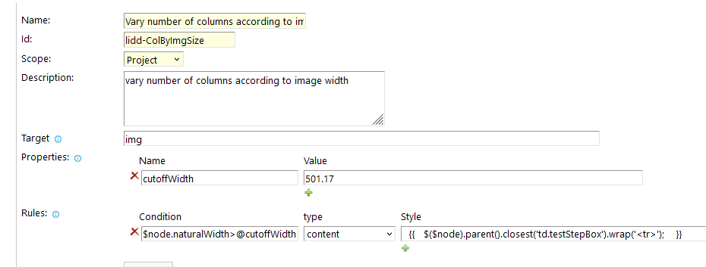
$node.naturalWidth>@cutoffWidth

{{ $($node).parent().closest('td.testStepBox').wrap('<tr>'); }}
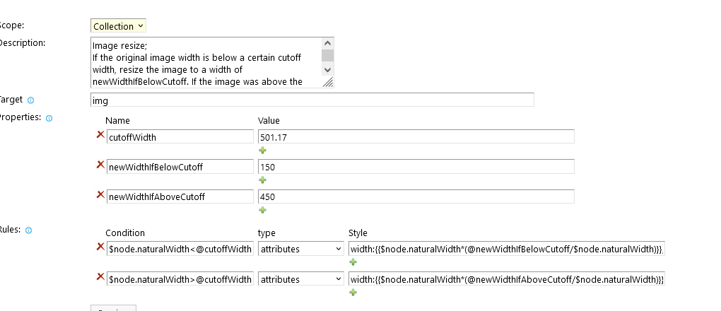

$node.naturalWidth<@cutoffWidth
width:{{$node.naturalWidth*(@newWidthIfBelowCutoff/$node.naturalWidth)}};height:{{$node.naturalHeight*(@newWidthIfBelowCutoff/$node.naturalWidth)}};

$node.naturalWidth>@cutoffWidth
width:{{$node.naturalWidth*(@newWidthIfAboveCutoff/$node.naturalWidth)}};height:{{$node.naturalHeight*(@newWidthIfAboveCutoff/$node.naturalWidth)}};

