

# Formal Modelling of a Pyramid Solitaire Game in VDM++

## Métodos Formais em Engenharia de Software

## Mestrado Integrado em Engenharia Informática

## January 4th, 2017

Alexandre Lima

João Vieira de Castro ei11004

Miguel Fernandes

Table Of Contents

# Informational Description and List of Requirements

## Informal System Description

Pyramid Solitaire is played with a single, well shuffled pack of 52 playing cards.

A pyramid of cards is dealt, consisting of 28 cards formed from seven overlapping rows. Each card in the top five rows are blocked by two cards in the row beneath with both cards needing to be discarded before releasing the card above, making it available for play.

The seven exposed cards in the bottom row of the pyramid are available for play immediately.

Bellow the pyramid also exist three different piles of cards which may be empty or not.

One pile contains the remainder of the deck, from which the player can draw one card at a time, placing it of the second pile (2). As he keeps drawing cards, before placing the next in the second pile, the previously drawn card must be placed on the third pile (3).

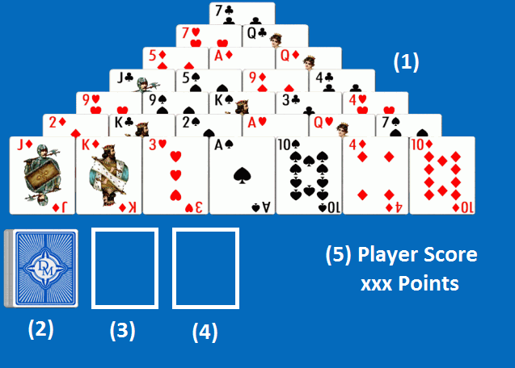

The implemented Pyramid Solitaire gameboard can be divided into five main areas

1. The Pyramid itself.
2. The remainder of the deck of cards.
3. The second pile.
4. The third pile.
5. The players’ score.

The **objective** of the game is to free all the cards by pairing them. A pair is made when the sum of the two cards’ value is equal to thirteen.

The numeric cards’ scores are equal to their number, and Aces count as 1, Jacks 11, Queens 12 and Kings total 13 in themselves and as such, are discarded as a single card rather than as a pair.

The **scoring** in Pyramid Solitaire revolves around bonus points the player can achieve, with the following actions:

* 100 pts - Discarding a pair of cards, totaling 13
* 200 pts – Discarding a King
* 400 pts – Clearing a row in the Pyramid.
* 100 pts – Clearing the whole reserve

## List of Requirements

# Visual UML Model

## Use case Model

## Class Model