|  |
| --- |
| Architecture Report – DAS – CARDMASTER2020  Version 1.0 |
| |  | | --- | |  | | Date: | 26/02/2016 | | Author: | Joao Lourenco (a21190948) |   Repository : https://github.com/joaovl/RC_DasCardMaster2020.git |
|  |

Table of Contents

User Interface 3

Functional Requirements diagram 4

Non Functional Requirements diagram 5

Use Cases 6

*Actors diagram* 7

*Use Case Description* 8

UC1: Login 8

UC2: Register 8

UC3: Logged Player 8

UC4: Select Game 9

UC5: Configure Game 9

UC6: Play Game 9

UC7: List Previous Played Cards 9

UC8: List Games Options 10

UC9: List Games Statistics 10

UC10: List Game Rules 10

*Use Case Model diagram* 11

UC1, UC2, UC3: Login diagram 12

UC1, UC2, UC3: Primary Use Cases diagram 13

UC4: Select Game diagram 14

UC5: Configure Game diagram 15

UC6: Play Game diagram 16

UC7: List Previous Cards diagram 17

UC8: List Game Options diagram 18

UC9: List Game Statistics diagram 19

UC10: List Game Rules diagram 21

Player Workflow diagram 22

*List Games diagram* 23

Players diagram 24

Select Games diagram 25

*Game Abstract Factory diagram* 26

Command diagram 27

Game Debugger diagram 29

Game Debugger2 diagram 30

Gateways Diagram 31

*Interface Menus diagram* 32

*System Architecture diagram* 33

Class Model diagram 34

Data Model - SQLite diagram 35

*Logical Model diagram* 36

*Design Model – UI Layer* 37

*Design Model – Business Layer – Domain* 38

*Design Model - Services – DB* 39

### User Interface

User Interface in package User Interface View'

User Interface

Version 1.0

Joao (a21190948) created on 12/02/2016. Last modified 24/02/2016



1. User Interface

### Functional Requirements diagram

Requirements diagram in package 'Functional Requirements'

Functional Requirements

Version 1.0

Joao (a21190948) created on 26/02/2016. Last modified 26/02/2016



1. Functional Requirements

### Non Functional Requirements diagram

Requirements diagram in package 'Non Functional Requirements'

Non Functional Requirements

Version 1.0

Joao (a21190948) created on 26/02/2016. Last modified 26/02/2016



1. Non Functional Requirements

### Use Cases

Use Case in package 'Use Case Model'

Use Case Model

Version 1.0

Joao (a21190948) created on 12/02/2016. Last modified 24/02/2016



1. Use Case Model

#### *Actors diagram*

Use Case diagram in package 'Actors'

Actors

Version 1.0

Joao (a21190948) created on 12/02/2016. Last modified 24/02/2016



1. Actors

##### *Use Case Description*

##### UC1: Login

Brief Description

This use case describes how a user logs into the DasCardMaster2020.

Basic Flow

User wishes to log into the DasCardMaster2020.

* The system requests that the user enter username and password.
* The actor enters username and password.
* The system validates the entered username and password and logs the user into the system.
* User enters the system and select “log is as guest” option.

Alternative Flows

1. If user enters an Invalid Username / Password, the system displays an error message.
2. User can leave the game clicking on “Exit” button.
3. User can use the system as guest. Games data will not be recorded.

Pre-Conditions

N/A

Post-Conditions

If user enter a valid username and password, will be logged into the system.

##### UC2: Register

Brief Description

This use case allows a User to register for DasCardMaster. It is required to add a username and a password.

Basic Flow

This use case starts when a user wishes to register for DasCardMaster.

The system requests that the User specify a valid username and password.

Alternative Flows

If Username is already used the system will ask the user for a new username and password.

If password validation does not match user will be asked to add their data again.

Pre-Conditions

None.

Post-Conditions

If the use case was successful registered can start playing any available game. Progress will be saved.

##### UC3: Logged Player

Brief Description

User can see his/her progress when registered in the system.

Basic Flow

If user enters a valid username and password, he/she will be logged in the system.

Alternative Flows

If User does not to log with his credentials can play the available games using the guest mode.

Pre-Conditions

User is already registered in the system a valid username and password were already set in the system.

Post-Conditions

User will be log in the system. Any game played will be saved for progress and later usage.

##### UC4: Select Game

Brief Description

A list of available games is available. User can check rules and information for each game

Basic Flow

After login screen the User will be given a list of available games. User selects one game and click on play the selected game.

Alternative Flows

If user enter the system as logged user, extra information will be shown, such as his/her details and last games played. Logged users have a list of games played, their score and progress.

Guest users do not have extra information in this screen. No history of last played games will be shown.

Pre-Conditions

User enter the system as Logged user or as Guest.

Post-Conditions

Selected game will be shown and user will be given configuration details.

##### UC5: Configure Game

Brief Description

Each game has different configuration details.

Basic Flow

If available User selects the number of human users, the number of machine users and their level (by default is set to Beginner).

Alternative Flows

User does not set any configuration and system select default defined for game.

Pre-Conditions

User selected a game that wants to play.

Post-Conditions

User can start playing the game

##### UC6: Play Game

Brief Description

Selected game can be played with defined rules.

Basic Flow

User waits for his/her turn to play (for non solo games) and select a card.

Alternative Flows

1. Selected card is not valid and user is asked to select a new one.
2. Selected card is valid and user waits for next time to play.
3. User is playing in solo mode game and does not need to wait for any player to play.
4. User does not wait until the end of game and click on “Leave Game” button.
5. At any time UC7, UC8, UC9 and UC10 are available.

Pre-Conditions

A game was selected and their configuration was accepted.

Post-Conditions

User is asked to play a card(s) until game can finish.

##### UC7: List Previous Played Cards

Brief Description

Previous cards played by each player can be seen.

Basic Flow

Human users can see cards previously played by any opponent or team member during the same game.

Alternative Flows

1. At any time UC6, UC8, UC9 and UC10 are available.

Pre-Conditions

At least one valid game play was successfully done by all the users.

Post-Conditions

User can leave this playback screen content by clicking on the “play” button. After clicking the “play” button the user is sent to actual playing moment (no changes can be done in game history).

##### UC8: List Games Options

Brief Description

Selected game options are available in the Options tab.

Basic Flow

At any time during the game user can click on this tab to see selected options on Game configuration. No actions can be performed.

Alternative Flows

1. At any time UC6, UC7, UC9 and UC10 are available.

Pre-Conditions

N/A

Post-Conditions

N/A

##### UC9: List Games Statistics

Brief Description

User can access his game statistics. This use case shows User’s (or team’s) score. User statistics and last games played.

Basic Flow

At any time during the game user can click on Game tab to see selected options on Game Statistics. No actions can be performed.

Alternative Flows

1. At any time UC6, UC7, UC8 and UC10 are available.

Pre-Conditions

N/A

Post-Conditions

N/A

##### UC10: List Game Rules

Brief Description

User can access game specific rules.

Basic Flow

At any time during the game user can click on Rules tab to see the game rules. No actions can be performed.

Alternative Flows

1. At any time UC6, UC7, UC8 and UC9 are available.

Pre-Conditions

N/A

Post-Conditions

N/A

#### *Use Case Model diagram*

Use Case diagram in package 'Use Case Model'

Use Case Model

Version 1.0

Joao (a21190948) created on 20/02/2016. Last modified 26/02/2016



1. Use Case Model

##### UC1, UC2, UC3: Login diagram

Interaction diagram in package 'UC1, UC2, UC3: Login'

Login

Version 1.0

Joao (a21190948) created on 12/02/2016. Last modified 26/02/2016



1. Login

##### UC1, UC2, UC3: Primary Use Cases diagram

Use Case diagram in package 'UC1, UC2, UC3: Login'

Primary Use Cases

Version 1.0

Joao (a21190948) created on 12/02/2016. Last modified 26/02/2016



1. Primary Use Cases

##### UC4: Select Game diagram

Interaction diagram in package 'UC4: Select Game'

UC4: Select Game

Version 1.0

Joao (a21190948) created on 22/02/2016. Last modified 24/02/2016



1. UC4: Select Game

##### UC5: Configure Game diagram

Interaction diagram in package 'UC5: Configure Game'

UC5: Configure Game

Version 1.0

Joao (a21190948) created on 22/02/2016. Last modified 22/02/2016



1. UC5: Configure Game

##### UC6: Play Game diagram

Interaction diagram in package 'UC6: Play Game'

Play Game

Version 1.0

Joao (a21190948) created on 20/02/2016. Last modified 26/02/2016



1. Play Game

##### UC7: List Previous Cards diagram

Interaction diagram in package 'UC7: List Previous Cards'

UC7: List Previous Cards

Version 1.0

Joao (a21190948) created on 22/02/2016. Last modified 22/02/2016



1. UC7: List Previous Cards

##### UC8: List Game Options diagram

Interaction diagram in package 'UC8: List Game Options'

UC8: List Game Options

Version 1.0

Joao (a21190948) created on 22/02/2016. Last modified 22/02/2016



1. UC8: List Game Options

##### UC9: List Game Statistics diagram

Interaction diagram in package 'UC9: List Game Statistics'

UC9: List Game Statistics

Version 1.0

Joao (a21190948) created on 22/02/2016. Last modified 24/02/2016



1. UC9: List Game Statistics

##### UC10: List Game Rules diagram

Interaction diagram in package 'UC10: List Game Rules'

UC10: List Game Rules

Version 1.0

Joao (a21190948) created on 22/02/2016. Last modified 24/02/2016



1. UC10: List Game Rules

##### Player Workflow diagram

Activity diagram in package 'Activity Overview Diagram'

Player Workflow

Version 1.0

Joao (a21190948) created on 20/02/2016. Last modified 26/02/2016



1. Player Workflow

###### *List Games diagram*

Interaction diagram in package 'Activity Overview Diagram'

List Games

Version 1.0

Joao (a21190948) created on 12/02/2016. Last modified 22/02/2016



1. List Games

##### Players diagram

Use Case diagram in package 'Players'

Players

Version 1.0

Joao (a21190948) created on 20/02/2016. Last modified 26/02/2016



1. Players

##### Select Games diagram

Use Case diagram in package 'Select Games'

Select Games

Version 1.0

Joao (a21190948) created on 20/02/2016. Last modified 24/02/2016



1. Select Games

#### *Game Abstract Factory diagram*

Class diagram in package 'GameAbstractFactory'

GameAbstractFactory

Version 1.0

Joao (a21190948) created on 26/02/2016. Last modified 26/02/2016



1. GameAbstractFactory

##### Command diagram

Class diagram in package 'Command'

Command

Version 1.0

Joao (a21190948) created on 26/02/2016. Last modified 26/02/2016



1. Command



1. Command Pattern

##### Game Debugger diagram

Class diagram in package 'Debugger'

Debugger

Version 1.0

Joao (a21190948) created on 26/02/2016. Last modified 26/02/2016



1. Debugger

##### Game Debugger2 diagram

Class diagram in package 'Debugger2'

Debugger2

Version 1.0

Joao (a21190948) created on 26/02/2016. Last modified 26/02/2016



1. Debugger2

##### Gateways Diagram

Class diagram in package 'gateways'

Gateways

Version 1.0

Joao (a21190948) created on 26/02/2016. Last modified 26/02/2016



1. gateways

#### *Interface Menus diagram*

Class diagram in package 'interfaceMenus'

Interface Menus

Version 1.0

Joao (a21190948) created on 26/02/2016. Last modified 26/02/2016



1. interfaceMenus

#### *System Architecture diagram*

Class diagram in package 'System'

System Architecture

Version 1.0

Joao (a21190948) created on 12/02/2016. Last modified 26/02/2016



1. System Architecture

### Class Model diagram

Class diagram in package 'Class Model'

Class Model

Version 1.0

Joao (a21190948) created on 12/02/2016. Last modified 26/02/2016



1. Class Model

### Data Model - SQLite diagram

Data Modeling diagram in package 'Data Model - SQLite'

Data Model - SQLite

Version 1.0

Joao (a21190948) created on 24/02/2016. Last modified 24/02/2016



1. Data Model - SQLite

#### *Logical Model diagram*

Data Modeling diagram in package 'Logical Model'

Logical Model

Version 1.0

Joao (a21190948) created on 24/02/2016. Last modified 24/02/2016



1. Logical Model

#### *Design Model – UI Layer*

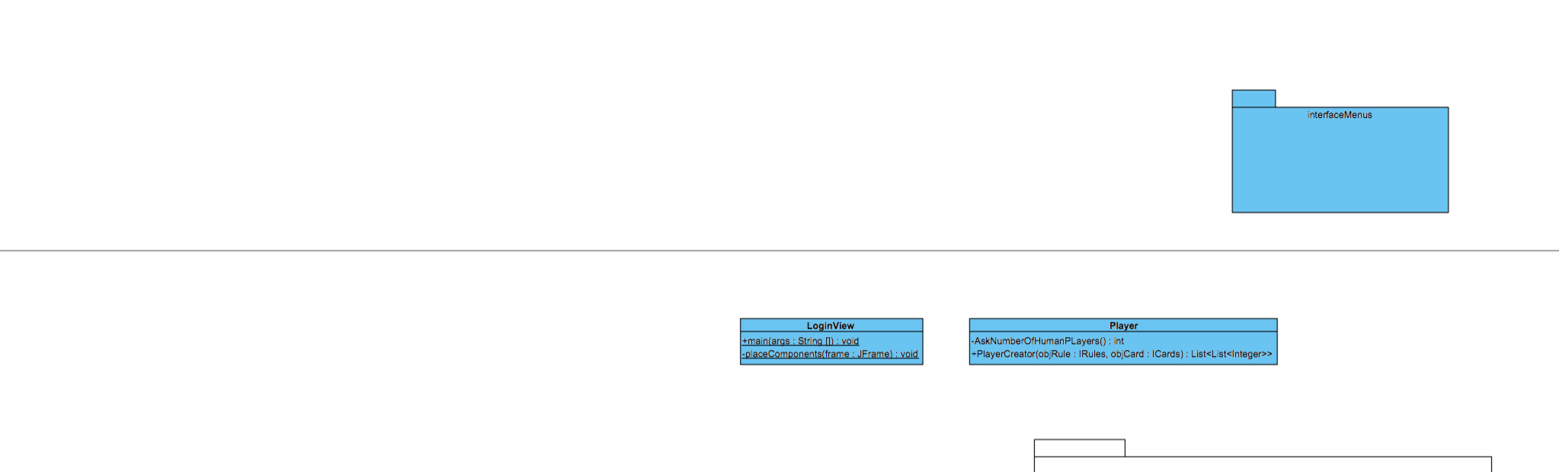

1. Layer Interface
2. Logical Model

#### *Design Model – Business Layer – Domain*

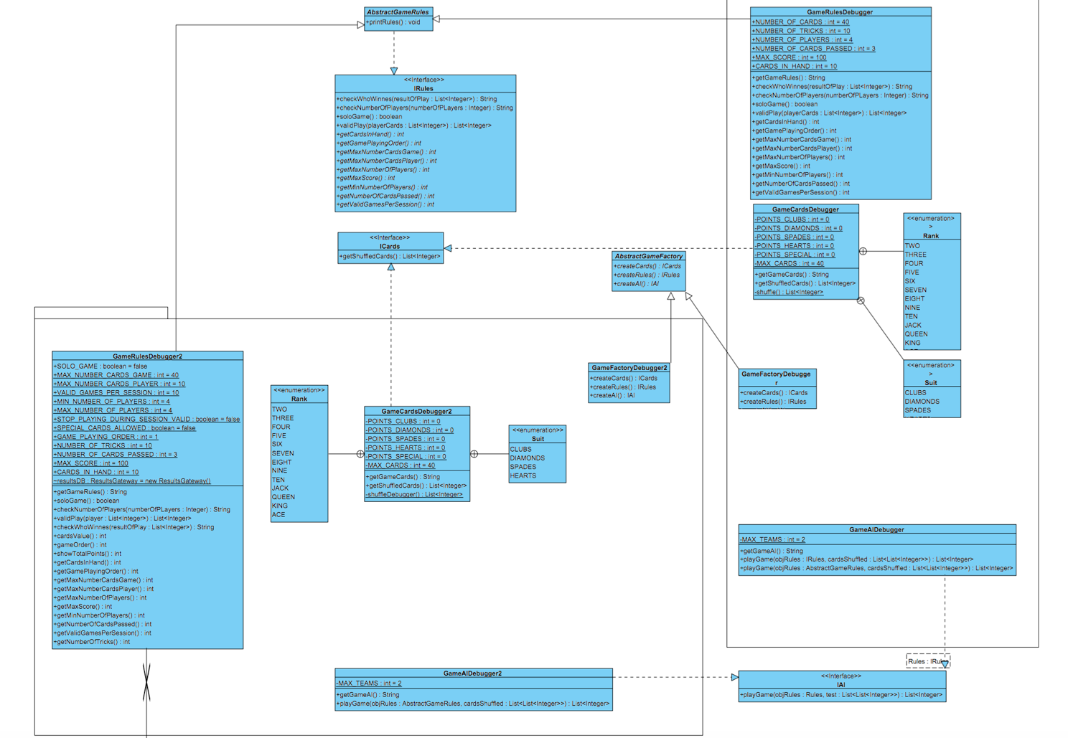

1. Business Layer (Abstract Factory and Template patterns)

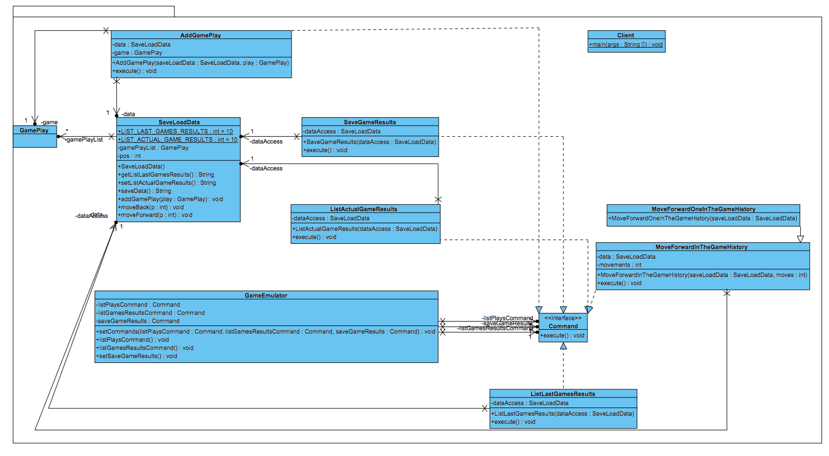

1. Business Layer (Command pattern)

#### *Design Model - Services – DB*

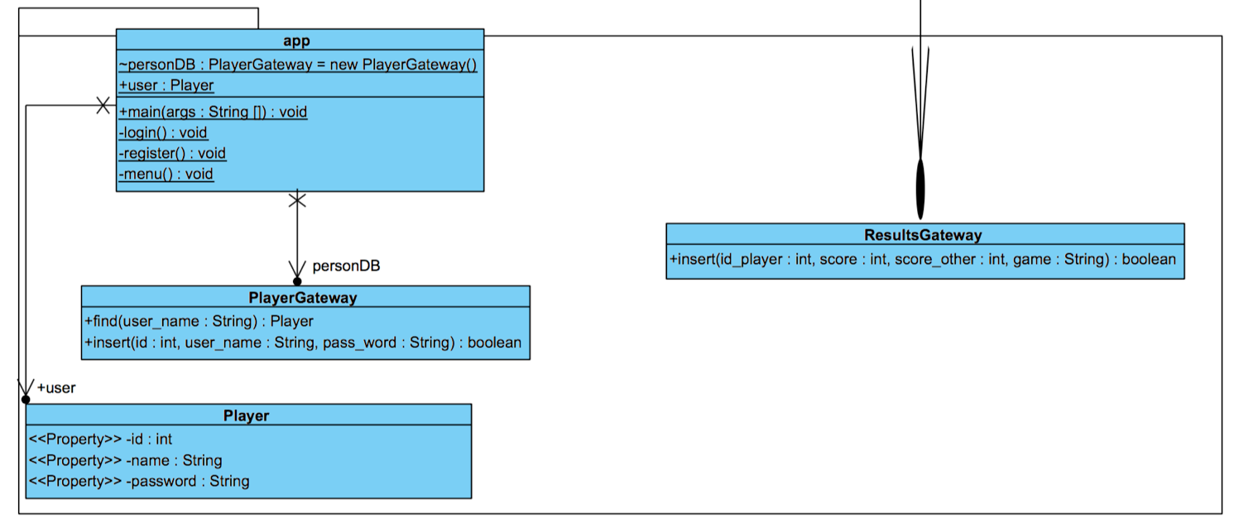

1. DB (Table Gateway)