SuitSupply order API Using document
Test site
baseUrl: http://api-mtm-test.cnjyy.cn/

1:get Token
url: http://api-mtm-test.cnjyy.cn/api/suitsupply/gettoken
Request method : POST
Content-Type：application/json
Input parameters:
{
"appId": "suitsupplydev",// For testing only
"appSecret": "suitsupply2022@dev"// For testing only
}
Return: you token
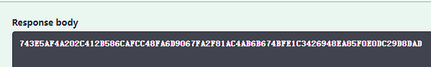
Note: This token will also be used in other apis in the future

2: Push the order
url: http://api-mtm-test.cnjyy.cn/api/suitsupply/importorder
Request method : POST

Content-Type：application/json
Authorization:you Token
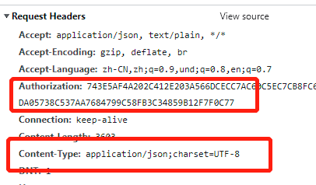
Input parameters:
{
[ //list
“order”:”…..”,
“order”:”…..”,
]
}
Return:
{
"factory_order_id": "string",// The factory order ID is not currently returned "order_status": 0,
"suitsupply_booking_information": {
"suitsupply_order_id": "string",
"order_booking_date": "string",
"order_ship_date": "string"
}
}

