Sales Tickets

# Ticket #1

Product Name: teste

Price: $12.0

Quantity: 1

Total Price: $12.0

## QR Code

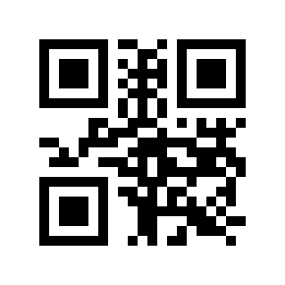

# Ticket #2

Product Name: teste

Price: $12.0

Quantity: 1

Total Price: $12.0

## QR Code

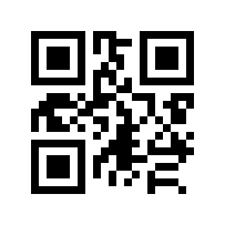

# Ticket #3

Product Name: teste

Price: $12.0

Quantity: 1

Total Price: $12.0

## QR Code

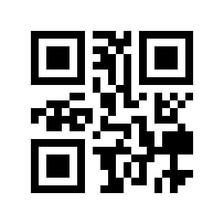

# Ticket #4

Product Name: teste

Price: $12.0

Quantity: 1

Total Price: $12.0

## QR Code

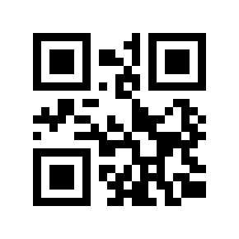

# Ticket #5

Product Name: teste

Price: $12.0

Quantity: 1

Total Price: $12.0

## QR Code

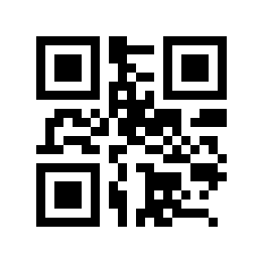

# Ticket #6

Product Name: teste

Price: $12.0

Quantity: 1

Total Price: $12.0

## QR Code

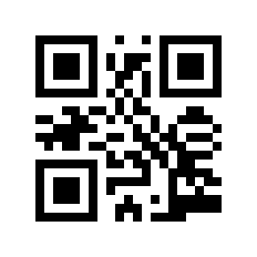

# Ticket #7

Product Name: teste

Price: $12.0

Quantity: 1

Total Price: $12.0

## QR Code

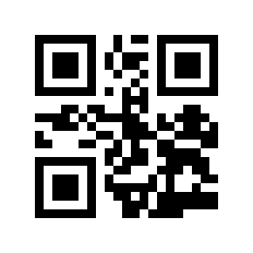

# Ticket #8

Product Name: teste

Price: $12.0

Quantity: 1

Total Price: $12.0

## QR Code

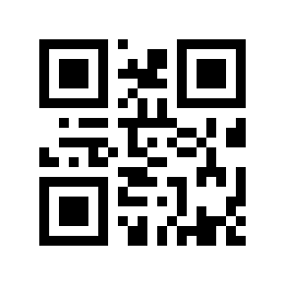

# Ticket #9

Product Name: teste

Price: $12.0

Quantity: 1

Total Price: $12.0

## QR Code

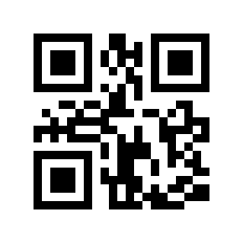

# Ticket #10

Product Name: teste

Price: $12.0

Quantity: 1

Total Price: $12.0

## QR Code

