# **DP201 - Designing an Azure Data Platform Solution**

## Lab 2 – Azure Batch Processing Reference Architectures

**Exercise 2**

**Task 1: Amend the high level architecture that reflects the Enterprise BI solution in AdventureWorks.**

Use the template below to document the high-level architecture that would automate batch mode processing of data in an Enterprise BI solution in AdventureWorks.

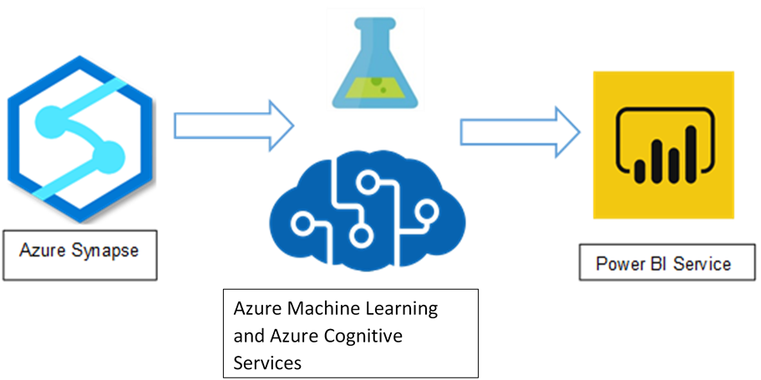

Azure Web application

|  |  |  |  |
| --- | --- | --- | --- |
| **Automated Business Reporting System** | | | |
| Data Source | Ingestion and Data Storage | Analysis | Visualisation |
|  |  |  |  |