# **DP201 - Designing an Azure Data Platform Solution**

## Lab 6 – Designing for Efficiency and Operations

**Exercise 1**

**Task 1: Maximize the efficiency of your cloud environment.**

List the Azure price calculator below:

|  |
| --- |
| <https://www.azure.microsoft.com/en-us/pricing/calculator/> |

Provide a list of best practises that the IS department should follow to minimize costs.

|  |  |  |
| --- | --- | --- |
| **#** | **Best practise** | **Service** |
| 1 | Pay as you go + Autoscale + Multiregion | Cosmos DB |
| 2 | 3 year reserved (~65% savings) | Synapse Analytics |
| 3 | For the Backend, it is a cheaper option than the App Service (Consumption Tier) | Function App |
| 4 | Choose a Linux Operating System | App Service |
| 5 | Choose the Basic Tier + B3 + IoT Hub Device Provisioning Service | IoT Hub |
| 6 | 3 year reserved (~58% savings) | Machine Learning |
| 7 | Premium Tier + Data Engineering Workload + Pay reserver (3 year ~61% savings) | Databricks |
| 8 | RA-GRS + Hot Access Tier + Standard Performance Tier + Block Blob Storage + Pay as you go | Storage Account |

**Cosmos DB Simulation**

Multi Region + Autoscale

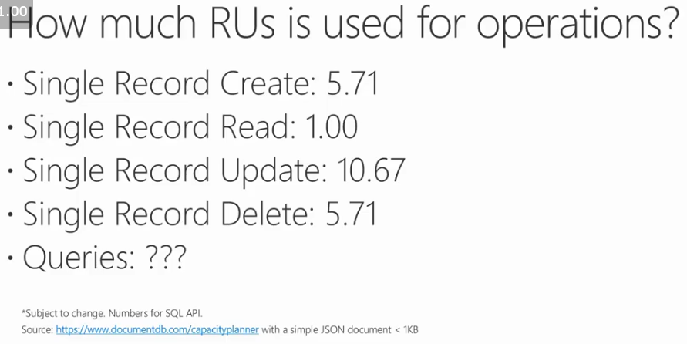

Source: <https://www.youtube.com/watch?v=4lYx-aG3sFM>

**RUs/s**

Considering 10,000 connected bicycles

Data (JSON Document with 1 KB) being written 2,880 times a day (every 30 seconds) for each bicycle

Single Record Create: 5.71 * 10,000 * 2,880 = 164,448,000 RUs

Single Record Read (considering a scenario where 2 people would be reading at the same time the record of a single bicycle): 1.00 * 10,000 * 5,760 = 57,600,000 RUs

Total of RUs in one day = 164,448,000 + 57,600,000 = 219,048,000 RUs

Per second = 219,048,000 / (24*3600) = 2,500 RUs/s

Minimum allowed = 4,000 RUs/s

100% Average utilization

Price: 476.16 USD/month

**Storage**

1 KB * 2,880 records/(bicycle*day) * 31 days/month * 10,000 bicycles =~ 900 GB/month

Price: = 225 USD/month

**Support**

Standard Support = 100 USD/month

**Total price per month:** 801.16 USD