**User’s Guide**  
**to**  
***CO Florida 2012***  
FDOT Intersection Air Quality (CO) Screening Model

Developed Under Research Sponsored by

The Florida Department of Transportation  
Project # BDK78 TWO 98501

FDOT Project Officer:  
Mr. Mariano Berrios

Developed at the University of Central Florida  
by  
  
C. David Cooper, PhD, PE, QEP  
and  
Mark D. Ritner, EI

January 31, 2012

TABLE OF CONTENTS

ABSTRACT 1

INSTALLATION INSTRUCTIONS 2

INTERFACE CONTROLS 3

WELCOME SCREEN 5

TITLE SCREEN 6

DISTRICT SCREEN 8

INTERSECTION TYPE SCREEN 9

INTERSECTION DATA SCREEN 10

RECEPTORS 14

EMISSION FACTORS 15

RUNNING THE FLORIDA CO SCREENING MODEL 16

EXAMPLE INPUTS AND OUTPUTS 19

LIST OF FIGURES

[Figure 1 - Title Screen Double-Click……………………………………………………………...2   
 Figure 2 - District Screen Double-Click 3](#_Toc310267200)

Figure 3 - Intersection Type Double-Click 3

Figure 4 – Upper Navigation Icons 4

Figure 5 - About Screen 4

Figure 6 - Welcome Screen 5

Figure 7 - Title Screen 6

Figure 8 - District Screen 8

Figure 9 – Intersection Type Screen 9

Figure 10 - Intersection Data Screen for 4X4 Intersections 11

Figure 11 - Intersection Data Screen for N-S Freeway Diamond Interchange 12

Figure 12 - Intersection Data Screen for E-W Freeway Tollbooth Interchange 13

Figure 13 – Example Run Screen 17

Figure 14 – Example 1 (4 X 4 Intersection) Inputs 20

Figure 15 – Example 1 (4 X 4 Intersection) Results 21

Figure 16 – Example 2 (N-S Freeway Diamond Interchange) Inputs 22

Figure 17 – Example 2 (N-S Freeway Diamond Interchange) Results 23

Figure 18 – Example 3 (E-W Freeway Tollbooth Interchange) Inputs 24

Figure 19 – Example 3 (E-W Freeway Tollbooth Interchange) Results 25

LIST OF TABLES

Table 1- Parameters Impacted by Land Use Type 7

Table 2 – Receptor Coordinate Examples 14

Table 3 - Comparison of EF Multipliers 15

Table 4 - Summary of Examples 19

# ABSTRACT

This model replaces CO Florida 2004, the previous version of Florida’s carbon monoxide (CO) screening model for intersections. It updates the screening model to incorporate emission factors produced from the U.S. environmental protection agency’s (EPA) motor vehicle emission simulator (MOVES) version 2010a. This new model includes more geographical orientations of previous intersection types and a tollbooth option. Additional receptors have been added and a 360° wind search is included in 5° increments. This version of the CO screening model also includes images from Florida’s state parks to add visual interest. This air quality screening model was developed under research performed for the Florida Department of Transportation (FDOT). This User Guide gives detailed instruction as to how to use the model; a more complete discussion of the theory and practice of screening models is included in the Final Report of this project.

COFL2012 quickly and easily analyzes intersections and other similar facilities in the state of Florida for possible exceedances of the ambient CO air quality standards. As a screening model, COFL2012 incorporates conservative assumptions including peak hour traffic, January time-frame temperatures, worst-case meteorology (wind speed, stability class, and wind angle search), and very close-in receptors. The use of are many built-in values of parameters saves the user considerable time and effort in conducting the analysis. The philosophy of a screening model is that if these worst-case assumptions do not produce an exceedance, then none of the normal conditions encountered during the year will either. COFL2012 runs in Windows and incorporates curve-fit equations of emission factors developed from numerous runs of MOVES. This avoids having to run MOVES from within the screening model, and thus allows for easier updates in the future. COFL also has a CAL3QHC module built into it, with all the different intersection configurations, pre-programmed as separate input files, just waiting for insertion of certain specific inputs that come from the data the user enters or the choices that the user makes. COFL2012 runs very quickly and the Windows-based environment allows for easy operation of the model as well as easy file management.

The Air Pollution Modeling and Control Research Group at the University of Central Florida (UCF) gratefully acknowledges the Florida Department of Transportation (FDOT) for supporting this work to develop this latest version of the CO Florida screening model. We also acknowledge the work of Ms. Debra K. Keely on CO Florida 2004, which served as an organizational framework, sourced all the Florida images incorporated into the model, and provided many link coordinates for the EPA’s preferred near-road dispersion model, CAL3QHC2. These link coordinates were utilized and transcribed into the various new roadway configurations.

# INSTALLATION INSTRUCTIONS

**Computer Requirements** CO Florida 2012 has been created to run on Windows XP, Vista, and Windows 7 operating systems. The program requires that the .net Framework 4 is installed (already part of most modern computers). If CO Florida 2012 installs, but will not run, please install .net Framework 4. This software ( .net Framework 4 ) is available for a free download directly from Microsoft at: <http://www.microsoft.com/download/en/details.aspx?id=17851> .

**Installation**  
 Download the COFL 2012 Screening Model setup file from the FDOT website. Once the file has been downloaded, you can simply double-click on the file *COFLsetup.exe* and it will install directly to your computer. Alternatively, click the Start button, then go to Run. Locate the installation file COFLsetup.exe using the Browse button or type in the drive plus COFLsetup.exe.

**Un-install** The COFL 2012 setup program includes an un-install component. Later, if you wish to un-install COFL 2012, click on the un-install icon in the COFL 2012 program folder, under the Windows Start menu. Be sure that COFL 2012 is shut down prior to attempting the un-install. After running the un-installer, delete the COFL 2012 folder from the C: drive (or other location chosen during installation.)

# INTERFACE CONTROLS

The input screens have been designed for rapid data entry. Users can navigate in three ways:

1. **Lower Navigation Buttons**Each of the user input screens has grey “Next” or “Previous” buttons in the lower/right section of the screen. The simplest way to navigate through the data input screens is to click on these navigation buttons.
2. 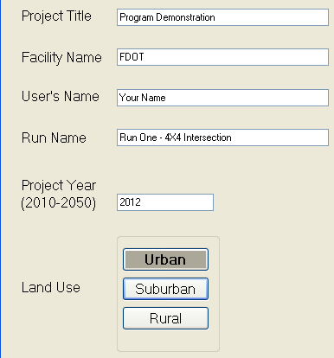**Double-Clicks**On the “Title”, “District”, and “Intersection Type” user input screens only it is also possible to advance to the next input screen in sequence by double-clicking on the final input button of the screen, as shown in Figures 1-3. For these buttons, the first click will visibly highlight the button and the second click is the equivalent to clicking on the “Next” button.

## District2.bmp

Figure - Title Screen Double-Click Figure - District Screen Double-Click

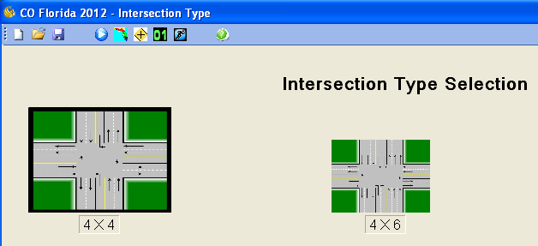

Figure - Intersection Type Double-Click

**3. Upper Navigation Icons**

It is also possible to navigate COFL 2012 using the upper navigation icons, which are split into three parts, as shown in Figure 4:

* The first three icons are the traditional “New”, “Open”, and “Save” icons.
* The second segment provides direct navigation between the “Title”, “District”, “Intersection Type”, “Intersection Data”, and “Results” screens. Note that it is only possible to navigate forward once the preceding screens have been completed.
* 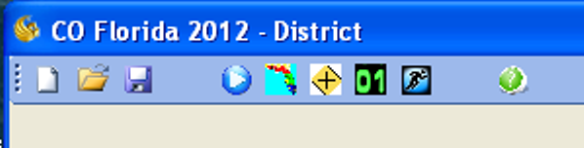The last of these icons (the “Question Mark”) links to the “**About”** screen (see Figure 5).

Figure – Upper Navigation Icons

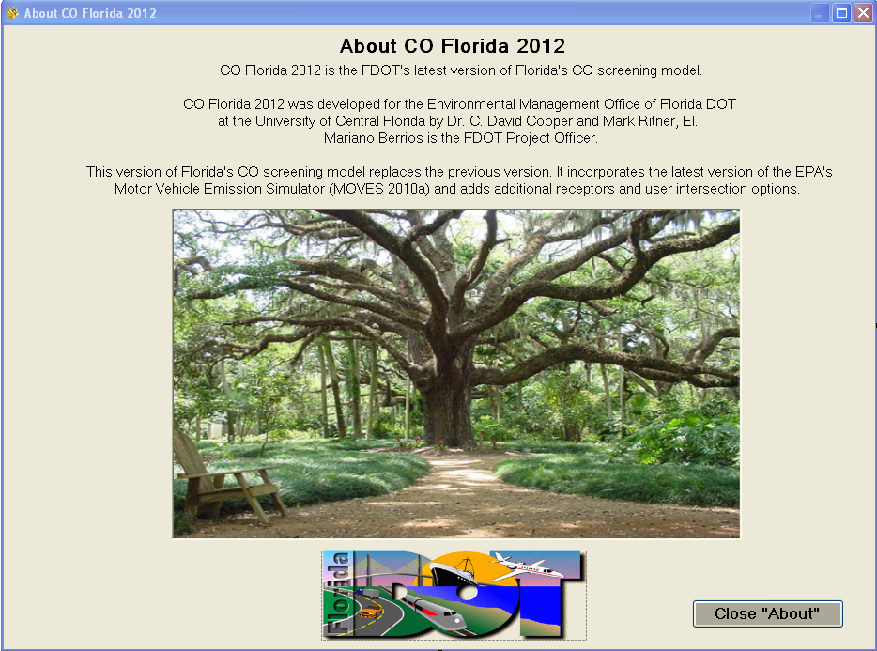

**Figure 5 - About Screen**

# WELCOME SCREEN

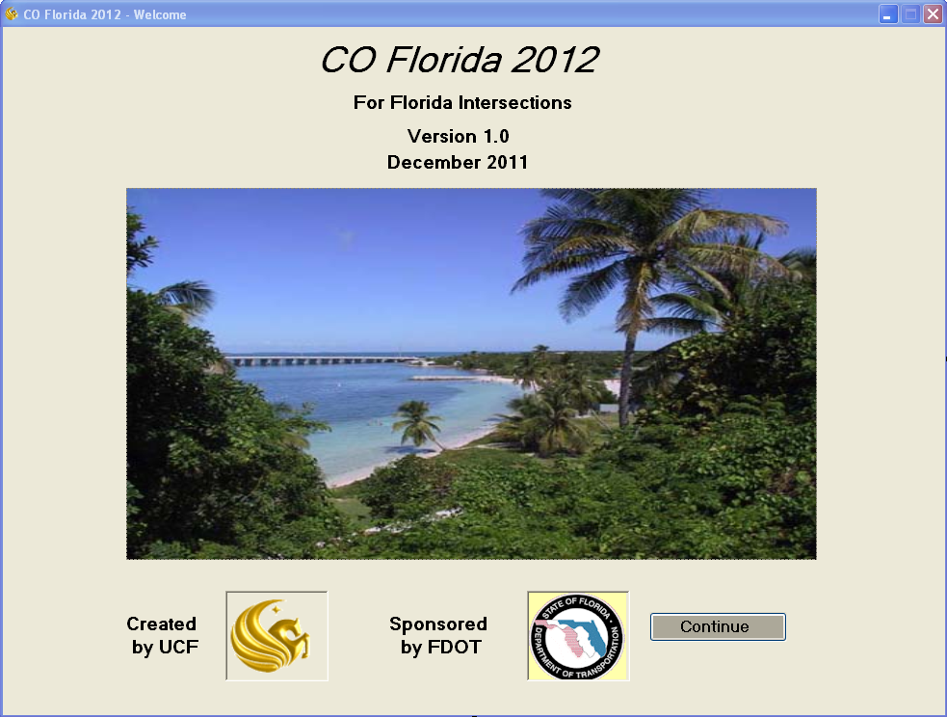The CO Florida 2012 Screening Model (COFL 2012) opens with the splash screen shown in Figure 6. Each time COFL 2012 is run a different image representing various Florida State symbols appears on the **Welcome** screen; several other screens also display images. Users can identify each image by mousing and hovering over the image, as demonstrated in Figure 6.

Bahia Honda State Park,  
Big Pine Key

Figure - Welcome Screen

When the user clicks on the “Continue” button, the program advances to the **Title** Screen (see Figure 7).

# TITLE SCREEN

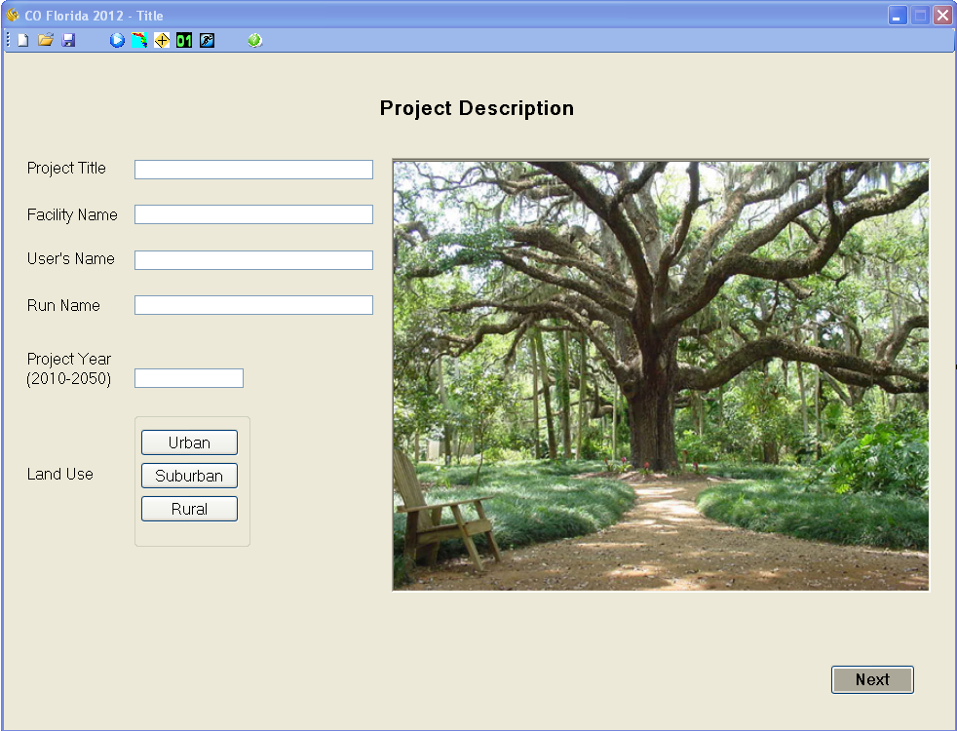

Figure - Title Screen

The **Title** screen (Figure 7) consists of the upper navigation icon bar, five data entry text boxes, and a group box containing land use type selection buttons. The screen also displays a randomly selected Florida picture. The identification of this picture can be viewed by mousing over the image. The cursor can be advanced between the text input boxes by the use of the “Tab” key. Please note that the “Project Title” and “Run Name” fields are restricted to a maximum of 40 characters, to accommodate the CAL3QHC2 input file requirements.

From the **Title** screen, the “Open” button on the upper navigation icon bar can be utilized to load an existing project. Any attempts to navigate forward within the model will not be allowed until all fields on this screen have been appropriately completed.

The following data fields require data entry:

* Project Title: This field can accept a maximum of 40 characters.
* Facility Name: This field does not have a maximum character limit.
* User’s Name: This field does not have a maximum character limit.
* Run Name: This field can accept a maximum of 40 characters.
* Project Year: The model is valid for project years from 2010 to 2050.
* Land Use Type: Select the appropriate land use type - urban, suburban, or rural. The choice of this parameter automatically selects the surface roughness coefficient and atmospheric stability which are inputs in the CAL3QHC2 dispersion modeling program. The land use selection also determines the background CO concentrations which are figured into the final results. Table 1 lists the land use options and their corresponding surface roughness coefficients, atmospheric stabilities and background concentrations.

Table - Parameters Impacted by Land Use Type

|  |  |  |  |  |
| --- | --- | --- | --- | --- |
| **Land Use Type** | **Surface Roughness (cm)** | **Atmospheric Stability Class** | **CO Background Concentration (ppm)** | |
| **1-hour** | **8-hour** |
| Urban | 175 | D | 5.0 | 3.0 |
| Suburban | 108 | D | 3.3 | 2.0 |
| Rural | 10 | E | 1.7 | 1.0 |

Once the **Title** screen has been completed, navigation to the next input screen, the **District** screen, may be made in one of the following three ways:

1. Clicking on the “Next” button on the bottom/right of the screen,
2. Clicking again on the highlighted land use type on the bottom/left of the screen, or
3. Clicking on the “District” icon, shaped like the state of Florida, on the upper navigation bar.

# DISTRICT SCREEN

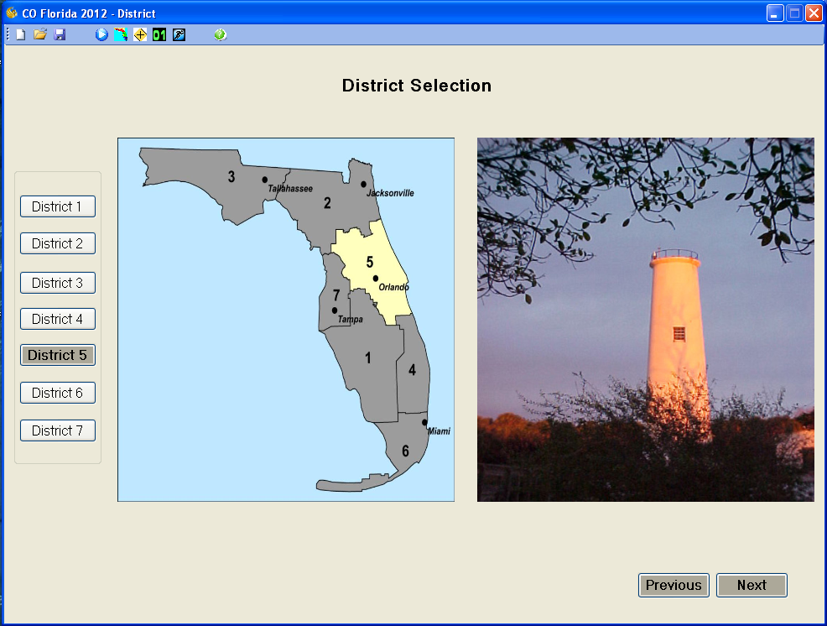

Figure - District Screen

This **District** screen (as shown in Figure 8) is used for identifying the Florida Department of Transportation (FDOT) district in which the project is located. The district is selected by clicking on the appropriately named district button inside the group box on the left of the screen. Once a district is selected, the other options will be grayed-out on the map in the center of the screen.

Once the **District** screen has been completed, navigation to the next input screen, the **Intersection Type** screen, may be made in one of the following three ways:

1. Clicking on the “Next” button on the bottom/right of the screen,
2. Clicking again on the highlighted “District” button on the left of the screen, or
3. Clicking on the “Intersection Type” icon, shaped like a four-way traffic intersection road sign, on the upper navigation icon bar.

# INTERSECTION TYPE SCREEN

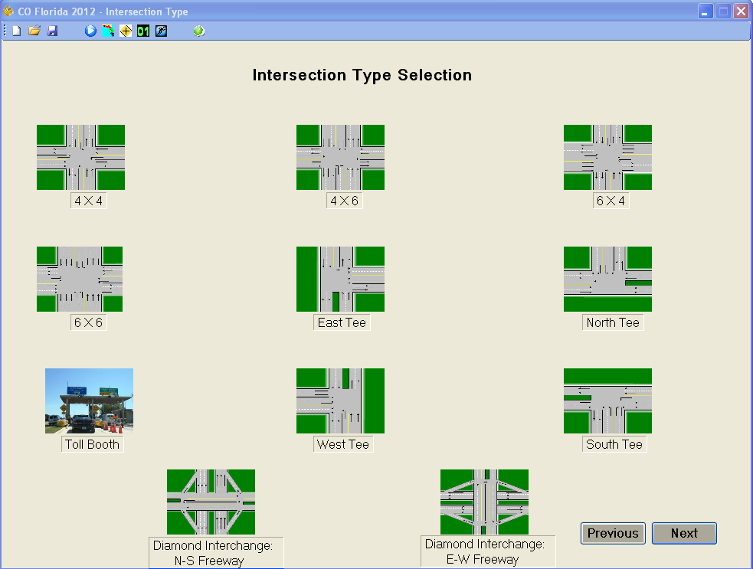

Figure – Intersection Type Screen

**Intersection Type** The user may choose from eleven intersection types as displayed in Figure 9. The layout that most closely represents the current roadway project should be selected. The **Tollbooth** screen will offer an east-west orientation and a north-south orientation by clicking on the graphic once it appears. COFL 2012 contains pre-built files depicting the geometry and signal timing of each intersection type.

Once the **Intersection Type** screen has been completed, navigation to the next input screen, theselected **Intersection Data** screen may be made in one of the following three ways:

1. Clicking on the “Next” button on the bottom/right of the screen,
2. Clicking on the highlighted intersection type image,
3. or clicking on the “Intersection Data” icon, with the green “01” numerals, on the upper navigation icon bar.

**INTERSECTION DATA SCREEN**

The eleven intersection configurations fall into three general categories, each with slightly different data input requirements. Each configuration has its own data input needs and corresponding figure (as seen in thumbnail size in Figure 9). Therefore, in the interest of space, no figures are presented here. However, the appropriate figure is shown in each of the three examples that follow. For each configuration, the top of the screen is referenced as north.

* Standard, arterial road intersections (e.g. 4 X 4 Intersection),
* Freeway diamond interchanges (e.g. N-S Freeway Diamond Interchange),
* and freeway tollbooth interchanges (e.g.. E-W Freeway Tollbooth Interchange).

**Speed** Entered speed values must be between 15 and 65 miles per hour. The speeds to be entered are defined as the cruise speed as vehicles approach the intersection before entering the queue - sometimes referred to as mid-block speed. (Note that the through traffic on the freeway in the diamond interchange does not enter a queue.) If cruise speed is unknown, use the speed limit. Roadway speeds (in miles per hour) are entered for each road.

**Approach Traffic Volume** The traffic volume, for each approach, is the peak hour volume on that leg. All data fields must have a value in them; the model will not allow the execution of a modeling run until all fields have been appropriately completed.

**Example 1. 4 X 4 Intersection** The 4 X 4 intersection shown in Figure 10 requires that speeds and approach traffic volumes be entered for all four directions. (The order of normal data entry progression is indicated numerically on Figure 10.) The tab key is normally used to facilitate data entry, but data can be entered in any order using the mouse to position the cursor. The model internally calculates right and left turning traffic from the approach traffic volumes entered. The model receptors (at pre-determined worst-case locations) are indicated with blue dots for each of the traffic scenarios.

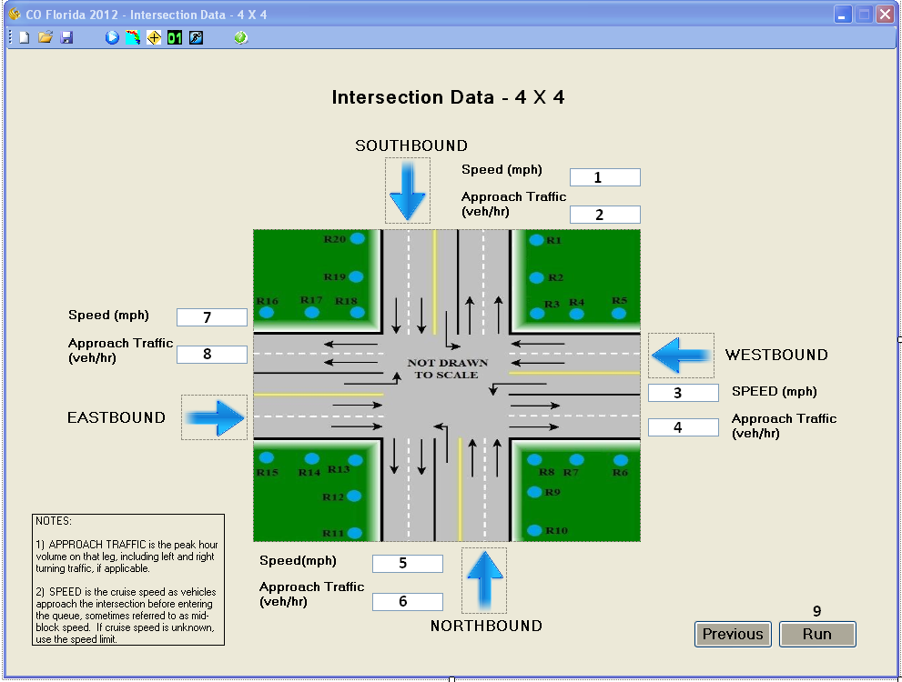

Figure - Intersection Data Screen for 4X4 Intersections

Example 2. N-S Freeway Diamond Interchange  
 The N-S freeway diamond interchange shown in Figure 11 requires that speeds and approach traffic be entered in all four directions, as with the 4 X 4 intersection configuration. The freeway diamond also requires that on and off-ramp traffic volumes be entered in each direction. Ramp volumes are the total, on or off volumes, regardless of percentages turning right or left. The model automatically apportions the off ramp traffic to each direction. The tab key is used to speed up data entry; the order of the tab progression is indicated numerically in Figure 11.

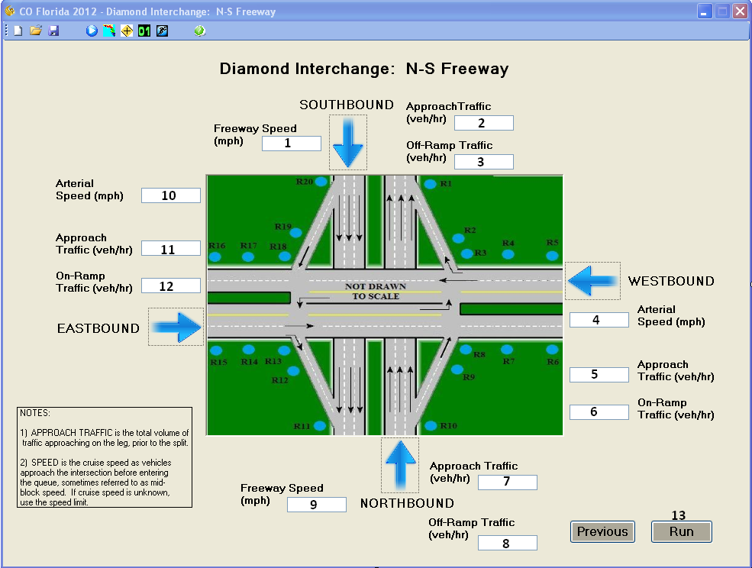

Figure - Intersection Data Screen for N-S Freeway Diamond Interchange

**Example 3. E-W Freeway Tollbooth Interchange**  
 The E-W freeway tollbooth interchange shown in Figure 12 requires that speeds and approach traffic be entered in both directions. The tollbooth interchange also requires that the percentage of vehicles utilizing the electronic toll collection-only (ETC-only) lanes be entered in each direction. If there are no ETC-only lanes for the scenario, a zero (0) should be input for this field. Note that the geographic orientation of the freeway tollbooth interchange can be switched, simply by clicking on the center image. The order of the tab progression of data entry is indicated numerically in Figure 12.

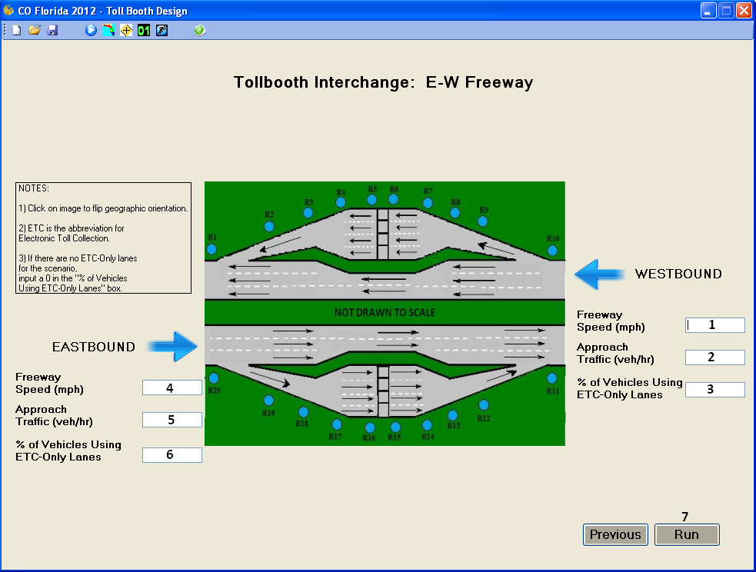

Figure - Intersection Data Screen for E-W Freeway Tollbooth Interchange

## Once the Intersection Data screen has been completed, a Run may be made by either:

1. Clicking on the “Run” button on the bottom, right of the screen, or
2. Clicking on the “Run” icon, (a running stick-figure), on upper navigation icon bar.

# RECEPTORS

COFL 2012 has pre-built all the receptor coordinates for each intersection configuration. Each of the **Intersection Data** screens indicates the approximate receptor locations with blue dots. The exact receptor coordinates for a particular run can be seen by viewing the CAL3QHC2 input file (“incal3qhc.in”) that has been created by COFL 2012. The pre-built receptors used in the model provide a comprehensive 360° representation of potential near-road CO concentrations. Table 2 provides examples of receptor coordinates that are utilized in creating the CAL3QHC2 input files. These three scenarios correspond to the three intersection configurations which were shown earlier. Note that that the Z-coordinate for all receptors are set to the EPA-recommended height of 6 ft.

Table – Receptor Coordinate Examples

|  |  |  |  |  |  |  |
| --- | --- | --- | --- | --- | --- | --- |
| **Receptor** | **4 X 4 Intersection** | | **N-S Freeway Diamond Interchange** | | **E-W Freeway Tollbooth Interchange (w/ ETC-only lanes)** | |
| **X (ft)** | **Y (ft)** | **X (ft)** | **Y (ft)** | **X (ft)** | **Y (ft)** |
| 1 | 40 | 180 | 46 | 1036 | -2000 | 68 |
| 2 | 40 | 80 | 116 | 336 | -1250 | 68 |
| 3 | 40 | 40 | 166 | 46 | -500 | 68 |
| 4 | 80 | 40 | 261 | 46 | -150 | 99 |
| 5 | 180 | 40 | 361 | 46 | -50 | 116 |
| 6 | 180 | -40 | 361 | -46 | 50 | 116 |
| 7 | 80 | -40 | 261 | -46 | 150 | 99 |
| 8 | 40 | -40 | 166 | -46 | 500 | 68 |
| 9 | 40 | -80 | 116 | -336 | 1250 | 68 |
| 10 | 40 | -180 | 46 | -1036 | 2000 | 68 |
| 11 | -40 | -180 | -46 | -1036 | 2000 | -68 |
| 12 | -40 | -80 | -116 | -336 | 1250 | -68 |
| 13 | -40 | -40 | -166 | -46 | 500 | -68 |
| 14 | -80 | -40 | -261 | -46 | 150 | -99 |
| 15 | -180 | -40 | -361 | -46 | 50 | -116 |
| 16 | -180 | 40 | -361 | 46 | -50 | -116 |
| 17 | -80 | 40 | -261 | 46 | -150 | -99 |
| 18 | -40 | 40 | -166 | 46 | -500 | -68 |
| 19 | -40 | 80 | -116 | 336 | -1250 | -68 |
| 20 | -40 | 180 | -46 | 1036 | -2000 | -68 |

# EMISSION FACTORS

This latest version of COFL 2012 derives its emission factors (EFs) from numerous runs of EPA’s motor vehicle emission simulator 2010a (MOVES), which have been compiled into text file look-up tables. For years and speeds that fall in between the table values, a double, linear interpolation is employed to produce the desired EF. In 2011, MOVES officially replaced MOBILE6 as the EPA’s preferred model for determining the EFs to be used in screening models and other applications.

In addition to the EFs for idle (g/hr) and for various cruise and turning speeds (g/mile), COFL 2012 utilizes EF “multipliers” that also have been developed through numerous runs of MOVES. The multipliers provide more realistic and conservative estimates of emissions from accelerating vehicles, by considering the additional load that is placed upon vehicle engines in acceleration mode. The increased emissions from acceleration are particularly evident when vehicles are simultaneously climbing grades and accelerating hard (e.g., while entering a freeway from an on-ramp). Table 3 provides examples of the effect of grade and acceleration on EF multipliers.

Table - Comparison of EF Multipliers

|  |  |  |  |  |  |
| --- | --- | --- | --- | --- | --- |
| **Terminal Speed (mph)** | **Acceleration Type** | **% Grade** | **EF Free Flow (g/mile)** | **EFAccel (g/mile)** | **Multiplier** |
| 40 | Typical | 0% | 4.41 | 41.9 | 9.5 |
| 50 | 4.16 | 44.2 | 10.6 |
| 60 | 4.28 | 46.6 | 10.9 |
| 40 | Typical | 2% | 4.41 | 44.4 | 10.1 |
| 50 | 4.16 | 46.8 | 11.3 |
| 60 | 4.28 | 49.4 | 11.5 |
| 40 | Aggressive | 0% | 4.41 | 62.4 | 14.2 |
| 50 | 4.16 | 62.6 | 15.0 |
| 60 | 4.28 | 52.3 | 12.2 |
| 40 | Aggressive | 2% | 4.41 | 66.4 | 15.1 |
| 50 | 4.16 | 66.6 | 16.0 |
| 60 | 4.28 | 55.6 | 13.0 |

# RUNNING THE FLORIDA CO SCREENING MODEL

A model run may be made directly from any of the completed **Intersection Data** screens. To make a run from an **Intersection Data** screen, the user may click on the “Run” lower navigation button or on the “Run” icon (a running stick-figure) on the upper navigation icon bar.

With all data entered, COFL 2012 extracts the relevant EFs from the table of MOVES EFs for the project FDOT district. The EF extraction occurs instantaneously, and these values are then incorporated into a CAL3QHC input file. Next, the model continues its analysis using CAL3QHC. The black DOS screen will appear for a few seconds while CAL3QHC runs, followed by a brief pause as COFL 2012 extracts the results from the CAL3QHC output file (“outcal3qhc.out”) COFL 2012 extracts the 1-hour concentrations calculated by CAL3QHC at the various receptors, adds the 1-hr background concentration, and also converts these data to 8-hour concentrations utilizing a total persistence factor (TPF) of 0.6.

The intermediate files are available in the application folder for viewing if desired. They are as follows:

*incal3q.in* the CAL3QHC input file

*outcal3q.out* the CAL3QHC output file

The folder, *EFTextFiles* contains lookup tables generated by multiple runs of MOVES that provide the EFs for the years 2010-2050 for each of the 7 FDOT districts. These files should not be modified in any way by the user.

After the model finishes running CAL3QHC, it extracts the outputs and creates a 1-page summary report which is displayed on the **Results** screen. Figure 13 displays an example **Results** screen for a 4 X 4 Intersection. Note that the user-entered data are summarized on the left side of the **Results** screen along with some of the built-in data used by the model. All concentration results appear on the right-hand side of this screen. The bottom of the screen indicates whether or not the run passed the screening model (did not exceed either the 1-hour (35 ppm) or the 8-hour (9 ppm) CO concentration standards).

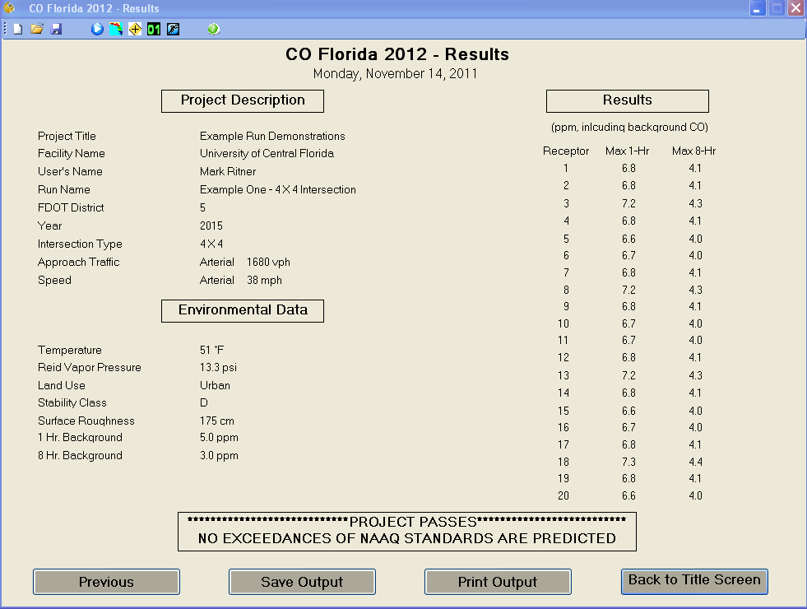

Figure – Example Results Screen

Once a run has been made, the user may utilize several different navigation paths:

* Click the “Previous” bottom button to return to the **Intersection Data** screen and modify inputs. The program will prompt the user at this point to save all the inputs from the run that was just made.
* Click the “Save Output” bottom button to save the results of the run. The default file extension is “.out”, which can be opened with a text view or Microsoft Word. The user may click the down arrow on the “Save as type:” line in the Save As input form to view files with other extensions.
* Click the “Print Output” bottom button to send the results directly to a printer configured from the user’s computer.
* Click the “Back to Title Screen” bottom button to return to the **Title** screen to make modifications to the existing scenario. The program will prompt the user at this point to save all the inputs from the run that was just made.
* Click the “New” upper navigation icon bar button to clear all existing data entries and return to the **Title** screen for a new run. The program will prompt the user at this point to save all the inputs from the run that was just made.
* Click the “Open” upper navigation icon bar button to clear all existing data entries, open a previously saved project and return to the **Title** screen. The program will prompt the user at this point to save all the inputs from the run that was just made.
* Click the “Save” upper navigation icon bar button to save all the inputs from the run that was just made.
* Click the red “X” button on the top, right of the screen to exit COFL 2012. The program will prompt the user at this point to save all the inputs from the run that was just made.

# EXAMPLE INPUTS AND OUTPUTSTEXT VIEWER

This section includes three examples, as summarized in Table 4.

Table - Summary of Examples

|  |  |  |  |
| --- | --- | --- | --- |
| **Example** | **Intersection Type** | **Input File** | **Output File** |
| 1 | 4 X 4 | Figure 14 | Figure 15 |
| 2 | N-S Freeway Diamond Interchange | Figure 16 | Figure 17 |
| 3 | E-W Freeway Tollbooth Interchange | Figure 18 | Figure 19 |

Please note that the input files have been formatted specifically for use by COFL 2012 in recalling saved scenarios. If users wish to modify saved scenarios, they should open the saved input files within COFL 2012, make the appropriate changes, and then save. Also, if users wish to re-format the saved inputs for use in reports, they should save the modified files to a different folder to prevent COFL 2012 from attempting to read an incorrectly formatted input file.

The COFL 2012 input files for examples 1, 2, and 3, are presented in Figures 14, 16, and 18, respectively. They have been modified slightly for purposes of presentation in this User’s guide. The information has been placed into four columns and the data type titles have been italicized. Note that some fields remain blank, if they don’t apply to the example under examination. (e.g. the on/off ramp traffic and ETC-only percentage fields are blank for the 4 X 4 intersection example.) Figures 15, 17, and 19 present the “results” reports for examples 1, 2, and 3 respectively.

|  |  |  |  |
| --- | --- | --- | --- |
| *Project Title*  Example Run Demonstrations  *Facility Name*  University of Central Florida  *User's Name*  Mark Ritner  *Run Name*  Example One - 4 X 4 Intersection  *Project Year*  2015  *Temperature*  51  *Land Use*  Urban  *Zo*  175  *Stability Class*  4  D  *1-hr CO Background Concentration*  5.0  *8-hr CO Background Concentration*  3.0  *FDOT District Number*  5  *Intersection Type*  4 X 4 | *Speed South Bound*  43  *Speed West Bound*  38  *Speed North Bound*  41  *Speed East Bound*  39  *Approach Traffic  South Bound*  1450  *Approach Traffic  West Bound*  1680  *Approach Traffic  North Bound*  1620  *Approach Traffic  East Bound*  1520  *On/Off Ramp Traffic  South Bound*  *On/Off Ramp Traffic West Bound*  *On/Off Ramp Traffic North Bound*  *On/Off Ramp Traffic East Bound* | *ETC-Only Percentage  South Bound*  *ETC-Only Percentage  West Bound*  *ETC-Only Percentage  North Bound*  *ETC-Only Percentage  East Bound*  *InputsCorrect(1)*  True  *InputsCorrect(2)*  True  *InputsCorrect(3)*  True  *InputsCorrect(4)*  True | *Receptor 'X' Coordinates*  40  40  40  80  180  180  80  40  40  40  -40  -40  -40  -80  -180  -180  -80  -40  -40  -40  *Receptor 'Y' Coordinates*  180  80  40  40  40  -40  -40  -40  -80  -180  -180  -80  -40  -40  -40  40  40  40  80  180 |

Figure – Example 1 (4 X 4 Intersection) Inputs

CO Florida 2012 - Results

Wednesday, November 30, 2011

Project Description

Project Title Example Run Demonstrations

Facility Name University of Central Florida

User's Name Mark Ritner

Run Name Example One - 4 X 4 Intersection

FDOT District 5

Year 2015

Intersection Type 4 X 4

Max Approach Traffic 1680 vph

Arterial Speed 38 mph

Environmental Data

Temperature 51 F

Reid Vapor Pressure 13.3 psi

Land Use Urban

Stability Class D

Surface Roughness 175 cm

1 Hr. Background Concentration 5.0 ppm

8 Hr. Background Concentration 3.0 ppm

Results

(ppm, including background CO)

Receptor Max 1-Hr Max 8-Hr

-------- -------- --------

1 6.8 4.1

2 6.8 4.1

3 7.2 4.3

4 6.8 4.1

5 6.6 4.0

6 6.7 4.0

7 6.8 4.1

8 7.2 4.3

9 6.8 4.1

10 6.7 4.0

11 6.7 4.0

12 6.8 4.1

13 7.2 4.3

14 6.8 4.1

15 6.6 4.0

16 6.7 4.0

17 6.8 4.1

18 7.3 4.4

19 6.8 4.1

20 6.6 4.0

************************************************

*****************PROJECT PASSES*****************

*NO EXCEEDANCES OF NAAQ STANDARDS ARE PREDICTED*

************************************************

Figure – Example 1 (4 X 4 Intersection) Results

|  |  |  |  |
| --- | --- | --- | --- |
| *Project Title*  Example Run Demonstrations  *Facility Name*  University of Central Florida  *User's Name*  Mark Ritner  *Run Name*  Example Two -  N-S Freeway Diamond  *Project Year*  2015  *Temperature*  51  *Land Use*  Urban  *Zo*  175  *Stability Class*  4  D  *1-hr CO Background Concentration*  5.0  *8-hr CO Background Concentration*  3.0  *FDOT District Number*  5  *Intersection Type*  N-S Diamond | *Speed South Bound*  65  *Speed West Bound*  38  *Speed North Bound*  64  *Speed East Bound*  39  *Approach Traffic  South Bound*  5000  *Approach Traffic  West Bound*  3500  *Approach Traffic  North Bound*  6000  *Approach Traffic  East Bound*  3800  *On/Off Ramp Traffic  South Bound*  1000  *On/Off Ramp Traffic  West Bound*  1500  *On/Off Ramp Traffic  North Bound*  1200  *On/Off Ramp Traffic  East Bound*  1500 | *ETC-Only Percentage  South Bound*  *ETC-Only Percentage  West Bound*  *ETC-Only Percentage  North Bound*  *ETC-Only Percentage  East Bound*  *InputsCorrect(1)*  True  *InputsCorrect(2)*  True  *InputsCorrect(3)*  True  *InputsCorrect(4)*  True | *Receptor 'X' Coordinates*  46  116  166  261  361  361  261  166  116  46  -46  -116  -166  -261  -361  -361  -261  -166  -116  -46  *Receptor 'Y' Coordinates*  1036  336  46  46  46  -46  -46  -46  -336  -1036  -1036  -336  -46  -46  -46  46  46  46  336  1036 |

Figure – Example 2 (N-S Freeway Diamond Interchange) Inputs

CO Florida 2012 - Results

Wednesday, November 30, 2011

Project Description

Project Title Example Run Demonstrations

Facility Name University of Central Florida

User's Name Mark Ritner

Run Name Example Two - N-S Freeway Diamond

FDOT District 5

Year 2015

Intersection Type E-W Freeway N-S Diamond

Speed Arterial 38 mph Freeway 65 mph

Approach Traffic Arterial 3800 vph Freeway 6000 vph

Environmental Data

Temperature 51 F

Reid Vapor Pressure 13.3 psi

Land Use Urban

Stability Class D

Surface Roughness 175 cm

1 Hr. Background Concentration 5.0 ppm

8 Hr. Background Concentration 3.0 ppm

Results

(ppm, including background CO)

Receptor Max 1-Hr Max 8-Hr

-------- -------- --------

1 8.9 5.3

2 7.2 4.3

3 8.9 5.3

4 8.6 5.2

5 8.5 5.1

6 8.7 5.2

7 8.6 5.2

8 8.4 5.0

9 6.6 4.0

10 8.8 5.3

11 8.9 5.3

12 7.2 4.3

13 8.7 5.2

14 8.6 5.2

15 8.5 5.1

16 8.6 5.2

17 8.5 5.1

18 8.4 5.0

19 6.6 4.0

20 8.9 5.3

************************************************

*****************PROJECT PASSES*****************

*NO EXCEEDANCES OF NAAQ STANDARDS ARE PREDICTED*

************************************************  
  
Figure – Example 2 (N-S Freeway Diamond Interchange) Results

|  |  |  |  |
| --- | --- | --- | --- |
| *Project Title*  Example Run Demonstrations  *Facility Name*  University of Central Florida  *User's Name*  Mark Ritner  *Run Name*  Example Three -  E-W Freeway Tollbooth  *Project Year*  2015  *Temperature*  51  *Land Use*  Suburban  *Zo*  108  *Stability Class*  4  D  *1-hr CO Background Concentration*  5.0  *8-hr CO Background Concentration*  3.0  *FDOT District Number*  5  *Intersection Type*  Toll Booth | *Speed South Bound*    *Speed West Bound*  62  *Speed North Bound*  *Speed East Bound*  65  *Approach Traffic  South Bound*  *Approach Traffic  West Bound*  7200  *Approach Traffic  North Bound*  *Approach Traffic  East Bound*  8000  *On/Off Ramp Traffic  South Bound*  *On/Off Ramp Traffic  West Bound*  *On/Off Ramp Traffic  North Bound*  *On/Off Ramp Traffic  East Bound* | *ETC-Only Percentage  South Bound*  *ETC-Only Percentage  West Bound*  15  *ETC-Only Percentage  North Bound*  *ETC-Only Percentage  East Bound*  15  *InputsCorrect(1)*  True  *InputsCorrect(2)*  True  *InputsCorrect(3)*  True  *InputsCorrect(4)*  True | *Receptor 'X' Coordinates*  -2000  -1250  -500  -150  -50  50  150  500  1250  2000  2000  1250  500  150  50  -50  -150  -500  -1250  -2000 *Receptor 'Y' Coordinates*  68  68  68  99  116  116  99  68  68  68  -68  -68  -68  -99  -116  -116  -99  -68  -68  -68 |

Figure – Example 3 (E-W Freeway Tollbooth Interchange) Inputs

CO Florida 2012 - Results

Thursday, December 01, 2011

Project Description

Project Title Example Run Demonstrations

Facility Name University of Central Florida

User's Name Mark Ritner

Run Name Example Three - E-W Freeway Tollbooth

FDOT District 5

Year 2015

Intersection Type E-W Freeway Toll Booth

Speed East Bound 65 mph West Bound 62 mph

Approach Traffic EB Stopping 6800 vph WB Stopping 6120 vph

EB ETC-only 1200 vph WB ETC-only 1080 vph

Environmental Data

Temperature 51 F

Reid Vapor Pressure 13.3 psi

Land Use Suburban

Stability Class D

Surface Roughness 108 cm

1 Hr. Background Concentration 3.3 ppm

8 Hr. Background Concentration 2.0 ppm

Results

(ppm, including background CO)

Receptor Max 1-Hr Max 8-Hr

-------- -------- --------

1 6.4 3.8

2 8.7 5.2

3 16.1 9.7

4 14.9 8.9

5 15.0 9.0

6 13.1 7.9

7 10.4 6.2

8 8.3 5.0

9 8.6 5.2

10 6.6 4.0

11 6.6 4.0

12 8.9 5.3

13 17.0 10.2

14 15.8 9.5

15 16.1 9.7

16 14.1 8.5

17 11.1 6.7

18 8.5 5.1

19 8.4 5.0

20 6.7 4.0

***********************************************

*********PROJECT FAILS SCREENING MODEL*********

*********DETAILED MODELING IS REQUIRED*********

***********************************************  
  
Figure – Example 3 (E-W Freeway Tollbooth Interchange) Results